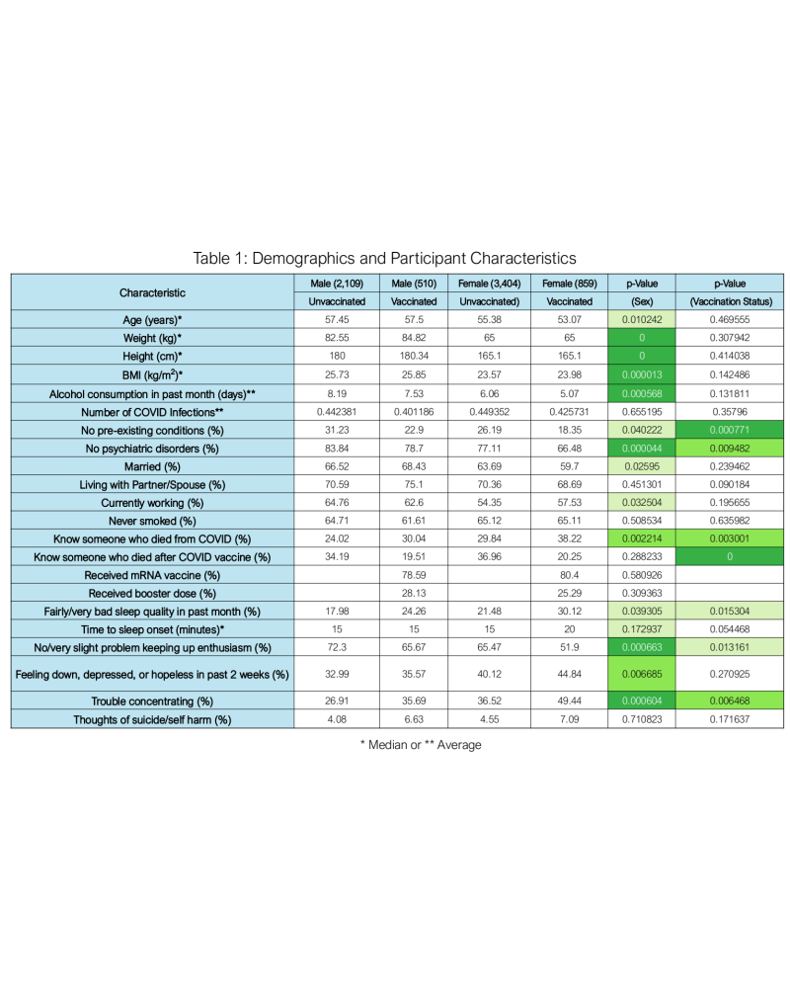

Table 1. Demographics and Participant Characteristics. Median or average values for various participant characteristics are shown for unvaccinated and vaccinated men and women. P values based on a two-tailed t-test for vaccination status and sex are shown. Cells with significant p values are filled in green with darkest shade for p<0.0001 and lightest for p<0.01. Unvaccinated male (n=2,109), Vaccinated male (n=510), Unvaccinated female (n=3,404), Vaccinated female (n=859).

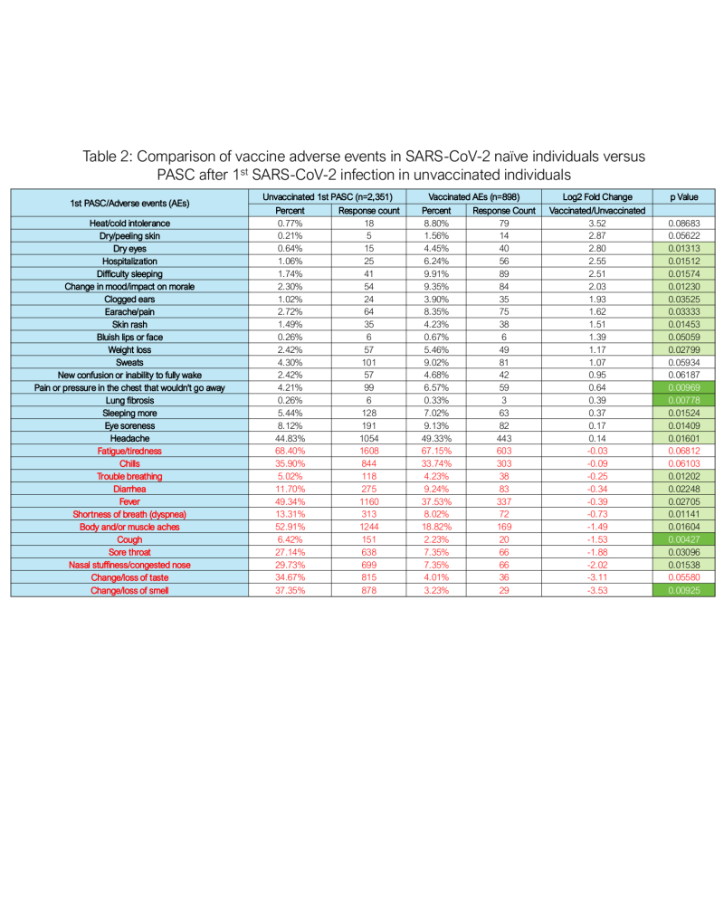

Table 2. Comparison of COVID-19 vaccine-associated adverse events versus COVID-19 symptoms (PASC) after 1st SARS-CoV-2 infection in unvaccinated. To evaluate benefits were risks of vaccines, adverse events reported by SARS-CoV-2 naïve vaccinated individuals after any dose were compared to PASC reported by COVID-19 vaccine naïve (unvaccinated) individuals after 1st SARS-CoV-2 infection. Log₂ fold change and p values based on a two-tailed t-test vaccinated versus unvaccinated are shown. Symptoms highlighted in red text were reported less frequently by vaccinated whereas others were reported more by the vaccinated individuals. Cells with significant p values are filled in green with darkest shade for p<0.001 and lightest for p<0.05. Vaccinated (n=898), Unvaccinated (2,351).

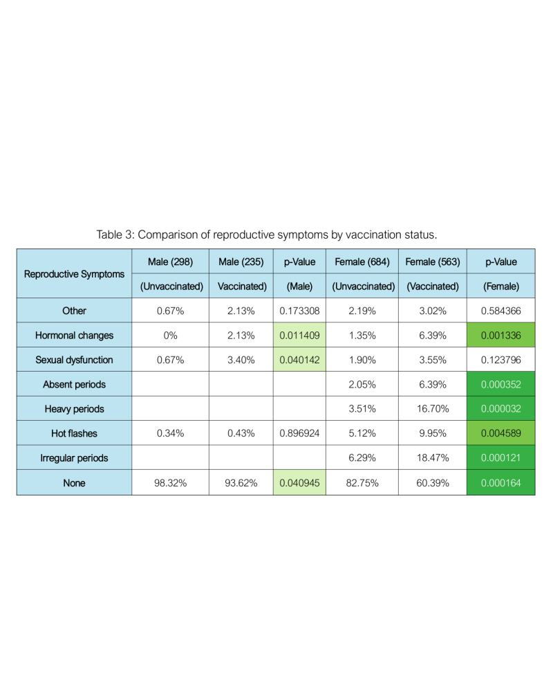

Table 3. Comparison of reproductive symptoms after infection with SARS-CoV-2 by vaccination status. Percent responses for various reproductive PASC experienced by unvaccinated and vaccinated men and women after 1st SARS-CoV-2 infection are shown. Sexual dysfunction (3.40%) and hormonal changes (2.13%) were reported by significantly more vaccinated men than unvaccinated after SARS-CoV-2 infection. Several menstrual cycle abnormalities were reported in greater numbers by vaccinated vs unvaccinated women after SARS-CoV-2 infection. P values based on a two-tailed t-test vaccinated versus unvaccinated. Cells with significant p values are filled in green with darkest shade for p<0.001 and lightest for p<0.05. Unvaccinated male (n=298), Vaccinated male (n=235), Unvaccinated female (n=684), Vaccinated female (n=563).

