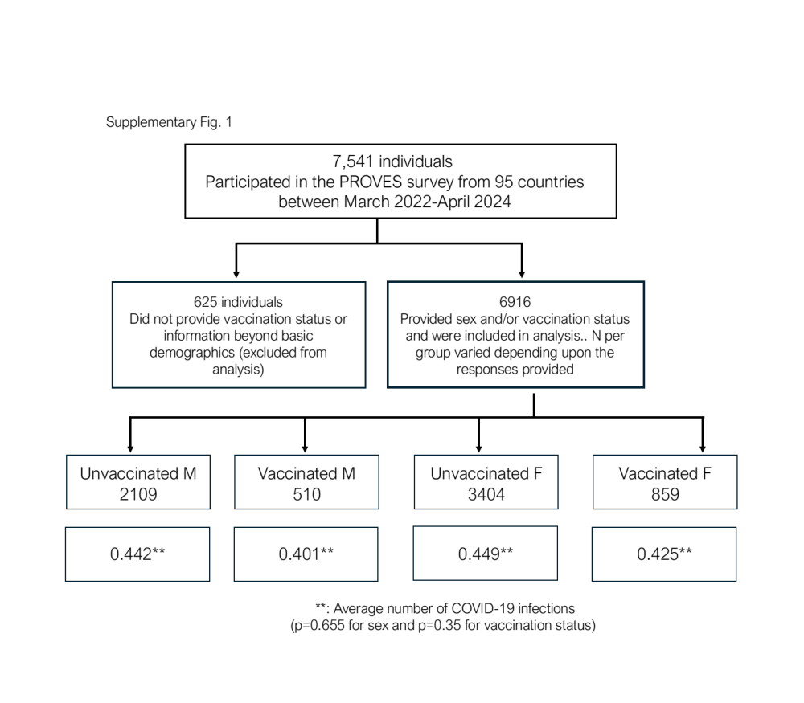
Supplementary Fig. 1. Flow chart of PROVES Survey participants, inclusion and exclusion criteria.

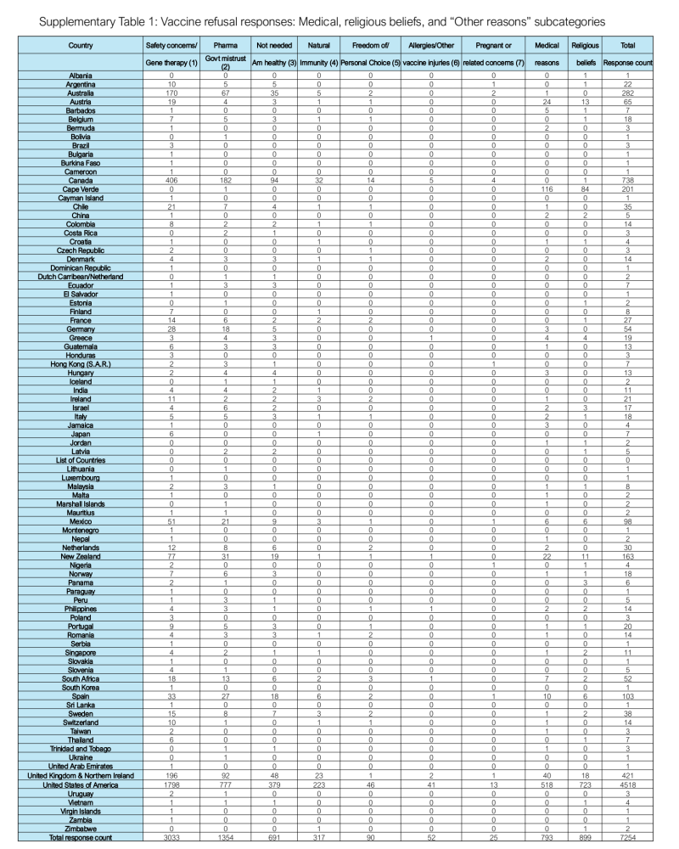
Supplementary Table. 1. Vaccine refusal responses: Medical, religious beliefs, and “Other reasons” subcategories were determined using the Mistral LLM was integrated via the “Ollama” Python library. See https://aseesa-inc.github.io/WorlMap/ for interactive maps.

