BIOGRAPHIES OF AUTHORS
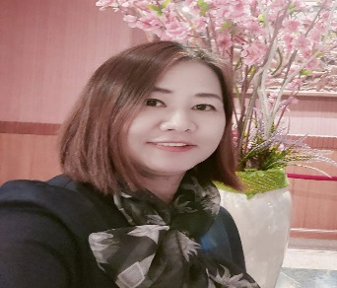 | Isaree Padphai https://orcid.org/0000-0003-2182-2620 is the Lecturer at Community Public Health Department, Sirindhorn College of Public Health Khon Kaen. Faculty of Public Health & Allied Health Sciences. Praboromarajchanok Institute. Ministry of Public Health, Thailand. She got Doctoral degree of Public Health, Faculty of Public Health, Khon Kaen University, Thailand in 2019. She interestes in non-communicable diseases, Health literacy and Health behavior. She can be contacted at e-mail: kaogrand@hotmail.com.
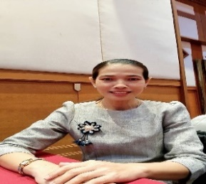 | Wanida Sripromsa https://orcid.org/0009-0009-1903-6357  is the Lecturer at Community Nursing Department, Faculty of Nursing Praboromarajchanok Institute, Boromarajonani College of Nursing Udon Thani. Ministry of Public Health, Thailand. She got Doctoral degree of Nursing Science, Faculty of Nursing, Khon Kaen University, Thailand in 2021. She interestes in non-communicable diseases, Health literacy and Health behavior Older Adults . She can be contacted at e-mail: wanida-sri@bcnu.ac.th.
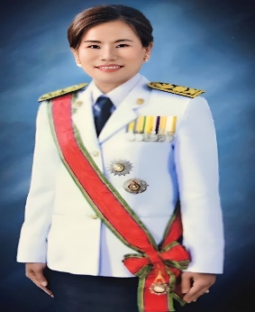 | Pawinee Sanchon https://orcid.org/0000-0002-2823-1949 is the Associate Professer at Sakonnakon Rajabhat University Faculty of Humnities and Social Sciences. Thailand. She got Doctoral degree of Philosophy Program in Information Science, Faculty of Art, Sukhothai Thammathirat Open University, Thailand in 2019. She interestes in Information Managemetn, Information Literacy, Digital Literacy Knowledge Management . She can be contacted at e-mail: Phawinee.sa@snru.ac.th
 | Nitchakarn Meelun https://orcid.org/0000-0003-2182-2620 is the Lecturer at Community Public Health Department, Sirindhorn College of Public Health Khon Kaen. Faculty of Public Health &amp; Allied Health Sciences. Praboromarajchanok Institute. Ministry of Public Health, Thailand. She got Master of Public Health (Environmental), Faculty of Public Health, Khon Kaen University, Thailand in 2011. She interestes in Public Health Science, Environmental Health, non-communicable diseases, Health literacy and Health behavior. She can be contacted at e-mail: ladynidricher@gmail.com.
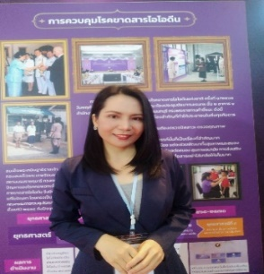 | Arinrada Ladla https://orcid.org/0000-0002-2823-1949 is the Lecturer at Community Public Health Department, Sirindhorn College of Public Health Khon Kaen. Faculty of Public Health & Allied Health Sciences. Praboromarajchanok Institute. Ministry of Public Health, Thailand. She got Doctoral degree of Philosophy Program in Health Science, Faculty of Faculty of Medicine, Mahasarakham University, Thailand in 2019. She interestes in Community diseases, Environmental Health, Health of Elderly and Systematic Reviews and Meta-Analysis. She can be contacted at e-mail: Arinrada.ladla@mail.com.

