Supplementary Material for

Assessing the capacity of agricultural research and development to increase the stability of global crop yields under climate change

Toshichika Iizumi, Toru Sakai, Yoshimitsu Masaki, Kei Oyoshi, Takahiro Takimoto, Hideo Shiogama, Yukiko Imada, David Makowski

The PDF file includes:
Figs. S1 to S16

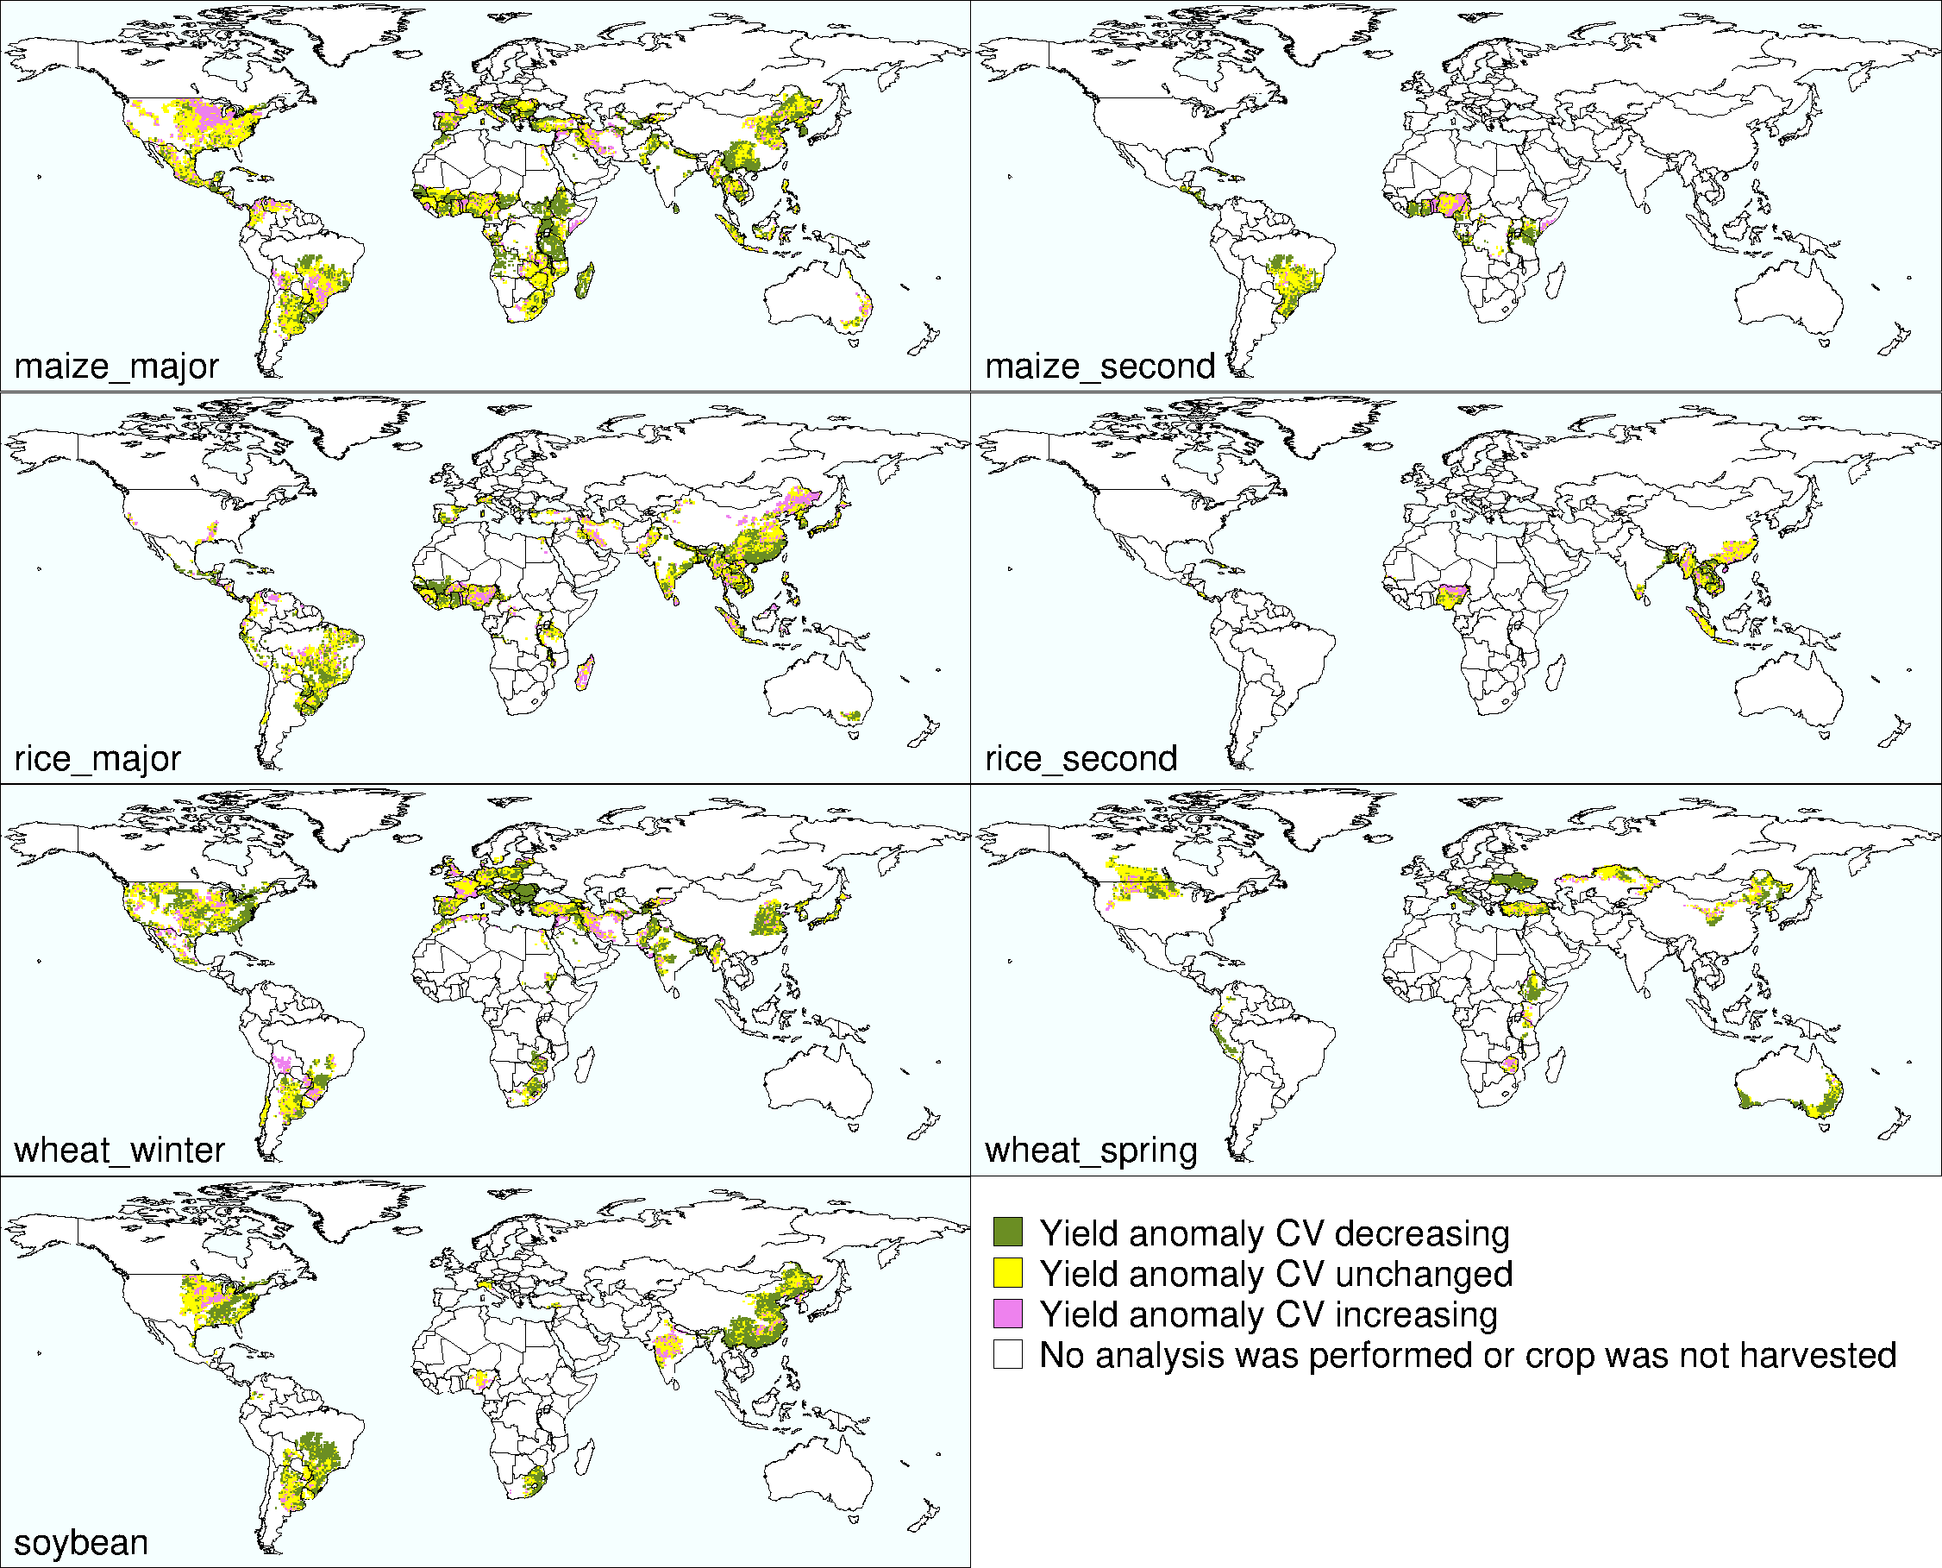
Fig. S1. Geographic patterns of the changes in yield anomaly CV.

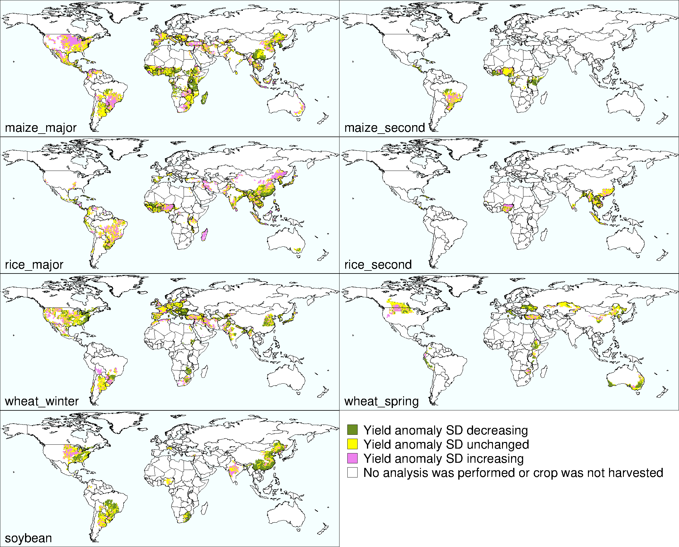
Fig. S2. Geographic patterns of the changes in yield anomaly SD.

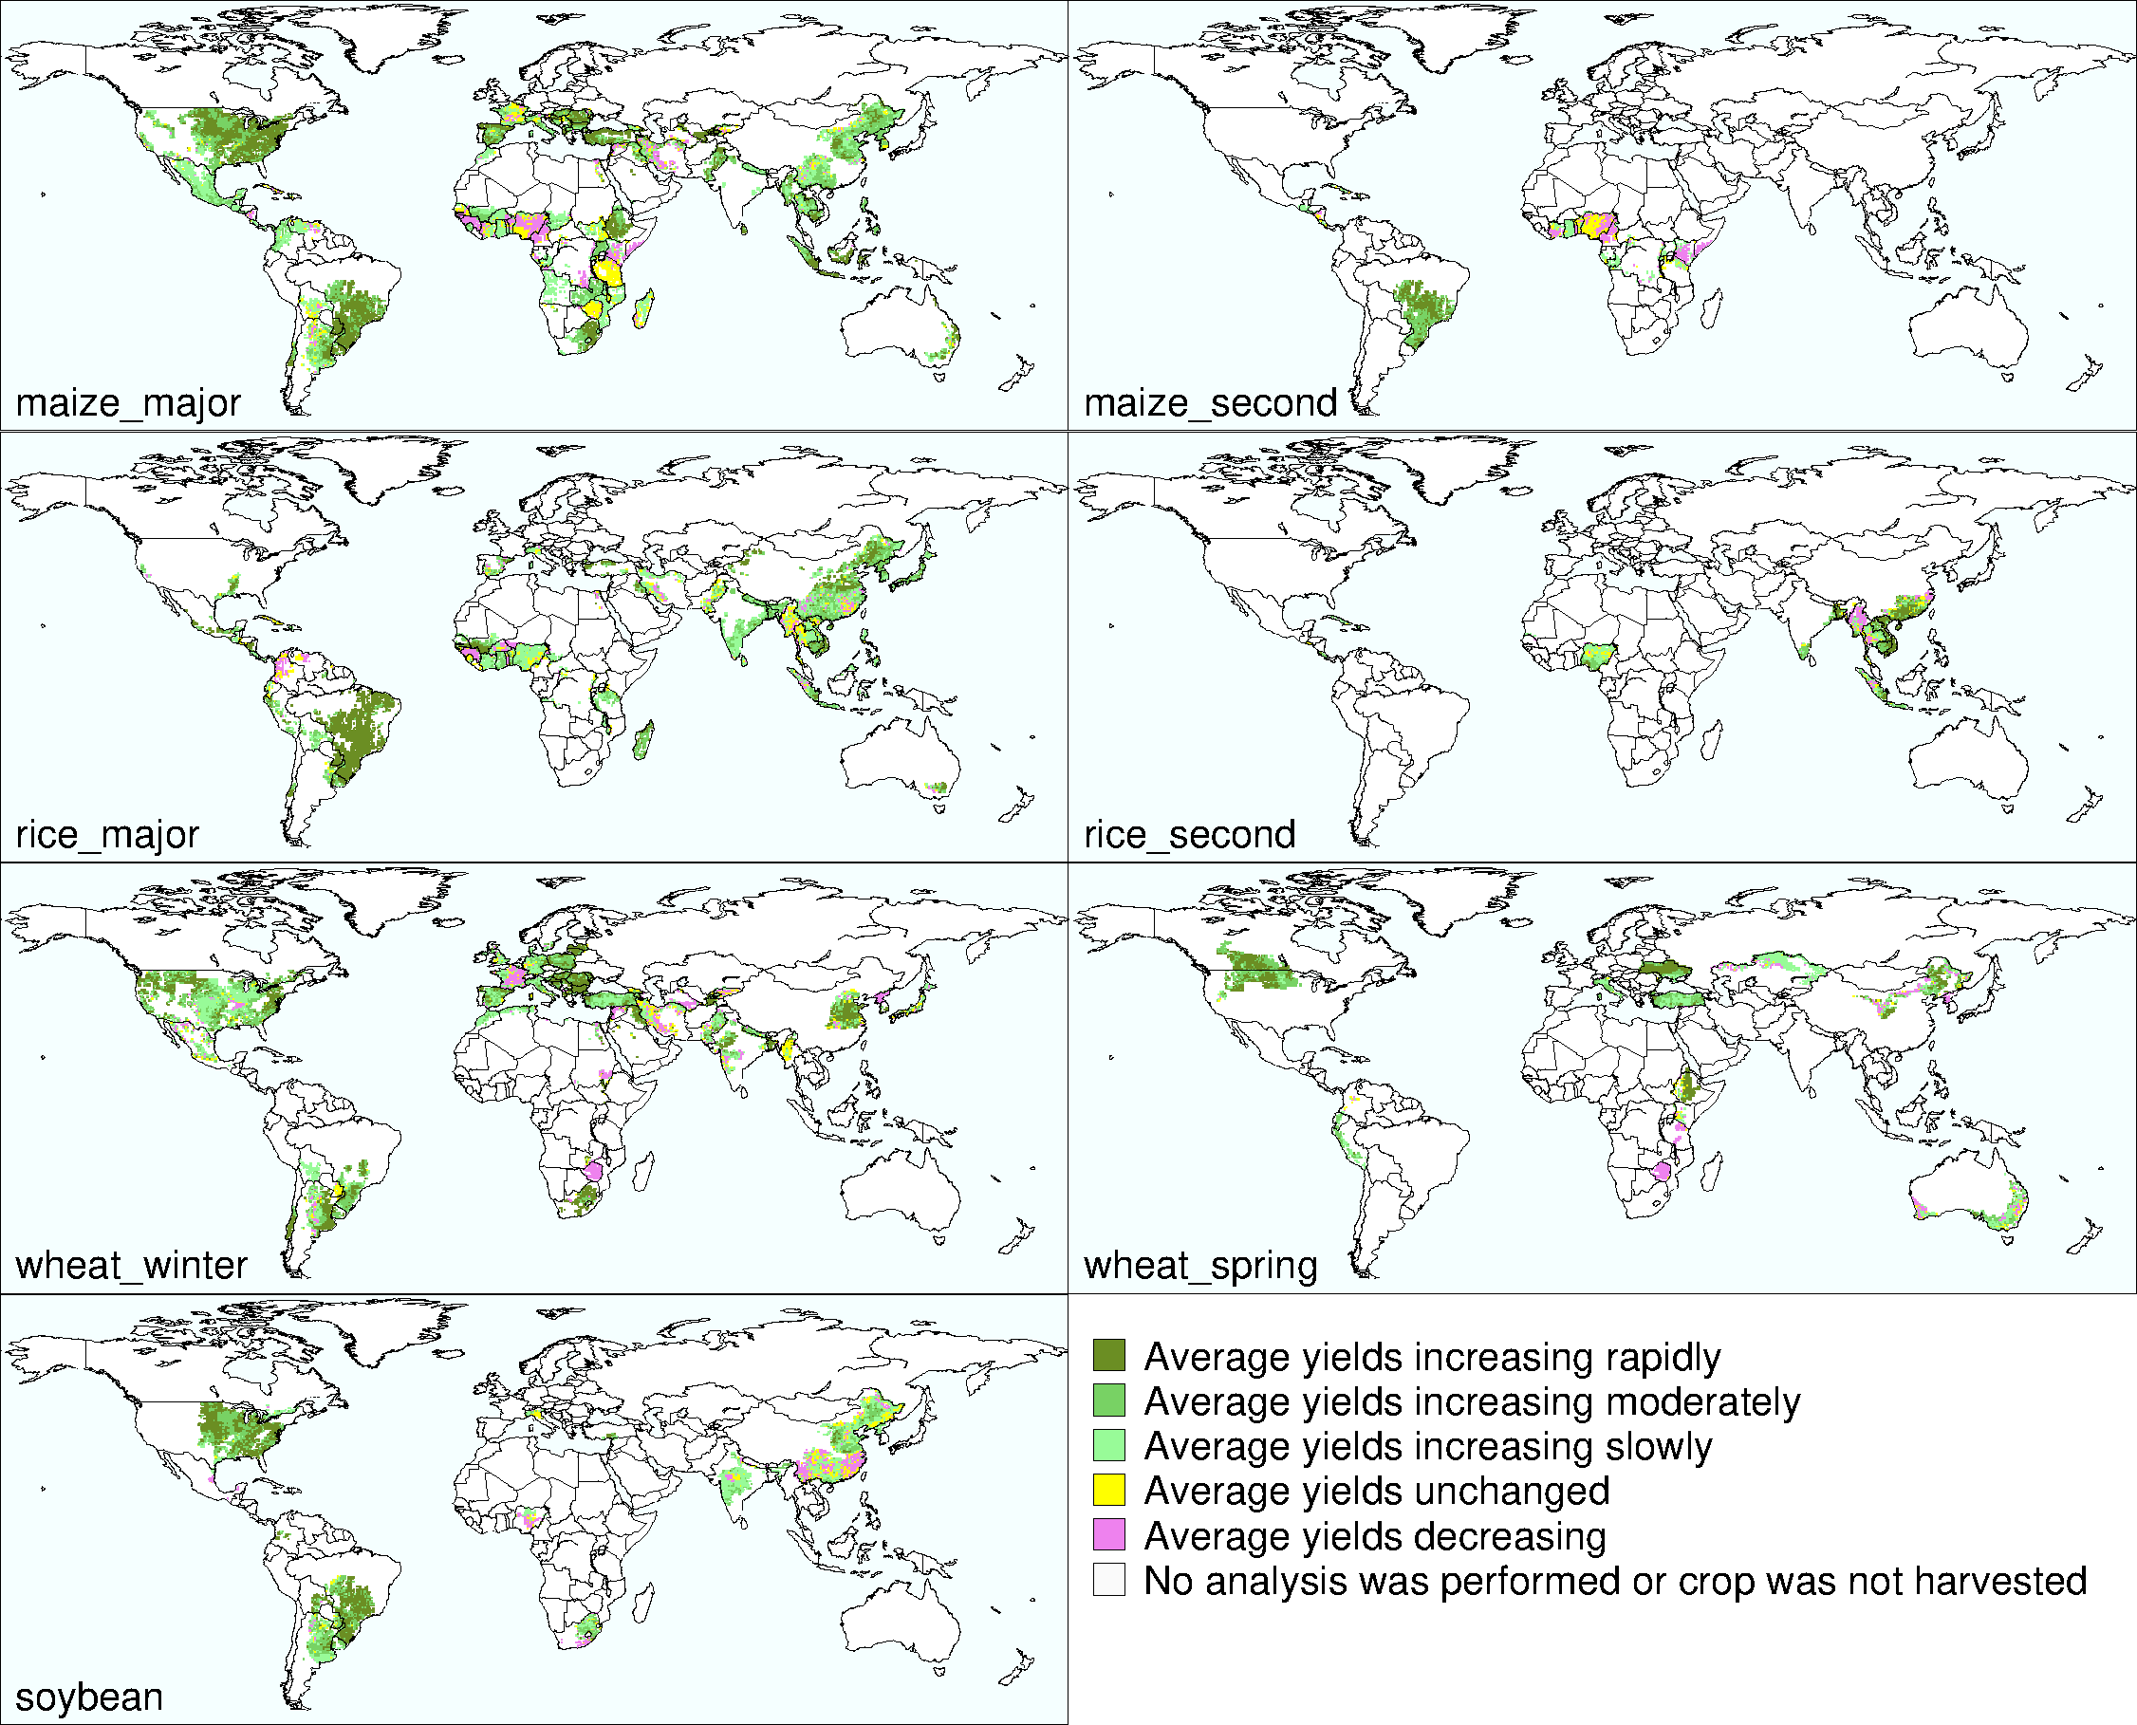
Fig. S3. Geographic patterns of the changes in average yield. Classes of increasing yield are classified by growth rate: rapidly, upper one-third of grid rates; moderately, middle one-third of the grid rates; and slowly, lower one-third of the grid rate.

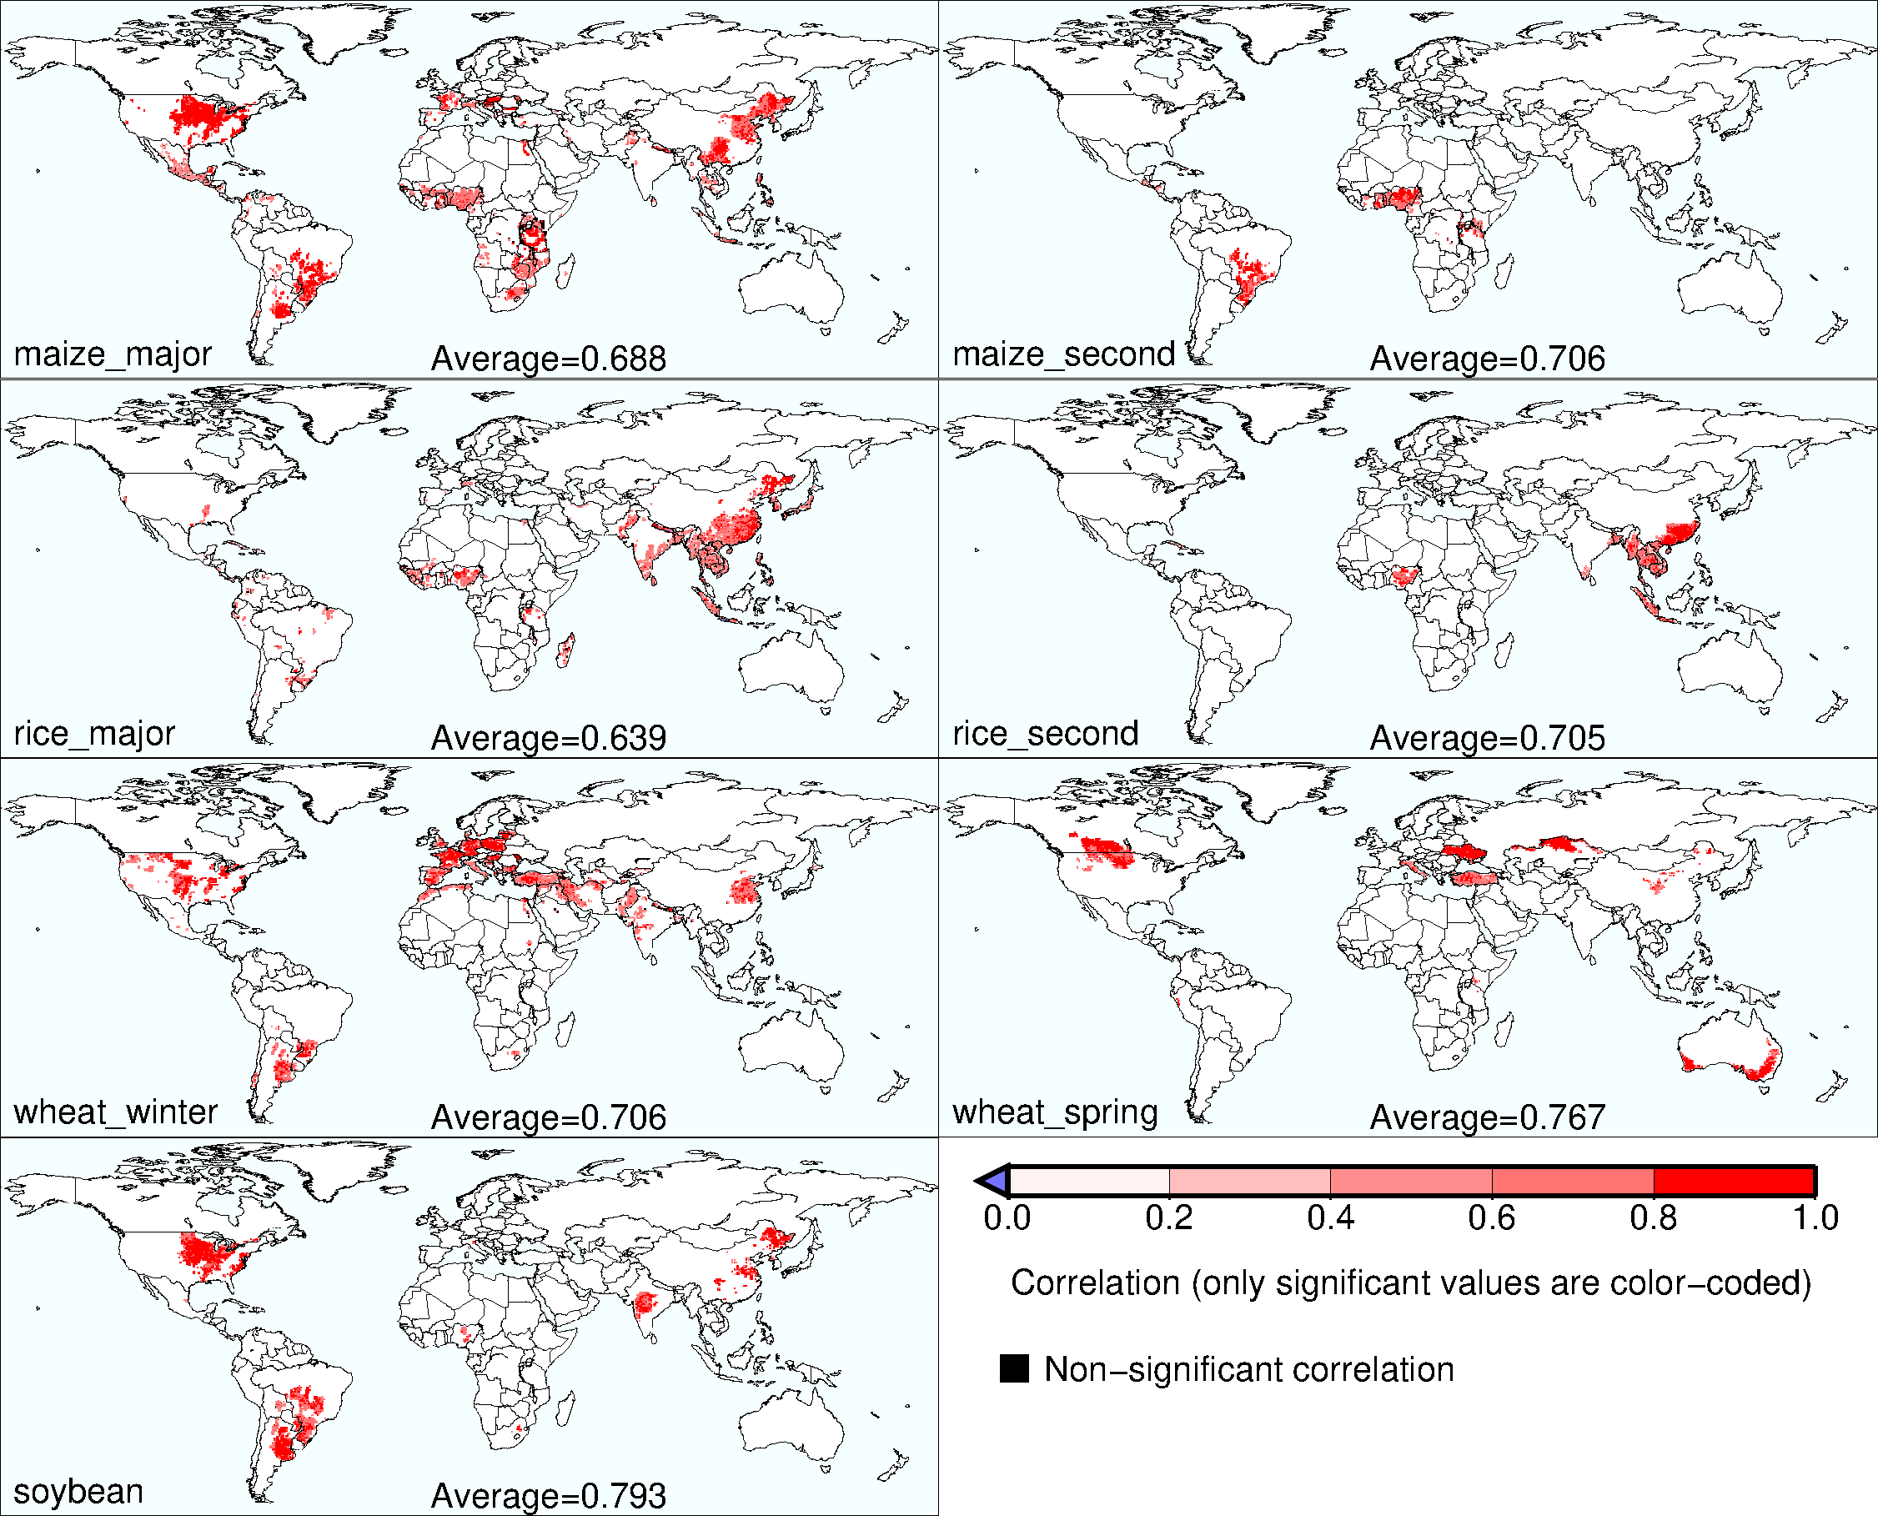
Fig. S4. Pearson’s correlation coefficients calculated between the estimated and actual yield anomalies in 2000–2019. The leave-one-year cross-validation is applied to the RF models. Average values across the locations are also shown.

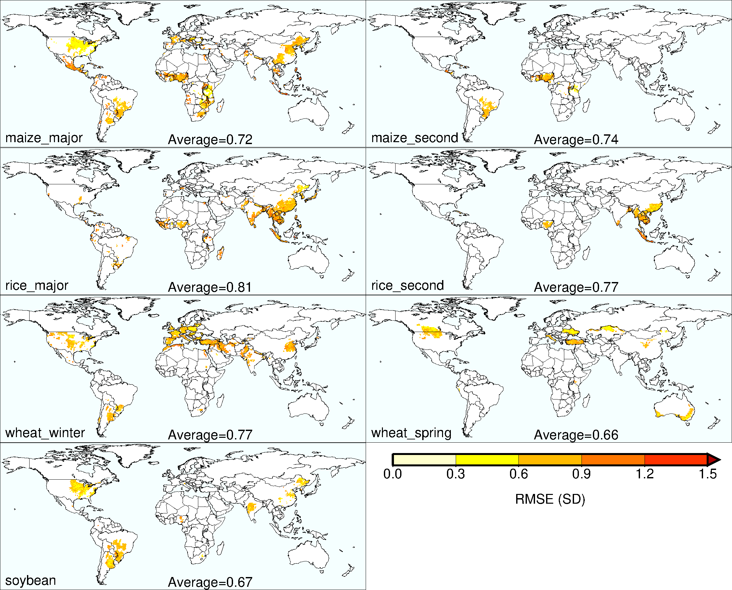
Fig. S5. Same as fig. S4 but for root mean squared errors calculated between the estimated and actual yield anomalies in 2000–2019.

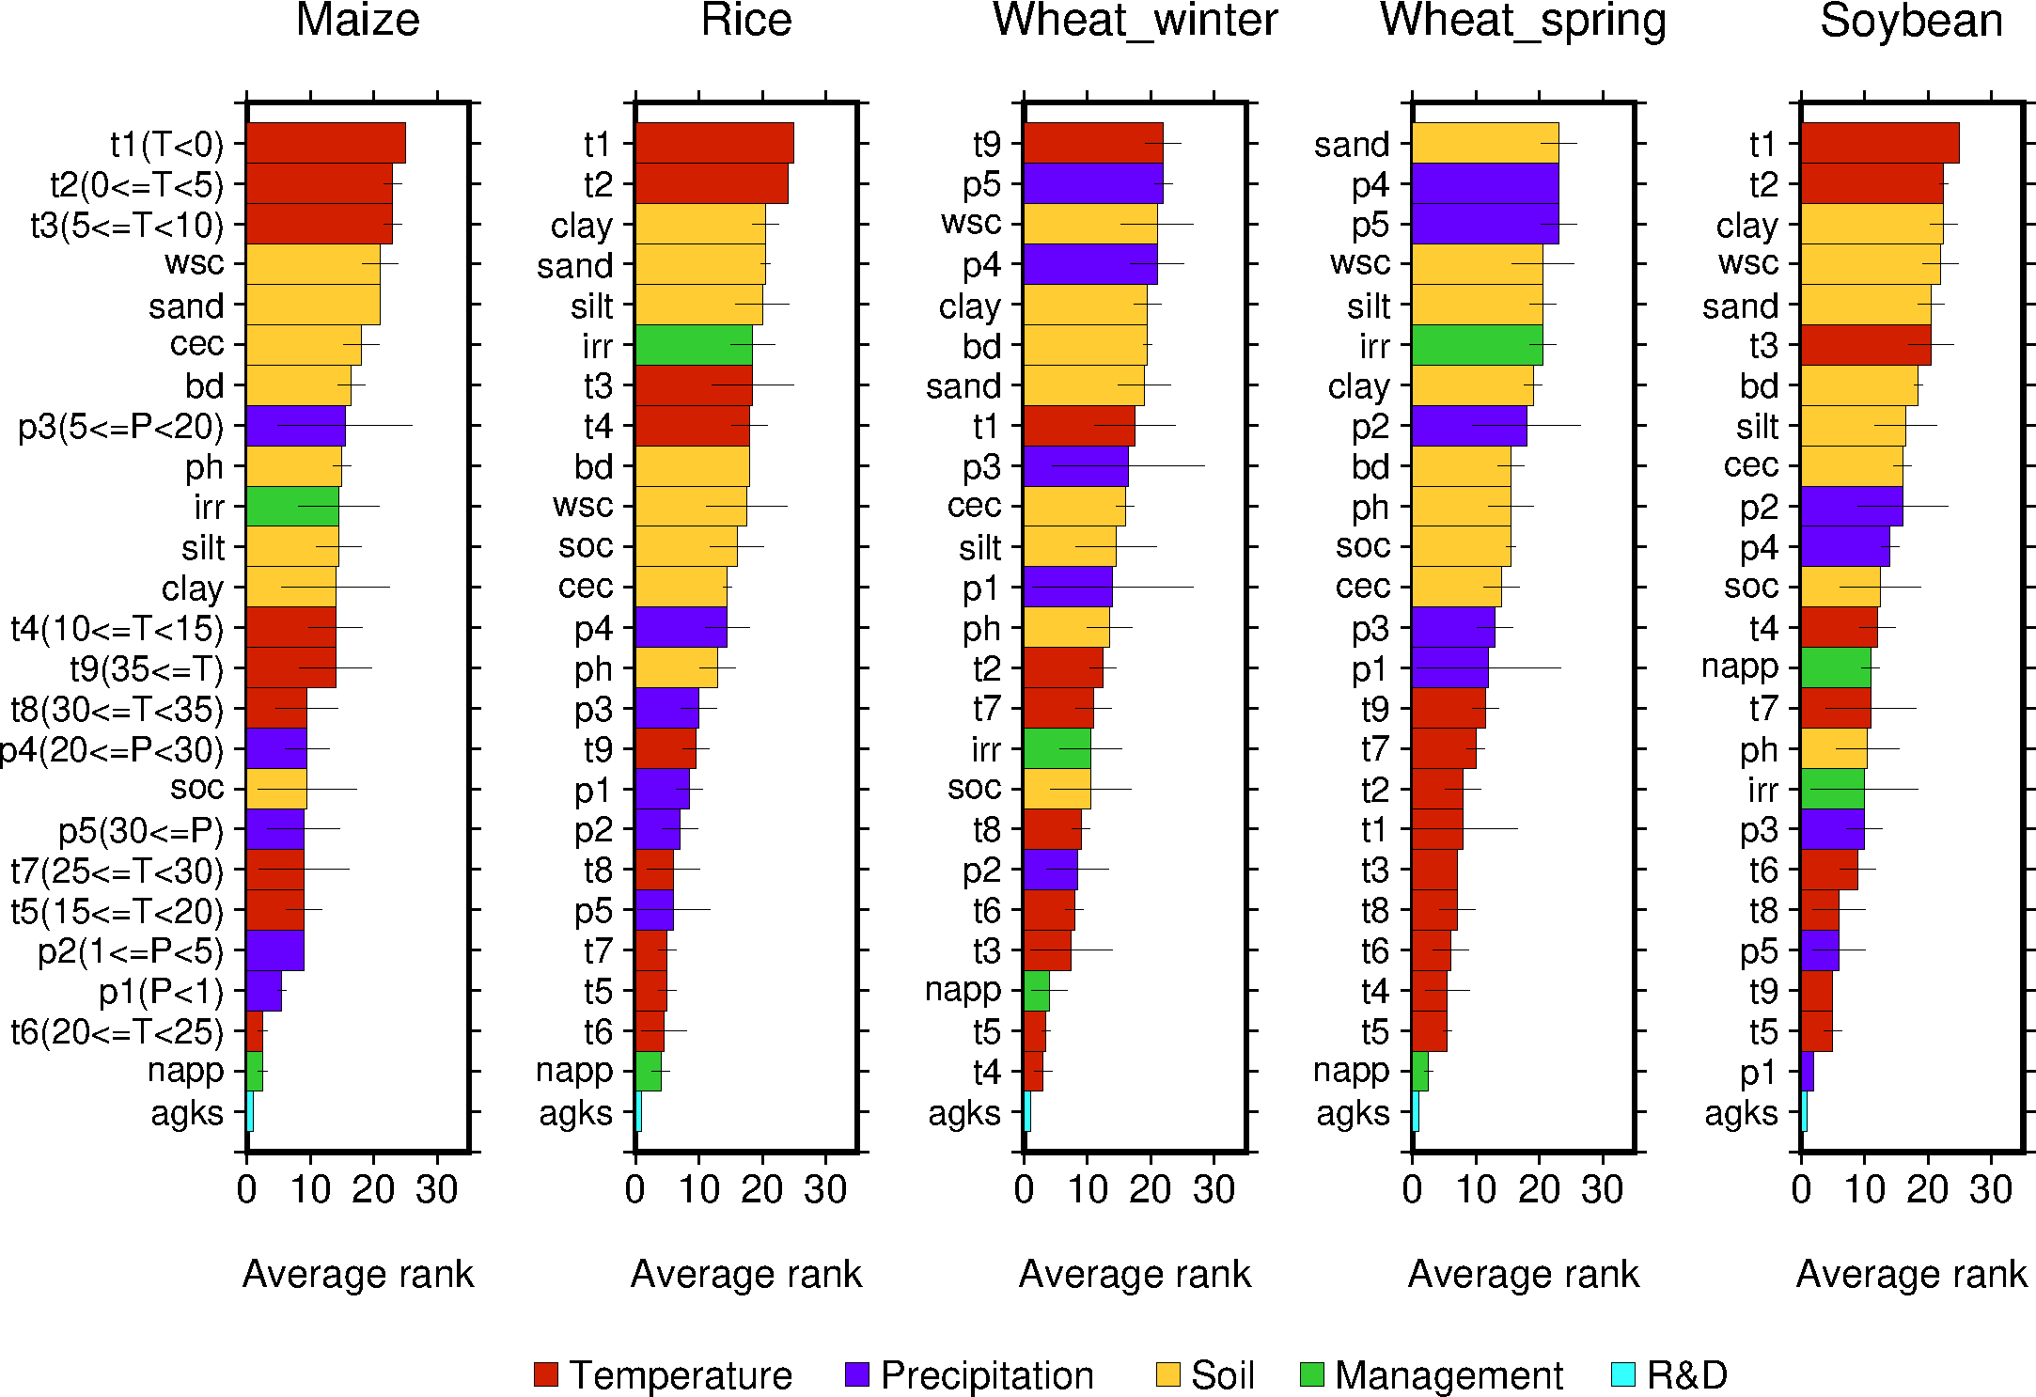
Fig. S6. Variable importance rank for each crop. The bars show the average rank calculated over the methods (the permutation and node purity). The closer the rank is to one, the more important the variable is in explaining yield anomaly. The thin lines indicate the standard deviation of the rank between the methods.

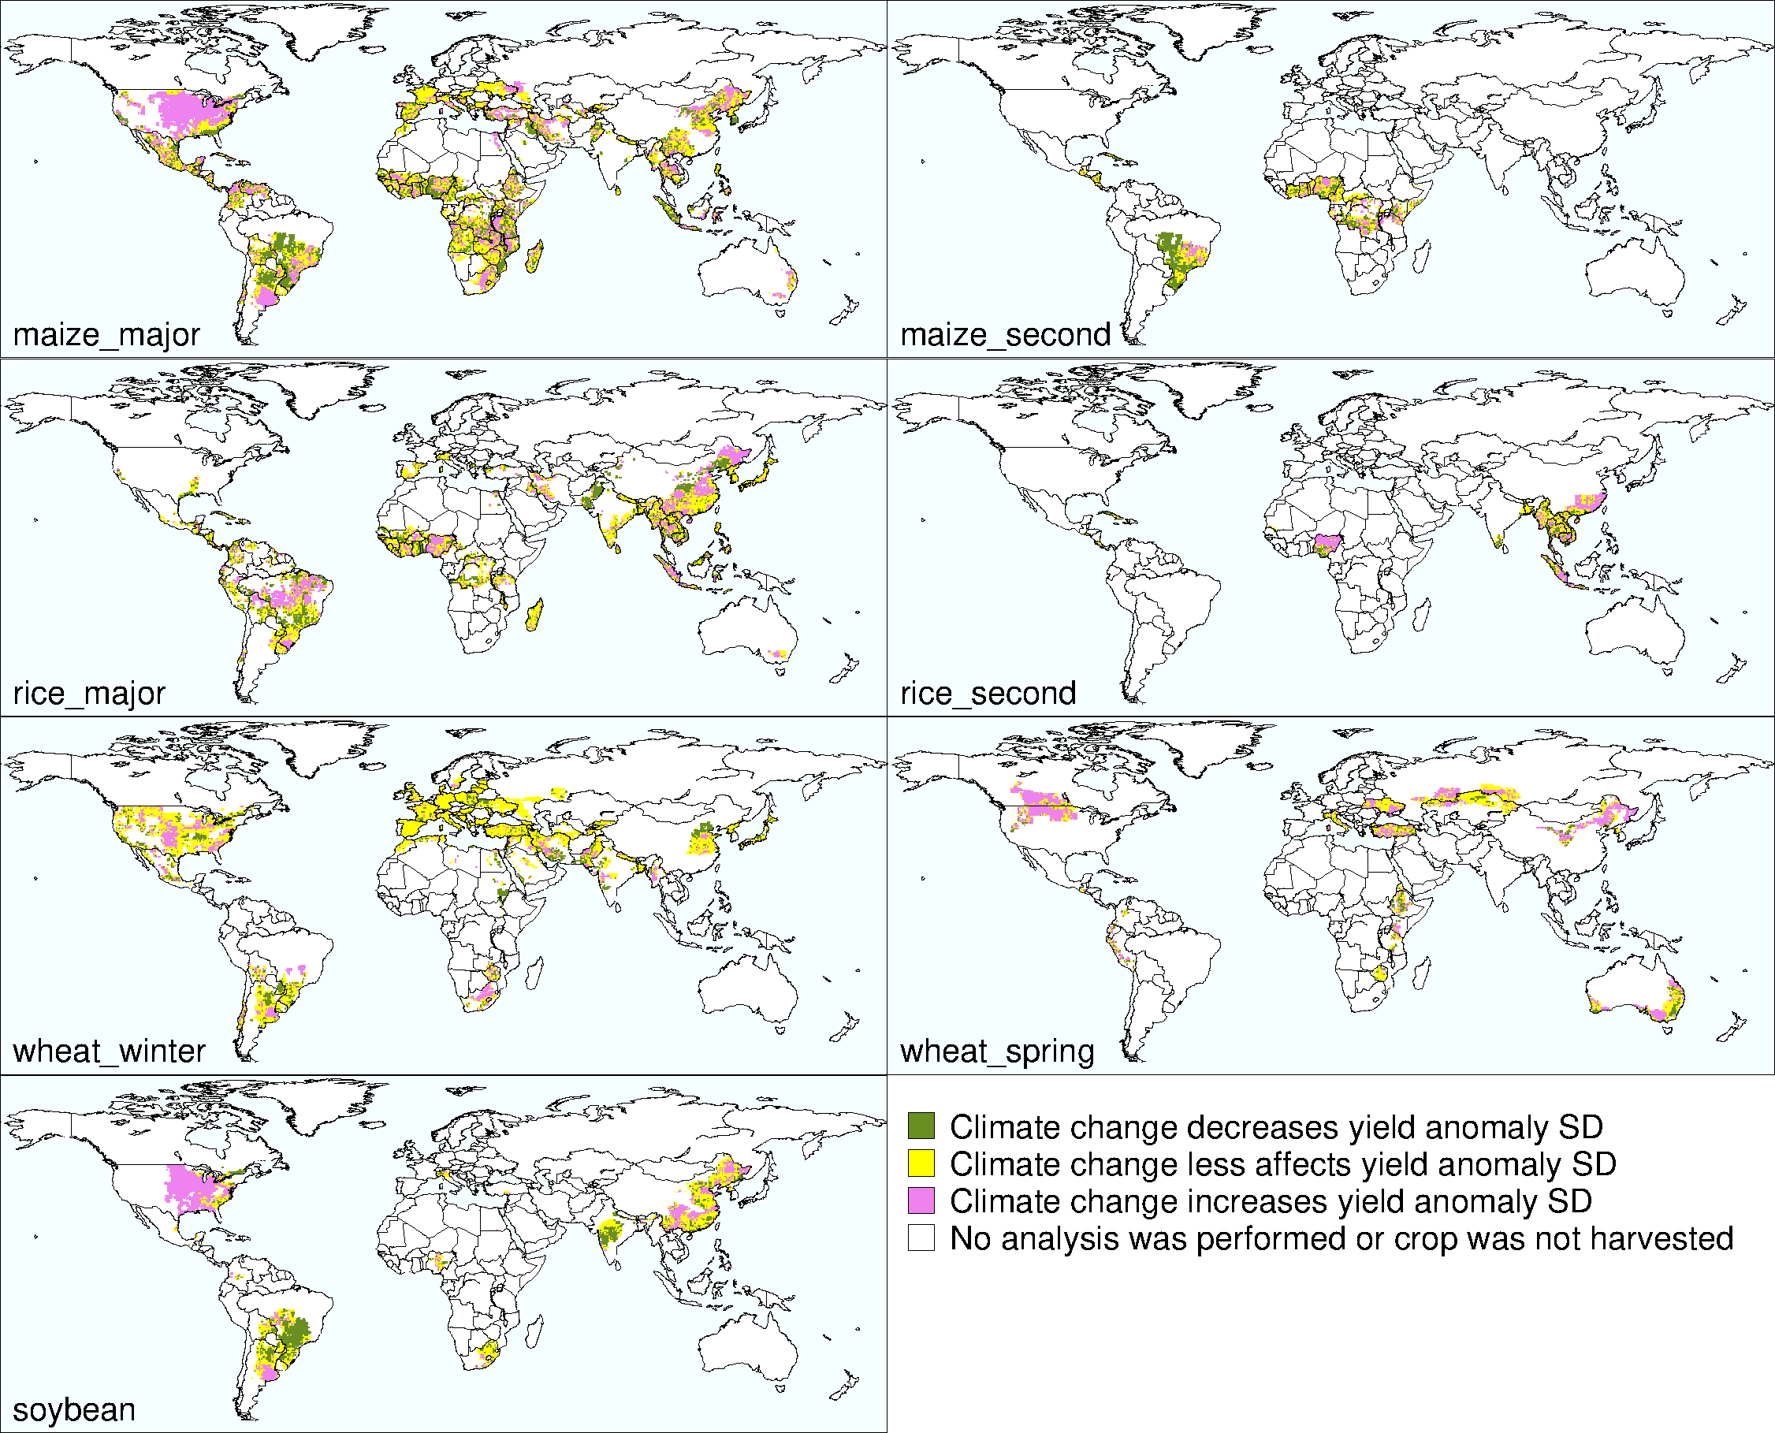
Fig. S7. Climate effect on the changes in yield anomaly SD.

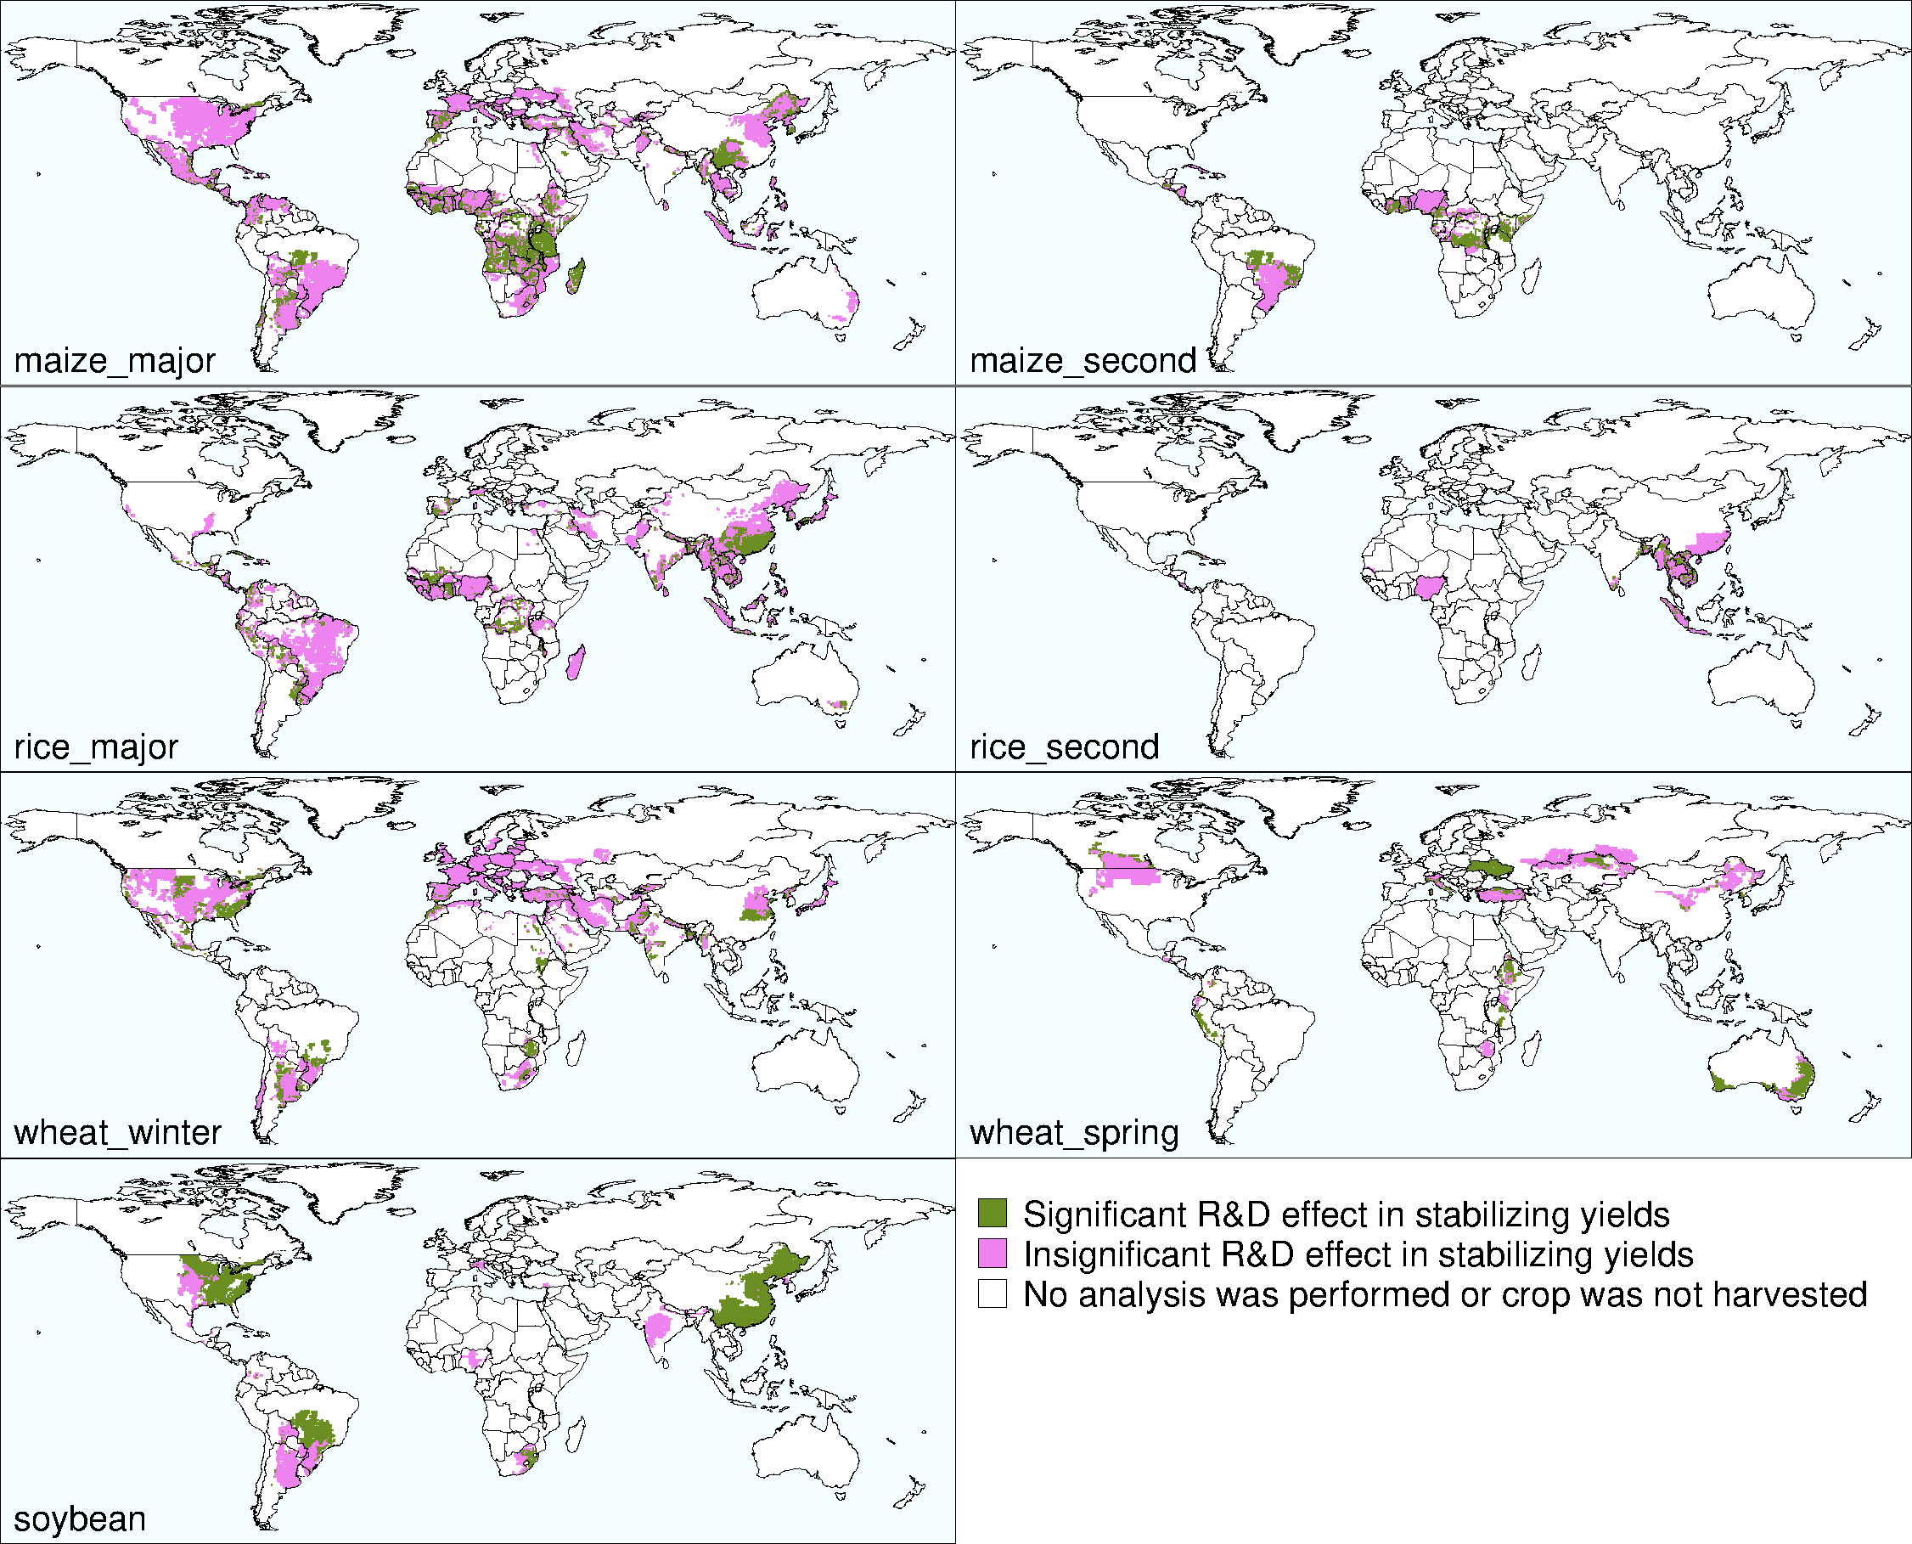
Fig. S8. R&D effect on the changes in the yield anomaly SD.

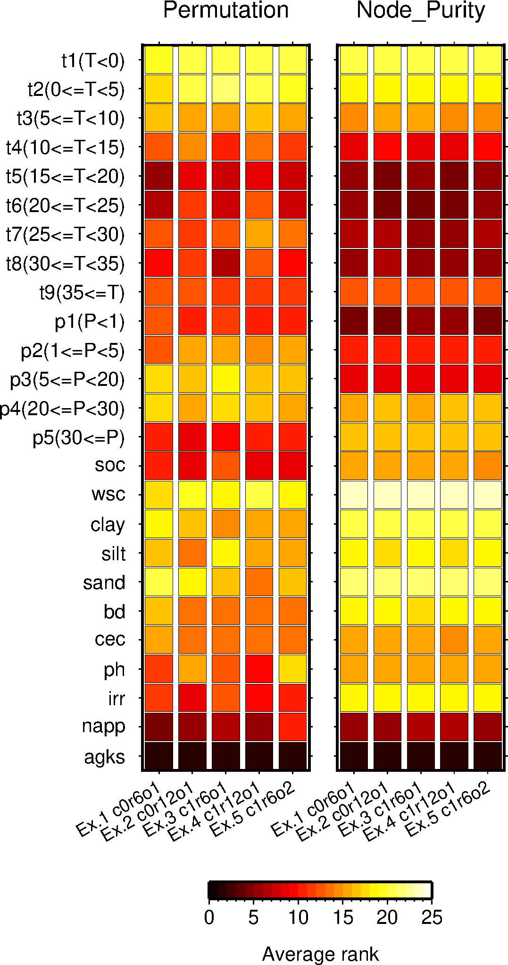
Fig. S9. Sensitivity of variable importance ranking to different R&D assumptions. The assumptions used in the R&D variable calculation include whether the R&D expenditure is for agriculture (c0) or for the four crops (c1), whether the time lag between research and adoption of technologies by producers is relatively shorter (r6) or longer (r12), and whether the technology obsolescence is relatively slower (o1) or faster (o2). The results from the first experiment (Ex. 1), denoted “r0r6o1”, are presented in Fig. 5 and fig. S6.

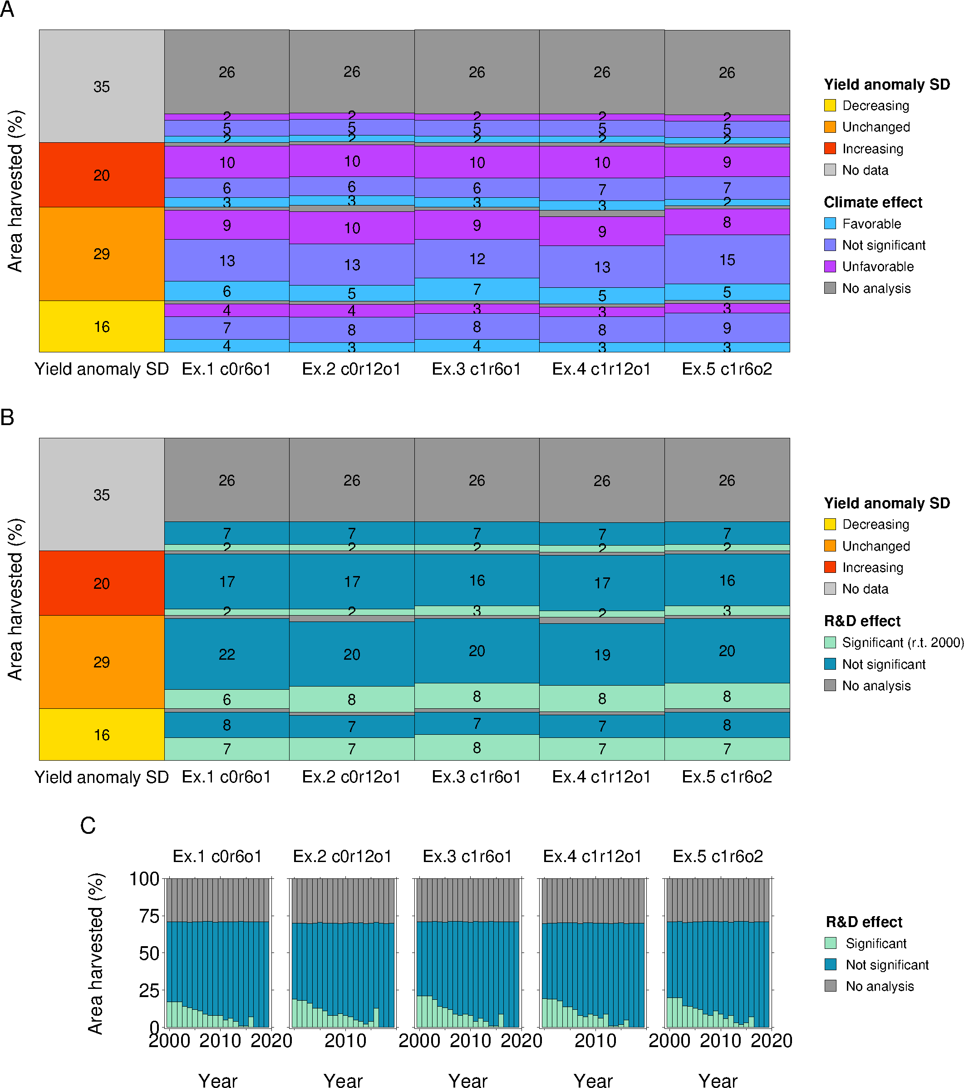
Fig. S10. Sensitivity of the estimated area shares to five different R&D assumptions. (A) Area share for the climate effect categories. (B) Area share for the R&D effect categories. (C) Area share for the R&D effect categories estimated from year to year. A, B and C is comparable to Fig. 7 D, E and F, respectively. The assumptions used in the R&D variable calculation include whether the R&D expenditure is for agriculture (c0) or for the four crops (c1), whether the time lag between research and adoption of technologies by producers is relatively shorter (r6) or longer (r12), and whether the technology obsolescence is relatively slower (o1) or faster (o2). The first experiment (Ex. 1), denoted “r0r6o1”, is presented in Fig. 7.
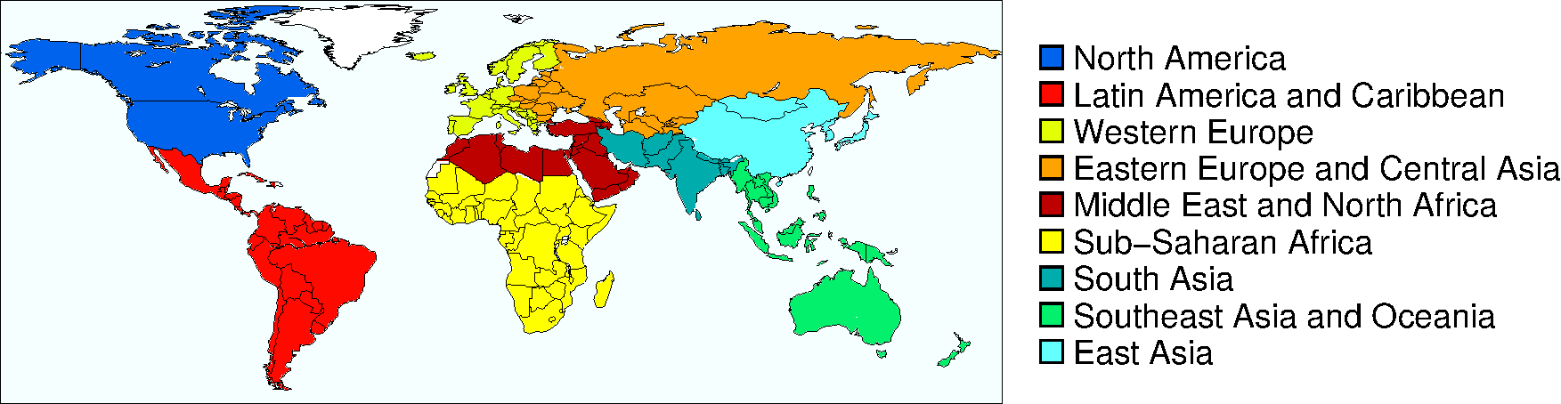
Fig. S11. The classification of world regions used in this study.

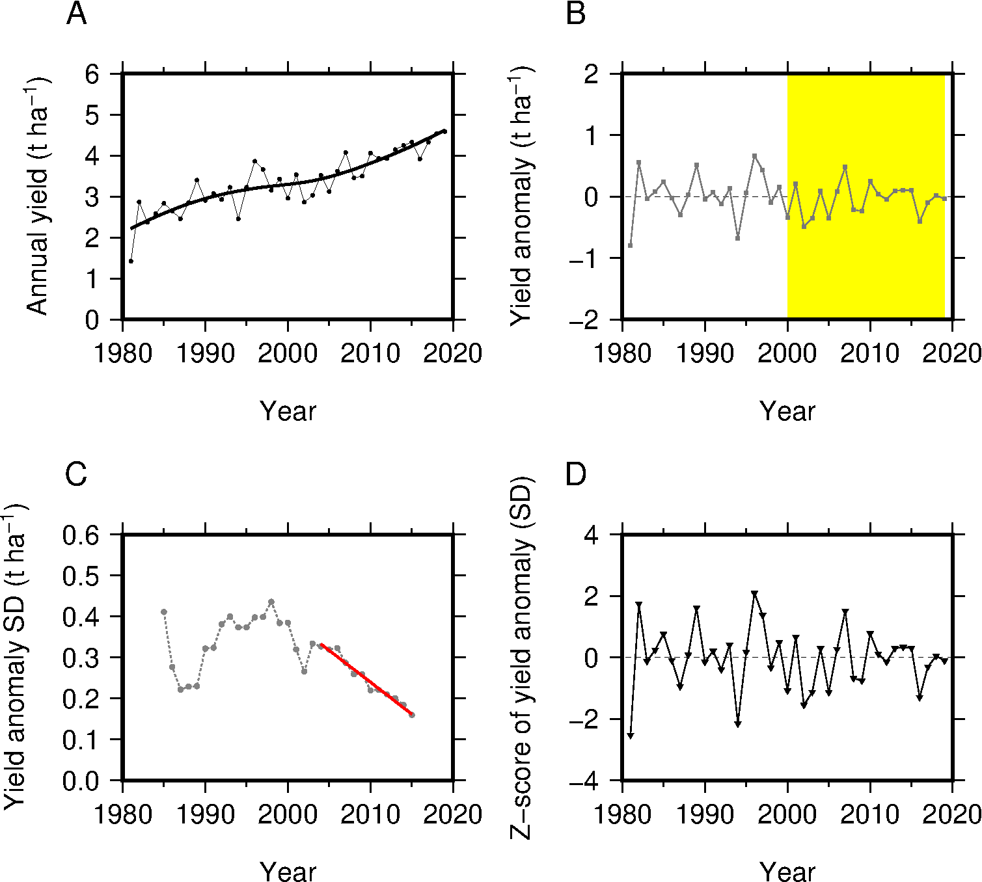
Fig. S12. Processing of annual yield data. (A) Annual and average yields. (B) Yield anomaly. (C) The standard deviation (SD) of yield anomaly calculated using a 9-year centered moving window and the best fitted line to the SD series. The regression line is fitted to the period 2004–2015 (the red solid line in C), calculated from the yield anomalies in 2000–2019 (the yellow shaded area in B). (D) Z-scored yield anomaly used in the random forest models. Data extracted from major-season (Kharif) rice in Odisha, India (21.25°N, 85.75°E) in the grid yield dataset are shown for explanatory purposes.

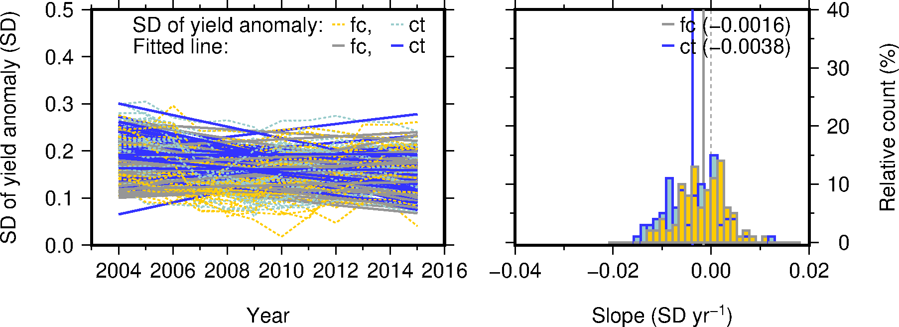
Fig. S13. Example of estimating the climate effect. Regression lines fitted to annual time series of the standard deviation (SD) of the factual (fc) and counterfactual (cf) yield anomalies to detect the climate effect on the changes in yield stability and the resulting histograms of the slope value.

Fig. S14. Random forest model settings used to estimate the R&D effect.

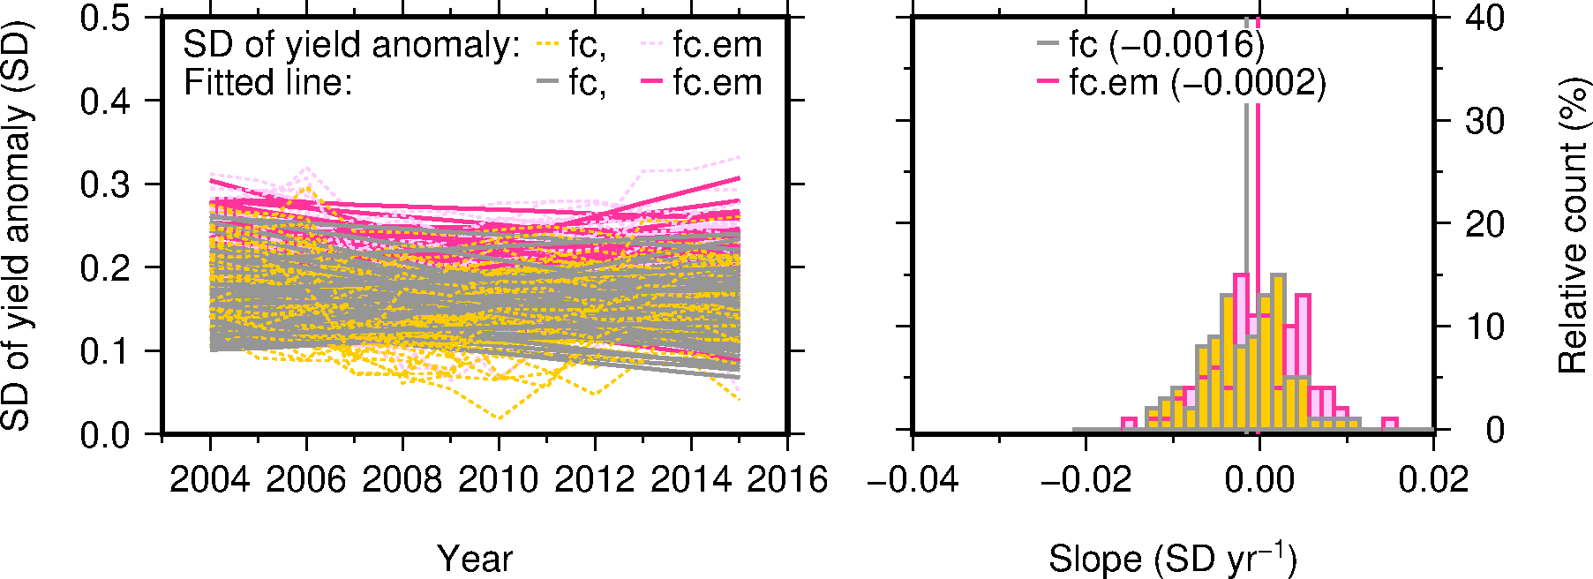
Fig. S15. Example of estimating the R&D effect. Regression lines fitted to annual time series of the standard deviation (SD) of the factual yield anomaly to compare the cases with and without advances in R&D (fc and fc.em, respectively) and the resulting histograms of the slope value.

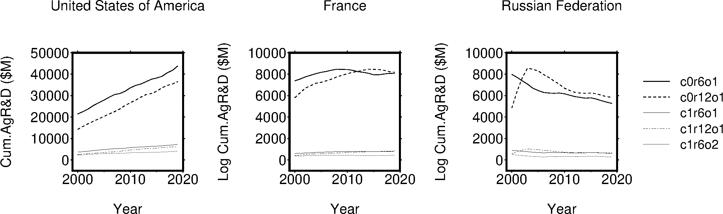
Fig. S16. Examples of cumulative R&D expenditure calculated with different assumptions. The data for the US, France and Russia, of which patterns are classified as increasing, unchanged and decreasing, respectively, are shown for illustrative purposes.

