Identification of Marek’s disease virus infection
Methods
DNA extraction and conventional PCR
Heart samples were aseptically collected and stored at -80 °C. The tissue samples were processed according to the manufacturer's protocol using a Blood and tissue kit (Anheal Laboratories, China). Total DNA concentration was quantified using a NanoDrop One spectrophotometer (NanoDrop Technologies, USA). Specific oligonucleotide primers for GaHV-2 meq and 132 bpr gene were used to detect MDV serotypes (Table 1).
Table 1 Set of primers for conventional PCR
Gene | Primer sequence 5'–3' | Product length | Temperature
MDV-meq | F: 5’-TTCCCTGACGGCCTATCTGA-3’  R: 5’-TTCGGGATCCTCGGTAAGAC-3’ | 786 /963 bp | 53 ℃
MDV-132 bpr | F: 5’-TGCGATGAAAGTGCTATGGAGG-3’  R: 5’-GAGAATCCCTATGAGAAAGCGC-3’ | 317/449 bp | 53 ℃
Note: Specific oligonucleotide primers and PCR conditions in this study were processed according to GB/T 18643-2021 (Diagnostic techniques for Marek’s disease of China).

PCR conditions were optimized in a 20 μl reaction volume including 0.5μl of Hot Start DNA polymerase (Sangon Biotech, China), 1.0 μl of forward and reverse primer, 10 μl 2 × Direct PCR Mix and 10 ng of DNA. Amplification of the MDV-meq and 132 bpr was performed using 35 cycles of 98 °C for 5 s, 53 °C for 20 s min, and 72°C for 1 min. PCR products were separated on a 1% agarose gel and stained with ethidium bromide (1 mg/ml). The bands were visualized in a UV trans-illuminator and analyzed using Bio-Rad Gel Doc™ XR+ system (BioRad, USA).
Sequencing and phylogenetic analysis
The meq gene PCR products were purified from the gel using the QIAquick gel extraction kit (Qiagen, USA) following the manufacturer's recommendations. The purified products were sequenced by Sangon Biotech (Shanghai) Co., Ltd. Sequence data were assembled and edited using the SeqMan program (DNA Star Laser gene software package, USA). Nucleotide alignments of meq gene sequences were performed with MEGA X using the Muscle algorithm (Tamura et al. 2021). A phylogenetic tree was generated using the neighbor-joining (N-J) method, with 1000 replicates. The MDV reference sequences were retrieved from the GenBank database (Table 2).
Table 2 GaHV-2 strains used for the phylogenetic analysis.
Isolate | Accession No. | Origin | Pathotype
686 | AY362727 | USA | vv+MDV
660-A | AY362726 | USA | vv+MDV
648A | AY362725 | USA | vv+MDV
X | AY362724 | USA | vv+MDV
U | AY362722 | USA | vv+MDV
TK | AY362721 | USA | vv+MDV
RL | AY362720 | USA | vv+MDV
New | AY362719 | USA | vv+MDV
N | AY362718 | USA | vv+MDV
L | AY362717 | USA | vv+MDV
584a | DQ534532 | USA | vv+MDV
W | AY362723 | USA | vv+MDV
ATE2539 | MF431493 | Hungary | vv+MDV
Polen5 | MF431496 | Poland | vv+MDV
UDEACO04/2013 | KU058701 | Colombia | vv+MDV
UDEACO06/2013 | KU058696 | Colombia | vv+MDV
UDEACO07/2013 | KU058697 | Colombia | vv+MDV
643P | AY362716 | USA | vvMDV
595 | AY362715 | USA | vvMDV
549 | AY362714 | USA | vvMDV
Js201801 | MK046676 | China | vvMDV
Md5 | NC_002229 | USA | vvMDV
RB1B | AY243332 | USA | vvMDV
02LAR | EF523772 | Australia | vvMDV
FT158 | EF523771 | Australia | vvMDV
Woodlands1 | EF523775 | Australia | vvMDV
567 | AY362709 | USA | vMDV
571 | AY362710 | USA | vMDV
573 | AY362711 | USA | vMDV
617A | AY362712 | USA | vMDV
637 | AY362713 | USA | vMDV
RB1B | DQ534541 | NA | vMDV
MD70/13 | MF431495 | Hungary | vMDV
04CRE | EF523773 | Australia | vMDV
MPF57 | EF523774 | Australia | vMDV
BC-1 | AY362707 | USA | vMDV
JM | AY243331 | USA | vMDV
JM/102W | DQ534539 | USA | vMDV
CU-2 | AY362708 | USA | vMDV
CVI988 | DQ530348 | Netherlands | vMDV
3004 | EU032468 | Russia | vMDV
RM-1 | DQ534542 | NA | vMDV
CVI988 | DQ534538 | NA | vMDV
2014021 | KU382455 | China | NA
2014055 | KU382456 | China | NA
2013032 | KU382454 | China | NA
J-1 | KU744555 | China | NA
GX060167 | EU697887 | China | NA
HNGS101 | HF546084 | China | NA
HNGS201 | HF546085 | China | NA
Note: 50 strains, including virulent (v), very virulent (vv), very virulent plus (vv+) pathotypes, were selected for comparison of their meq gene sequences. NA, not available.
Results
The meq PCR primers were used to determine the meq gene of MDV-1. Strains and differences in its sequence are associated with oncogenicity. As expected, an approximately 786 bp DNA fragment was amplified and visualized on an agarose gel, confirming the presence of wildtype of MDV-1 according to GB/T 18643-2021 (Diagnostic techniques for Marek’s disease of China) (Figure 1). The BamH1-H-BamH1-D-132 bp PCR amplicons analyzed by agarose gel electrophoresis reconfirmed the presence of wildtype of MDV-1 in the isolates (Figure 2). For every isolate, a band was produced corresponding to a 317 bp DNA fragment associated with wildtype MDV-1. The presence of a single band also indicated the presence of virulent MDV-1 strain(s) and the absence of the CVI988/Rispens vaccine strain according to GB/T 18643-2021 (Diagnostic techniques for Marek’s disease of China).
Partial sequencing of the meq gene of the isolate revealed > 99% nucleotide sequence identity to virulent and very virulent plus strains from a few countries, placing it in the same clade as a very virulent Chinese strain (Js201801, MK046676) and a very virulent plus Hungary strain (ATE2539, MF431493) (Figure 3).
Figure 1. PCR amplification of meq gene of MDV-1
Lanes M: DL2000 marker, lanes 1-5: the MDV-1 infected samples, lanes 6-10: the samples from the control group.
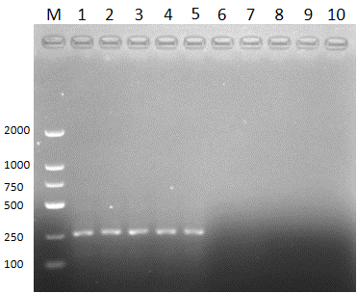
Figure 2. PCR amplification of BamH1-H-BamH1-D-132 bp of MDV-1
Lanes M: DL2000 marker, lanes 1-5: the MDV-1 infected samples, lanes 6-10: the samples from the control group.

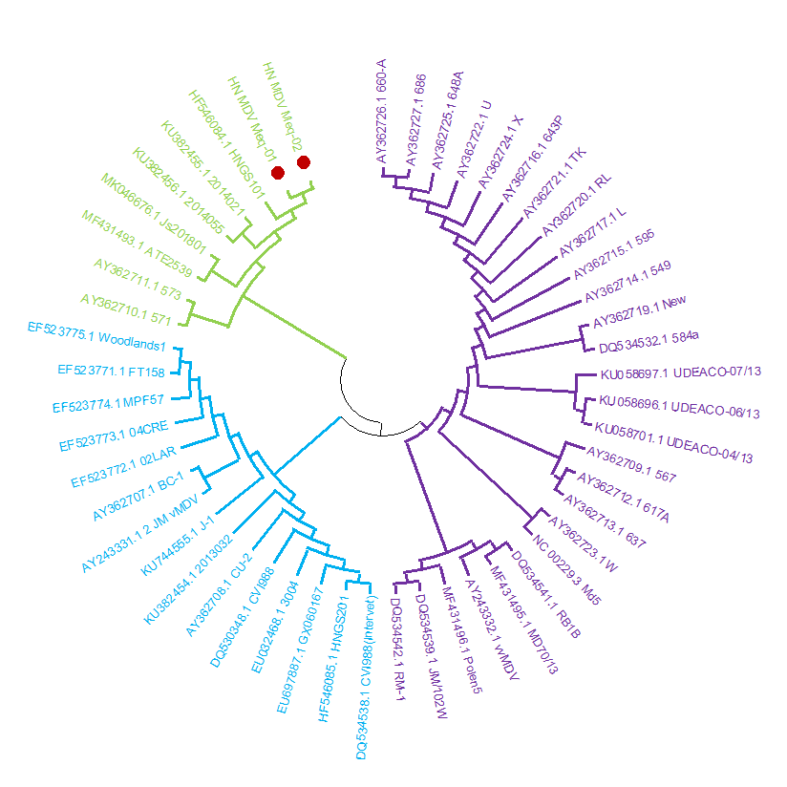
Figure 3. Phylogenetic tree assessing relationship of Hainan strains with known MDV strains
Sequences of meq gene that had been sequenced in this study were compared against some known strains. Dendrograms were generated by NJ method.

References
Lai H, Zhang H, Ning Z, Chen R, Zhang W, Qing A, Xin C, Yu K, Cao W, Liao M. Isolation and characterization of emerging subgroup J avian leukosis virus associated with hemangioma in egg-type chickens. Vet. Microbiol., 2011, 151: 275-283.
Li Y, Liu X, Liu H, Xu C, Liao Y, Wu X, Cao W, Liao M. Isolation, identification, and phylogenetic analysis of two avian leukosis virus subgroup J strains associated with hemangioma and myeloid leucosis. Vet. Microbiol., 2013, 166: 356-364.
State Administration for Market Regulation & Standardization Administration. Diagnostic techniques for Marek’s disease of China, GB/T 18643-2021, issued on 30 April, 2021 and executed on 1 November, 2021.
Tamura K, Stecher G, Kumar S. MEGA11: Molecular Evolutionary Genetics Analysis Version 11. Molecular Biology and Evolution, 2021, 38(7): 3022-3027.

