Title: Examining coastal habitat co-utilization of chimaeras using social network analysis
Authors: Laura Avila Turriago^{1*}, David Moreno¹, Jayson Semmens¹

¹Institute for Marine and Antarctic Studies, University of Tasmania, Hobart, Australia

*Corresponding author: laura.avilaturriago@utas.edu.au
Laura Avila Turriago 0009-0000-7242-4329, David Moreno 0000-0002-9474-1082,
Jayson Semmens 0000-0003-1742-6692

Association matrix

Table S1 Association matrix of adult elephant fish in a) 2012, and b) 2013. The first half of the matrix correspond to the binary matrix where 0 represents no association and 1 represents association. The other half correspond to the Simple Ratio Index (SRI) where the continuous values (0-1) represent the strength of the association. Females*. Numbers in bold are the highest associations
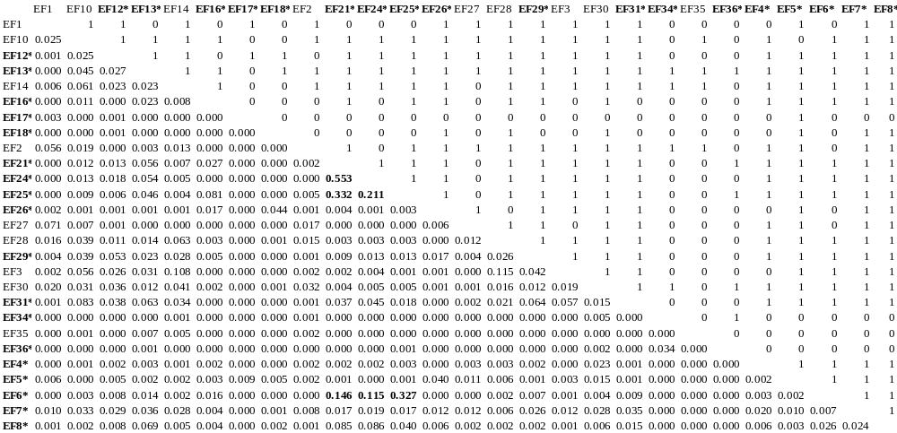
a
2012
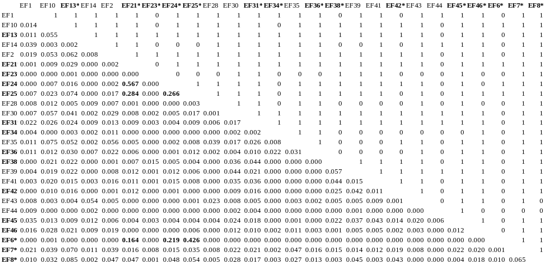
b
2013

Influence of detections in SNA

Relationship between detected Days, detections and strength
We calculate a Generalized Linear Model (GLM) and Pearson correlation coefficient (r) using IGRAPH to establish the relationship between different acoustic biotelemetry aspects that could impact the SNA. We found a positive relationship between detected days and the strength calculated for each individual (r = 0.92, $P<$ 0.001) (Fig. A3). The more detected days an individual has, the strength increases with a coefficient of 0.00179. Additionally, the GLM model provided a good fit to the relationship (AIC = -40.518) according to the AIC (Akaike Information Criterion).

We also calculated the relationship between detections as the independent variable and strength as the dependent variable. The outliers (elephants 21, 25, 24, and 42) were removed to fit the model better. We found a positive statistically significant relationship (r = 0.8, $P<$ 0.001) with a low AIC value (AIC = -30.164). The lower AIC values indicated that the model represented a good fit for the relationship between detected days, detections, and strength. These results confirmed the susceptibility of SNA to the acoustic biotelemetry information such as the number of detections and detected days; therefore, it is recommended to be cautious in interpreting the results.
a
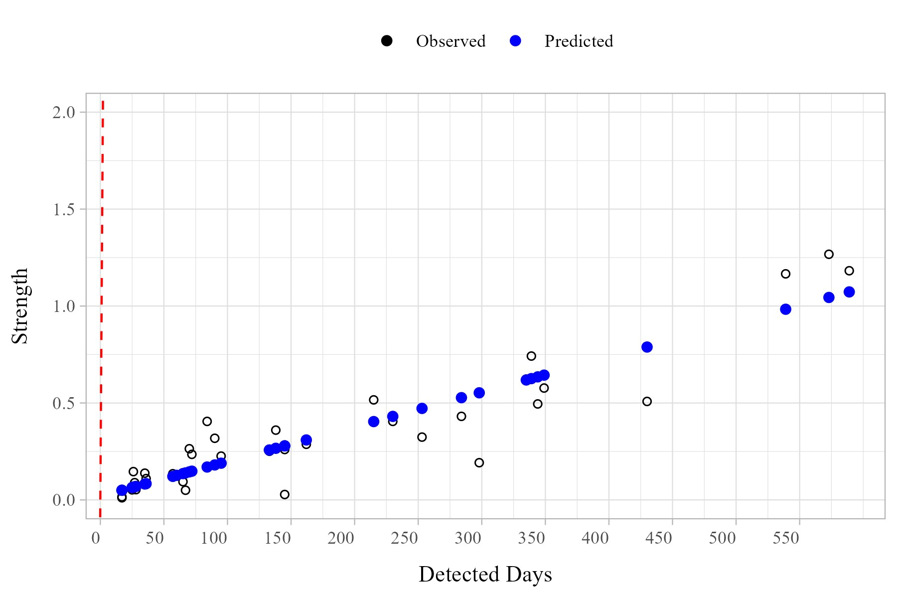
b
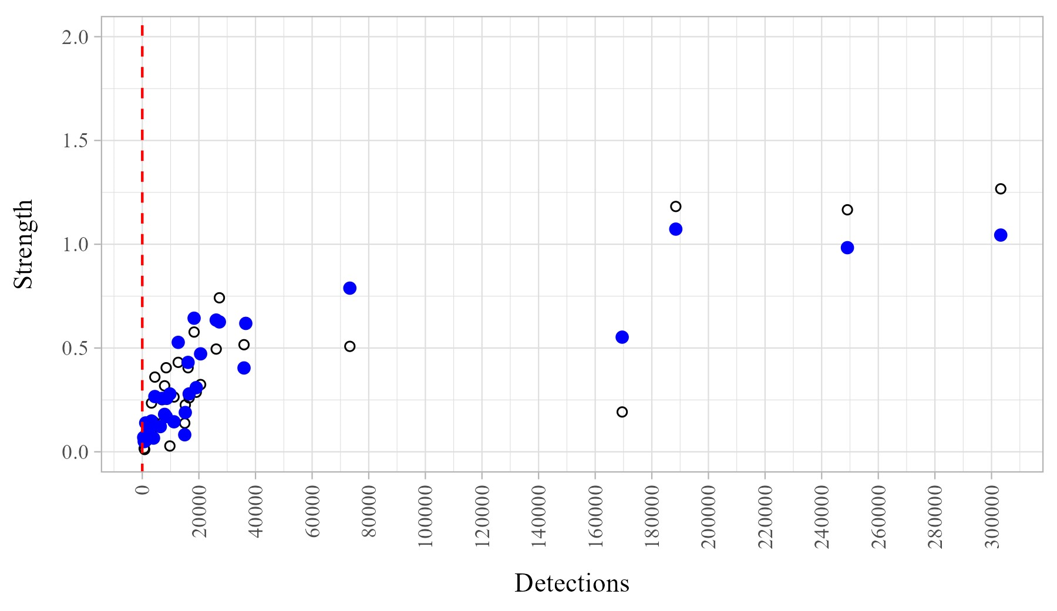
Fig. S1 Performance of the Generalized Linear Model (GLM) of the relationship between acoustic biotelemetry parameters and strength of each elephant fish. a) Relationship with detected days. b) Relationship with number of detections. The outliers were removed from this graph to better capture the relationship. Black circles without filling are the observed values. Blue filled circles are the predicted values. Red dashed line is the p-value

Relationship between detected days, detections and community
We compared the relationship between the number of detections and detected days and clusters to explore the relationship between the acoustic information and community analysis. Only the clusters from 2012 (Fig. A4) were considered, as in 2013, there were only two clusters. As a result, it was evident that detections and detected days affected the assignation of the individuals to a cluster. This further highlights the importance of considering the data collection in the community analysis; in this way, researchers can ensure that the cluster comes from an appropriate biological factor and not because of the limitation of the data collection.
a
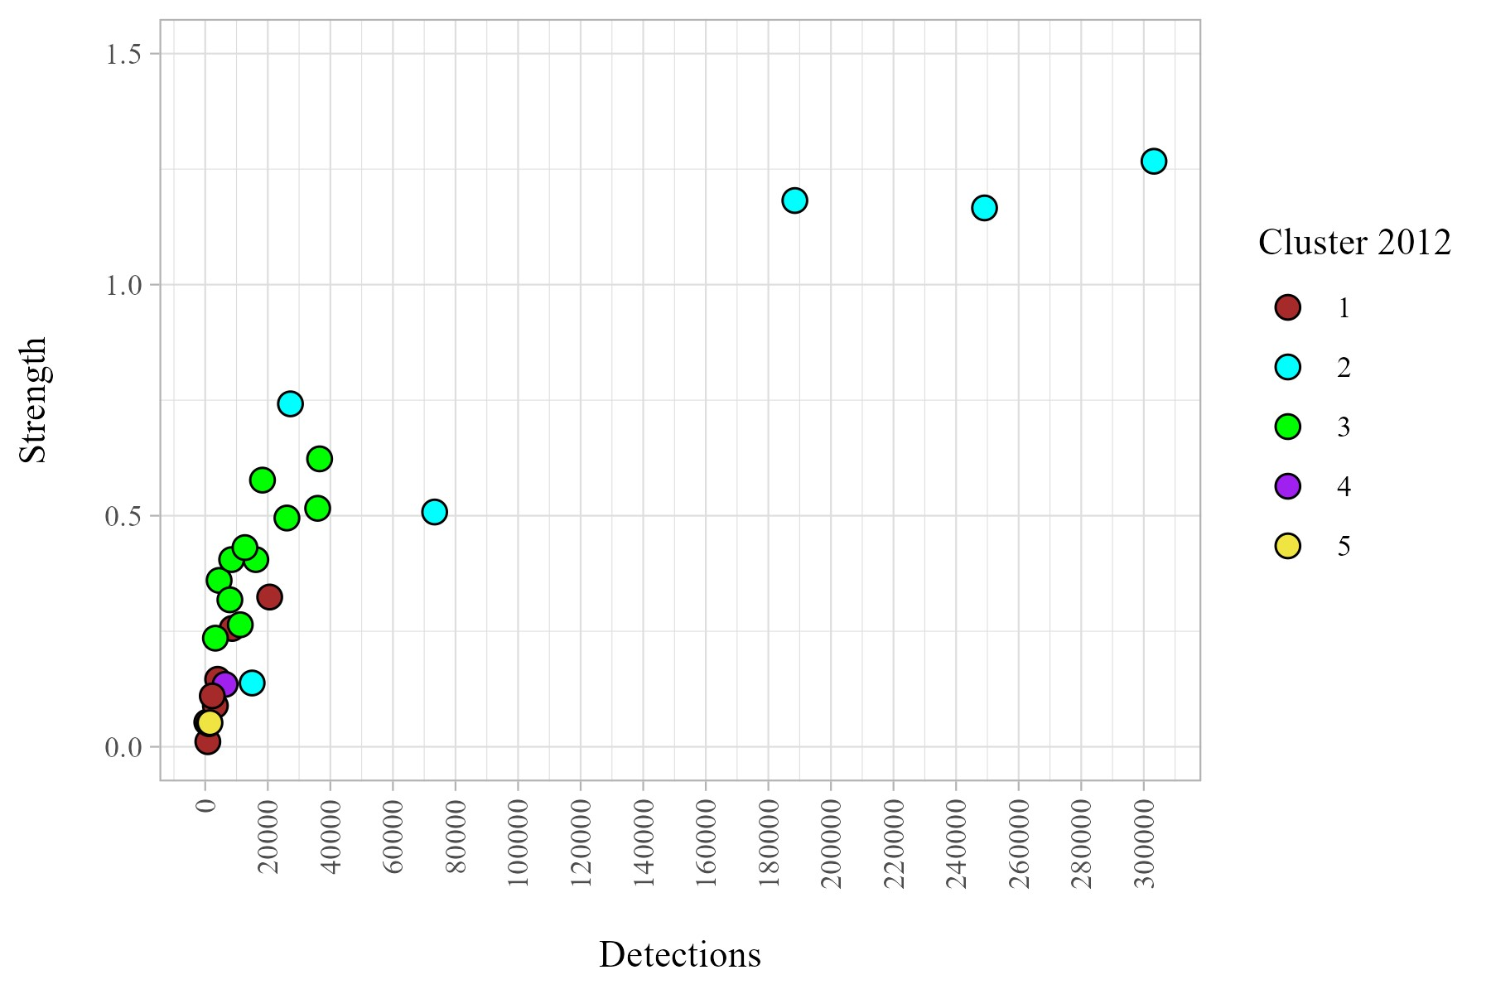
b
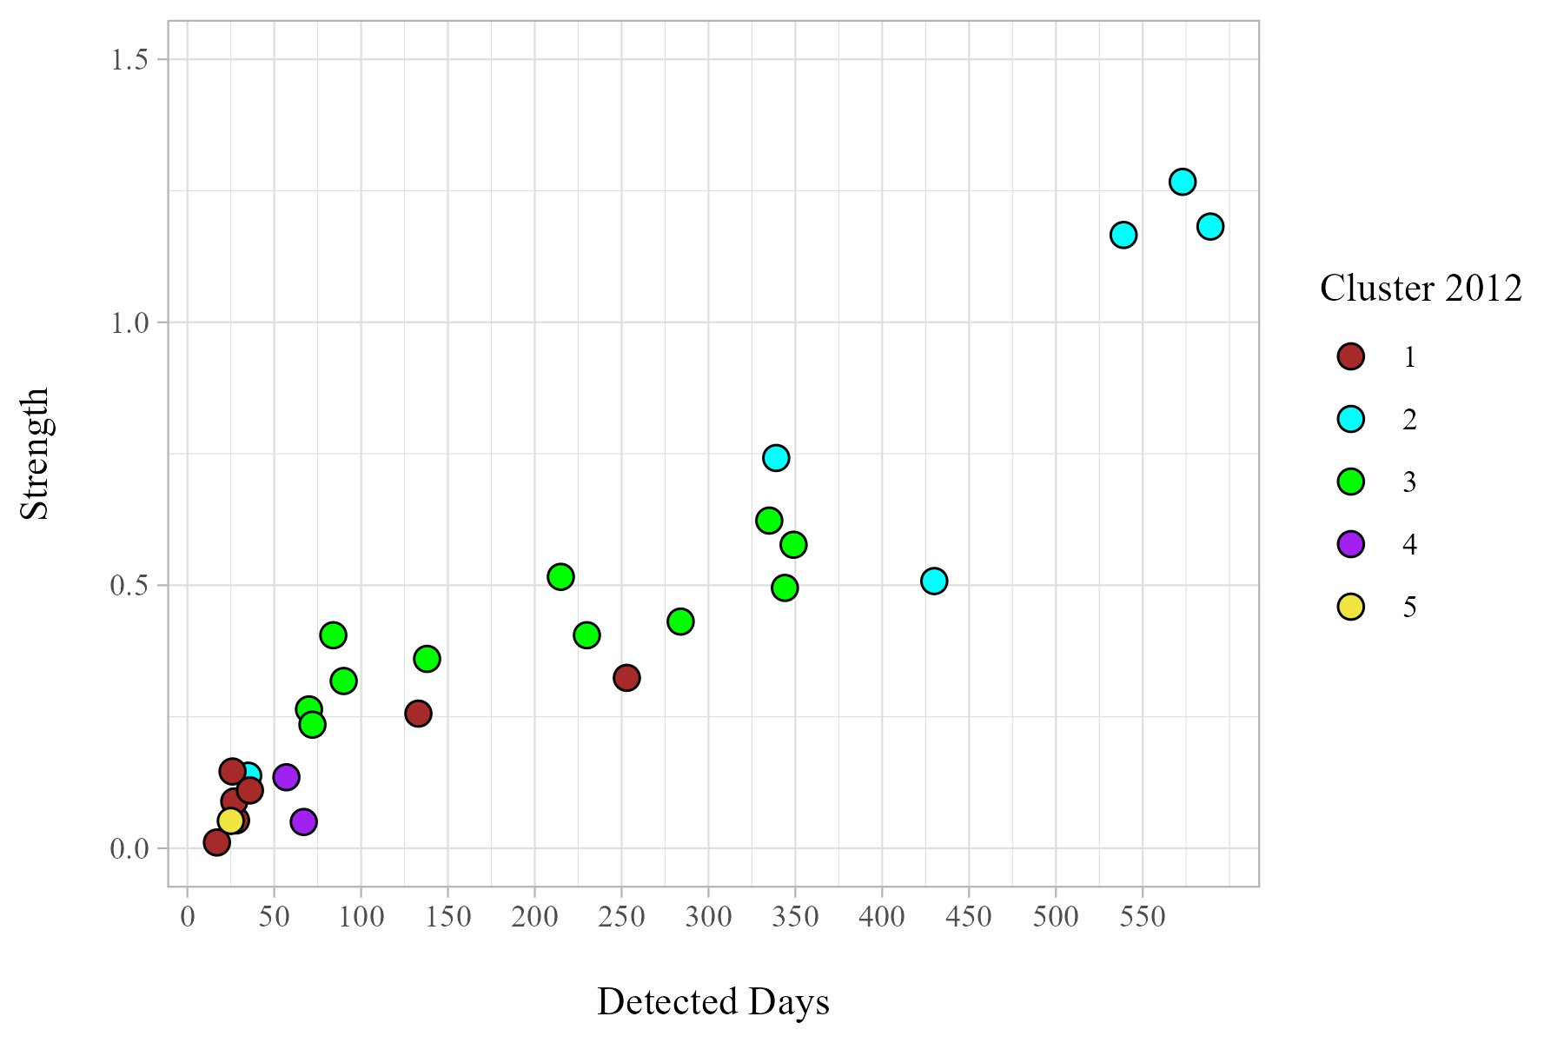
Fig. S2 Relationship between a) detected days b) detections and the cluster assigned for 2012 from the community analysis. Each colour represents a cluster. Cluster 4 represent the female group of UP. It is evident how the clusters were not only assigned by strength but also that the acoustic information provided affected the grouping of individuals

