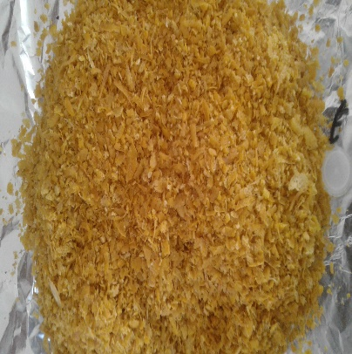
Plate 1: Dried orange peel

