Supplementary Materials for
Improving Polygenic Risk Score Based Drug Response Prediction Using Transfer Learning
Youshu Cheng^{1#}, Song Zhai^{2#}, Wujuan Zhong², Rachel Marceau West², Judong Shen^{2*}
¹Department of Biostatistics, Yale University, New Haven, CT 06520, USA
²Biostatistics and Research Decision Sciences, Merck & Co., Inc., Rahway, NJ 07065, USA
# These authors contributed equally to this work
* To whom correspondence should be addressed
Correspondence: judong.shen@merck.com (J.S.)

This file includes:
Supplementary Figures S1-S7
Supplementary Tables S1-S3

Supplementary Figures

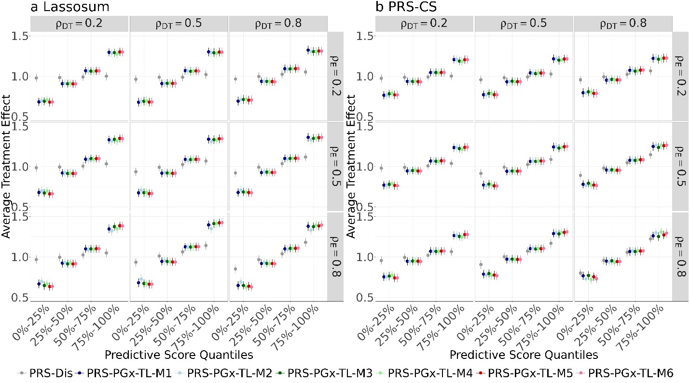

Figure S1 Simulation based patient stratification comparisons between disease PRS methods and PRS-PGx-TL method with different implementation strategies (M1 – M6) for (a) Lassosum, and (b) PRS-CS. $H_{D}^{2}=0.3$, $γ=1$, pcausal = 0.01, $ρ_{DT}∈\{0.2, 0.5, 0.8\}$, $ρ_{E}∈\{0.2, 0.5, 0.8\}$.

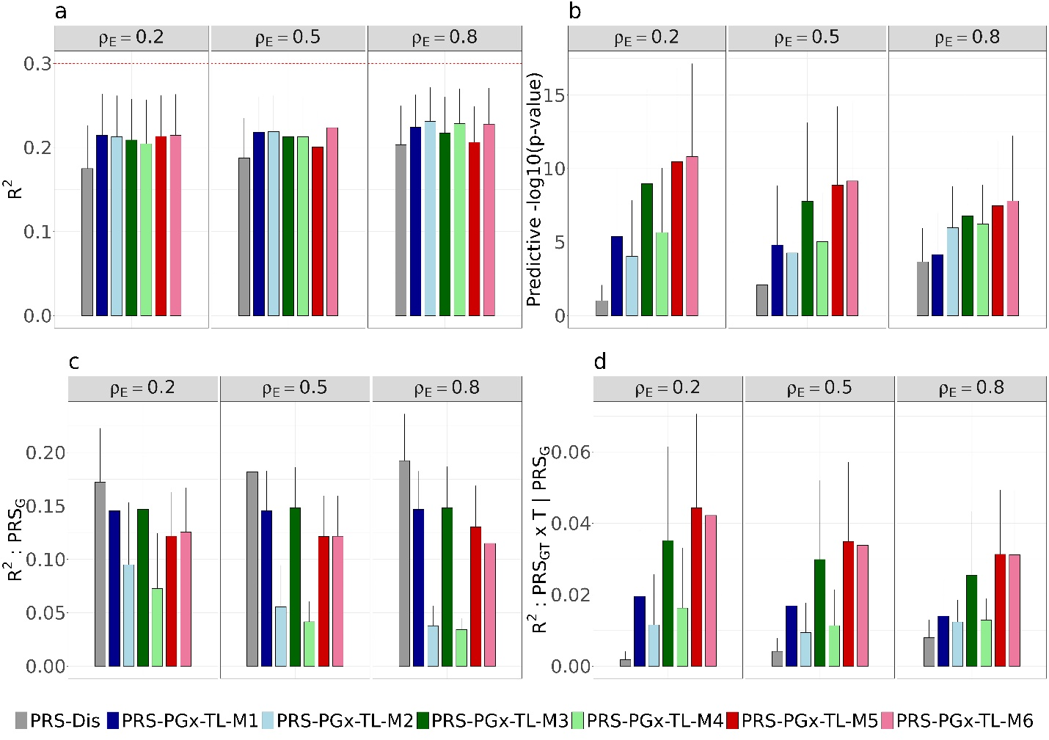

Figure S2 Simulation results based on C+T baseline disease PRS method in terms of (a) overall $R^{2}$, (b) predictive p-value, (c) partial $R^{2}$ explained by the $PRS_{G}$ term, and (d) partial $R^{2}$ explained by the $PRS_{GT}×T$term (conditional on $PRS_{G}$). $H_{D}^{2}=0.3$, $γ=1$, pcausal = 0.01, $ρ_{DT}=1$, $ρ_{E}∈\{0.2, 0.5, 0.8\}$.

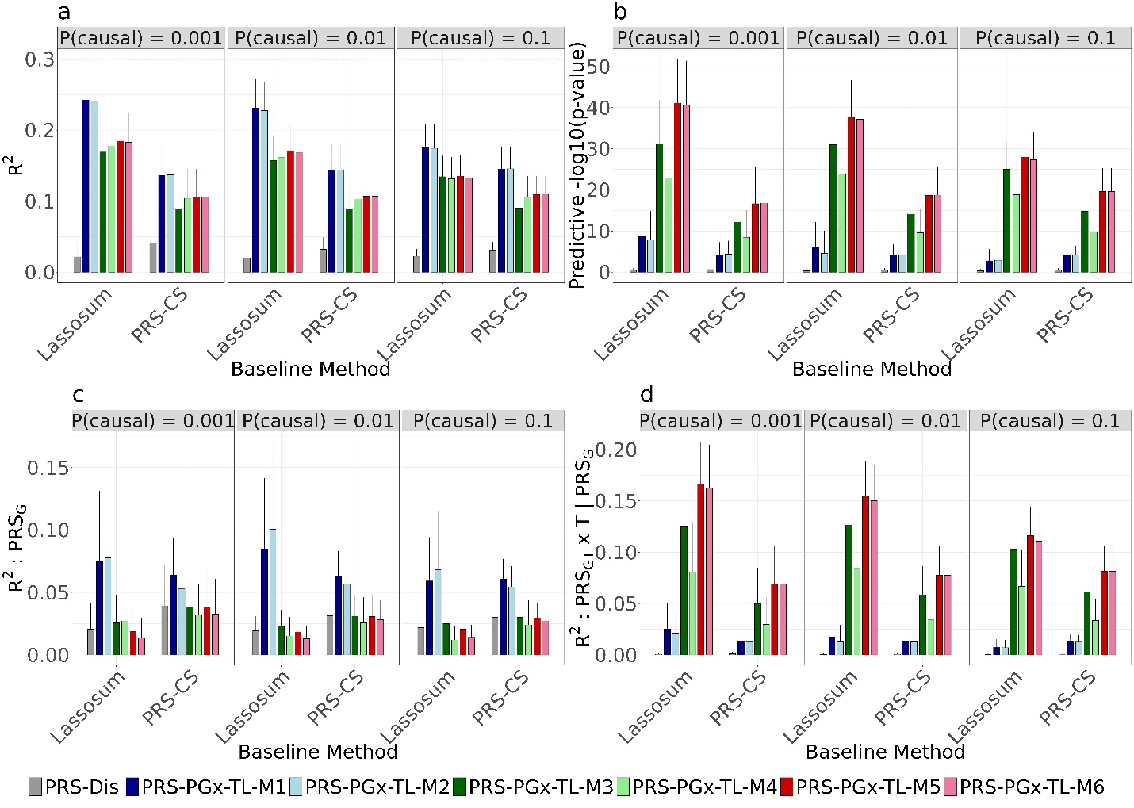

Figure S3 Simulation based performance comparisons between disease PRS methods (Lassosum, and PRS-CS) and PRS-PGx-TL method with different implementation strategies (M1 – M6). Methods are compared in terms of (a) overall $R^{2}$, (b) predictive p-value, (c) partial $R^{2}$ explained by the $PRS_{G}$ term, and (d) partial $R^{2}$ explained by the $PRS_{GT}×T$ term (conditional on $PRS_{G}$). $H_{D}^{2}=0.3$, $γ=1$, pcausal $∈\{0.001, 0.01, 0.1\}$, $ρ_{DT}=0.5$, $ρ_{E}=0.5$.

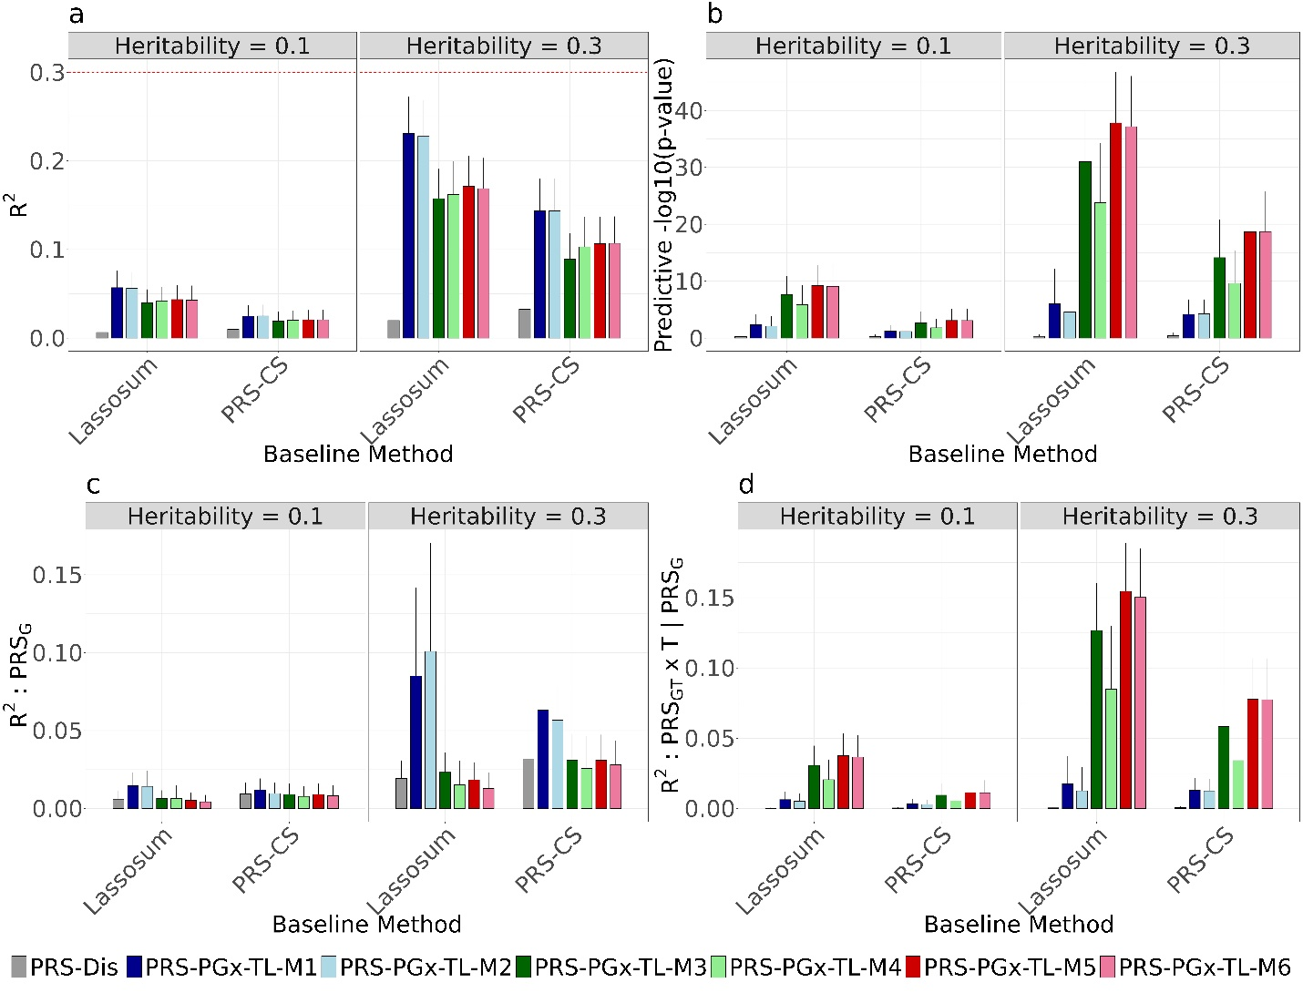

Figure S4 Simulation based performance comparisons between disease PRS methods (Lassosum, and PRS-CS) and PRS-PGx-TL method with different implementation strategies (M1 – M6). Methods are compared in terms of (a) overall $R^{2}$, (b) predictive p-value, (c) partial $R^{2}$ explained by the $PRS_{G}$ term, and (d) partial $R^{2}$ explained by the $PRS_{GT}×T$ term (conditional on $PRS_{G}$). $H_{D}^{2}∈\{0.1, 0.3\}$, $γ=1$, pcausal = 0.01, $ρ_{DT}=0.5$, $ρ_{E}=0.5$.

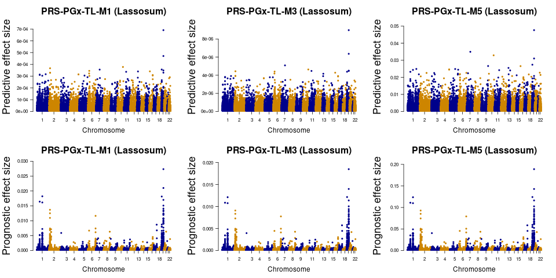

Figure S5 Manhattan plots of prognostic and predictive effect sizes for PRS-PGx-TL-M1/M3/M5 using Lassosum as the baseline method from the PRS analysis of the IMPROVE-IT PGx GWAS data.

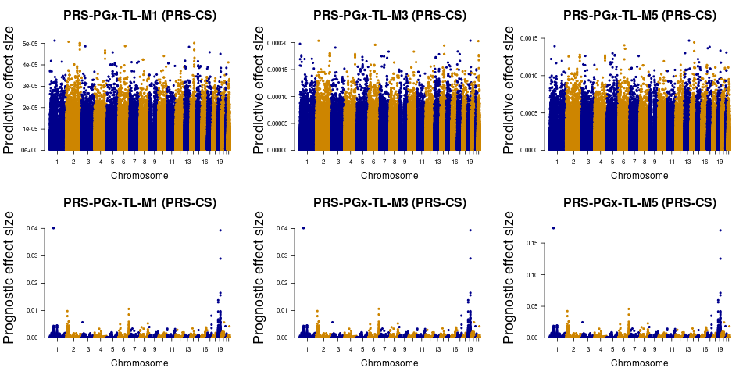

Figure S6 Manhattan plots of prognostic and predictive effect sizes for PRS-PGx-TL-M1/M3/M5 using PRS-CS as the baseline method from the PRS analysis of the IMPROVE-IT PGx GWAS data.

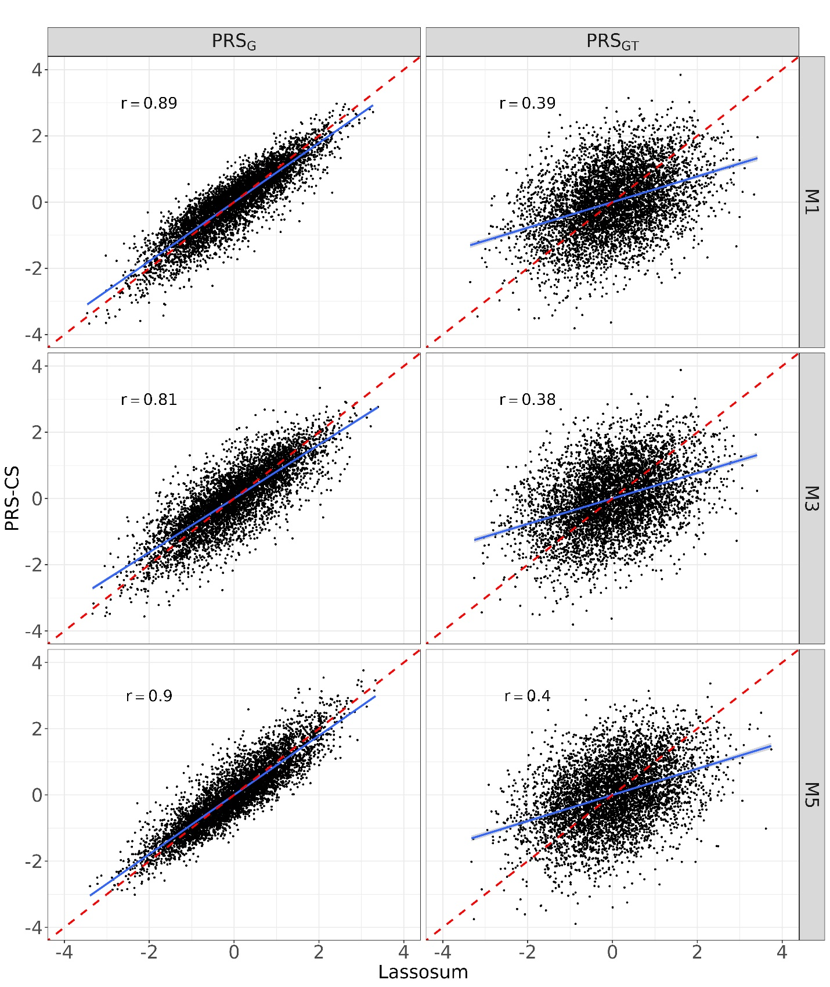

Figure S7 Scatter plots of PRS_{G} from Lassosum vs. PRS_{G} from PRS-CS and PRS_{GT} from PRS-CS vs. PRS_{GT} from PRS-CS for PRS-PGx-TL-M1, -M3 and -M5, respectively from the PRS analysis of the IMPROVE-IT PGx GWAS data. r stands for the Pearson’s correlation.

Supplementary Tables

Table S1 Simulation parameters setup.
Parameter | Description | Value
p | Proportion of causal SNPs | 0.1, 0.01, 0.001
$$h_{T}^{2}$$ | Heritability to explain the trait (in the base cohort) | 0.5
$$ρ_{E}$$ | Correlation between prognostic and predictive effects in PGx GWAS | 0.2, 0.5, 0.8
$$ρ_{DT}$$ | Effect correlation between the trait in the base cohort and the drug response in the target cohort | 0.2, 0.5, 0.8
G | IMPROVE-IT PGx GWAS genotype matrix with N patients and m SNPs | N = 5,000; m = 20,854 SNPs on chr 19
$$β_{T}$$ | Coefficient of treatment | 1
$$h_{D}^{2}$$ | Heritability to explain the drug response (in the target cohort) | 0.1, 0.3
$$γ$$ | Scaling factor of predictive effect (so that prognostic and predictive effects may have different scales) | 0.5, 1, 5

Table S2 Information about top 20 SNPs ranked by their absolute predictive effect sizes, estimated by PRS-PGx-TL-M1/M3/M5, respectively from the PRS analysis of the IMPROVE-IT PGx GWAS data. Lassosum was used as the baseline disease PRS method.
M1 |  |  |  | M3 |  |  |  | M5
chr | SNP | BP | Gene | chr | SNP | BP | Gene | chr | SNP | BP | Gene
19 | rs7254892 | 45389596 | PVRL2 | 19 | rs7254892 | 45389596 | PVRL2 | 19 | rs7254892 | 45389596 | PVRL2
19 | rs7412 | 45412079 | APOE | 19 | rs7412 | 45412079 | APOE | 7 | rs1362234 | 75588366 | POR
10 | rs11196299 | 115073097 | - | 7 | rs1362234 | 75588366 | POR | 10 | rs11196299 | 115073097 | -
2 | rs2723147 | 23618209 | KLHL29 | 10 | rs11196299 | 115073097 | - | 19 | rs7412 | 45412079 | APOE
19 | rs35918857 | 10254234 | DNMT1 | 19 | rs3208856 | 45296806 | CBLC | 19 | rs35918857 | 10254234 | DNMT1
7 | rs1362234 | 75588366 | POR | 19 | rs445925 | 45415640 | APOE | 9 | rs11137198 | 140638534 | EHMT1
19 | rs3208856 | 45296806 | CBLC | 11 | rs3136524 | 46750525 | F2 | 16 | rs210711 | 12611017 | SNX29
6 | rs6935708 | 29416652 | OR11A1 | 2 | rs2723147 | 23618209 | KLHL29 | 13 | rs3751432 | 41044128 | LINC00598
16 | rs210711 | 12611017 | SNX29 | 6 | rs6935708 | 29416652 | OR11A1 | 1 | rs11576216 | 179733859 | FAM163A
13 | rs4473067 | 44689605 | LINC00390 | 19 | rs35918857 | 10254234 | DNMT1 | 5 | rs7714291 | 111161642 | NREP
11 | rs3136524 | 46750525 | F2 | 16 | rs210711 | 12611017 | SNX29 | 4 | rs4610314 | 175240518 | CEP44
19 | rs445925 | 45415640 | APOE | 6 | rs2281027 | 26446705 | BTN3A3 | 4 | rs17060463 | 175241378 | CEP44
2 | rs1530046 | 23623283 | KLHL29 | 13 | rs4473067 | 44689605 | LINC00390 | 5 | rs10043715 | 173594472 | NSG2
2 | rs2577747 | 23624756 | KLHL29 | 2 | rs1530046 | 23623283 | KLHL29 | 1 | rs12401944 | 109239079 | PRPF38B
6 | rs2281027 | 26446705 | BTN3A3 | 2 | rs2577747 | 23624756 | KLHL29 | 11 | rs7952632 | 95711345 | MAML2
1 | rs11576216 | 179733859 | FAM163A | 1 | rs11576216 | 179733859 | FAM163A | 13 | rs549431 | 75874682 | TBC1D4
4 | rs4610314 | 175240518 | CEP44 | 16 | rs17666927 | 72143414 | DHX38 | 1 | rs11591147 | 55505647 | PCSK9
4 | rs17060463 | 175241378 | CEP44 | 13 | rs3751432 | 41044128 | LINC00598 | 22 | rs5752079 | 25597842 | CRYBB3
1 | rs17112640 | 56161325 | RP11-466L17.1 | 16 | rs17666993 | 72146666 | DHX38 | 6 | rs11964205 | 163418400 | PACRG
1 | rs17112655 | 56168803 | RP11-466L17.1 | 1 | rs17112640 | 56161325 | RP11-466L17.1 | 2 | rs12621976 | 144106558 | ARHGAP15

Table S3 Information about top 20 SNPs ranked by their absolute predictive effect sizes, estimated by PRS-PGx-TL-M1/M3/M5, respectively from the PRS analysis of the IMPROVE-IT PGx GWAS data. PRS-CS was used as the baseline disease PRS method.
M1 |  |  |  | M3 |  |  |  | M5
chr | SNP | BP | Gene | chr | SNP | BP | Gene | chr | SNP | BP | Gene
1 | rs10493495 | 72722584 | NEGR1 | 19 | rs7254892 | 45389596 | PVRL2 | 13 | rs12429177 | 93071017 | GPC5
2 | rs17023938 | 39773237 | AC007246.3 | 2 | rs17023938 | 39773237 | AC007246.3 | 14 | rs759591 | 77551671 | RP11-7F17.4
14 | rs759591 | 77551671 | RP11-7F17.4 | 22 | rs5752851 | 29398459 | ZNRF3 | 6 | rs6932200 | 91787815 | -
2 | rs6754838 | 214375447 | SPAG16 | 1 | rs6662635 | 1220425 | SCNN1D | 1 | rs10493495 | 72722584 | NEGR1
2 | rs16850465 | 214430651 | SPAG16 | 6 | rs9322774 | 104303973 | - | 17 | rs9905211 | 37260188 | PLXDC1
2 | rs2130057 | 214249895 | SPAG16 | 6 | rs9322775 | 104304350 | - | 17 | rs3935950 | 7974179 | ALOX12B
2 | rs1503380 | 214324201 | SPAG16 | 14 | rs759591 | 77551671 | RP11-7F17.4 | 6 | rs9322774 | 104303973 | -
2 | rs10498007 | 214345142 | SPAG16 | 3 | rs3732514 | 56667480 | FAM208A | 6 | rs9322775 | 104304350 | -
2 | rs16850416 | 214354140 | SPAG16 | 17 | rs3935950 | 7974179 | ALOX12B | 19 | rs7254892 | 45389596 | PVRL2
2 | rs6709713 | 214378285 | SPAG16 | 7 | rs8176059 | 142651354 | KEL | 14 | rs2021766 | 77546692 | RP11-7F17.4
6 | rs9322774 | 104303973 | - | 10 | rs12098564 | 86953327 | RP11-181F12.1 | 14 | rs204982 | 77553969 | RP11-7F17.4
6 | rs9322775 | 104304350 | - | 2 | rs6754838 | 214375447 | SPAG16 | 21 | rs17811387 | 30413855 | USP16
3 | rs3732514 | 56667480 | FAM208A | 2 | rs16850465 | 214430651 | SPAG16 | 13 | rs3809376 | 31308722 | ALOX5AP
13 | rs12429177 | 93071017 | GPC5 | 4 | rs3792614 | 164532973 | MARCH1 | 5 | rs157237 | 89389697 | -
2 | rs7587811 | 214457257 | SPAG16 | 17 | rs9905211 | 37260188 | PLXDC1 | 2 | rs6754838 | 214375447 | SPAG16
14 | rs2021766 | 77546692 | RP11-7F17.4 | 14 | rs2021766 | 77546692 | RP11-7F17.4 | 2 | rs16850465 | 214430651 | SPAG16
14 | rs204982 | 77553969 | RP11-7F17.4 | 14 | rs204982 | 77553969 | RP11-7F17.4 | 5 | rs7708937 | 123169574 | -
4 | rs3792614 | 164532973 | MARCH1 | 13 | rs12429177 | 93071017 | GPC5 | 4 | rs3792614 | 164532973 | MARCH1
17 | rs9905211 | 37260188 | PLXDC1 | 2 | rs2130057 | 214249895 | SPAG16 | 5 | rs10519734 | 123191183 | -
5 | rs1422174 | 92194417 | - | 22 | rs8138016 | 36702149 | MYH9 | 3 | rs3732514 | 56667480 | FAM208A

