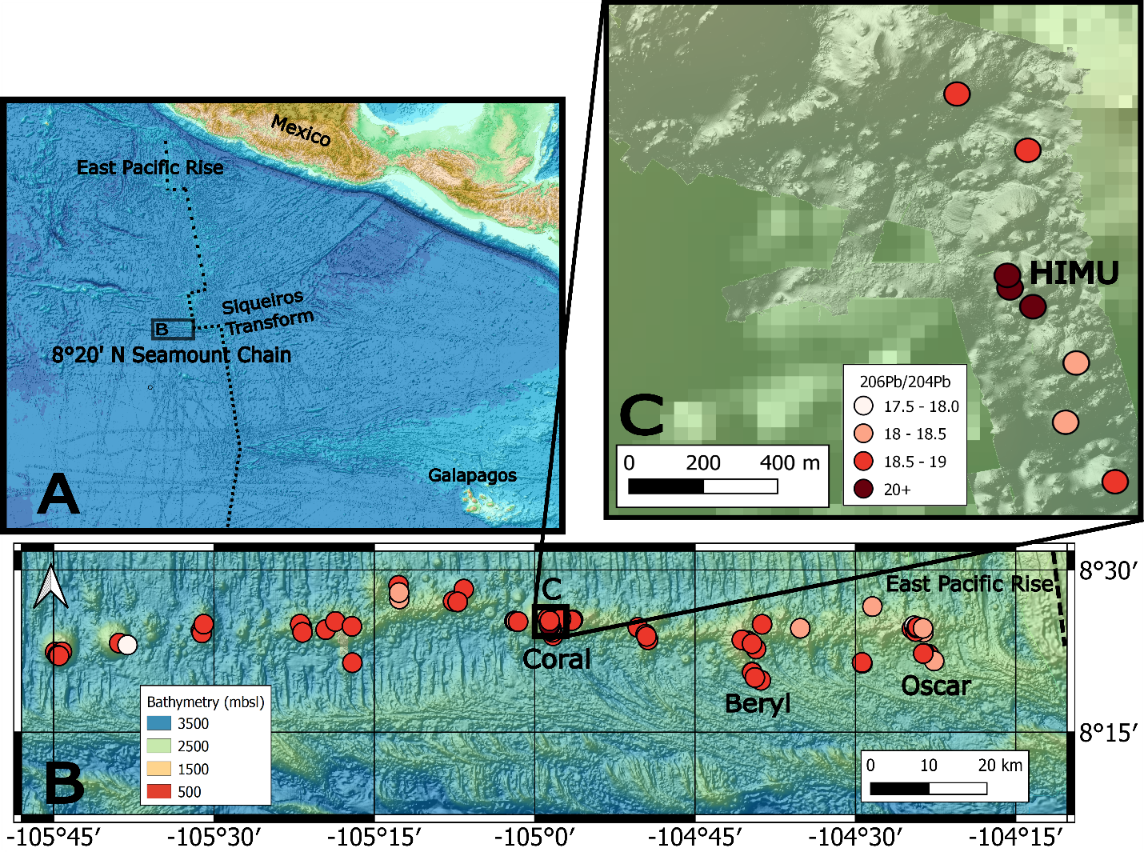
Figure S1. A) Regional GEBCO 2022 bathymetric map acquired from gebco.net with the East Pacific Rise axis marked by a dashed black line. B) Shipboard EM122 bathymetric map of 8°20’ N Seamount Chain oriented perpendicular to the East Pacific Rise, northwest of the Siqueiros transform. Circles are sample locations. Dark red circles are more radiogenic (darkest red are the HIMU samples), and the lighter are less radiogenic. C) Inset map of Coral seamount with EM122 (same as A), overlain by high-resolution AUV Sentry bathymetry. Sample color scheme is the same as panel B. There are three HIMU lavas on one flow flanked by lavas with un-radiogenic Pb < 300 m north and south of the HIMU lava flow.

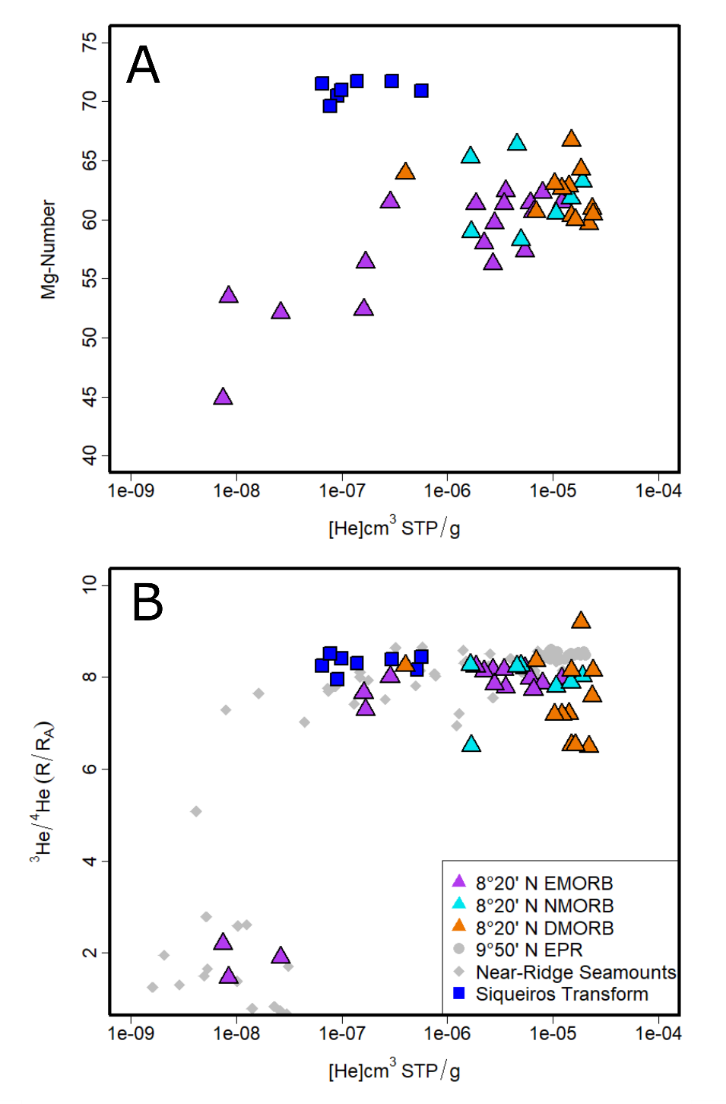
Figure S2. [He] (cm³STP/g) vs A) Mg-number and B) ³He/⁴He (R/R_{A}) for 8°20’ N seamounts (triangles) and Siqueiros transform (squares), compared with 9°50’ N EPR⁴⁶ and other near-EPR seamounts¹⁶. Highly differentiated and degassed samples ([He] < 5x10⁻⁸; Mg-number < 55; ³He/⁴He < 5 R/R_{A}) are not included in interpretations (this eliminated 3 of 44 samples). The samples were filtered because they are unlikely to reflect mantle characteristics, but rather late-stage modified magma compositions resulting from degassing plus assimilation/atmospheric contamination.

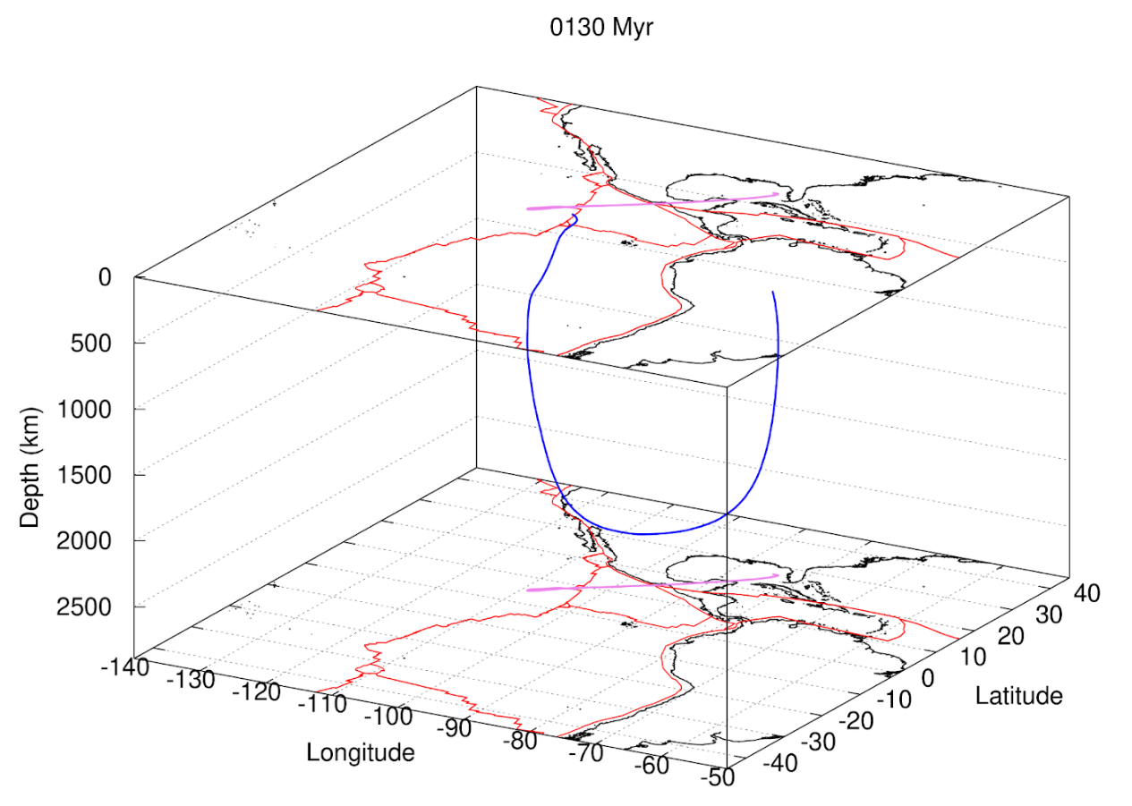
Figure S3. Particle tracking model using V1 mantle viscosity model⁶⁵, which imposes on average a lower viscosity (about 30% lower than V2), a thinner lithosphere, and a low velocity zone, making the profile more realistic for oceanic mantle settings like below mid-ocean ridges. The particle tracks deep into the lower mantle within the past ~ 76 million years and flows directly back to the upper mantle, completing a whole mantle cycle within ~ 130 Ma. See Figure S4 and supplementary discussion A for commentary on uncertainties introduced by viscosity profile selection.

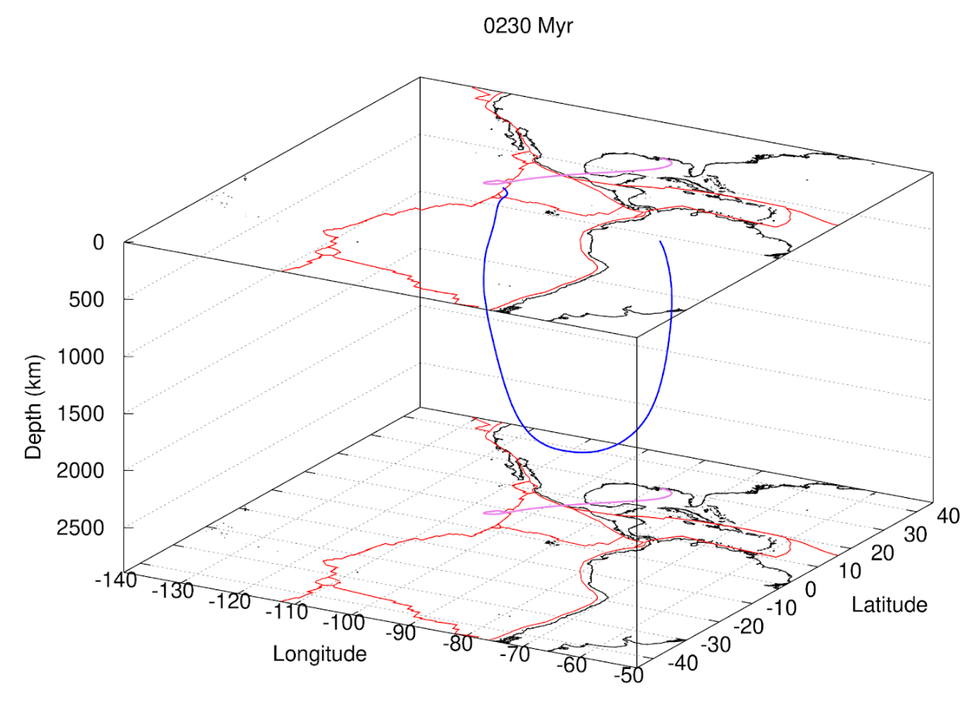
Figure S4. Particle tracking model using alternative V2 mantle viscosity model⁶⁶ to assess the model’s dependence on viscosity profile. V2 imposes a viscosity continuity between upper and lower mantle (thus eliminating the low velocity zone at the base of the upper mantle in V1), and has a higher viscosity overall, resulting in stiffer lower mantle behavior and slower overall transport time. V2 also has a thicker lithosphere, and is therefore more realistic for sub-continental mantle modeling. Like the V1 viscosity model, the particle tracks deep into the mantle, but the traverse is much slower. The trajectory reaches a similar maximum depth as the V1 model but in this case around 124 Ma (to ~2440 km depth), and then returns to the upper mantle around 240 Ma. The overall higher viscosity (~30% more viscous than the V1 model) thus significantly impacts the model estimate for recycling time (almost doubling the V1 cycling time). Most importantly, however, regardless of viscosity profile, the particle traces back to the surface proximal to the paleo Caribbean-Guerrero arc associated with the subduction of the Mezcalera plate below the Farallon plate. This demonstrates that the particle tracking model results are consistent with Mezcalera-Farallon paleo-subduction zone origins of sub-EPR mantle heterogeneity regardless of assumed viscosity profile, consistent with plate reconstruction models⁶⁷.
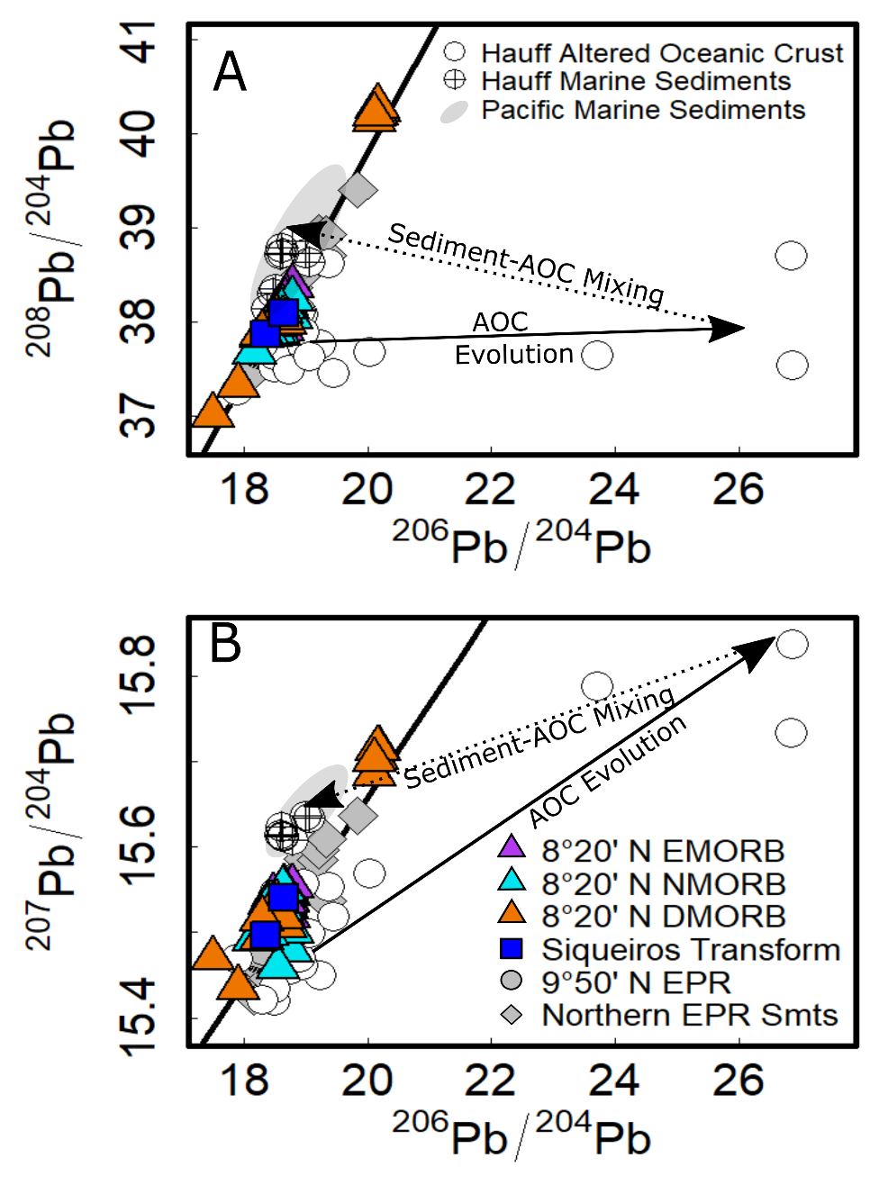
Figure S5. ²⁰⁶Pb/²⁰⁴Pb vs A) ²⁰⁸Pb/²⁰⁴Pb and B) ²⁰⁷Pb/²⁰⁴Pb isotopic compositions of the 8°20’ N seamount lavas (filled triangles) and Siqueiros transform (dark blue filled squares) relative to the NHRL (black solid line). Samples are compared with 9°50’ N on-axis lavas (filled grey circles^{38,39}), other northern EPR off-axis seamount lavas (filled grey diamonds¹⁶), altered oceanic crust (AOC; open circles) and sediments (circles with a cross) from the Marianas and Izu-Bonin ODP sites⁷⁴, as well as an approximate Pb isotope range for Pacific marine sediments^{74,75}. The approximate expected path of evolution for AOC with carbonate veins is indicated with an arrow, which notably deviates from the 8°20’ N seamount HIMU. We considered the highest ²⁰⁶Pb/²⁰⁴Pb AOC samples as potential mixing end-members. While the seamount HIMU could feasibly be formed by mixing highest ²⁰⁶Pb/²⁰⁴Pb AOC lavas with sediments, this model is insufficient for forming the HIMU ²⁰⁸Pb/²⁰⁴Pb ratios.
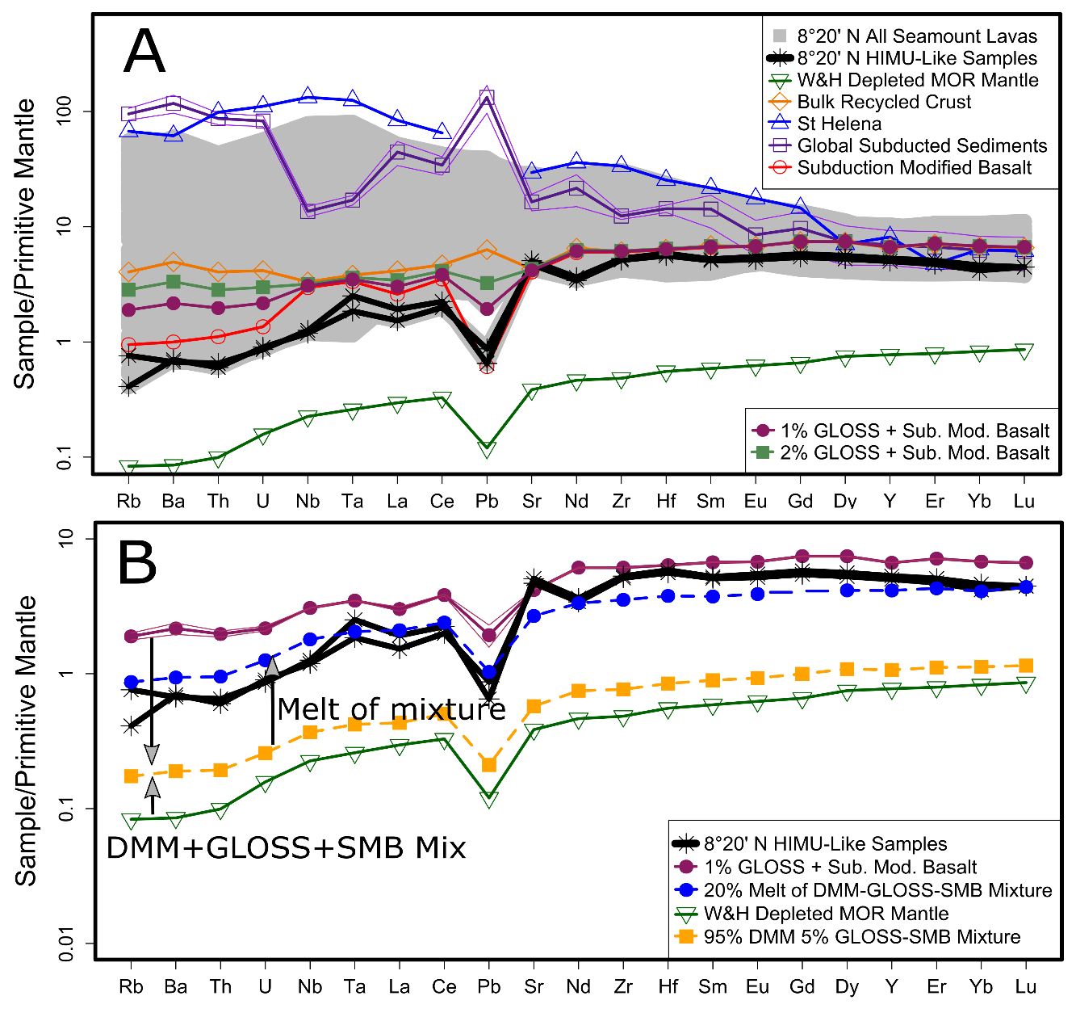
Figure S6. (A) Trace element abundances of 8°20’ N seamount lavas (grey region and black lines) normalized to primitive mantle⁴, compared with depleted MORB mantle (DMM), Bulk recycled crust, St Helena HIMU, global subducted sediments (GLOSS), subduction-modified basalt (SMB), a mixture of 1% GLOSS + 99% SMB²⁷(the mantle component mixture selected here), and a mixture of 2% GLOSS + 98% SMB. (B) Trace element abundances of 8°20’ N HIMU lavas compared with DMM, 1% GLOSS + 99% SMB with error envelopes propagated from GLOSS standard deviation estimates⁶⁰, and a mixture of 95% DMM with 5% recycled material (1% GLOSS+99% SMB). Melting is calculated using the modal batch melting equation C_melt = Cs/(F+D(1-F)), and assumes a lherzolite lithology (55% ol, 35% opx, and 10% cpx). To recreate the HIMU basalt trace element abundances, this mixture appears to need to melt 20% off-axis.

Supplementary Material for
Deeply Recycled Origins of Mantle Heterogeneity at the Northern East Pacific Rise
Anderson, Molly K.^{1,2}; Johnston, Gabriel¹; Perfit, Michael R.¹; Forte, Alessandro^{1,3}; Kamenov, George¹; Graham, David W.⁴; Dixon, Jacqueline⁵; Wanless, V. Dorsey⁶; Glisovic, Petar^{3,7}
University of Florida¹; Woods Hole Oceanographic Institution²; Institut de Physique du Globe de Paris³; Oregon State University⁴; University of South Florida⁵; Boise State University⁶; Queens University⁷
* Corresponding author, email: molly.anderson@whoi.edu
Supplementary material includes:
Supplementary discussion: sections A to C
Tables S1 to S5 (currently in-line with relevant text for submission, and S1 and S2 in separate excel files due to size)
Figure S1 to S8 (currently in-line with relevant text for submission)
A. Uncertainty in Particle Trajectories
Because we assume a purely adiabatic geotherm (excluding thermal boundary layers) in the reconstruction of the past evolution of the mantle, the amplitude of lateral temperature anomalies gradually diminishes as the reconstruction extends further back in time. In effect, the deeper we go in time, the more the adiabatic geotherm will “homogenize” the mantle’s temperature, thus reducing the buoyancy-driven mantle flow speeds. This homogenization is an inevitable consequence of assuming a purely adiabatic geotherm at all depths in the mantle. Consequently, particle travel times tend to increase the further back we reconstruct, potentially biasing path trajectories and speeds.
To mitigate this, we tested two approaches:
- 70 Ma Reconstruction, Then Quasi-Static Wind:
- We run the full backward flow calculation only to 70 Ma, by which point most particle paths have entered the lower mantle where flow evolves very slowly. Forward convection modelling of the reconstructed structure at 70 Ma reveals the homogenization arising from the adiabatic geotherm is controlled, thus allowing a good prediction of present-day mantle structure, given seismic tomography.
For times prior to 70 Ma, we hold the lower-mantle flow “quasi-static,” effectively freezing the evolution of the deep circulation while continuing to advect particles in it.
- Full 250 Ma Reconstruction:
- We push the entire back-and-forth scheme to 250 Ma. However, the further we go in time, the more the temperature anomalies decay, reducing predicted flow speeds and also reducing the ability to adequately recover the present-day mantle structure in a forward convection simulation.
- This can introduce (potentially large) biases in travel times.
In both approaches, the outcome of the backward-in-time reconstructions of mantle structure are also conditioned by the assumed mantle viscosity profile and surface boundary condition. Table S4 illustrates the magnitude of these differences. For example, in a 70 Ma reconstruction with the V2 model and no matching of past plate motions(2n), the particle’s deepest point is 399.89 km above the CMB at ~155 Ma. But if we extend the backward reconstruction to 250 Ma under the same model (2n, 250 Ma), the deepest point shifts to 200.66 km above the CMB at ~168 Ma. These differences – nearly 200 km in depth and ~13 Myr in timing – stem from how the amplitude of the mantle “wind” evolves before 70 Ma.

Table S4. Deepest‐penetration particle positions illustrating uncertainties under different viscosity profiles and boundary conditions.
Latitude | Longitude | Model | Height above CMB (km) | Time (Ma) | Comments
14.93 | –95.96 | 1m | 387.18 | –76 | 70 Ma reconstruction, V1 viscosity, matched plates
9.91 | –93.43 | 1n | 339.17 | –103 | 70 Ma reconstruction, V1 viscosity, no plate match
18.37 | –95.09 | 2m | 449.73 | –124 | 70 Ma reconstruction, V2 viscosity, matched plates
15.46 | –92.76 | 2n | 399.89 | –155 | 70 Ma reconstruction, V2 viscosity, no plate match
15.01 | –89.50 | 2n | 200.66 | –168 | 250 Ma reconstruction, V2 viscosity, no plate match
“Height above the CMB” is the distance from the core–mantle boundary where each backward‐tracked particle reaches its maximum depth.
“Time” (in Ma) indicates when (in the past) that occurs in the reconstruction. Negative times denote years before present.
“1” or “2” denotes V1 or V2 viscosity, and “m” or “n” indicates whether the model matches observed plate motions (m) or not (n).

Table S5 builds on the uncertainties highlighted in Table S4 by summarizing the reconstructed positions and (time-reversed) “ascent” times of mantle particles as they reach the top of the lower mantle. Table S5 shows that the model differences explored in Table S4, yield modest variations in the lateral, geographic coordinates of the reconstructed particle positions at the top of the lower mantle. We note, in particular, that the more extended 250 Ma reconstruction (model 2n) suggests the particle ascended later (at –384 Ma) compared to the 70 Ma reconstructions. This reflects the effect of the assumed adiabatic geotherm, which gradually homogenizes temperature anomalies and slows buoyancy-driven flows the further back in time we extend these reconstructions. Nonetheless, although the estimated ascent times vary widely (from –130 Ma to –384 Ma), the reconstructed latitudes (roughly 20° to 30°) and longitudes (approximately –84° to –90°) differ by only a few degrees. These differences, which translate to several hundred kilometers in absolute terms, are relatively small compared to the vast scales involved in the mantle flow paths we are modelling. In essence, despite the notable uncertainties in timing, the overall lateral flow pattern remains robust, underscoring the importance of considering model assumptions when interpreting mantle dynamics over geologic time. These results quantify how assumptions about viscosity, surface boundary matching, and long-duration backward reconstructions can produce shifts in particle trajectories.

Table S5. Reconstructed particle positions at top of lower mantle
Latitude | Longitude | Model | Depth (km) | Time (Ma) | Comments
26.6 | –84.7 | 1m | 698.4 | –130 | 70 Ma reconstruction, V1 viscosity, matched plates
20.1 | -84.4 | 1n | 694.7 | –182 | 70 Ma reconstruction, V1 viscosity, no plate match
30.1 | –89.8 | 2m | 687.7 | –231 | 70 Ma reconstruction, V2 viscosity, matched plates
23.4 | –88.1 | 2n | 698.0 | –289 | 70 Ma reconstruction, V2 viscosity, no plate match
26.5 | –81.8 | 2n | 695.0 | –384 | 250 Ma reconstruction, V2 viscosity, no plate match
“Depth” corresponds to the reconstructed particle position “ascending” – in reverse time – to the top of the lower mantle (at ~670 km depth).
“Time” (in Ma) indicates when (in the past) that occurs in the reconstruction. Negative times denote years before present.
“1” or “2” denotes V1 or V2 viscosity, and “m” or “n” indicates whether the model matches observed plate motions (m) or not (n).

B. Pacific LLSVP “Edges”and the 8°20′ N Seamounts
Figure S7 shows the compositional (“non‐thermal”) density anomalies in the lowermost mantle (~350 km above the CMB), taken from the GyPSuM tomography model⁸⁹. The orange circles mark the surface positions of several Pacific hotspots. Among these, “8S” denotes the 8°20′ N Seamounts in the East Pacific. By contrast, the magenta and cyan circles represent deepest‐penetration points of backward‐tracked particles that originate at the surface location of 8S (i.e., 50 km depth beneath the 8°20′ N Seamounts) and then descend into the lowermost mantle through time‐reversed flow fields. Each magenta/cyan label (e.g., “1m,” “2n”) corresponds to a specific combination of viscosity profile (V1 or V2) and whether or not estimated tectonic plate motions in the geologic past are matched or not (“m” vs. “n”).
A key finding is that the deepest‐penetration points for the 8°20′ N Seamount trajectories lie well outside the classical “edge” contours of the Pacific LLSVP, which is often defined by the –1% shear‐wave velocity perturbation: δVs/Vs​. One immediate implication is that the interpretation of subduction-derived geochemical signatures sampled at the 8°20′ N seamounts are therefore not originating from the canonical LLSVP margin. We acknowledge the possibility of gradational or complex LLSVP “edges”, whereby the traditionally used –1% contour of δVs/Vs may be an oversimplification and that the actual thermochemical piles may have continuous gradients of density along their margins. We nonetheless note that the reconstructed deepest-penetration points are situated well outside the high-density “core” of the thermochemical pile inside the Pacific LLSVP (see dark‐blue coloured region in Fig. S7).
Despite not sampling the LLSVP “core” or “rim,” the “8S” reconstructed flow paths (Fig. S7) could still yield distinctive HIMU‐like or recycled‐sediment isotope signatures if the deeper mantle there contains subducted basaltic or sedimentary components. This inference is supported by the mantle-wide flow trajectories (see Fig. 4), which reveal that materials injected into the mantle below far-field paleo-subduction zones may then be transported into the lowermost mantle by the global-scale mantle “wind”. Consequently, a seamount chain (8°20′ N in this case) may record “deep” geochemical signals that do not require a source strictly at the LLSVP edge or core. This offers an explanation for the observed variety of OIB “flavors” in the Pacific, reinforcing that multiple deep subregions can be sourced by hot upwellings with unique chemical fingerprints.
We finally note that the surface location of 8°20′ N seamounts (Fig. S7) and its deepest mantle intersection (magenta/cyan circles, Fig. S7) are not co‐located. This observation reveals that hotspot-related mantle upwellings can derive from transitional domains beyond the classic LLSVP “edge vs. core” framework – suggesting complex internal structure and flow within the lowermost Pacific mantle.
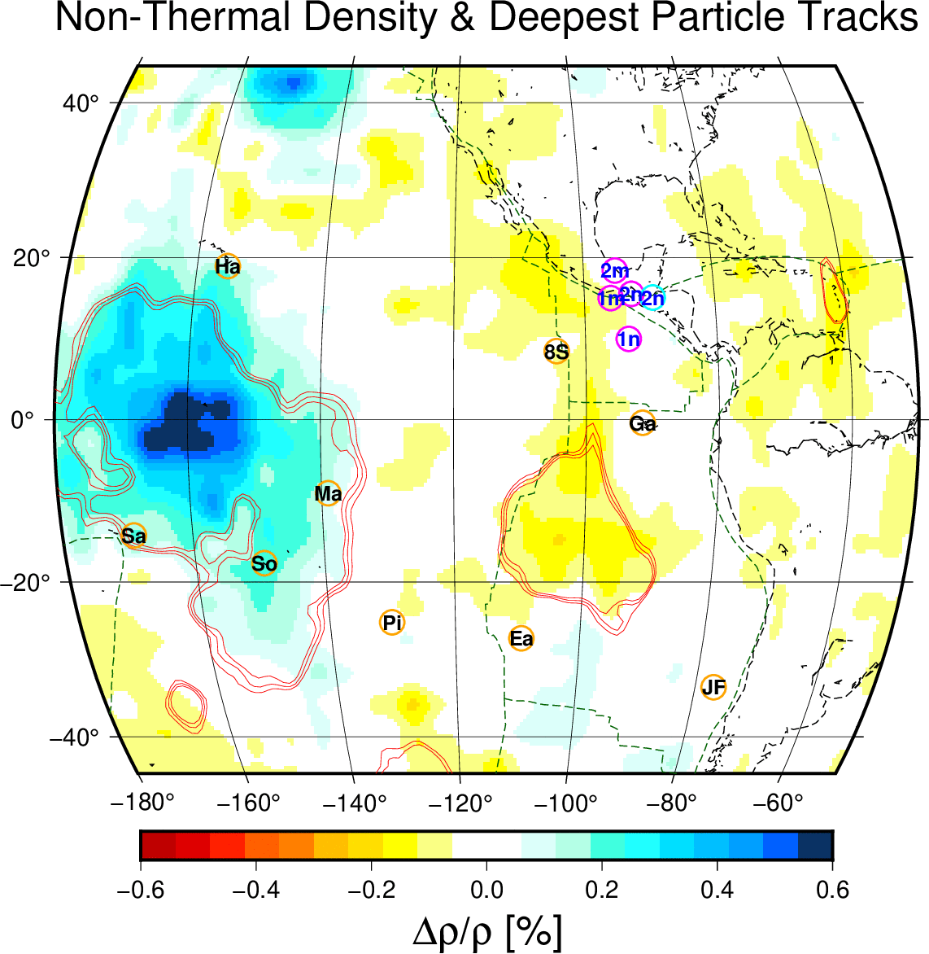
Figure S7: Non‐Thermal Density and Deepest Particle Tracks above the Core–Mantle Boundary. Contours and color shading show the distribution of compositional (non‐thermal) density anomalies in the lowermost mantle, derived from the GyPSuM global tomography model⁸⁹ at ~350 km above the core–mantle boundary (CMB). Negative anomalies (dark blue) indicate regions of higher‐than‐average compositional density, often referred to as “thermochemical piles.” The solid red lines mark –0.9%, –1.0%, and –1.1% S‐wave velocity perturbations (also from GyPSuM) at the same depth. The dashed black curves outline continental margins, and dashed blue curves outline mid‐ocean ridges. Orange circles show the surface locations of the 8°20′ N Seamounts, labelled “8S” and of the Pacific hotspots labelled as: “Ha” = Hawai‘i, “Ga” = Galápagos, “Ea” = Easter, “JF” = Juan Fernandez, “Co” = Cobb, “Pi” = Pitcairn, “Lo” = Louisville, “Sa” = Samoa, “Ma” = Marquesas, “So” = Society (Tahiti). The magenta circles mark the deepest points of backward‐tracked particles (initiated at 50 km depth) based on different viscosity profiles (V1 or V2) and plate‐matching conditions (“m” = matched, “n” = not matched) employed in the mantle flow calculations. For example, “1m” denotes the V1 viscosity profile with matched plate motions, while “2n” indicates V2 viscosity with no plate‐motion matching. The cyan circle (labeled “2n”) shows a further time‐reversed solution, with continuously evolving mantle wind, extended back to 250 Ma, in contrast to mantle reconstructions (magenta circles) that extend back to 70 Ma and assume a static mantle wind for earlier times.
C. Estimating Mantle Mixing
Figure S8 shows the backward‐in-time evolution of a central particle, and twelve neighboring particles, arranged in a cylindrical array, located 50 km beneath the 8°20′ N seamounts at t = 0 Ma (i.e. present day). At this initial time, each particle is laterally offset by 2.5° relative to the central particle, corresponding to a distance of ~275 km and hence the initial lateral diameter of the particle array is ~550 km.
At t = –76 Ma, when the central particle in the array is at its maximum depth in the lower mantle, the average radius of the particle array is about 455 km, implying a diameter of about 910 km for the entire cylindrical array. Even at t = –130 Ma, after the central parcel has “ascended” (in reverse time) to the top of the lower mantle, the furthest neighbors in the cylindrical array remain ~600 km away from the central particle, so the lateral diameter of the array spans a distance of about 1,200 km.
This modest time-reversed “expansion”, or “contraction” in a time-forward perspective, of the particle array suggests – from a geochemical perspective – that some internal “marble‐cake” style shearing occurs, but the particle array remains sufficiently coherent to preserve any distinct signature of recycled crust or sediment that may have been injected into the top of the lower mantle at t = –130 Ma. The limited lateral spreading, and hence internal deformation of the particle array over the entire 130 million year trajectory across the mantle will inhibit significant homogenization of internal chemical heterogeneity. If the mantle material in the particle array carries, for example, high U/Pb (“HIMU‐type”) anomalies inherited from an ancient subduction zone, it can still deliver these signals to the near‐surface region beneath the 8°20′ N seamounts with comparatively limited dilution.
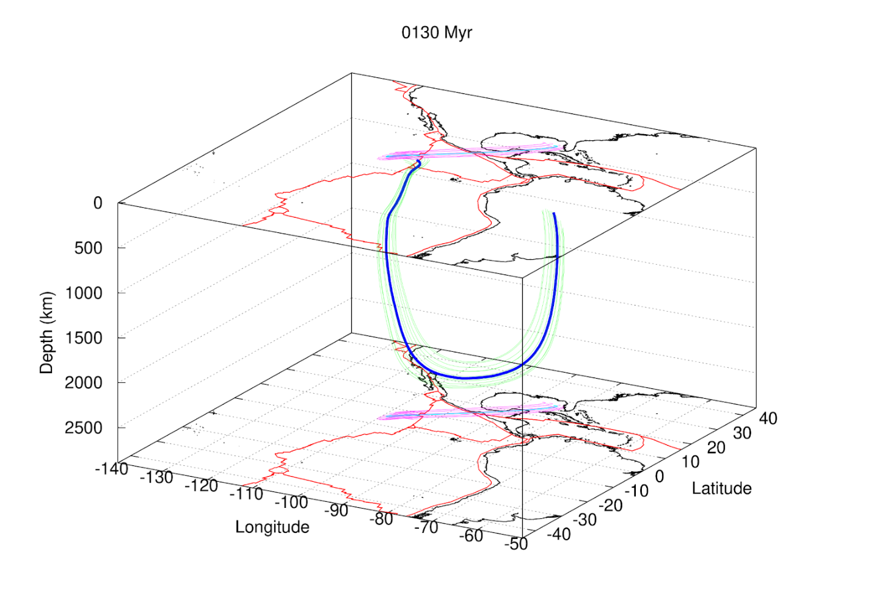
Figure S8: Time-reversed trajectories of a cylindrical array of particles beneath the 8°20′ N seamounts. The calculated trajectories of all particles the cylindrical array beneath the 8°20′ N seamounts, are based on a reconstruction extending to 70 Ma with quasi‐static flow for earlier times. At 0 Ma, the central particle (dark blue path) is 2.5° away (275 km separation) from its twelve neighbors (green paths), and the flow calculation employs the V1 viscosity profile with explicit matching to past plate motions. Despite moderate lateral expansion (on the order of a few hundred kilometers) as the ring of particles descends to maximum depth (–76 Ma) and then “ascends” (in reversed time) to the top of lower mantle at –130 Ma, the particle array traces a spatially coherent corridor, indicating only partial mixing, thus preserving any subduction‐derived mantle signature consistent with isotopic enrichments observed in the 8°20′ N seamount basalts.

Table S3. Pb, Sr, and Nd standards measured between analyses of 820’ N seamount basalts and compared with accepted values. Average values of laboratory measurements are reported for n (number of analyses).
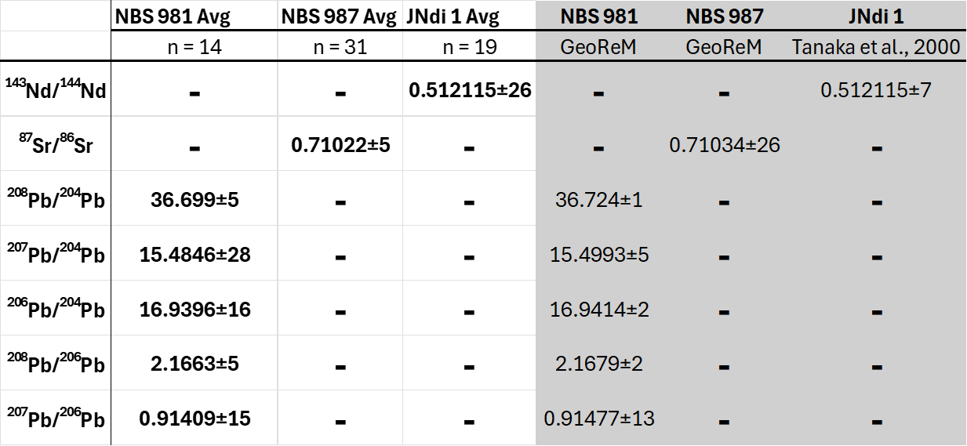

s

