Supplementary S1 Methods.

Table S1- 1: Means calculated in each grid-cell; each cell represents an assemblage of co-occurring species. All Σ denotes the sum over all N species (i = 1 to i = N) wi is the weight assigned to the ith species. wi= (1/number of pixels occupied by each specie). 2

Figure S1- 1: Freshwater fish richness pattern, A) Using the complete set of maps (García-Andrade et al., 2023) B) Using a subset with 5242 species of freshwater fish. 2
Figure S1- 2: Correlation between all speciation metrics evaluated in this study. 3

Table S1- 1: Means calculated in each grid-cell; each cell represents an assemblage of co-occurring species. All Σ denotes the sum over all N species (i = 1 to i = N) wi is the weight assigned to the ith species. wi= (1/number of pixels occupied by each specie).

^{Mean} | ^{Formula}
Arithmetic | $$\overline{X}=\frac{\sum{λi}}{n}$$
Geometric | $$\overline{X}=exp⁡\left(\frac{1}{n}\sum{lnλi}\right)$$
Weighted arithmetic mean | $$\overline{X}=\frac{\sum{wiλi}}{\sum{wi}}$$
Weighted geometric mean | $$\overline{X}=exp⁡\left(\frac{\sum{wilnλi}}{\sum{wi}}\right)$$

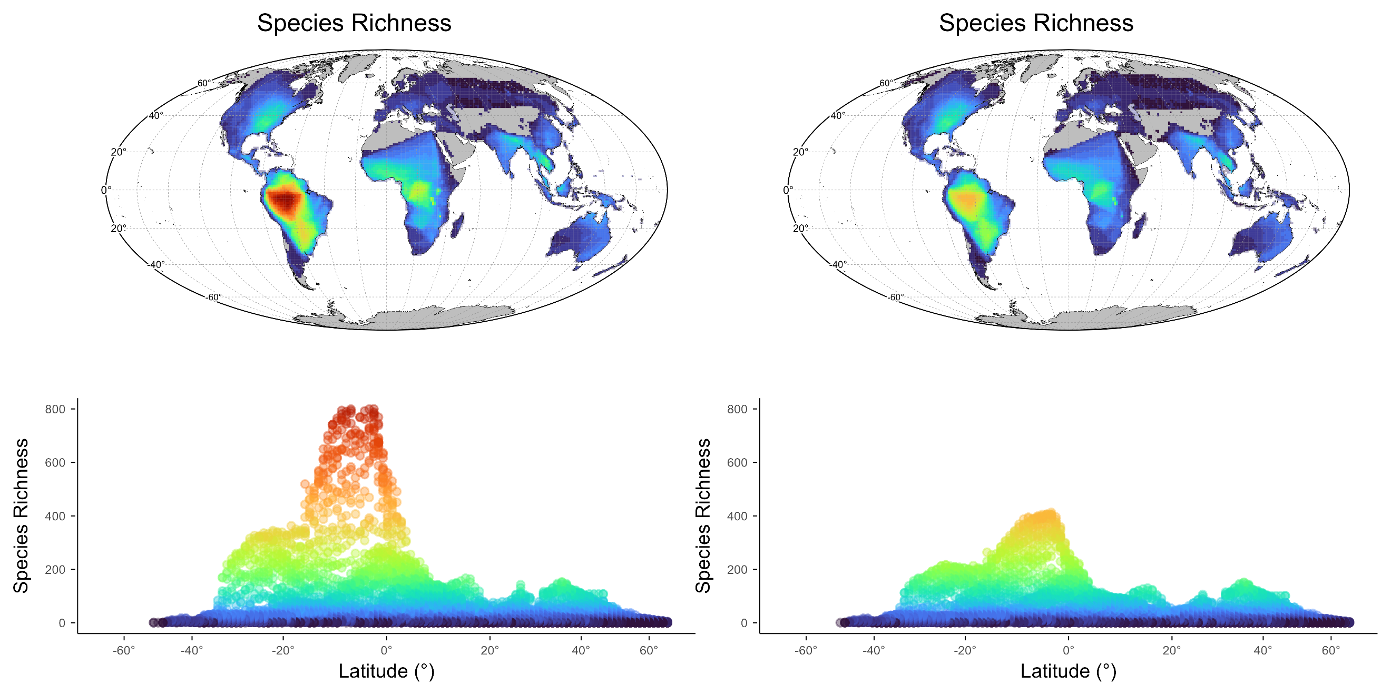

Figure S1- 1: Freshwater fish richness pattern, A) Using the complete set of maps (García-Andrade et al., 2023) B) Using a subset with 5242 species of freshwater fish.

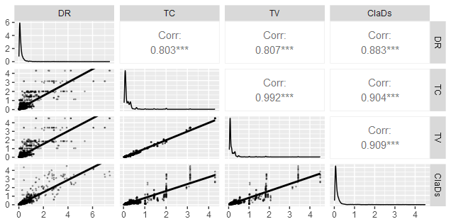

Figure S1- 2: Correlation between all speciation metrics evaluated in this study λDR, λTC, λTV, λClaDs

