Appendix 3. Supplementary materials Species level

Table S3- 1: Results for the OLS, GAM, OLS-segmented models using molecular dataset (5,242 sp) 5
Table S3- 2: Results of PGLS model using molecular dataset (5,242 sp) 6
Table S3- 3: Results for the OLS, GAM, OLS-segmented models using molecular dataset without Cichliformes (4,522 sp) 8
Table S3- 4: Results for OLS segmented Right and left part using molecular dataset without Cichliformes (4,522 sp), estimates of λDR, λTC, λTV and λClaDS and log measures 9
Table S3- 4 : Results of PGLS model using molecular data set without Cichliformes (4,522 sp), estimates of λDR, λTC, λTV and λClaDS and log measures. 10

Figure S3- 1: Speciation rates by taxonomic order, based on molecular data, comparing freshwater species with their marine counterparts. 2
Figure S3- 2: Speciation rate by Order 3
Figure S3- 3: Latitudinal Gradient in Freshwater Fish Speciation at the Species Level. This figure illustrates the speciation patterns of freshwater fishes across latitudes, using a molecular dataset comprising 5,242 species and employing λDR, λBAMM-TC, λBAMM-TV and λClaDS speciation metrics. The first horizontal panel displays the global spatial distribution of speciation. The second panel depicts the distribution of speciation across each pixel along the latitudinal gradient. The third panel shows the relationship between speciation and the absolute value of latitude, modeled using different adjusted approaches: orange represents the OLS model, red the OLS segmented model, and blue the GAM model. a) and b) illustrate these relationships using speciation and log variation. 7
Figure S3- 4: Latitudinal Gradient in Freshwater Fish Speciation at the Species Level. This figure illustrates the speciation patterns of freshwater fishes across latitudes, using a molecular dataset without Cichliformes (4,522 sp), and employing λDR, λBAMM-TC, λBAMM-TV and λClaDS speciation metrics. The first horizontal panel displays the global spatial distribution of speciation. The second panel depicts the distribution of speciation across each pixel along the latitudinal gradient. The third panel shows the relationship between speciation and the absolute value of latitude, modeled using different adjusted approaches: orange represents the OLS model, red the OLS segmented model, and blue the GAM model. a) and b) illustrate these relationships using the speciation and log variation. 11

Figure S3- 1: Speciation rates by taxonomic order, based on molecular data, comparing freshwater species with their marine counterparts.
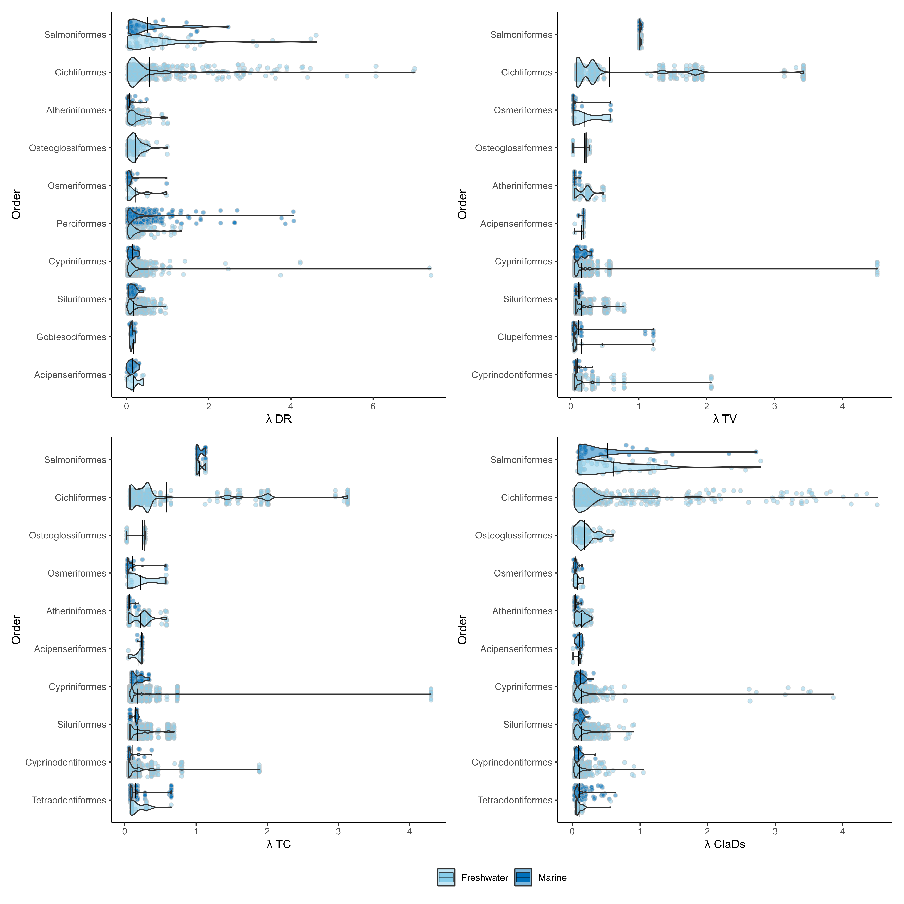

Figure S3- 2: Speciation rate by Order

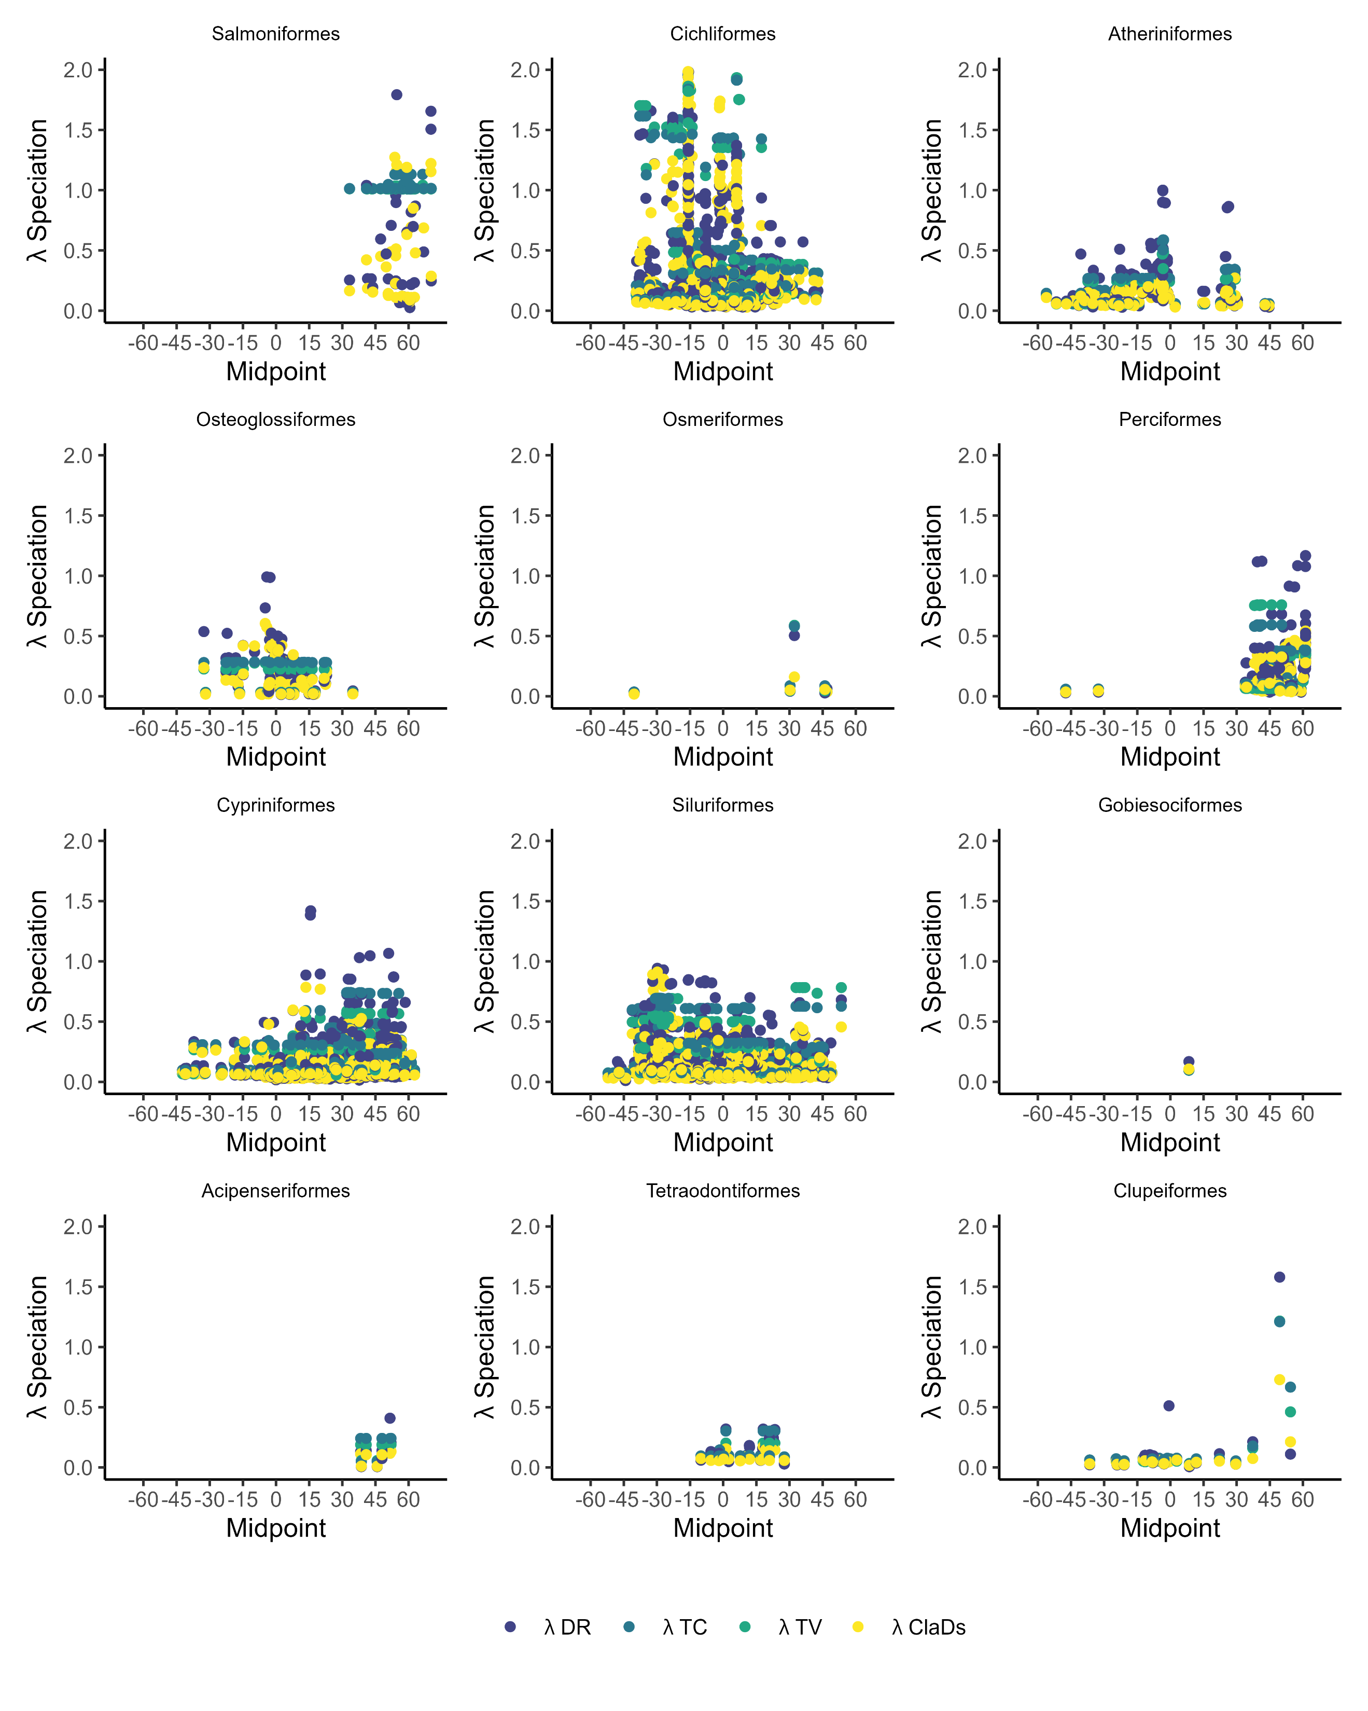

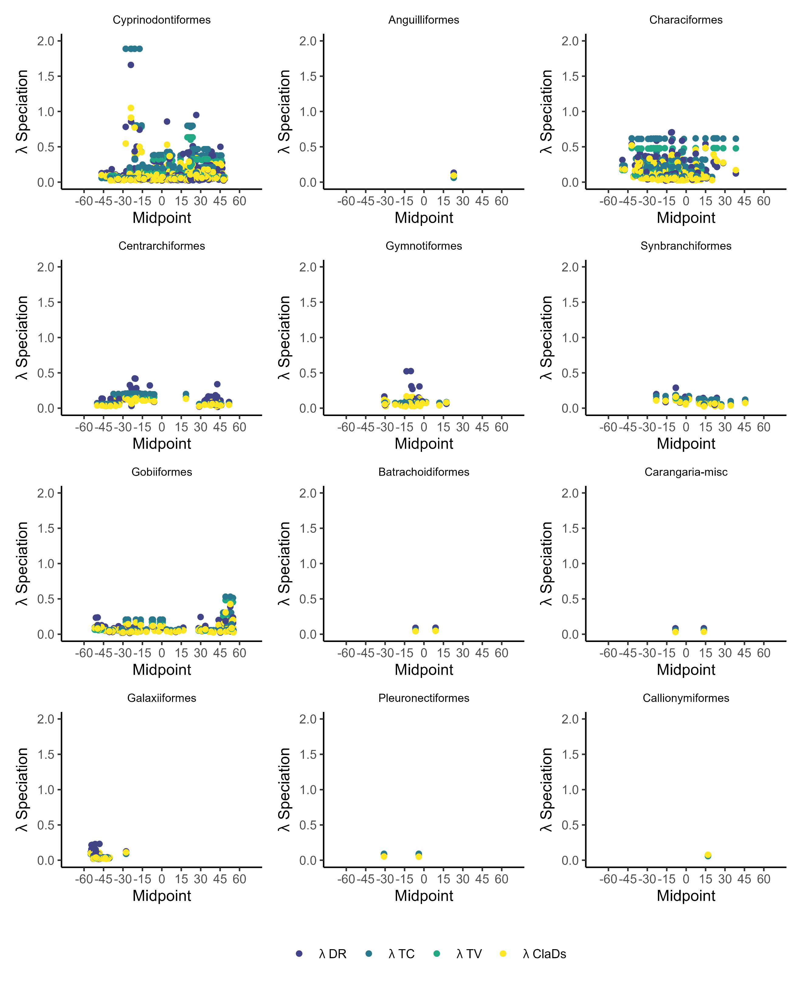

Table S3- 1: Results for the OLS, GAM, OLS-segmented models using molecular dataset (5,242 sp)
 | OLS model |  |  |  | GAM |  |  |  | OLS segmented
Mtric | Slope (1°) | R² | p-value | AIC | R2 | edf | p-value | AIC | BK | R² | Davies | AIC
λDR | -0.0008 | 9.00E-04 | p<0.05 | 6070 | 0.062 | 8.86 | p<0.001 | 5746 | 42.28 | 0.0138 | 0.76 | 6006
λTC | -0.0011 | 0.002 | p<0.05 | 5093 | 0.0738 | 8.88 | p<0.001 | 4708 | 42.28 | 0.0115 | 0.13 | 5047
λTV | -0.0013 | 0.0027 | p<0.001 | 5200 | 0.0724 | 8.88 | p<0.001 | 4826 | 42.28 | 0.0123 | 0.25 | 5153
λClaDS | -0.0011 | 0.0026 | p<0.001 | 3896 | 0.0802 | 8.9 | p<0.001 | 3478 | 42.28 | 0.0112 | 0.15 | 3855
log(λDR) | -0.0003 | 6.00E-04 | 0.0874 | -2037 | 0.0575 | 8.83 | p<0.001 | -2337 | 41.83 | 0.019 | 0.07 | -2130
log(λTC) | -0.0004 | 9.00E-04 | p<0.05 | -1706 | 0.0624 | 8.85 | p<0.001 | -2032 | 42.28 | 0.0168 | 0.83 | -1786
log(λTV | -0.0006 | 0.0019 | p<0.05 | -1882 | 0.0667 | 8.87 | p<0.001 | -2227 | 41.2 | 0.0198 | 0.41 | -1973
log(λClaDS) | -0.0005 | 0.0018 | p<0.05 | -3293 | 0.0725 | 8.9 | p<0.001 | -3671 | 42.28 | 0.0166 | 0.8 | -3367
Slope (1°): Slope values transformed to decimal degrees. R²: Proportion of variance in speciation rate explained by latitude. p-value: p-value of each slope. AIC: Akaike Information Criterion. BK: Break point estimated in degrees. p-Davies: p-value of segmented model, edf: The effective degrees of freedom.

Table S3- 2: Results of PGLS model using molecular dataset (5,242 sp)
 | PGLS
Metric | Slope (1°) | R² | p-value | Lambda
λDR | 0.0015 | 0.00124 | p<0.05 | 0.75
λTC | 0 | 3.00E-05 | 0.6722 | 1
λTV | 0 | 2.00E-05 | 0.7306 | 1
λClaDS | 0.0007 | 0.00059 | 0.0778 | 0.95
log(λDR) | 0.0009 | 0.00227 | p<0.001 | 0.86
log(λTC) | 0 | 6.00E-05 | 0.56 | 1
log(λTV | 0 | 4.00E-05 | 0.6317 | 1
log(λClaDS) | 0.0004 | 0.00099 | p<0.05 | 0.98
. Slope (1°): Slope values transformed to decimal degrees. R²: Proportion of variance in speciation rate explained by latitude. p-value: p-value of each slope, Lambda: Pagel's λ (lambda),

Figure S3- 3: Latitudinal Gradient in Freshwater Fish Speciation at the Species Level. This figure illustrates the speciation patterns of freshwater fishes across latitudes, using a molecular dataset comprising 5,242 species and employing λDR, λBAMM-TC, λBAMM-TV and λClaDS speciation metrics. The first horizontal panel displays the global spatial distribution of speciation. The second panel depicts the distribution of speciation across each pixel along the latitudinal gradient. The third panel shows the relationship between speciation and the absolute value of latitude, modeled using different adjusted approaches: orange represents the OLS model, red the OLS segmented model, and blue the GAM model. a) and b) illustrate these relationships using speciation and log variation.
A) 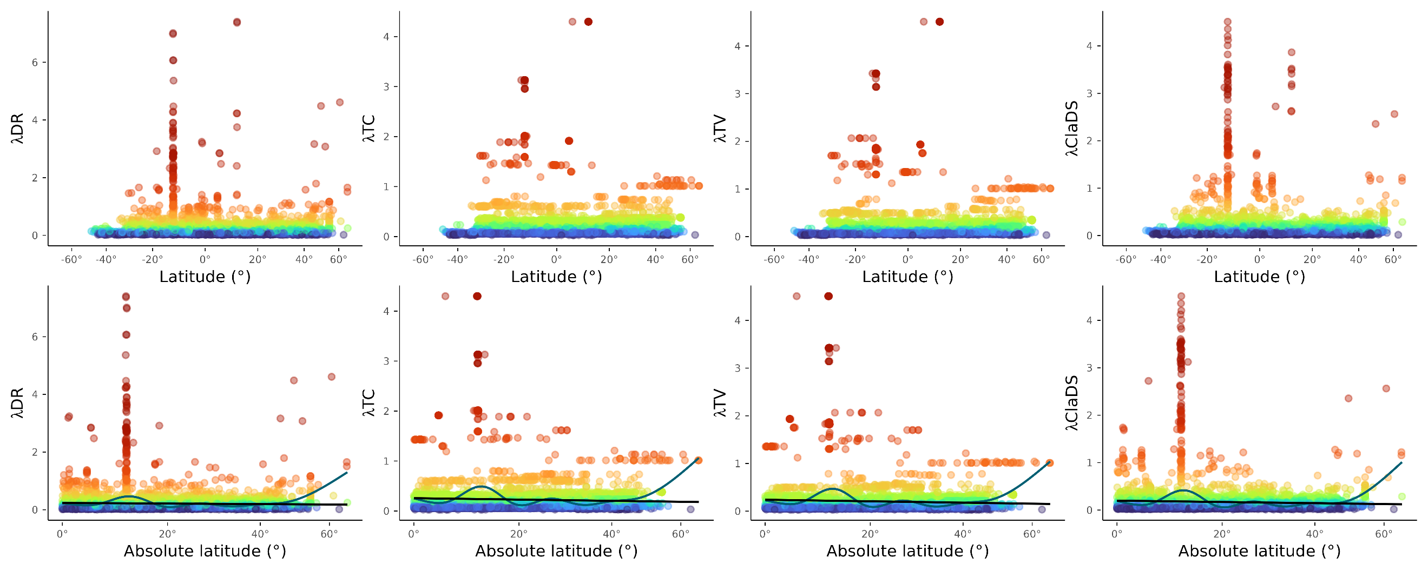
B) 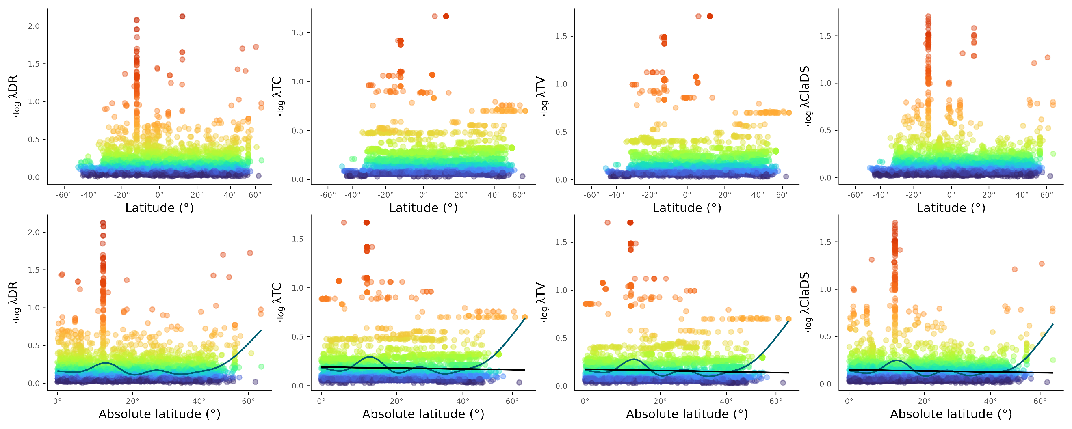

Table S3- 3: Results for the OLS, GAM, OLS-segmented models using molecular dataset without Cichliformes (4,522 sp)
 | OLS model |  |  |  | GAM |  |  |  | OLS segmented
Metric | Slope (1°) | R² | p-value | AIC | R2 | edf | p-value | AIC | BK | R2 | Davies | AIC
λDR | 0.0013 | p<0.001 | 0.0058 | 934 | 0.0432 | 7.68 | p<0.001 | 767 | 43.09 | 0.0405 | p<0.001 | 778
λTC | 0.0011 | p<0.001 | 0.0054 | 227 | 0.0342 | 7.21 | p<0.001 | 100 | 43.09 | 0.0293 | p<0.001 | 121
λTV | 0.001 | p<0.001 | 0.0038 | 243 | 0.034 | 7.61 | p<0.001 | 109 | 43.09 | 0.0286 | p<0.001 | 133
λClaDS | 0.0008 | p<0.001 | 0.005 | -2745 | 0.0444 | 8.49 | p<0.001 | -2921 | 43.09 | 0.0387 | p<0.001 | -2897
log(λDR) | 0.0009 | p<0.001 | 0.012 | -5329 | 0.0555 | 7.29 | p<0.001 | -5527 | 41.87 | 0.0528 | p<0.001 | -5515
log(λTC) | 0.0009 | p<0.001 | 0.0118 | -5115 | 0.053 | 6.87 | p<0.001 | -5303 | 43.09 | 0.0471 | p<0.001 | -5276
log(λTV | 0.0008 | p<0.001 | 0.0094 | -5599 | 0.0588 | 7.43 | p<0.001 | -5825 | 42.76 | 0.0523 | p<0.001 | -5795
log(λClaDS) | 0.0007 | p<0.001 | 0.0113 | -7770 | 0.0593 | 8.35 | p<0.001 | -7989 | 43.09 | 0.0548 | p<0.001 | -7970
Slope (1°): Slope values transformed to decimal degrees. R²: Proportion of variance in speciation rate explained by latitude. p-value: p-value of each slope. AIC: Akaike Information Criterion. BK: Break point estimated in degrees. p-Davies: p-value of segmented model, edf: The effective degrees of freedom.

Table S3- 4: Results for OLS segmented Right and left part using molecular dataset without Cichliformes (4,522 sp), estimates of λDR, λTC, λTV and λClaDS and log measures
 | OLS segmented Left |  |  | OLS segmented Rigth
name | Slope (1°) | R² | p-value | Slope (1°) | R² | p-value
DR | 0.0002 | 0.4386 | -1.00E-04 | 0.047 | p<0.001 | 0.0869
TC | 0.0003 | 0.2118 | 1.00E-04 | 0.0367 | p<0.001 | 0.1805
TV | 0.0001 | 0.7107 | -2.00E-04 | 0.0365 | p<0.001 | 0.1881
ClaDS | 0.0001 | 0.5122 | -1.00E-04 | 0.0327 | p<0.001 | 0.147
log_DR | 0.0002 | 0.0572 | 6.00E-04 | 0.0222 | p<0.001 | 0.1102
log_TC | 0.0004 | p<0.05 | 0.0015 | 0.0245 | p<0.001 | 0.1803
log_TV | 0.0002 | 0.169 | 2.00E-04 | 0.0244 | p<0.001 | 0.1928
log_ClaDS | 0.0002 | p<0.05 | 0.001 | 0.0209 | p<0.001 | 0.1685
Slope (1°): Slope values transformed to decimal degrees. R²: Proportion of variance in speciation rate explained by latitude. p-value: p-value of each slope.

Table S3- 4 : Results of PGLS model using molecular data set without Cichliformes (4,522 sp), estimates of λDR, λTC, λTV and λClaDS and log measures.
Metric | Slope (1°) | R² | p-value | Lambda
DR | 0.00086 | 0.0009 | p<0.05 | 0.76
TC | 0.00004 | 0.00004 | 0.66 | 1
TV | 0.00004 | 0.00004 | 0.68 | 1
ClaDS | 0.00062 | 0.0012 | p<0.05 | 0.96
log_DR | 0.00063 | 0.002 | p<0.05 | 0.89
log_TC | 0.00002 | 0.00008 | 0.54 | 1
log_TV | 0.00002 | 0.00007 | 0.57 | 1
log_ClaDS | 0.00037 | 0.0021 | p<0.05 | 0.99
. Slope (1°): Slope values transformed to decimal degrees. R²: Proportion of variance in speciation rate explained by latitude. p-value: p-value of each slope, Lambda: Pagel's λ (lambda),

Figure S3- 4: Latitudinal Gradient in Freshwater Fish Speciation at the Species Level. This figure illustrates the speciation patterns of freshwater fishes across latitudes, using a molecular dataset without Cichliformes (4,522 sp), and employing λDR, λBAMM-TC, λBAMM-TV and λClaDS speciation metrics. The first horizontal panel displays the global spatial distribution of speciation. The second panel depicts the distribution of speciation across each pixel along the latitudinal gradient. The third panel shows the relationship between speciation and the absolute value of latitude, modeled using different adjusted approaches: orange represents the OLS model, red the OLS segmented model, and blue the GAM model. a) and b) illustrate these relationships using the speciation and log variation.
A) 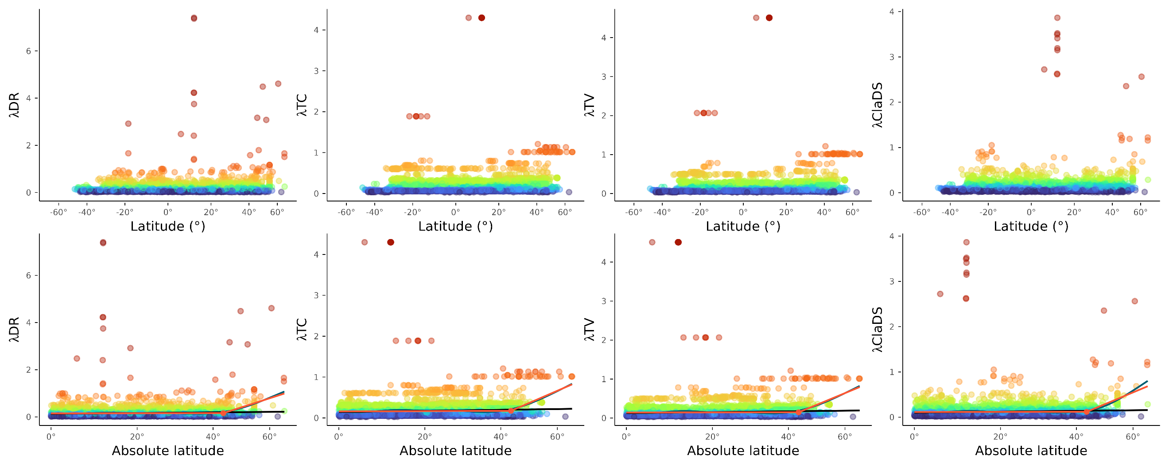

B) 