Appendix 2. Supplementary materials Assemblage level

Table S2-1: Results for the OLS global model and the SAR global model using the complete dataset (12,577 species) and λDR mean variations 2
Table S2-2: Results for the OLS global and SAR model global using molecular dataset (5,242 sp) and the mean variation of λDR, λTC, λTV and λClaDS. 3
Table S2-3: Results for the OLS-segmented model and GAM model using complete dataset (12,577sp) and λDR mean variations 4
Table S2-4: Results for the OLS-segmented model and GAM model using molecular dataset (5242 sp) and the mean variation of λDR, λTC, λTV and λClaDS. 5
Table S2-5: Results for the OLS and SAR left model using complete dataset (12,577sp) and λDR mean variations 6
Table S2-6: Results for the OLS and SAR left model using molecular dataset (5,242 sp) and mean variation of λDR, λTC, λTV and λClaDS 7
Table S2-7: Results for the OLS right model and SAR left model using complete dataset (12,577sp) and λDR speciation with mean variations. 8
Table S2-8: Results for the OLS right model and SAR left model molecular dataset (5,242 sp) and the mean variation of λDR, λTC, λTV and λClaDS. 9

Figure S2-1: Latitudinal Gradient in Freshwater Fish Speciation at the Assemblage Level. This figure illustrates the speciation patterns of freshwater fishes across latitudes, using a comprehensive dataset comprising 12,577 species and employing λDR speciation metrics with mean variations. 10
Figure S2-2: Latitudinal Gradient in Freshwater Fish Speciation at the Assemblage Level. This figure illustrates the speciation patterns of freshwater fishes across latitudes, using a molecular dataset comprising 5,242 species and employing λDR speciation metrics with mean variations. The first horizontal panel displays the global spatial distribution of speciation. 11
Figure S2-3: Latitudinal Gradient in Freshwater Fish Speciation at the Assemblage Level. This figure illustrates the speciation patterns of freshwater fishes across latitudes, using a molecular dataset comprising 5,242 species and employing λBAMM-TC speciation metrics with mean variations. The first horizontal panel displays the global spatial distribution of speciation. 12
Figure S2-4: Latitudinal Gradient in Freshwater Fish Speciation at the Assemblage Level. This figure illustrates the speciation patterns of freshwater fishes across latitudes, using a molecular dataset comprising 5,242 species and employing λBAMM-TV speciation metrics with mean variations. 13
Figure S2-5: Latitudinal Gradient in Freshwater Fish Speciation at the Assemblage Level. This figure illustrates the speciation patterns of freshwater fishes across latitudes, using a molecular dataset comprising 5,242 species and employing λClaDS metrics with mean variations. The first horizontal panel displays the global spatial distribution of speciation. 14

Table S2-1: Results for the OLS global model and the SAR global model using the complete dataset (12,577 species) and λDR mean variations

OLS model |  |  |  |  |  | SAR model
Metric | Slope (1°) | R² | p-value | AIC | Slope (1°) |  | R² | p-value | AIC | Scheme | IMoran
λDR | 0.0004 | 0.0071 | p<0.001 | -20392 | 0.0011 |  | 0.5623 | p<0.001 | -27916 | Wd1 | 0.676
λDR-geo | 0.0004 | 0.0108 | p<0.001 | -24358 | 0.0012 |  | 0.5967 | p<0.001 | -32600 | Wd1 | 0.707
w-λDR | 0.0005 | 0.0036 | p<0.001 | -8824 | 0.001 |  | 0.3692 | p<0.001 | -13023 | Sd1 | 0.524
w-λDR-geo | 0.0003 | 0.0029 | p<0.001 | -14957 | 0.0006 |  | 0.3466 | p<0.001 | -18838 | Wd1 | 0.511
log(λDR) | 0.0003 | 0.0060 | p<0.001 | -25043 | 0.0009 |  | 0.6119 | p<0.001 | -33681 | Wd1 | 0.716
log(λDR-geo) | 0.0003 | 0.0090 | p<0.001 | -28272 | 0.001 |  | 0.6454 | p<0.001 | -37712 | Wd1 | 0.744
log(w-λDR) | 0.0003 | 0.0030 | p<0.001 | -16881 | 0.0006 |  | 0.4787 | p<0.001 | -22836 | Wd1 | 0.613
log(w-λDR-geo) | 0.0002 | 0.0021 | p<0.001 | -21605 | 0.0005 |  | 0.4466 | p<0.001 | -27019 | Wd1 | 0.596
Slope (1°): Slope values transformed to decimal degrees. R²: Proportion of variance in speciation rate explained by latitude. p-value: p-value of each slope. AIC: Akaike Information Criterion. Scheme: Spatial weight and matrix distance scheme best fitted to the SAR model, chosen by the lowest AIC. IMoran: Moran autocorrelation using the scheme and matrix of distance in the scheme column.
Table S2-2: Results for the OLS global and SAR model global using molecular dataset (5,242 sp) and the mean variation of λDR, λTC, λTV and λClaDS.
OLS model |  |  |  |  | SAR model
Metric | Slope(°) | R2 | p-value | AIC | Slope(°) | R2 | p-value | AIC | Scheme | Imoran
λDR | 0.0003 | 0.004 | p<0.001 | -18527 | 0.0006 | 0.4889 | p<0.001 | -24365 | Wd1 | 0.62
λTC | 0.0041 | 0.1236 | p<0.001 | -4250 | 0.0046 | 0.8548 | p<0.001 | -19981 | Wd1 | 0.901
λTV | 0.0043 | 0.1328 | p<0.001 | -4195 | 0.0047 | 0.8583 | p<0.001 | -20049 | Wd1 | 0.903
λClaDS | -1.46E-05 | 1.55E-05 | 0.7126 | -23088 | 0.0003 | 0.4978 | p<0.05 | -29114 | Wd1 | 0.624
λDR-geo | 0.0004 | 0.015 | p<0.001 | -24992 | 0.0008 | 0.5983 | p<0.001 | -32840 | Wd1 | 0.719
λTC-geo | 0.0038 | 0.123 | p<0.001 | -5618 | 0.0044 | 0.8884 | p<0.001 | -23657 | Wd1 | 0.922
λTV-geo | 0.0038 | 0.124 | p<0.001 | -5613 | 0.0046 | 0.896 | p<0.001 | -24258 | Wd1 | 0.927
λClaDS-geo | 0.0002 | 0.0067 | p<0.001 | -30287 | 0.0005 | 0.5846 | p<0.001 | -37915 | Wd1 | 0.706
w-λDR | 0.0001 | 1.00E-04 | 0.3979 | -4325 | 0.0006 | 0.3985 | p<0.05 | -8771 | Cd1 | 0.553
w-λTC | 0.0035 | 0.0482 | p<0.001 | 2112 | 0.0038 | 0.645 | p<0.001 | -6518 | Sd1 | 0.741
w-λTV | 0.0034 | 0.0472 | p<0.001 | 1717 | 0.0037 | 0.6485 | p<0.001 | -7007 | Sd1 | 0.744
w-λClaDS | -0.0005 | 0.0034 | p<0.001 | -8559 | 0.0004 | 0.4646 | p<0.05 | -13995 | Cd1 | 0.605
w-λDR-geo | 0.0001 | 1.00E-04 | 0.3601 | -10039 | 0.0004 | 0.3182 | p<0.05 | -13388 | Sd1 | 0.482
w-λTC-geo | 0.0033 | 0.0652 | p<0.001 | -1740 | 0.0037 | 0.6872 | p<0.001 | -11320 | Sd1 | 0.778
w-λTV-geo | 0.0033 | 0.0649 | p<0.001 | -1619 | 0.0037 | 0.6894 | p<0.001 | -11264 | Sd1 | 0.78
w-λClaDS-geo | -0.0002 | 0.0012 | p<0.05 | -14616 | 0.0002 | 0.3823 | 0.12667 | -18820 | Sd1 | 0.533
log(λDR) | 0.0002 | 0.0041 | p<0.001 | -23691 | 0.0006 | 0.5775 | p<0.001 | -31192 | Wd1 | 0.694
log(λTC) | 0.0028 | 0.1218 | p<0.001 | -10940 | 0.0031 | 0.8626 | p<0.001 | -27174 | Wd1 | 0.906
log(λTV) | 0.0029 | 0.1348 | p<0.001 | -10900 | 0.0033 | 0.8681 | p<0.001 | -27361 | Wd1 | 0.909
log(λClaDS) | -1.34E-05 | 2.20E-05 | 0.661 | -27632 | 0.0003 | 0.5802 | p<0.001 | -35225 | Wd1 | 0.694
log(λDR-geo) | 0.0003 | 0.0141 | p<0.001 | -28565 | 0.0007 | 0.6578 | p<0.001 | -37823 | Wd1 | 0.763
log(λTC-geo) | 0.0026 | 0.1246 | p<0.001 | -12474 | 0.003 | 0.8868 | p<0.001 | -30374 | Wd1 | 0.922
log(λTV-geo) | 0.0026 | 0.1265 | p<0.001 | -12456 | 0.0031 | 0.8946 | p<0.001 | -30964 | Wd1 | 0.927
log(λClaDS-geo) | 0.0002 | 0.0065 | p<0.001 | -33434 | 0.0005 | 0.6394 | p<0.001 | -42303 | Wd1 | 0.748
log(w-λDR) | 0.0001 | 1.00E-04 | 0.3552 | -13404 | 0.0006 | 0.5166 | p<0.001 | -19764 | Sd1 | 0.641
log(w-λTC) | 0.0024 | 0.0655 | p<0.001 | -7112 | 0.0026 | 0.7147 | p<0.001 | -17493 | Sd1 | 0.798
log(w-λTV) | 0.0026 | 0.0709 | p<0.001 | -6931 | 0.0027 | 0.7215 | p<0.001 | -17472 | Sd1 | 0.804
log(w-λClaDS) | -0.0003 | 0.0031 | p<0.001 | -16784 | 0.0004 | 0.538 | p<0.05 | -23514 | Sd1 | 0.656
log(w-λDR-geo) | 4.42E-05 | 8.06E-05 | 0.4011 | -18106 | 0.0005 | 0.4546 | p<0.001 | -23408 | Sd1 | 0.595
log(w-λTC-geo) | 0.0023 | 0.0743 | p<0.001 | -9430 | 0.0026 | 0.7318 | p<0.001 | -20270 | Wd1 | 0.809
log(w-λTV-geo) | 0.0023 | 0.0756 | p<0.001 | -9401 | 0.0026 | 0.7412 | p<0.001 | -20542 | Sd1 | 0.82
log(w-λClaDS-geo) | -0.0001 | 0.0011 | p<0.05 | -21375 | 0.0003 | 0.4733 | p<0.05 | -26974 | Sd1 | 0.607
Slope (1°): Slope values transformed to decimal degrees. R²: Proportion of variance in speciation rate explained by latitude. p-value: p-value of each slope. AIC: Akaike Information Criterion. Scheme: Spatial weight and matrix distance scheme best fitted to the SAR model, chosen by the lowest AIC. IMoran: Moran autocorrelation using the scheme and matrix of distance in the scheme column.

Table S2-3: Results for the OLS-segmented model and GAM model using complete dataset (12,577sp) and λDR mean variations
OLS segmented |  |  |  |  | GAM
Metric | BK | R2 | p-Davies | AIC | R2 | edf | p-value | AIC
λDR | 47.83 | 0.0356 | p<0.001 | -20656 | 0.0414 | 8.25 | p<0.001 | -20709
λDR-geo | 50.37 | 0.0671 | p<0.001 | -24893 | 0.0759 | 8.26 | p<0.001 | -24977
w-λDR | 38.19 | 0.0162 | p<0.001 | -8938 | 0.0177 | 8.19 | p<0.001 | -8949
w-λDR-geo | 47 | 0.0231 | p<0.001 | -15141 | 0.0243 | 7.45 | p<0.001 | -15151
log(λDR) | 47.66 | 0.0386 | p<0.001 | -25345 | 0.0458 | 8.42 | p<0.001 | -25412
log(λDR-geo) | 49.85 | 0.0689 | p<0.001 | -28842 | 0.0787 | 8.53 | p<0.001 | -28936
log(w-λDR) | 25.9 | 0.0162 | p<0.001 | -16999 | 0.0245 | 8.4 | p<0.001 | -17074
log(w-λDR-geo) | 48.78 | 0.0328 | p<0.001 | -21888 | 0.0345 | 7.84 | p<0.001 | -21903
BK: Break point estimated in degrees. R²: Proportion of variance in speciation rate explained by latitude. p-Davies: p-value of segmented model. AIC: Akaike Information Criterion. edf: The effective degrees of freedom.

Table S2-4: Results for the OLS-segmented model and GAM model using molecular dataset (5242 sp) and the mean variation of λDR, λTC, λTV and λClaDS.
OLS segmented |  |  |  |  | GAM
Metric | BK | R2 | Davies | AIC | R2 | edf | p-value | AIC
λDR | 35.83 | 0.0152 | p<0.001 | -18622 | 0.0232 | 8.9 | p<0.001 | -18691
λTC | 45.27 | 0.2776 | p<0.001 | -5937 | 0.2986 | 8.97 | p<0.001 | -6192
λTV | 45.08 | 0.2948 | p<0.001 | -6000 | 0.3157 | 8.97 | p<0.001 | -6261
λClaDS | 26.31 | 0.0028 | p<0.001 | -23108 | 0.0098 | 8.23 | p<0.001 | -23168
λDR-geo | 49.52 | 0.0403 | p<0.001 | -25215 | 0.0516 | 8.92 | p<0.001 | -25316
λTC-geo | 47.64 | 0.2889 | p<0.001 | -7449 | 0.3016 | 8.97 | p<0.001 | -7604
λTV-geo | 47.45 | 0.3035 | p<0.001 | -7615 | 0.3161 | 8.96 | p<0.001 | -7772
λClaDS-geo | 50.87 | 0.0092 | 0.1378 | -30305 | 0.0309 | 8.96 | p<0.001 | -30496
w-λDR | 32.87 | 0.0088 | p<0.001 | -4397 | 0.0114 | 8.23 | p<0.001 | -4418
w-λTC | 42.87 | 0.1453 | p<0.001 | 1174 | 0.1573 | 8.92 | p<0.001 | 1054
w-λTV | 43.71 | 0.1411 | p<0.001 | 813 | 0.1536 | 8.93 | p<0.001 | 687
w-λClaDs | 28.35 | 0.0077 | p<0.001 | -8594 | 0.0083 | 6.43 | p<0.001 | -8599
w-λDR-geo | 44.76 | 0.0057 | p<0.001 | -10084 | 0.0071 | 8.22 | p<0.001 | -10094
w-λTC-geo | 46.37 | 0.1791 | p<0.001 | -2873 | 0.1886 | 8.94 | p<0.001 | -2973
w-λTV-geo | 46.18 | 0.1883 | p<0.001 | -2854 | 0.1979 | 8.94 | p<0.001 | -2955
w-λClaDs-geo | 24.39 | 0.0044 | p<0.001 | -14640 | 0.0048 | 7.17 | p<0.001 | -14643
log(λDR) | 45.79 | 0.0189 | p<0.001 | -23818 | 0.0295 | 8.85 | p<0.001 | -23910
log(λTC) | 45 | 0.269 | p<0.001 | -12541 | 0.2923 | 8.96 | p<0.001 | -12822
log(λTV | 44.69 | 0.2923 | p<0.001 | -12654 | 0.3157 | 8.95 | p<0.001 | -12946
log(λClaDs) | 26.31 | 0.003 | p<0.001 | -27654 | 0.012 | 8.62 | p<0.001 | -27730
log(λDR-geo) | 49.11 | 0.0388 | p<0.001 | -28783 | 0.0543 | 8.92 | p<0.001 | -28923
log(λTC-geo) | 47.3 | 0.2833 | p<0.001 | -14221 | 0.298 | 8.96 | p<0.001 | -14398
log(λTV-geo) | 47.07 | 0.3023 | p<0.001 | -14419 | 0.3169 | 8.97 | p<0.001 | -14600
log(λClaDs-geo) | 49.87 | 0.0087 | 0.2500 | -33450 | 0.0343 | 8.97 | p<0.001 | -33676
log(w-λDR) | 34.95 | 0.0107 | p<0.001 | -13494 | 0.0168 | 8.71 | p<0.001 | -13545
log(w-λTC) | 43.71 | 0.1733 | p<0.001 | -8181 | 0.1905 | 8.94 | p<0.001 | -8362
log(w-λTV) | 42.74 | 0.1871 | p<0.001 | -8096 | 0.2039 | 8.93 | p<0.001 | -8277
log(w-λClaDS) | 28.68 | 0.0075 | p<0.001 | -16819 | 0.0097 | 7.84 | p<0.001 | -16836
log(w-λDR-geo) | 45.68 | 0.0084 | p<0.001 | -18175 | 0.0123 | 8.83 | p<0.001 | -18206
log(w-λTC-geo) | 46.16 | 0.1918 | p<0.001 | -10614 | 0.203 | 8.94 | p<0.001 | -10733
log(w-λTV-geo) | 45.92 | 0.2077 | p<0.001 | -10746 | 0.2191 | 8.94 | p<0.001 | -10871
log(w-λClaDs-geo) | 23.8 | 0.0043 | p<0.001 | -21399 | 0.0065 | 8.4 | p<0.001 | -21416
BK: Break point estimated in degrees. R²: Proportion of variance in speciation rate explained by latitude. p-Davies: p-value of segmented model. AIC: Akaike Information Criterion. edf: The effective degrees of freedom.

Table S2-5: Results for the OLS and SAR left model using complete dataset (12,577sp) and λDR mean variations
OLS mode |  |  |  |  | SAR model
Metric | Slope(°) | R2 | p-value | AIC | Slope(°) | R2 | p-value | AIC | Scheme | Imoran
λDR | -0.0002 | 0.0022 | p<0.001 | -18480 | 0.0003 | 0.5622 | 0.05 | -24499 | Wd1 | 0.681
λDR-geo | -0.0002 | 0.0037 | p<0.001 | -23314 | 0.0002 | 0.6185 | p<0.05 | -30668 | Wd1 | 0.734
w-λDR | -0.0007 | 0.0056 | p<0.001 | -9793 | 0.000011 | 0.4178 | 0.97 | -13114 | Sd1 | 0.558
w-λDR-geo | -0.0004 | 0.0043 | p<0.001 | -15574 | -0.0002 | 0.3954 | 0.34 | -19216 | Wd1 | 0.548
log(λDR) | -0.0002 | 0.0037 | p<0.001 | -21765 | 0.0003 | 0.6112 | p<0.05 | -28639 | Wd1 | 0.722
log(λDR-geo) | -0.0002 | 0.0059 | p<0.001 | -25989 | 0.0002 | 0.6381 | p<0.05 | -33729 | Wd1 | 0.75
log(w-λDR) | -0.0011 | 0.0125 | p<0.001 | -10181 | -0.0007 | 0.4607 | 0.05 | -12904 | Wd1 | 0.591
log(w-λDR-geo) | -0.0004 | 0.0062 | p<0.001 | -19323 | -0.0002 | 0.4321 | 0.2 | -23510 | Wd1 | 0.587
Slope (1°): Slope values transformed to decimal degrees. R²: Proportion of variance in speciation rate explained by latitude. p-value: p-value of each slope. AIC: Akaike Information Criterion. Scheme: Spatial weight and matrix distance scheme best fitted to the SAR model, chosen by the lowest AIC. IMoran: Moran autocorrelation using the scheme and matrix of distance in the scheme column.
Table S2-6: Results for the OLS and SAR left model using molecular dataset (5,242 sp) and mean variation of λDR, λTC, λTV and λClaDS

OLS mode |  |  |  |  | SAR model
Metric | Slope(°) | R² | p-value | AIC | Slope(°) | R² | p-value | AIC | Scheme | Imoran
λDR | -0.0004 | 0.0038 | p<0.001 | -13656 | -0.0002 | 0.4008 | 0.3814 | -16542 | Wd1 | 0.539
λTC | -3.70E-05 | 2.69E-05 | 0.6732 | -12547 | 3.44E-06 | 0.4985 | 0.9873 | -17116 | Wd1 | 0.64
λTV | -4.51E-05 | 4.34E-05 | 0.5923 | -13107 | -4.17E-06 | 0.4563 | 0.9835 | -17135 | Wd1 | 0.603
λClaDS | -0.0004 | 0.0029 | p<0.001 | -11302 | -0.0002 | 0.4108 | 0.4406 | -13647 | Wd1 | 0.54
λDR-geo | 3.96E-05 | 1.51E-04 | 0.2979 | -23710 | 0.0002 | 0.5584 | 0.1235 | -29558 | Wd1 | 0.697
λTC-geo | 0.0003 | 0.0056 | p<0.001 | -19537 | 0.0004 | 0.5501 | p<0.05 | -25070 | Wd1 | 0.7
λTV-geo | 0.0002 | 0.0018 | p<0.001 | -21529 | 0.0002 | 0.5008 | p<0.05 | -26362 | Wd1 | 0.665
λClaDS-geo | 0.0001 | 0.0023 | p<0.001 | -27174 | 0.0002 | 0.6401 | p<0.05 | -34650 | Wd1 | 0.756
w-λDR | -0.0015 | 0.0077 | p<0.001 | -3739 | -0.0001 | 0.4671 | 0.7714 | -7039 | Cd1 | 0.601
w-λTC | -0.0015 | 0.0063 | p<0.001 | -327 | 3.80E-07 | 0.4633 | 0.9995 | -4295 | Sd1 | 0.589
w-λTV | -0.0015 | 0.0067 | p<0.001 | -645 | -0.0001 | 0.4705 | 0.9055 | -4635 | Sd1 | 0.595
w-λClaDs | -0.0016 | 0.0067 | p<0.001 | -3143 | 0.0001 | 0.5113 | 0.8667 | -6514 | Cd1 | 0.636
w-λDR-geo | -0.0005 | 0.003 | p<0.001 | -10331 | 0.0001 | 0.43 | 0.6619 | -14026 | Sd1 | 0.57
w-λTC-geo | -0.0004 | 0.0012 | p<0.05 | -6097 | 0.0003 | 0.4056 | 0.3825 | -9621 | Sd1 | 0.546
w-λTV-geo | -0.0006 | 0.0029 | p<0.001 | -6140 | 0.0001 | 0.3933 | 0.8629 | -9514 | Sd1 | 0.536
w-λClaDS-geo | -0.001 | 0.004 | p<0.001 | -5534 | -0.0003 | 0.4417 | 0.5732 | -7887 | Sd1 | 0.574
log(λDR) | -0.0002 | 0.0014 | p<0.05 | -20288 | -4.34E-06 | 0.535 | 0.9731 | -25479 | Wd1 | 0.663
log(λTC) | -2.70E-05 | 2.63E-05 | 0.6764 | -16605 | 1.34E-05 | 0.5978 | 0.9369 | -22625 | Wd1 | 0.72
log(λTV | -3.07E-05 | 3.83E-05 | 0.6149 | -17378 | 1.69E-05 | 0.5625 | 0.914 | -22842 | Wd1 | 0.692
log(λClaDS) | -0.0003 | 0.0027 | p<0.001 | -13745 | -0.0001 | 0.5032 | 0.7605 | -16794 | Wd1 | 0.622
log(λDR-geo) | 1.47E-05 | 2.85E-05 | 0.6513 | -25976 | 0.0001 | 0.6008 | 0.1071 | -32549 | Wd1 | 0.73
log(λTC-geo) | 0.0002 | 0.0047 | p<0.001 | -22504 | 0.0003 | 0.6184 | p<0.05 | -29189 | Wd1 | 0.746
log(λTV-geo) | 0.0001 | 0.0012 | p<0.05 | -24311 | 0.0002 | 0.5812 | 0.0535 | -30372 | Wd1 | 0.721
log(λClaDS-geo) | 0.0001 | 0.0019 | p<0.001 | -29087 | 0.0002 | 0.6826 | p<0.05 | -37487 | Wd1 | 0.786
log(w-λDR) | -0.0009 | 0.009 | p<0.001 | -9461 | -0.0001 | 0.5207 | 0.7192 | -13526 | Sd1 | 0.64
log(w-λTC) | -0.0007 | 0.0045 | p<0.001 | -8574 | 0.0006 | 0.5294 | 0.0613 | -13402 | Sd1 | 0.648
log(w-λTV) | -0.0009 | 0.0073 | p<0.001 | -8379 | 0.0002 | 0.5257 | 0.5669 | -13065 | Sd1 | 0.646
log(w-λClaDS) | -0.001 | 0.007 | p<0.001 | -7943 | 0.0001 | 0.5612 | 0.7454 | -11825 | Sd1 | 0.667
log(w-λDR-geo) | -0.0004 | 0.0041 | p<0.001 | -15445 | 0.0001 | 0.4839 | 0.4486 | -19910 | Sd1 | 0.616
log(w-λTC-geo) | -0.0002 | 7.00E-04 | p<0.05 | -12694 | -0.0001 | 0.4769 | 0.7171 | -17090 | Wd1 | 0.61
log(w-λTV-geo) | -0.0003 | 0.0026 | p<0.001 | -13123 | 0.0003 | 0.4704 | 0.1878 | -17422 | Sd1 | 0.602
log(w-λClaDS-geo) | -0.0007 | 0.0042 | p<0.001 | -8653 | -0.0001 | 0.4972 | 0.8383 | -11378 | Sd1 | 0.621
AIC=Akaike information criterion, Slope (1°): Slope values transformed to degrees, p-value: p-value of each slope, R²: Proportion of variance in speciation rate explained by latitude, Scheme: Scheme on the spatial weight and matrix distance best fitted to SAR model choose by lowest AIC Model. IMoran: Moran Auto correlation using Scheme and matrix of distance in Scheme column.

Table S2-7: Results for the OLS right model and SAR rigth model using complete dataset (12,577sp) and λDR speciation with mean variations.
OLS mode |  |  |  |  | SAR model
Metric | Slope(°) | R2 | p-value | AIC | Slope(°) | R2 | p-value | AIC | Scheme | Imoran
λDR | 0.0062 | 0.0369 | p<0.001 | -2966 | 0.0101 | 0.5433 | p<0.001 | -4366 | Wd1 | 0.657
λDR-geo | 0.0087 | 0.0653 | p<0.001 | -2777 | 0.0125 | 0.5408 | p<0.001 | -3858 | Wd1 | 0.651
w-λDR | 0.0041 | 0.0115 | p<0.001 | -914 | 0.005 | 0.3385 | p<0.001 | -2108 | Sd1 | 0.503
w-λDR-geo | 0.0064 | 0.0176 | p<0.001 | -1383 | 0.0079 | 0.2926 | p<0.001 | -2000 | Wd1 | 0.472
log(λDR) | 0.005 | 0.0444 | p<0.001 | -4112 | 0.0082 | 0.5941 | p<0.001 | -5718 | Wd1 | 0.697
log(λDR-geo) | 0.0069 | 0.0712 | p<0.001 | -3639 | 0.0101 | 0.6281 | p<0.001 | -5034 | Wd1 | 0.715
log(w-λDR) | 0.0015 | 0.0152 | p<0.001 | -7350 | 0.002 | 0.4852 | p<0.001 | -10386 | Wd1 | 0.623
log(w-λDR-geo) | 0.0063 | 0.0408 | p<0.001 | -3057 | 0.0076 | 0.4662 | p<0.001 | -4053 | Wd1 | 0.605
Slope (1°): Slope values transformed to decimal degrees. R²: Proportion of variance in speciation rate explained by latitude. p-value: p-value of each slope. AIC: Akaike Information Criterion. Scheme: Spatial weight and matrix distance scheme best fitted to the SAR model, chosen by the lowest AIC. IMoran: Moran autocorrelation using the scheme and matrix of distance in the scheme column.

Table S2-8: Results for the OLS right model and SAR left model molecular dataset (5,242 sp) and the mean variation of λDR, λTC, λTV and λClaDS.
OLS mode |  |  |  |  | SAR model
Metric | Slope(°) | R2 | p-value | AIC | Slope(°) | R2 | p-value | AIC | Scheme | Imoran
λDR | 0.002 | 0.0131 | p<0.001 | -5399 | 0.0035 | 0.5696 | p<0.001 | -7946 | Wd1 | 0.694
λTC | 0.0334 | 0.1454 | p<0.001 | 1028 | 0.0314 | 0.9133 | p<0.001 | -3843 | Wd1 | 0.936
λTV | 0.0341 | 0.1505 | p<0.001 | 1055 | 0.0319 | 0.918 | p<0.001 | -3942 | Wd1 | 0.939
λClaDS | 0.0004 | 0.0027 | p<0.001 | -11861 | 0.0011 | 0.6138 | p<0.001 | -15931 | Wd1 | 0.732
λDR-geo | 0.0055 | 0.0308 | p<0.001 | -3080 | 0.0068 | 0.6256 | p<0.001 | -4594 | Wd1 | 0.73
λTC-geo | 0.0382 | 0.1252 | p<0.001 | 1111 | 0.0371 | 0.9049 | p<0.001 | -2825 | Wd1 | 0.926
λTV-geo | 0.039 | 0.1288 | p<0.001 | 1130 | 0.038 | 0.9085 | p<0.001 | -2868 | Wd1 | 0.928
λClaDS-geo | 0.0016 | 0.005 | p<0.05 | -3847 | 0.0017 | 0.472 | p<0.05 | -4744 | Wd1 | 0.608
w-λDR | 0.0029 | 0.0086 | p<0.001 | -872 | 0.0025 | 0.3386 | p<0.05 | -2264 | Cd1 | 0.514
w-λTC | 0.0315 | 0.1433 | p<0.001 | 1204 | 0.0207 | 0.8354 | p<0.001 | -2598 | Sd1 | 0.888
w-λTV | 0.0294 | 0.1419 | p<0.001 | 1147 | 0.0185 | 0.8261 | p<0.001 | -2691 | Sd1 | 0.882
w-λClaDs | 0.0007 | 0.0027 | p<0.05 | -6314 | 0.0009 | 0.3354 | p<0.05 | -7934 | Cd1 | 0.511
w-λDR-geo | 0.0037 | 0.0052 | p<0.001 | -936 | 0.0043 | 0.2189 | p<0.05 | -1452 | Sd1 | 0.393
w-λTC-geo | 0.0341 | 0.1218 | p<0.001 | 1159 | 0.0234 | 0.8346 | p<0.001 | -2107 | Sd1 | 0.887
w-λTV-geo | 0.0351 | 0.1269 | p<0.001 | 1177 | 0.0241 | 0.8438 | p<0.001 | -2190 | Sd1 | 0.893
w-λClaDS-geo | 0.0004 | 0.0019 | p<0.05 | -9627 | 0.0006 | 0.2862 | p<0.05 | -11196 | Sd1 | 0.46
log(λDR) | 0.0032 | 0.0177 | p<0.001 | -4166 | 0.0053 | 0.6285 | p<0.001 | -6067 | Wd1 | 0.735
log(λTC) | 0.0219 | 0.1411 | p<0.001 | -684 | 0.0206 | 0.9089 | p<0.001 | -5482 | Wd1 | 0.933
log(λTV | 0.0224 | 0.1445 | p<0.001 | -639 | 0.0211 | 0.9135 | p<0.001 | -5539 | Wd1 | 0.936
log(λClaDS) | 0.0003 | 0.0033 | p<0.001 | -13909 | 0.001 | 0.6604 | p<0.001 | -18616 | Wd1 | 0.768
log(λDR-geo) | 0.0042 | 0.0308 | p<0.001 | -3912 | 0.0122 | 0.7244 | p<0.001 | -5914 | Wd1 | 0.797
log(λTC-geo) | 0.0246 | 0.1201 | p<0.001 | -360 | 0.0251 | 0.9076 | p<0.001 | -4357 | Wd1 | 0.928
log(λTV-geo) | 0.0254 | 0.1246 | p<0.001 | -329 | 0.0258 | 0.911 | p<0.001 | -4384 | Wd1 | 0.931
log(λClaDS-geo) | 0.0011 | 0.0043 | p<0.05 | -4671 | 0.0011 | 0.5174 | p<0.05 | -5696 | Wd1 | 0.646
log(w-λDR) | 0.0021 | 0.0099 | p<0.001 | -4170 | 0.0022 | 0.5108 | p<0.05 | -6391 | Sd1 | 0.645
log(w-λTC) | 0.0203 | 0.1348 | p<0.001 | -657 | 0.0132 | 0.821 | p<0.001 | -4288 | Sd1 | 0.876
log(w-λTV) | 0.0201 | 0.1436 | p<0.001 | -728 | 0.0126 | 0.8303 | p<0.001 | -4620 | Sd1 | 0.884
log(w-λClaDS) | 0.0005 | 0.0026 | p<0.05 | -9340 | 0.0008 | 0.4823 | p<0.05 | -11959 | Sd1 | 0.627
log(w-λDR-geo) | 0.0028 | 0.0083 | p<0.001 | -3118 | 0.0039 | 0.4062 | p<0.05 | -4120 | Sd1 | 0.562
log(w-λTC-geo) | 0.0222 | 0.1177 | p<0.001 | -449 | 0.0242 | 0.8372 | p<0.001 | -3754 | Wd1 | 0.883
log(w-λTV-geo) | 0.023 | 0.124 | p<0.001 | -417 | 0.0162 | 0.84 | p<0.001 | -3742 | Sd1 | 0.891
log(w-λClaDS-geo) | 0.0002 | 0.0016 | p<0.05 | -13119 | 0.0006 | 0.4325 | p<0.05 | -15806 | Sd1 | 0.583
Slope (1°): Slope values transformed to decimal degrees. R²: Proportion of variance in speciation rate explained by latitude. p-value: p-value of each slope. AIC: Akaike Information Criterion. Scheme: Spatial weight and matrix distance scheme best fitted to the SAR model, chosen by the lowest AIC. IMoran: Moran autocorrelation using the scheme and matrix of distance in the scheme column.

A) | 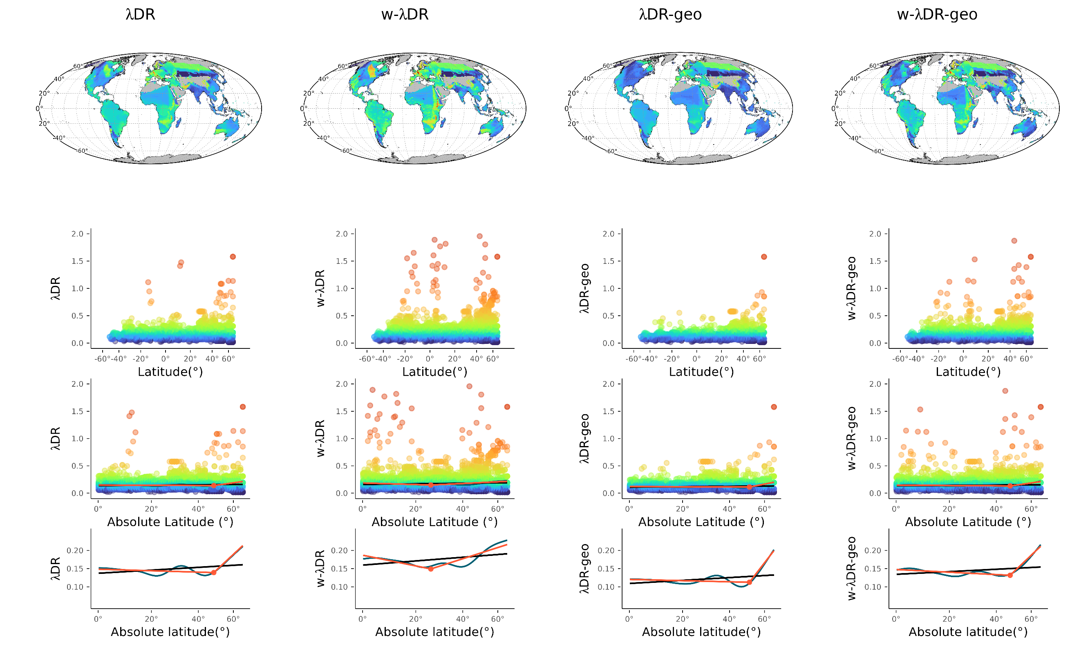
B) | 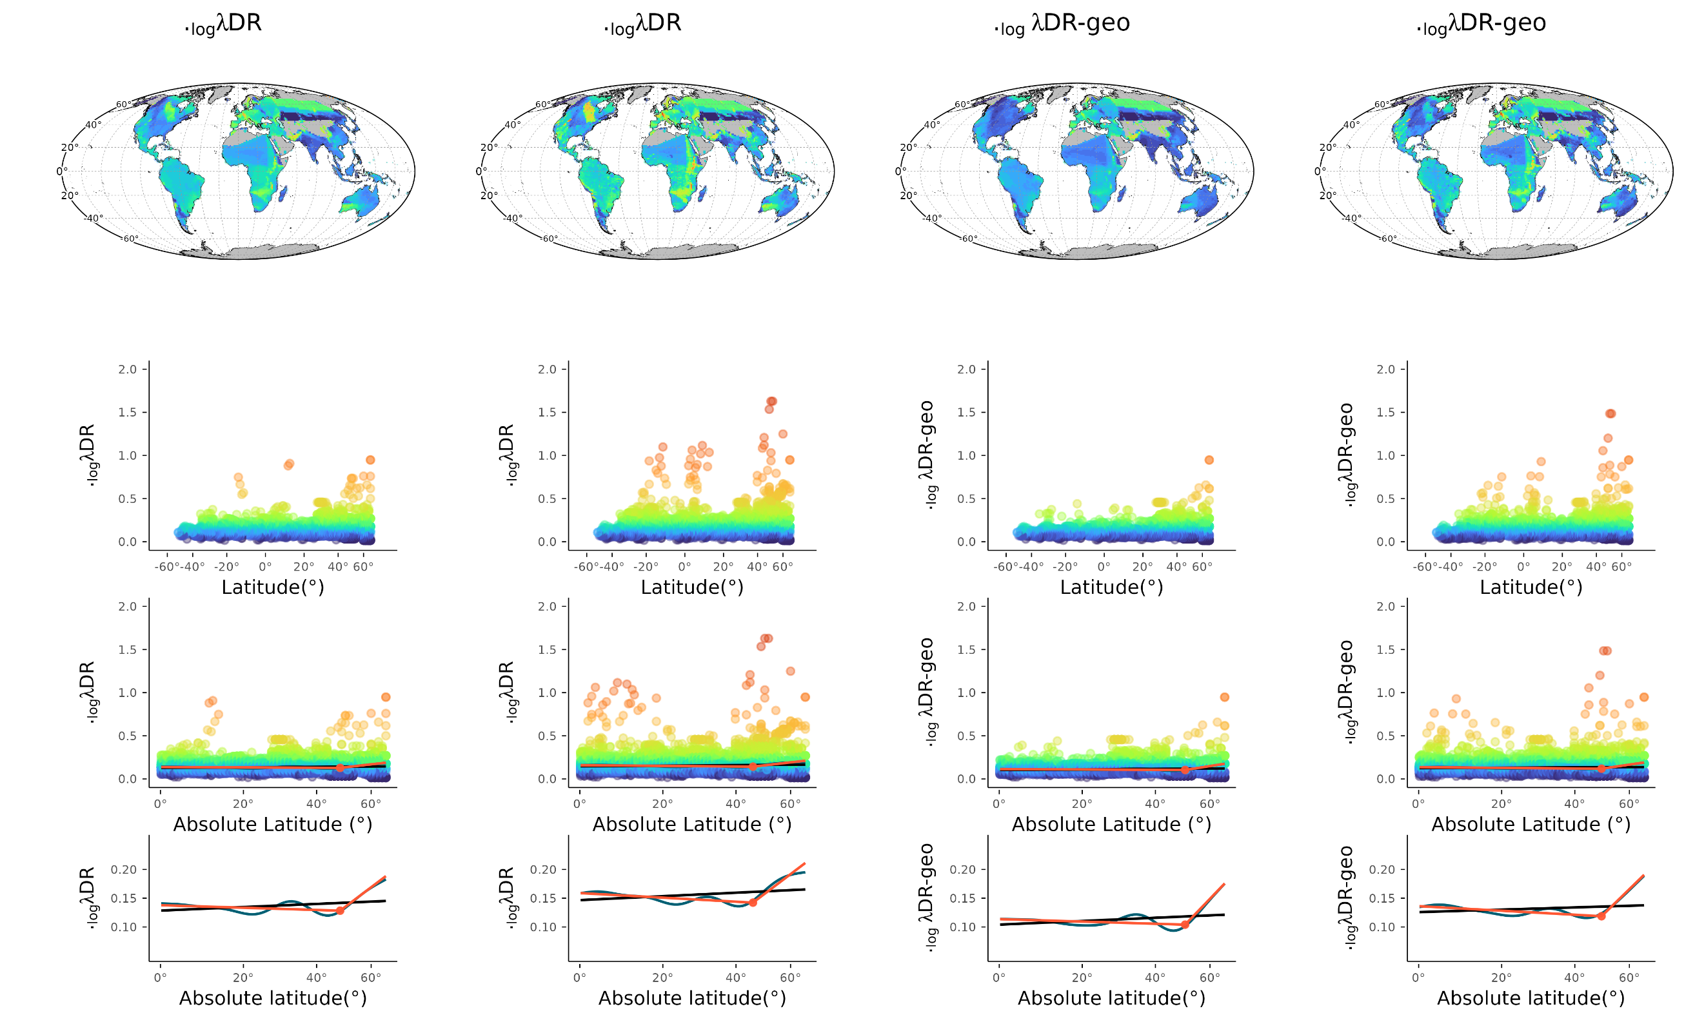
Figure S2-1: Latitudinal Gradient in Freshwater Fish Speciation at the Assemblage Level. This figure illustrates the speciation patterns of freshwater fishes across latitudes, using a comprehensive dataset comprising 12,577 species and employing λDR speciation metrics with mean variations.
The first horizontal panel displays the global spatial distribution of speciation. The second panel depicts the distribution of speciation across each pixel along the latitudinal gradient. The third panel shows the relationship between speciation and the absolute value of latitude, modeled using different adjusted approaches: orange represents the OLS model, red the OLS segmented model, and blue the GAM model. The fourth panel presents the relationship without data points for clarity. a) and b) illustrate these relationships using λDR and log λDR speciation metrics
A) | 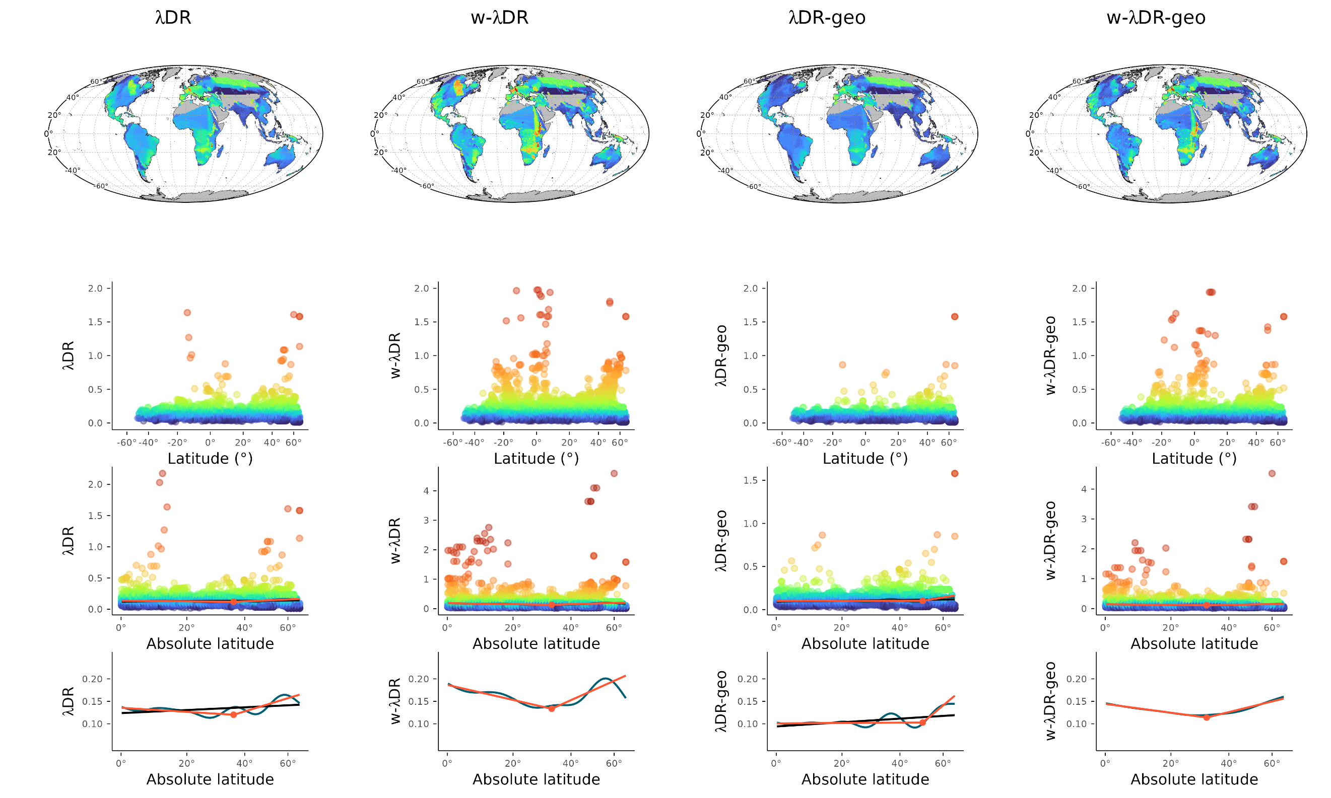
B) | 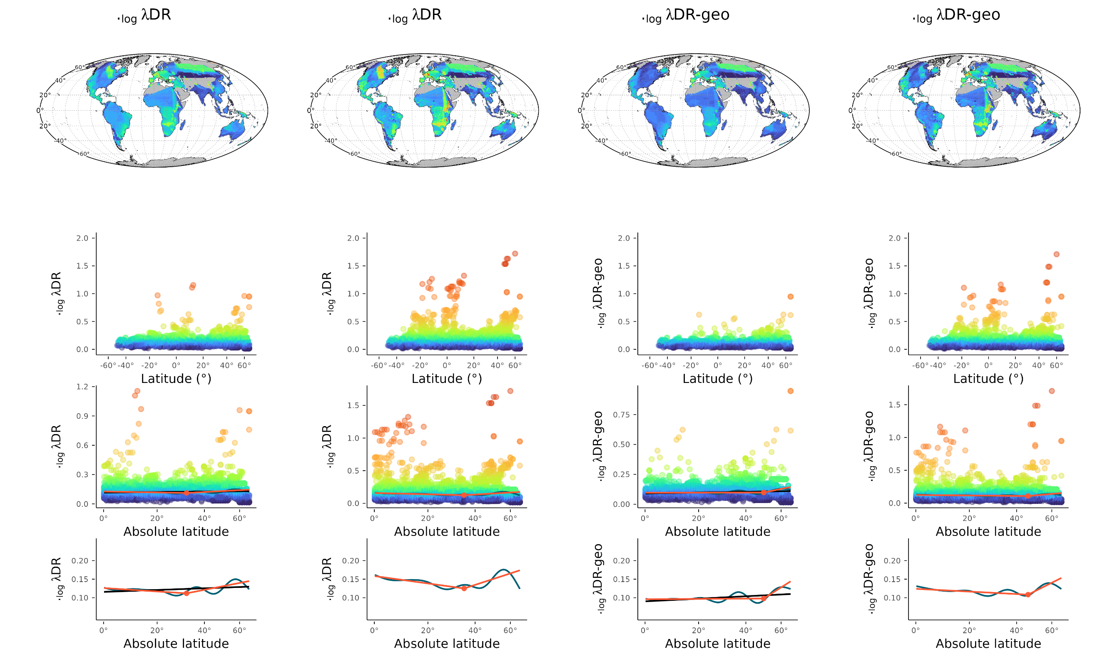
Figure S2-2: Latitudinal Gradient in Freshwater Fish Speciation at the Assemblage Level. This figure illustrates the speciation patterns of freshwater fishes across latitudes, using a molecular dataset comprising 5,242 species and employing λDR speciation metrics with mean variations. The first horizontal panel displays the global spatial distribution of speciation.
The second panel depicts the distribution of speciation across each pixel along the latitudinal gradient. The third panel shows the relationship between speciation and the absolute value of latitude, modeled using different adjusted approaches: orange represents the OLS model, red the OLS segmented model, and blue the GAM model. The fourth panel presents the relationship without data points for clarity. a) and b) illustrate these relationships using λDR and log λDR speciation metrics
A) | 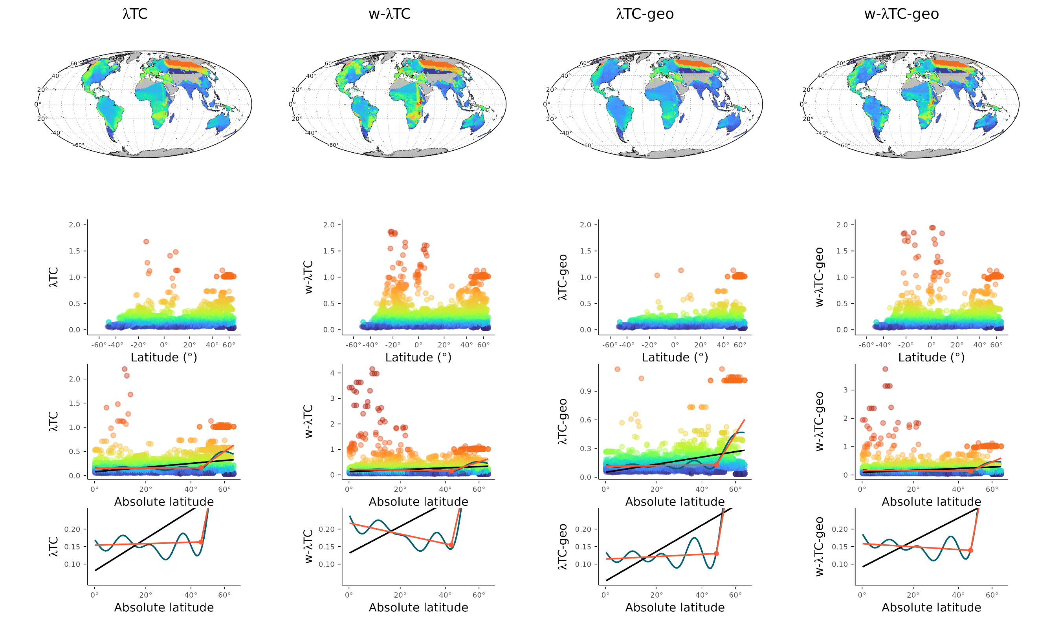
B) | 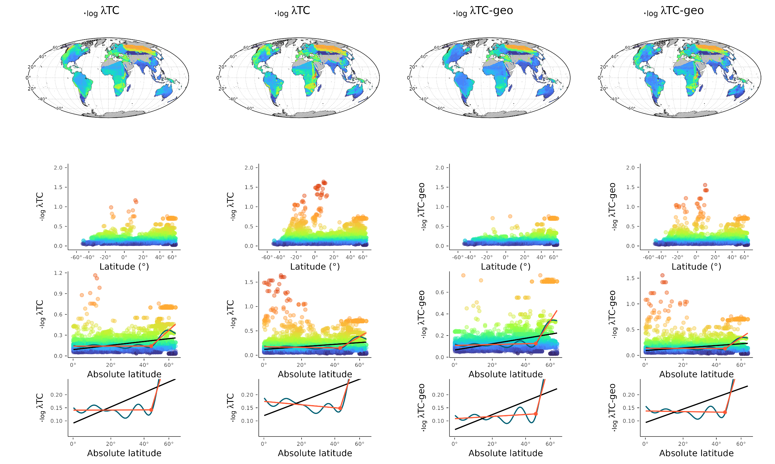
Figure S2-3: Latitudinal Gradient in Freshwater Fish Speciation at the Assemblage Level. This figure illustrates the speciation patterns of freshwater fishes across latitudes, using a molecular dataset comprising 5,242 species and employing λBAMM-TC speciation metrics with mean variations. The first horizontal panel displays the global spatial distribution of speciation.
The second panel depicts the distribution of speciation across each pixel along the latitudinal gradient. The third panel shows the relationship between speciation and the absolute value of latitude, modeled using different adjusted approaches: orange represents the OLS model, red the OLS segmented model, and blue the GAM model. The fourth panel presents the relationship without data points for clarity. a) and b) illustrate these relationships using λBAMM-TC and log λBAMM-TC speciation metrics
A) | 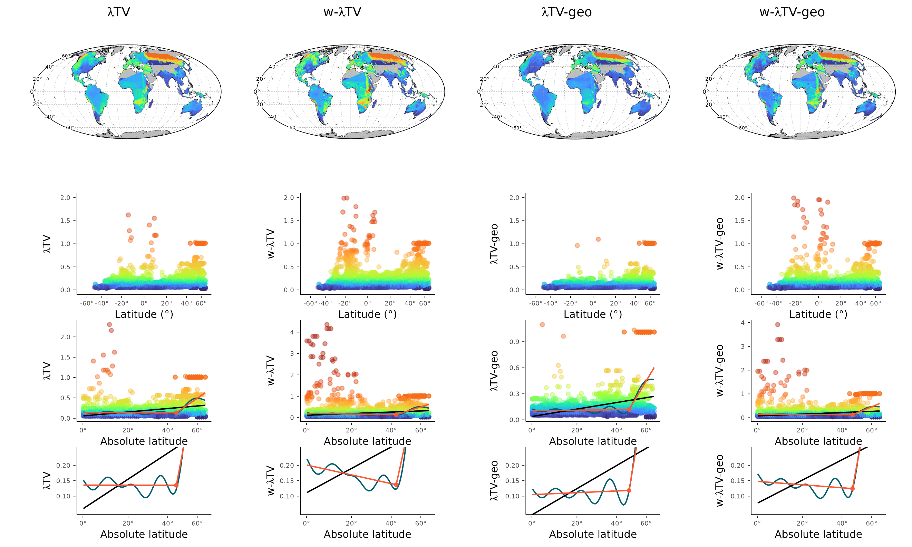
B) | 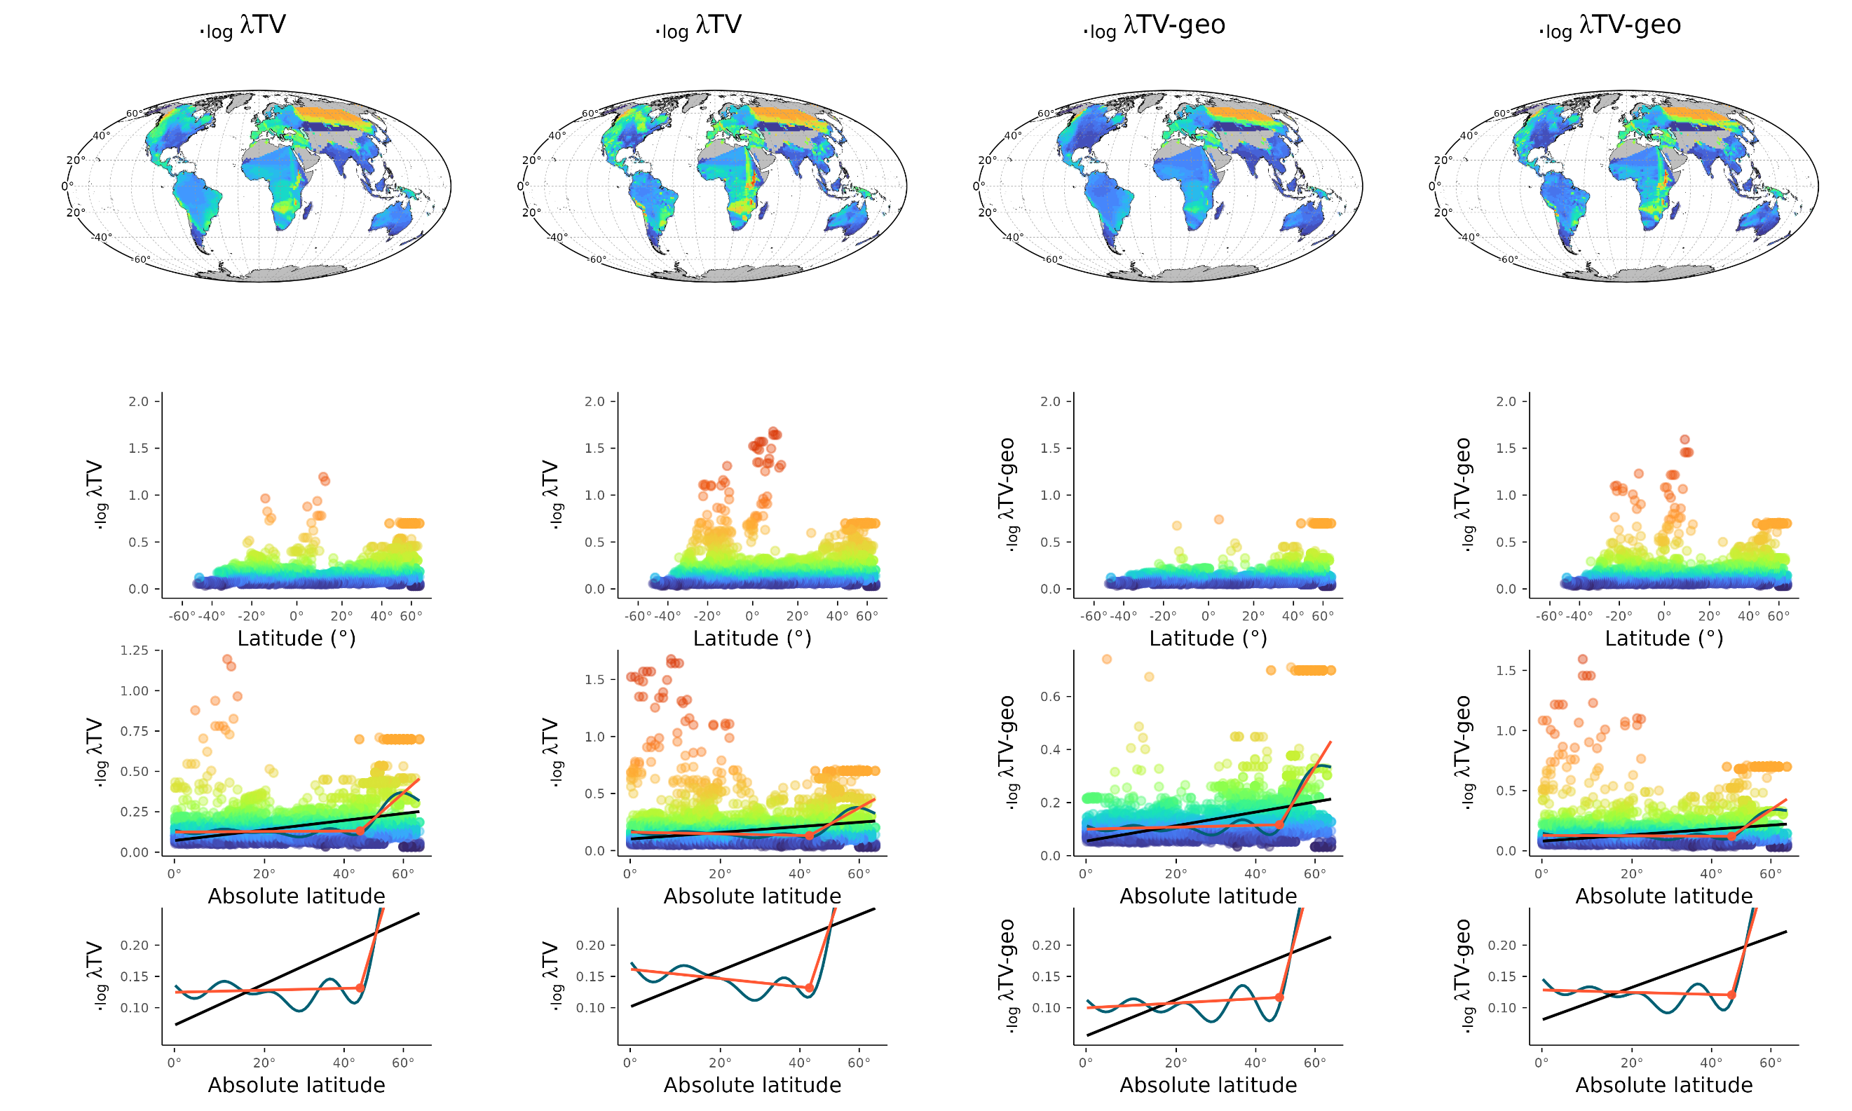
Figure S2-4: Latitudinal Gradient in Freshwater Fish Speciation at the Assemblage Level. This figure illustrates the speciation patterns of freshwater fishes across latitudes, using a molecular dataset comprising 5,242 species and employing λBAMM-TV speciation metrics with mean variations.
The first horizontal panel displays the global spatial distribution of speciation. The second panel depicts the distribution of speciation across each pixel along the latitudinal gradient. The third panel shows the relationship between speciation and the absolute value of latitude, modeled using different adjusted approaches: orange represents the OLS model, red the OLS segmented model, and blue the GAM model. The fourth panel presents the relationship without data points for clarity. a) and b) illustrate these relationships using λBAMM-TV and log λBAMM-TV speciation metrics
A) | 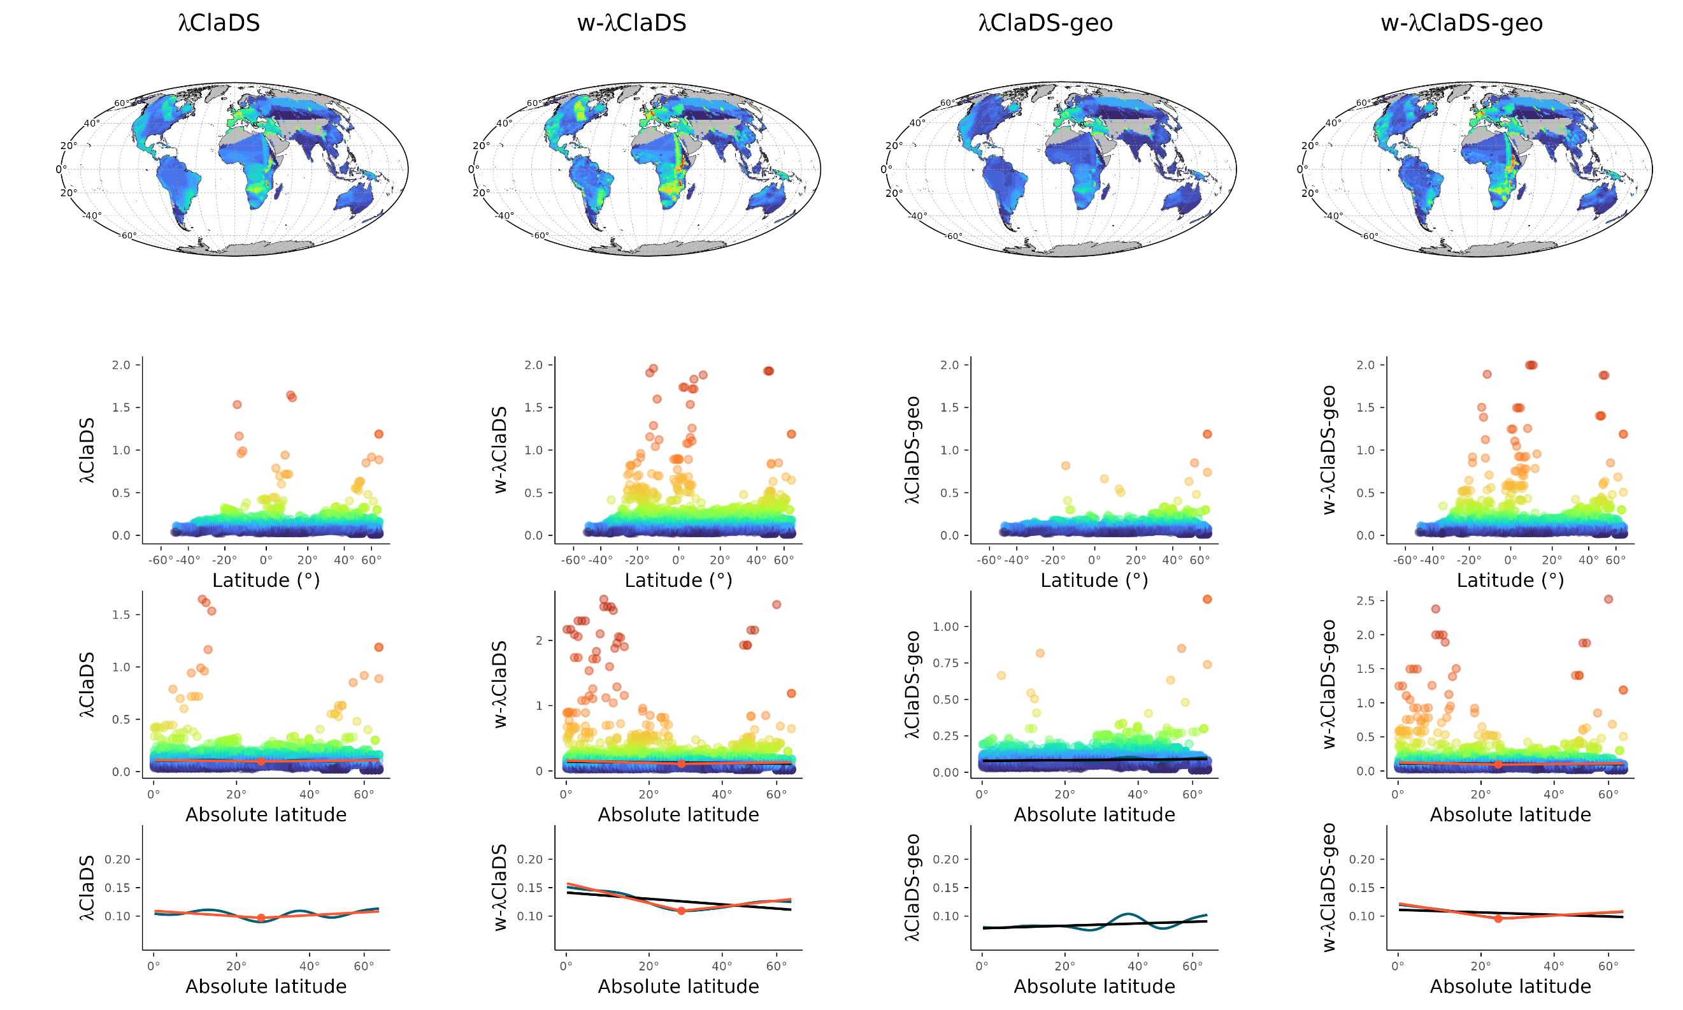
B) | 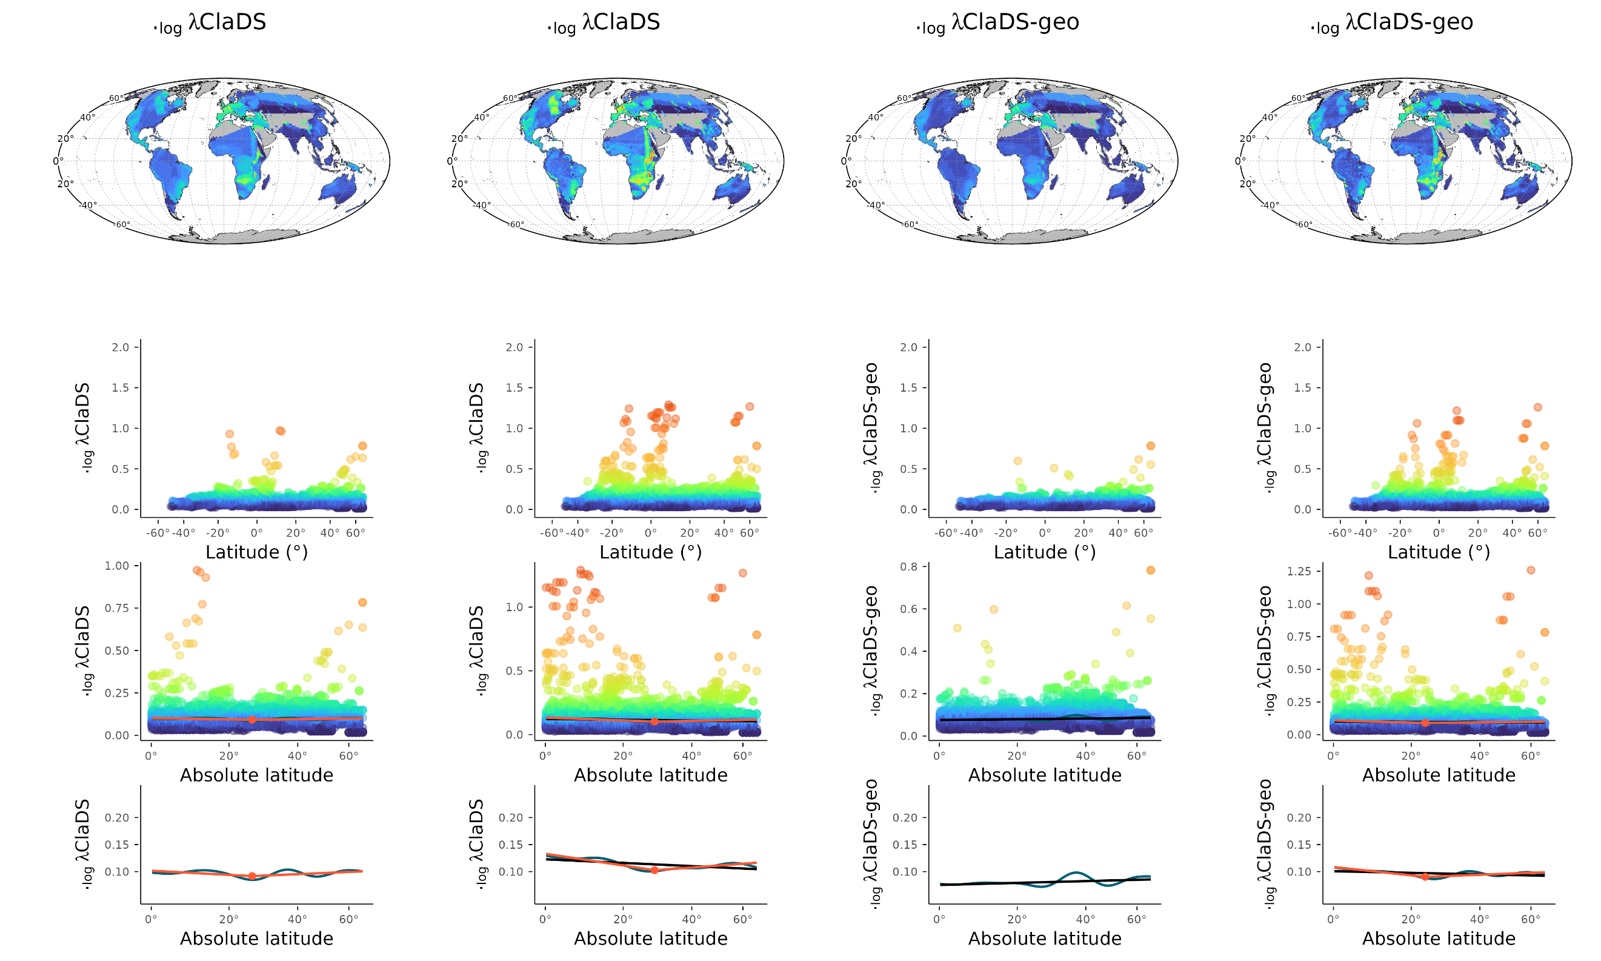
Figure S2-5: Latitudinal Gradient in Freshwater Fish Speciation at the Assemblage Level. This figure illustrates the speciation patterns of freshwater fishes across latitudes, using a molecular dataset comprising 5,242 species and employing λClaDS metrics with mean variations. The first horizontal panel displays the global spatial distribution of speciation.
The second panel depicts the distribution of speciation across each pixel along the latitudinal gradient. The third panel shows the relationship between speciation and the absolute value of latitude, modeled using different adjusted approaches: orange represents the OLS model, red the OLS segmented model, and blue the GAM model. The fourth panel presents the relationship without data points for clarity. a) and b) illustrate these relationships using λClaDS and log λClaDS speciation metrics

