Supplementary 1: Supervised Land Use Land Cover Classification
Purpose: To create a random forest classifier to identify active aquaculture ponds, dry aquaculture ponds, and other land uses on a Landsat Satellite imagery. We use field observations and high-resolution Sentinel 2 imagery for reference data. This supplementary includes the code used, and the accuracy results of the supervised classification.
Code: (Google Earth Engine) - 1_LULCClassification_Code.txt

Hyperparameter tuning: We use 50 trees based on the following result:
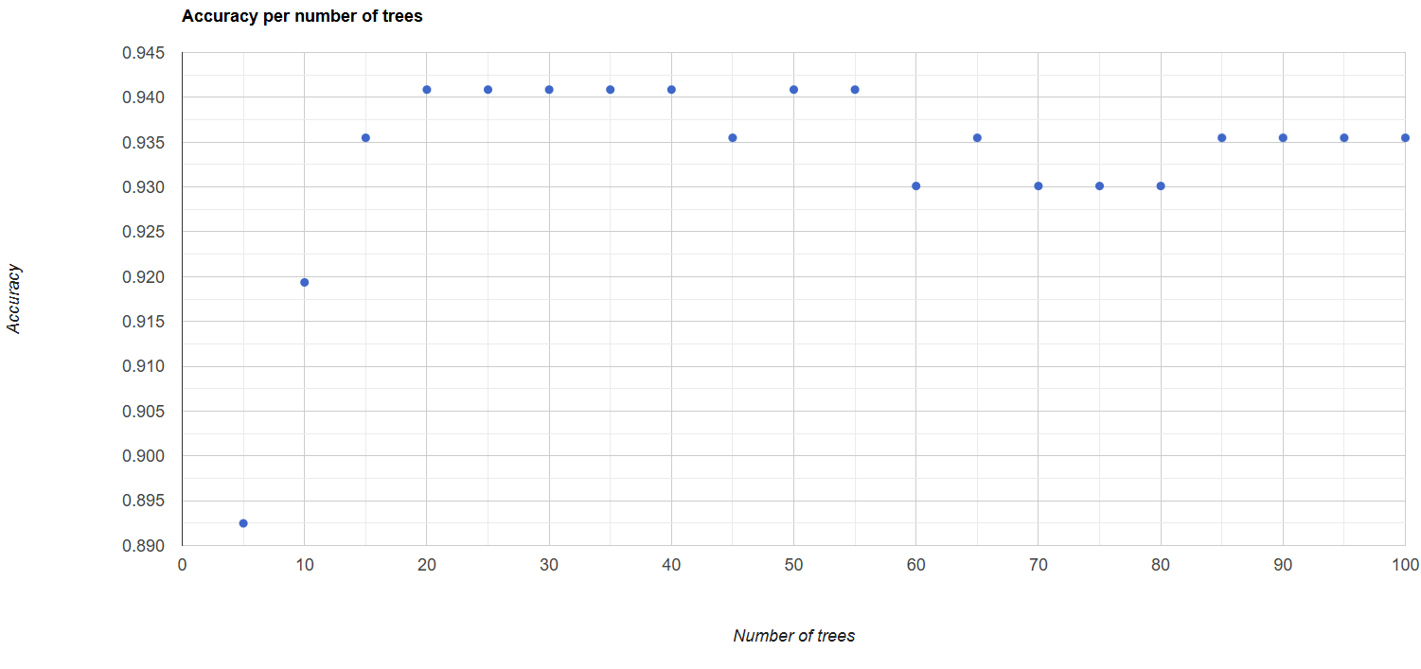
Final model accuracy results:
Confusion matrix:
[[75,4,0],[2,41,0],[1,0,44]]
0: [75,4,0]
0: 75
1: 4
2: 0
1: [2,41,0]
0: 2
1: 41
2: 0
2: [1,0,44]
0: 1
1: 0
2: 44

Overall Accuracy:
0.96

Producers Accuracy:
List (3 elements)
0: [0.95]
1: [0.95]
2: [0.98]

Consumers Accuracy:
0: 0.96
1: 0.91
2: 1

Kappa:
0.93

Comparing accuracy outputs with alternate pixel reducers
The accuracy results with the 30th percentile (listed in the previous section in more detail) are the best among the various reducers tested, closely followed by the geometric median. For the CoSal-SA model, we have therefore employed the 30th percentile.
Accuracy measure | Percentile (30) | Geometric median | Median/Percentile (50) | Percentile (70)
Overall accuracy | 0.96 | 0.94 | 0.92 | 0.90
Kappa | 0.93 | 0.91 | 0.88 | 0.84
Producers accuracy | 0: [0.95]  1: [0.95]  2: [0.98] | 0: [0.95]  1: [0.93]  2: [0.94] | 0: [0.97]  1: [0.85]  2: [0.90] | 0: [0.95]  1: [0.80]  2: [0.90]
Consumers accuracy | 0: [0.96]  1: [0.91]  2: [1] | 0: [0.95]  1: [0.93]  2: [0.94] | 0: [0.92]  1: [0.85]  2: [0.98] | 0: [0.91]  1: [0.86]  2: [0.91]

Supplementary 2: Surface Reflectance Parameters and Indices
28 Parameters:
- 6 Surface Reflectance bands – Blue, Green, Red, NIR, SWIR1, SWIR2
- 11 Normalized Band Combinations
# Blue and Red: NBR <- (Blue-Red)/(Blue+Red)
# Blue and green: NBG <- (Blue-Green)/(Blue+Green)
# Blue and NIR: NBNIR <- (Blue-NIR)/(Blue+NIR)
# Blue and SWIR1: NBSWIR1 <- (Blue-SWIR1)/(Blue+SWIR1)
# Blue and SWIR2: NBSWIR2 <- (Blue-SWIR2)/(Blue+SWIR2)
# Red and SWIR1: NRSWIR1 <- (Red-SWIR1)/(Red+SWIR1)
# Red and SWIR2: NRSWIR2 <- (Red-SWIR2)/(Red+SWIR2)
# Green and SWIR1: NGSWIR1 <- (Green-SWIR1)/(Green+SWIR1)
# Green and SWIR2: NGSWIR2 <- (Green-SWIR2)/(Green+SWIR2)
# NIR and SWIR1: NNIRSWIR1 <- (NIR-SWIR1)/(NIR+SWIR1)
# NIR and SWIR2: NNIRSWIR2 <- (NIR-SWIR2)/(NIR+SWIR2)

- 11 Widely used salinity and other indices
# Salinity Index 1 = sqrt(green^2+red^2)
SI1 <- sqrt((Green)^2 + (Red)^2)

# Salinity Index 2 = sqrt(green x red)
SI2 <- sqrt(Green * Red)

# Salinity Index 3 = sqrt(blue x red)
SI3 <- sqrt(Blue * Red)

# salinity index 4 = red x NIR / green
SI4 <- (Red * NIR / Green)

# salinity index 5 = blue/red
SI5 <- (Blue / Red)

# Soil Adjusted Vegetation Index (SAVI) = ((1.5)x NIR) - (red/0.5) + NIR + Red
SAVI <- (1.5 * NIR) - (0.5 * Red) + NIR + Red

# Vegetation Soil Salinity Index (VSSI) = (2 x green) - 5 x (red + NIR)
VSSI <- (2 * Green) - 5 * (Red + NIR)

# NDVI
NDVI <- (Red-Green)/(Red+Green)

# NDWI
NDWI <- (Green-NIR)/(Green+NIR)

# NDSI2 or Normalised Difference Salinity Index 2 as per as per Khan et al 2001 in Nguyen et al 2020)
NDSI2 <- (Red-NIR)/(Red+NIR)

# NDSI as per the Index Database: https://www.indexdatabase.de/db/is.php?sensor_id=168 )
NDSI1 <- (SWIR1-SWIR2)/(SWIR1+SWIR2)

Correlation matrix

Regression model fit results with EC

Table 1: Regression coefficients of univariate relationships between EC and various parameters starting with the highest explanatory powers
Band/Index | Fit | β₀ | SE (β₀) | β₁ | SE(β₁) | β2 | SE (β2) | R2 | Adj R2 | AIC | BIC | RMSE
NDWI | Polynomial (quad) | 1896.20 | 177.98 | 10932.14 | 1631.20 | 4088.29 | 1631.20 | 0.39 | 0.37 | 1486.00 | 1495.80 | 1601.81
NDSI2 | Polynomial (quad) | 1896.20 | 180.41 | 9731.52 | 1653.45 | 5966.86 | 1653.45 | 0.37 | 0.36 | 1488.30 | 1498.00 | 1623.66
NDWI | Linear | 8098.46 | 972.29 | 15322.05 | 2358.71 |  |  | 0.34 | 0.33 | 1490.30 | 1497.60 | 1662.76
NIR | Polynomial (quad) | 1896.20 | 191.69 | -9292.76 | 1756.82 | 3923.95 | 1756.82 | 0.29 | 0.27 | 1498.50 | 1508.20 | 1725.16
NRSWIR2 | Polynomial (quad) | 1896.20 | 192.15 | 6131.74 | 1761.05 | -7933.99 | 1761.05 | 0.29 | 0.27 | 1498.90 | 1508.60 | 1729.32
NDSI2 | Linear | 5827.36 | 740.85 | 10155.36 | 1847.64 |  |  | 0.27 | 0.26 | 1498.80 | 1506.10 | 1749.32
NBNIR | Polynomial (quad) | 1896.20 | 194.29 | 9058.04 | 1780.65 | 3588.26 | 1780.65 | 0.27 | 0.25 | 1500.80 | 1510.5 | 1748.57
NDWI | Log Linear | 10.13 | 0.60 | 7.89 | 1.47 |  |  | 0.26 | 0.25 | 1414.50 | 1421.80 | 1.03
NIR | Linear | 9751.56 | 1533.38 | -36597.69 | 7085.17 |  |  | 0.25 | 0.24 | 1501.50 | 1508.80 | 1777.50
NBNIR | Linear | 9065.56 | 1449.01 | 12148.39 | 2432.33 |  |  | 0.23 | 0.22 | 1502.90 | 1510.20 | 1791.86
NRSWIR1 | Linear | 7977.23 | 1271.23 | 14762.02 | 3047.83 |  |  | 0.22 | 0.21 | 1504.00 | 1511.30 | 1804.45
SAVI | Polynomial (quad) | 1896.20 | 199.41 | -8484.27 | 1827.59 |  |  | 0.23 | 0.21 | 1505.10 | 1514.90 | 1794.65
NRSWIR1 | Polynomial (quad) | 1896.20 | 199.44 | 8845.69 | 1827.88 |  |  | 0.23 | 0.21 | 1505.20 | 1514.90 | 1794.94
NGSWIR1 | Polynomial (quad) | 1896.20 | 199.76 | 5523.74 | 1830.79 | -7053.17 | 1830.79 | 0.23 | 0.21 | 1505.40 | 1515.20 | 1797.80
SAVI | Linear | 9671.47 | 1704.71 | -13312.60 | 2898.29 |  |  | 0.21 | 0.20 | 1505.90 | 1513.20 | 1824.99

Supplementary 3: LASSO Regression Results
LASSO regressions are regressions that penalize adding more variables into the model and decrease coefficient values of variables that contribute less to the model. Two LASSO penalized regressions were run in R with the package ‘glmnet’ to reduce dimensionality of predictors. The first regression was used to determine the best lambda value for penalizing adding more predictors. The second regression was used to select predictors to retain in the model.
Step 1: Initial LASSO regression to determine lambda value
(1) Code:
cvmodel <- cv.glmnet(x, y, alpha=1, family='binomial')
(2) Cross-validation error plot:
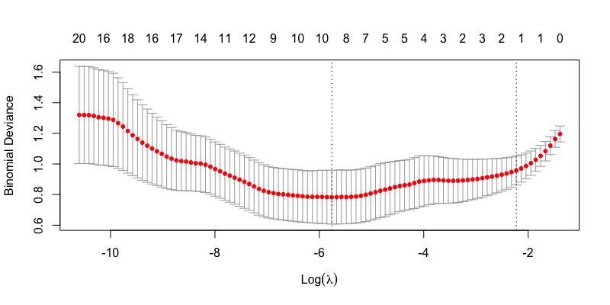
(3) Best lambda value with the lowest error: 0.003145
Step 2: Final LASSO regression to select variables
(1) Code:
bestlasso <- glmnet(x, y, alpha=1, lambda=best_lambda, family='binomial')
(2) Coefficients:

Table 1: LASSO regression coefficients
Predictor | Coefficient values
(Intercept) | 3.03
Blue_R | .
Green_R | 16.79
Red_R | .
NIR_R | .
SWIR1_R | .
SWIR2_R | -31.04
NDVI | .
NDWI | 6.82
NDSI1 | 2.52
NDSI2 | .
SI1 | .
SI2 | .
SI3 | .
SI4 | .
SI5 | .
SAVI | .
VSSI | -0.10
NBR | .
NBG | .
NBNIR | 12.35
NBSWIR1 | .
NBSWIR2 | -14.16
NRSWIR1 | -3.81
NRSWIR2 | .
NGSWIR1 | -5.63
NGSWIR2 | .
NNIRSWIR1 | -0.66
NNIRSWIR2 | .

(3) Retained predictors (with non-zero coefficient values): Green_R, SWIR2_R, NDWI, NDSI1, VSSI, NBSWIR, NBSWIR2, NRSWIR1, NGSWIR1, NNIRSWIR1.

Supplementary 4: Model validation metrics
For each model as they use a different subset of data—training, and internal and external testing data sets—we calculated the confusion matrix of true positives (TP), true negatives (TN), false positives (FP), and false negatives (FN), and derived the four metrics to evaluate the model comprehensively:
- Accuracy = correct classifications / total classifications = (TP + TN)/(TP+TN+FP+FN)
Accuracy involves all four components of the confusion matrix, and usually serves as a coarse measure of overall model quality. In case of imbalanced data, such as ours where there are fewer high salinity points (30 out of 106) than there are for lower salinity (70 out of 106), there is a possibility of getting a relatively high accuracy even if all the high salinity points are incorrectly classified as low (accuracy would still be 70% because TN=70 even when FN=30). We, therefore, also consider the following three metrics in tandem.

- Precision = correctly classified positives / all classified as positive = TP / (TP+FP)
Precision improves when false positives decrease, that is, high saline data is not classified as low.

- Recall = correctly classified positives / all actual positives = TP / (TP+FN)
Recall, or sensitivity or true positive rate, improves when false negatives reduce (that is fewer low saline points are classified as high).

- F1-score = 2 * (precision * recall) / (precision + recall)
F1 score is the harmonic mean of precision and recall, and higher score suggests a more balanced model.

Supplementary 5: Band Mean-variance normalization comparisons
We normalized Landsat 5 bands using Landsat 8 (2024) composite as a reference. The following are reflectance distributions of original Landsat 5 composite, matched-normalized band reflectance, and the reference Landsat 8 histogram.
1995
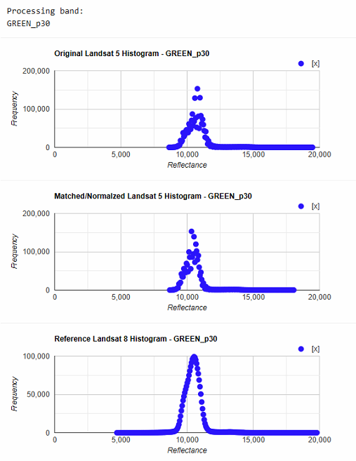 | 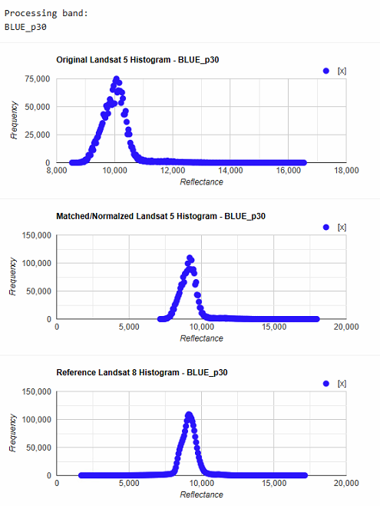 | 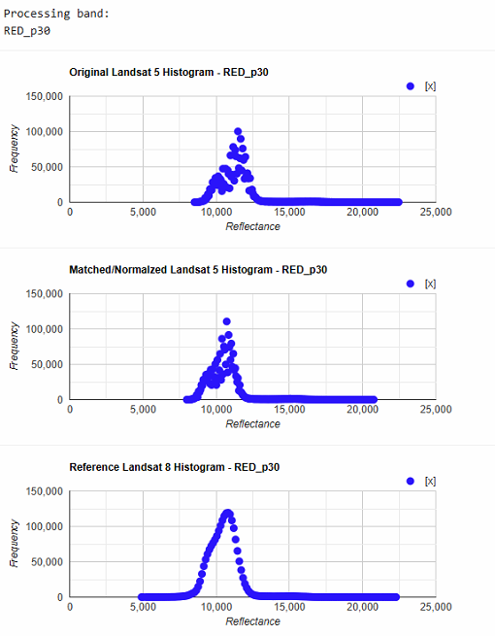
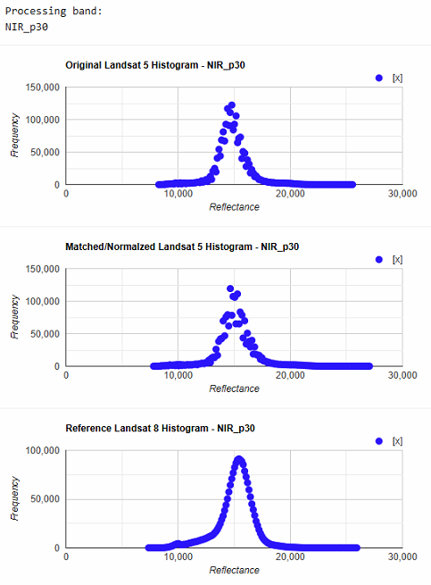 | 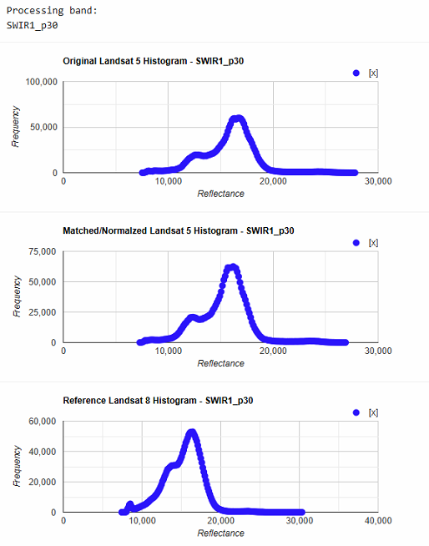 | 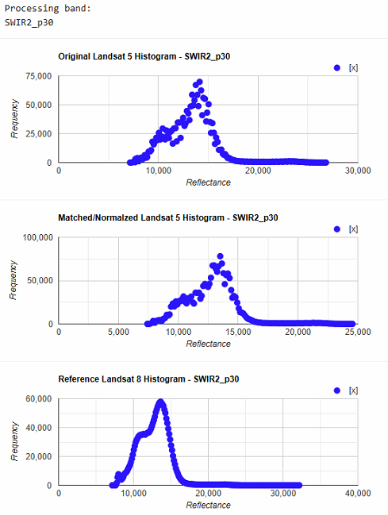

2001
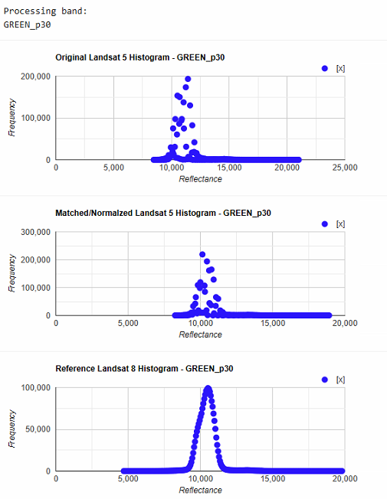 | 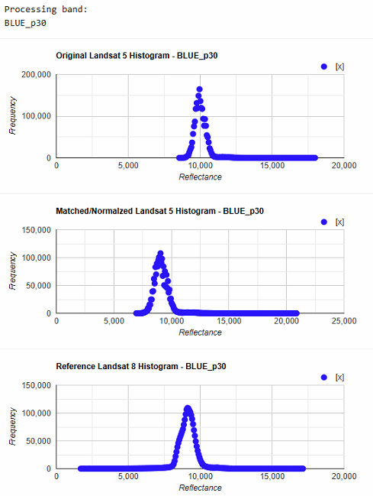 | 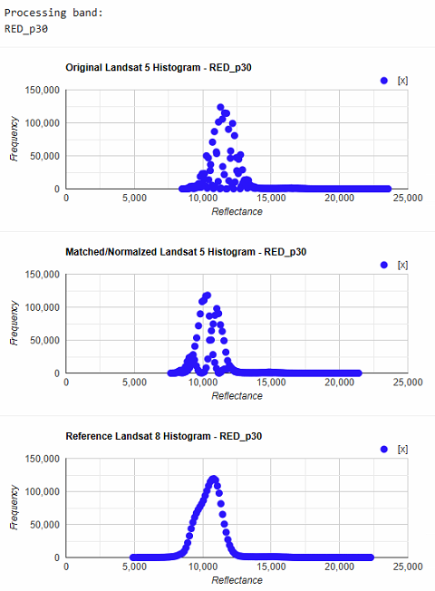
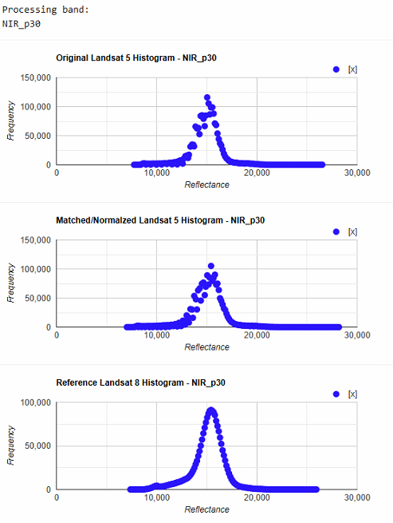 | 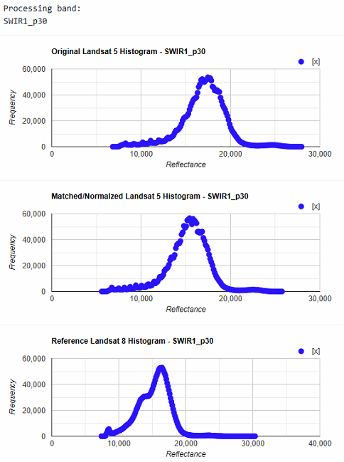 | 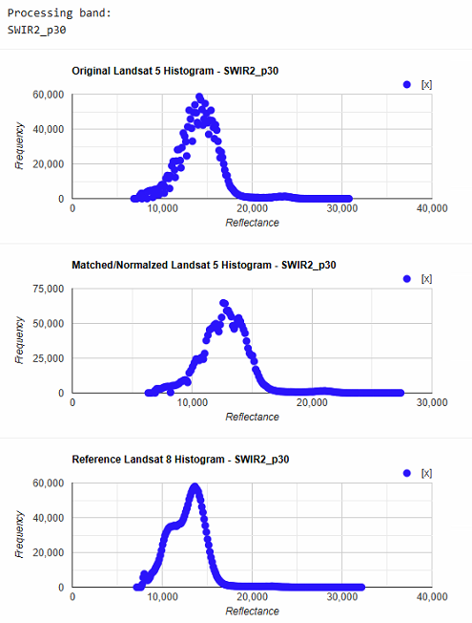

2005
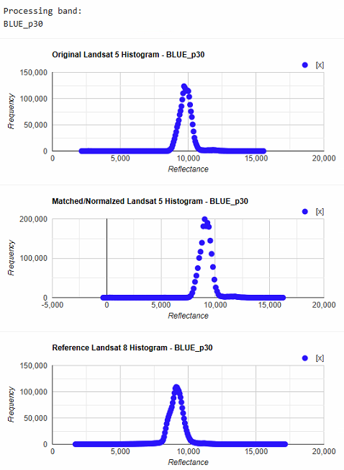 | 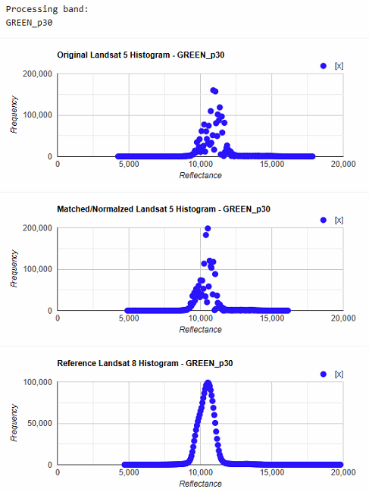 | 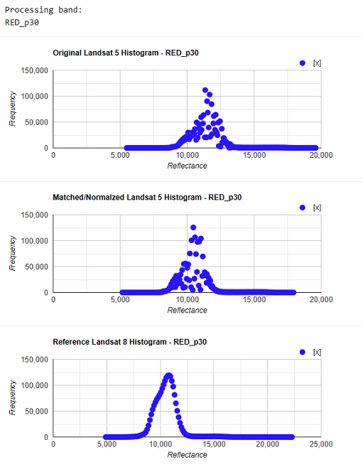
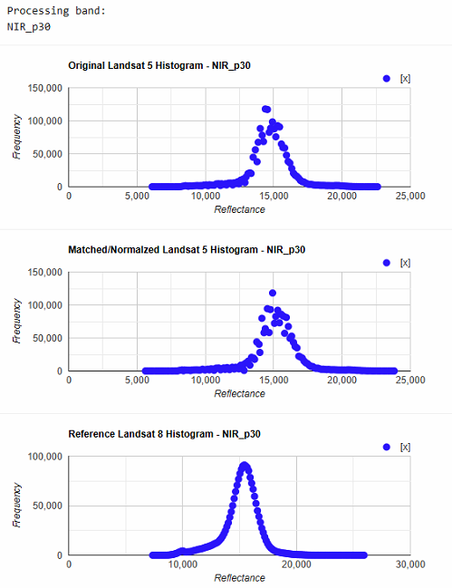 | 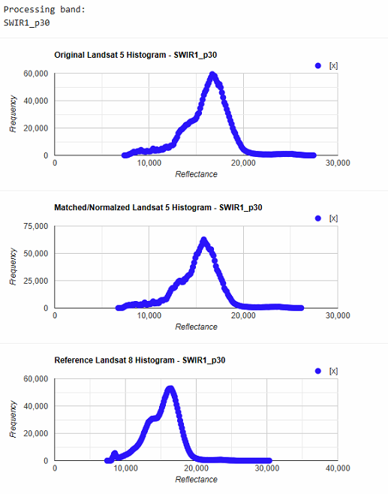 | 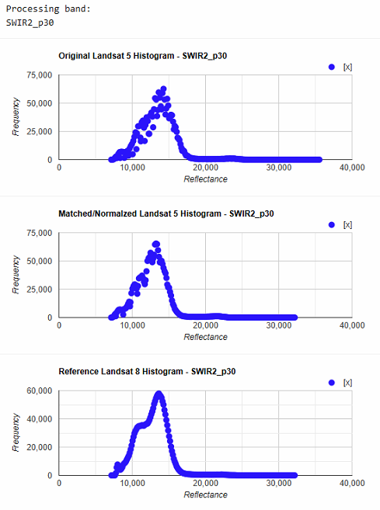

2010
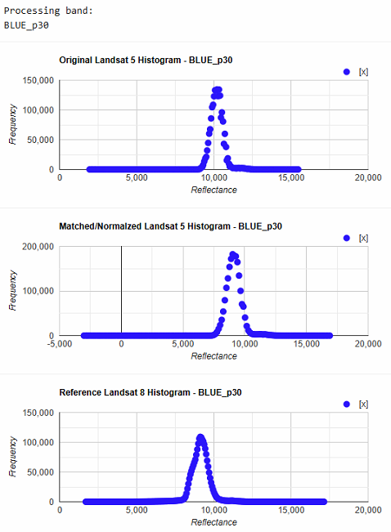 | 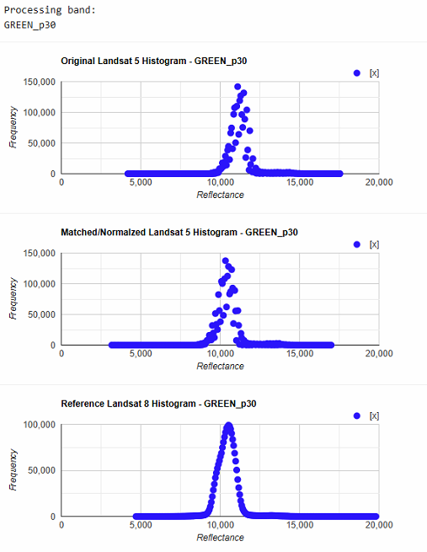 | 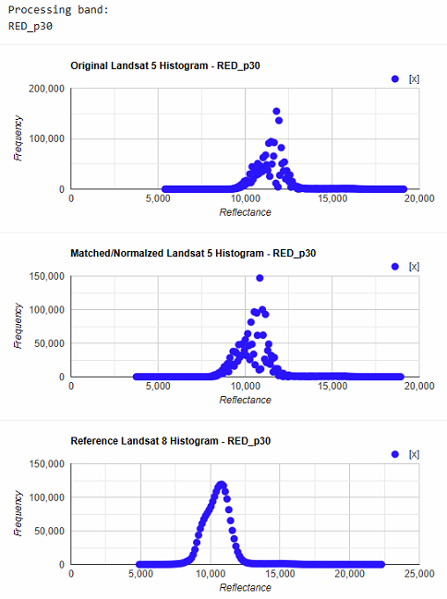
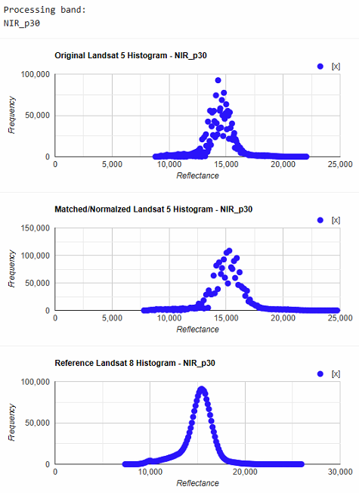 | 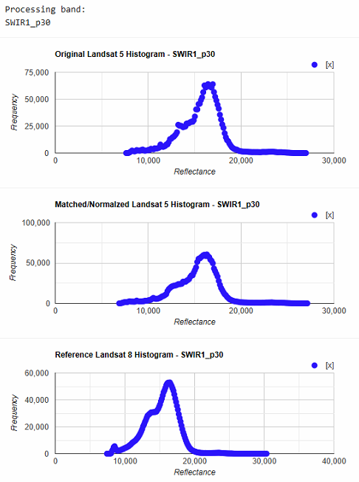 | 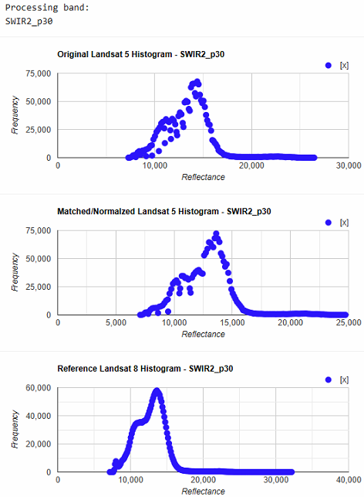

Supplementary 6: 100 Iteration average results of individual machine learning and regression models under varying model specifications
- Testing a variety of linear and non-linear machine learning and regression models
EC | Continuous
Variables | All
Train-Test | 70-30
Row Labels | Average of R2_Train | Average of R2_Test
Bagging | 0.883958695 | 0.390130017
RandomForest | 0.886629656 | 0.38153062
Quadratic_correlated | 0.493063218 | 0.075613038
Stepwise | 0.667250327 | -0.4812077
OLS | 0.684766378 | -0.881249685
ANN | 0.899084686 | -1.589536008
Quadratic_all | 0.883570262 | -66.78533693
Log-Linear | 0.480977049 | -9.34509E+19

EC | Continuous
Variables | All
Train-Test | 70-30
Random Forest maxnodes = 6 (reduced depth to avoid overfitting in small dataset)
Row Labels | Average of R2_Train | Average of R2_Test
Bagging | 0.740572046 | 0.40654547
RandomForest | 0.761469885 | 0.402998112
Quadratic_correlated | 0.485572096 | 0.075818915
Stepwise | 0.65584359 | -0.519069914
OLS | 0.674089184 | -0.821922951
ANN | 0.889559236 | -4.73293199
Quadratic_all | 0.875804963 | -69.9171603
Log-Linear | 0.465514807 | -2.5877E+14

EC | Continuous
Variables | Pure bands and highly correlated
Train-Test | 80-20
Parameter adjustments for small data (maxnodes = 6)
Row Labels | Average of R2_Train | Average of R2_Test
RandomForest | 0.729574484 | 0.444587276
Bagging | 0.745901662 | 0.432524444
Lasso | 0.385876678 | 0.301727259
Ridge | 0.336485852 | 0.273195735
OLS | 0.519148023 | 0.270856197
Quadratic_correlated | 0.546587506 | 0.247986491
Stepwise | 0.504797542 | 0.235174696
Quadratic_all | 0.606914335 | -0.234295277
Log-Linear | -0.113285846 | -6.731768748
ANN | -6.586192881 | -179.2320997

EC | Continuous
Variables | PCA (3)
Train-Test | 80-20 (random)
Row Labels | Average of R2_Train | Average of R2_Test
Bagging | 0.454671094 | 0.191897586
Ridge | 0.271008882 | 0.167371934
Quantile Regression | 0.294190471 | 0.156754325
OLS | 0.339315496 | 0.151301889
Lasso | 0.336095118 | 0.145802083
Log-Linear | 0.226656671 | 0.145261048
RandomForest | 0.362814088 | 0.140630829
Stepwise | 0.332848696 | 0.127901676
ANN | -5.770963851 | -30.57203946

- Testing variable selection with random sampling
EC | Binary
Variables | All
Train-Test | 80-20 (random)
Row Labels | Average of Accuracy_Train | Average of Accuracy_Test
Random Forest | 0.992857143 | 0.847272727
ANN | 0.954166667 | 0.787272727
Logistic | 0.956785714 | 0.762727273

EC | Binary
Variables | Lasso
Train-Test | 80-20 (random)
Row Labels | Average of Accuracy_Train | Average of Accuracy_Test
Logistic | 0.889166667 | 0.848181818
Random Forest | 0.992857143 | 0.841363636
ANN | 0.960595238 | 0.789090909

EC | Binary
Variables | Pure bands and highly correlated
Train-Test | 80-20 (random)
Row Labels | Average of Accuracy_Train | Average of Accuracy_Test
Random Forest | 0.992857143 | 0.838181818
Logistic | 0.901071429 | 0.833181818
ANN | 0.96 | 0.775909091

EC | Categorical
Variables | All
Train-Test | 80-20 (random)
Row Labels | Average of Accuracy_Train | Average of Accuracy_Test
Random Forest | 0.995364489 | 0.76482743
ANN | 0.899229683 | 0.671691396

EC | Categorical
Variables | Pure bands and highly correlated
Train-Test | 80-20 (random)
Row Labels | Average of Accuracy_Train | Average of Accuracy_Test
Random Forest | 0.995541963 | 0.74184358
ANN | 0.886974731 | 0.667993751

EC | Categorical
Variables | Lasso variables
Train-Test | 80-20 (random)
Row Labels | Average of Accuracy_Train | Average of Accuracy_Test
Random Forest | 0.947499565 | 0.730831604
ANN | 0.780972881 | 0.709749143

- Testing Variable selection with stratified sampling
EC | Binary
Variables | All
Train-Test | 80-20 (stratified)
Row Labels | Average of Accuracy_Train | Average of Accuracy_Test
Random Forest | 0.992352941 | 0.844285714
ANN | 0.954705882 | 0.798571429
Logistic | 0.947294118 | 0.754761905

EC | Binary
Variables | Lasso
Train-Test | 80-20 (stratified)
Row Labels | Average of Accuracy_Train | Average of Accuracy_Test
Logistic | 0.890470588 | 0.843809524
Random Forest | 0.992352941 | 0.834761905
ANN | 0.956352941 | 0.810952381

EC | Binary
Variables | Pure bands and highly correlated
Train-Test | 80-20 (stratified)
Row Labels | Average of Accuracy_Train | Average of Accuracy_Test
Logistic | 0.900941176 | 0.830952381
Random Forest | 0.992352941 | 0.826190476
ANN | 0.960117647 | 0.798095238

EC | Categorical
Variables | All
Train-Test | 80-20 (stratified)
Row Labels | Average of Accuracy_Train | Average of Accuracy_Test
Random Forest | 0.99173913 | 0.78800641
ANN | 0.900927668 | 0.686840798

EC | Categorical
Variables | Pure bands and highly correlated
Train-Test | 80-20 (stratified)
Row Labels | Average of Accuracy_Train | Average of Accuracy_Test
Random Forest | 0.992463768 | 0.76102381
ANN | 0.881891211 | 0.710176005

EC | Categorical
Variables | Lasso variables
Train-Test | 80-20 (stratified)
Row Labels | Average of Accuracy_Train | Average of Accuracy_Test
Random Forest | 0.931594203 | 0.752554487
ANN | 0.781774522 | 0.707827381

Supplementary 7: Threshold Test Results
The sensitivity of the final ensemble model to threshold values for converting predicted probabilities to binary values was tested. 81 possible threshold values were tested ranging from 0.1 to 0.9 at 0.01 increments. In each iteration, the threshold was used to convert predicted probabilities to binary values and compute accuracy for the training set and the internal testing set. Mean accuracy for the training set was 0.91 (±0.025) and mean accuracy for the testing set was 0.82 (±0.056). Differences between the training and testing sets were low for all threshold values, with a mean value of 0.090 (±0.045). These results suggest low possibility of overfitting and relatively low sensitivity of model performance to changing threshold values.
Table 1: Accuracy results for different threshold values.
Threshold | Train accuracy | Test accuracy | Difference in accuracy
0.1 | 0.80 | 0.67 | 0.13
0.11 | 0.81 | 0.67 | 0.15
0.12 | 0.84 | 0.67 | 0.17
0.13 | 0.85 | 0.67 | 0.18
0.14 | 0.86 | 0.67 | 0.19
0.15 | 0.86 | 0.67 | 0.19
0.16 | 0.87 | 0.67 | 0.20
0.17 | 0.87 | 0.71 | 0.16
0.18 | 0.87 | 0.76 | 0.11
0.19 | 0.89 | 0.76 | 0.13
0.2 | 0.89 | 0.76 | 0.13
0.21 | 0.89 | 0.81 | 0.08
0.22 | 0.91 | 0.81 | 0.10
0.23 | 0.91 | 0.86 | 0.05
0.24 | 0.91 | 0.86 | 0.05
0.25 | 0.91 | 0.86 | 0.05
0.26 | 0.91 | 0.86 | 0.05
0.27 | 0.91 | 0.86 | 0.05
0.28 | 0.91 | 0.86 | 0.05
0.29 | 0.91 | 0.86 | 0.05
0.3 | 0.92 | 0.86 | 0.06
0.31 | 0.93 | 0.81 | 0.12
0.32 | 0.93 | 0.81 | 0.12
0.33 | 0.93 | 0.81 | 0.12
0.34 | 0.93 | 0.81 | 0.12
0.35 | 0.93 | 0.81 | 0.12
0.36 | 0.93 | 0.81 | 0.12
0.37 | 0.93 | 0.81 | 0.12
0.38 | 0.93 | 0.76 | 0.17
0.39 | 0.93 | 0.76 | 0.17
0.4 | 0.93 | 0.76 | 0.17
0.41 | 0.93 | 0.81 | 0.12
0.42 | 0.93 | 0.81 | 0.12
0.43 | 0.93 | 0.81 | 0.12
0.44 | 0.93 | 0.81 | 0.12
0.45 | 0.93 | 0.81 | 0.12
0.46 | 0.93 | 0.81 | 0.12
0.47 | 0.93 | 0.81 | 0.12
0.48 | 0.93 | 0.81 | 0.12
0.49 | 0.93 | 0.81 | 0.12
0.5 | 0.93 | 0.81 | 0.12
0.51 | 0.92 | 0.81 | 0.11
0.52 | 0.92 | 0.81 | 0.11
0.53 | 0.92 | 0.81 | 0.11
0.54 | 0.92 | 0.81 | 0.11
0.55 | 0.91 | 0.81 | 0.10
0.56 | 0.91 | 0.81 | 0.10
0.57 | 0.92 | 0.81 | 0.11
0.58 | 0.92 | 0.86 | 0.06
0.59 | 0.92 | 0.86 | 0.06
0.6 | 0.92 | 0.86 | 0.06
0.61 | 0.92 | 0.86 | 0.06
0.62 | 0.92 | 0.86 | 0.06
0.63 | 0.92 | 0.86 | 0.06
0.64 | 0.92 | 0.86 | 0.06
0.65 | 0.92 | 0.86 | 0.06
0.66 | 0.91 | 0.86 | 0.05
0.67 | 0.91 | 0.86 | 0.05
0.68 | 0.91 | 0.86 | 0.05
0.69 | 0.91 | 0.86 | 0.05
0.7 | 0.91 | 0.86 | 0.05
0.71 | 0.91 | 0.86 | 0.05
0.72 | 0.91 | 0.86 | 0.05
0.73 | 0.91 | 0.86 | 0.05
0.74 | 0.91 | 0.86 | 0.05
0.75 | 0.91 | 0.86 | 0.05
0.76 | 0.91 | 0.86 | 0.05
0.77 | 0.91 | 0.86 | 0.05
0.78 | 0.91 | 0.86 | 0.05
0.79 | 0.91 | 0.86 | 0.05
0.8 | 0.91 | 0.86 | 0.05
0.81 | 0.91 | 0.86 | 0.05
0.82 | 0.91 | 0.86 | 0.05
0.83 | 0.91 | 0.86 | 0.05
0.84 | 0.91 | 0.86 | 0.05
0.85 | 0.91 | 0.86 | 0.05
0.86 | 0.91 | 0.86 | 0.05
0.87 | 0.91 | 0.86 | 0.05
0.88 | 0.91 | 0.86 | 0.05
0.89 | 0.88 | 0.86 | 0.03
0.9 | 0.88 | 0.86 | 0.03

Supplementary 8: Relationship between predictor variables and Electrical Conductivity and Soil Moisture

Relationship of predictor with EC | Relationship of predictor with soil moisture
Normalized Difference Water Index (NDWI)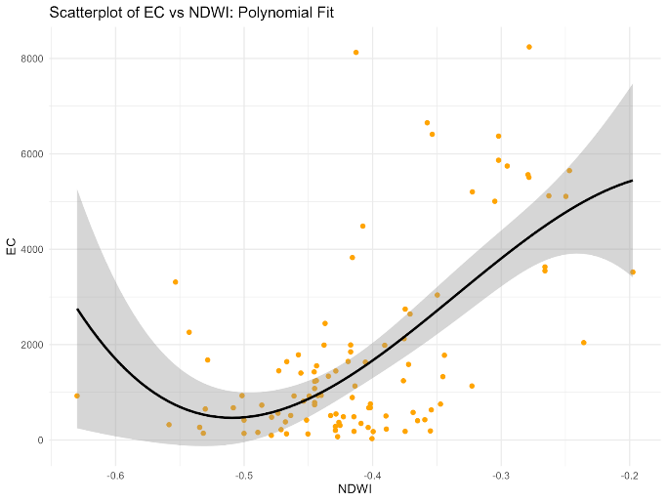 | 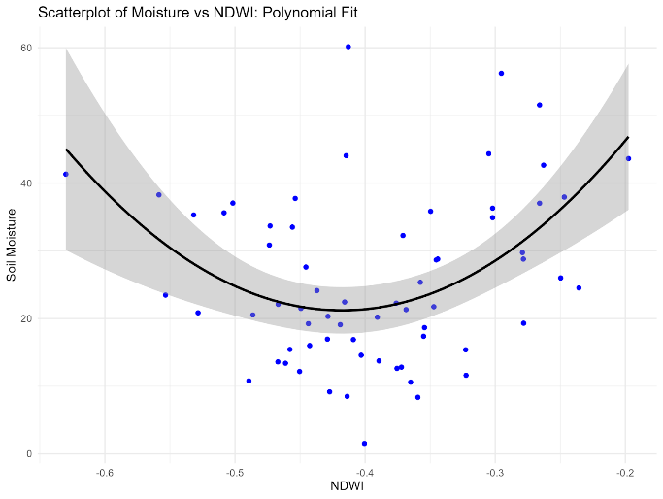
Normalized Blue and NIR (NBNIR)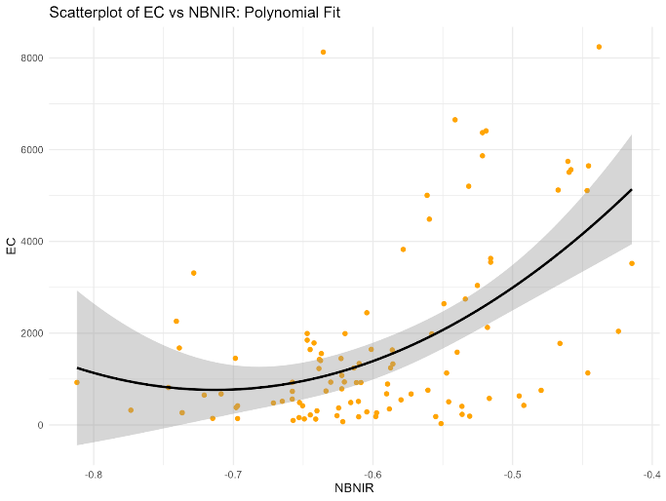 | 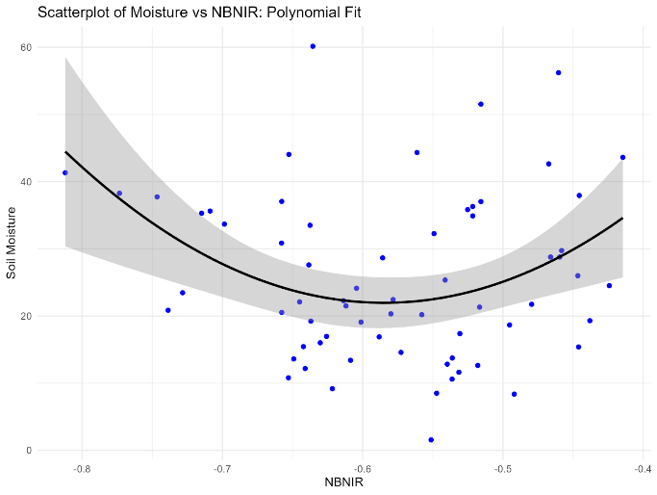
SWIR2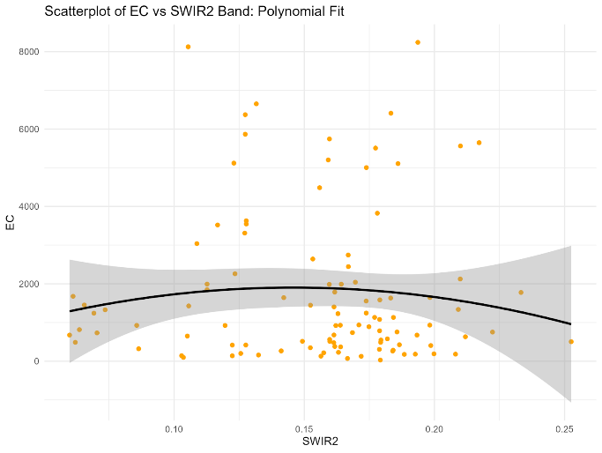 | 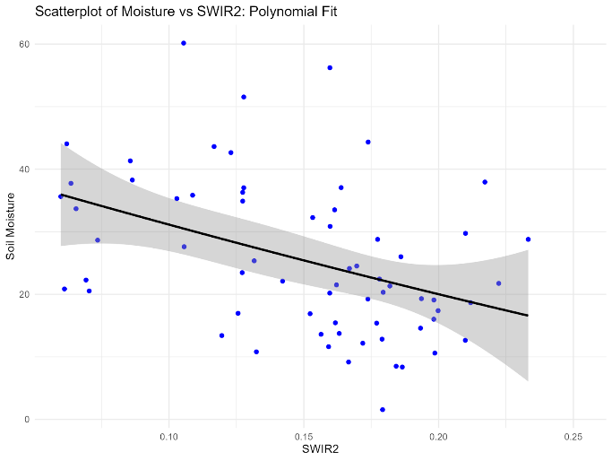
Green  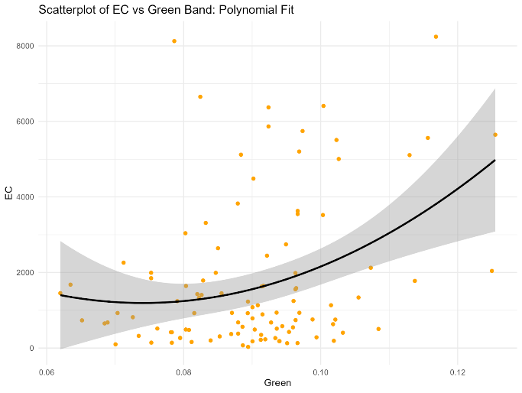 | 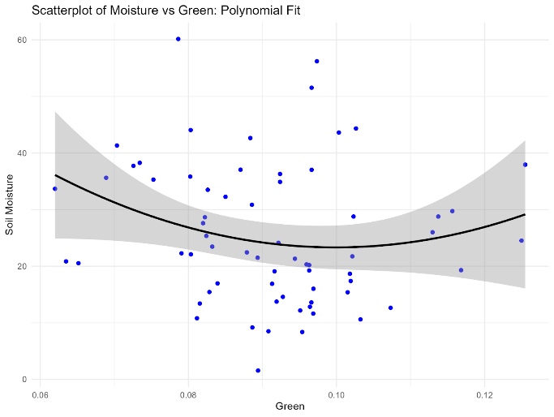
Normalized Red and SWIR1 (NRSWIR1)  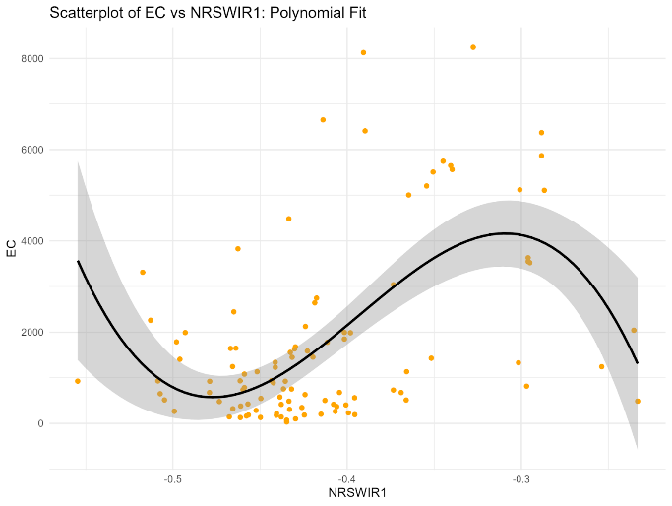 | 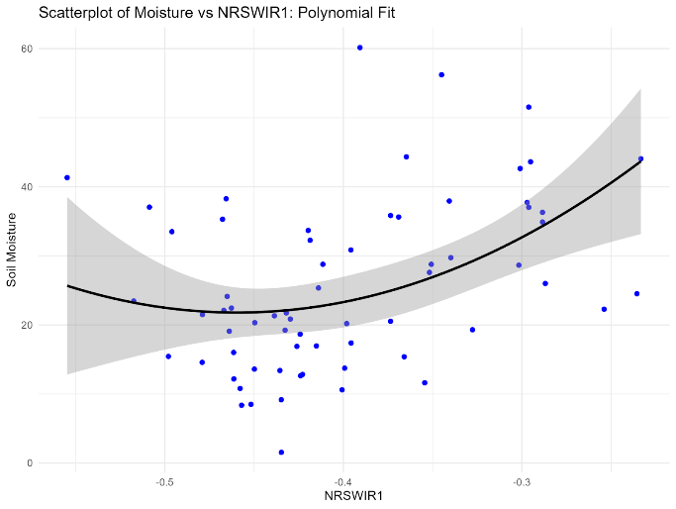
Vegetation Soil Salinity Index (VSSI)  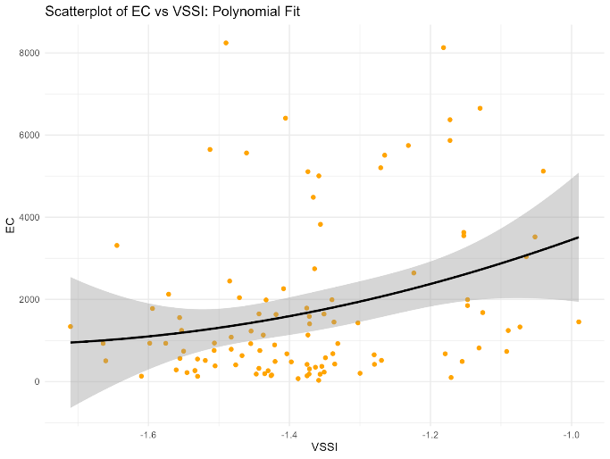 | 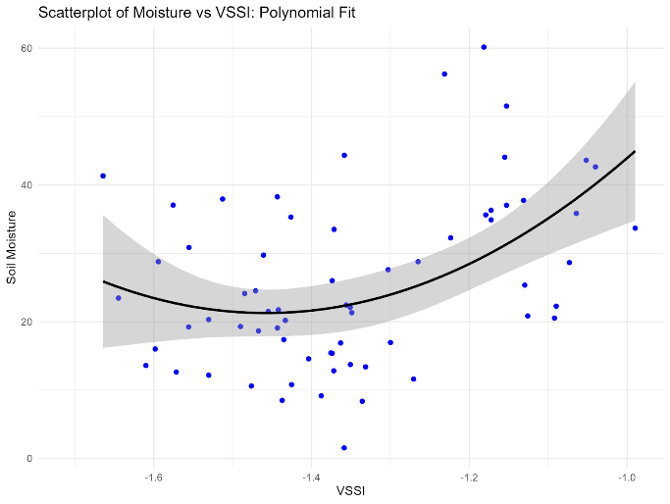
Normalized NIR and SWIR1 (NNIRSWIR1)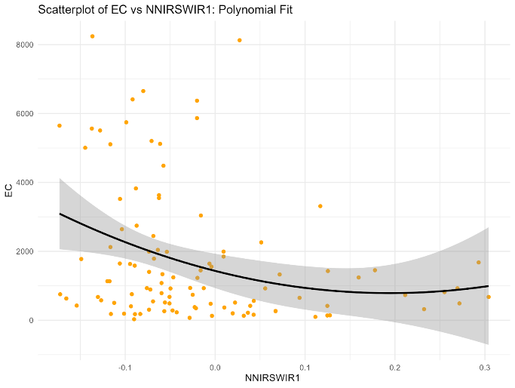 | 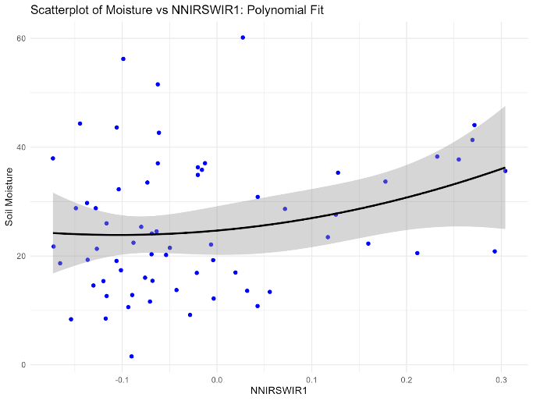
Normalized Difference Salinity Index (NDSI1)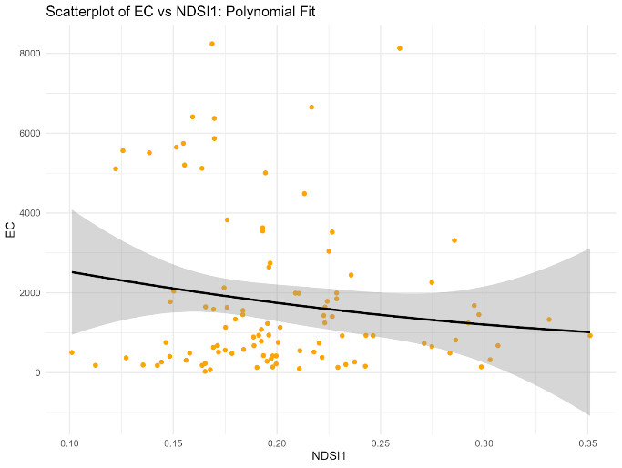 | 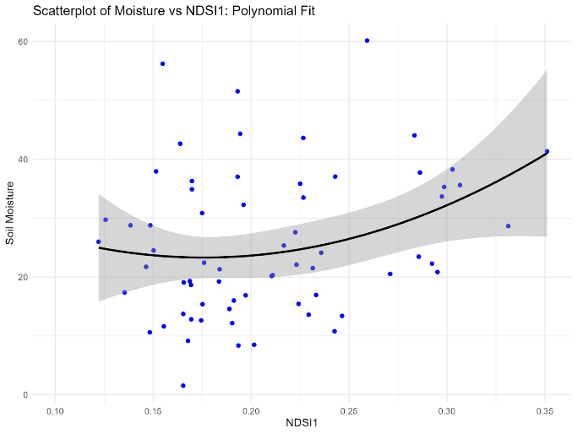
Normalized Green and SWIR1 (NGSWIR1)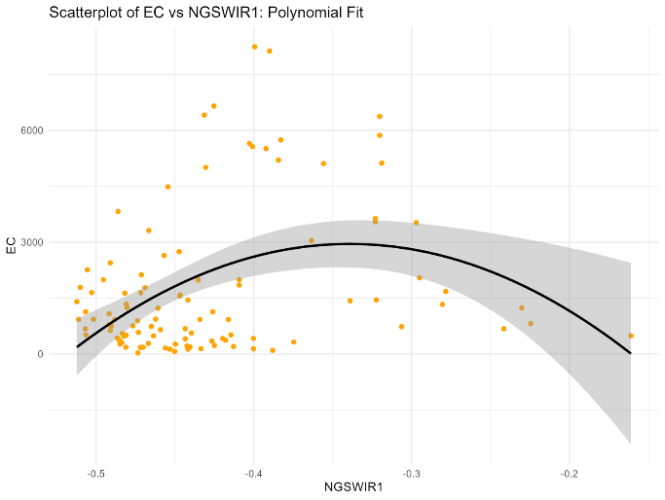 | 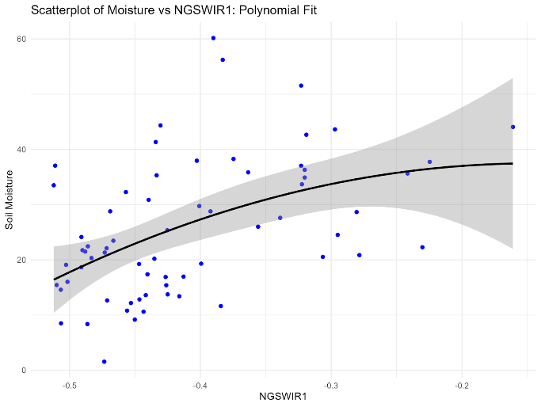
Normalized Blue and SWIR2 (NBSWIR2)  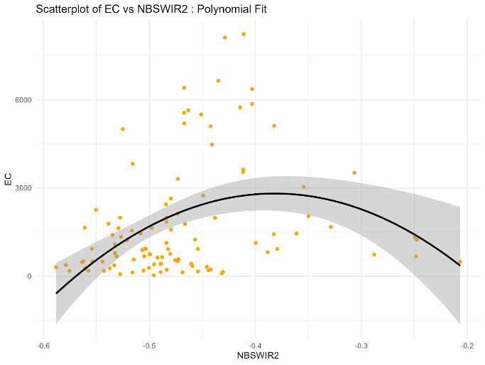 | 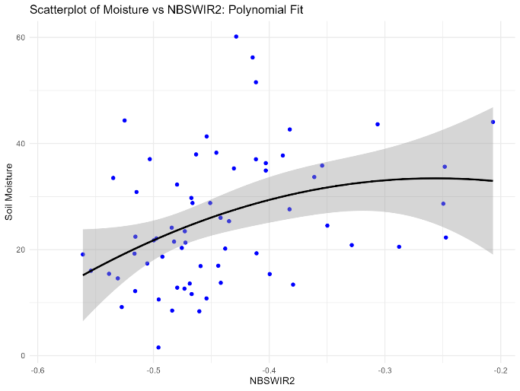
Relationships between indices featuring highest in CoSal-SA model with EC and moisture. NDWI, NBNIR and VSSI increase for higher levels of EC as well as moisture.

Supplementary 9: Accuracies of Training and Testing Sets
Table 1: Model ensemble methods, sampling strategies, and corresponding accuracy metrics for the training set and testing sets (one internal and one external).
 | Final Model | Model 1 | Model 2
Ensemble method | RF | RF | glm
Sampling | Cross validation with k-fold (5) | Bootstrap 0.632 (with replacement) | Cross validation with k-fold (5)
Training
Accuracy | 0.92 | 0.91 | 0.82
Precision | 1 | 0.86 | 0.65
Recall | 0.71 | 0.79 | 0.79
F1-Score | 0.83 | 0.83 | 0.72
Testing (Internal)
Accuracy | 0.86 | 0.81 | 0.76
Precision | 0.8 | 0.6 | 0.55
Recall | 0.67 | 1 | 1
F1-Score | 0.73 | 0.75 | 0.71
Testing (External)
Accuracy | 0.69 | - | -
Precision | 0.71 | - | -
Recall | 0.82 | - | -
F1-Score | 0.76 | - | -

