Supplementary Data
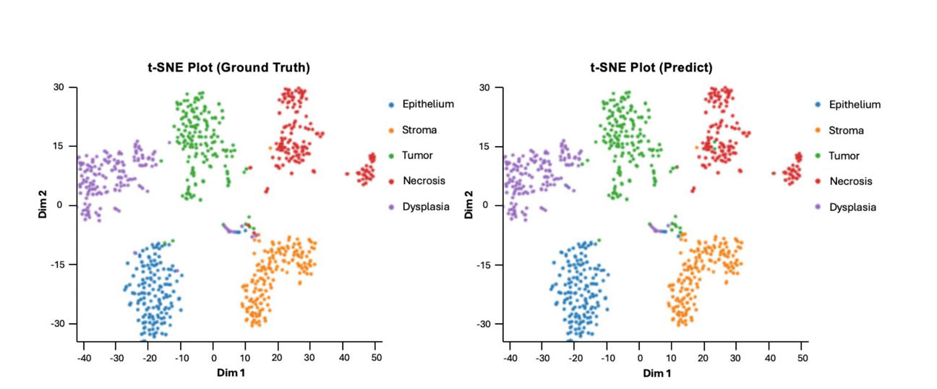
Supplementary Data 1. t-SNE visualization of ground truth and SBU colon cancer detection model predictions. Comparing ground truth (left) and model-predicted (right) histological categories in the SBU colon cancer detection model. Clusters for epithelium, stroma, tumor, necrosis, and dysplasia are distinct and consistent, reflecting the model’s high accuracy.

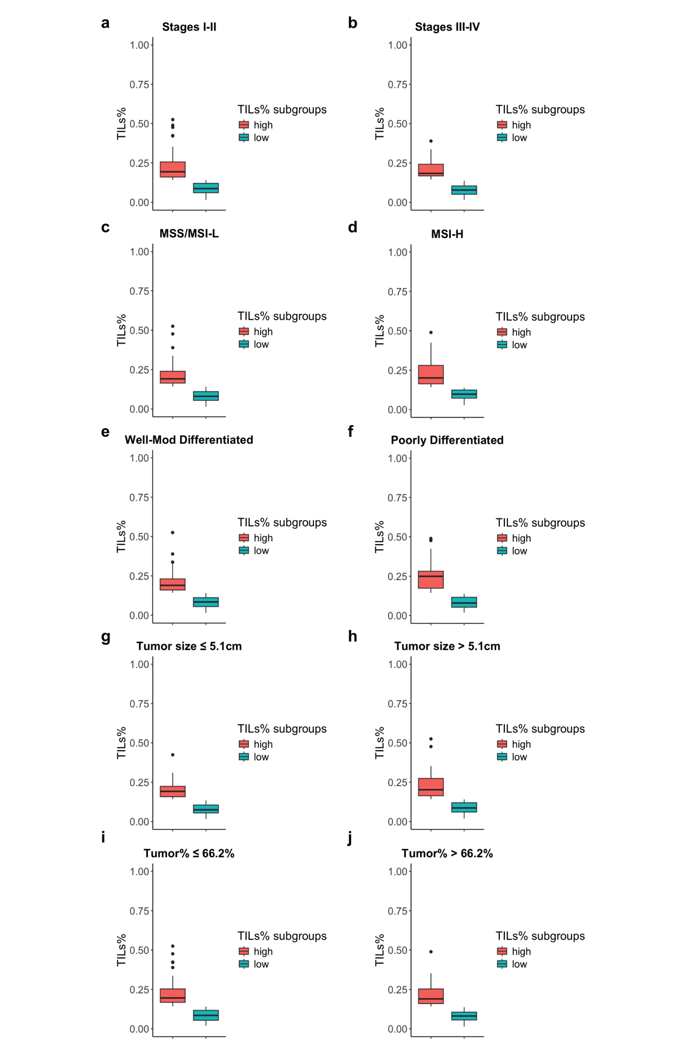
Supplementary Data 2. TILs% distribution in TCGA COAD dataset across clinical and pathological subgroups. Boxplots (a-h) display the distribution of TILs% across various subgroups in the TCGA COAD dataset, comparing samples with high and low TILs% with each subgroup.
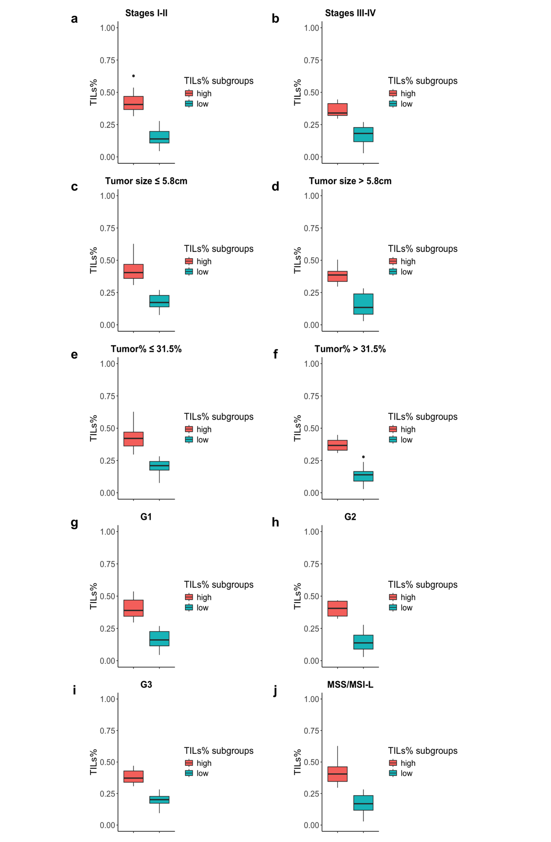
Supplementary Data 3. Comparison of high and low TILs% distribution in UKentucky dataset. Boxplots (a-j) illustrate the distribution of Tils% across AJCC stages, tumor size, tumor content, tumor budding score, and MSI status subgroups.
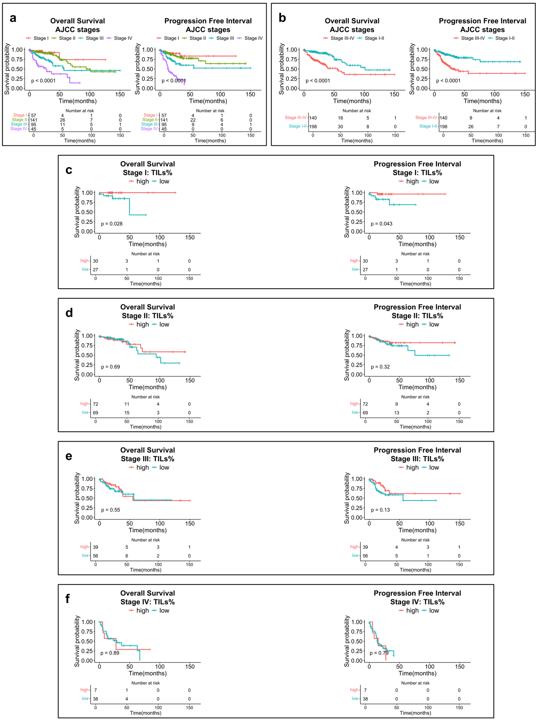
Supplementary Data 4. Kaplan-Meier curves for OS and PFI by AJCC stages and TILs% in TCGA COAD. a) Kaplan-Meier curves illustrate OS and PFI for individual AJCC stages (I, II, III, and IV), providing a detailed view of survival outcomes by each cancer stage. b) localized stages (I-II) versus metastatic stages (III-IV). c-f) TILs% analyses within individual AJCC stages: OS and PFI stratified by TILs% in each stage.

 | Table 1. Patient characteristics
 | Characteristics | TCGA COAD  N=347
 | Immune subtypes
 | C1 | 249 (71.8%)
 | C2 | 69 (19.9%)
 | C3 | 8 (2.3%)
 | C4 | 7 (2.0%)
 | C5 | NA
 | C6 | 2 (0.6%)
Supplementary Data 5. Demographics and clinicopathologic features of TCGA COAD dataset. C1 is characterized by a wound-healing phenotype, C2 exhibits an IFN-γ dominant profile, C3 represents an inflammatory subtype, C4 is defined by lymphocyte depletion, C5 is classified as immunologically quiet, and C6 is dominated by TGF-β signaling.

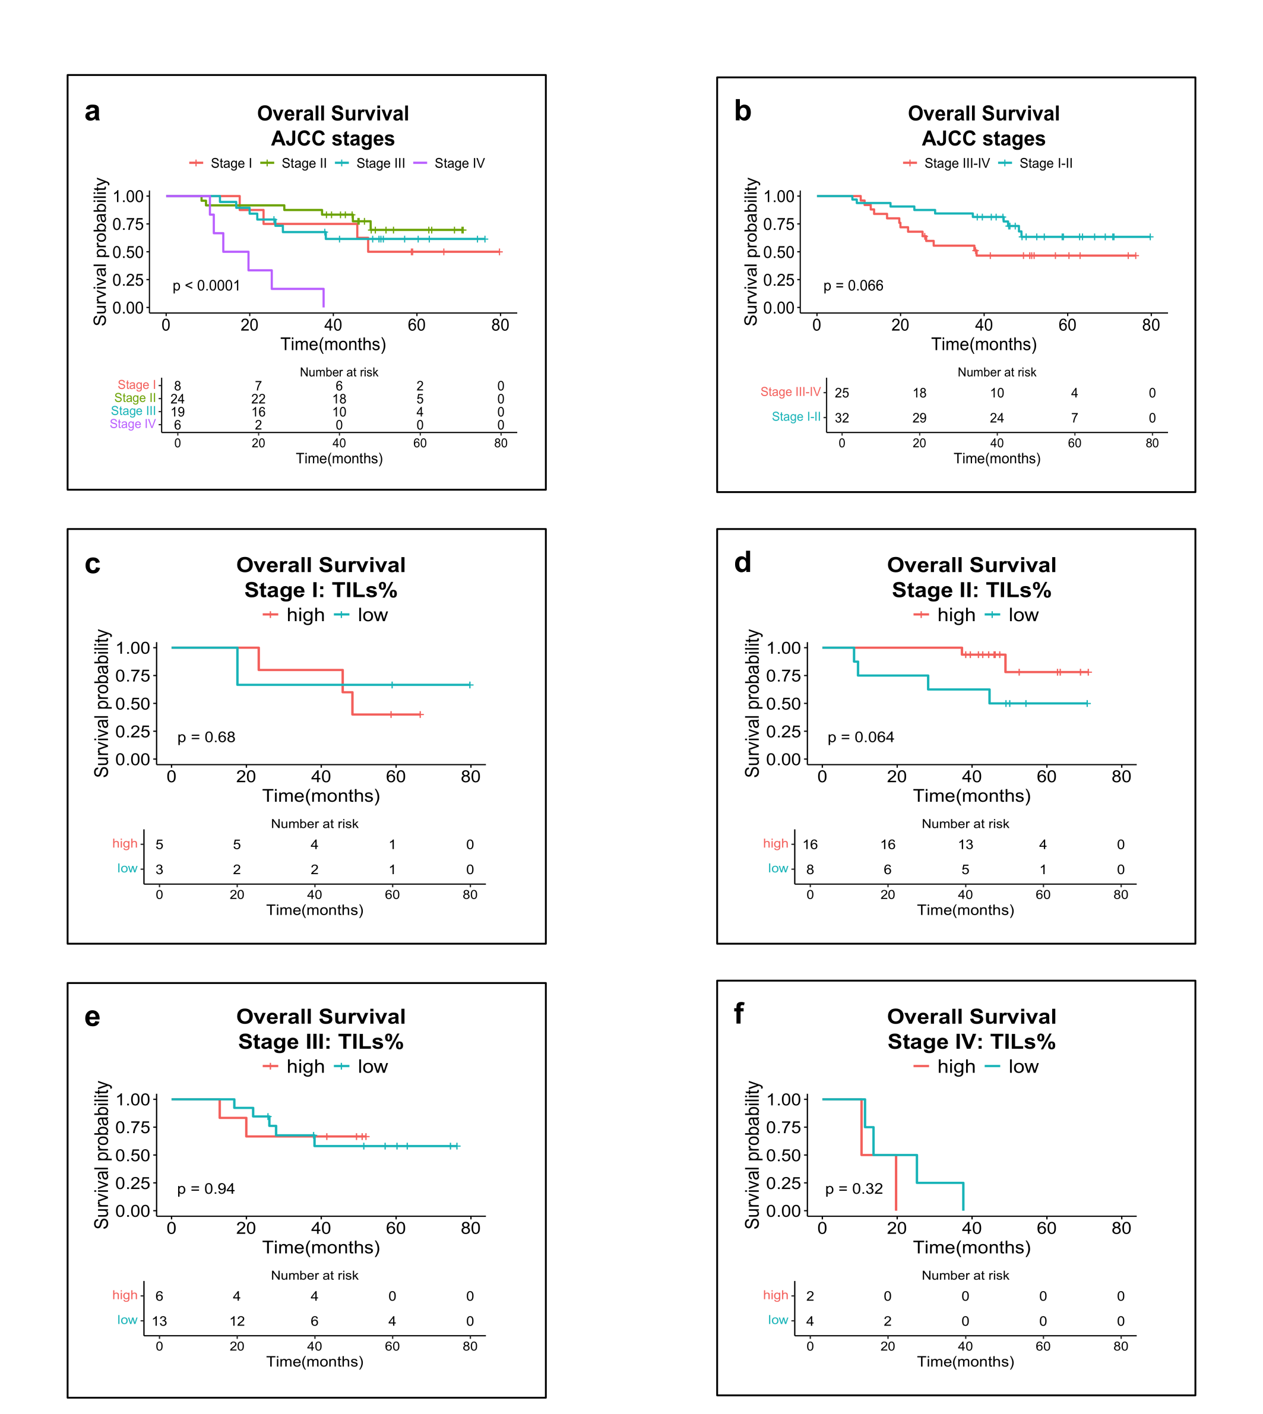
Supplementary Data 6. Kaplan-Meier survival curves showing survival probability by AJCC stages and TILs% across stages in UK dataset. a) OS by AJCC stages I, II, III, and IV. b) OS grouped as stages I-II versus III-IV. c-f) OS within each AJCC stage (I-IV) based on high vs. low TILs%.

