Supplemental Table 1 Septicemia –related Deaths, Stratified by Sex and Race, in the United States, 1999 to 2020.
Deaths
Year | Overall | Women | Men | NH White | NH Black or African American | NH Asian or Pacific Islander | NH American Indian or Alaska Native | Hispanic or Latino | Population
1999 | 137397 | 73917 | 63480 | 101855 | 24387 | 2313 | 744 | 7622 | 180408769
2000 | 135856 | 73409 | 62447 | 101196 | 23699 | 2312 | 717 | 7433 | 181984640
2001 | 138371 | 74803 | 63568 | 102844 | 23819 | 2448 | 729 | 8073 | 184305128
2002 | 141585 | 76159 | 65426 | 105245 | 23941 | 2693 | 801 | 8441 | 186208028
2003 | 143754 | 77172 | 66582 | 106894 | 24103 | 2696 | 873 | 8806 | 188090429
2004 | 144105 | 76969 | 67136 | 107125 | 23765 | 2912 | 844 | 9119 | 190205384
2005 | 150906 | 80221 | 70685 | 111975 | 24538 | 3165 | 917 | 9994 | 192551384
2006 | 150767 | 79862 | 70905 | 111556 | 24362 | 3382 | 906 | 10258 | 195019359
2007 | 150844 | 79508 | 71336 | 111153 | 24478 | 3487 | 1022 | 10451 | 197403777
2008 | 157631 | 83334 | 74297 | 116591 | 24667 | 3773 | 1100 | 11190 | 199795090
2009 | 155788 | 81670 | 74118 | 114995 | 24007 | 3780 | 1202 | 11488 | 202107016
2010 | 158097 | 82448 | 75649 | 116857 | 24032 | 3916 | 1157 | 11803 | 203891983
2011 | 163420 | 85557 | 77863 | 120955 | 24416 | 4097 | 1245 | 12384 | 206592936
2012 | 163765 | 84752 | 79013 | 120755 | 24084 | 4292 | 1283 | 12796 | 208826037
2013 | 172318 | 89011 | 83307 | 126535 | 25524 | 4766 | 1379 | 13603 | 211085314
2014 | 180905 | 92776 | 88129 | 132919 | 26163 | 4871 | 1521 | 14693 | 213809280
2015 | 193873 | 98825 | 95048 | 142408 | 27972 | 5385 | 1620 | 15606 | 216553817
2016 | 196633 | 99610 | 97023 | 143874 | 28374 | 5637 | 1681 | 16406 | 218641417
2017 | 202446 | 102176 | 100270 | 147520 | 28897 | 6034 | 1775 | 17548 | 221447331
2018 | 204714 | 102356 | 102358 | 148529 | 29731 | 6120 | 1707 | 18041 | 223311190
2019 | 199988 | 99303 | 100685 | 145001 | 28968 | 6143 | 1684 | 17734 | 224981167
2020 | 241176 | 116517 | 124659 | 164716 | 38021 | 8222 | 2400 | 27258 | 226635013
Total | 3,684,339 | 1,910,355 | 1,773,984 | 2,701,498 | 571,948 | 92,444 | 27,307 | 280,747 | 4473854489
NH, non-Hispanic.

Supplemental Table 2 Septicemia –related Mortality, Stratified by Place of Death in the United States, 1999 to 2020.

Deaths
Year | Medical Facility - Inpatient | Medical Facility - Outpatient or ER | Medical Facility - Dead on Arrival | Medical Facility - Status unknown | Decedent's home | Nursing home/long term care | Other | Place of death unknown | Total
1999 | 111553 | 3532 | 252 | 962 | 3496 | 16567 | 998 | 37 | 137397
2000 | 110622 | 3505 | 234 | 1068 | 3401 | 15998 | 981 | 47 | 135856
2001 | 113421 | 3784 | 227 | 1016 | 3415 | 15306 | 1173 | 29 | 138371
2002 | 116783 | 3913 | 209 | 1129 | 3476 | 14605 | 1424 | 46 | 141585
2003 | 118887 | 4120 | 176 | 3609 | 93 | 14652 | 1595 | 622 | 143754
2004 | 119344 | 4027 | 156 | 3988 | 260 | 13840 | 1936 | 554 | 144105
2005 | 124059 | 4452 | 166 | 4322 | 783 | 14620 | 1873 | 631 | 150906
2006 | 125141 | 4414 | 128 | 4229 | 1320 | 13436 | 1659 | 440 | 150767
2007 | 125472 | 4323 | 140 | 4260 | 1980 | 12848 | 1622 | 199 | 150844
2008 | 129236 | 4304 | 140 | 4309 | 2537 | 12257 | 1644 | 3204 | 157631
2009 | 125526 | 4388 | 101 | 4314 | 2883 | 11877 | 1795 | 4904 | 155788
2010 | 130740 | 4533 | 117 | 4640 | 3851 | 11961 | 2107 | 148 | 158097
2011 | 133974 | 4655 | 116 | 5184 | 4771 | 12269 | 2312 | 139 | 163420
2012 | 133084 | 4793 | 102 | 5345 | 5891 | 11959 | 2451 | 140 | 163765
2013 | 139750 | 5074 | 161 | 5889 | 6414 | 12073 | 2811 | 146 | 172318
2014 | 145992 | 5391 | 111 | 6487 | 8333 | 12576 | 1882 | 133 | 180905
2015 | 155153 | 5744 | 108 | 7097 | 10541 | 13486 | 1669 | 75 | 193873
2016 | 155933 | 5987 | 109 | 8124 | 11295 | 13377 | 1787 | 21 | 196633
2017 | 159320 | 6391 | 111 | 8554 | 12706 | 13557 | 1777 | 30 | 202446
2018 | 161235 | 6483 | 98 | 9015 | 12902 | 13183 | 1758 | 40 | 204714
2019 | 157401 | 6636 | 77 | 8981 | 12832 | 12111 | 1922 | 28 | 199988
2020 | 191402 | 8438 | 121 | 12971 | 13167 | 12465 | 2577 | 35 | 241176
Total | 2984028 | 108887 | 3160 | 115493 | 126347 | 295023 | 39753 | 11648 | 3684339

Supplemental Table 3 Annual percent change (APC) of Septicemia –related Age-Adjusted Mortality Rates per 100,000 in the United States, 1999 to 2020.
Year Interval | APC (95% CI)
Overall
1999-2012 | -0.36 ( -1.77 to 0.14)
2012-2020 | 1.77* (0.78 to 5.16)
Male
1999-2012 | -0.52 (-1.83 to 0.10)
2012-2020 | 2.15* (1.07 to 5.46)
Female
1999-2012 | -0.32 (-2.35 to 0.25)
2012-2020 | 1.34* (0.47 to 4.65)
NH White
1999-2011 | 0.07 (-1.29 to 0.54)
2012-2020 | 1.70* (1.04 to 3.90)
NH Black or African American
1999-2018 | -1.81* (-2.28 to -1.46)
2018-2020 | 10.70* (2.57 to 14.59)
NH American Indian or Alaska Native
1999-2020 | 1.55* (1.04 to 2.19)
Hispanic or Latino
1999-2018 | -0.78* (-1.97 to -0.06)
2018-2020 | 15.80* (2.97 to 21.36)
NH Asian or Pacific Islander
1999-2018 | -0.76* (-1.98 to -0.21)
2018-2020 | 7.81 (-0.12 to 11.49)
Northeast region
1999-2012 | -1.23* (-3.18 to -0.71)
2012-2020 | 0.64 (-0.30 to 4.16)
Midwest region
1999-2013 | -0.01 (0.97 to 0.45)
2013-2020 | 2.57* (1.41 to 5.96)
South region
1999-2012 | -0.50 (-2.11 to 0.16)
2012-2020 | 2.07* (0.99 to 5.59)
West region
1999-2020 | 0.91* (0.62 to 1.2)
Metropolitan Areas
1999-2012 | -0.6* (-2.09 to -1.0)
2012-2020 | 1.49* (0.49 to 4.95)
Nonmetropolitan Areas
1999-2010 | 0.52 (-0.99 to 1.22)
2010-2020 | 2.81* (2.16 to 4.28)
APC = annual percent change; NH = non-Hispanic; * Indicates that the annual percentage change (APC) is significantly different from zero at α = 0.05. AAMR = age-adjusted mortality rate.

Supplemental Table 4 Overall and Sex‐Stratified Septicemia –related Age-Adjusted Mortality Rates per 100,000 in the United States, 1999 to 2020.

Age-Adjusted Rate (95% CI)
Year | Male | Female | Overall
1999 | 89.9 (89.2 - 90.6) | 69.5 (69.0-70.0) | 77.8 (77.4-78.2)
2000 | 87.2(86.5-87.9) | 68.2(67.7-68.7) | 76(75.6-76.4)
2001 | 86.7(86-87.4) | 68.7(68.2-69.2) | 76.1(75.7-76.5)
2002 | 87.5(86.8-88.2) | 69.1(68.6-69.6) | 76.7(76.3-77.1)
2003 | 87.1(86.4-87.8) | 69.2(68.7-69.7) | 76.5(76.1-76.9)
2004 | 86(85.3-86.6) | 68.2(67.7-68.7) | 75.5(75.1-75.9)
2005 | 88.4(87.8-89.1) | 69.9(69.4-70.4) | 77.6(77.2-78)
2006 | 86.5(85.9-87.2) | 68.6(68.1-69.1) | 76(75.6-76.4)
2007 | 84.9(84.3-85.5) | 67.1(66.7-67.6) | 74.6(74.2-74.9)
2008 | 86.3(85.7-86.9) | 69.2(68.7-69.7) | 76.3(75.9-76.7)
2009 | 83.9(83.3-84.5) | 66.9(66.4-67.3) | 74(73.6-74.4)
2010 | 84.1(83.5-84.7) | 66.4(65.9-66.8) | 73.8(73.4-74.2)
2011 | 83.8(83.2-84.4) | 67.3(66.9-67.8) | 74.3(73.9-74.7)
2012 | 82.5(82-83.1) | 65.4(64.9-65.8) | 72.7(72.3-73)
2013 | 84.5(83.9-85.1) | 67.5(67-67.9) | 74.8(74.4-75.1)
2014 | 86.9(86.3-87.4) | 69(68.5-69.4) | 76.6(76.3-77)
2015 | 91.4(90.8-92) | 72(71.5-72.5) | 80.3(79.9-80.7)
2016 | 91(90.4-91.6) | 71.4(71-71.9) | 79.9(79.5-80.2)
2017 | 91.8(91.2-92.3) | 71.7(71.3-72.2) | 80.4(80-80.7)
2018 | 91.3(90.7-91.9) | 70.6(70.2-71.1) | 79.5(79.2-79.9)
2019 | 87.8(87.2-88.3) | 67.5(67-67.9) | 76.2(75.9-76.6)
2020 | 105.9(105.3-106.5) | 78.4(77.9-78.8) | 90.5(90.1-90.8)
Total | 88.3(88.2-88.5) | 69.3(69.2-69.4) | 77.3(77.2-77.4)

Supplemental Table 5 Septicemia –related Age-Adjusted Mortality Rates per 100,000, Stratified by Race in the United States, 1999 to 2020.
Age-Adjusted Rate (95% CI)
Year | NH White | NH Black or African American | NH American Indian or Alaska Native | Hispanic or Latino | NH Asian or Pacific Islander
1999 | 68.8 (68.4-69.2) | 160.4 (158.4-162.5) | 94.8 (87.4-102.2) | 83.8 (81.8-85.8) | 58.4 (55.9-60.9)
2000 | 67.8 (67.3-68.2) | 155.0 (153.0-157.0) | 86.2 (79.5-93.0) | 78.1 (76.2-80) | 54.3 (52.0-56.7)
2001 | 68.1 (67.7-68.5) | 152.5 (150.6-154.5) | 82.6 (76.2-89.0) | 80.7 (78.8-82.5) | 53.0 (50.8-55.2)
2002 | 68.9 (68.5-69.3) | 151.2 (149.3-153.2) | 89.3 (82.6-95.9) | 79.9 (78.1-81.7) | 55.1 (52.9-57.3)
2003 | 69.1 (68.7-69.6) | 148.9 (147.0-150.8) | 93.7 (87.0-100.4) | 78.7 (77-80.5) | 52.3 (50.3-54.4)
2004 | 68.5 (68.1-69.0) | 144.1 (142.2-146.0) | 86.2 (80.0-92.5) | 78.1 (76.4-79.8) | 54.1 (52.0-56.1)
2005 | 70.6 (70.2-71.0) | 145.3 (143.4-147.2) | 92.7 (86.2-99.2) | 81.3 (79.6-83) | 54.5 (52.5-56.4)
2006 | 69.3 (68.9-69.7) | 140.2 (138.4-142.0) | 88.8 (82.6-95.1) | 78.4 (76.8-80) | 54.8 (52.9-56.7)
2007 | 68.0 (67.6-68.4) | 137.3 (135.5-139.0) | 96.8 (90.4-103.2) | 76.3 (74.7-77.8) | 54.2 (52.4-56.1)
2008 | 70.3 (69.9-70.7) | 134.8 (133.0-136.5) | 102.4 (95.9-108.9) | 77.6 (76.1-79.2) | 55.3 (53.5-57.1)
2009 | 68.4 (68.0-68.8) | 127.1 (125.5-128.8) | 110.0 (103.4-116.7) | 74.8 (73.4-76.3) | 52.4 (50.7-54.1)
2010 | 68.6 (68.2-69.0) | 124.3 (122.7-126.0) | 100.8 (94.6-107.1) | 74.8 (73.3-76.2) | 52.5 (50.8-54.2)
2011 | 69.6 (69.2-70.0) | 122.1 (120.5-123.7) | 102.6 (96.5-108.7) | 73 (71.6-74.3) | 50.6 (49.0-52.1)
2012 | 68.3 (67.9-68.7) | 116.2 (114.7-117.7) | 101.9 (95.9-107.8) | 71.4 (70.1-72.7) | 49.8 (48.2-51.3)
2013 | 70.5 (70.1-70.8) | 119.1 (117.6-120.6) | 102.4 (96.7-108.1) | 72.2 (70.9-73.4) | 51.5 (50.0-53.0)
2014 | 72.9 (72.5-73.3) | 117.9 (116.4-119.3) | 110.0 (104.2-115.8) | 73 (71.7-74.2) | 49.2 (47.8-50.6)
2015 | 76.9 (76.5-77.3) | 121.9 (120.4-123.3) | 112.3 (106.6-118.1) | 73.6 (72.4-74.8) | 50.7 (49.4-52.1)
2016 | 76.7 (76.3-77.1) | 119.7 (118.3-121.1) | 111.7 (106.1-117.2) | 73.5 (72.4-74.7) | 50.4 (49.0-51.7)
2017 | 77.4 (77.0-77.8) | 118.0 (116.6-119.4) | 114.4 (108.9-119.9) | 74.9 (73.7-76) | 50.9 (49.6-52.2)
2018 | 76.7 (76.3-77.1) | 118.0 (116.6-119.3) | 104.6 (99.5-109.8) | 73.4 (72.3-74.5) | 49.1 (47.8-50.3)
2019 | 73.9 (73.6-74.3) | 111.6 (110.3-112.9) | 100.1 (95.2-105.0) | 69.2 (68.2-70.3) | 47.0 (45.8-48.2)
2020 | 83.3 (82.9-83.8) | 142.5 (141.0-144.0) | 136.3 (130.7-142.0) | 100 (98.8-101.3) | 59.5 (58.2-60.8)
TOTAL | 71.7 (71.6-71.8) | 131.2 (130.8-131.5) | 102.0 (100.7-103.2) | 76.8 (76.5-77.1) | 52.1 (51.7-52.4)
NH = non-Hispanic.

Supplemental Table 6 Septicemia –related Age-Adjusted Mortality Rates per 100,000, Stratified by States in the United States, 1999 to 2020.

State | Age-Adjusted Rate (95% CI)
Alabama | 94.5 (93.8-95.2)
Alaska | 56.3 (54.3-58.2)
Arizona | 55.5 (55.0-56.0)
Arkansas | 93.8 (92.9-94.7)
California | 75.0 (74.7-75.2)
Colorado | 54.9 (54.3-55.4)
Connecticut | 76.5 (75.8-77.2)
Delaware | 81.8 (80.3-83.3)
District of Columbia | 135.4 (132.9-137.9)
Florida | 60.8 (60.6-61.1)
Georgia | 92.6 (92.0-93.1)
Hawaii | 52.8 (51.8-53.7)
Idaho | 49.8 (48.9-50.7)
Illinois | 82.8 (82.4-83.2)
Indiana | 80.4 (79.8-80.9)
Iowa | 54.6 (54.0-55.3)
Kansas | 64.2 (63.4-64.9)
Kentucky | 103.6 (102.9-104.4)
Louisiana | 104.0 (103.2-104.8)
Maine | 52.8 (51.9-53.7)
Maryland | 92.7 (92.1-93.4)
Massachusetts | 72.1 (71.6-72.6)
Michigan | 76.5 (76.0-76.9)
Minnesota | 43.4 (42.9-43.8)
Mississippi | 107.6 (106.6-108.6)
Missouri | 72.4 (71.9-72.9)
Montana | 49.5 (48.5-50.6)
Nebraska | 52.3 (51.5-53.2)
Nevada | 85.8 (84.8-86.7)
New Hampshire | 54.3 (53.3-55.3)
New Jersey | 103.6 (103.1-104.1)
New Mexico | 68.8 (67.8-69.7)
New York | 72.8 (72.5-73.1)
North Carolina | 87.0 (86.5-87.4)
North Dakota | 54.3 (52.9-55.7)
Ohio | 81.1 (80.7-81.6)
Oklahoma | 92.8 (92.0-93.6)
Oregon | 47.0 (46.4-47.5)
Pennsylvania | 79.5 (79.2-79.9)
Rhode Island | 81.9 (80.6-83.2)
South Carolina | 97.3 (96.6-98.0)
South Dakota | 57.4 (56.1-58.6)
Tennessee | 93.0 (92.3-93.6)
Texas | 96.2 (95.8-96.5)
Utah | 56.1 (55.2-56.9)
Vermont | 49.2 (47.9-50.5)
Virginia | 82.7 (82.2-83.3)
Washington | 61.6 (61.1-62.0)
West Virginia | 101.5 (100.4-102.6)
Wisconsin | 51.6 (51.1-52.0)
Wyoming | 58.3 (56.7-60.0)

Supplemental Table 7 Septicemia –related Age-Adjusted Mortality Rates per 100,000, Stratified by Census Region in the United States, 1999 to 2020.

Census Region | Year | Age-Adjusted Rate (95% CI)
Northeast | 1999 | 85.5 (84.5-86.4)
Northeast | 2000 | 84.7 (83.8-85.6)
Northeast | 2001 | 84 (83.1-84.9)
Northeast | 2002 | 83.8 (82.9-84.7)
Northeast | 2003 | 81.4 (80.5-82.3)
Northeast | 2004 | 81.9 (81-82.7)
Northeast | 2005 | 84 (83.1-84.9)
Northeast | 2006 | 81.3 (80.4-82.2)
Northeast | 2007 | 78.8 (78-79.7)
Northeast | 2008 | 78.6 (77.7-79.5)
Northeast | 2009 | 73.6 (72.7-74.4)
Northeast | 2010 | 74 (73.2-74.9)
Northeast | 2011 | 74.4 (73.6-75.2)
Northeast | 2012 | 71.9 (71.1-72.7)
Northeast | 2013 | 74.7 (73.9-75.5)
Northeast | 2014 | 76.4 (75.6-77.3)
Northeast | 2015 | 78.4 (77.5-79.2)
Northeast | 2016 | 76.8 (76-77.7)
Northeast | 2017 | 73.9 (73.2-74.7)
Northeast | 2018 | 73.9 (73.1-74.7)
Northeast | 2019 | 71 (70.3-71.8)
Northeast | 2020 | 82.6 (81.7-83.4)
Northeast | TOTAL | 78.2 (78.1-78.4)
Midwest | 1999 | 69.9 (69.1-70.7)
Midwest | 2000 | 67.7 (67-68.5)
Midwest | 2001 | 67.6 (66.8-68.4)
Midwest | 2002 | 68.7 (67.9-69.5)
Midwest | 2003 | 68.3 (67.5-69.1)
Midwest | 2004 | 67.1 (66.3-67.9)
Midwest | 2005 | 69.9 (69.1-70.6)
Midwest | 2006 | 67.7 (66.9-68.4)
Midwest | 2007 | 67.2 (66.5-68)
Midwest | 2008 | 70.4 (69.6-71.1)
Midwest | 2009 | 68.2 (67.4-68.9)
Midwest | 2010 | 67.3 (66.6-68)
Midwest | 2011 | 69.5 (68.8-70.3)
Midwest | 2012 | 67 (66.3-67.7)
Midwest | 2013 | 68.1 (67.4-68.9)
Midwest | 2014 | 70.8 (70-71.5)
Midwest | 2015 | 75 (74.2-75.7)
Midwest | 2016 | 73.5 (72.8-74.3)
Midwest | 2017 | 74.8 (74.1-75.6)
Midwest | 2018 | 75.3 (74.5-76)
Midwest | 2019 | 73.4 (72.6-74.1)
Midwest | 2020 | 86.8 (86.1-87.6)
Midwest | TOTAL | 70.9 (70.8-71.1)
South | 1999 | 87.6 (86.9-88.4)
South | 2000 | 85.6 (84.9-86.3)
South | 2001 | 86 (85.3-86.7)
South | 2002 | 86.7 (86-87.4)
South | 2003 | 86.9 (86.2-87.6)
South | 2004 | 85.1 (84.4-85.8)
South | 2005 | 87.1 (86.4-87.8)
South | 2006 | 85.2 (84.5-85.8)
South | 2007 | 83.4 (82.7-84)
South | 2008 | 85 (84.3-85.7)
South | 2009 | 83.3 (82.6-83.9)
South | 2010 | 82.5 (81.9-83.2)
South | 2011 | 81.7 (81.1-82.4)
South | 2012 | 81.3 (80.7-81.9)
South | 2013 | 83.5 (82.9-84.2)
South | 2014 | 85.6 (84.9-86.2)
South | 2015 | 89.9 (89.2-90.5)
South | 2016 | 89.8 (89.1-90.4)
South | 2017 | 91.1 (90.5-91.8)
South | 2018 | 90.7 (90.1-91.3)
South | 2019 | 86.1 (85.5-86.7)
South | 2020 | 102.6 (102-103.2)
South | TOTAL | 87 (86.8-87.1)
West | 1999 | 62 (61.2-62.8)
West | 2000 | 59.7 (58.9-60.5)
West | 2001 | 60.6 (59.8-61.4)
West | 2002 | 61.2 (60.4-61.9)
West | 2003 | 63 (62.2-63.8)
West | 2004 | 62.1 (61.4-62.9)
West | 2005 | 63.5 (62.7-64.2)
West | 2006 | 64.3 (63.5-65.1)
West | 2007 | 63.2 (62.5-64)
West | 2008 | 65.7 (64.9-66.4)
West | 2009 | 64.6 (63.9-65.4)
West | 2010 | 65.7 (64.9-66.4)
West | 2011 | 66.3 (65.6-67.1)
West | 2012 | 64.4 (63.7-65.1)
West | 2013 | 66.4 (65.7-67.2)
West | 2014 | 67.2 (66.5-67.9)
West | 2015 | 71 (70.2-71.7)
West | 2016 | 71.6 (70.9-72.4)
West | 2017 | 72.7 (72-73.5)
West | 2018 | 69.4 (68.7-70)
West | 2019 | 66.4 (65.8-67.1)
West | 2020 | 79.5 (78.8-80.2)
West | TOTAL | 66.6 (66.4-66.7)

Supplemental Table 8 Septicemia –related Age-Adjusted Mortality Rates per 100,000, Stratified by Urban-Rural Classification in the United States, 1999 to 2020.

Age-Adjusted Rate (95% CI)
Year | Metropolitan | Nonmetropolitan
1999 | 79.4 (79-79.9) | 71 (70.1-71.9)
2000 | 77.5 (77-77.9) | 69.6 (68.7-70.5)
2001 | 77.2 (76.8-77.7) | 71.2 (70.3-72.1)
2002 | 78 (77.5-78.4) | 71.1 (70.2-72)
2003 | 77.6 (77.1-78) | 72 (71.1-72.9)
2004 | 76.6 (76.2-77.1) | 70.8 (69.9-71.7)
2005 | 78.5 (78-78.9) | 73.9 (73-74.8)
2006 | 76.9 (76.5-77.4) | 72 (71.1-72.9)
2007 | 75.3 (74.9-75.7) | 71.5 (70.7-72.4)
2008 | 76.7 (76.3-77.1) | 75.1 (74.2-76)
2009 | 74 (73.5-74.4) | 74.5 (73.6-75.4)
2010 | 73.7 (73.3-74.1) | 74.6 (73.7-75.5)
2011 | 73.9 (73.5-74.3) | 76.6 (75.8-77.5)
2012 | 72.1 (71.7-72.4) | 76.1 (75.2-76.9)
2013 | 73.8 (73.5-74.2) | 79.6 (78.7-80.5)
2014 | 75.4 (75-75.8) | 83.2 (82.3-84.1)
2015 | 78.6 (78.2-79) | 89.2 (88.3-90.2)
2016 | 78.1 (77.7-78.5) | 89.3 (88.3-90.2)
2017 | 78.5 (78.2-78.9) | 90.2 (89.3-91.2)
2018 | 77.5 (77.1-77.9) | 90.7 (89.7-91.6)
2019 | 74 (73.6-74.3) | 88.7 (87.8-89.7)
2020 | 88.4 (88-88.8) | 102.2 (101.2-103.2)
Total | 77 (76.9-77.1) | 79.3 (79.1-79.5)

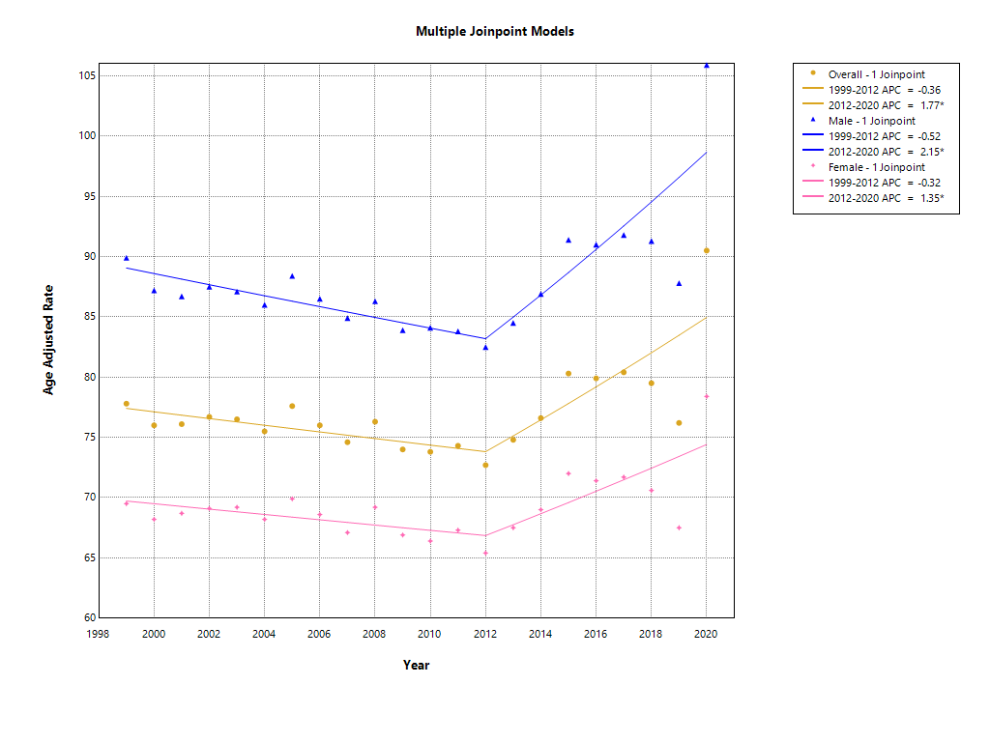
Supplementary figure 1: Joinpoint graph showing overall trends stratified by gender for Septicemia related mortality in the US adults from 1999 to 2020

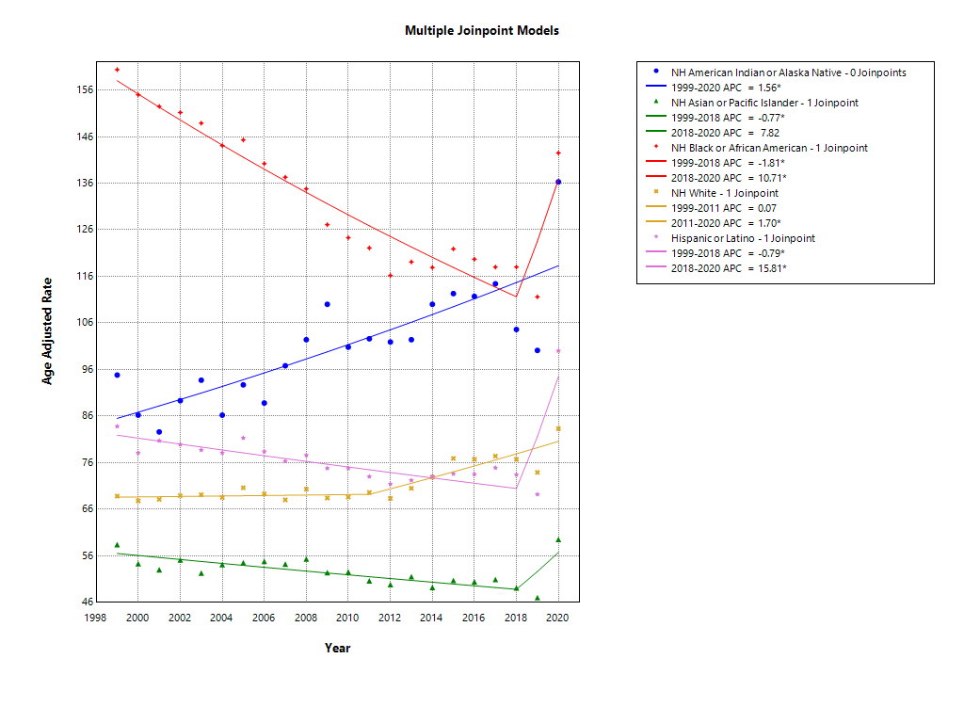
Supplementary figure 2: Joinpoint graph showing overall trends stratified by race for septicemia related mortality in the US adults from 1999 to 2020

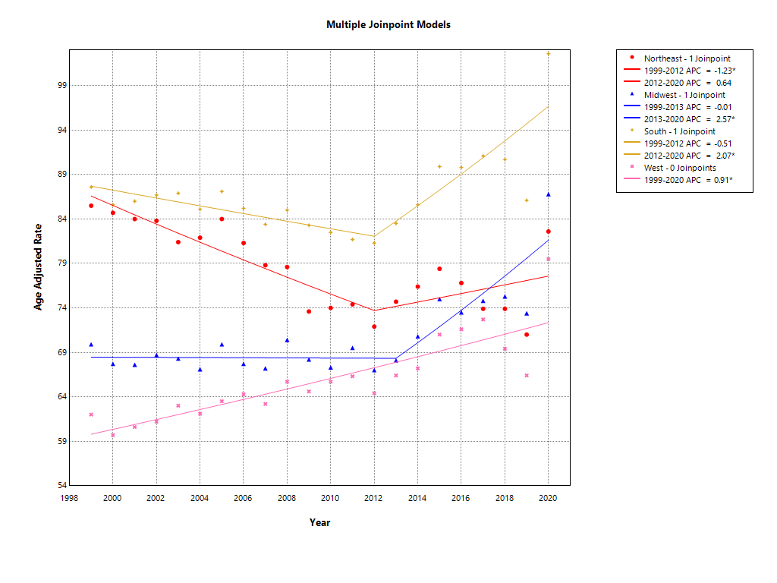
Supplementary figure 3: Joinpoint graph showing overall trends stratified by census region for septicemia related mortality in the US adults from 1999 to 2020

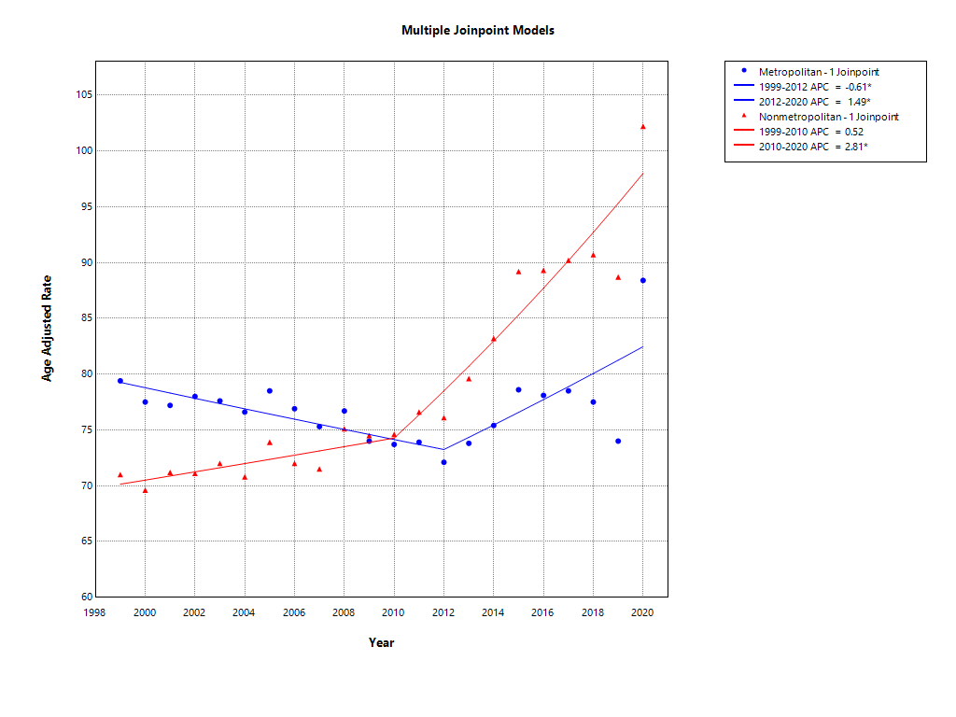Supplementary figure 4: Joinpoint graph showing overall trends stratified by Urbanization for septicemia related mortality in the US adults from 1999 to 2020

