Supplemental Figure 1: Cell death in anti-microbial peptide samples after 24 hour exposure to 1% bacteria free supernatants from L. crispatus or G. vaginalis in ectocervical, endocervical and vaginal epithelial cells. NYCIII (NYC) media without bacteria acted as controls. Values are mean ± SEM. Asterisks over solid lines represent comparisons between treatment groups. *p<0.05, **p<0.01

Supplementary Figure 2: Mapping (number and percentage) of reads for each cell type. hg38 = mapped to the human reference genome and used for downstream analysis. Duplicates = removed for the same exact DNA fragment. rCRSd = mitochondrial genome per revised Cambridge Reference Sequence doubled genome. QC filtered = poor quality reads that were removed (MAPQ score <10).

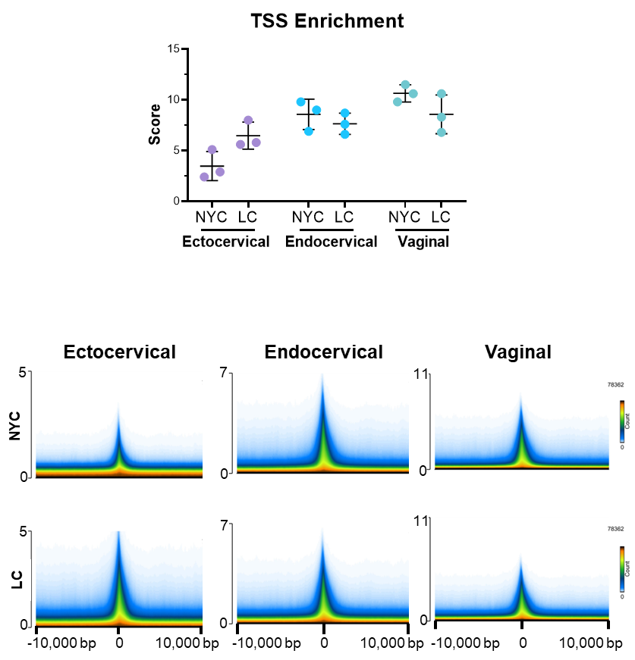
Supplementary Figure 3: Enrichment of reads around the TSS. Top: Graph of TSS enrichment score for each biological replicate. Bottom: Density of counts around the TSS for each condition by cell types.

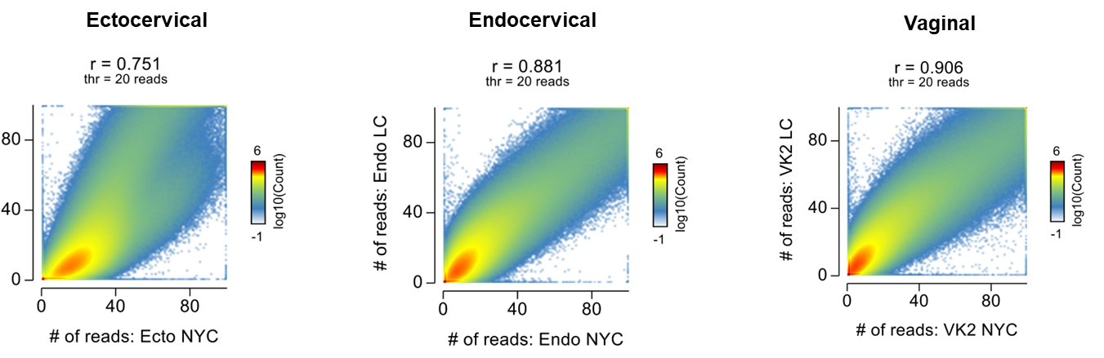
Supplementary Figure 4: Correlation between treatment conditions of read counts (not normalized)

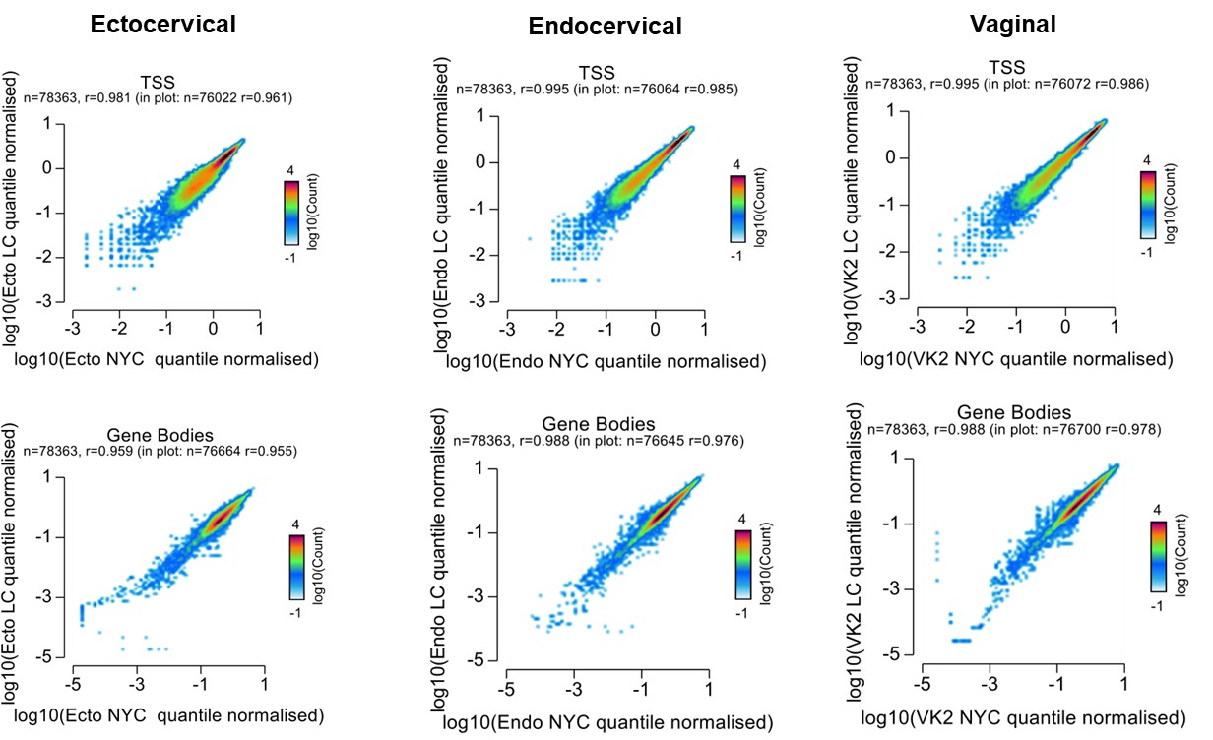

Supplementary Figure 5: Correlation of normalized read counts between conditions at TSS or within the gene bodies

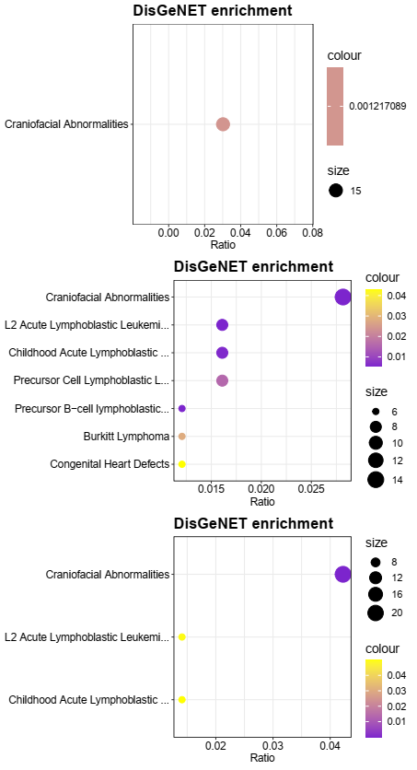
FDR
FDR
FDR

Supplementary Figure 6: Random DisGeNET enrichment bubble charts for random motif lists that were generated.

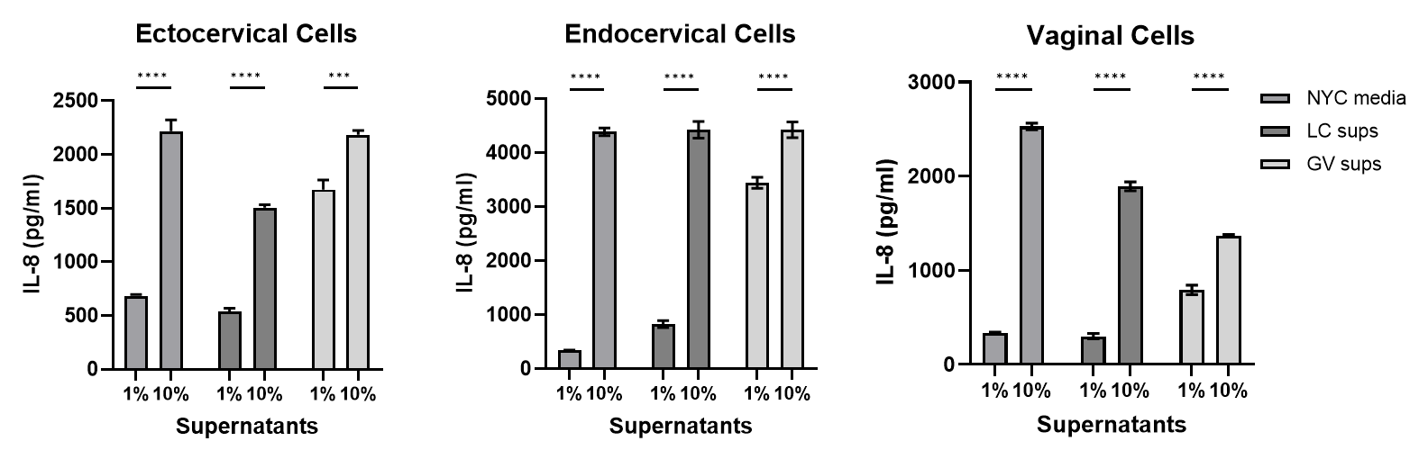

Supplementary Figure 7: Dose response of bacteria-free supernatants from L. crispatus (LC) or G. vaginalis (GV) cultures in ectocervical, endocervical or vaginal epithelial cells. Bacteria-free supernatants were diluted to either 1% (v/v) or 10% (v/v) in keratinocyte serum free media (KSFM). NYCIII media without bacteria diluted in KSMF was used as the control. IL-8 was utilized as a general marker of detectable inflammation and was measured by ELISA. Values are mean ± SEM. Asterisks over solid lines represent comparisons between treatment groups. ***p<0.001, ****p<0.0001

Supplemental Figure 8: Cell death in RNA sequencing samples after 24 hour exposure to 1% bacteria free supernatants from L. crispatus or G. vaginalis in ectocervical, endocervical and vaginal epithelial cells. Non-treated (NT) cells or NYCIII (NYC) media without bacteria acted as controls. Values are mean ± SEM. Asterisks over solid lines represent comparisons between treatment groups. *p<0.05, **p<0.01, ***p<0.001

