An isolable germa-isonitrile featuring a terminal nitrogen-germanium triple bond
Zixu Wang,¹⁺ Chengxiang Ding,²⁺ Yizhen Chen,¹ Mengdi Huang,³ Dongmin Wang,¹ Lei Xu,⁴ Sudip Pan,²* Shengfa Ye,^{1,3}* Gengwen Tan¹*
¹ Key Laboratory of Bioinorganic and Synthetic Chemistry of Ministry of Education, Guangdong Basic Research Center of Excellence for Functional Molecular Engineering, School of Chemistry, IGCME, Sun Yat-sen University, Guangzhou 510275, China
² Institute of Atomic and Molecular Physics, Jilin University, Changchun 130023, China
³ State Key Laboratory of Catalysis, Dalian Institute of Chemical Physics, Chinese Academy of Sciences, 457 Zhongshan Road, Dalian 116023, China
⁴ Jiangsu Key Lab of Data Engineering and Knowledge Service, Key Laboratory of Data Intelligence and Interdisciplinary Innovation, Nanjing University, Nanjing 210023, China
E-mail: sudip@jlu.edu.cn; yeshf6@mail.sysu.edu.cn; tangw55@mail.sysu.edu.cn

Content
Experimental methods S3
Synthesis of 2 S5
Synthesis of 3 S7
Synthesis of 4 S10
Synthesis of 5 S12
Synthesis of 6 S15
Synthesis of 7 S17
Synthesis of 8 S19
Synthesis of 9 S24
Synthesis of 10 S22
Molecular structures determined by single-crystal X-ray diffraction analysis with refinement details S27
Theoretical Calculations S39
Electronic absorption spectra S53
Infra-red absorption spectra S56
References S62

Experimental methods
General methods
All experiments were carried out under dry oxygen-free nitrogen using standard Schlenk techniques or in a N₂ filled-glovebox (Vigor) unless otherwise stated. Solvents were dried by standard methods: n-Hexane, toluene and THF were dried by distilling from Na/benzoquinone under N₂ atmosphere; deuterated benzene was distilled from Na, and deuterated chloroform was distilled from CaH₂ under N₂ atmosphere. All the solvents were stored in activated 4Å molecular sieves in the glovebox. Commercially available reagents were purchased from Energy Chemical and used as received. The starting materials M^{s}Fluid*-GeCl,⁷⁸ ¹⁵N labeled sodium azide (NaN₂¹⁵N),⁷⁹ 1,3,4,5-tetramethyl-imidazolin-2-ylidene (NHC^{Me4}),⁸⁰ and Fe(PMe₃)₄⁸¹ were synthesized according to the reported procedures

NMR and ESI-MS measurements
The ¹H and ¹³C{¹H} NMR spectra were recorded on Bruker spectrometers (AV400 or AV600) referenced to residual solvent signals as internal standards. ³¹P{¹H} NMR was referenced externally to an 85% H₃PO₄ solution in H₂O. ²⁹Si{¹H} NMR was referenced externally to SiMe₄. Chemical shift values for protons are referenced to the residual proton resonance of CDCl₃ (δ: 7.26), C₆D₆ (δ: 7.16); chemical shift values for carbons are referenced to the carbon resonance of CDCl₃ (δ: 77.16), C₆D₆ (δ: 127.96). NMR multiplicities are abbreviated as follows: s = singlet, d = doublet, t = triplet, q = quartet, sept = septet, m = multiplet, br = broad signal. Chemical shifts are quoted in δ (ppm) and coupling constants in Hz. The samples were dissolved in deuterated solvents, and were sealed off in J-Young NMR tubes for measurements. All the solid-state NMR spectra were collected at room temperature (297 K) on a Bruker Advance III 400 MHz (9.4 T) NMR spectrometer equipped with a 4 mm HX double resonance Magic-Angle-Spinning (MAS) probe. Samples were packed into 4 mm zirconia rotors and tightly sealed with Kel-F rotor caps in an Ar-filled glovebox prior to the transportation to the spectrometer. ¹⁵N spin echo NMR spectrum was acquired for complex X with π/2 excitation with a recycle delay of 5 s. ¹H→¹⁵N Cross-Polarization (CP) MAS NMR spectra were acquired for 3, with a CP contact time of 3 ms and a recycle delay of 1.5 s. Line-shape fitting of the spectra were performed using the DMFIT software. ESI-MS spectra were measured on Waters ACQUITY UPLC I Class plus or Thermo Scientific Q Exactive.

Single-Crystal X-ray Diffraction Analyses
For the single crystal X-ray structural analyses, the crystals were each mounted on a glass capillary in perfluorinated oil and measured in a cold N₂ flow. The data was collected on an XtaLAB Synergy R, DW system, HyPix diffractometer at low temperatures. Structures were solved by intrinsic phasing method using the SHELXT 2018/2 program⁸² and refined with full-matrix least squares on F² using the SHELXL 2019/3 program⁸³ by using OLEX2 1.5⁸⁴ as the graphical interface. All non-hydrogen atoms in the structure were refined anisotropically and all hydrogen atoms were assigned isotropic displacement coefficients U(H) = 1.2 U or 1.5 U and their coordinates were allowed to ride on their respective atoms.

UV-vis measurements
UV-vis measurements were carried out on Perkin Elmer Lambda 950 UV-Vis-NIR.

Infrared Spectroscopy
Infrared spectra of samples were recorded on PerkinElmer Frontier FT-NIR Spectrometer.

Synthesis of 2
In an N₂-filled glovebox, anhydrous THF (50 mL) was added to a 100 mL Schlenk flask that containing M^{S}Fluid*-GeCl (1.06 g, 1.0 mmol) and sodium azide (195 mg, 3.0 mmol). The mixture was stirred for 3 days at room temperature, followed by removal of THF under vacuum, extraction with toluene, and filtration to remove NaCl and excess NaN₃. All volatiles were removed under vacuum, and the residue was re-dissolved in THF (50 ml). Another potion of sodium azide (195 mg, 3.0 mmol) was added to the solution. After stirring for another 4 days, the solvent was removed under vacuum to give a pale yellow solid. The residue was extracted with toluene, and filtered. All volatiles were removed under vacuum, and the remaining pale yellow solid was washed with n-hexane (5 mL × 2) to yield the product as a yellow solid. Yield: 813 mg, 0.76 mmol, 76%. Pale yellow crystals suitable for X-ray diffraction analysis were obtained from n-hexane solution at room temperature. ¹H NMR (600 MHz, C₆D₆, 298 K, ppm): δ = 1.18-1.30 (m, 48H, C(CH₃)₂), 1.55-1.66 (m, 28H, C(CH₃)₂ + CH₂CH₂), 2.54 (s, 4H, CCH₂C(CH₃)₂), 7.19 (s, 1H, Ar-H), 7.36 (s, 4H, fluorenyl-H), 7.79 (s, 4H, fluorenyl-H). ¹³C{¹H} NMR (150 MHz, C₆D₆, 298 K, ppm): 31.78 (C(CH₃)₂), 31.86 (C(CH₃)₂), 31.89 (C(CH₃)₂), 32.21 (C(CH₃)₂), 34.34, 34.60, 35.14, 35.18 (CH₂CH₂), 44.25 ((CH₃)₂CCH₂C), 55.00 ((CH₃)₂CCH₂C), 62.68 ((CH₃)₂CCH₂C), 116.43, 117.69, 122.80, 123.38, 145.08, 151.46, 153.35, 158.01(Ar-C). ESI-MS [M + H]⁺ (m/z): Calcd: 1070.6341; Found: 1070.6343.
Synthesis of ¹⁵N labeled 2: In an N₂-filled glovebox, anhydrous THF (20 mL) was added to a 100 mL Schlenk flask that containing M^{S}Fluid*-GeCl (531 mg, 0.5 mmol) and ¹⁵N labeled sodium azide NaN₂¹⁵N (40 mg, 0.6 mmol). Then crypt-222 (38 mg, 0.1 mmol) was added to the mixture to promote reaction. After stirring for 7 days, the solvent was removed under vacuum to give a pale yellow solid. The residue was extracted with toluene, and filtered. All volatiles were removed under vacuum, and the remaining pale yellow solid was washed with n-hexane (2 mL × 2) to yield the product ¹⁵N-2 as a yellow solid.

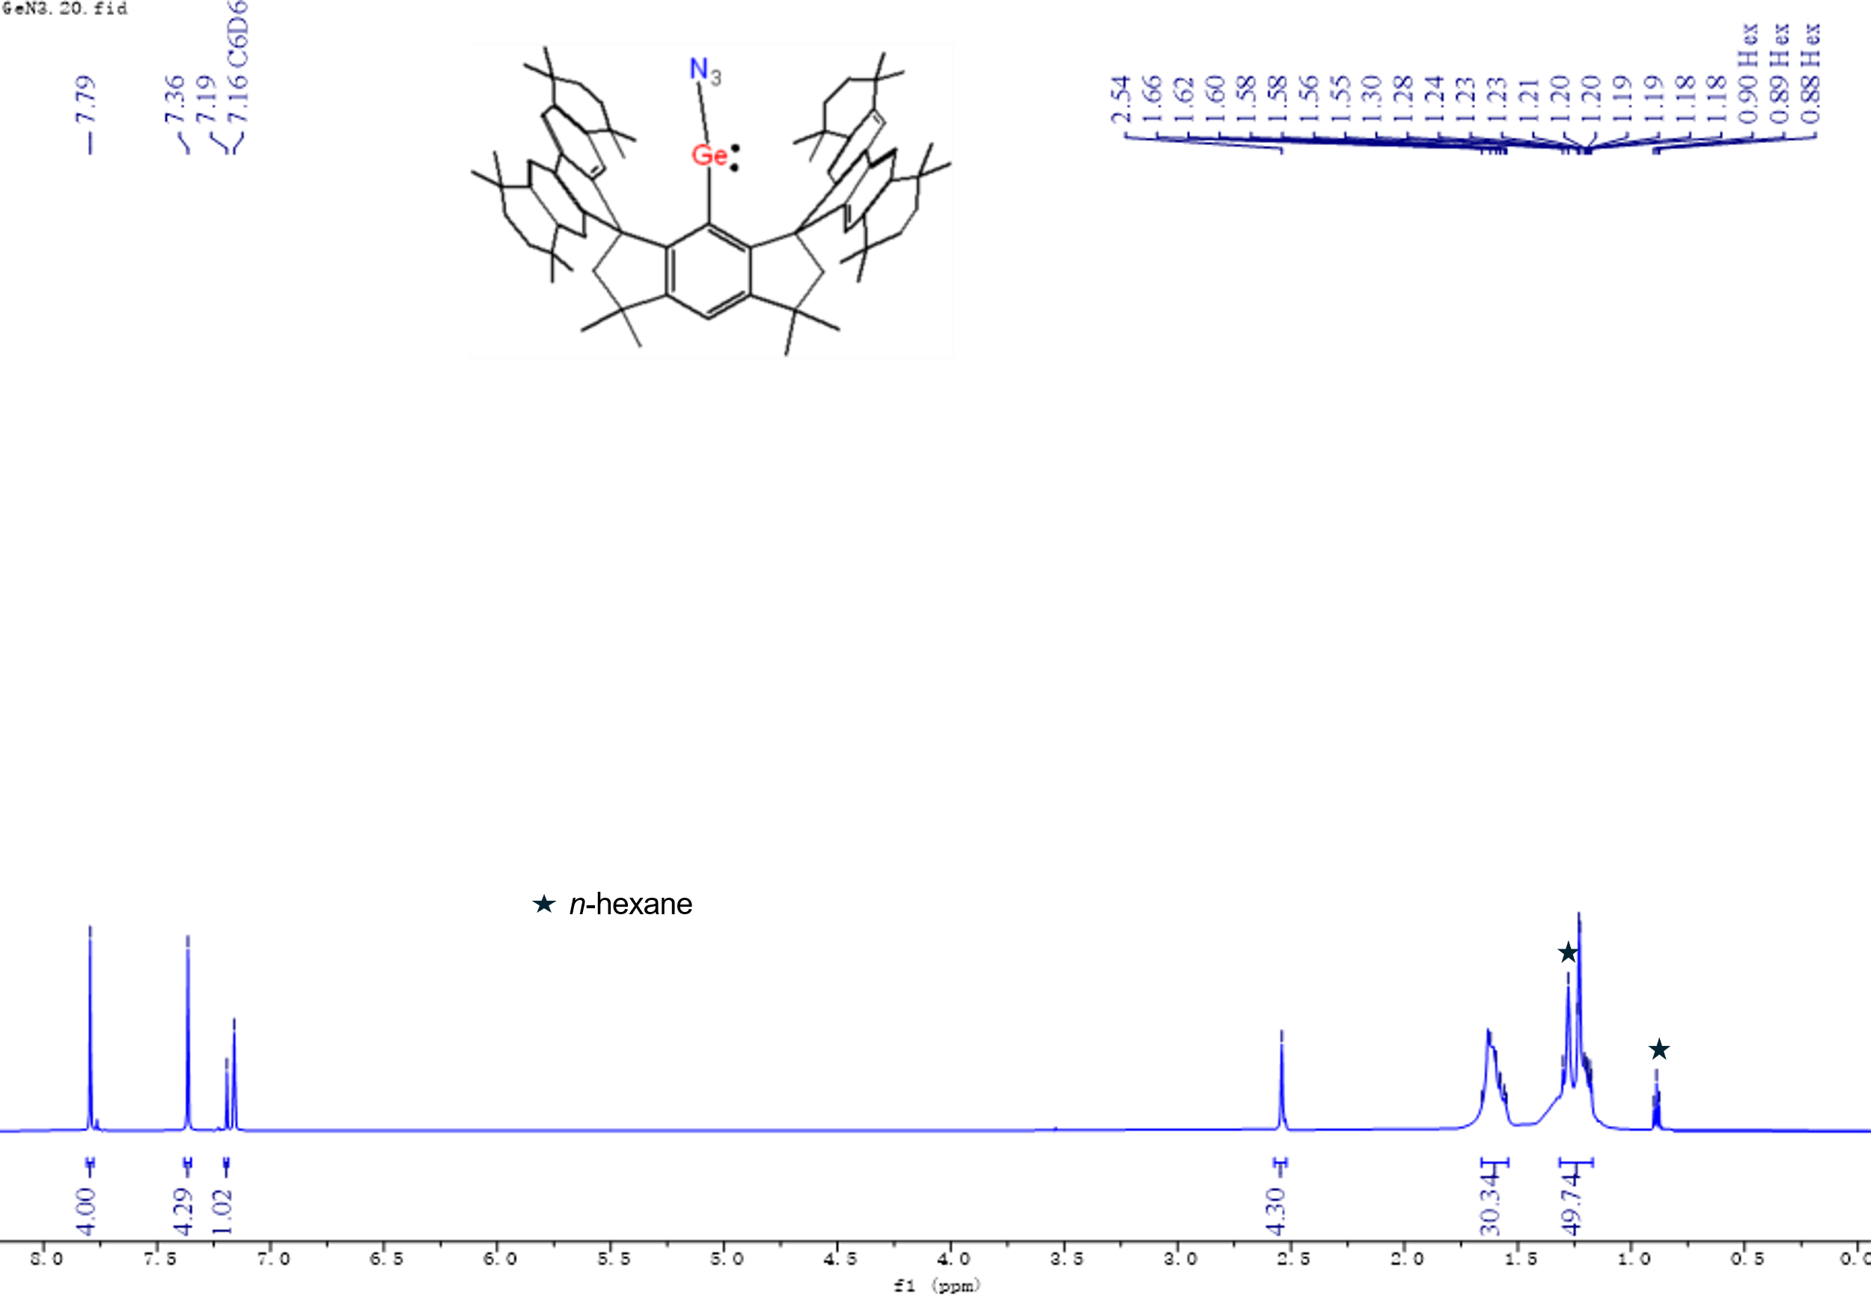
Supplementary Fig. 1 ¹H NMR spectrum of 2 in C₆D₆ at room temperature.

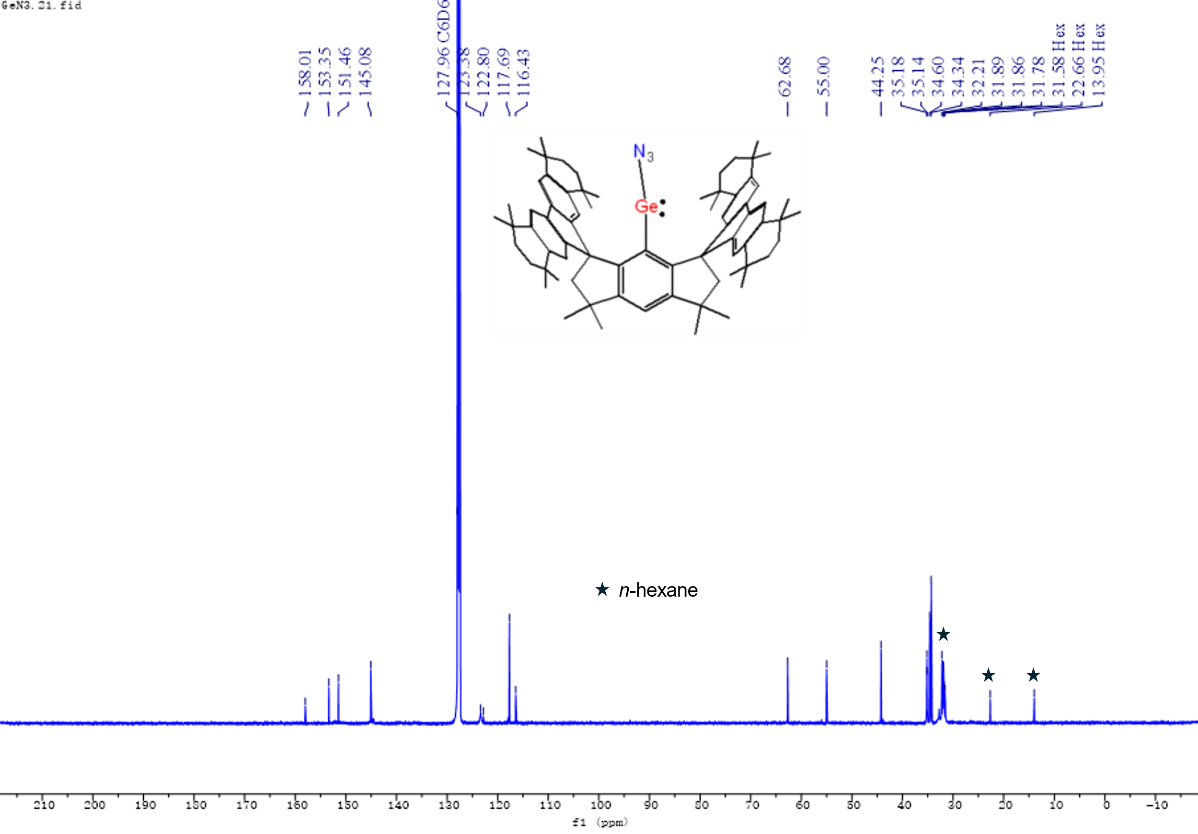
Supplementary Fig. 2 ¹³C{¹H} NMR spectrum of 2 in C₆D₆ at room temperature.

Supplementary Fig. 3 Mass spectrum of 2 (top: expt.; bottom: calcd.).

Synthesis of 3
In an N₂-filled glovebox, 2 (1.07 g, 1.0 mmol) was dissolved in anhydrous C₆H₆ (50 mL). The mixture was illuminated with 313 nm light (100 W) for 40 hours at room temperature. Afterwards all volatiles were removed under vacuum to give an orange residue, which was extracted with n-hexane (20 mL), and filtered. The filtrate was concentrated to ca. 10 mL and kept at –30 ºC for 24 h to give a yellow crystalline solid. Yield: 512 mg, 0.49 mmol, 49%. Yellow crystals suitable for X-ray diffraction analysis were obtained from n-hexane solution at room temperature. ¹H NMR (600 MHz, C₆D₆, 298 K, ppm): δ = 1.17 (s, 12H, C(CH₃)₂), 1.21 (s, 12H, C(CH₃)₂), 1.27 (s, 12H, C(CH₃)₂), 1.33 (s, 12H, C(CH₃)₂), 1.57-1.67 (m, 28H, C(CH₃)₂ + CH₂CH₂), 2.56 (s, 4H, CCH₂C(CH₃)₂), 7.03 (s, 1H, Ar-H), 7.34 (s, 4H, fluorenyl-H), 7.73 (s, 4H, fluorenyl-H). ¹³C{¹H} NMR (600 MHz, C₆D₆, 298 K, ppm): δ = 31.99 (C(CH₃)₂), 32.02 (C(CH₃)₂), 32.45 (C(CH₃)₂), 32.51 (C(CH₃)₂), 34.20, 34.44 (CCH₂C(Ar)(CH₃)₂), 35.29, 35.37 (CH₂CH₂), 42.45 ((CH₃)₂CCH₂C), 57.33 ((CH₃)₂CCH₂C), 61.73 ((CH₃)₂CCH₂C), 109.41, 115.90, 121.81, 138.50, 138.94, 142.17, 142.69, 143.42, 151.49, 154.80 (Ar-C). ESI-MS [M + H]⁺ (m/z): Calcd: 1042.6280; Found: 1042.6281.
Synthesis of 3 with 50% ¹⁵N labeling (¹⁵N-3): In an N₂-filled glovebox, ¹⁵N-2 (275 mg, 0.26 mmol) was dissolved in anhydrous C₆H₆ (10 mL) in a quartz tube. The mixture was illuminated with 313 nm light (100 W) for 5 hours at room temperature. Afterwards, all volatiles were removed under vacuum to give an orange residue, which was extracted with n-hexane (5 mL), and filtered. The filtrate was concentrated to ca. 1 mL and kept at –30 ºC for 24 h to give a yellow crystalline solid ¹⁵N-3. The sample was collected by removing mother liquor with syringe and dried under vacuum for 3 hours, which was used for infra-red and ¹⁵N{¹H} NMR spectroscopic characterizations.
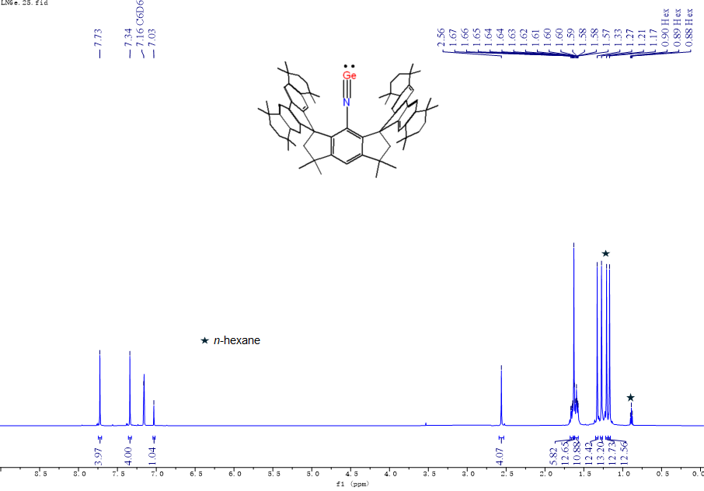
Supplementary Fig. 4 ¹H NMR spectrum of 3 in C₆D₆ at room temperature.

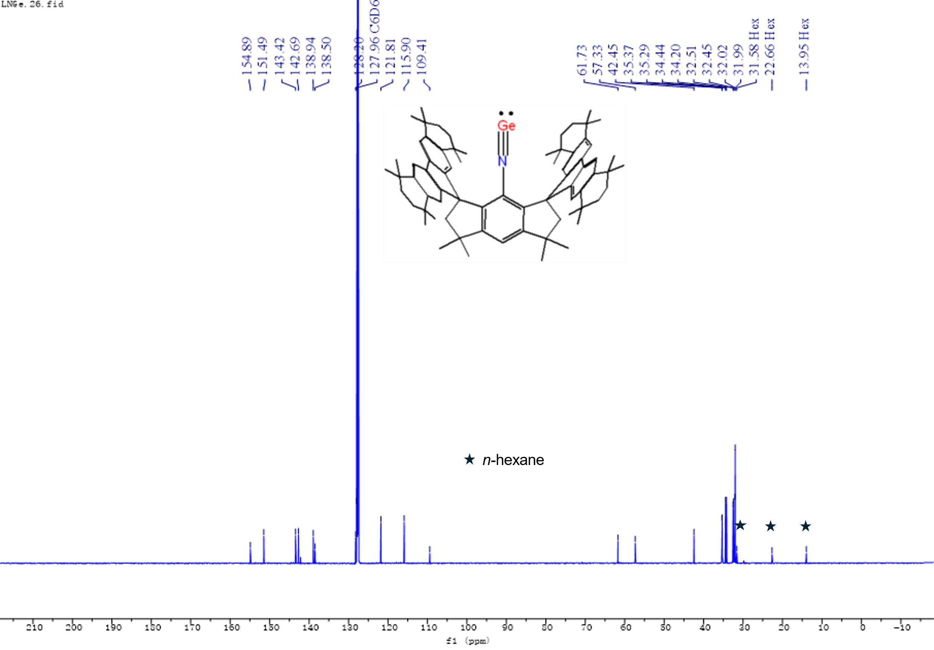
Supplementary Fig. 5 ¹³C{¹H} NMR spectrum of 3 in C₆D₆ at room temperature.

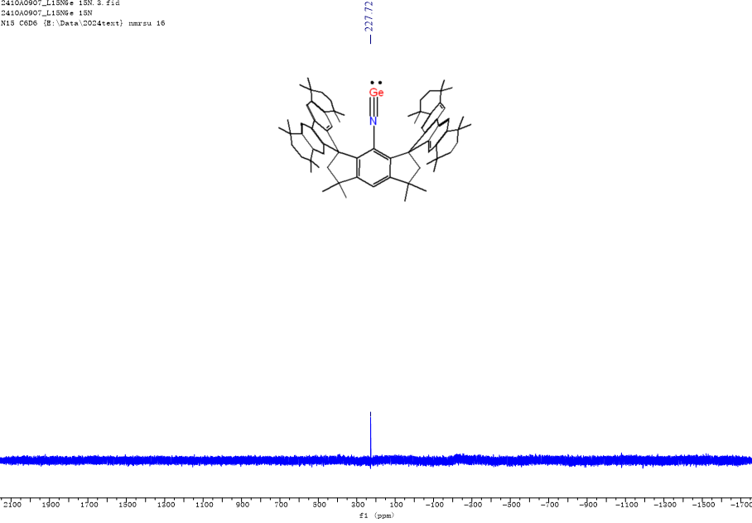
Supplementary Fig. 6 ¹⁵N{¹H} NMR spectrum of 3 in C₆D₆ at room temperature.
Supplementary Fig. 7 Solid-state ¹⁵N CP-MAS NMR spectrum with line broadening factor of 100 (black) with simulated line shape (red) of 3 obtained at 3 kHz MAS, 9.4 T, room temperature.

Supplementary Fig. 8 Mass spectrum of 3 (top: expt.; bottom: calcd.).

Synthesis of 4
In an N₂-filled glovebox, anhydrous n-hexane (5 mL) was added to a 25 mL Schlenk flask containing 3 (104 mg, 0.1 mmol) and 1,3,4,5-tetramethyl-imidazolin-2-ylidene NHC^{Me4} (14 mg, 0.11 mmol). A violet suspension was formed in 5 min and stirred for 10 hours. The mixture was filtered and the residue was dried under vacuum for 2 hours to yield a violet solid of 4. Yield: 75 mg, 0.06 mmol, 64% Violet crystals suitable for X-ray diffraction analysis were obtained from n-hexane solution at room temperature. ¹H NMR (600 MHz, C₆D₆, 298 K, ppm): δ = 1.18 (s, 12H, C(CH₃)₂), 1.24 (s, 12H, C(CH₃)₂), 1.29 (s, 12H, C(CH₃)₂), 1.33 (s, 6H, CH₃C=CCH₃), 1.37 (s, 12H, C(CH₃)₂), 1.59-1.72 (m, 16H, CH₂CH₂), 1.81 (s, 12H, C(CH₃)₂), 2.58 (s, 4H, CCH₂C(CH₃)₂), 2.89 (s, 6H, NCH₃), 6.67 (s, 1H, Ar-H), 7.41 (s, 4H, fluorenyl-H), 7.52 (s, 4H, fluorenyl-H). ¹³C{¹H} NMR (150 MHz, C₆D₆, 298 K, ppm): δ = 7.45 (H₃CC=CCH₃), 31.19 (N-CH₃), 32.02 (C(CH₃)₂), 32.28 (C(CH₃)₂), 32.39 (C(CH₃)₂), 32.87 (C(CH₃)₂), 33.14 (C(CH₃)₂), 34.09, 34.49 (CCH₂C(Ar)(CH₃)₂), 34.59, 34.74 (CH₂CH₂), 42.57 ((CH₃)₂CCH₂C), 59.54 ((CH₃)₂CCH₂C), 62.35 ((CH₃)₂CCH₂C), 99.65, 115.20, 122.10, 122.54 (H₃CC=CCH₃), 123.71, 138.39, 141.43, 143.13, 154.83, 154.88, 156.05 (Ar-C), 170.51 (N-C-N). ESI-MS [M + H]⁺ (m/z): Calcd: 1166.7280; Found: 1166.7240.

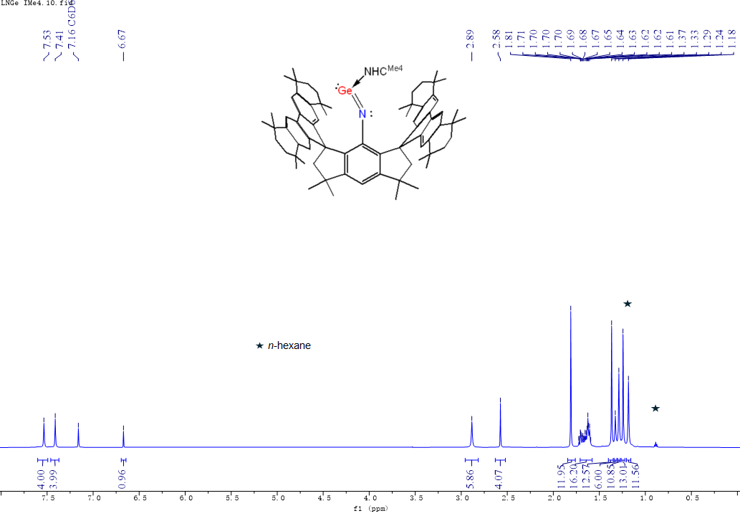
Supplementary Fig. 9 ¹H NMR spectrum of 4 in C₆D₆ at room temperature.

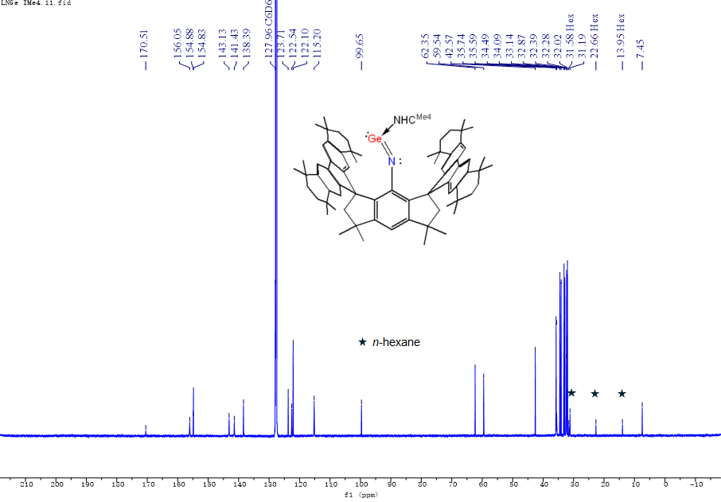
Supplementary Fig. 10 ¹³C{¹H} NMR spectrum of 4 in C₆D₆ at room temperature.

Supplementary Fig. 11 Mass spectrum of 4 (top: expt.; bottom: calcd.).

Synthesis of 5
In an N₂-filled glovebox, phenylsilane (12 mg, 0.11 mmol) was added to n-hexane solution (5 mL) of 3 (104 mg, 0.1 mmol) at room temperature. The mixture was stirred for 10 hours at room temperature to afford a light yellow solution. The mixture was filtered and concentrated to ca. 3 mL. After standing at –30 ºC for 24 h a crystalline colorless solid of 5 was formed, which was collected by removing the mother liquor with syringe and dried under vacuum for 2 hours. Yield: 66 mg, 0.06 mmol, 57%. Colorless crystals suitable for X-ray diffraction analysis were obtained from n-hexane solution at room temperature. ¹H NMR (600 MHz, C₆D₆, 298 K, ppm): δ = 1.14 (s, 12H, C(CH₃)₂), 1.22 (s, 6H, C(CH₃)₂), 1.27 (s, 6H, C(CH₃)₂), 1.30 (s, 6H, C(CH₃)₂), 1.39 (s, 6H, C(CH₃)₂), 1.43 (s, 6H, C(CH₃)₂), 1.51-1.64 (m, 28H, C(CH₃)₂ + CH₂CH₂), 1.76 (s, 6H, C(CH₃)₂), 2.47 (d, ²J_{H,H} = 13.8 Hz, 2H, CCH₂C(CH₃)₂), 2.66 (d, ²J_{H,H} = 13.8 Hz, 2H, CCH₂C(CH₃)₂), 2.88 (s, 2H, NSiH₂), 7.19-7.21 (m, 3H, Ar-H), 7.32 (s, 1H, Ar-H), 7.34 (s, 2H, Ar-H), 7.37 (s, 1H, Ar-H), 7.50 (s, 2H, Ar-H), 7.78 (s, 2H, Ar-H), 7.85 (s, 2H, Ar-H), 10.83 (s, 1H, GeH). ¹³C{¹H} NMR (150 MHz, C₆D₆, 298 K, ppm): δ = 30.45 (C(CH₃)₂), 31.41 (C(CH₃)₂), 31.95 (C(CH₃)₂), 32.13 (C(CH₃)₂), 32.19 (C(CH₃)₂), 32.39(C(CH₃)₂), 32.80 (C(CH₃)₂), 33.20 (C(CH₃)₂), 34.15, 34.24, 34.56, 34.66 (CCH₂C(Ar)(CH₃)₂), 35.05, 35.19, 35.30, 35.50 (CH₂CH₂), 42.28 ((CH₃)₂CCH₂C), 59.51 ((CH₃)₂CCH₂C), 62.31 ((CH₃)₂CCH₂C), 112.08, 117.21, 117.57, 120.63, 123.17, 126.92, 128.78, 134.74, 136.22, 136.89, 137.61, 138.85, 143.59, 143.95, 144.03, 144.66, 151.45, 153.03, 153.25, 156.71 (Ar-C). ²⁹Si{¹H} NMR (119 MHz, C₆D₆, 298 K, ppm): δ = –27.89. ESI-MS [M + H]⁺ (m/z): Calcd: 1150.6675; Found: 1150.6675.

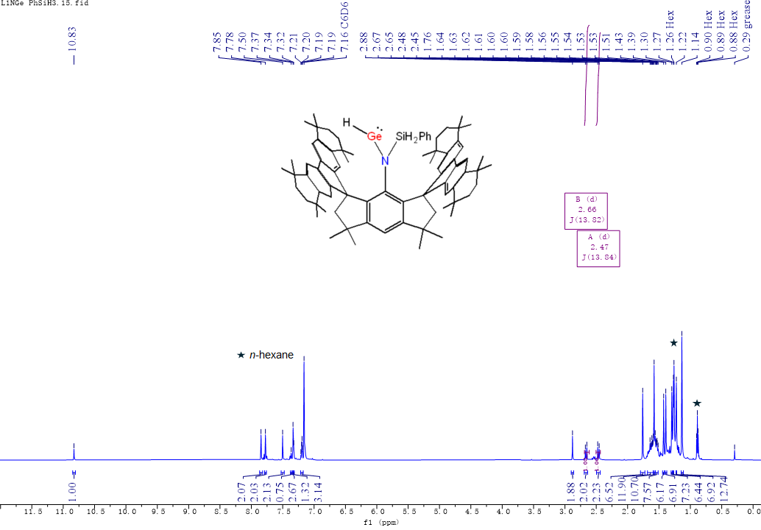
Supplementary Fig. 12 ¹H NMR spectrum of 5 in C₆D₆ at room temperature.

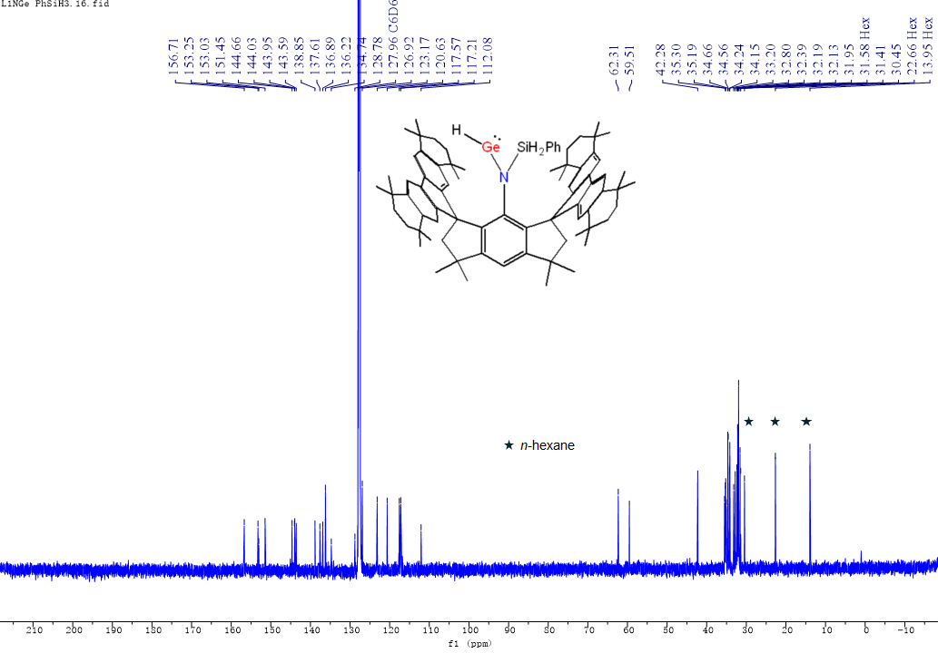
Supplementary Fig. 13 ¹³C{¹H} NMR spectrum of 5 in C₆D₆ at room temperature.
Supplementary Fig. 14 ²⁹Si{¹H} NMR spectrum of 5 in C₆D₆ at room temperature.

Supplementary Fig. 15 Mass spectrum of 5 (top: expt.; bottom: calcd.).

Synthesis of 6
In an N₂-filled glovebox, TMSN₃ (13 mg, 0.11 mmol) was added to n-hexane solution (5 mL) of 3 (104 mg, 0.1 mmol) at room temperature. The mixture was stirred for 10 hours at room temperature to afford a light yellow solution. The mixture was filtered, and the filtrate was concentrated to ca. 3 mL. After standing at –30 ºC for 24 h a crystalline colorless solid of 6 was formed, which was collected by removing the mother liquor with syringe and dried under vacuum for 2 hours. Yield: 82 mg, 0.07 mmol, 71%. Colorless crystals suitable for X-ray diffraction analysis were obtained from n-hexane solution at room temperature. ¹H NMR (400 MHz, C₆D₆, 301.6 K, ppm): δ = 0.38 (s, 9H, Si(CH₃)₃), 1.18 (s, 6H, C(CH₃)₂), 1.23 (s, 6H, C(CH₃)₂), 1.27 (s, 6 H, C(CH₃)₂), 1.28 (s, 6 H, C(CH₃)₂), 1.33 (s, 6H, C(CH₃)₂), 1.40 (s, 6 H, C(CH₃)₂), 1.41 (s, 6 H, C(CH₃)₂), 1.54-1.75 (m, 28H, C(CH₃)₂ + CH₂CH₂), 2.47 (d, ²J_{H,H} = 14.1 Hz, 2H, CCH₂C(CH₃)₂), 2.56 (d, ²J_{H,H} = 14.1 Hz, 2H, CCH₂C(CH₃)₂), 7.28 (s, 2H, fluorenyl-H), 7.33 (s, 2H, fluorenyl-H), 7.35 (s, 1H, Ar-H), 7.37 (s, 4H, fluorenyl-H). ¹³C{¹H} NMR (100 MHz, C₆D₆, 302.9 K, ppm): δ = 1.57 (Si(CH₃)₃), 31.75 (C(CH₃)₂), 32.00 (C(CH₃)₂), 32.04 (C(CH₃)₂), 32.13 (C(CH₃)₂), 32.24 (C(CH₃)₂), 32.53 (C(CH₃)₂), 32.59 (C(CH₃)₂), 32.68 (C(CH₃)₂), 32.80 (C(CH₃)₂), 32.95 (C(CH₃)₂), 34.19, 34.23, 34.43, 34.61 (CCH₂C(Ar)(CH₃)₂), 35.23, 35.31, 35.39, 35.48 (CH₂CH₂), 42.79 ((CH₃)₂CCH₂C), 58.23 ((CH₃)₂CCH₂C), 61.09 ((CH₃)₂CCH₂C), 115.90, 116.33, 121.59, 122.42, 135.97, 138.38, 142.30, 142.49, 143.56, 143.63, 143.97, 151.93, 151.95, 156.03 (Ar-C). ²⁹Si{¹H} NMR (119 MHz, C₆D₆, 298 K, ppm): δ = 8.49. ESI-MS [M + H]⁺ (m/z): Calcd: 1157.6845; Found: 1157.6853.

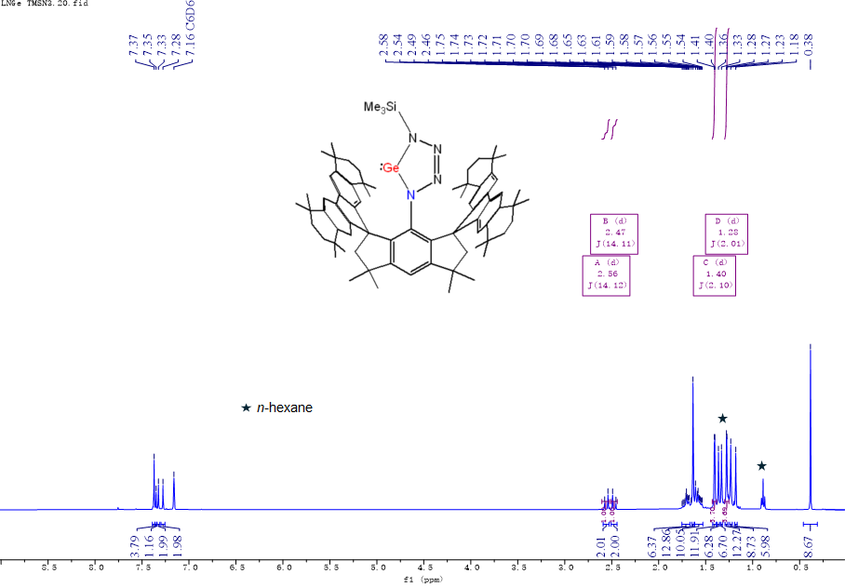
Supplementary Fig. 16 ¹H NMR spectrum of 6 in C₆D₆ at room temperature.

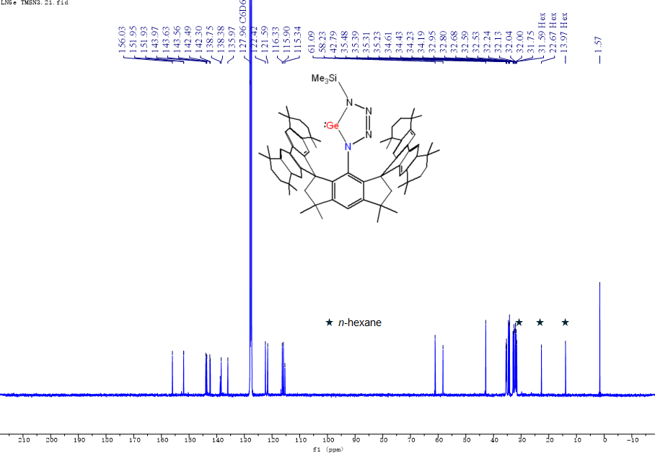
Supplementary Fig. 17 ¹³C{¹H} NMR spectrum of 6 in C₆D₆ at room temperature.
Supplementary Fig. 18 ²⁹Si{¹H} NMR spectrum of 5 in C₆D₆ at room temperature.

Supplementary Fig. 19 Mass spectrum of 6 (top: expt.; bottom: calcd.).

Synthesis of 7
In an N₂-filled glovebox, iodomethane (35 mg, 0.25 mmol) was added to n-hexane solution (5 mL) of 3 (104 mg, 0.1 mmol) at room temperature. The mixture was stirred for 10 hours at room temperature to afford a light yellow solution. The mixture was filtered, and the filtrate was concentrated to ca. 3 mL. After standing at –30 ºC for 24 h a crystalline colorless solid of 7 was formed, which was collected by removing the mother liquor with syringe and dried under vacuum for 2 hours. Yield: 67 mg, 0.05 mmol, 50%. Colorless crystals suitable for X-ray diffraction analysis were obtained from n-hexane solution at room temperature. ¹H NMR (400 MHz, C₆D₆, 298 K, ppm): δ = 1.15 (s, 6H, C(CH₃)₂), 1.20 (s, 6H, C(CH₃)₂), 1.22 (s, 6H, C(CH₃)₂), 1.25 (s, 6H, C(CH₃)₂), 1.26 (s, 6H, C(CH₃)₂), 1.28 (s, 6H, C(CH₃)₂), 1.30 (s, 6H, C(CH₃)₂), 1.53-1.63 (m, 40H, C(CH₃)₂ + CH₂CH₂+ C(CH₃)₂+NCH₃+GeI₂CH₃), 2.58 (d, ²J_{H,H} = 14.3 Hz, 2H, CCH₂C(CH₃)₂), 2.71 (d, ²J_{H,H} = 14.3 Hz, 2H, CCH₂C(CH₃)₂), 7.14 (s, 2H, fluorenyl-H), 7.18 , 7.31 (s, 2H, fluorenyl-H), 7.76 (s, 2H, fluorenyl-H), 7.86 (s, 2H, fluorenyl-H). ¹³C{¹H} NMR (100 MHz, C₆D₆, 298 K, ppm): δ = 31.60, 31.72, 31.90, 31.99, 32.12, 32.19, 32.38, 32.42, 32.69, 33.13 (C(CH₃)₂+GeI₂CH₃), 34.27, 34.44, 34.46, 34.55 (CCH₂C(Ar)(CH₃)₂), 35.11, 35.22, 35.27, 35.49 (CH₂CH₂), 42.82 ((CH₃)₂CCH₂C), 47.65 (NCH₃), 56.29 ((CH₃)₂CCH₂C), 61.51 ((CH₃)₂CCH₂C), 114.97, 118.26, 119.24, 121.43, 121.94, 137.87, 138.11, 143.69, 144.22, 144.37, 144.41, 151.28, 152.87, 155.82 (Ar-C). ESI-MS [M + H]⁺ (m/z): Calcd: 1326.4838; Found: 1326.4848.
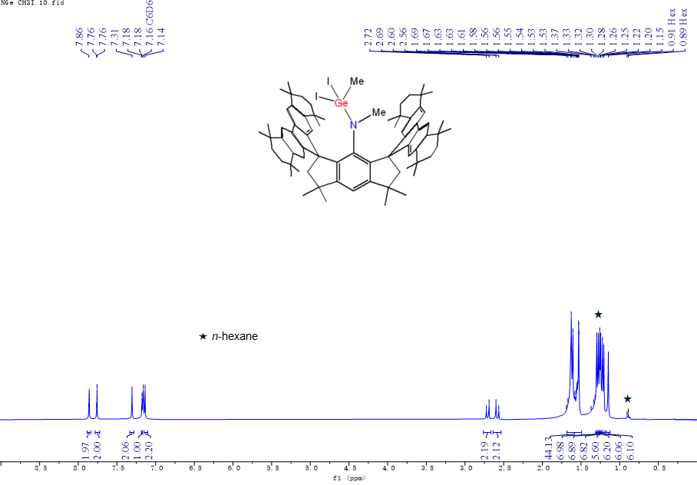
Supplementary Fig. 20 ¹H NMR spectrum of 7 in C₆D₆ at room temperature.

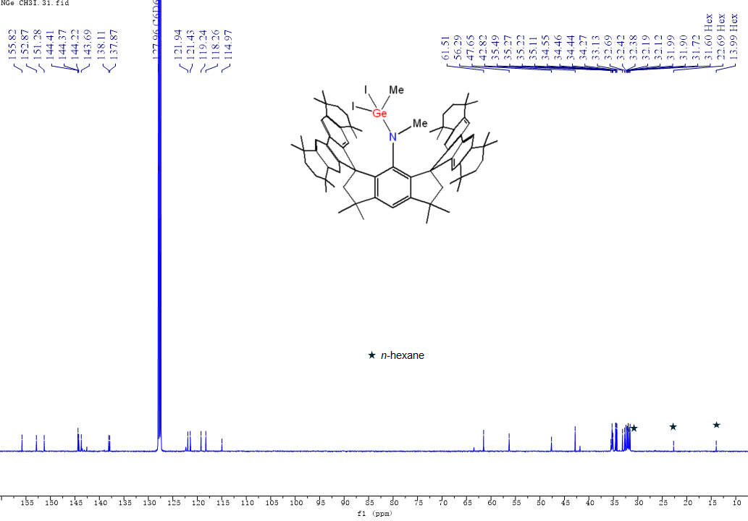
Supplementary Fig. 21 ¹³C{¹H} NMR spectrum of 5 in C₆D₆ at room temperature.
Supplementary Fig. 22 Mass spectrum of 7 (top: expt.; bottom: calcd.).

Synthesis of 8
In an N₂-filled glovebox, 2,3-dimethyl-1,3-butadiene (18 mg, 0.22 mmol) was added to n-hexane solution (5 mL) of 3 (104 mg, 0.1 mmol) at room temperature. The mixture was stirred for 10 hours at room temperature to afford a light yellow solution. The mixture was filtered, and the filtrate was concentrated to ca. 3 mL. After standing at –30 ºC for 24 h a crystalline colorless solid of 8 was formed, which was collected by removing the mother liquor with syringe and dried under vacuum for 2 hours. Yield: 62 mg, 0.05 mmol, 51%. Colorless crystals suitable for X-ray diffraction analysis were obtained from n-hexane solution at room temperature. ¹H NMR (600 MHz, C₆D₆, 298 K, ppm): δ = 0.18 (d, ²J_{H, H} = 16.5 Hz, 2H, C=CCH₂Ge), 0.55 (d, ²J_{H, H} = 15.4 Hz, 2H, C=CCH₂Ge), 0.87 (s, 2H, CH₂=CCH₂Ge), 1.25 (s, 12H, C(CH₃)₂), 1.33 (s, 12H, C(CH₃)₂), 1.36 (s, 12H, C(CH₃)₂), 1.41 (s, 12H, C(CH₃)₂), 1.44 (s, 6H, CH₃C=CCH₃), 1.56 (s, 3H, CH₂=CCH₃), 1.57 (s, 12H, C(CH₃)₂), 1.63-1.65 (m, 16H, CH₂CH₂), 2.37 (s, 4H, CCH₂C(CH₃)₂), 2.75 (s, 1H, NH), 3.92 (s, 1H, CH₂=CCH₂Ge), 4.24 (d, ²J_{H, H} = 1.6 Hz, 1H, CH₂=CCH₃), 4.62 (d, ²J_{H, H} = 1.7 Hz, 1H, CH₂=CCH₂Ge), 4.65 (d, ²J_{H, H} = 1.9 Hz, 1H, CH₂=C) , 7.07 (s, 1H, Ar-H), 7.48 (s, 4H, fluorenyl-H), 7.92 (s, 4H, fluorenyl-H). ¹³C{¹H} NMR (600 MHz, C₆D₆, 301.8 K, ppm): δ = 18.92 (CH₃C=CCH₃), 20.58 (CH₂=CCH₃), 22.61 (CH₂=CCH₂Ge), 24.74 (C=CCH₂Ge), 31.92 (C(CH3)2), 32.12 (C(CH₃)₂), 32.30 (C(CH₃)₂), 32.32 (C(CH₃)₂), 32.42 (C(CH₃)₂), 34.41, 34.62 (CCH₂C(Ar)(CH₃)₂), 35.40 (CH₂CH₂), 42.16 ((CH₃)₂CCH₂C), 62.25 ((CH₃)₂CCH₂C), 63.10 ((CH₃)₂CCH₂C), 108.68 (Ar-C), 110.79 (CH₂=C), 113.32 (CH₂=C), 117.30, 122.20, (Ar-C), 128.91 (CH₃C=CCH₃), 131.25, 137.69 (Ar-C), 141.72 (CH₂=CCH₂Ge), 143.57, 143.75 (Ar-C), 144.71 (CH₂=CCH₃), 144.85, 151.02, 157.58 (Ar-C). ESI-MS [M + H]⁺ (m/z): Calcd: 1206.7845; Found: 1206.7849.
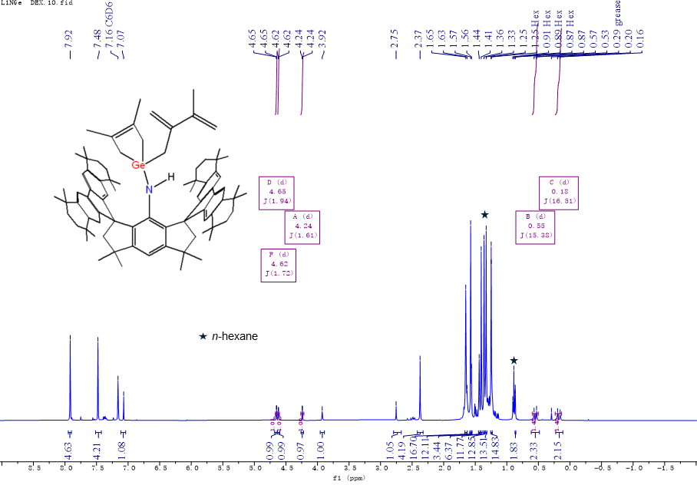
Supplementary Fig. 23 ¹H NMR spectrum of 8 in C₆D₆ at room temperature.

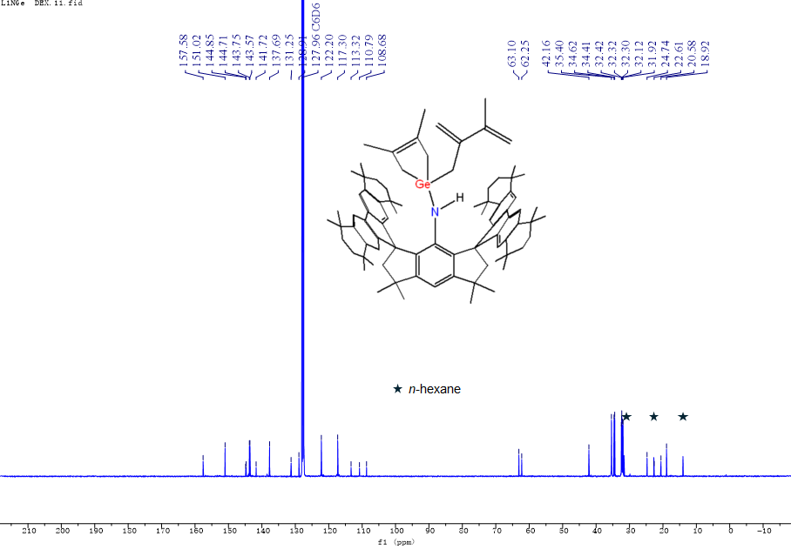
Supplementary Fig. 24 ¹³C{¹H} NMR spectrum of 8 in C₆D₆ at room temperature.

Supplementary Fig. 25 Mass spectrum of 8 (top: expt.; bottom: calcd.).

Synthesis of 9
In an N₂-filled glovebox, tetrakis(trimethylphosphine)iron (40 mg, 0.11 mmol) was added to n-hexane solution (5 mL) of 3 (104 mg, 0.1 mmol) at room temperature. The mixture was stirred for 10 hours at room temperature to afford a deep brown solution. All volatiles were removed in vacuum. The solid was further purified by recrystallization in n-hexane at RT. Yield: 42 mg, 0.05 mmol, 30%. Brown crystals suitable for X-ray diffraction analysis were obtained from n-heptane solution at room temperature. ¹H NMR (600 MHz, C₆D₆, 298 K, ppm): δ = 0.81-0.96 (m, 36H, P(CH₃)₃), 1.32 (s, 12H, C(CH₃)₂), 1.35 (s, 12H, C(CH₃)₂), 1.37 (s, 12H, C(CH₃)₂), 1.48 (s, 12H, C(CH₃)₂), 1.61 (s, 12H, C(CH₃)₂), 1.63-1.75 (m, 16H, CH₂CH₂), 2.20 (s, 4H, CCH₂C(CH₃)₂), 6.95 (s, 1H, Ar-H), 7.43 (s, 4H, fluorenyl-H), 7.74 (s, 4H, fluorenyl-H). ¹³C NMR (150 MHz, C₆D₆, 298 K, ppm): δ= 31.87 (C(CH3)2), 31.89 (C(CH3)2), 32.13 (C(CH3)2), 32.53 (C(CH3)2), 32.56 (C(CH3)2), 32.82 (C(CH3)2), 34.31, 34.56 (CCH₂C(Ar)(CH₃)₂), 35.64, 35.83 (CH₂CH₂), 41.89 ((CH₃)₂CCH₂C), 63.72 ((CH₃)₂CCH₂C), 63.95 ((CH₃)₂CCH₂C), 104.23, 117.28, 121.07, 133.21, 137.20, 137.67, 141.02, 143.37, 153.87, 156.81 (Ar-C). ³¹P{¹H} NMR (243 MHz, C₆D₆, 298 K, ppm): δ= –62.15, –1.09, 6.12, 16.20. ESI-MS [M + H]⁺ (m/z): Calcd: 1402.7401; Found: 1402.7548.
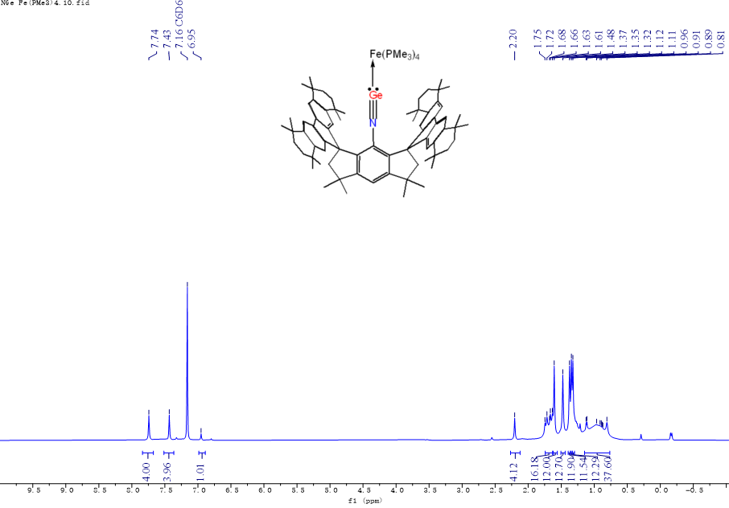
Supplementary Fig. 26 ¹H NMR spectrum of 9 in C₆D₆ at room temperature.

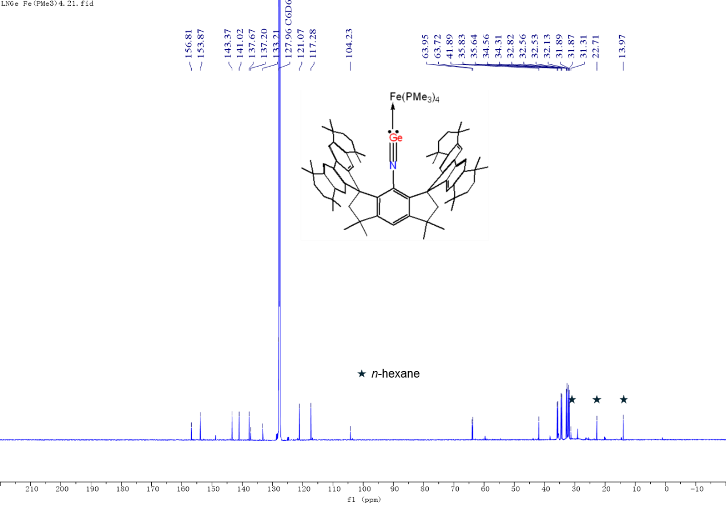
Supplementary Fig. 27 ¹³C{¹H} NMR spectrum of 9 in C₆D₆ at room temperature
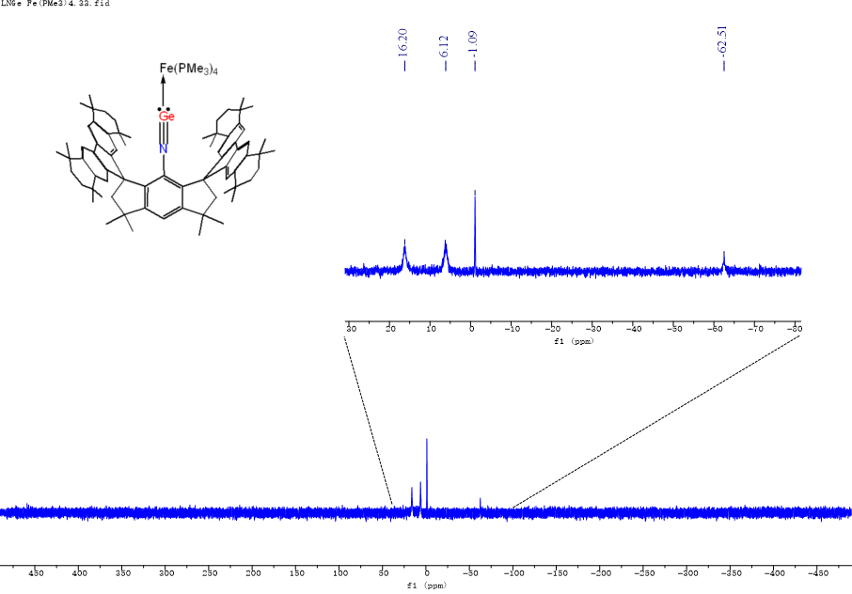
Supplementary Fig. 28 ³¹P{¹H} NMR spectrum of 9 in C₆D₆ at room temperature
Supplementary Fig. 29 Mass spectrum of 9 (top: calcd.; bottom: expt.).

Synthesis of 10
In an N₂-filled glovebox, diiron nonacarbonyl (44 mg, 0.12 mmol) was added to n-hexane solution (5 mL) of 3 (104 mg, 0.1 mmol) at room temperature. The mixture was stirred for 10 hours at room temperature to afford a deep brown solution. All volatiles were removed in vacuum. The solid was further purified by recrystallization in n-hexane at RT. Yield: 56 mg, 0.05 mmol, 47%. Brown crystals suitable for X-ray diffraction analysis were obtained from n-hexane solution at room temperature. ¹H NMR (600 MHz, C₆D₆, 298 K, ppm): δ =1.16 (s, 6H, C(CH₃)₂), 1.19 (s, 6H, C(CH₃)₂), 1.29 (s, 6H, C(CH₃)₂), 1.38 (s, 18H, C(CH₃)₂), 1.44 (s, 6H, C(CH₃)₂), 1.52-1.66 (m, 28H, C(CH₃)₂ + CH₂CH₂), 1.74 (s, 6H, C(CH₃)₂), 2.36 (d, ²J_{H,H} = 14.1 Hz, 2H, CCH₂C(CH₃)₂), 2.58 (d, ²J_{H,H} = 13.8 Hz, 2H, CCH₂C(CH₃)₂), 7.13 (s, 1H, Ar-H), 7.33 (s, 2H, fluorenyl-H), 7.39 (s, 2H, fluorenyl-H), 7.51 (s, 2H, fluorenyl-H), 7.60 (s, 2H, fluorenyl-H). ¹³C NMR (150 MHz, C₆D₆, 298 K, ppm): δ = 31.20 (C(CH3)2), 31.26 (C(CH3)2), 31.52 (C(CH3)2), 32.14 (C(CH3)2), 32.17 (C(CH3)2), 32.19 (C(CH3)2), 32.63 (C(CH3)2), 32.88 (C(CH3)2), 33.05 (C(CH3)2), 33.44 (C(CH3)2), 34.30, 34.48, 34.65 (CCH₂C(Ar)(CH3)₂), 35.11, 35.22, 35.24, 35.28 (CH₂CH₂), 42.29 ((CH₃)₂CCH₂C), 58.38 ((CH₃)₂CCH₂C), 60.96 ((CH₃)₂CCH₂C), 111.17, 118.36, 118.94, 121.25, 121.71, 127.34, 136.17, 138.36, 143.31, 143.35, 144.19, 144.59, 150.64, 151.53, 155.39, 156.79 (Ar-C). IR (in nujol): υ = 2033 cm⁻¹, 1961 cm⁻¹, 1934 cm⁻¹ (C=O). ESI-MS [M + H]⁺ (m/z): Calcd: 1182.5482; Found:1182.5669.
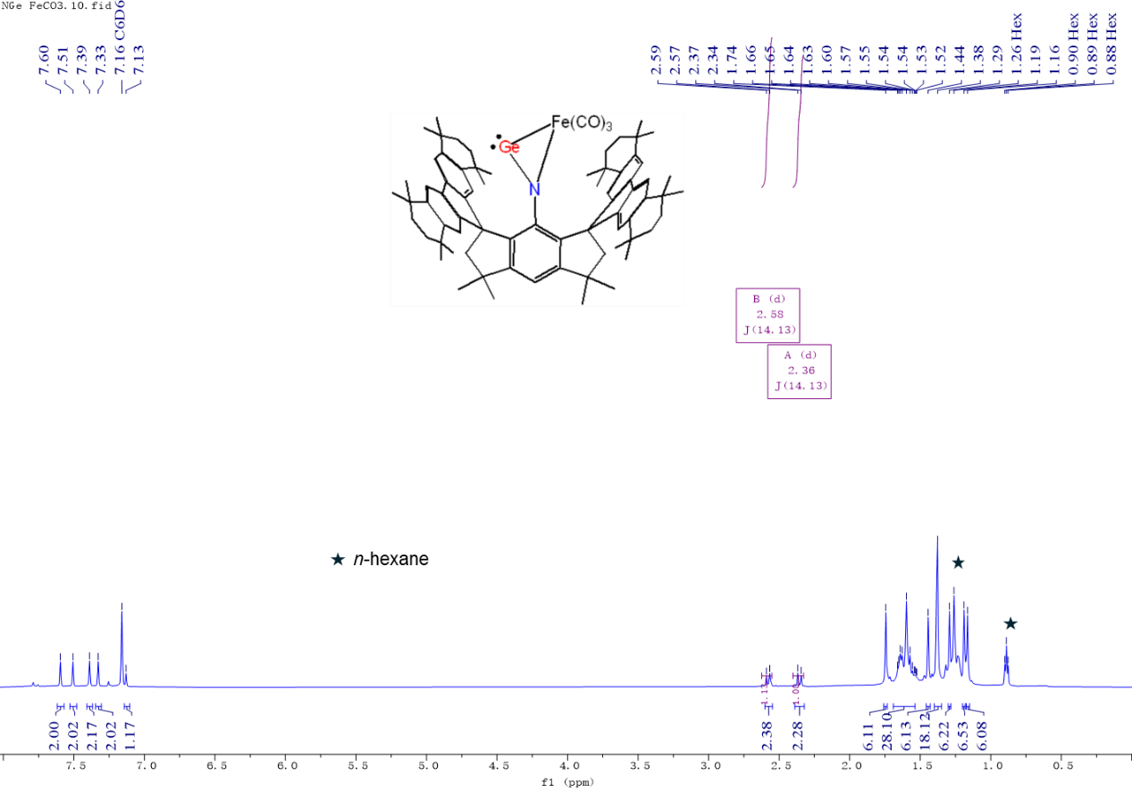
Supplementary Fig. 30 ¹H NMR spectrum of 10 in C₆D₆ at room temperature.

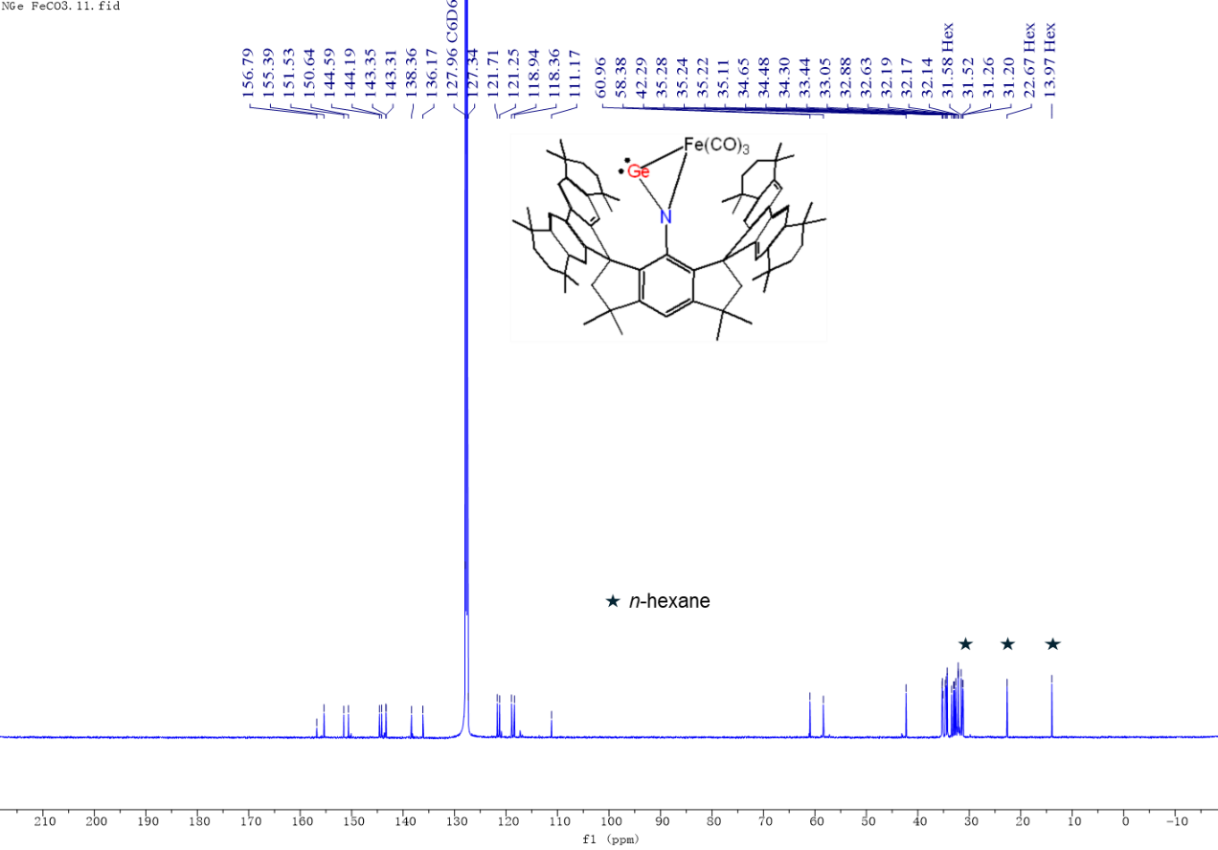Supplementary Fig. 31 ¹³C{¹H} NMR spectrum of 10 in C₆D₆ at room temperature.
Supplementary Fig. 32 Mass spectrum of 10 (top: calcd.; bottom: expt.).

Molecular structures determined by single-crystal X-ray diffraction analysis with refinement details
Single crystal structure analysis of 2
C₇₂H₈₉GeN₃·C₆H₁₄ (M =1155.22 g/mol): triclinic, space group P-1 (no. 2), a = 14.3609(2) Å, b = 15.6097(2) Å, c = 16.7560(2) Å, α = 99.1690(10)°, β = 113.5330(10)°, γ = 94.5230(10)°, V = 3357.39(8) Å³, Z = 2, T = 100.15 K, μ(CuKα) = 0.941 mm⁻¹, Dcalc = 1.143 g/cm³, 36367 reflections measured (5.808° ≤ 2Θ ≤ 143.83°), 12868 unique (R_{int} = 0.0195, R_{sigma} = 0.0211) which were used in all calculations. The final R₁ was 0.0361 (I > 2σ(I)) and wR₂ was 0.0961 (all data). In the structure, the Ge-N3 unit exhibits a positional disorder over two positions, they were separated using PART instruction and refined using a free variable (FVAR). SAME instruction was applied to make the shape and position of disordered Ge-N3 units in a reasonable range, the final occupancies of 0.9237(9):0.0763(9) have been determined for PART 1 and PART 2, respectively. PART 2 of Ge-N3 units were refined as isotropic because of the low occupancy. C36 to C43 and n-hexane solvents (C73 to C78) also exhibit a positional disorder and they were separated using PART 1 and PART 2 instructions and refined using free variables (FVAR). SAME instruction was used to fix the disordered parts in reasonable shape and positions, RIGU and ISOR instructions to make the anisotropic displacement parameters of the disordered parts within reasonable limits. The occupancies of 0.454(4):0.546(4) for C36 to C43 and 0.669 (9):0.331(9) for C73 to C78 have been determined for PART 1 and PART 2.
Supplementary Fig. 33 Thermal ellipsoid drawing of the molecular structure of 2 at 50% probability, PART 2 of the disordered Ge-N3 unit, carbon atoms of the organic ligand as well as n-hexane solvents were shown in light green. H atoms were omitted for clarity.
Single crystal structure analysis of 3
C₇₂H₈₉GeN·C₆H₁₄ (M =1127.20 g/mol): triclinic, space group P-1 (no. 2), a = 14.8433(2) Å, b = 15.6651(2) Å, c = 16.7070(2) Å, α = 97.0070(10)°, β = 115.4520(10)°, γ = 97.1400(10)°, V = 3413.15(8) Å³, Z = 2, T = 150.15 K, μ(CuKα) = 0.905 mm⁻¹, Dcalc = 1.097 g/cm³, 57630 reflections measured (5.798° ≤ 2Θ ≤ 153.08°), 14062 unique (R_{int} = 0.0312, R_{sigma} = 0.0298) which were used in all calculations. The final R₁ was 0.0663 (I > 2σ(I)) and wR₂ was 0.2030 (all data). In the structure, C13 to C24, C29 to C36, and C48 to C55 groups exhibit a positional disorder, they were separated using PART 1 and PART 2 instructions and refined using free variables (FVAR). SAME instruction has been used to fix the disordered parts in reasonable shape and positions, RIGU and SIMU instruction to make the anisotropic displacement parameters of the disordered parts within reasonable limits. The occupancies of 0.421(5):0.579(5) for C13 to C24, 0.538(4):0.462(4) for C29 to C36 and 0.159(6):0.841(6) for C48 to C55 have been determined for PART 1 and PART 2. n-hexane solvent (C73 to C78) exhibit a positional disorder, they were separated using PART instruction and refined using a free variable (FVAR). SAME, RIGU and SIMU instructions were applied make the shape, position and anisotropic displacement parameters in a reasonable range, the final occupancies of 0.262(5):0.738(5) have been determined for PART 1 and PART 2, respectively.
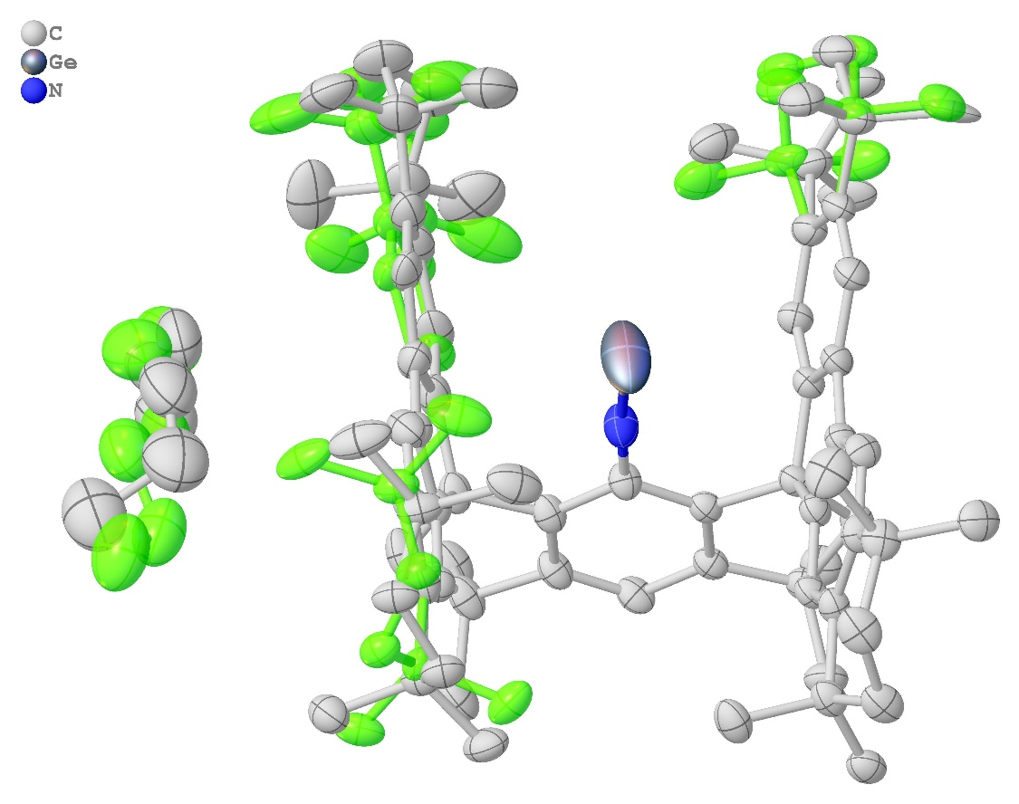
Supplementary Fig. 34 Thermal ellipsoid drawing of the molecular structure of 3 at 50% probability, PART 2 of the disordered carbon atoms of the organic ligand as well as n-hexane solvents were shown in light green. H atoms were omitted for clarity.

Single crystal structure analysis of 4
C₇₉H₁₀₁GeN₃ (M =1165.21 g/mol): monoclinic, space group P2₁/n (no. 14), a = 14.9984(2) Å, b = 15.2702(2) Å, c = 31.3024(3) Å, β = 103.8300(10)°, V = 6961.30(15) Å³, Z = 4, T = 150.15 K, μ(CuKα) = 0.912 mm⁻¹, Dcalc = 1.112 g/cm³, 105395 reflections measured (5.816° ≤ 2Θ ≤ 153.274°), 14488 unique (R_{int} = 0.0868, R_{sigma} = 0.0532) which were used in all calculations. The final R₁ was 0.0599 (I > 2σ(I)) and wR₂ was 0.1534 (all data). In the structure, C28 to C35, C36 to C43 and C57 to C64 groups exhibit a positional disorder, they were separated using PART 1 and PART 2 instructions and refined using free variables (FVAR). SAME instruction has been used to fix the disordered parts in reasonable shape and positions, RIGU and ISOR instruction to make the anisotropic displacement parameters of the disordered parts within reasonable limits. The occupancies of 0.491 (8):0.509(8) for C28 to C35, 0.783(8):0.217(8) for C36 to C43 and 0.179(8):0.821(8) for C65 to C72 have been determined for PART 1 and PART 2.
Supplementary Fig. 35 Thermal ellipsoid drawing of the molecular structure of 4 at 50% probability, PART 2 of the disordered carbon atoms were shown in light green. H atoms were omitted for clarity.

Single crystal structure analysis of 5
C₇₈H₉₇GeNSi·C₆H₁₄ (M =1235.41 g/mol): triclinic, space group P-1 (no. 2), a = 14.6976(3) Å, b = 15.2150(3) Å, c = 17.4355(4) Å, α = 84.988(2)°, β = 75.453(2)°, γ = 72.888(2)°, V = 3606.55(14) Å³, Z = 2, T = 150.15 K, μ(MoKα) = 0.485 mm⁻¹, Dcalc = 1.138 g/cm³, 45565 reflections measured (3.774° ≤ 2Θ ≤ 54.962°), 16107 unique (R_{int} = 0.0415, R_{sigma} = 0.0508) which were used in all calculations. The final R₁ was 0.0758 (I > 2σ(I)) and wR₂ was 0.2225 (all data). In the refinement of 5, SIMU instruction was applied to C1, N1 and Ge1 to make their anisotropic displacement parameters reasonable, n-hexane solvent (C79 to C84) exhibit a positional disorder, they were separated using PART instruction and refined using a free variable (FVAR). SAME, RIGU and SIMU instructions were applied make the shape, position and anisotropic displacement parameters in a reasonable range, the final occupancies of 0.825(7):0.175(7) have been determined for PART 1 and PART 2, respectively.
Supplementary Fig. 36 Thermal ellipsoid drawing of the molecular structure of 5 at 50% probability, PART 2 of the disordered n-hexane solvent was shown in light green. H atoms except for those attached to Ge1 and Si1 were omitted for clarity.

Single crystal structure analysis of 6
C₇₅H₉₈GeN₄Si·C₆H₁₄ (M =1242.42 g/mol): triclinic, space group P-1 (no. 2), a = 13.4555(2) Å, b = 15.3862(2) Å, c = 18.4991(2) Å, α = 93.3890(10)°, β = 92.7760(10)°, γ = 103.9750(10)°, V = 3702.21(8) Å³, Z = 2, T = 150.15 K, μ(CuKα) = 1.038 mm⁻¹, Dcalc = 1.115 g/cm³, 63863 reflections measured (4.796° ≤ 2Θ ≤ 153.502°), 15262 unique (R_{int} = 0.0366, R_{sigma} = 0.0340) which were used in all calculations. The final R₁ was 0.0398 (I > 2σ(I)) and wR₂ was 0.1104 (all data). In the structure, Ge-N4 moiety exhibit a positional disorder, they were separated using PART instruction and refined using a free variable (FVAR). SAME and RIGU instructions were applied make the shape, position and anisotropic displacement parameters in a reasonable range, the final occupancies of 0.8654(12):0.1346(12) have been determined for PART 1 and PART 2, respectively. C36 to C43, C57 to C64, C65 to C72 and n-hexane solvents (C81 to C86) groups also exhibit a positional disorder, they were separated using PART 1 and PART 2 instructions and refined using free variables (FVAR). SAME instruction was used to fix the disordered parts in reasonable shape and positions, RIGU and SIMU instruction to make the anisotropic displacement parameters of the disordered parts within reasonable limits. The occupancies of 0.656(5):0.344(5) for C36 to C43, 0.735(6):0.265(6) for C57 to C64, 0.133(5):0.867(5) for C65 to C72 and 0.243(5):0.757(5) for C81 to C86 have been determined for PART 1 and PART 2.
Supplementary Fig. 37 Thermal ellipsoid drawing of the molecular structure of 6 at 50% probability, PART 2 of the disordered Ge-N4 moiety, carbon atoms of the organic ligand as well as n-hexane solvents were shown in light green. H atoms were omitted for clarity.
Single crystal structure analysis of 7
C₇₄H₉₅GeI₂N·C₆H₁₄ (M =1411.07 g/mol): monoclinic, space group C2/c (no. 15), a = 37.4261(4) Å, b = 15.14820(10) Å, c = 31.6565(4) Å, β = 122.816(2)°, V = 15083.2(4) Å³, Z = 8, T = 100.15 K, μ(CuKα) = 7.268 mm⁻¹, Dcalc = 1.243 g/cm³, 52028 reflections measured (5.62° ≤ 2Θ ≤ 154.39°), 15644 unique (R_{int} = 0.0245, R_{sigma} = 0.0254) which were used in all calculations. The final R₁ was 0.0475 (I > 2σ(I)) and wR₂ was 0.1551 (all data). In the structure, Ge-I₂CH₃ moiety exhibit a positional disorder, they were separated using PART instruction and refined using a free variable (FVAR). SAME and SADI instructions were applied to fix the disordered parts in reasonable shape and positions, EADP as well as SIMU instructions were used to make the anisotropic displacement parameters of the disordered Ge, I and C atoms within reasonable limits. The final occupancies of 0.9837(7):0.0163(7) have been determined for PART 1 and PART 2, respectively. C57 to C64 and C65 to C72 groups exhibit a positional disorder, they were separated using PART 1 and PART 2 instructions and refined using free variables (FVAR). SAME instruction has been used to fix the disordered parts in reasonable shape and positions, RIGU instruction to make the anisotropic displacement parameters of the disordered parts within reasonable limits. The occupancies of 0.854(8):0.146(8) for C57 to C64 and 0.328(11):0.672(11) for C65 to C72 have been determined for PART 1 and PART 2. In the structure there exist disordered n-hexane molecules, some of the disordered parts were disordered across symmetry element, PART 1, PART -1 and PART -2 were used to separate them. RESI, DFIX, DANG, RIGU, SIMU, ISOR instructions have been used to make the disordered parts of n-hexane reasonable.
Supplementary Fig. 38 Thermal ellipsoid drawing of the molecular structure of 7 at 50% probability, PART 2 of the disordered Ge-I₂CH₃ moiety, carbon atoms of the organic ligand were shown in light green. PART -1 and PART -2 of the disordered n-hexane were shown in blue and orange, respectively. H atoms were omitted for clarity.
Single crystal structure analysis of 8
C₈₄H₁₀₉GeN·C₆H₁₄ (M =1291.48 g/mol): triclinic, space group P-1 (no. 2), a = 14.6376(3) Å, b = 15.1815(2) Å, c = 18.6021(3) Å, α = 82.2930(10)°, β = 82.701(2)°, γ = 73.172(2)°, V = 3904.02(12) Å³, Z = 2, T = 150.15 K, μ(MoKα) = 0.436 mm⁻¹, Dcalc = 1.099 g/cm³, 59388 reflections measured (3.762° ≤ 2Θ ≤ 61.504°), 19212 unique (Rint = 0.0356, Rsigma = 0.0424) which were used in all calculations. The final R₁ was 0.0458 (I > 2σ(I)) and wR₂ was 0.1248 (all data). In the structure, one of the coordinated 2,3-dimethyl-1,3-butadiene moiety exhibit a positional disorder, they were separated using PART instruction and refined using a free variable (FVAR). SAME, SADI, ISOR and RIGU instructions were applied make the shape, position and anisotropic displacement parameters in a reasonable range, the final occupancies of 0.893(4):0.107(4) have been determined for PART 1 and PART 2, respectively. C57 to C64 and C65 to C72 groups exhibit a positional disorder, they were separated using PART 1 and PART 2 instructions and refined using free variables (FVAR). SAME instruction has been used to fix the disordered parts in reasonable shape and positions, RIGU instruction to make the anisotropic displacement parameters of the disordered parts within reasonable limits. The occupancies of 0.438(7):0.562(7) for C57 to C64 and 0.685(8):0.315(8) for C65 to C72 have been determined for PART 1 and PART 2. In the structure there exist disordered n-hexane molecules, PART -1 was applied because these n-hexane molecules were disordered across symmetry element. RESI, DFIX, DANG, RIGU, SIMU instructions have been used to make the disordered parts of n-hexane reasonable. There is a B-level alert in checkcif report, the alert was mainly due to there is Q peak (2.28e) that not assigned to any element. Such Q peak is likely an artefact of twinning.
Supplementary Fig. 39 Thermal ellipsoid drawing of the molecular structure of 8 at 50% probability, PART 2 of the disordered 2,3-dimethyl-1,3-butadiene moiety as well as carbon atoms of the organic ligand were shown in light green, disordered n-hexane molecules were shown in blue. H atoms except for that attached to N atom were omitted for clarity.
Single crystal structure analysis of 9
C₈₄H₁₂₄FeGeNP₄ (M =1400.15 g/mol): monoclinic, space group P2₁/c (no. 14), a = 25.4240(10) Å, b = 12.8816(2) Å, c = 27.2623(10) Å, β = 114.412(4)°, V = 8130.2(5) Å³, Z = 4, T = 100.15 K, μ(CuKα) = 2.928 mm⁻¹, Dcalc = 1.144 g/cm³, 24547 reflections measured (6.544° ≤ 2Θ ≤ 136.914°), 24547 unique (Rint = merged, Rsigma = 0.0280) which were used in all calculations. The final R₁ was 0.0540 (I > 2σ(I)) and wR₂ was 0.1423 (all data). The crystal of 9 was twinning and the structure was refined against twined HKLF5 file that generated by using CrysAlisPro, the BASF factor was 0.2441. In the structure, C65 to C72, C36 and C43 atoms exhibit a positional disorder, they were separated using PART 1 and PART 2 instructions and refined using free variables (FVAR). SAME and SADI instructions have been used to fix the disordered parts in reasonable shape and positions, RIGU and SIMU instruction to make the anisotropic displacement parameters of the disordered parts within reasonable limits. The occupancies of 0.420(9):0.580(9) for C65 to C72, 0.740(12):0.260(12) for C36 and C43 have been determined for PART 1 and PART 2.
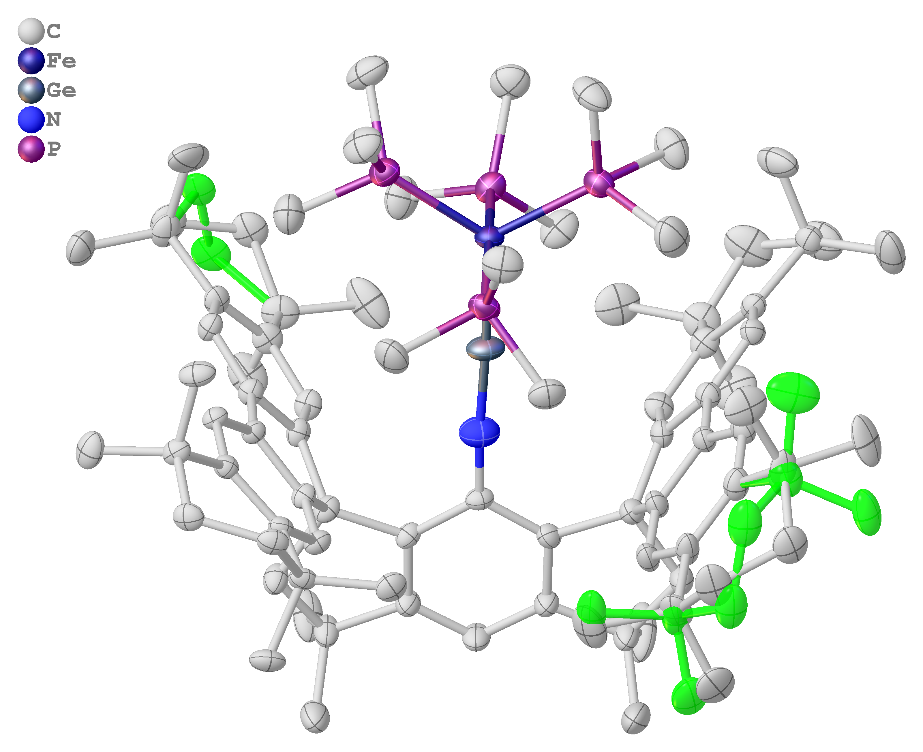
Supplementary Fig. 40 Thermal ellipsoid drawing of the molecular structure of 9 at 50% probability, PART 2 of the disordered carbon atoms were shown in light green. H atoms were omitted for clarity.

Single crystal structure analysis of 10
C₇₅H₈₉FeGeNO₃·C₆H₁₄ (M =1267.08 g/mol): monoclinic, space group P2₁/c (no. 14), a = 17.0615(12) Å, b = 17.4435(11) Å, c = 23.7614(15) Å, β = 99.269(3)°, V = 6979.3(8) Å³, Z = 4, T = 120.00 K, μ(MoKα) = 0.687 mm⁻¹, Dcalc = 1.206 g/cm³, 136238 reflections measured (4.546° ≤ 2Θ ≤ 52.768°), 14247 unique (Rint = 0.0956, Rsigma = 0.0594) which were used in all calculations. The final R₁ was 0.0519 (I > 2σ(I)) and wR₂ was 0.1434 (all data). In the structure, n-hexane solvent exhibits a positional disorder over two positions, they were separated using PART instruction and refined using a free variable (FVAR). RESI, DFIX, SAME, RIGU and SIMU instructions were applied make the shape, position and anisotropic displacement parameters in a reasonable range, the final occupancies of 0.544(7):0.456(7) have been determined for PART 1 and PART 2, respectively.
Supplementary Fig. 41 Thermal ellipsoid drawing of the molecular structure of 10 at 50% probability, PART 2 of the disordered n-hexane solvent was shown in light green. H atoms were omitted for clarity.

Supplementary Table 1. Crystallographic data and refinement results of 2-4

 | 2 | 3 | 4
CCDC | 2424293 | 2424294 | 2424295
formula | C₇₈H₁₀₃GeN₃ | C₇₈H₁₀₃GeN | C₇₉H₁₀₁GeN₃
formula weight | 1155.22 | 1127.20 | 1165.21
crystal system | triclinic | triclinic | monoclinic
space group | P-1 | P-1 | P2₁/n
a/Å | 14.3609(2) | 14.8433(2) | 14.9984(2)
b/Å | 15.6097(2) | 15.6651(2) | 15.2702(2)
c/Å | 16.7560(2) | 16.7070(2) | 31.3024(3)
α/deg | 99.1690(10) | 97.0070(10) | 90
β/deg | 113.5330(10) | 115.4520(10) | 103.8300(10)
γ/deg | 94.5230(10) | 97.1400(10) | 90
V/Å³ | 3357.39(8) | 3413.15(8) | 6961.30(15)
Z | 2 | 2 | 4
ρ_{calcd}/g∙cm⁻³ | 1.143 | 1.097 | 1.112
μ/mm⁻¹ | 0.941 | 0.905 | 0.912
F(000) | 1248.0 | 1220.0 | 2512.0
crystal size/mm³ | 0.19 × 0.14 × 0.08 | 0.16 × 0.12 × 0.1 | 0.16 × 0.12 × 0.12
2θ range/deg | 5.808 – 143.83 | 5.798 – 153.08 | 5.816 – 153.274
index ranges | -17 ≤ h ≤ 17  -18 ≤ k ≤ 19  -20 ≤ l ≤ 12 | -18 ≤ h ≤ 18  -19 ≤ k ≤ 16  -20 ≤ l ≤ 20 | -18 ≤ h ≤ 18  -19 ≤ k ≤ 19  -39 ≤ l ≤ 28
collected data | 36367 | 57630 | 105395
unique data | 12868  (R_{int} = 0.0195) | 14062  (R_{int} = 0.0312) | 14488  (R_{int} = 0.0868)
GOF on F² | 1.053 | 1.057 | 1.071
final R indices [I>2σ(I)] | R₁ = 0.0361  wR₂ = 0.0944 | R₁ = 0.0663  wR₂ =0.1974 | R₁ = 0.0599  wR₂ = 0.1458
R indices (all data) | R₁ = 0.0383  wR₂ = 0.0961 | R₁ = 0.0720  wR₂ = 0.2030 | R₁ = 0.0737  wR₂ = 0.1534
Largest diff. peak/hole (e⋅Å⁻³) | 0.59/-1.40 | 1.26/-1.18 | 0.56/-0.84

Supplementary Table 2. Crystallographic data and refinement results of 5-7

 | 5 | 6 | 7
CCDC | 2424296 | 2424297 | 2424298
formula | C₈₄H₁₁₁GeNSi | C₈₁H₁₁₂GeN₄Si | C₈₀H₁₀₉GeI₂N
formula weight | 1235.41 | 1242.42 | 1411.07
crystal system | triclinic | triclinic | monoclinic
space group | P-1 | P-1 | C2/c
a/Å | 14.6976(3) | 13.4555(2) | 37.4261(4)
b/Å | 15.2150(3) | 15.3862(2) | 15.14820(10)
c/Å | 17.4355(4) | 18.4991(2) | 31.6565(4)
α/deg | 84.988(2) | 93.3890(10) | 90
β/deg | 75.453(2) | 92.7760(10) | 122.816(2)
γ/deg | 72.888(2) | 103.9750(10) | 90
V/Å³ | 3606.55(14) | 3702.21(8) | 15083.2(4)
Z | 2 | 2 | 8
ρ_{calcd}/g∙cm⁻³ | 1.138 | 1.115 | 1.243
μ/mm⁻¹ | 0.485 | 1.038 | 7.268
F(000) | 1336.0 | 1344.0 | 5872.0
crystal size/mm³ | 0.16 × 0.14 × 0.12 | 0.18 × 0.15 × 0.12 | 0.13 × 0.11 × 0.09
2θ range/deg | 3.774 – 54.962 | 4.796 – 153.502 | 5.62 – 154.39
index ranges | -18 ≤ h ≤ 18  -19 ≤ k ≤ 19  -22 ≤ l ≤ 22 | -15 ≤ h ≤ 16  -19 ≤ k ≤ 18  -23 ≤ l ≤ 23 | -45 ≤ h ≤ 47  -18 ≤ k ≤ 13  -36 ≤ l ≤ 40
collected data | 45565 | 63863 | 52026
unique data | 16107  (R_{int} =0.0415) | 15262  (R_{int} =0.0366) | 1564  (R_{int} =0.0245)
GOF on F² | 1.020 | 1.057 | 1.037
final R indices [I>2σ(I)] | R₁ = 0.0758  wR₂ = 0.2092 | R₁ = 0.0398  wR₂ = 0.1067 | R₁ = 0.0475  wR₂ = 0.1509
R indices (all data) | R₁ =0.0980  wR₂ = 0.2225 | R₁ = 0.0444  wR₂ = 0.1104 | R₁ = 0.0505  wR₂ = 0.1551
Largest diff. peak/hole (e⋅Å⁻³) | 1.74/-1.56 | 0.44/-0.46 | 1.41/-1.44

Supplementary Table 3. Crystallographic data and refinement results of 8-10

 | 8 | 9 | 10
CCDC | 2424299 | 2474066 | 2474067
formula | C₉₀H₁₂₃GeN | C₈₄H₁₂₄FeGeNP₄ | C₈₁H₁₀₃FeGeNO₃
formula weight | 1291.48 | 1400.15 | 1267.08
crystal system | triclinic | monoclinic | monoclinic
space group | P-1 | P2₁/c | P2₁/c
a/Å | 14.6376(3) | 25.4240(10) | 17.0615(12)
b/Å | 15.1815(2) | 12.8816(2) | 17.4435(11)
c/Å | 18.6021(3) | 27.2623(10) | 23.7614(15)
α/deg | 82.2930(10) | 90 | 90
β/deg | 82.701(2) | 114.412(4) | 99.269(3)
γ/deg | 73.172(2) | 90 | 90
V/Å³ | 3904.02(12) | 8130.2(5) | 6979.3(8)
Z | 2 | 4 | 4
ρ_{calcd}/g∙cm⁻³ | 1.099 | 1.144 | 1.206
μ/mm⁻¹ | 0.436 | 2.928 | 0.687
F(000) | 1404.0 | 3012.0 | 2712.0
crystal size/mm³ | 0.13 × 0.11 × 0.08 | 0.13 × 0.12 × 0.09 | 0.13 × 0.11 × 0.09
2θ range/deg | 3.762 – 61.504 | 6.544 – 136.914 | 4.546 – 52.768
index ranges | -20 ≤ h ≤ 19  -21 ≤ k ≤ 20  -24 ≤ l ≤ 25 | -30 ≤ h ≤ 30  -15 ≤ k ≤ 15  -32 ≤ l ≤ 32 | -21 ≤ h ≤ 21  -21 ≤ k ≤ 21  -28 ≤ l ≤ 29
collected data | 59388 | 24547 | 136238
unique data | 19212  (R_{int} = 0.0356) | 24547 | 14247  (R_{int} = 0.0956)
GOF on F² | 1.038 | 1.029 | 1.051
final R indices [I>2σ(I)] | R₁ = 0.0458  wR₂ = 0.1187 | R₁ = 0.0540  wR₂ = 0.1348 | R₁ = 0.0519  wR₂ = 0.1320
R indices (all data) | R₁ = 0.0608  wR₂ = 0.1248 | R₁ = 0.0658  wR₂ = 0.1423 | R₁ = 0.0835  wR₂ = 0.1434
Largest diff. peak/hole (e⋅Å⁻³) | 2.28/-0.51 | 0.83/-0.61 | 0.93/-0.81

Theoretical Calculations
Optimization of compound 3 and 4 involved in this study in the gas phase was performed with the Gaussian 16 software package (version A.03) ⁸⁵ with the BP86-D3(BJ) functional using the def2-SVP basis set.⁸⁶⁻⁹⁰ Compounds 9 and 10 were optimized with multiple density functional theory (DFT) functionals (BP86-D3(BJ), PBE0-D3(BJ), TPSSh-D3(BJ), M06-D3) combined with the def2-SVP basis set.⁹¹⁻⁹⁴ Based on the optimized structures, frequency analysis calculations were carried out to confirm whether the structures were at minima (no imaginary frequency). Molecular orbitals were visualized using Avogado (v 1.2.0) program. The natural bond orbital (NBO) analysis was performed using NBO 7.0 at the same level.⁹⁵ Intrinsic bond orbital (IBOs)^{96, 97} computations were performed with ORCA program⁹⁸ and visualized by IBOview program. The Wiberg bond indices (WBIs) and Mayer bond orders (MBOs), the quantum theory of atoms-in-molecules (QTAIM) and noncovalent interaction studies were performed at the BP86-D3(BJ)/def2-SVP level using Multiwfn 3.8(dev).^{99, 100}
The energy decomposition analysis (EDA)¹⁰¹ together with the natural orbitals for chemical valence (NOCV)¹⁰² method were carried out by using the ADF 2020 program package.¹⁰³ The EDA-NOCV calculations^{104, 105} were carried out at the BP86-D3(BJ)/TZ2P-ZORA level. This calculation divides the intrinsic interaction energy (ΔΕ_{int}) between two fragments into three energy components as follows:
ΔΕ_{int} = ΔE_{elstat} + ΔE_{Pauli} + ΔE_{orb} + ΔE_{disp} (1).
While the electrostatic ΔE_{elstat} term accounts for the quasiclassical electrostatic interaction between the unperturbed charge distributions of the prepared fragments, the Pauli repulsion ΔE_{Pauli} represents the energy change associated with the transformation from the superposition of the unperturbed electron densities of the isolated fragments to the wavefunction, that properly obeys the Pauli principle through explicit antisymmetrization and renormalization of the production wavefunction. Since we used D3(BJ), it provides us with the dispersion interactions between the fragments. Finally, the mixing of orbitals, charge transfer and polarization between the isolated fragments provide the orbital term ΔE_{orb}, which can be further decomposed into contributions from each irreducible representation of the point group of the interacting system as follows:
(2)
The combination of the EDA with NOCV makes the partition of the total ΔE_{orb} into pairwise contributions of the orbital interactions which give very important information about the bonding situation. The charge deformation Δρ_{k}(r), resulting from the mixing of the orbital pairs 𝜓_{k}(r) and 𝜓_{-k}(r) of the interacting fragments provides the amount and the shape of the charge flow due to the orbital interactions (see Equation 3), and the associated energy term ΔE_{orb} shows the size of stabilizing orbital energy originated from such interaction (Equation 4).
(3)
${∆E}_{Orb}= \sum_{k}{{∆E}_{Orb}^{k}}=\sum_{k}{ν_{k}\left[-F_{-k,-k}^{TS} + F_{k,k}^{TS}\right] }$${∆E}_{Orb}=\sum_{k}{{∆E}_{Orb}^{k}}=\sum_{k}{ν_{k}\left[-F_{-k,-k}^{TS}+F_{k,k}^{TS}\right]}$ (4)

Supplementary Table 4. Experimental and calculated bond lengths and angles of 3.
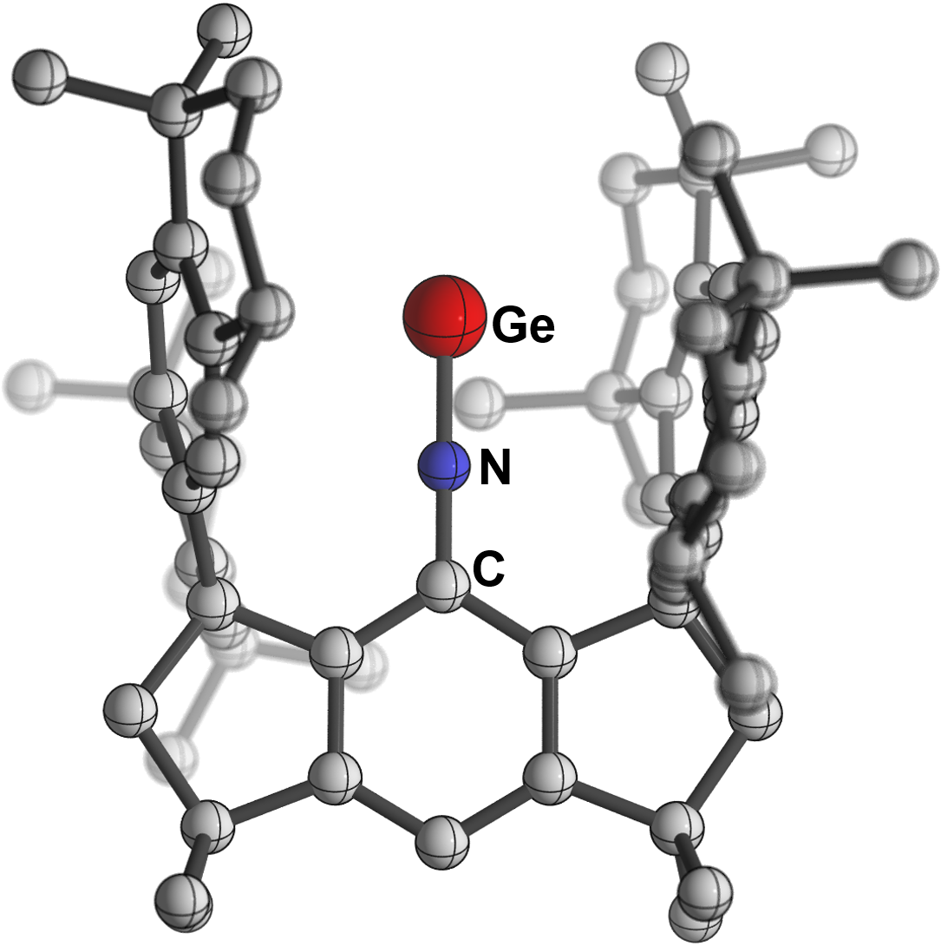
 | Ge–N | N–C | C-N-Ge
X-ray | 1.6395(19) Å | 1.362(3) Å | 174.80(16) deg
Calculated | 1.691 Å | 1.355 Å | 180 deg

Supplementary Table 5. Experimental and calculated bond lengths and angles of 4.
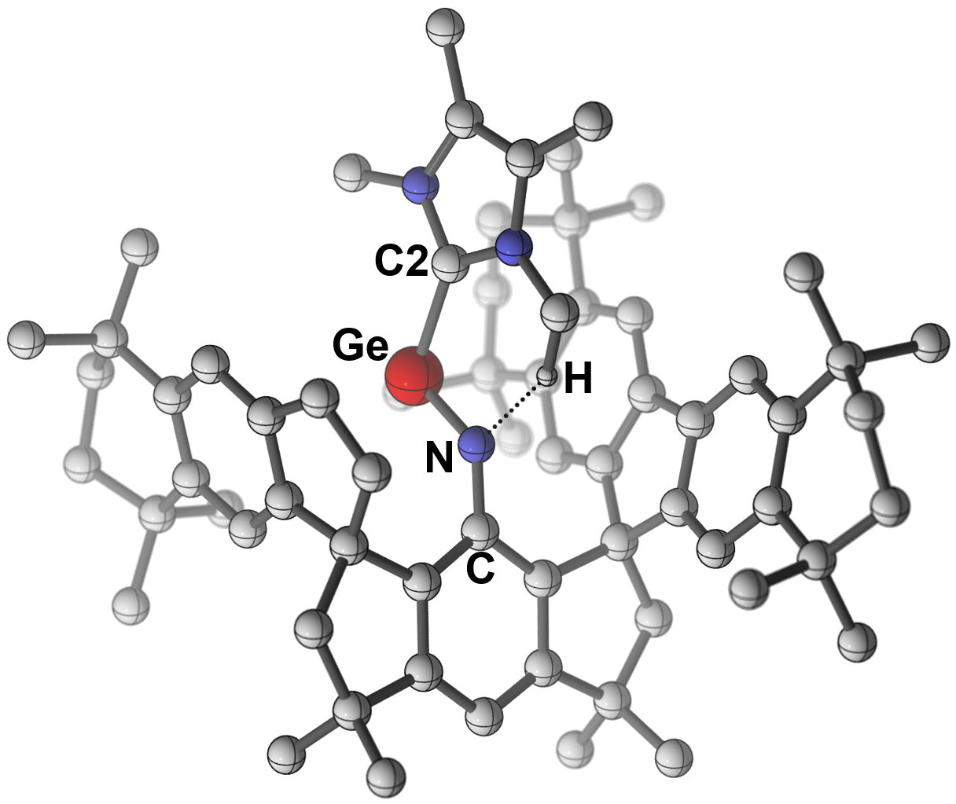
 | Ge–N | N–C | Ge–C2 | C-N-Ge | C2-Ge-N
X-ray | 1.737(2) Å | 1.364(3) Å | 2.123(3) Å | 134.42(18) deg | 93.90(10) deg
Calculated | 1.786 Å | 1.361 Å | 2.131 Å | 129.5 deg | 93.9 deg

Supplementary Table 6. Experimental and calculated bond lengths and angles of 9.
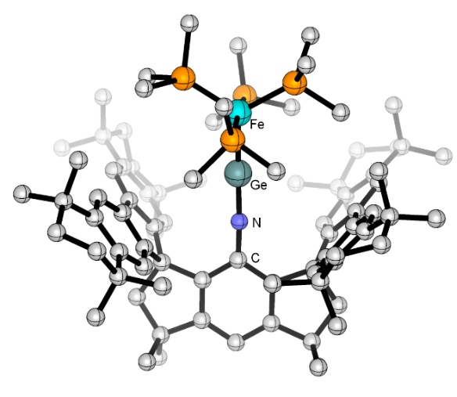
functional | N–Ge | N–C | Ge–Fe | Ge-N-C | Fe-Ge-N | RD(%)ª
Xray | 1.620(3) Å | 1.357(4) Å | 2.1520(6) Å | 173.6(3) deg | 177.94(13) deg | 0.00
m06  (WBI)^{b}  (MBO)^{c} | 1.682 Å  1.89  1.45 | 1.338 Å  1.39  1.24 | 2.156 Å  1.69  1.20 | 176.199 deg | 174.366 deg | 1.80
TPPSH  (WBI)^{b}  (MBO)^{c} | 1.699 Å  1.86  1.48 | 1.346 Å  1.39  1.25 | 2.142 Å  1.71  1.29 | 162.496 deg | 163.372 deg | 4.14
BP86  (WBI)^{b}  (MBO)^{c} | 1.720 Å  1.81  1.45 | 1.350 Å  1.40  1.31 | 2.159 Å  1.67  1.37 | 154.734 deg | 155.773 deg | 6.06
PBE0  (WBI)^{b}  (MBO)^{c} | 1.684 Å  1.88  1.50 | 1.338 Å  1.39  1.24 | 2.133 Å  1.73  1.27 | 168.4 deg | 168.8 deg | 2.88
ª RD=$\frac{\sum_{i=1}^{n}{\frac{\left|BL\left(DFT\right)-BL(Xray)\right|}{BL(Xray)}}}{n}$
^{b} WBI: Wiberg bond indices
^{c} MBO: Mayer bond orders; basis set:def2-SVP

Supplementary Table 7. Experimental and calculated bond lengths and angles of 10.
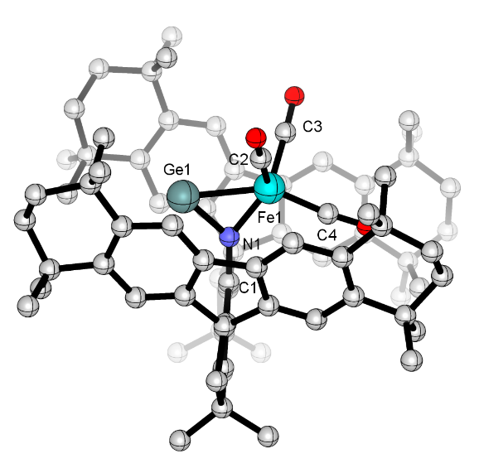
functional | N1–Ge1 | N1–C1 | Ge1–Fe1 | N1–Fe1 | Fe1–C2 | Fe1–C3 | Fe1–C4 | Ge1-N1-C1 | Fe1-Ge1-N1 | RD(%)ª
Xray | 1.804(2) Å | 1.423(3) Å | 2.3878(6) Å | 1.836(2) Å | 1.754(3) Å | 1.756(3) Å | 1.820(4) Å | 135.33(19) deg | 49.58(7) deg | 0.00
m06  (WBI)^{b}  (MBO)^{c} | 1.821 Å  1.39  0.96 | 1.390 Å  1.21  1.11 | 2.446 Å  0.76  0.70 | 1.856 Å  0.94  0.94 | 1.750 Å  1.39  1.39 | 1.758 Å  1.40  1.40 | 1.814 Å  1.29  1.29 | 133.5 deg | 48.9 deg | 1.12
TPPSH  (WBI)^{b}  (MBO)^{c} | 1.839 Å  1.31  0.95 | 1.391 Å  1.22  1.09 | 2.413 Å  0.82  0.76 | 1.847 Å  0.99  0.99 | 1.745 Å  1.40  1.40 | 1.751 Å  1.41  1.41 | 1.801 Å  1.32  1.32 | 134.5 deg | 49.2 deg | 0.99
BP86  (WBI)^{b}  (MBO)^{c} | 1.857 Å  1.29  0.93 | 1.393 Å  1.23  1.12 | 2.470 Å  0.76  0.70 | 1.853 Å  0.98  0.98 | 1.742 Å  1.41  1.38 | 1.742 Å  1.44  1.42 | 1.785 Å  1.38  1.36 | 134.0 deg | 48.2 deg | 1.83
PBE0  (WBI)^{b}  (MBO)^{c} | 1.819 Å  1.35  0.99 | 1.386 Å  1.22  1.10 | 2.400 Å  0.81  0.75 | 1.844 Å  0.96  0.90 | 1.738 Å  1.40  1.35 | 1.746 Å  1.39  1.36 | 1.799 Å  1.29  1.24 | 134.6 deg | 49.5 deg | 0.86
ª RD=$\frac{\sum_{i=1}^{n}{\frac{\left|BL\left(DFT\right)-BL(Xray)\right|}{BL(Xray)}}}{n}$
^{b} WBI: Wiberg bond indices
^{c} MBO: Mayer bond orders; basis set:def2-SVP

Supplementary Fig. 42 The reaction energy profile for the formation of 3 from 2 at the BP86-D3(BJ)/def2-SVP level. S₁ and S₂ states are computed using TDDFT approach. Trivial hydrogen atoms have been omitted for clarity.

Supplementary Fig. 43 Selected frontier molecular orbitals of 3 (isovalue = 0.03).
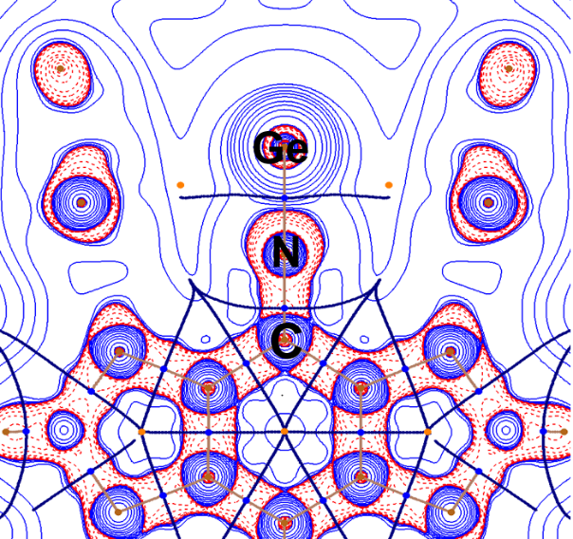
3 (C₂, ¹A)
Ge-N: ∇²ρ(r_{c}) = 0.811 au; H(r_{c}) = -0.804 au;
ε(r_{c}) = 0.03
N-C: ∇²ρ(r_{c}) = -0.926 au; H(r_{c}) = -0.485 au;
ε(r_{c}) = 0.05
Supplementary Fig. 44 The contour plot of the Laplacian of electron density, ∇²ρ(r) of 3 at the BP86-D3(BJ)/def2-SVP level. Red lines indicate the areas of charge concentration (∇²ρ(r) < 0), while blue lines show the areas of charge depletion (∇²ρ(r) > 0). The thick solid lines connecting the atomic nuclei are the bond paths. Blue dots are bond critical points (BCP). The thin lines which cross the BCP show the zero-flux surfaces in the molecular plane that separate the atomic basins.

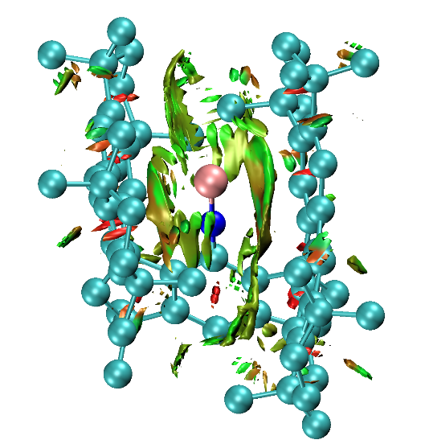
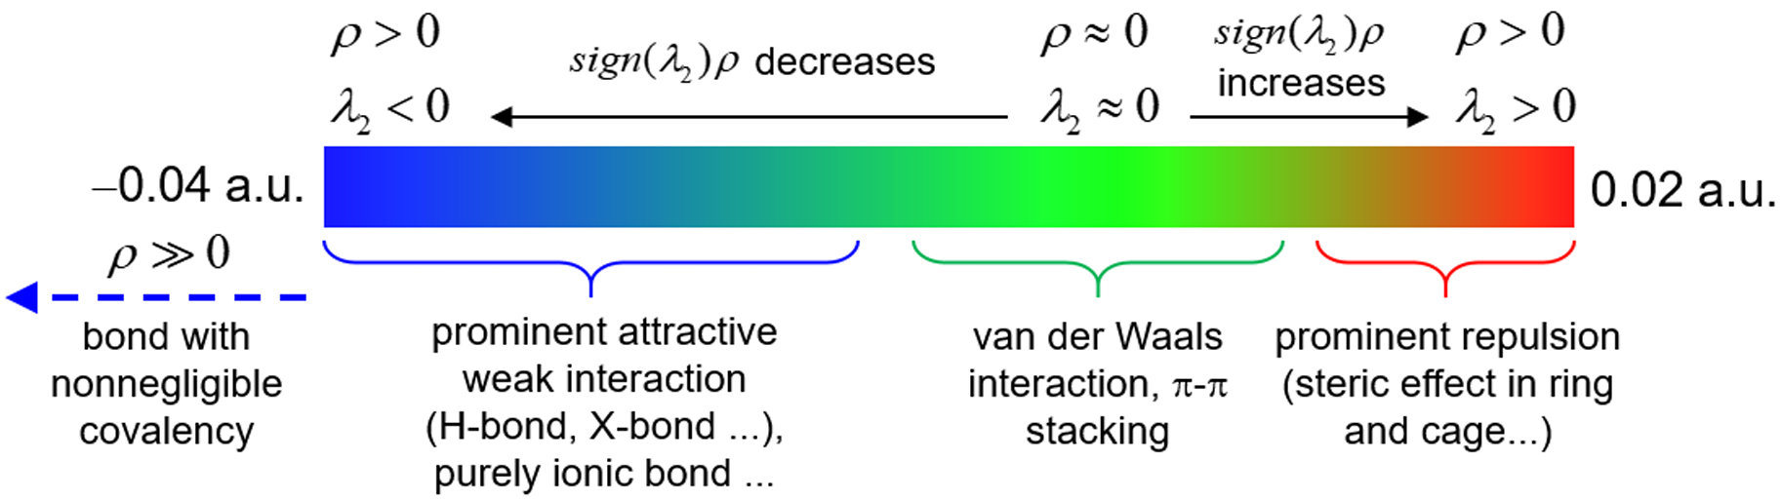
Supplementary Fig. 45 The reduced gradient isosurface of 3 colored on a blue-green-red scale in accordance with the value of sign(λ₂)ρ, ranging from -0.04 to 0.02 au.

Supplementary Fig. 46 Selected frontier molecular orbitals of 4 (isovalue = 0.03).

Supplementary Fig. 47 Selected frontier molecular orbitals of 9 calculated at the M06(D3)/def2-SVP level of theory (isovalue = 0.03). HOMO and HOMO-4 comprise of the interaction between the 3d orbitals of the Fe atom with the π*(Ge-N) orbitals; HOMO-1 shows the coordination between the Ge and Fe atoms; HOMO-2 and HOMO-7 reveal the π(Ge-N) orbitals.

Supplementary Fig. 48 Selected frontier molecular orbitals of 10 calculated at the M06(D3)/def2-SVP level of theory (isovalue = 0.03).

EDA-NOCV results of 3
The EDA-NOCV) theory is carried out to get the quantitative strength of each bonding component in the N≡Ge bond. The numerical values of EDA-NOCV are very dependent on the charge and electronic states of the interacting fragments. Therefore, it is paramount to choose the correct fragmentation scheme. Using the size of the orbital interaction (ΔE_{orb}) as a probe is the prescribed recipe for selecting the best fragmentation scheme, and usually, the smallest (in absolute value) is the best one as it suggests the chosen fragments electronically closest to those in the complex.¹⁰⁶ The EDA results given in Supplementary Table 8 suggest that the bonding in the N≡Ge bond is best described as Ge in a triplet spin state with 4s²4p_{x}¹4p_{y}¹4p_{z}⁰ electron configuration forming two electron-sharing π-bonds and one dative σ-bond with the remaining moiety [-CN] in triplet spin state. The bonding situation is very similar to the CO molecule where the CO has two electron-sharing π-bonds and one C←O dative σ-bond.

Supplementary Table 8. EDA-NOCV results of complex 3 considering Ge as one fragment and the rest [-C-N] as another at the BP86-D3(BJ)/TZ2P-ZORA//BP86-D3(BJ)/def2-SVP level. Energy values are given in kcal mol⁻¹.
Energies | Interaction | Ge (T, 4s²4p_{x}¹4p_{y}¹4p_{z}⁰) + [-CN] (T) | Ge⁺ (D, 4s²4p_{x}¹4p_{y}⁰4p_{z}⁰) + [-CN]⁻ (D)
ΔE_{int} |  | -141.4 | -294.8
ΔE_{Pauli} |  | 306.8 | 280.1
ΔE_{disp}ª |  | -24.7 (5.5%) | -24.7
ΔE_{elstat}ª |  | -182.5 (40.7%) | -281.8
ΔE_{orb}ª |  | -241.0 (53.8%) | -268.4
ΔE_{orb(1)}^{b} | [-CN]−Ge  electron sharing π-bond | -78.6 (32.6%)
ΔE_{orb(2)}^{b} | [-CN]−Ge  electron sharing π-bond | -69.7 (28.9%)
ΔE_{orb(3)}^{b} | [-CN]→Ge  σ-donation | -74.0 (30.7%)
ΔE_{orb(rest)}^{b} |  | -18.7 (7.8%)
ªThe values in parentheses give the percentage contribution to the total attractive interactions ΔE_{elstat} + ΔE_{orb} + ΔE_{disp}.
^{b}The values in parentheses give the percentage contribution to the total orbital interactions ΔE_{orb}.
High interaction energy (ΔE_{int} = -141.4 kcal/mol) reflects quite strong N-Ge interaction in 3. The N-Ge bond is more covalent in nature (54%) than electrostatic (41%). The division of the total ΔE_{orb} term into pair-wise orbital interaction gives three distinct major orbital interaction terms, ΔE_{orb(1)-(3)}, the origin of which can be distinguished with the help of the corresponding deformation densities, Δρ₍₁₎₋₍₃₎, and the associated molecular orbitals of the fragments (see Supplementary Fig. 49 and Fig. 50). In the deformation density plots, electron density moves from the red to blue region. Two electron-sharing π-bonds, which are originated from the overlap of two p_{π} (in-plane and out-of-plane) atomic orbitals of Ge and two singly occupied molecular orbitals (SOMOs) of the [-CN] fragment having two p_{π} orbitals of N. Two π-orbitals together are responsible for 61.5% of the total orbital interaction. The dative σ-bond comes from the electron density donation from the HOMO-5 of [-CN] fragment to an s-p_{σ} hybrid orbital of Ge. The σ-bond is accountable for 30.7% of total covalent character. The remaining orbital interaction arises from the several small intra- and inter-fragment polarization terms.

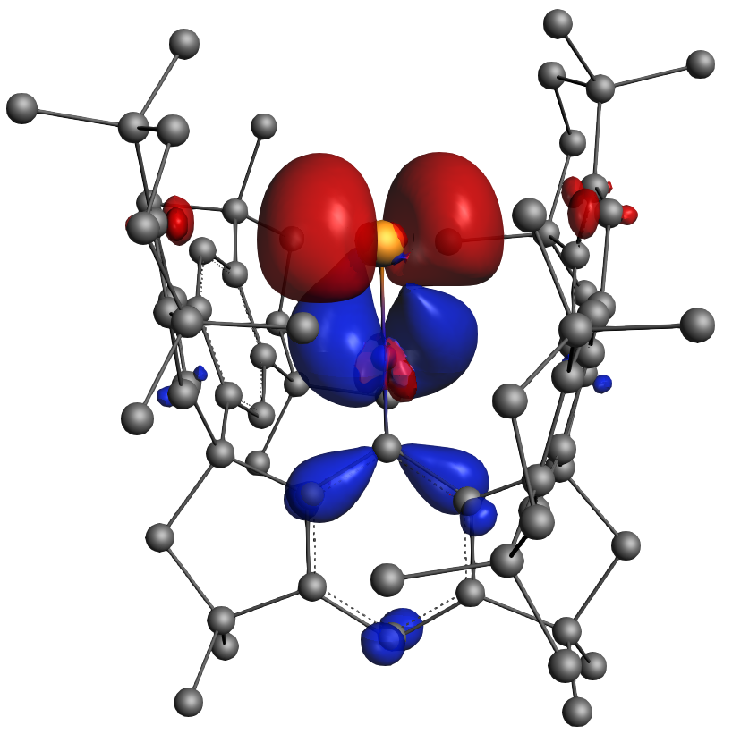  ∆E_{orb(1)} = -78.6 kcal/mol; |ν_{1α/1β}| = 0.82/0.38 | 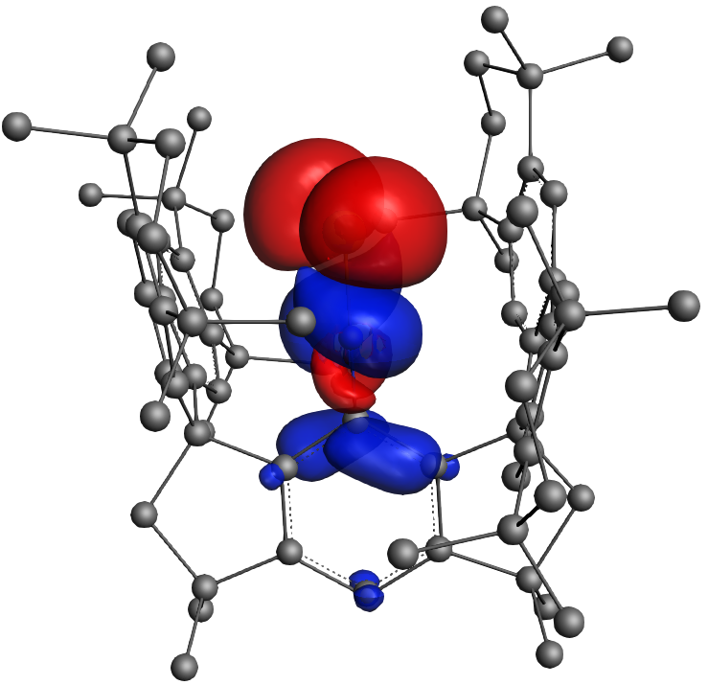  ∆E_{orb(2)} = -69.7 kcal/mol; |ν_{2α/2β}| = 0.84/0.44 | 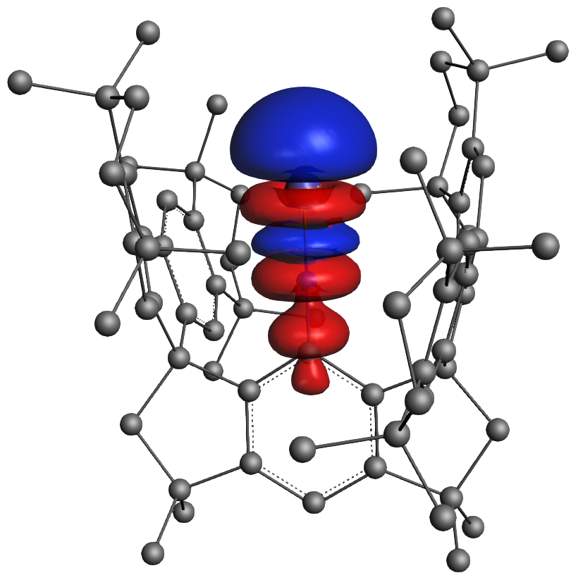  ∆E_{orb(3)} = -74.0 kcal/mol; |ν₃| = 0.72
Supplementary Fig. 49 The plot of the deformation densities, Δρ₍₁₎₋₍₃₎, corresponding to ΔE_{orb(1)-(3)} in 3 obtained at the BP86-D3(BJ)/TZ2P-ZORA//BP86-D3(BJ)/def2-SVP level. Electron density moves from red to blue region.
Deformation density | Ge (T) |  | [-CN] (T)
∆E_{orb(1)} = -78.6 kcal/mol; |ν_{1α/1β}| = 0.82/0.38 | 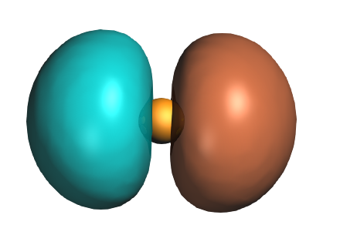  SOMO (ν_{1α/1β} = -0.53/0.25) | ↔ | 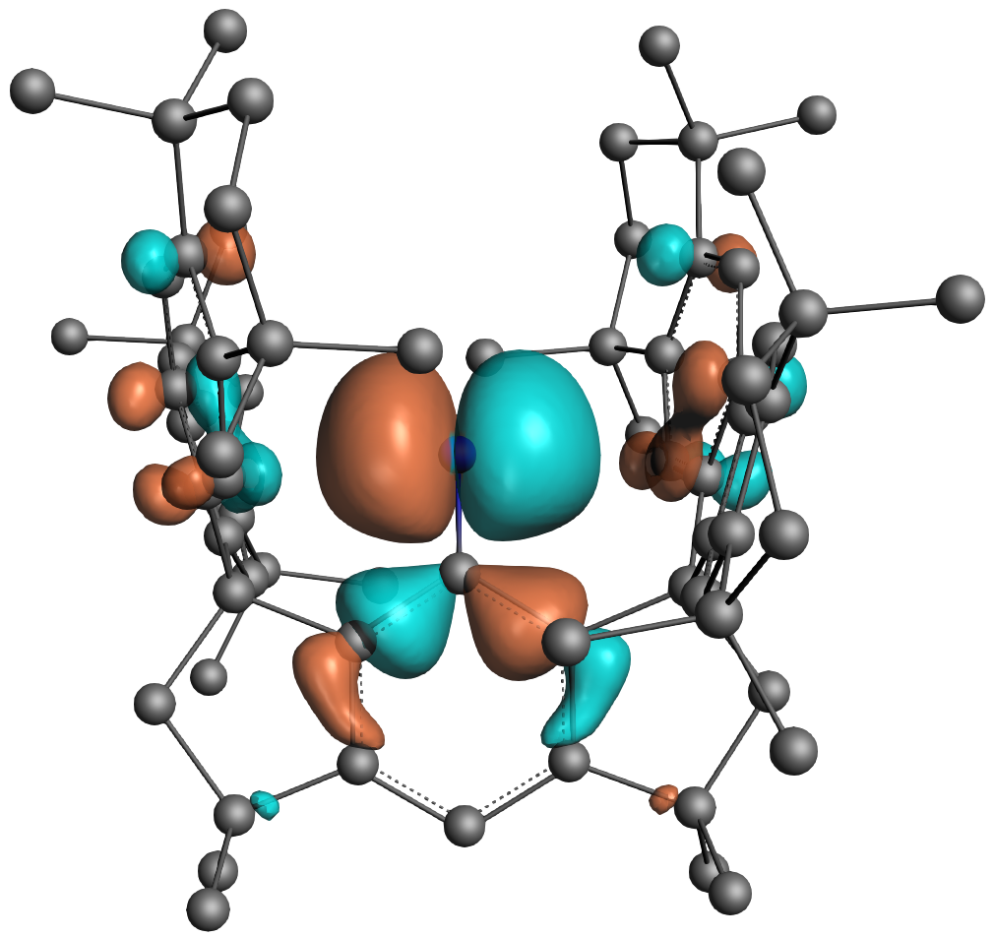  SOMO (ν_{1α/1β} = 0.48/-0.22)
∆E_{orb(2)} = -69.7 kcal/mol; |ν_{2α/2β}| = 0.84/0.44 | 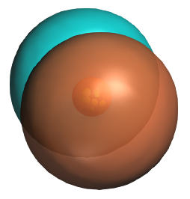  SOMO-1 (ν_{2α/2β} = -0.54/0.25) | ↔ | 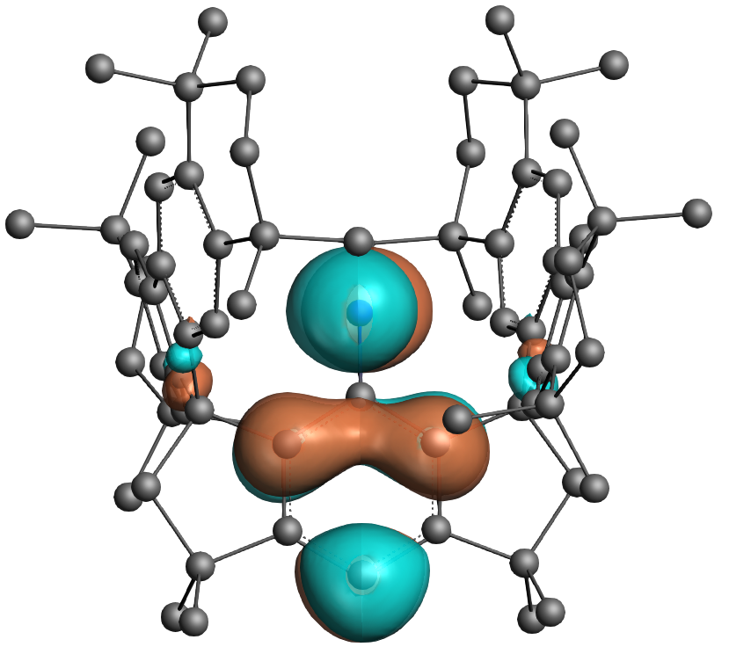  SOMO-1 (ν_{2α/2β} = 0.47/-0.24)
∆E_{orb(3)} = -74.0 kcal/mol; |ν₃| = 0.72 | 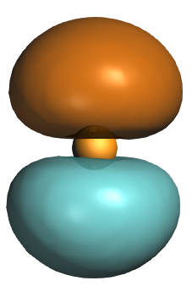  LUMO (ν₃ =0.68)  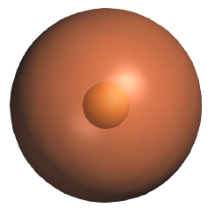  HOMO (ν₃ =-0.20) | ← | 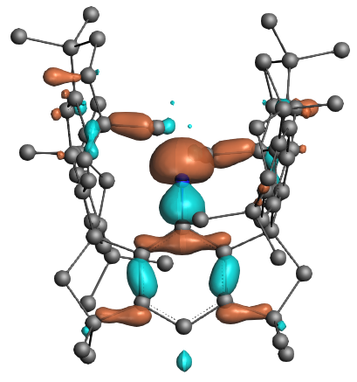  HOMO-5 (ν₃ = -0.20)

Supplementary Fig. 50 The plot of deformation densities, Δρ₍₁₎₋₍₃₎ corresponding to ΔE_{orb(1)-(3)} in the EDA-NOCV of complex 3 considering Ge (T) + [-CN] (T) as interacting fragments and the related interacting orbitals of the fragments at the BP86-D3(BJ)/TZ2P-ZORA//BP86-D3(BJ)/def2-SVP level. Energy values are in kcal/mol. Electron density moves from red to blue region. ν represents the charge eigenvalue.

Calculation of shielding tensors
All calculations were performed using the ORCA program package.¹⁰⁷ First, hydrogen atom positions in the X-ray crystal structure were optimized at the BP86/def2-SVP level of theory. The resulting structure was then utilized as the input for ¹⁵N NMR chemical shift calculations performed with multiple density functional theory (DFT) functionals (BP86, PBE, PBE0, B3LYP, TPSSh, and M06-2X) combined with the def2-TZVP basis set, while nitrogen atoms were specifically treated using the pcSseg-2 basis set. The absolute shielding tensor obtained from these calculations were then converted to chemical shifts (δ ppm) using eq. 5:¹⁰⁸⁻¹¹⁰
δ(S, calc.) = σ(N₂, calc.) − σ(S, calc.) + δ(N₂, ref) (5)
In this equation, δ (S, calc) represents the calculated chemical shift (in ppm) of the compound of interest, σ (N₂, calc.) denotes the calculated absolute shielding tensor for the reference compound (N₂ gas;), σ (S, calc.) is the calculated absolute shielding tensor of interesting compound and δ (N₂, ref.) is the experimental chemical shift (ppm) of the reference compound (N₂ gas). The NMR shielding (σ) of N₂ (with reference to nitromethane) = 74.2 ppm, therefore δ (N₂, ref.) = 380.2−74.2 = 306 ppm (referenced to liquid NH₃ at 0 ppm)^{111, 112} We have summarized these chemical shift values in Supplementary Table 9 and compared them with the experimental values.
Supplementary Table 9. Calculated chemical shift values of complex 3 using different density functionals (BP86, PBE, PBE0, B3LYP, TPSSH and M062X).
Complex | Exp | BP86 | PBE | PBE0 | B3LYP | TPSSH | M062X
$$δ_{iso}^{ }$$ | 213.3 | 192.3 | 189.9 | 168.4 | 177.9 | 185.5 | 116.0
$$δ_{11}^{ }$$ | 410.5 | 382 | 378.5 | 363 | 378.2 | 371.5 | 332.6
$$δ_{22}^{ }$$ | 286.3 | 304.1 | 300.2 | 277.9 | 291 | 293 | 226.1
$$δ_{33}^{ }$$ | –56.6 | –109.3 | –108.9 | –135.7 | –135.6 | –108.1 | –210.6

As shown in Supplementary Table 9, the BP86 method yields the best agreement with the experimental results. Therefore, we employed the BP86 method to perform canonical orbital decomposition and analyze the theoretical chemical shielding in our study. The results are summarized in Supplementary Table 10.

Supplementary Table 10. Calculated chemical shielding values of 3 using BP86.
Complex | $$σ_{total}^{ }$$ | $$σ_{ }^{dia}$$ | $$σ_{ }^{para}$$
$$σ_{iso}^{ }$$ | 24.1 | 353.9 | –329.8
$$σ_{x}^{ }$$ | –87.7 | 337.0 | –424.7
$$σ_{y}^{ }$$ | –165.6 | 318.7 | –484.3
$$σ_{z}^{ }$$ | 325.7 | 405.9 | –80.3

As shown in Supplementary Table 10, DFT calculations revealed that the primary magnetic orbital couplings contributing to the paramagnetic shifts of –60.5 ppm in the x-component and –78.1 ppm in the y-direction arise from electron transitions between the filled σ(Ge-N) orbital to the vacant π*(Ge-N) orbital (Supplementary Fig. 51). These contributions account for 14.2% and 16.1% of the $σ_{x}^{para}$ and $σ_{y}^{para}$, respectively. For the z-component, the coupling between the π(Ge-N) and π(N-C) orbitals contributes –51.5 ppm, representing 64.1% of the $σ_{z}^{p}$.

Supplementary Fig. 51 Important magnetic couplings for the paramagnetic shielding term of complex 3. For each coupling pathway, its contribution and percentage to the total paramagnetic shielding term,$σ_{x}^{p}$, $σ_{y}^{p}$, and $σ_{z}^{p}$, and the energy difference of the constituent canonical MOs are given.

Electronic absorption spectra
Supplementary Fig. 52 UV-vis-NIR absorption spectra of 2 recorded in a 0.05 mM n-hexane solution. Optical path = 10 mm.
Supplementary Fig. 53 UV-vis-NIR absorption spectra of 3 recorded in a 0.01 mM n-hexane solution. Optical path = 10 mm.

Supplementary Fig. 54 UV-vis-NIR absorption spectra of 4 recorded in a 0.10 mM n-hexane solution. Optical path = 10 mm.
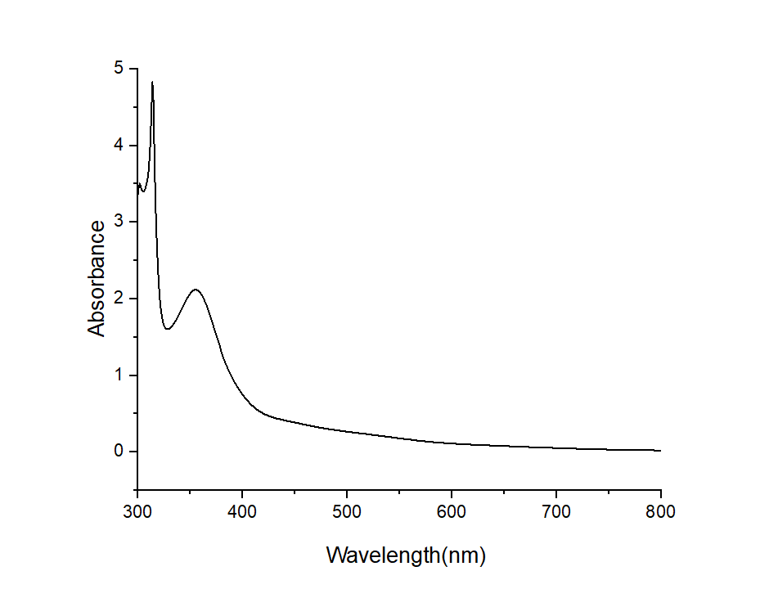
Supplementary Fig. 55 UV-vis-NIR absorption spectra of 9 recorded in a 0.20 mM n-hexane solution. Optical path = 10 mm.
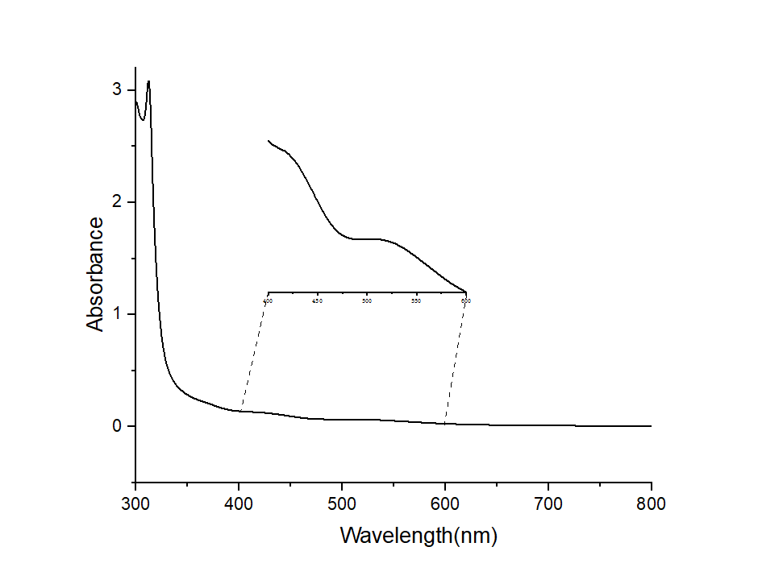
Supplementary Fig. 56 UV-vis-NIR absorption spectra of 10 recorded in a 0.10 mM n-hexane solution. Optical path = 10 mm.

Infra-red absorption spectra
Supplementary Fig. 57 Infra-red absorption spectrum of 2 measured in nujol.

Supplementary Fig. 58 Infra-red absorption spectrum of ¹⁵N-2 measured in nujol.

Supplementary Fig. 59 Infra-red absorption spectrum of 3 measured in nujol.
Supplementary Fig. 60 Infra-red absorption spectrum of ¹⁵N-3 measured in nujol.

Supplementary Fig. 61 Infra-red absorption spectrum of 4 measured in nujol.

Supplementary Fig. 62 Infra-red absorption spectrum of 5 measured in nujol.

Supplementary Fig. 63 Infra-red absorption spectrum of 6 measured in nujol.

Supplementary Fig. 64 Infra-red absorption spectrum of 7 measured in nujol.

Supplementary Fig. 65 Infra-red absorption spectrum of 8 measured in nujol.
Supplementary Fig. 66 Infra-red absorption spectrum of 9 measured in nujol.Supplementary Fig. 67 Infra-red absorption spectrum of 10 measured in nujol.

References
78. Wang, D. et al., An isolable germylyne radical with a one-coordinate germanium atom. Nat. Chem. 15, 200-205 (2023).
79. Yan, Z., Deng, J., Tian, J. & Luo, G., A safer, greener and faster synthesis process of sodium azide by simply altering the alcohol reactant. Green Chem. 26, 6139-6149 (2024).
80. Kuhn, N. & Kratz, T., Synthesis of imidazol-2-ylidenes by reduction of imidazole-2(3H)-thiones. Synthesis 1993, 561-562 (1993).
81. Karsch, H. H., Klein, H. F. & Schmidbaur, H., The dimethylphosphinomethanide ion, (CH₃)₂PCH₂c⊖: A novel ligand for transition metals. Angew. Chem. Int. Ed. 14, 637-638 (1975).
82. Sheldrick, G., Shelxt - integrated space-group and crystal-structure determination. Acta Cryst. A A71, 3-8 (2015).
83. Sheldrick, G. M., Crystal structure refinement with shelxl. Acta Cryst. C71, 3-8 (2015).
84. Dolomanov, O. V., Bourhis, L. J., Gildea, R. J., Howard, J. A. K. & Puschmann, H., Olex2: A complete structure solution, refinement and analysis program. J. Appl. Cryst. 42, 339-341 (2009).
85. Frisch, M. J.; Trucks, G. W.; Schlegel, H. B.; Scuseria, G. E.; Robb, M. A.; Cheeseman, J. R.; Scalmani, G.; Barone, V.; Mennucci, B.; Petersson, G. A.; Nakatsuji, H.; Caricato, M.; Li, X.; Hratchian, H. P.; Izmaylov, A. F.; Bloino, J.; Zheng, G.; Sonnenberg, J. L.; Hada, M.; Ehara, M.; Toyota, K.; Fukuda, R.; Hasegawa, J.; Ishida, M.; Nakajima, T.; Honda, Y.; Kitao, O.; Nakai, H.; Vreven, T.; Montgomery, J. A., Jr.; Peralta, J. E.; Ogliaro, F.; Bearpark, M.; Heyd, J. J.; Brothers, E.; Kudin, K. N.; Staroverov, V. N.; Kobayashi, R.; Normand, J.; Raghavachari, K.; Rendell, A.; Burant, J. C.; Iyengar, S. S.; Tomasi, J.; Cossi, M.; Rega, N.; Millam, J. M.; Klene, M.; Knox, J. E.; Cross, J. B.; Bakken, V.; Adamo, C.; Jaramillo, J.; Gomperts, R.; Stratmann, R. E.; Yazyev, O.; Austin, A. J.; Cammi, R.; Pomelli, C.; Ochterski, J. W.; Martin, R. L.; Morokuma, K.; Zakrzewski, V. G.; Voth, G. A.; Salvador, P.; Dannenberg, J. J.; Dapprich, S.; Daniels, A. D.; Farkas, O.; Foresman, J. B.; Ortiz, J. V.; Cioslowski, J.; Fox, D. J., Gaussian 16, Revision A.03; Gaussian, Inc., Wallingford CT, 2016.
86. Perdew, J. P., Density-functional approximation for the correlation energy of the inhomogeneous electron gas. Phys. Rev. B 33, 8822-8824 (1986).
87. Becke, A. D., Density-functional exchange-energy approximation with correct asymptotic behavior. Phys. Rev. A 38, 3098-3100 (1988).
88. Weigend, F. & Ahlrichs, R., Balanced basis sets of split valence, triple zeta valence and quadruple zeta valence quality for H to Rn: Design and assessment of accuracy. Phys. Chem. Chem. Phys. 7, 3297-3305 (2005).
89. Weigend, F., Accurate coulomb-fitting basis sets for H to Rn. Phys. Chem. Chem. Phys. 8, 1057-1065 (2006).
90. Grimme, S., Ehrlich, S. & Goerigk, L., Effect of the damping function in dispersion corrected density functional theory. J. Comput. Chem. 32, 1456-1465 (2011).
91. Adamo, C. & Barone, V., Toward reliable density functional methods without adjustable parameters: The pbe0 model. J. Chem. Phys. 110, 6158-6170 (1999).
92. Tao, J., Perdew, J. P., Staroverov, V. N. & Scuseria, G. E., Climbing the density functional ladder: Nonempirical meta--generalized gradient approximation designed for molecules and solids. Phys. Rev. Lett. 91, 146401 (2003).
93. Staroverov, V. N., Scuseria, G. E., Tao, J. & Perdew, J. P., Comparative assessment of a new nonempirical density functional: Molecules and hydrogen-bonded complexe. J. Chem. Phys. 119, 12129 (2003).
94. Zhao, Y. & Truhlar, D. G., The m06 suite of density functionals for main group thermochemistry, thermochemical kinetics, noncovalent interactions, excited states, and transition elements: Two new functionals and systematic testing of four m06-class functionals and 12 other functionals. Theor. Chem. Acc. 120, 215-241 (2008).
95. Glendening, E. D.; Badenhoop, J. K.; Reed, A. E.; Carpenter, J. E.; Bohmann, J. A.; Morales, C. M.; Karafiloglou, P.; Landis, C. R.; Weinhold, F. NBO 7.0; Theoretical Chemistry Institute, University of Wisconsin: Madison, WI, 2018 (http://nbo7.chem.wisc.edu/)
96. Knizia, G., Intrinsic atomic orbitals: An unbiased bridge between quantum theory and chemical concepts. J. Chem. Theory Comput. 9, 4834-4843 (2013).
97. Knizia, G. & Klein, J. E. M. N., Electron flow in reaction mechanisms—revealed from first principles. Angew. Chem. Int. Ed. 54, 5518-5522 (2015).
98. Neese, F., The orca program system. WIREs Comput. Mol. Sci. 2, 73-78 (2012).
99. Lu, T. & Chen, F., Multiwfn: A multifunctional wavefunction analyzer. J. Comput. Chem. 33, 580-592 (2012).
100. Lu, T., A comprehensive electron wavefunction analysis toolbox for chemists, multiwfn. J. Chem. Phys. 161, 082503 (2024).
101. Ziegler, T. & Rauk, A., On the calculation of bonding energies by the hartree fock slater method. Theoret. Chim. Acta 46, 1-10 (1977).
102. Mitoraj, M. & Michalak, A., Donor–acceptor properties of ligands from the natural orbitals for chemical valence. Organometallics 26, 6576-6580 (2007).
103. ADF2020, SCM, Theoretical Chemistry, Vrije Universiteit, Amsterdam, The Netherlands, Http://www.scm.com.
104. Mitoraj, M. P., Michalak, A. & Ziegler, T., A combined charge and energy decomposition scheme for bond analysis. J. Chem. Theory Comput. 5, 962-975 (2009).
105. Zhao, L., von Hopffgarten, M., Andrada, D. M. & Frenking, G., Energy decomposition analysis. WIREs Comput. Mol. Sci. 8, e1345 (2018).
106. Chi, C. et al., Alkali metal covalent bonding in nickel carbonyl complexes ENi(CO)₃⁻. Angew. Chem. Int. Ed. 58, 1732-1738 (2019).
107. Neese, F., Software update: The orca program system—version 5.0. WIREs Comput. Mol. Sci. 12, e1606 (2022).
108. van Wüllen, C., A comparison of density functional methods for the calculation of phosphorus-31 nmr chemical shifts. Phys. Chem. Chem. Phys. 2, 2137-2144 (2000).
109. Bertani, P., Raya, J. & Bechinger, B., ¹⁵N chemical shift referencing in solid state nmr. Solid State Nucl. Magn. Reson. 61-62, 15-18 (2014).
110. Stoychev, G. L., Auer, A. A., Izsák, R. & Neese, F., Self-consistent field calculation of nuclear magnetic resonance chemical shielding constants using gauge-including atomic orbitals and approximate two-electron integrals. J. Chem. Theory Comput. 14, 619-637 (2018).
111. Witanowski, M.; Sicinska, W.; Biernat, S.; Webb, G. A. Dinitrogen as a Possible Internal Standard for Nitrogen Nuclear Magnetic Resonance. Spectros. Int. J., 9, 55 (1991).
112. Jameson, C. J. et al., ¹⁵N nuclear magnetic shielding scale from gas phase studies. J. Chem. Phys. 74, 81-88 (1981).

