Supplemental Material
Table S1. List of annotations that indicate walking at moderate intensity or higher.
[1] "transportation;walking;17250 walking as the single means to a destination not to work or class;MET 3.0"
[2] "home activity;miscellaneous;walking;5147 walking moving away light items (pens/papers/keys not included);MET 3.0"
[3] "walking;MET 3.0"
[4] "manual-work;walking+activity;MET 3.5"
[5] "home activity;miscellaneous;walking;5121 walking with moving and lifting loads such as bikes and furniture;MET 4.0"
[6] "transportation;walking;17270 walking as the single means to work or class (not from);MET 3.5"
[7] "home activity;miscellaneous;walking;5165 (generic) walking non-cleaning task such as closing windows lock door putting away items;MET 3.5"
[8] "manual-work;walking+activity;MET 3.0"
[9] "occupation;interruption;walking;11795 walking on job and carrying light objects such as boxes or pushing trolleys;MET 3.5"
[10] "leisure;miscellaneous;walking;17031 loading /unloading a car implied walking;MET 3.5"
[11] "home activity;household chores;preparing meals/cooking/washing dishes;5035 cleaning up table after meal implied walking (e.g. leaving from eating table to the kitchen);MET 3.3"
[12] "home activity;leisure;mixed-activity;walking+activity;MET 3.0"
[13] "household-chores;walking+activity;MET 3.0"
[14] "manual-work;walking+activity;MET 3.8"
[15] "occupation;miscellaneous;11615 (generic) standing lifting items continuously with limited walking;MET 4.5"
[16] "manual-work;walking+activity;MET 5.5"
[17] "occupation;interruption;17133 walking upstairs;MET 4.0"
[18] "leisure;miscellaneous;walking;17133 walking upstairs;MET 4.0"
[19] "occupation;interruption;11795 walking on job and carrying light objects such as boxes or pushing trolleys;MET 3.5"
[20] "home activity;child/elderly/pet care;child care;5181 walking and carrying child;MET 3.0"
[21] "transportation;walking;12150 running;MET 8.0"
[22] "home activity;household chores;house cleaning;floors;5140 sweeping garage sidewalk or outside of house;MET 4.0"
[23] "occupation;interruption;walking;17133 walking upstairs;MET 4.0"
[24] "occupation;interruption;walking;17070 walking downstairs;MET 3.5"
[25] "leisure;recreation;outdoor;5175 walking/running playing with child(ren);MET 3.5"
[26] "leisure;sports;miscellaneous;17082 hiking or walking at a normal pace through fields and hillsides;MET 5.0"
[27] "leisure;miscellaneous;walking;17070 descending stairs;MET 3.5"
[28] "leisure;miscellaneous;21070 (generic) walking/standing combination indoor;MET 3.0"
[29] "leisure;miscellaneous;17031 loading /unloading a car implied walking;MET 3.5"

Figure S1. Distribution of bouted MVPA.
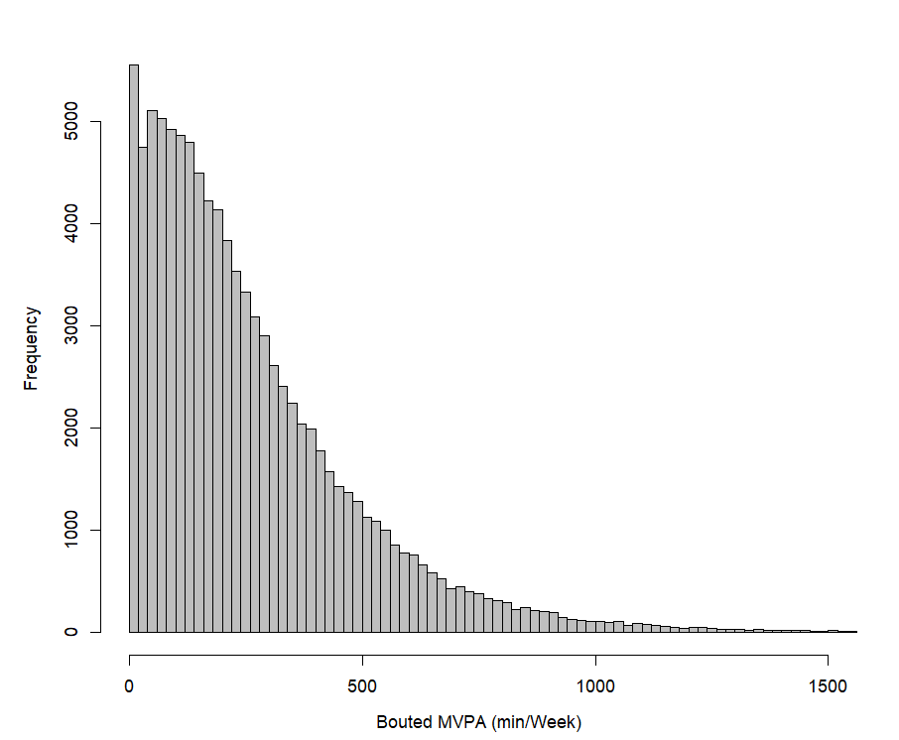
Figure S2. Distribution of sporadic MVPA.

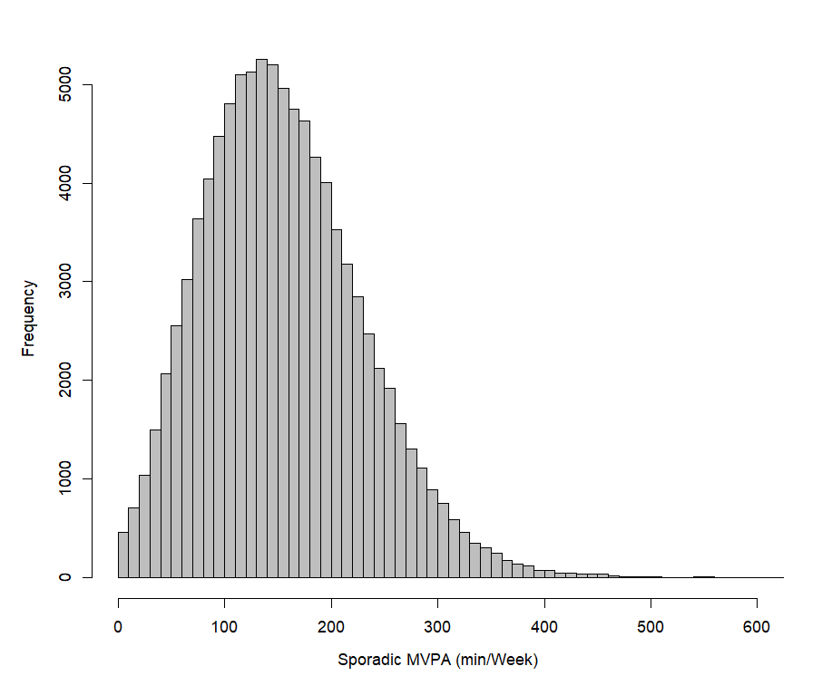
Figure S3. Analyses further adjusting for cardiovascular disease (not in the analysis of CVD incidence), cancer, diabetes, long-term illness, and self-rated health.
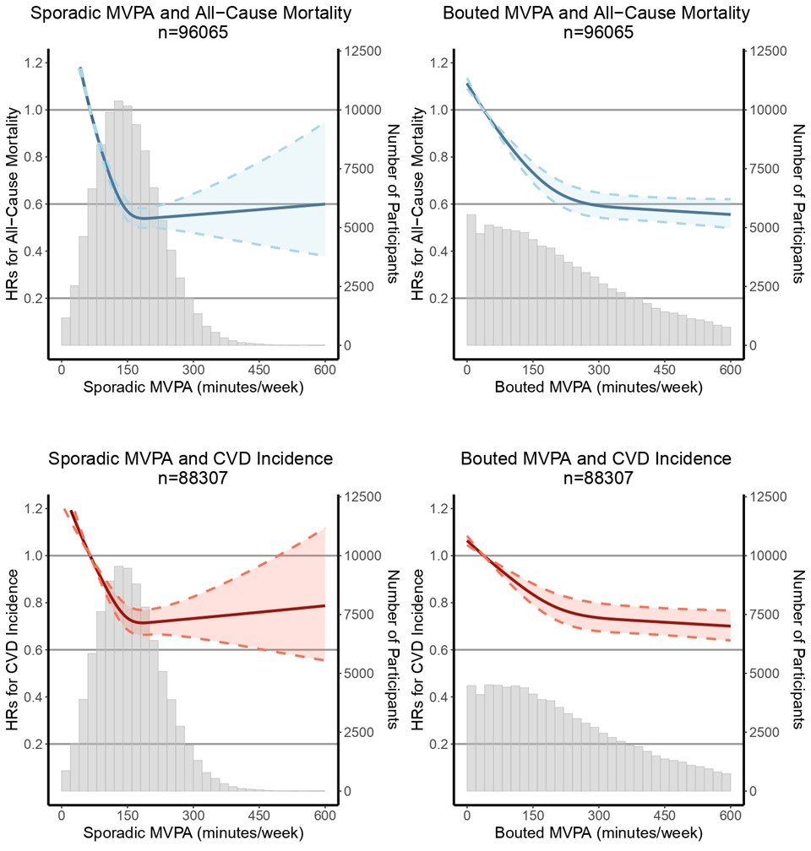

Figure S4. Analyses in males.
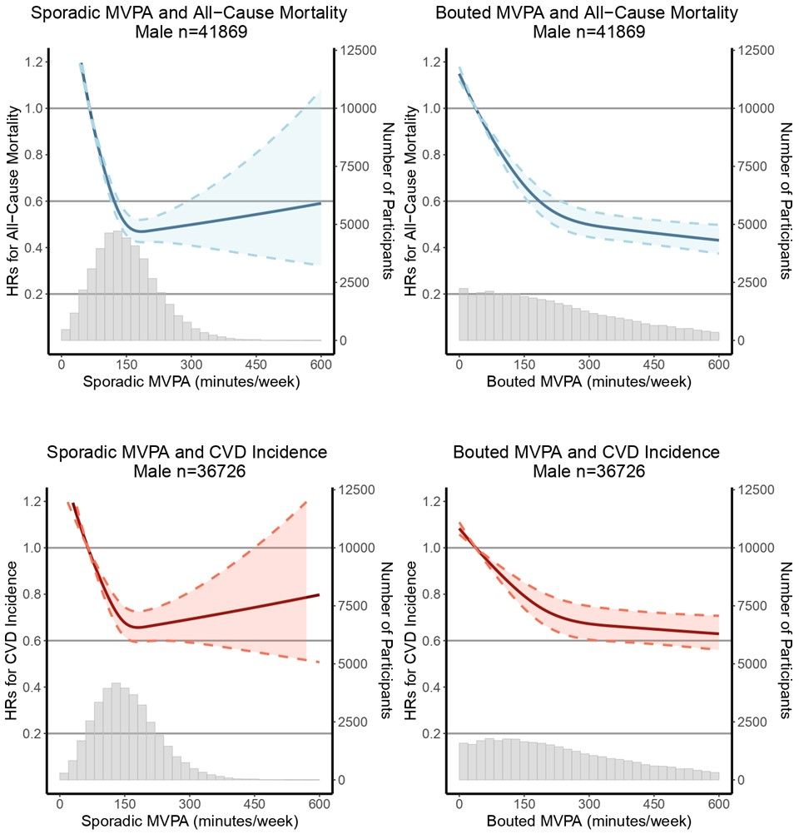

Figure S5. Analyses in females.
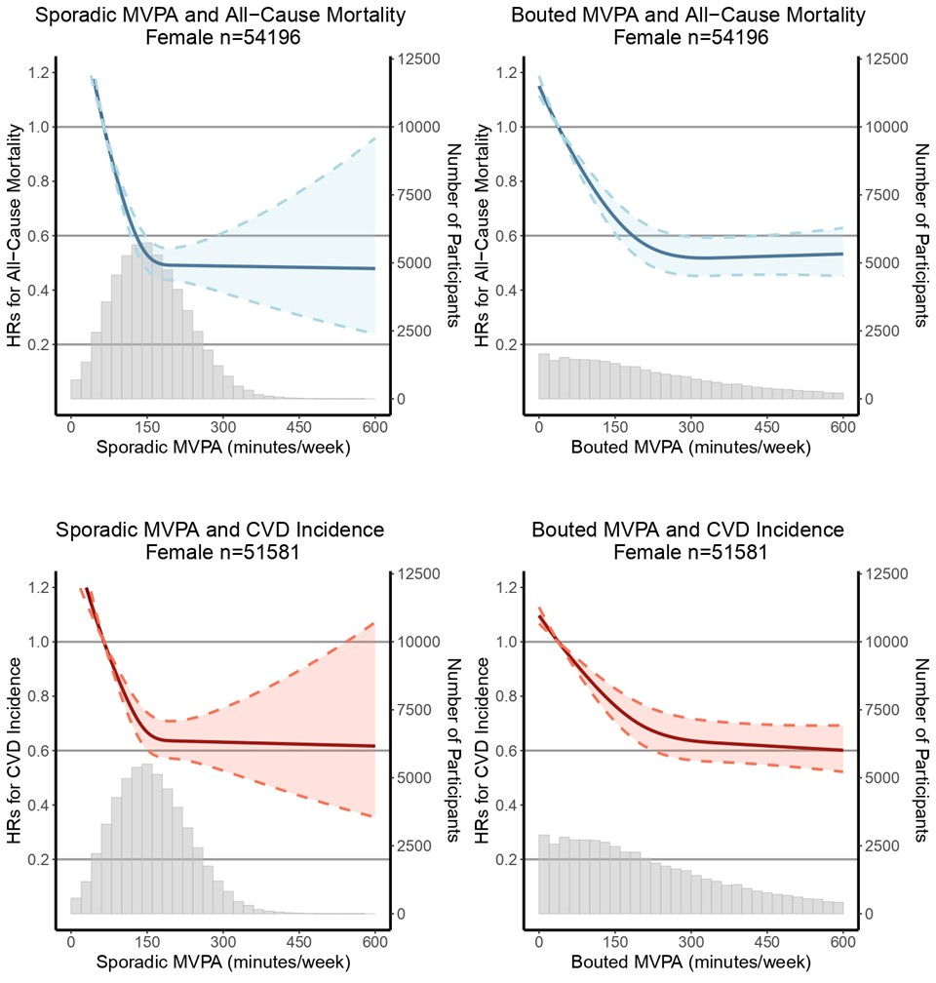

Figure S6. Analyses in those < 65 years.
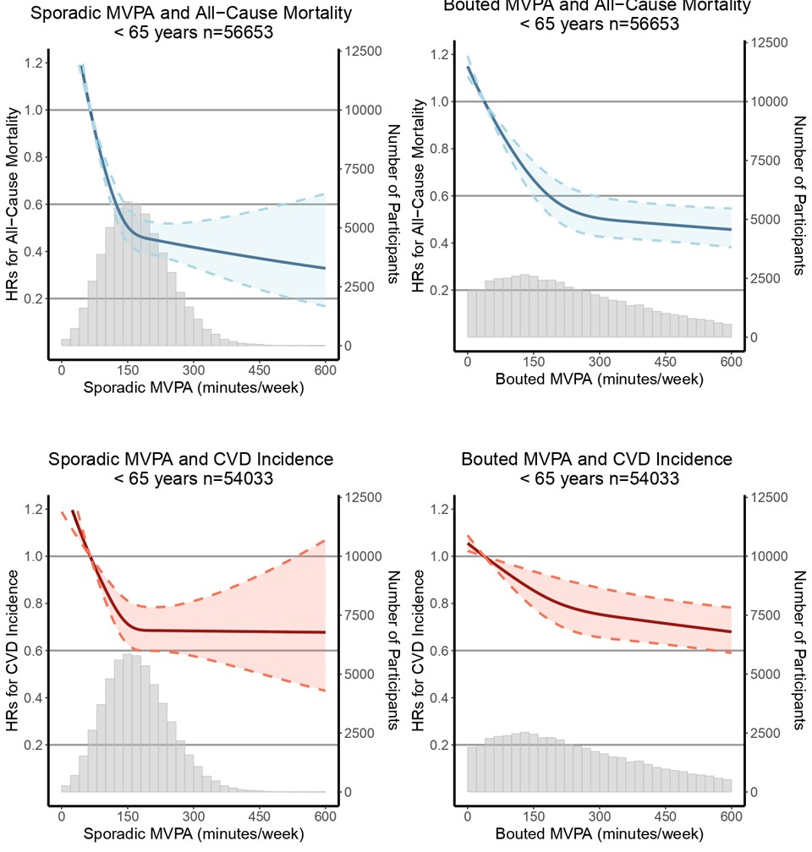

Figure S7. Analyses in those ≥ 65 years.
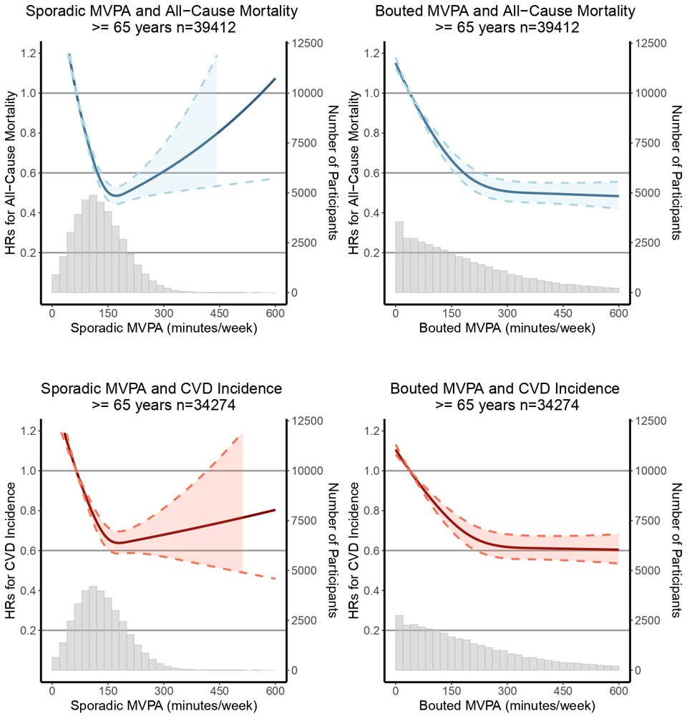

Figure S8. Sample selection diagram.
