Appendix 1
a |  |  |  | B
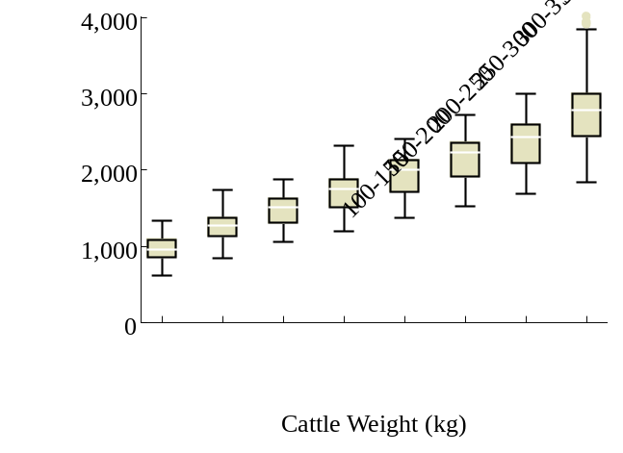 |  |  |  | 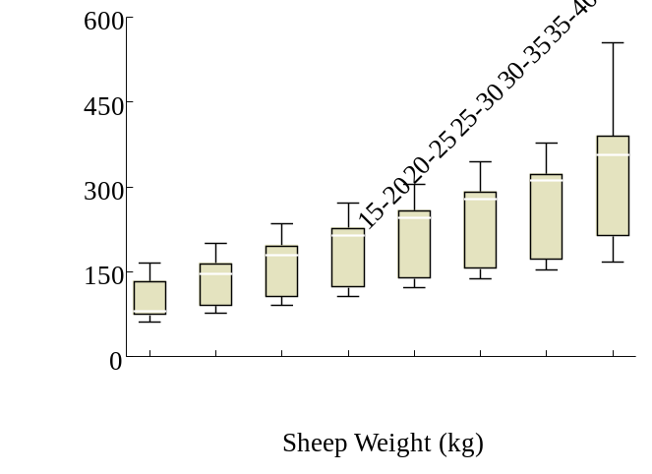
c |  |  |  | d
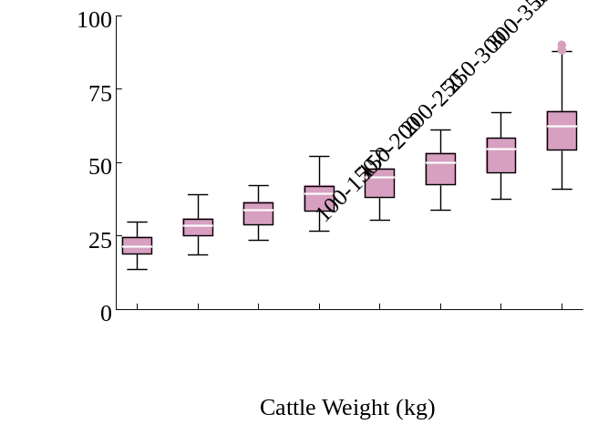 |  |  |  | 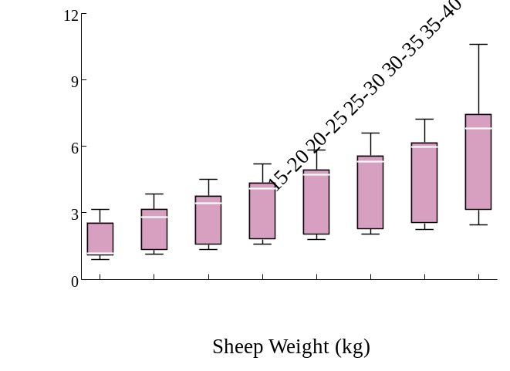
e |  |  |  | f
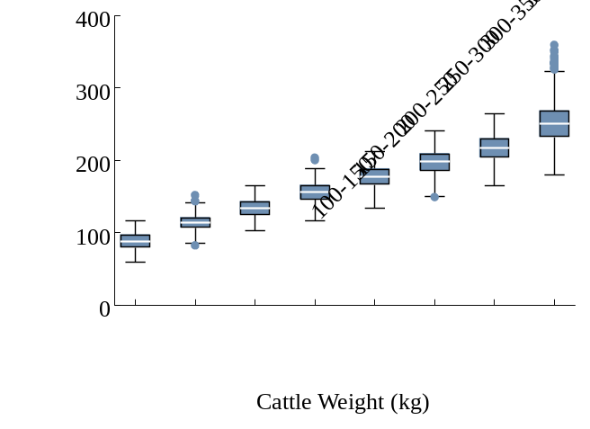 |  |  |  | 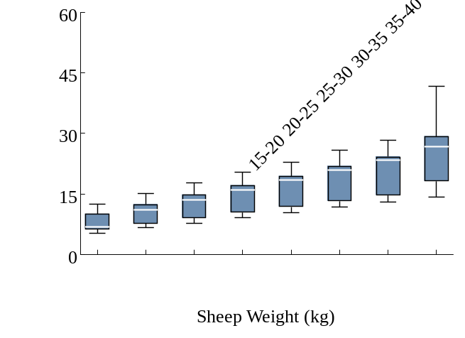
 | CH₄ emission from enteric fermentation |  | CH₄ emission from manure management |  |  | N₂O emission from manure management
Fig. S1 Estimated animal GHG emissions based on animal weight, breeding methods, and feed quality
Notes: Figures a and b show the CH₄ emissions from enteric fermentation of cattle and sheep, respectively. Figures c and d display the CH₄ emissions from manure management of cattle and sheep, respectively, while Figures e and f present the N₂O emissions from manure management of cattle and sheep.

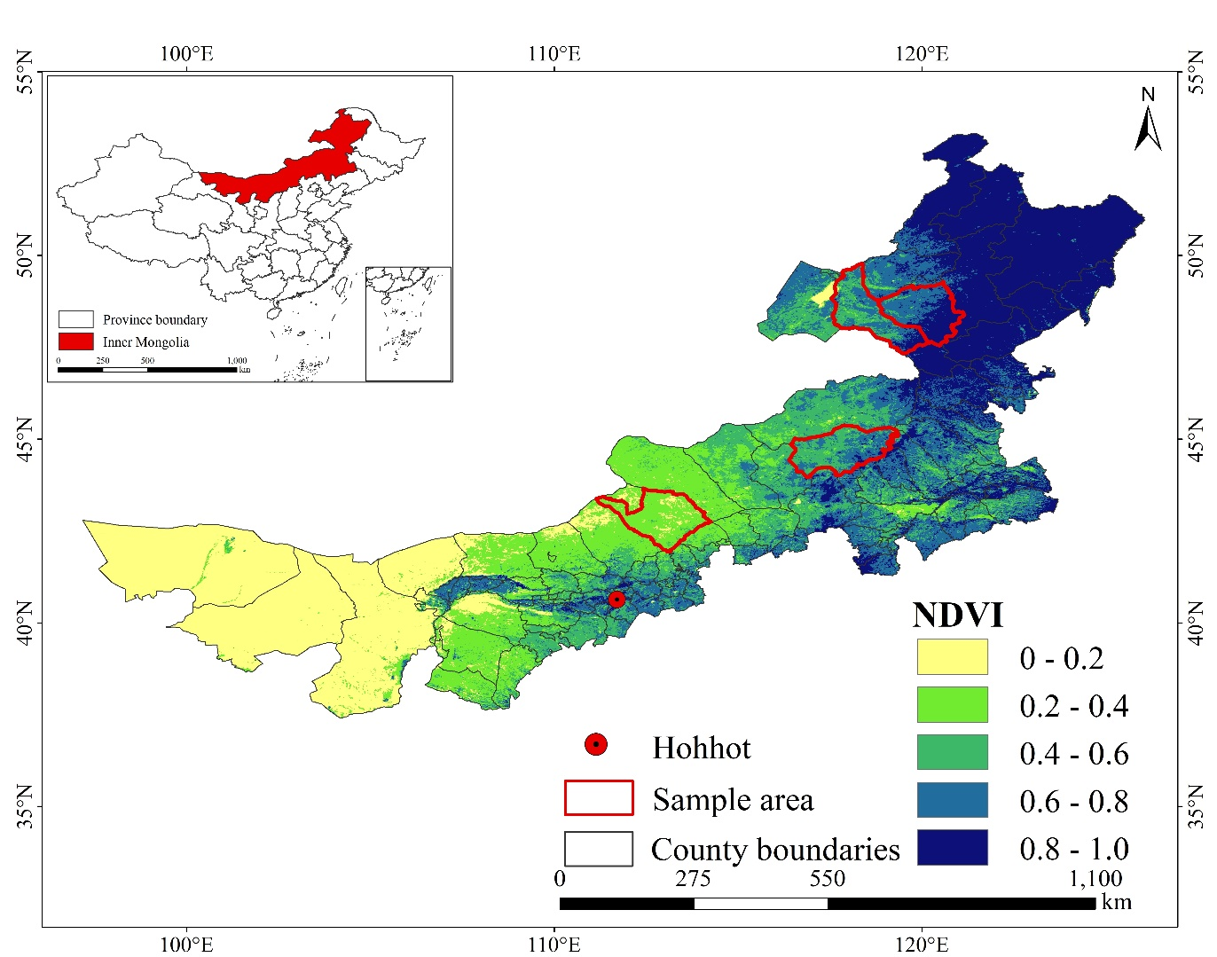Fig. S2 Location of the survey areas

Appendix 2
Table S1 Descriptive analysis of animal weights
Animal | Estimated weight with UAVs | Estimated mean weight | Reference Weight by IPCC 2006 Tire1 (kg) | Reference Weight by IPCC 2019 Tire1 (kg) | Reference Weight by Chinese national government (kg)
Cattle | [100, 750] | 336.2 | 300 | 305 | 320
Sheep | [15, 90] | 36.3 | 28 | 31 | 35
Notes: The estimated weight for cattle is based on the 13,656 cattle images collected using UAVs, and sheep weight is based on 70,137 sheep images. The lower bound for cattle weight is set at 100kg because cattle under 100kg that are not yet weaned do not produce CH₄ through enteric fermentation (Berends et al., 2015), and the GHG emissions from their manure are minimal. The same applies to sheep, with a lower bound set at 15kg. The reference weights provided by the IPCC are from the 2019 Refinement and the 2006 IPCC Guidelines for National GHG Inventories. The reference weights from the Chinese national government are sourced from China’s GHG Inventory Research.

Appendix 3
Table S2 Animal GHG emission factors under four different conditions in desert grasslands
 | Breeding methods |  | High-quality feed |  |  |  |  | Medium-quality feed |  |  |  |  | Low-quality feed
 | Breeding methods |  | Cattle |  | Sheep |  |  | Cattle |  | Sheep |  |  | Cattle |  | Sheep
 | Breeding methods |  | Young | Adult | Young | Adult |  | Young | Adult | Young | Adult |  | Young | Adult | Young | Adult
CH₄ emission from enteric fermentation | Stall-feeding |  | 34.0 | 48.8 | 2.9 | 4.9 |  | 57.9 | 82.0 | 4.1 | 7.0 |  | 70.2 | 113.8 | 7.6 | 13.0
CH₄ emission from enteric fermentation | Grazing on flat pasture |  | 34.5 | 52.6 | 3.0 | 5.1 |  | 61.8 | 93.4 | 4.3 | 7.3 |  | 75.4 | 119.6 | 8.0 | 13.8
CH₄ emission from enteric fermentation | Grazing on hilly pasture |  | 37.7 | 62.0 | 3.4 | 5.6 |  | 65.4 | 105.3 | 4.6 | 8.1 |  | 95.7 | 144.8 | 8.9 | 14.8
CH₄ emission from manure management | Stall-feeding |  | 1.01 | 1.50 | 0.03 | 0.06 |  | 1.26 | 1.98 | 0.06 | 0.11 |  | 1.60 | 2.56 | 0.15 | 0.26
CH₄ emission from manure management | Grazing on flat pasture |  | 1.03 | 1.57 | 0.04 | 0.06 |  | 1.37 | 2.08 | 0.06 | 0.11 |  | 1.69 | 2.68 | 0.15 | 0.26
CH₄ emission from manure management | Grazing on hilly pasture |  | 1.13 | 1.85 | 0.04 | 0.07 |  | 1.45 | 2.34 | 0.07 | 0.12 |  | 2.14 | 3.24 | 0.17 | 0.28
N₂O emission from manure management | Stall-feeding |  | 0.420 | 0.605 | 0.025 | 0.041 |  | 0.498 | 0.713 | 0.031 | 0.051 |  | 0.515 | 0.832 | 0.050 | 0.086
N₂O emission from manure management | Grazing on flat pasture |  | 0.445 | 0.683 | 0.025 | 0.042 |  | 0.507 | 0.772 | 0.031 | 0.052 |  | 0.557 | 0.890 | 0.050 | 0.087
N₂O emission from manure management | Grazing on hilly pasture |  | 0.487 | 0.808 | 0.028 | 0046 |  | 0.536 | 0.870 | 0.033 | 0.058 |  | 0.707 | 1.079 | 0.056 | 0.093
Notes: Following the animal growth curve described in the literature, we categorized animals into two groups based on weight: young and adult. Feed quality was classified into three categories—low-quality, medium-quality, and high-quality—based on roughage quality standards and corresponding digestibility rates outlined in the IPCC guidelines. Breeding methods were differentiated based on the activity levels associated with various feeding conditions, as specified in the IPCC 2019 guidelines, including stall-feeding, grazing on flat pastures, and grazing on hilly pastures.
Table S3 Animal GHG emission factors under different conditions in typical grassland
 | Breeding methods |  | High-quality feed |  |  |  |  | Medium-quality feed |  |  |  |  | Low-quality feed
 | Breeding methods |  | Cattle |  | Sheep |  |  | Cattle |  | Sheep |  |  | Cattle |  | Sheep
 | Breeding methods |  | Young | Adult | Young | Adult |  | Young | Adult | Young | Adult |  | Young | Adult | Young | Adult
CH₄ emission from enteric fermentation | Stall-feeding |  | 35.0 | 51.2 | 3.5 | 5.2 |  | 56.1 | 88.5 | 5.3 | 7.5 |  | 80.8 | 115.8 | 9.0 | 14.3
CH₄ emission from enteric fermentation | Grazing on flat pasture |  | 35.6 | 54.7 | 3.6 | 5.3 |  | 63.6 | 97.4 | 5.1 | 7.5 |  | 79.9 | 122.8 | 9.7 | 14.6
CH₄ emission from enteric fermentation | Grazing on hilly pasture |  | 41.2 | 57.9 | 4.2 | 6.0 |  | 71.2 | 101.5 | 7.5 | 9.1 |  | 90.5 | 126.7 | 11.0 | 16.1
CH₄ emission from manure management | Stall-feeding |  | 1.04 | 1.53 | 0.04 | 0.06 |  | 1.25 | 1.97 | 0.08 | 0.11 |  | 1.81 | 2.59 | 0.17 | 0.27
CH₄ emission from manure management | Grazing on flat pasture |  | 1.06 | 1.63 | 0.04 | 0.06 |  | 1.41 | 2.16 | 0.08 | 0.11 |  | 1.79 | 2.75 | 0.19 | 0.28
CH₄ emission from manure management | Grazing on hilly pasture |  | 1.20 | 1.69 | 0.05 | 0.07 |  | 1.62 | 2.24 | 0.09 | 0.13 |  | 2.06 | 2.90 | 0.21 | 0.31
N₂O emission from manure management | Stall-feeding |  | 0.452 | 0.666 | 0.029 | 0.043 |  | 0.460 | 0.731 | 0.038 | 0.053 |  | 0.597 | 0.862 | 0.057 | 0.089
N₂O emission from manure management | Grazing on flat pasture |  | 0.460 | 0.711 | 0.030 | 0.044 |  | 0.522 | 0.805 | 0.037 | 0.054 |  | 0.590 | 0.913 | 0.061 | 0.092
N₂O emission from manure management | Grazing on hilly pasture |  | 0.512 | 0.726 | 0.034 | 0.047 |  | 0.556 | 0.819 | 0.041 | 0.059 |  | 0.655 | 0.935 | 0.068 | 0.098
Notes: Following the animal growth curve described in the literature, we categorized animals into two groups based on weight: young and adult. Feed quality was classified into three categories—low-quality, medium-quality, and high-quality—based on roughage quality standards and corresponding digestibility rates outlined in the IPCC guidelines. Breeding methods were differentiated based on the activity levels associated with various feeding conditions, as specified in the IPCC 2019 guidelines, including stall-feeding, grazing on flat pastures, and grazing on hilly pastures.
Table S4 Animal GHG emission factors under different conditions in meadow grassland
 | Breeding methods |  | High-quality feed |  |  |  |  | Medium-quality feed |  |  |  |  | Low-quality feed
 | Breeding methods |  | Cattle |  | Sheep |  |  | Cattle |  | Sheep |  |  | Cattle |  | Sheep
 | Breeding methods |  | Young | Adult | Young | Adult |  | Young | Adult | Young | Adult |  | Young | Adult | Young | Adult
CH₄ emission from enteric fermentation | Stall-feeding |  | 34.3 | 52.1 | 3.1 | 5.1 |  | 61.0 | 92.8 | 5.2 | 7.5 |  | 79.3 | 120.0 | 8.1 | 14.2
CH₄ emission from enteric fermentation | Grazing on flat pasture |  | 36.5 | 54.0 | 3.4 | 5.4 |  | 64.7 | 95.9 | 5.1 | 7.5 |  | 82.4 | 121.3 | 8.9 | 14.7
CH₄ emission from enteric fermentation | Grazing on hilly pasture |  | 41.2 | 57.9 | 4.2 | 6.0 |  | 73.2 | 104.3 | 7.8 | 9.3 |  | 92.0 | 129.3 | 11.2 | 16.3
CH₄ emission from manure management | Stall-feeding |  | 1.02 | 1.56 | 0.04 | 0.06 |  | 1.35 | 2.06 | 0.07 | 0.11 |  | 1.78 | 2.69 | 0.15 | 0.27
CH₄ emission from manure management | Grazing on flat pasture |  | 1.09 | 1.61 | 0.04 | 0.06 |  | 1.44 | 2.13 | 0.07 | 0.11 |  | 1.84 | 2.72 | 0.17 | 0.28
CH₄ emission from manure management | Grazing on hilly pasture |  | 1.23 | 1.73 | 0.05 | 0.07 |  | 1.67 | 2.25 | 0.09 | 0.14 |  | 2.06 | 2.90 | 0.21 | 0.31
N₂O emission from manure management | Stall-feeding |  | 0.444 | 0.679 | 0.025 | 0.041 |  | 0.500 | 0.768 | 0.035 | 0.053 |  | 0.586 | 0.894 | 0.051 | 0.089
N₂O emission from manure management | Grazing on flat pasture |  | 0.472 | 0.702 | 0.028 | 0.044 |  | 0.531 | 0.793 | 0.036 | 0.054 |  | 0.609 | 0.902 | 0.056 | 0.092
N₂O emission from manure management | Grazing on hilly pasture |  | 0.532 | 0.752 | 0.035 | 0.049 |  | 0.560 | 0.822 | 0.042 | 0.061 |  | 0.680 | 0.961 | 0.071 | 0.102
Notes: Following the animal growth curve described in the literature, we categorized animals into two groups based on weight: young and adult. Feed quality was classified into three categories—low-quality, medium-quality, and high-quality—based on roughage quality standards and corresponding digestibility rates outlined in the IPCC guidelines. Breeding methods were differentiated based on the activity levels associated with various feeding conditions, as specified in the IPCC 2019 guidelines, including stall-feeding, grazing on flat pastures, and grazing on hilly pastures.

Appendix 4
Gross Energy (GE) presented in eq. (1), which indicates the amount of energy (MJ/day) required for animal maintenance, growth, lactation, pregnancy, and other activities, is calculated based on the formulas in Table S5.
Table S5 The Calculation of Gross Energy (GE)
Type of metabolic functions | Equations and description | Data
Net energy of maintenance (NE_{m}) for cattle/sheep | NE_{m} = C_{fi}× (weight)^{0.75}  NE_{m} is net energy required by the animal for  maintenance MJ day⁻¹, Weight is body weight of the animals, kg, C_{fi} is a coefficient for each animal category | According the IPCC Tier 2, C_{fi} for cattle = a₁ × 0.322 + b₁ ×0.386 + c₁ × 0.370, where a₁ is the proportion of other cattle (excluding lactating cattle and bulls) to all cattle, b₁ is the proportion of lactating cattle to all cattle, and c₁ is the proportion of bulls to all cattle. C_{fi} for sheep = a₂ × 0.236 + b₂ ×0.217, where a₂ is the proportion of little sheep (lamb to 1 year) to all sheep, and b₂ is the proportion of adult sheep (older than 1 year) to all sheep.
Net energy of activity (NE_{a}) for cattle | NE_{a} = Ca × NE_{m}  NE_{a} is net energy for animal activity MJ day⁻¹, Ca is coefficient corresponding to animal’s breeding situation coefficients | According the default value of IPCC Tier 2, Ca in stall for cattle is 0, Ca in Grazing on flat pasture for cattle is 0.17; and Ca in Grazing on hilly pasture for cattle is 0.36. Ca in stall for sheep is 0.0096, Ca in Grazing on flat pasture for sheep is 0.0107, and Ca in Grazing on hilly pasture for sheep is 0.024.
Net energy of activity (NE_{a}) for sheep | NE_{a} = Ca × weight
Net energy of growth (NE_{g}) for cattle | NE_{g} = 22.02× (weight/C x MW)^{0.75} ×WG^{1.097}  NE_{g} is Net energy needed for growth MJ day⁻¹,  C is a coefficient with a value cattle, MW is the mature animal weight of an adult female in moderate body condition kg, WG is the average daily weight | According the IPCC Tier 2, C for cattle = a₁×0.8+ b₁×1 + c₁× 1.2, where a₁ is the proportion of other cattle (excluding lactating cattle and bulls) to all cattle, b₁ is the proportion of lactating cattle to all cattle, and c₁ is the proportion of bulls to all cattle.MW for cattle is the default value of 485kg. a for sheep =a₃ × 4.4 + b₃ ×2.5+ c₃×2.1, b for sheep =a₃ × 0.32 + b₃ ×0.35+ c₃×0.45, where a₃ is the proportion of Castrates (sheep) to all sheep, b₃ is the proportion of Intact males (sheep) to all sheep, and c₃ is the proportion of female (sheep) to all sheep.
Net energy of growth (NE_{g}) for sheep | NE_{g}=(WG×(weight+15 )×(a+0.5×b×(weight+15)))/365  a, b are constants as described
Net energy of lactation (NE_{l}) for cattle | NE_{l} =milk × (1.47+0.40×Fat)  NE_{l} is net energy for lactation MJ day⁻¹, Milk is amount of milk produced kg of milk day⁻¹, Fat is fat content of milk, % by weight | According the default value of IPCC Tier 2, Fat for cattle is 4%, and EV_{milk} for sheep is 4.6 MJ/kg.
Net energy of lactation (NE_{l}) for sheep | NE_{l} =milk × EV_{milk}  EV_{milk} is the net energy required to produce 1 kg of milk
Net energy required of pregnancy (NE_{p}) for cattle/sheep | NE_{p} = C_{P}× Ne_{m}  NE_{p} is net energy required for pregnancy (NE_{p}) MJ day ⁻¹, C_{p} is pregnancy coefficient | According the default value of IPCC Tier 2, C_{P} for cattle is 0.1, and C_{P} for sheep is 0.077.
Ratio of net energy available in a diet of maintenance to digestible energy consumed (REM) for cattle/sheep | REM = [1.123 - (4.092 × 10⁻³ × DE%) + [1.126 × 10⁻⁵ × (DE%)²] - (25.4/DE%)]  REM is Ratio of net energy available in a diet for  maintenance to digestible energy consumed, DE% is digestible energy expressed as a percentage of gross energy | DE% of low-quality feed for cattle is 62%, DE% of medium-quality feed for cattle is 67%, and DE% of high-quality feed for cattle is 72%.DE% of low-quality feed for sheep is 52%, DE% of medium-quality feed for sheep is 56%, and DE% of high-quality feed for sheep is 59%.
Ratio of net energy available of growth in a diet to digestible energy consumed (REG) for cattle/sheep | REG = [1.164 - (5.160× 10⁻³×DE%) + [1.308×10⁻⁵ × (DE%) - (37.4/(DE%)²] - (37.4/DE%)]  REG is Ratio of net energy available for growth in  a diet to digestible energy consumed
Gross Energy (GE) for cattle/sheep | GE = [((NE_{m} + NE_{a} + NE_{l}+ NE_{p})/REM)) + (NE_{g}/REG)]/(DE%/100)  GE is Gross Energy MJ day⁻¹
Notes: In above equations, the data for the variable of weight was obtained by UAV and deep learning technology. The data for the variable of weighted WG for cattle is the ratio of other cattle (excluding lactating cattle and bulls) / lactating cattle / bulls multiplied by the corresponding daily gain, and the data for the variable of weighted WG for sheep is the ratio of Castrates (sheep) / Intact males (sheep) / female (sheep) multiplied by the corresponding daily gain, and the data for average daily gain of animal were obtained by total animal weights and the number of growing days of animals reported by sample households. The data for the variables of milk is obtained by household survey. Since the UAV images could not distinguish the animal sex, we used the data from the household survey to get the weighted cfi, weighted C, weighted a and weighted b.

Appendix 5
VS presented in eq. (2) presents the daily excretion of volatile solids (kg VS/day) based on dry matter.

$VS=\left[GE×\left(1-\frac{DE\%}{100}\right)+\left(UE×GE\right)\right]×\left[\frac{1-ASH}{18.45}\right]$ (1)

where GE is the total energy intake in MJ/day. DE% is the percentage of digestible energy in the feed (e.g., 60%). (UE × GE) represents the urinary energy of GE, which is generally considered to be 0.04GE for most ruminants (reduces to 0.02 for ruminants fed a diet with grain content reaching or exceeding 85%). ASH is the percentage of ash content in feces, calculated as the proportion of dry matter intake (e.g., 0.08 for cattle). 18.45 is the conversion factor of total daily feed energy per kilogram of dry matter (MJ/kg).
Appendix 6
Table S6 Distribution of the sample households
Grassland type | County | Town | Village | Household
Desert grasslands | 1 | 3 | 9 | 108
Typical grassland | 1 | 3 | 9 | 162
Meadow grassland | 2 | 4 | 12 | 144
Total | 4 | 10 | 30 | 414
Notes: Table S6 is a descriptive statistical analysis on sample households. Demographic information and livestock production information were obtained through on-site interviews. Grassland area, grassland types, feed quality, and breeding methods were used to calculate GHG emissions from animals.

Table S7 Statistical analysis of sample households
 | Variable | Definition | Mean | Std. Dev.
Feed quality_{it} |  | The feed quality for livestock production of household i in year t. 1=Low-quality feed; 2=Medium-quality feed; 3=High-quality feed | 1.353 | 0.478
Breeding method_{it} |  | The breeding method for livestock production of household i in year t. 1=Stall-feeding; 2=Grazing on flat pasture; 3=Grazing on hilly pasture | 2.008 | 0.238
Cattle_{it} |  | The number of cattle of household i in year t (heads) | 47.956 | 67.231
Sheep_{it} |  | The number of sheep of household i in year t (heads) | 333.299 | 310.173
Land_{it} |  | Grassland area of household i in year t (mu) | 5340.043 | 4514.55
Grassland type_{it} |  | The grassland type of household i in year t. 1=Desert grasslands; 2=Typical grassland; 3=Meadow grassland | 2.092 | 0.778
Notes: 15 mu=1 hectare.
Source: survey data.

Appendix 7

Cost-benefit analysis of animal GHG emission reductions using different emission reduction methods

Based on the costs of different emission reduction methods, we calculated the cost of reducing animal GHG emissions. The current trading price on the China carbon market was used to calculate the revenue from these reductions. The cost per unit of GHG emission reduction was then analyzed to assess the economic effectiveness of different methods, including reducing livestock size, improving feed quality, and enhancing breeding methods.

Reducing livestock population. Table S8 presents the cost-benefit analysis of reducing animal GHG emissions by decreasing livestock numbers to varying degrees while keeping other factors constant. The economic loss from reducing livestock numbers is considered the emission reduction cost for herders, and the benefit is calculated based on the current carbon trading price in China’s carbon market and the amount of GHG emission reduction. The results show that the cost per unit of emission reduction for sheep is lower than that for cattle.
In S1-1, the number of cattle per household is reduced by 25% (from an average of 48 to 36 cattle per household), resulting in an average reduction of 22.59 tons of CO₂e per household (a 14.3% reduction from the average household animal GHG emissions of 158 tons of CO₂e). The emission reduction revenue, calculated using the current carbon market trading price, amounts to 1,894 RMB. Based on survey data, the sale price of cattle per household is 9,185 RMB per head, so the emission reduction cost for herders when the number of cattle is reduced by 25% is 110,220 RMB per household. Therefore, in this scenario, the cost per unit of emission reduction is 4,795 RMB per ton.
In S1-2, the number of sheep per household is reduced by 25% (from an average of 333 to 250 sheep per household), resulting in a reduction of 16.88 tons of CO₂e per household (a 10.7% reduction). The emission reduction revenue, calculated using the current carbon market trading price, amounts to 1,415 RMB. Based on survey data, the sale price of sheep per household is 893 RMB per head, so the emission reduction cost for herders when the number of sheep is reduced by 25% is 74,119 RMB per household. Therefore, in this scenario, the cost per unit of emission reduction is 4,307 RMB per ton.
In S1-3, the number of cattle per household is reduced by 50% (from an average of 48 to 24 cattle per household), resulting in a reduction of 45.20 tons of CO₂e per household (a 28.6% reduction). The cost per unit of emission reduction is 3,789 RMB per ton.
In S1-4, the number of sheep per household is reduced by 50% (from an average of 333 to 167 sheep per household), resulting in a reduction of 33.76 tons of CO₂e per household (a 21.4% reduction). The cost per unit of emission reduction is 2,830 RMB per ton.

Table S8 Cost-benefit analysis of emission reduction by reducing livestock numbers.
 | CH₄ emission reduction from enteric fermentation (ton/year) | CH₄ emission reduction from manure management (ton/year) | N₂O emission reduction from manure management (ton/year) | Total carbon emission reduction (ton/year) | Emission reduction revenue (yuan/year) | Emission reduction costs (yuan/year) | Net revenue of GHG emission reduction (yuan/year) | Net revenue per unit of emission reduction (yuan/ton/year)
S1-1 | 20.28 | 0.45 | 1.86 | 22.59 | 1894 | 110,220 | -108,326 | -4,795
S1-2 | 15.41 | 0.27 | 1.19 | 16.88 | 1415 | 74,119 | -72,704 | -4,307
S1-3 | 40.55 | 0.93 | 3.72 | 45.20 | 3789 | 220,440 | -216,651 | -4,793
S1-4 | 30.83 | 0.54 | 2.39 | 33.76 | 2830 | 148,238 | -145,408 | -4,307
Notes: In S1-1, the average number of cattle per household decreases by 25%; in S1-2, the average number of sheep per household decreases by 25%; in S1-3, the average number of cattle per household decreases by 50%; in S1-4, the average number of sheep per household decreases by 50%. The emission reduction revenue is equal to the national carbon market trading price multiplied by the reduced carbon emissions. The emission reduction costs only consider the economic losses brought by the reduction of livestock by herders. The 100-year Global Warming Potential (GWP100) carbon dioxide equivalent (CO₂e) coefficients for methane (CH₄) and nitrous oxide (N₂O) are 25 and 298, respectively (IPCC, 2019), which are used to convert greenhouse gas emissions into a common unit. The emission reduction revenue is equal to the national carbon market trading price multiplied by the reduced carbon emissions, with the carbon price referring to the comprehensive price of 83.83 yuan/ton on the national carbon market as of March 21, 2024.

Improving feed quality. Table S9 shows the cost-benefit analysis of animal GHG emission reduction through improving the quality of feed for livestock to different degrees while keeping other factors constant. The cost of changing feed quality is considered the emission reduction cost for herders, and the benefit is calculated based on the current carbon trading price in China’s carbon market and the amount of emission reduction.
In S2-1, only low-quality feed is converted into medium-quality feed, resulting in an average reduction of 31.8 tons CO₂e per household (a 19.5% reduction). The GHG emission reduction benefit, calculated using the current carbon trading price, amounts to 2,667 RMB. Based on survey data, the price of low-quality feed is 331 RMB per ton, and the price of medium-quality feed is 542 RMB per ton. The cost for herders to convert all low-quality feed into medium-quality feed is calculated to be 14,066 RMB per household. Therefore, the cost per unit of GHG emission reduction through converting all low-quality feed to medium-quality feed is 358 RMB per ton.
In S2-2, low-quality feed is converted into medium-quality feed, and medium-quality feed is converted into high-quality feed, resulting in a reduction of 45.7 tons of CO₂e per household (a 28.1% reduction). The GHG emission reduction benefit, calculated using the current carbon market trading price, amounts to 3,834 RMB. Based on survey data, the price of medium-quality feed is 542 RMB per ton, and the price of high-quality feed is 782 RMB per ton. The cost for herders to make these conversions is calculated to be 35,109 RMB per household. Therefore, the cost per unit of GHG emission reduction through converting all low-quality feed to medium-quality feed and converting all medium-quality feed to high-quality feed is 684 RMB per ton.
In S2-3, both low-quality and medium-quality feed are converted into high-quality feed, resulting in an average reduction of 81.0 tons of CO₂e per household (a 49.8% reduction). The emission reduction benefit, calculated using the current carbon market trading price, amounts to 6,793 RMB. Based on survey data, the price of high-quality feed is 782 RMB per ton, and the cost for herders to convert both low-quality and medium-quality feed into high-quality feed is calculated to be 80,235 RMB. Therefore, the cost per unit of GHG emission reduction through converting both low-quality and medium-quality feed into high-quality feed is 906 RMB per ton.
In summary, the results reveal that as feed quality increases, the reduction in carbon emissions becomes significant, particularly in reducing methane emissions from enteric fermentation, which is more notable than the reduction in methane and nitrous oxide emissions from manure management. However, from the perspective of cost-benefit analysis, as the proportion of high-quality feed increases, the cost per unit of GHG emission reduction gradually rises.

Table S9 Cost-benefit analysis of emission reduction by improving feed quality.
 | CH₄ emission reduction from enteric fermentation (ton/year) | CH₄ emission reduction from manure management (ton/year) | N₂O emission reduction from manure management (ton/year) | Total carbon emission reduction (ton/year) | Emission reduction revenue (yuan/year) | Emission reduction costs (yuan/year) | Net revenue of GHG emission reduction (yuan/year) | Net revenue per unit of emission reduction (yuan/ton/year)
S2-1 | 29.66 | 0.56 | 1.58 | 31.81 | 2,667 | 14,066 | -11,399 | -358
S2-2 | 42.81 | 0.82 | 2.12 | 45.74 | 3,834 | 35,109 | -31,275 | -684
S2-3 | 76.31 | 1.40 | 3.32 | 81.03 | 6,793 | 80,235 | -73,442 | -906
Notes: In S2-1, all low-quality forage is converted to medium-quality forage; in S2-2, all low-quality forage is converted to medium-quality forage, and then medium-quality forage is upgraded to high-quality forage; in S2-3, all low-quality and medium-quality feed is converted to high-quality feed. The emission reduction revenue is calculated as the national carbon market trading price multiplied by the reduced carbon emissions. The emission reduction costs only consider the expenses incurred by herders for improving the quality of feed. The 100-year Global Warming Potential (GWP100) carbon dioxide equivalent (CO₂e) coefficients for methane (CH₄) and nitrous oxide (N₂O) are 25 and 298, respectively (IPCC, 2019), which are used to convert greenhouse gas emissions into a common unit. Survey data indicates that herders using low to medium-quality forage account for 64.6%, and those using medium-quality forage account for 35.4%. The emission reduction revenue is calculated as the national carbon market trading price multiplied by the reduced carbon emissions, with the carbon price referencing the comprehensive price of 83.83 yuan/ton on the national carbon market as of March 21, 2024.

Enhancing breeding methods. Table S10 shows the cost-benefit analysis of animal GHG emission reduction through improving the breeding methods of livestock to different degrees while keeping other factors constant. The additional labor costs incurred by herders when changing breeding methods are considered the GHG emission reduction cost, and the benefit is calculated based on the current carbon trading price in China’s carbon market and the amount of emission reduction. The results reveal that changing cattle breeding methods has a modest impact on GHG emission reduction, but the cost is very high.
In S3-1, 50% of the cattle are switched from grazing to stall-feeding, while the breeding method for sheep remains unchanged, resulting in an average reduction of 5.2 tons of CO₂e per household (a 3.3% reduction). The GHG emission reduction benefit, calculated using the current carbon trading price, amounts to 438 RMB. Based on survey data, with a labor cost of 25 RMB per work hour, the GHG emission reduction cost for herders when 50% of the cattle are switched from grazing to stall-feeding is calculated to be 19,163 RMB per household. Therefore, the cost per unit of GHG emission reduction through switching 50% of the cattle from grazing to stall-feeding is 3,587 RMB per ton.
In S3-2, the breeding method for cattle remains unchanged, but switching 50% of the sheep from grazing to stall-feeding actually leads to an increase in carbon emissions by 1.86 tons.
In S3-3, 100% of the cattle are switched from grazing to stall-feeding, while the breeding method for sheep remains unchanged, resulting in an average reduction of 10.5 tons of CO₂e per household (a 6.6% reduction). The emission reduction benefit, calculated using the current carbon trading price, amounts to 877 RMB, with a cost per unit of GHG emission reduction of 3,580 RMB per ton.
In S3-4, the breeding method for cattle remains unchanged, but switching 100% of the sheep to stall-feeding actually leads to an increase in carbon emissions by 3.72 tons.

Table S10 Cost-benefit analysis of emission reduction by changing breeding methods.
 | CH₄ emission reduction from enteric fermentation (ton/year) | CH₄ emission reduction from manure management (ton/year) | N₂O emission reduction from manure management (ton/year) | Total carbon emission reduction (ton/year) | Emission reduction revenue (yuan/year) | Emission reduction costs (yuan/year) | Net revenue of GHG emission reduction (yuan/year) | Net revenue per unit of emission reduction (yuan/ton/year)
S3-1 | 4.75 | 0.11 | 0.36 | 5.22 | 438 | 19,163 | -18,725 | -3,587
S3-2 | -1.67 | -0.04 | -0.15 | -1.86 | -156 | 26,588 | N/A | N/A
S3-3 | 9.50 | 0.25 | 0.71 | 10.46 | 877 | 38,325 | -37,448 | -3,580
S3-4 | -3.34 | -0.08 | -0.29 | -3.72 | -312 | 53,716 | N/A | N/A
Notes: N/A stands for 'not available.' In S3-1, 50% of the cattle are changed to stall feeding, while the grazing method for sheep remains unchanged; in S3-2, 50% of the sheep are changed to stall feeding, while the grazing method for cattle remains unchanged; in S3-3, 100% of the cattle are changed to stall feeding, while the grazing method for sheep remains unchanged; in S3-4, 100% of the sheep are changed to stall feeding, while the grazing method for cattle remains unchanged. The emission reduction revenue is calculated as the national carbon market trading price multiplied by the reduced carbon emissions. The emission reduction costs only consider the additional labor costs incurred by herders when changing grazing methods. The 100-year Global Warming Potential (GWP100) carbon dioxide equivalent (CO₂e) coefficients for methane (CH₄) and nitrous oxide (N₂O) are 25 and 298, respectively (IPCC, 2019), which are used to convert greenhouse gas emissions into a common unit. Survey data indicates that the proportion of cattle in stall feeding is 3.7%, and the proportion of sheep in stall feeding is 1.4%. The emission reduction revenue is calculated as the national carbon market trading price multiplied by the reduced carbon emissions, with the carbon price referencing the comprehensive price of 83.83 yuan/ton on the national carbon market as of March 21, 2024.

In different types of grasslands. Table S11 shows the animal GHG emission reduction outcomes under different methods across various grassland types. The results indicate that improving feed quality is more cost-efficient than reducing livestock numbers or changing breeding methods in all grassland types. Additionally, the costs of reducing GHG emissions are lower in meadow and typical grasslands compared to desert grasslands.
In (S1-3)+(S1-4), where cattle and sheep numbers are reduced by 50%, GHG emissions in desert grasslands are reduced by an average of 49.0 tons of CO₂e per household (50%), with a cost per unit of GHG emission reduction of 4,443 RMB/ton. In typical grasslands, GHG emissions are reduced by 90.4 tons of CO₂e per household (50.4%), with a cost per unit of 4,582 RMB/ton. In meadow grasslands, GHG emissions are reduced by 88.5 tons of CO₂e per household (49.6%), with a cost per unit of 4,847 RMB/ton.
In S2-3, where low-quality and medium-quality feed is converted to high-quality feed, GHG emissions in desert grasslands are reduced by an average of 48.1 tons of CO₂e per household (49.1%), with a cost per unit of emission reduction of 532 RMB/ton. In typical grasslands, GHG emissions are reduced by 86.5 tons of CO₂e per household (48.2%), with a cost per unit of 462 RMB/ton. In meadow grasslands, GHG emissions are reduced by 85.6 tons of CO₂e per household (48.0%), with a cost per unit of 410 RMB/ton.
In (S3-3)+(S3-4), where the breeding method for cattle and sheep is changed to stall-feeding, GHG emissions in desert grasslands are reduced by an average of 0.8 tons of CO₂e per household (0.8%), with a cost per unit of emission reduction of 82,185 RMB/ton. In typical grasslands, GHG emissions are reduced by 6.6 tons of CO₂e per household (3.7%), with a cost per unit of 16,176 RMB/ton. In meadow grasslands, GHG emissions are reduced by 11.2 tons of CO₂e per household (6.3%), with a cost per unit of 8,696 RMB/ton.

 | Table S11 Cost-benefit analysis of different emission reduction methods under various grassland types.
 |  |  | CH₄ emission reduction from enteric fermentation (ton/year) | CH₄ emission reduction from manure management (ton/year) | N₂O emission reduction from manure management (ton/year) | Total carbon emission reduction (ton/year) | Emission reduction revenue (yuan/year) | Emission reduction costs (yuan/year) | Net revenue of GHG emission reduction (yuan/year) | Net revenue per unit of emission reduction (yuan/ton/year)
Desert grasslands |  | (S1-3)+(S1-4) | 44.50 | 0.85 | 3.65 | 49.01 | 4109 | 221,846 | -217,737 | -4,443
 |  | (S2-3) | 44.91 | 0.96 | 2.23 | 48.09 | 4031 | 29,625 | -25,594 | -532
 |  | (S3-3)+(S3-4) | 0.76 | 0.01 | 0.02 | 0.79 | 66 | 64,992 | -64,926 | -82,185
Typical grassland |  | (S1-3)+(S1-4) | 81.86 | 1.64 | 6.91 | 90.41 | 7579 | 421,875 | -414,296 | -4,582
 |  | (S2-3) | 81.42 | 1.57 | 3.51 | 86.50 | 7251 | 47,195 | -39,944 | -462
 |  | (S3-3)+(S3-4) | 6.05 | 0.13 | 0.40 | 6.58 | 552 | 106,990 | -106,438 | -16,176
Meadow grassland |  | (S1-3)+(S1-4) | 79.79 | 1.68 | 7.02 | 88.50 | 7419 | 436,417 | -428,998 | -4,847
 |  | (S2-3) | 80.94 | 1.45 | 3.19 | 85.57 | 7173 | 42,221 | -35,048 | -410
 |  | (S3-3)+(S3-4) | 10.26 | 0.23 | 0.74 | 11.24 | 942 | 98,687 | -97,745 | -8,696
 | Notes: In (S1-3)+(S1-4), the number of animals per household is reduced by 50%; in S2-3, low and medium-quality feed is replaced with high-quality feed; in (S3-3)+(S3-4), 100% of cattle and 100% of sheep are changed to stall feeding. The emission reduction revenue is calculated as the national carbon market trading price multiplied by the reduced carbon emissions. The emission reduction costs only consider the costs associated with a single change. The 100-year Global Warming Potential (GWP100) carbon dioxide equivalent (CO₂e) coefficients for methane (CH₄) and nitrous oxide (N₂O) are 25 and 298, respectively (IPCC, 2019), which are used to convert greenhouse gas emissions into a common unit. The emission reduction revenue is calculated as the national carbon market trading price multiplied by the reduced carbon emissions, with the carbon price referencing the comprehensive price of 83.83 yuan/ton on the national carbon market as of March 21, 2024.

