Amino acid-assisted carbon quantum dots for bioimaging, Picric acid detection, antibacterial activity, and prefabrication of Pd nanoparticles as a potent nanocatalyst for coupling reactions and reduction of nitrophenols
Namrata Priyadarshini Hota, Saluja Diksha, Nandhini Karthikeyan., Prakash Seenu. and Sathiyanarayanan Kulathu Iyer*
Department of Chemistry, School of Advanced Sciences, Vellore Institute of Technology,
Vellore-632 014, India. *E-mail: sathiyanarayanank@vit.ac.in
Table of Contents:
1. Quantum Yield Measurement---------------------------------------------------------------------S1
2. PH study of NCQD---------------------------------------------------------------------------------Figure S1
3. Comparison Table of different sensors for PA detection--------------------------------------Table S1
4. UV- Visible spectra of NCQD and Pd nanoparticles-------------------------------------------Figure S2
5. Plausible mechanism for denitrogenative coupling reactions--------------------------------S2
6. Optimization Table for denitrogenative coupling Reactions---------------------------------Table S2
7. Reaction of 4- nitrophenol in Presence of NaBH₄ and catalyst alone----------------------Figure S3
8 Comparison table of PdNPs for denitrogenative coupling reactions------------------------Table S3
9. Comparison table of PdNPs for reduction of 2, 3, and 4- nitrophenols--------------------Table S4
10. Recyclability of PdNPs 3 cycle -----------------------------------------------------------------Figure S3
11. H¹ analysis of denitrogenative coupling Reactions-------------------------------------------S3
12. H¹ spectra (400 MHz) of the products----------------------------------------------------------S4

S1 Quantum Yield Measurement:
Using quinine sulfate (φ= 0.54 in 0.1M H₂SO₄) as a standard reference, we determined the quantum yield of carbon dots. Using the following formula, the quantum yield was determined.
The carbon dot and reference are denoted by CQD and R, respectively, in the equation above. " ŋ " indicates the refractive index of the solvent medium (water has a refractive index of 1.33), "I" stands for the integrated fluorescence intensity, and "A" for the absorbance value at the exiting wavelength. After calculating every value, the quantum Yield was found to be 29.40%.
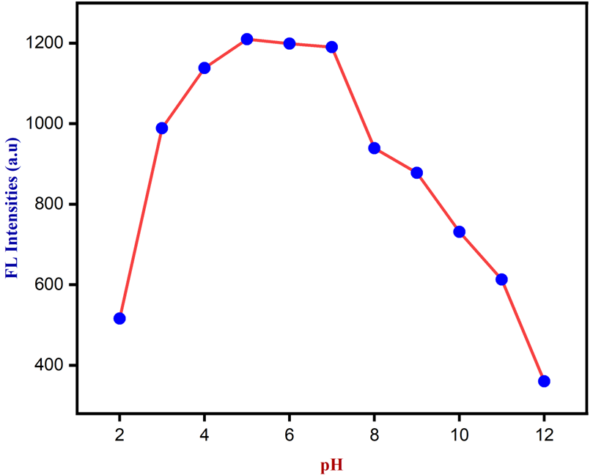
Figure S1. PH study of NCQD
Table S1: Comparison Table of different sensors for PA detection:
Sensing Probe for Fe³⁺ | Linear range ($μM$) | LoD ($nM$) | Ref.
Blue-Emissive Nitrogen-Doped Carbon Dots | 0-1.6 | 33 | [ ACS Applied Nano Materials,2023, 6(9), 8059-8070.]
NCQD from citric  acid and thiourea | 0.1-0.5 | 12 | [Analyst, 2020,145(13), 4532-4539]
NCQD from mandelic acid and ethylenediamine | 0.4-30 | 40 | [Sustainable materials and technologies, 2020, 23, e00138]
L-serine and citric acid-based NCQD | 0-30 | 1.8 | [[Journal of Environmental Chemical Engineering, 2022, 10(2), 107209]
Urea and malonic acid-based NCQD | 0.1-26.5 | 50 | [Sensors and Actuators B: Chemical, 2017, 240, 949-955]
Nitrogen-doped bottle gourd CQD | 0-40 | 10 | [This work]

S2. Plausible mechanism for denitrogenative coupling reactions:
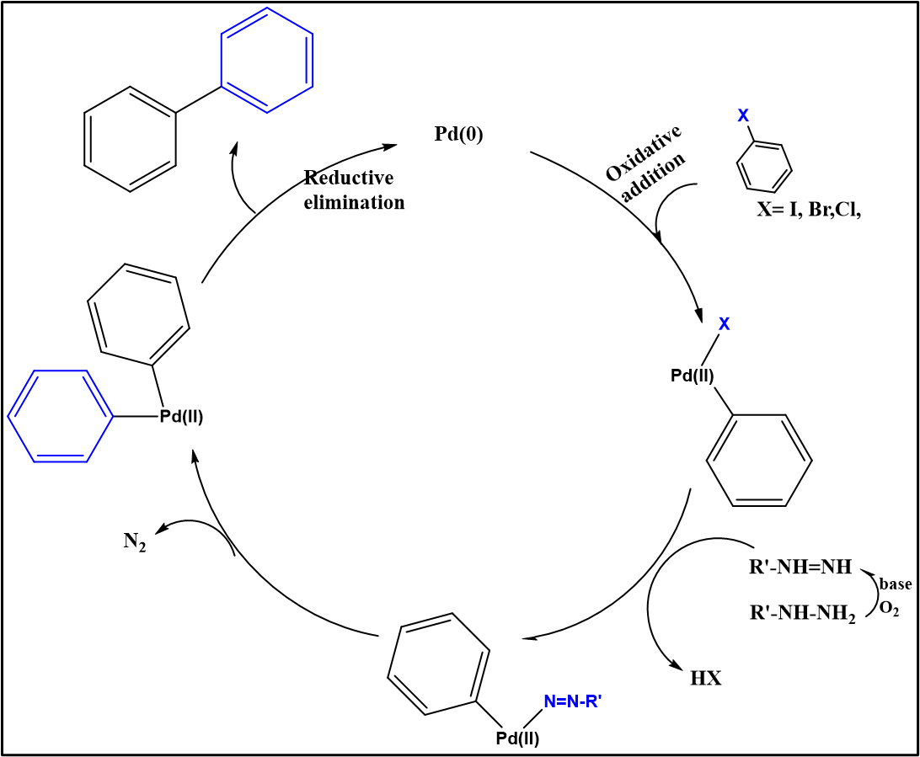

Table S2. Optimization Table for denitrogenative coupling Reactions:
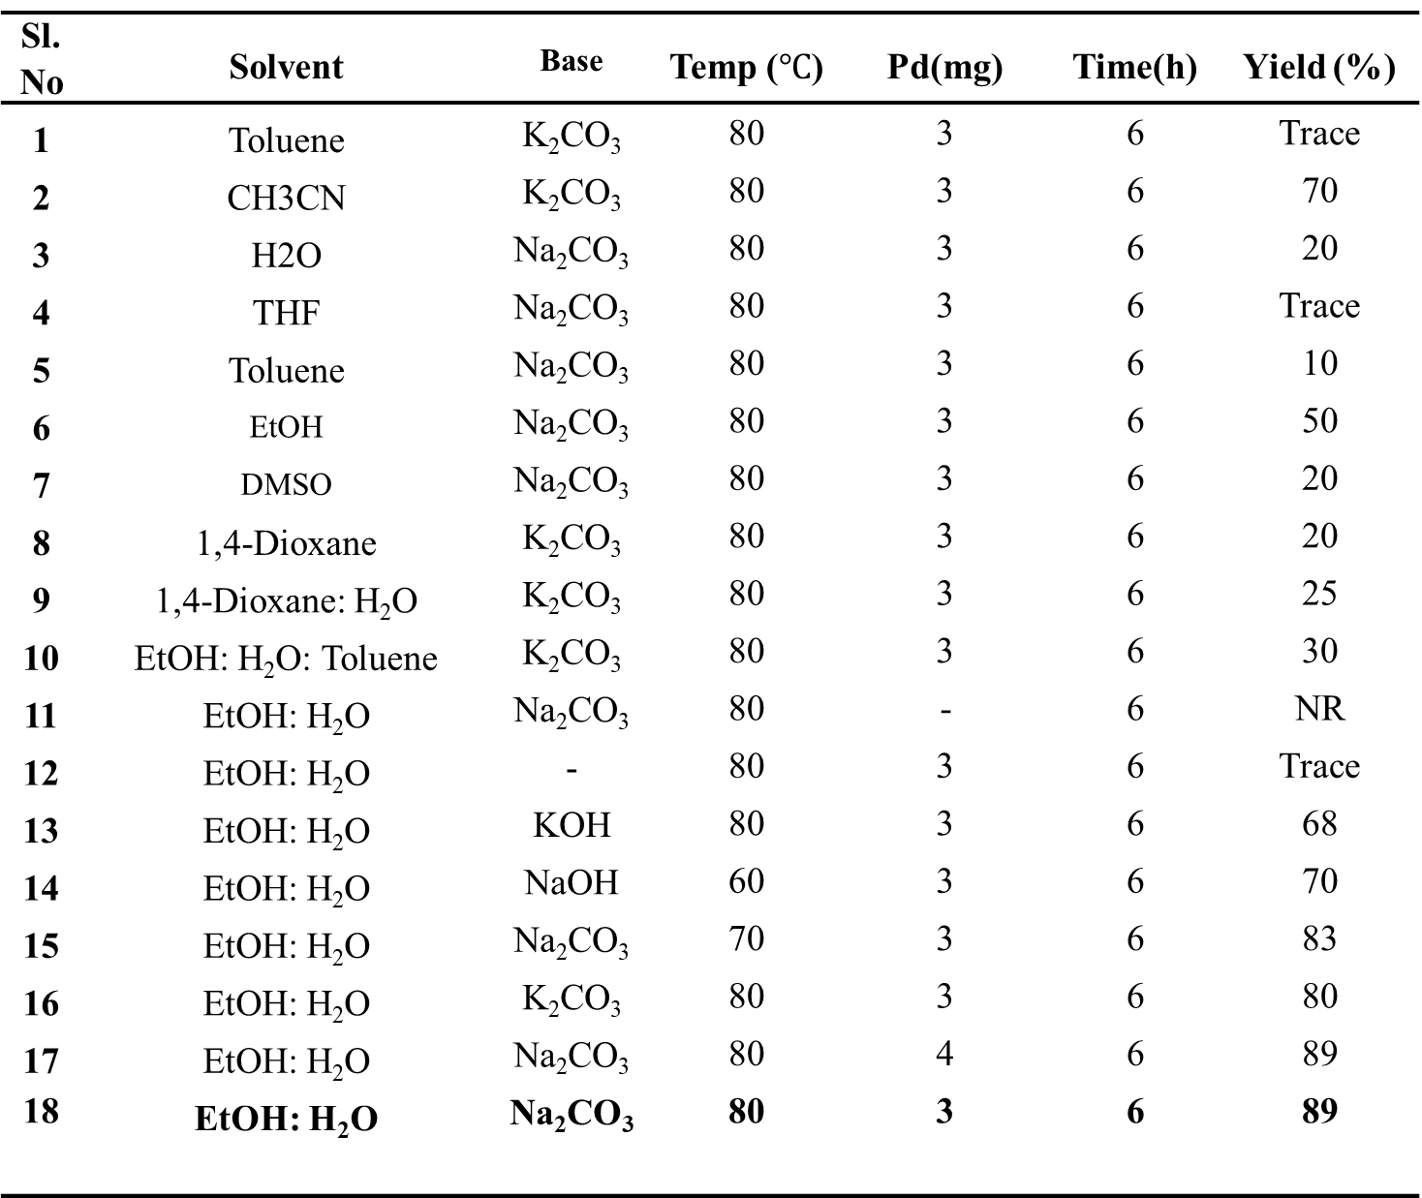

Figure S2. UV- visible spectra of Pd nanoparticles:
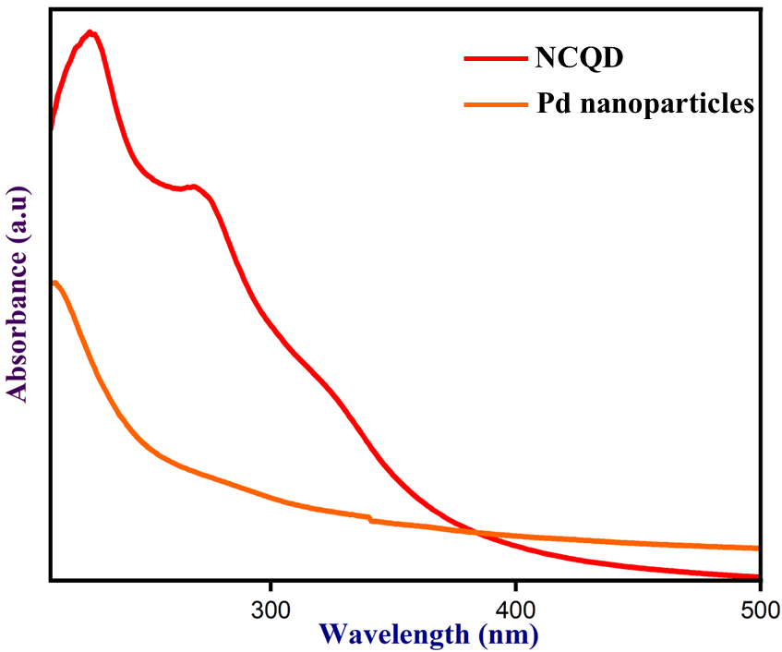
Figure S2. UV- visible spectra of NCQD and Pd nanoparticles
Figure S3. Reaction of 4- nitrophenol in the Presence of NaBH₄ and catalyst alone:
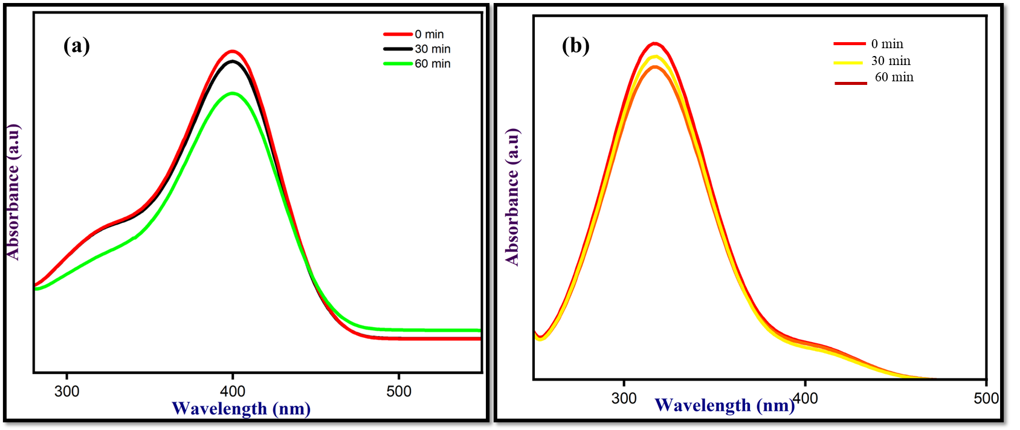
Figure S3. Reaction of 4- nitrophenol in the Presence of (a) NaBH₄ and (b) catalyst alone

Table S3. Comparison table of PdNPs for denitrogenative coupling reactions:
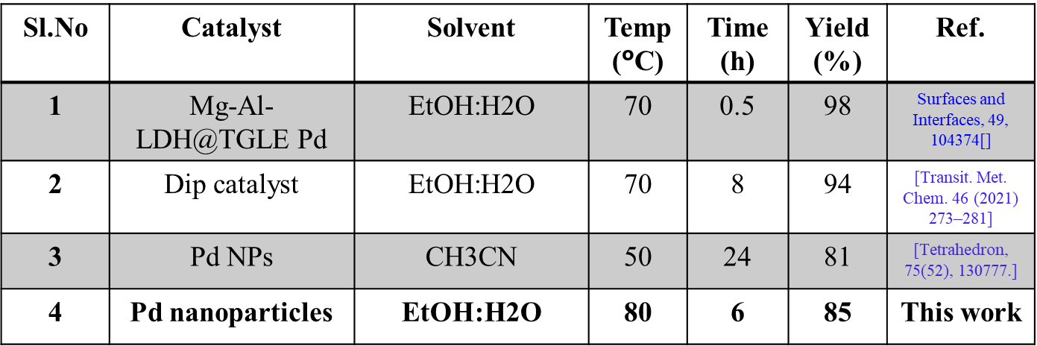
Table S4. Comparison table of PdNPs for reduction of 4- nitrophenol:
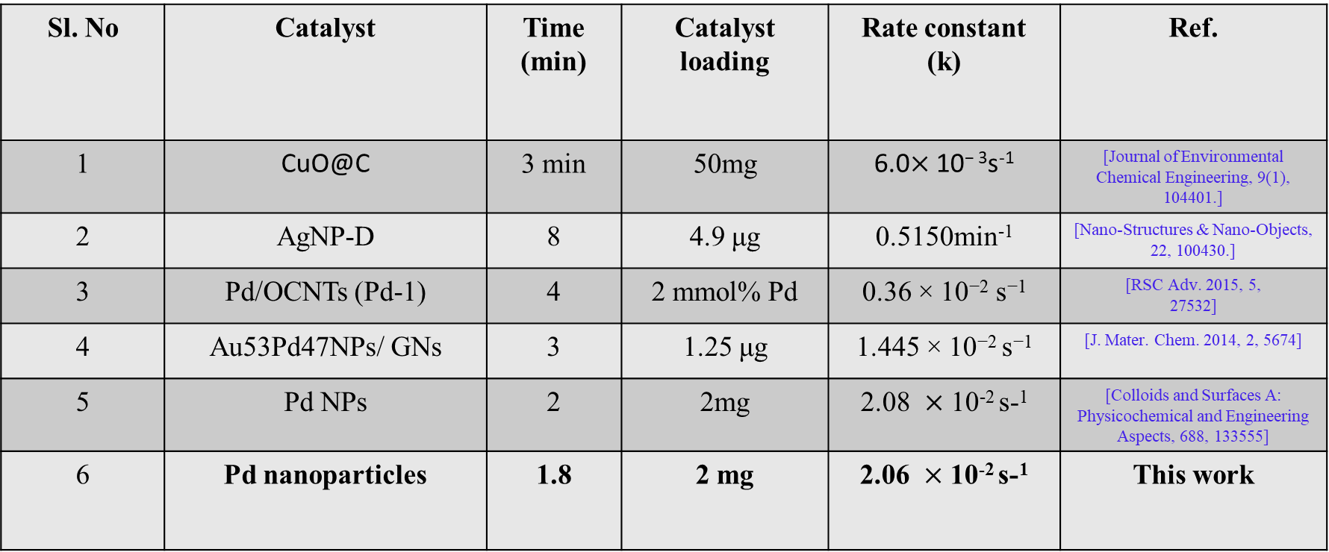

Figure S4 Recyclability of Pd nanoparticles 3 cycles:
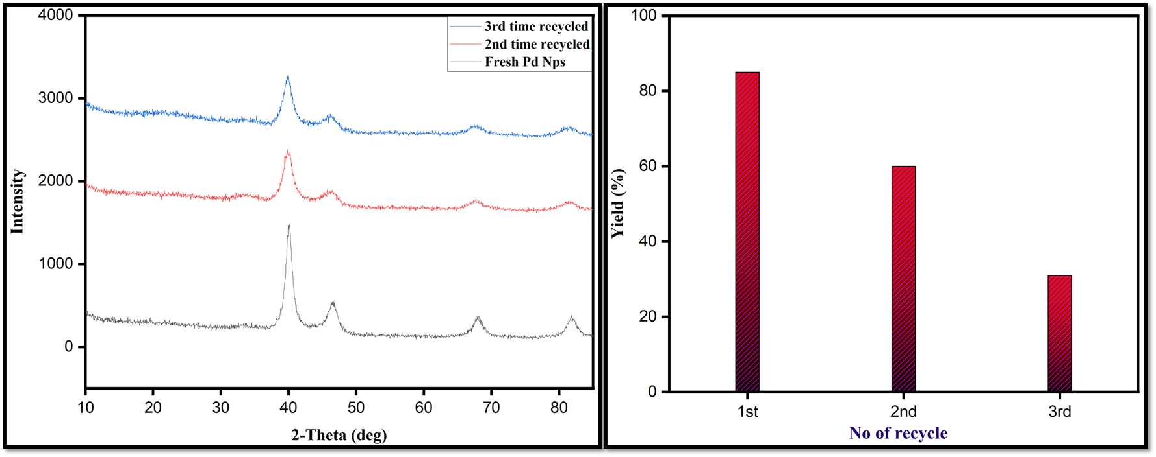
Figure S4. Recyclability of Pd nanoparticles
S3. H¹ and C¹³NMR analysis of denitrogenative coupling Reactions:
1. Biphenyl (Scheme 1. 3a,3b): Colourless Crystals. H¹ NMR (400 MHZ, CDCl₃), $δ$ (PPM) = 7.60 (d, J=8Hz, 4H), 7.44 (t, J= 7.2Hz, 4H), 7.35 (t, J=7.5 Hz, 2H).
2. 4-Phenylbenzaldehyde (Scheme 1. 3b): Light yellow Crystals. H¹ NMR (400 MHZ, CDCl₃), $δ$ (PPM)= 10.06 (s, 1H), 7.96 (d, J= 8.4Hz, 2H), 7.76 (d, J= 8.4Hz, 2H), 7.65 (d, J= 7.2Hz, 2H), 7.50 (t, J =7.2Hz, 2H), 7.43 (m, 1H).
3. 4-Cyanobiphenyl (Scheme 1. 3g): white crystalline Powder. H¹ NMR (400 MHZ, CDCl₃), $δ$ (PPM)= 7.65 (m,4H), 7.52 (t, J=7.2 Hz, 2H), 7.42 (m, 2H), 7.44 (m,1H).
4. 4-Acetylbiphenyl (Scheme 1. 3h): White powder. H¹ NMR (400 MHZ, CDCl₃), $δ$ (PPM)= 8.02 (d, J = 8.0 Hz, 2H), 7.69 (d, J = 8.0 Hz, 2H), 7.64 (t, J = 7.6 Hz, 2H), 7.49 (m, 2H), 7.42 (m, 1H), 2.64 (s, 3H).
5. [1,1'-biphenyl]-4-yl(phenyl)methanone (Scheme 1. 3j): Off White powder. H¹ NMR (400 MHZ, CDCl₃), $δ$ (PPM)= 7.91 (d, J= 8.4Hz, 2H), 7.85 (d, J= 7.2Hz,2H), 7.72 (d, J= 8Hz, 2H), 7.66 (d, J= 7.6Hz, 2H), 7.62 (t, J= 7.2 Hz, 1H), 7.50 (m,4H), 7.42 (t, J= 7.2Hz, 1H).
6. 2,4-dinitro-1,1'-biphenyl (Scheme 1. 3d,3e): Light yellow powder. H¹ NMR (400 MHZ, CDCl₃), $δ$ (PPM)= 9.02 (d, J= 2.0Hz, 2H), 8.53 (d, J= 4.0 Hz,2H), 8.51 (d, J= 4.00 Hz, 2H), 7.77 (t, J= 8.0 Hz, 2H).
7.3-hydroxy-[1,1'-biphenyl]-4-carbaldehyde (Scheme 1. 3f): White powder. H¹ NMR (400 MHZ, CDCl₃), $δ$ (PPM)= 11.04 (S, 1H), 9.85 (S, 1H), 7.57 (m, 3H), 7.42 (m,3H), 7.20 (m,2H).
8.4-methoxy-1,1'-biphenyl (Scheme 1. 3i): White powder. H¹ NMR (400 MHZ, CDCl₃), $δ$ (PPM)= 7.58 (t, J= 8.0Hz, 4H), 7.46 (t, J= 8.2 Hz, 2H), 7.34(t, J= 8.2 Hz, 1H), 7.01 (t, J= 4 Hz, 2H), 3.88 (s, 1H).
S4. H¹ spectra (400 MHz) of the products
