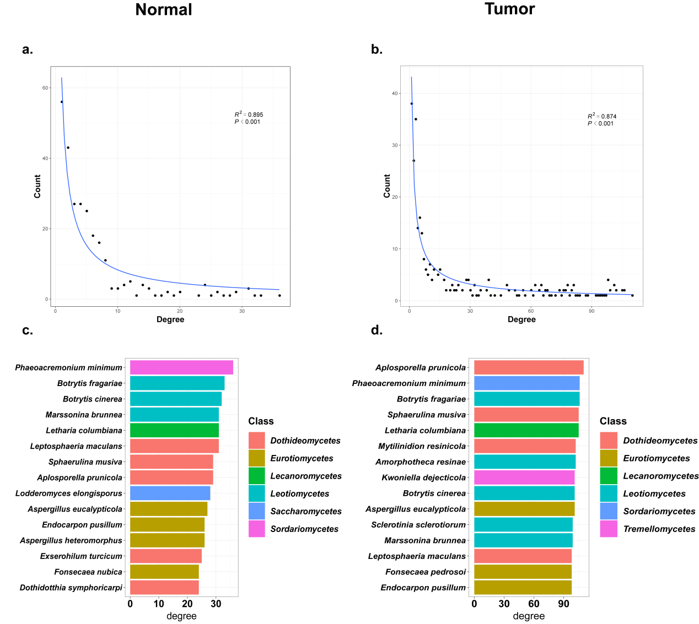Figure S2 a. b. The degree distribution for co-occurrence networks in control group and NSCLC. c. d. show top 15 fungal species with most degrees in non-cancer controls and NSCLC patients respectively.

