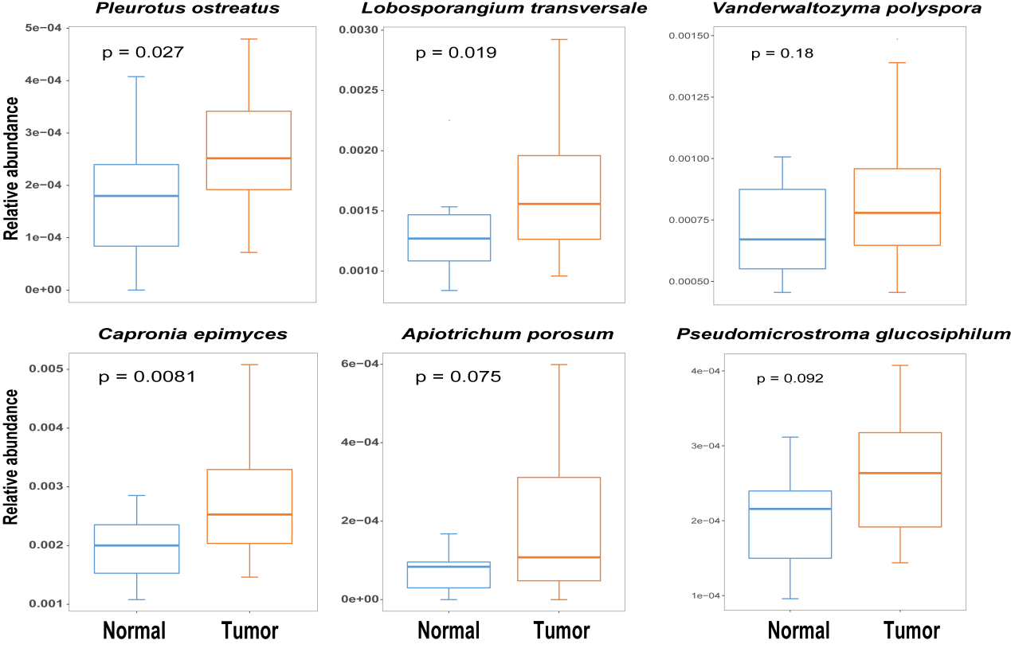
Figure S3. The relative abundances of 6 hubs in non-cancer controls and NSCLC patients assessed by the Wilcox test.

