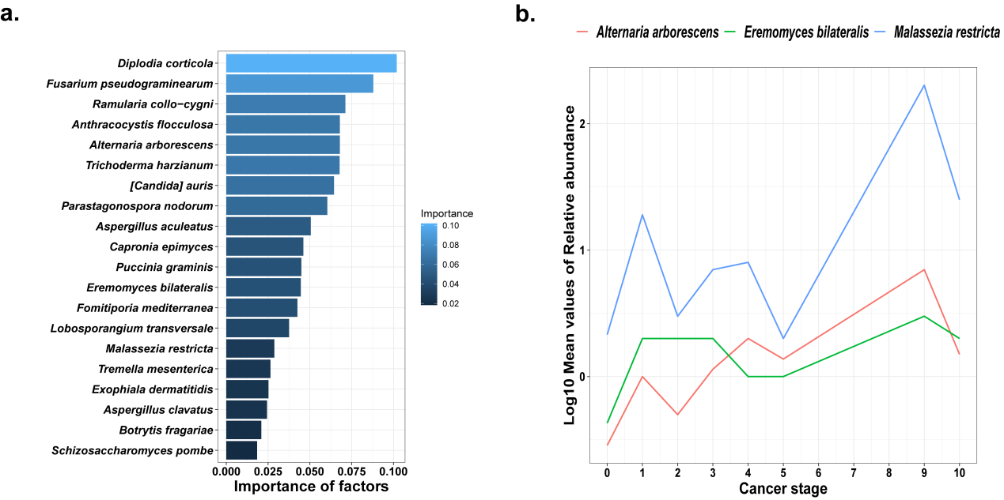
Figure S4. a. shows the top 15 species which contribute to the Random forest model. b. shows the mean relative abundance of 3 detected species by both DESeq2 and Random forest varies by cancer stage.

