Inherited burden for disease predisposition in diverse populations

Barış Kayaalp, Meltem Ece Kars, Yuval Itan, Ayşe Nazlı Başak, Jean-Laurent Casanova, and Tayfun Özçelik

Supplementary Notes
ACMG Variant Classification Guideline
ACMG has 28 criteria for variant classification [1]. Currently, 21 of them are implemented in AAVC [2]. The most utilized criterion was BP7 (synonymous or non-coding variant with no predicted splice effect), followed by BP4 (benign in silico prediction) (Additional File 1: Table S4). Each variant had 0.90 assigned criteria on average, ranging from 3.63 for Pathogenic to 0.20 for VUS-low. No ACMG criteria could be ascertained for 4,752,065 VUS-low variants, of which 88% of them were relatively conserved (phyloP > 0.1) and non-splice altering (SpliceAI < 0.2) synonymous and non-coding variants, and 10% were missense or in-frame indels. In the VUS-mid group, 86% of the variants were comprised of missense or inframe indels, and there was insufficient evidence to support benignity or pathogenicity.
For the gnomAD dataset, the concordance of AAVC with the reported variants ranged from 98.41% for all entries to 99.86% for above 1-star entries (Additional File 1: Table S4).
VUS Subclasses
The rationale behind the inclusion of subclasses in VUS, low and high, was first delineated at the presentation “ACMG v4 Sequence Variant Guidelines” by Steven Harrison on September 15, 2023 (https://clinicalgenome.org/tools/clingen-summer-workshop-series-2023/sept-15-2023/), which is further supported by our previous studies on AAVC. The inclusion of subclasses increased the concordance of AAVC with the Food and Drug Administration-approved variant list without any major sensitivity and specificity drawbacks [2].
Calculated and Reported Carrier Frequencies
The list consisted of 70 different entries after accounting for different ancestries, of which 44 were from European and 26 from non-European groups. Later, we removed the BLM gene for the Ashkenazi population since the main driver variant was the variant blm^{Ash}, a complex indel absent in gnomAD, leaving 69 entries to test.
Overall, the P+LP group provided closer CrF estimations to previously reported estimates than that of P or P+LP+VUS-H (Fig. S1 and Additional File 1: Table S2). For instance, the estimated CrFs of ATP7B, which leads to Wilson’s Disease, have a reported CrF of 1 in 90 for Europeans, and our estimated CrF ranges from 1 in 79 to 1 in 33. On the contrary, for ALDH3A2, the cause of Sjogren-Larsson syndrome, the CrF, 1 in 1390 to 523, was insufficient to elucidate the reported prevalence rate, 1 in 251.
CFTR Variants
Our approach suggested that the carrier rate is 1.4 times to 2.9 times higher across different variant sets. Leveraging the data from CFTR-France September 2024, we downloaded data (https://cftr.chu-montpellier.fr/), and there were 550 disease-causing variants, 41 of which were structural variants. We converted the remaining 509 variants to genomic positions using GeneBe (https://genebe.net/tools/hgvs). The genomic position is used to match the variants with their allele frequency. Two hundred forty-six variants had allele frequency information for non-Finnish Europeans. 1 in 27 individuals carried a CF-causing variant, while 1 in 21 carried a hypomorphic variant; in total, 1 in 12 individuals carried a variant related to either CF-causing or CF-related disorder.
Allele frequency data was also used to calculate the genotype prevalence of all possible homozygous and compound heterozygous CFTR variant combinations (Additional File 1: Table S7) [3]. The most common causal genotype for cystic fibrosis or related disorder was Δ508/R668C compound heterozygote followed by Δ508 homozygote with 1 in 3313 and 1 in 4455, respectively. Assuming full penetrance for CF-causing homozygotes and compound heterozygotes, GP was calculated as 1 in 2909, which becomes 1 in 2490 with the inclusion of variants with varying clinical consequences and CF-causing compound heterozygotes. The expected prevalence of CFTR-related disorder was 1 in 1219. The compound heterozygotes or homozygotes of variants that were in the unclassified group were proposed to lead to phenotype; however, given their rarity, it has not been defined yet, and their expected genetic prevalence was 1 in 80,585. 1 in 1734 individuals were either homozygous or compound heterozygous for hypomorphic CFTR variants, and they had no expected phenotype.
Gene Constraint
Genes associated with Mendelian diseases have been reported to be more constrained [4–6]. When compared to genes with no reported disease association in PanelApp (pLI=15%, LOEUF=19%, S_{het}=22%, missense-z=6%, syn-z=0.14%), a higher proportion was constrained for the 3970 disease genes (pLI=25%, LOEUF=31%, S_{het}=27%, missense-z=16%, syn-z=0.03%), for both missense and pLoF variants. However, no such difference was observed for synonymous variants.
2624 genes out of 3970 were labeled with more than one disease group. We observed that genes that have more than one disease group assigned (pLI=27%, LOEUF=33%, S_{het}=28%, missense-z=19%, syn-z=0.04%) were significantly more constrained compared to genes with a single disease group (pLI=22%, LOEUF=28%, S_{het}=26%, missense-z=12%, syn-z=0%), except for S_{het} and synonymous z-score values. Genes associated with neoplasms were under the strongest selective pressure, followed by those linked to circulatory diseases and the nervous system (Fig. S4A and S4B, and Additional File 1: Table S10).
Carrier Screening
Tier 3 genetic screening for genetic disorders with a carrier frequency higher than 1 in 200 is recommended by ACMG for all couples [7]. Previous studies used various gnomAD versions, including 4.1, for the detection of candidate genes for genetic screening; however, they were mainly based on reported pathogenic variants [7–9]. Our approach revealed that 192 genes were suitable for screening for at least one genetic ancestry group when using P variants, and the number increased to 372 genes when P+LP and 488 for P+LP+VUS-H variants were used. For the list of all genes and their recommended ancestries, please see Additional File 1: Table S12. The number of genes to be screened for different populations ranged from 94 to 151 for different genetic ancestries for P+LP variants (Fig. S3).
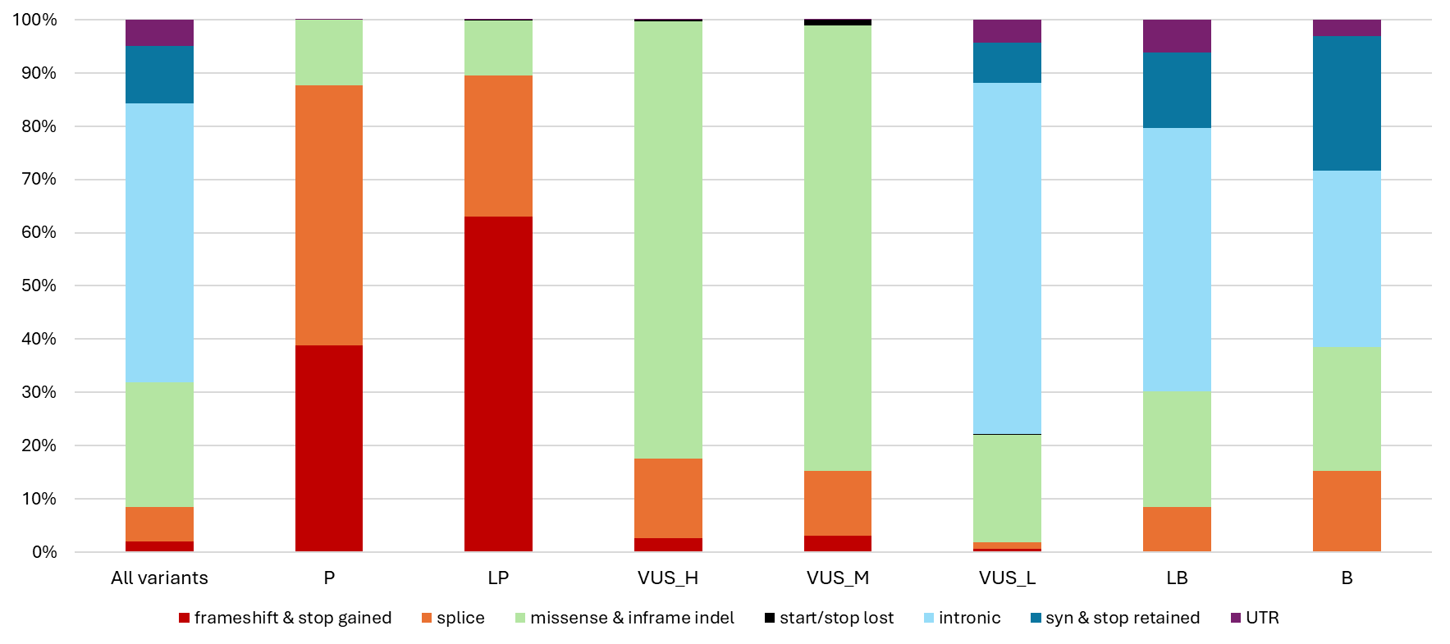
Supplementary Figures
Fig. S1 Distribution of variant effects based on ACMG classification. The stacked column graph shows the distribution of variant effects based on ACMG classifications assigned by AAVC.
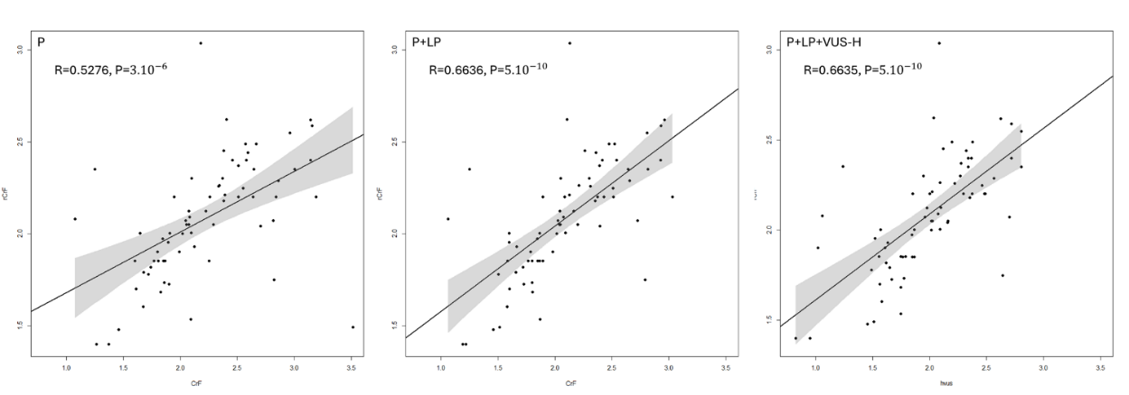
Fig. S2 Correlation of reported and estimated CrF. Correlation of reported and estimated CRF Correlation of reported and estimated prevalence for P, P+LP, and P+LP+VUS-H variants. Reported and estimated CrF were both log-transformed with a base of 10. Dots represent recessive diseases, the x-axis represents the log-transformed values of CrF, and the y-axis represents the log-transformed values of rCrF.
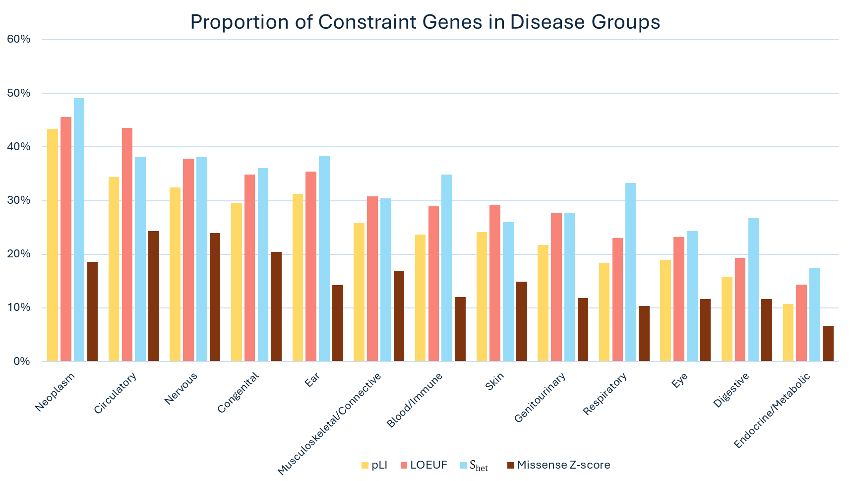
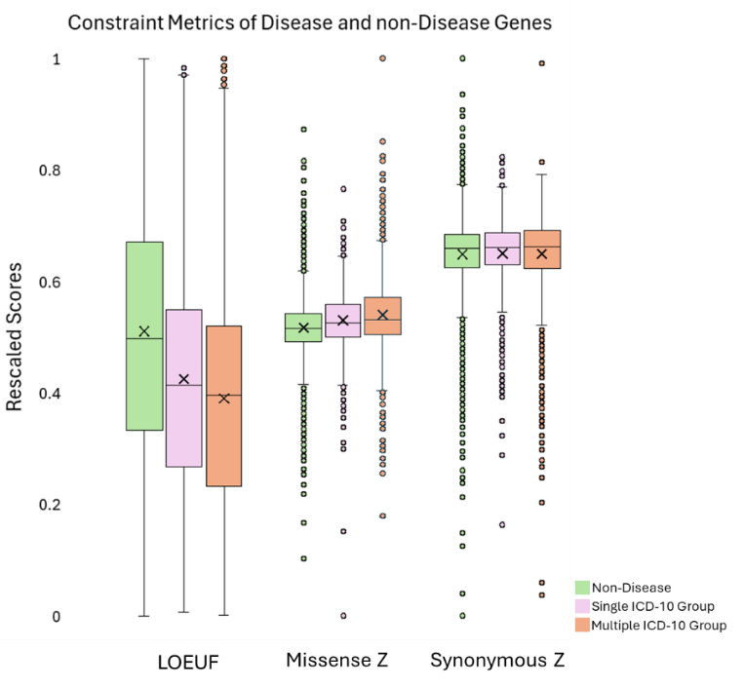
B.
A.

Fig. S3 Constraint of Disease Genes. A The box plot delineates the differences in constraint metrics between non-disease-associated genes, genes labeled with one disease group, and more than one disease group. Dots represent individual genes, colored boxes show the central quartiles of the distribution in each constraint metric, horizontal bars within boxes show the medians, and crosses show the means. The scores for each metric were rescaled via min-max normalization and shown on the y-axis. B The clustered column chart represents the proportion of genes that were classified as constrained according to different metrics on the y-axis and disease groups on the x-axis (Thresholds for constraint: pLI > 0.9, LOEUF < 0.6, S_{het} > 0.073, Missense Z-score> 3.09).
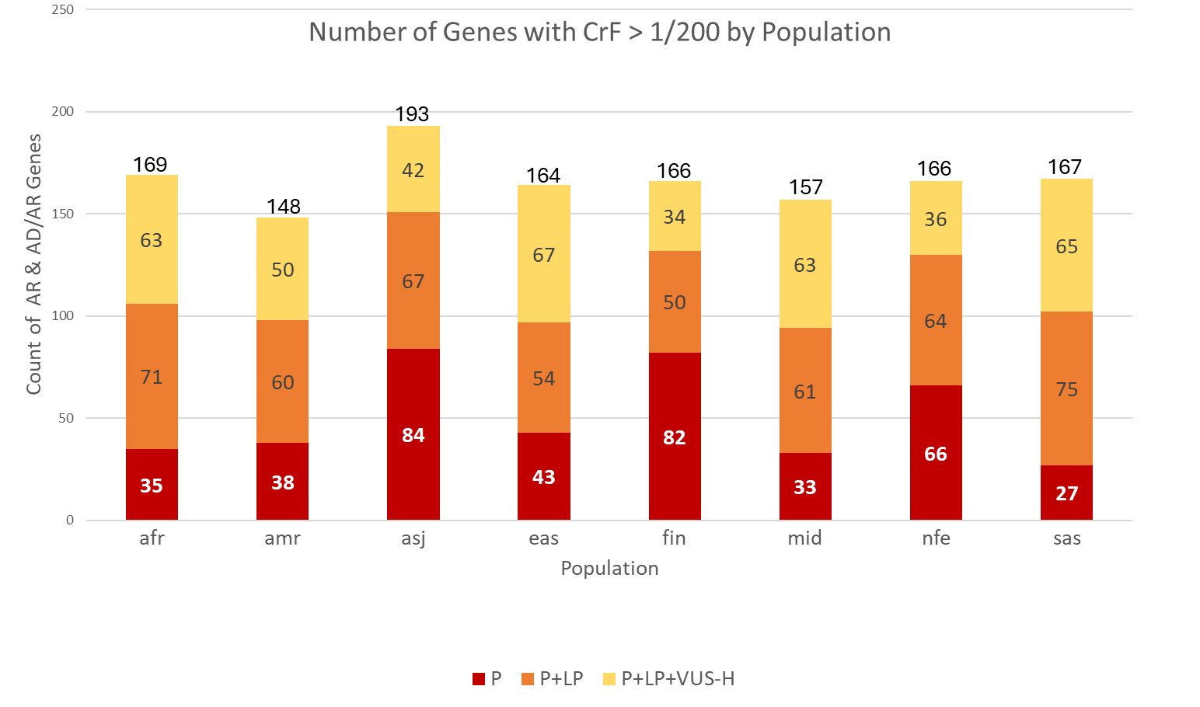
- Fig. S4 Candidate genes for carrier screening. The bar chart illustrates the number of candidate genes for Tier 3 carrier screening.

References
1. Richards S, Aziz N, Bale S, Bick D, Das S, Gastier-Foster J, et al. Standards and guidelines for the interpretation of sequence variants: a joint consensus recommendation of the American College of Medical Genetics and Genomics and the Association for Molecular Pathology. Genet Med. 2015;17:405–24.
2. R. A. İnan, (Automated sequence variant classification tool for DNA diagnostics.) MSc Thesis, İhsan Doğramacı Bilkent University, Ankara. (2024), Available at: https://tez.yok.gov.tr/UlusalTezMerkezi/TezGoster?key=usXiZIM9Lp0wk-YzRoaT-6jm6gfjBIGzWdMM_QPb6lXjdQRN1PAL4LDcaMqhJrYl
3. Claustres M, Thèze C, des Georges M, Baux D, Girodon E, Bienvenu T, et al. CFTR-France, a national relational patient database for sharing genetic and phenotypic data associated with rare CFTR variants. Hum Mutat. 2017;38:1297–315.
4. Cassa CA, Weghorn D, Balick DJ, Jordan DM, Nusinow D, Samocha KE, et al. Estimating the selective effects of heterozygous protein-truncating variants from human exome data. Nat Genet. 2017;49:806–10.
5. Weghorn D, Balick DJ, Cassa C, Kosmicki JA, Daly MJ, Beier DR, et al. Applicability of the Mutation–Selection Balance Model to Population Genetics of Heterozygous Protein-Truncating Variants in Humans. Mol Biol Evol. 2019;36:1701–10.
6. Sun KY, Bai X, Chen S, Bao S, Zhang C, Kapoor M, et al. A deep catalogue of protein-coding variation in 983,578 individuals. Nature. 2024;631:583–92.
7. Gregg AR, Aarabi M, Klugman S, Leach NT, Bashford MT, Goldwaser T, et al. Screening for autosomal recessive and X-linked conditions during pregnancy and preconception: a practice resource of the American College of Medical Genetics and Genomics (ACMG). Genet Med. 2021;23:1793–806.
8. Schmitz MJ, Aarabi M, Bashar A, Rajkovic A, Gregg AR, Yatsenko SA. Carrier frequency of autosomal recessive genetic conditions in diverse populations: Lessons learned from the genome aggregation database. Clin Genet. 2022;102:87–97.
9. Schmitz MJ, Bashar A, Soman V, Nkrumah EAF, Mulla H Al, Darabi H, et al. Leveraging diverse genomic data to guide equitable carrier screening: Insights from gnomAD v.4.1.0. Am J Hum Genet. 2025;112(1):181-195.

