Supplementary methodology

IAF Whole-genome sequencing

DNA samples were randomly fragmented into 350 base-pair reads using Covaris technology. Subsequently, 3’-end repair was performed, followed by amplification through ligation-mediated polymerase chain reaction, single-strand separation, and cyclization. DNA Nanoball were then generated with rolling circle amplification and sequenced using the BGI-SEQ500 platform.

Population structure analysis

We performed population stratification analysis by applying a PCA on the UKB sequencing and array data jointly with the IAF whole-genome data, using the R package flashpca from FlashPCA2²⁸. We first performed quality control on the reference dataset (UKB) using PLINK^{115,116} by filtering variants at MAF > 1% and LD at r² < 0.1. We then merged the reference (UKB) sequencing and genotype data with the target dataset (IAF) and retained common variants across sets. The final datasets for PC analysis included 200,673 samples and 8,201 SNPs for the WES-based dataset. For the array-based, the dataset included 487,489 samples and 66,063 SNPs.

For the UKB, population groups were identified by mapping the PCs using the reported ethnic grouping labels (Data field: 22006). To check for fine-scale population structure and potential outliers¹¹⁷, we UMAP to the 40 PCs from the merged IAF-UKB datasets using the R package umap¹¹⁸. We then retained individuals from the UKB that clustered with the individuals from the IAF cohort from the results of PC and UMAP analyses.

Genotype quality control

For association analyses and polygenic risk modeling, we applied stringent quality control to the genomic data of the reference dataset (UKB), following the recommendations by Chang (2020) and Marees et al. (2018). We first removed duplicated, multi-allelic variants, insertions, and deletions (INDELs). We retained SNPs located only on the autosomal chromosomes. Next, we removed samples and SNPs with missing information in a two-step manner. First, by removing samples and SNPs with missingness > 10% and then, from the remaining dataset, with > 1%. We then retained variants with MAF > 1% and removed SNPs that deviated from Hardy-Weinberg equilibrium (HWE). For HWE, we first removed variants with P-value < 5 × 10⁻¹⁰ and then with 5 × 10⁻⁶. To eliminate correlated genetic variants that could introduce biases in analyses¹²² ³³, we tagged all SNPs LD at r² > 0.8 and performed LD-pruning by retaining variants with r² < 0.1. We excluded genetically related individuals with KING kinship coefficient > 0.177, those with a heterozygosity rate greater than 3 standard deviations (SD) above the sample average, and those with discrepancies between genetic and self-reported sex. From the quality-controlled datasets, we then lifted over the sequencing data to the hg19 genome build using LiftOver from Picard toolkit¹²³, to facilitate downstream analyses with the imputed array data. Finally, we annotated SNPs using VEP (v107)²⁹ and kept SNPs with available dbSNP information to facilitate comparisons across platforms. A summary of the sample-level quality control performed on the WES reference dataset is shown in Figure S1.

Methods for the estimation of PRSs

We generated PRSs for the traits using five different approaches based on clumping and thresholding (PRSice2), Bayesian regression (LDpred2, RápidoPGS, PRS-CS), and penalized regression (lassosum2).

PRSice2 follows a clumping and thresholding approach, from which PRSs are estimated using SNPs not in LD or weakly correlated with a P-value above a significance threshold. We first clumped the target dataset by retaining SNPs with an r² < 0.1 within a 250 kb window, using default parameters “--clump-r2 0.1” and “--clump-kb 250”. Then, we varied the P-values for thresholding from a minimum value of 5 × 10⁻⁸to 0.5, with a step-size increase of 5 × 10⁻⁵.

LDpred2 is a Bayesian approach that estimates posterior mean effects from the summary statistics by conditioning on a prior and accounting for LD between SNPs. We used three model configurations: an infinitesimal model (LDpred2-inf), which assumes a normal distribution of priors; a grid of models (LDpred2-grid), which provides a grid of values for the priors; and an automatic model (LDpred2-auto), which calculates the priors directly from the data using a Gibbs sampler. For each model, we estimated the LD correlation matrix from the target dataset and used the default parameters, following the recommendations from the developers.

Similar to LDpred2, PRS-CS uses a Bayesian regression approach but applies a continuous shrinkage prior to adjust the effect sizes of genetic variants. We specified default options to estimate the global shrinkage parameter directly from the data and used the pre-computed LD matrix from 1KG, which was provided by the developers. With the generated posterior SNP effect sizes, we used PLINK to calculate the PRSs for the target dataset using the “--score” option.

RápidoPGS operates within a Bayesian framework but employs fine-mapping approaches to estimate the summary statistics’ posterior mean effects and adjust the effect sizes. Priors for a true causal effect size are sample from a uniform distribution. We used the “rapidopgs_single” option to estimate the posterior effect sizes using default parameters. We then used PLINK to calculate the scores for the target datasets.

Lastly, lassosum2 uses a regularized regression model on the summary statistics, accounting for LD between variants. We estimated the LD correlation matrix from the target dataset and used default parameters with shrinkage parameters set at 0.001, 0.01, 0.1, and 1, along with a penalty parameter of 0.01.

Supplementary Figures

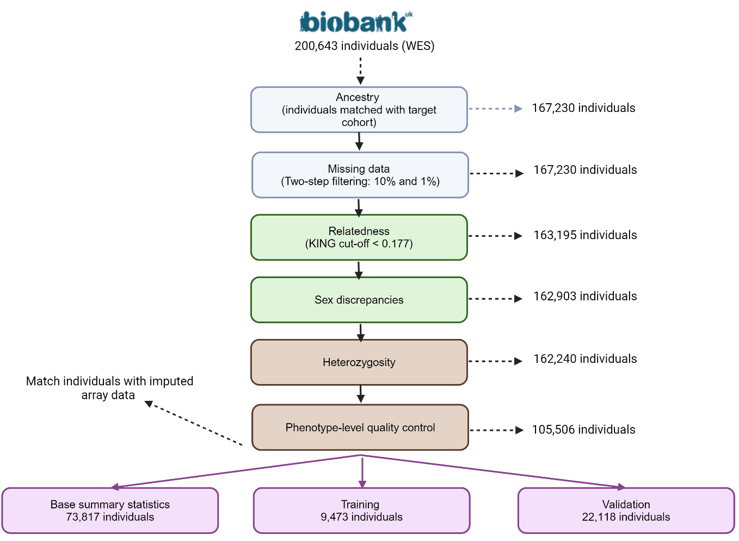

Fig S1. Sample-level quality control of the exome-based reference dataset. Overview of the sample-level processing of the WES base dataset (UK Biobank). For the imputed array base dataset, samples that passed WES quality control were retained for analyses.

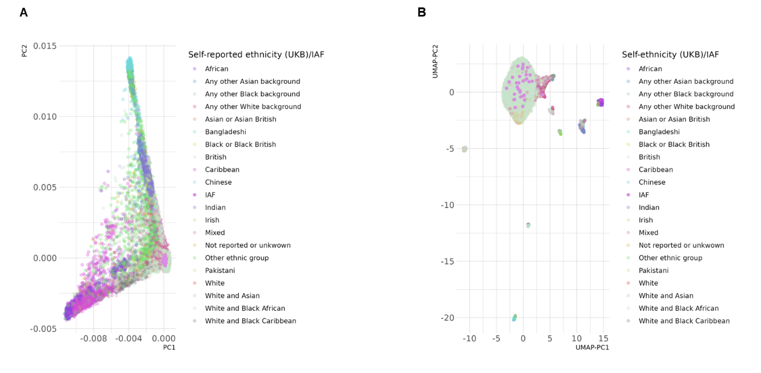
Fig S2. Population structure analysis and fine-scale analysis for the reference (UKB) and target (IAF) sequencing datasets (N_{Samples} = 487,439; N_{SNPs} = 66,063). (A) Principal component (PC) analysis for population structure. (B) UMAP analyses on the PCs for fine-scale population structure. Individuals from the target cohort clustered each other with the individuals self-reported as British which were retained for association and prediction analyses.

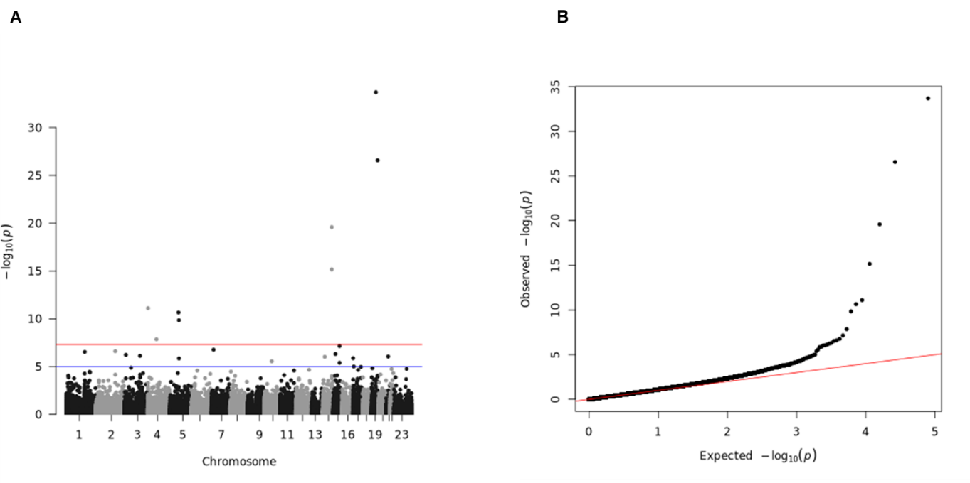

Fig S3. Manhattan plot and Q-Q plot for the single-variant association test for ALB in WES base reference dataset (UKB). (A) Manhattan plot. Blue line represents significance threshold at P-value < 0.05. Red line represents genome-wide significance threshold at P-value < 5E-08. (B) Q-Q plot.

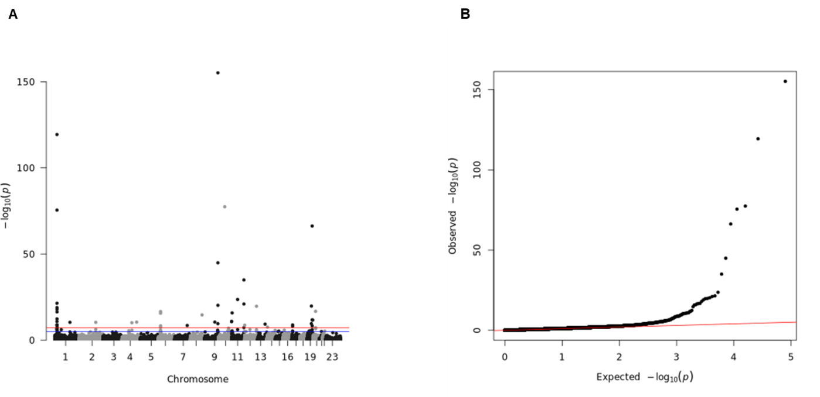

Fig S4. Manhattan plot and Q-Q plot for the single-variant association test for ALP in the WES base reference dataset (UKB). (A) Manhattan plot. Blue line represents significance threshold at P-value < 0.05. Red line represents genome-wide significance threshold at P-value < 5E-08. (B) Q-Q plot.

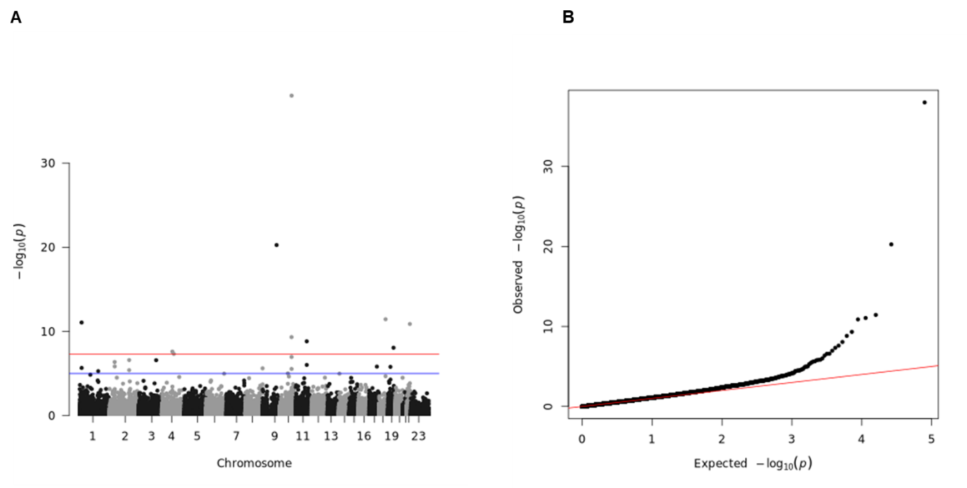

Fig S5. Manhattan plot and Q-Q plot for the single-variant association test for ALT in the WES base reference dataset (UKB). (A) Manhattan plot. Blue line represents significance threshold at P-value < 0.05. Red line represents genome-wide significance threshold at P-value < 5E-08. (B) Q-Q plot.

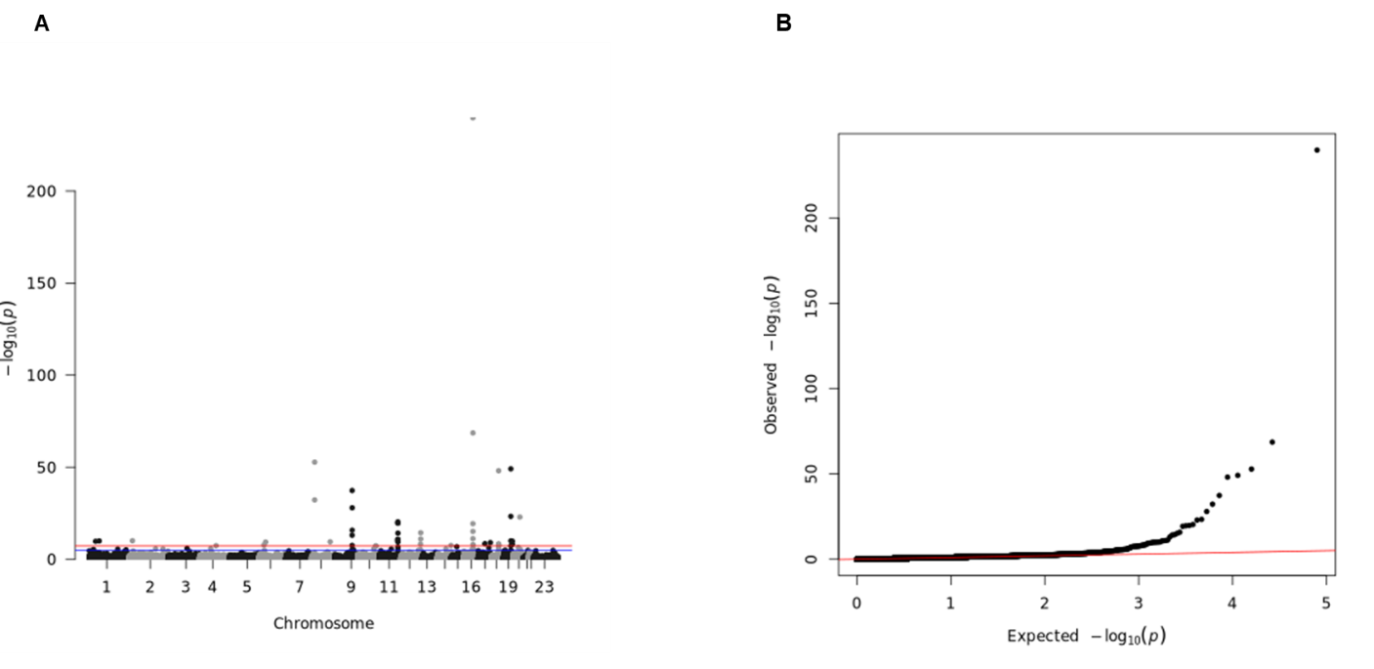

Fig S6. Manhattan plot and Q-Q plot for the single-variant association test for APOA in the WES base reference dataset (UKB). (A) Manhattan plot. Blue line represents significance threshold at P-value < 0.05. Red line represents genome-wide significance threshold at P-value < 5E-08. (B) Q-Q plot.

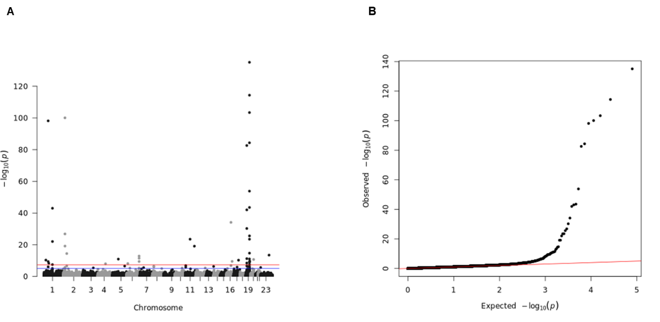

Fig S7. Manhattan plot and Q-Q plot for the single-variant association test for APOB in the WES base reference dataset (UKB). (A) Manhattan plot. Blue line represents significance threshold at P-value < 0.05. Red line represents genome-wide significance threshold at P-value < 5E-08. (B) Q-Q plot.

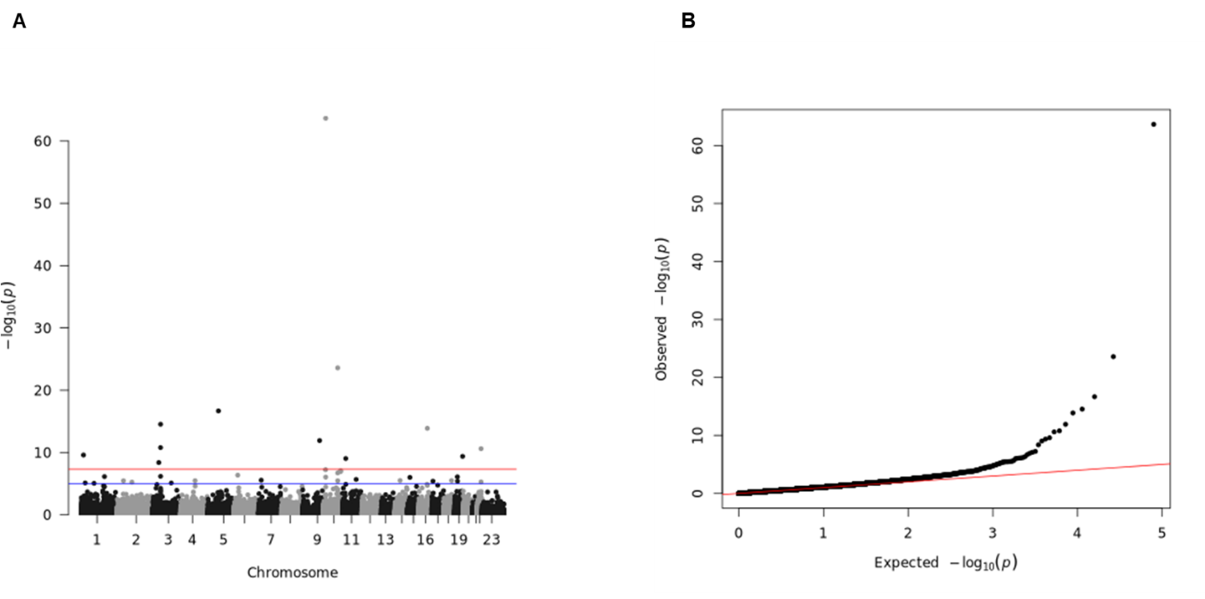

Fig S8. Manhattan plot and Q-Q plot for the single-variant association test for AST in the WES base reference dataset (UKB). (A) Manhattan plot. Blue line represents significance threshold at P-value < 0.05. Red line represents genome-wide significance threshold at P-value < 5E-08. (B) Q-Q plot.

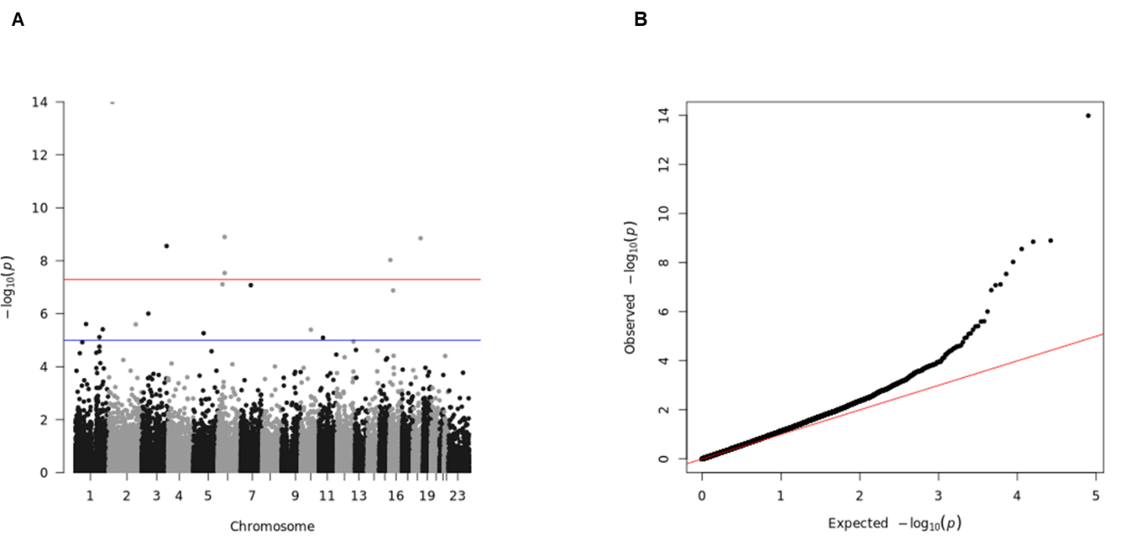

Fig S9. Manhattan plot and Q-Q plot for the single-variant association test for BMI in the WES base reference dataset (UKB). (A) Manhattan plot. Blue line represents significance threshold at P-value < 0.05. Red line represents genome-wide significance threshold at P-value < 5E-08. (B) Q-Q plot.

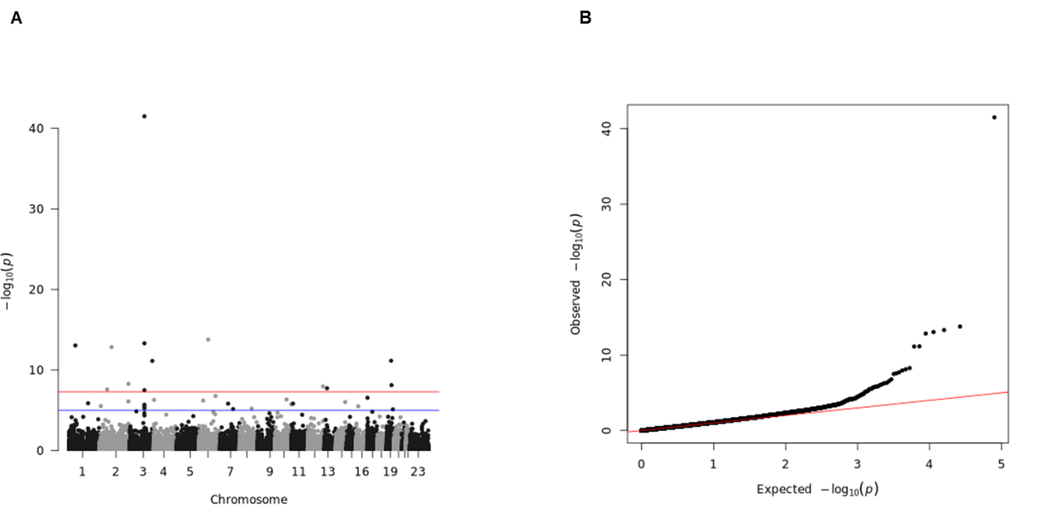

Fig S10. Manhattan plot and Q-Q plot for the single-variant association test for CAL in the WES base reference dataset (UKB). (A) Manhattan plot. Blue line represents significance threshold at P-value < 0.05. Red line represents genome-wide significance threshold at P-value < 5E-08. (B) Q-Q plot.

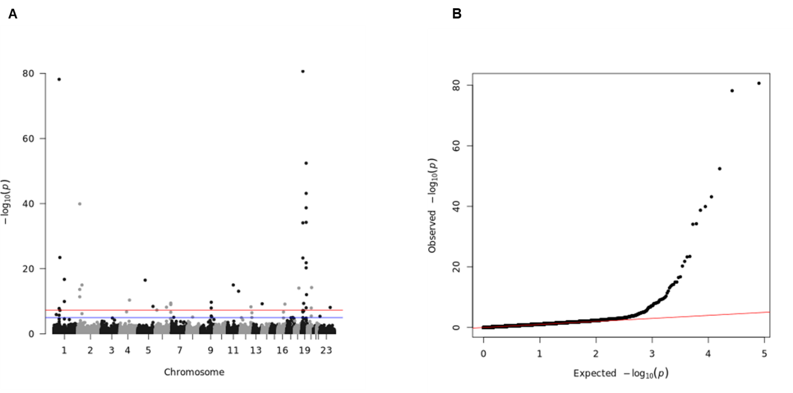

Fig S11. Manhattan plot and Q-Q plot for the single-variant association test for CHO in the WES base reference dataset (UKB). (A) Manhattan plot. Blue line represents significance threshold at P-value < 0.05. Red line represents genome-wide significance threshold at P-value < 5E-08. (B) Q-Q plot.

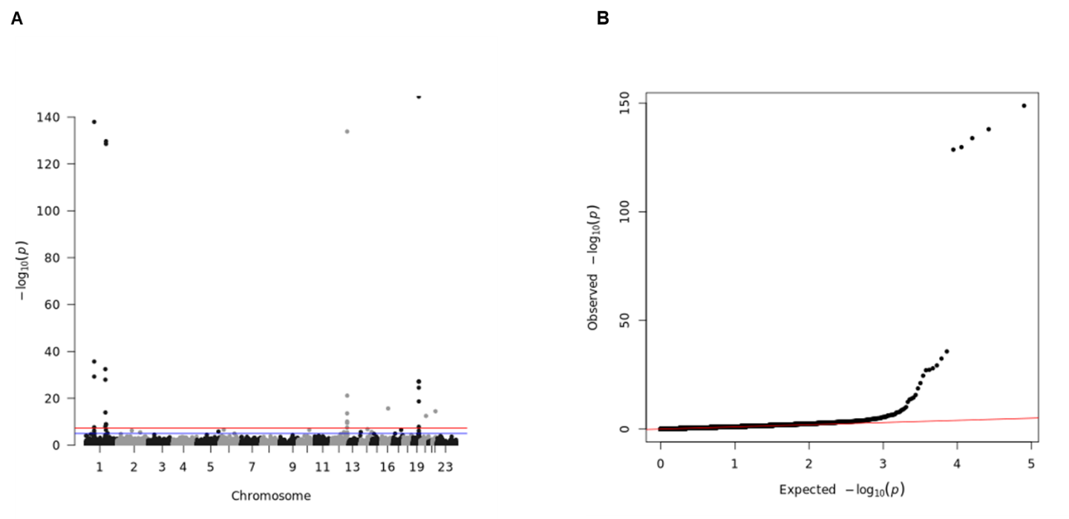

Fig S12. Manhattan plot and Q-Q plot for the single-variant association test for CRP in the WES base reference dataset (UKB). (A) Manhattan plot. Blue line represents significance threshold at P-value < 0.05. Red line represents genome-wide significance threshold at P-value < 5E-08. (B) Q-Q plot.

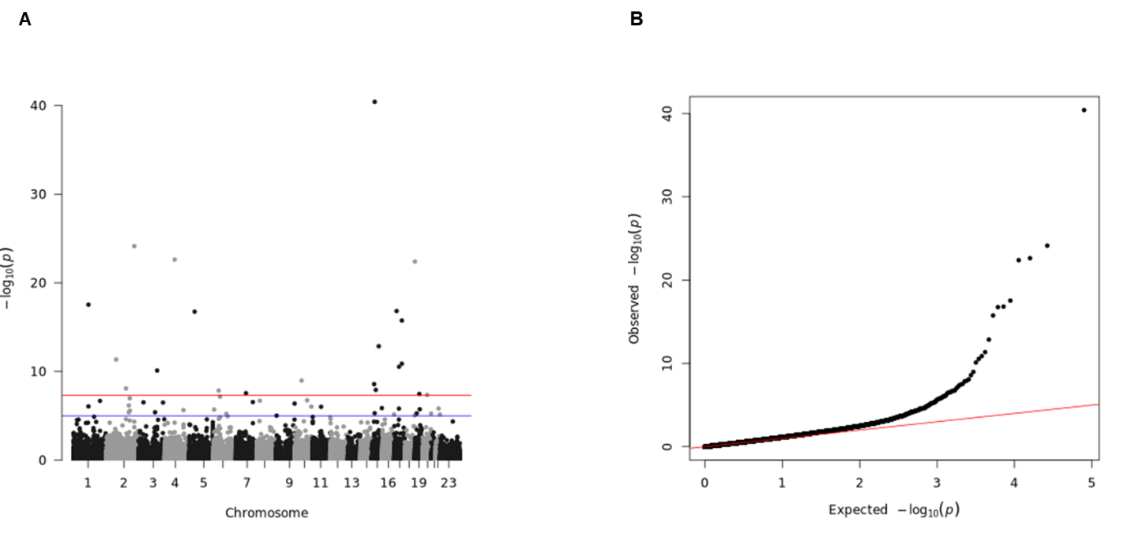

Fig S13. Manhattan plot and Q-Q plot for the single-variant association test for CREA in the WES base reference dataset (UKB). (A) Manhattan plot. Blue line represents significance threshold at P-value < 0.05. Red line represents genome-wide significance threshold at P-value < 5E-08. (B) Q-Q plot.

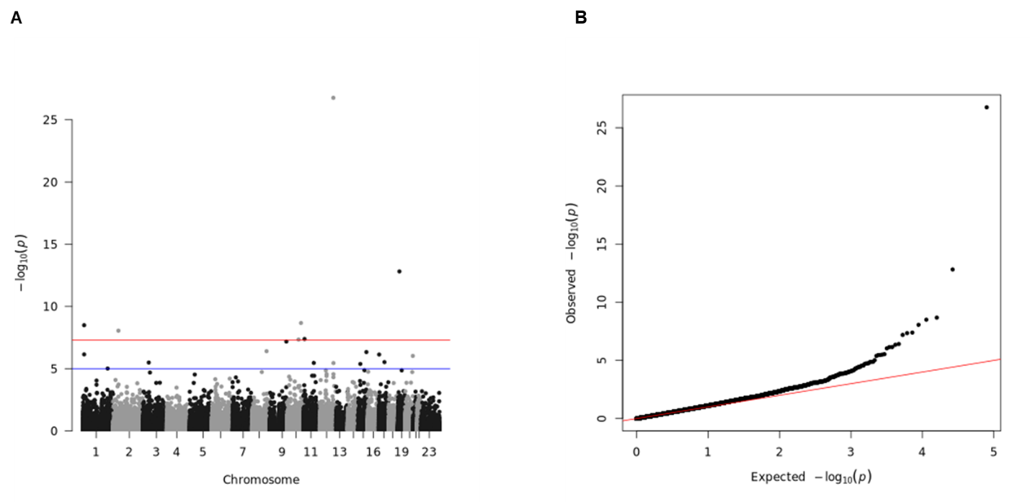

Fig S14. Manhattan plot and Q-Q plot for the single-variant association test for DBP in the WES base reference dataset (UKB). (A) Manhattan plot. Blue line represents significance threshold at P-value < 0.05. Red line represents genome-wide significance threshold at P-value < 5E-08. (B) Q-Q plot.

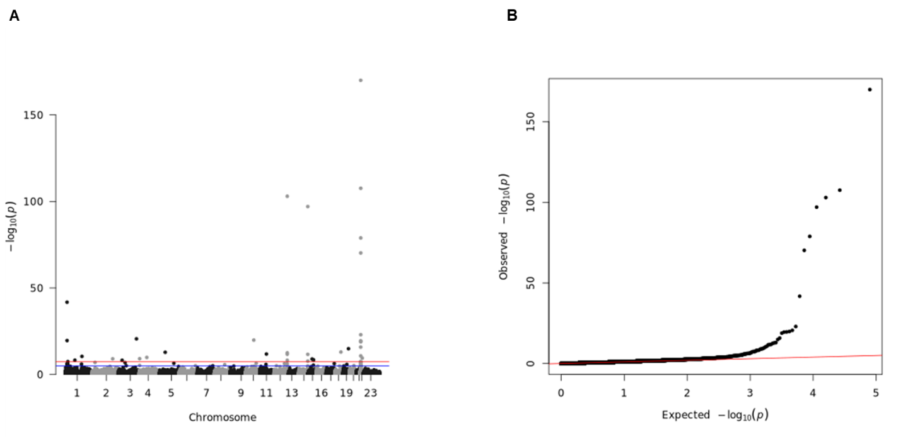

Fig S15. Manhattan plot and Q-Q plot for the single-variant association test for GGT in the WES base reference dataset (UKB). (A) Manhattan plot. Blue line represents significance threshold at P-value < 0.05. Red line represents genome-wide significance threshold at P-value < 5E-08.(B) Q-Q plot.

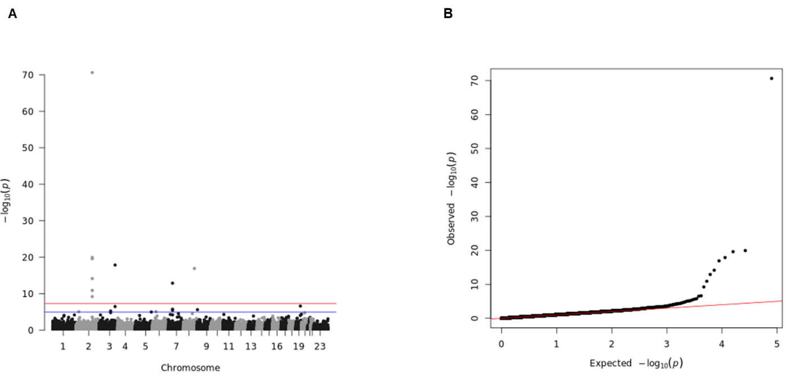

Fig S16. Manhattan plot and Q-Q plot for the single-variant association test for GLUC in the WES base reference dataset (UKB). (A) Manhattan plot. Blue line represents significance threshold at P-value < 0.05. Red line represents genome-wide significance threshold at P-value < 5E-08. (B) Q-Q plot.

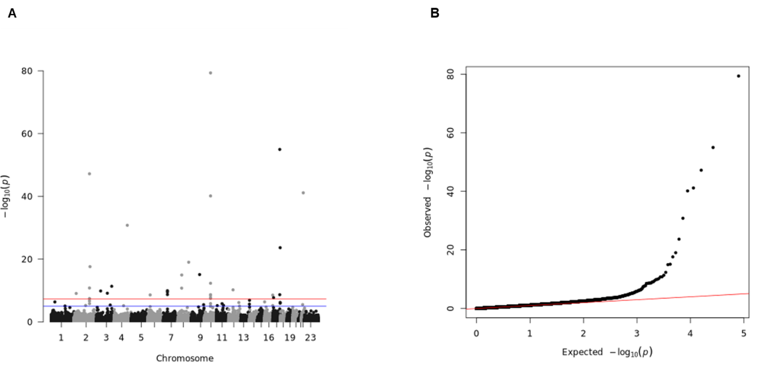

Fig S17. Manhattan plot and Q-Q plot for the single-variant association test for HBA1C in the WES base reference dataset (UKB). (A) Manhattan plot. Blue line represents significance threshold at P-value < 0.05. Red line represents genome-wide significance threshold at P-value < 5E-08. (B) Q-Q plot.

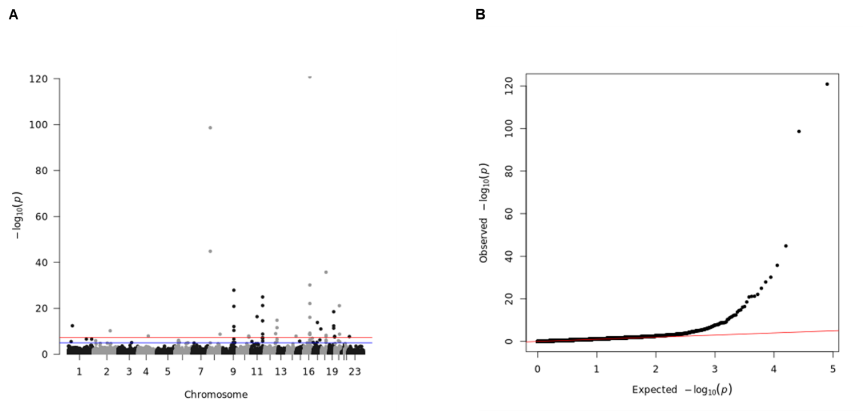

Fig S18. Manhattan plot and Q-Q plot for the single-variant association test for HDL in the WES base reference dataset (UKB). (A) Manhattan plot. Blue line represents significance threshold at P-value < 0.05. Red line represents genome-wide significance threshold at P-value < 5E-08. (B) Q-Q plot.

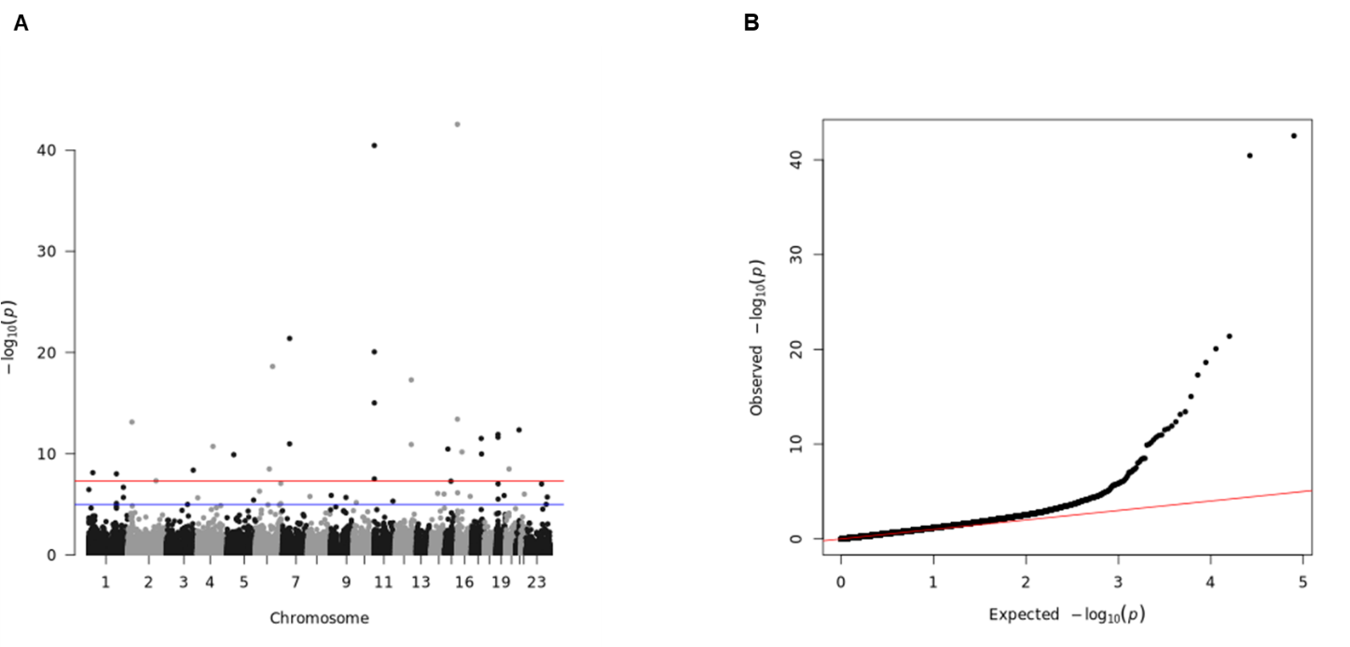

Fig S19. Manhattan plot and Q-Q plot for the single-variant association test for IGF1 in the WES base reference dataset (UKB). (A) Manhattan plot. Blue line represents significance threshold at P-value < 0.05. Red line represents genome-wide significance threshold at P-value < 5E-08. (B) Q-Q plot.

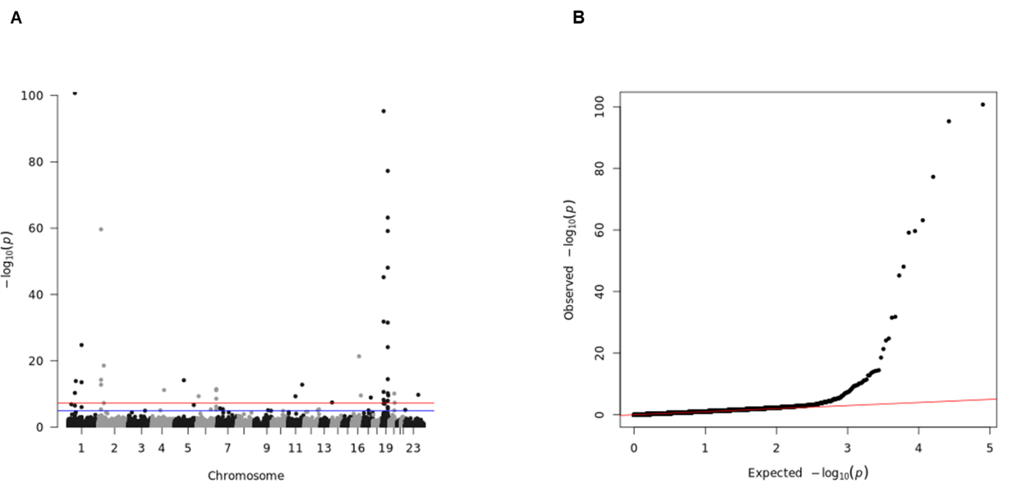

Fig S20. Manhattan plot and Q-Q plot for the single-variant association test for LDL in the WES reference dataset (UKB). (A) Manhattan plot. Blue line represents significance threshold at P-value < 0.05. Red line represents genome-wide significance threshold at P-value < 5E-08. (B) Q-Q plot.

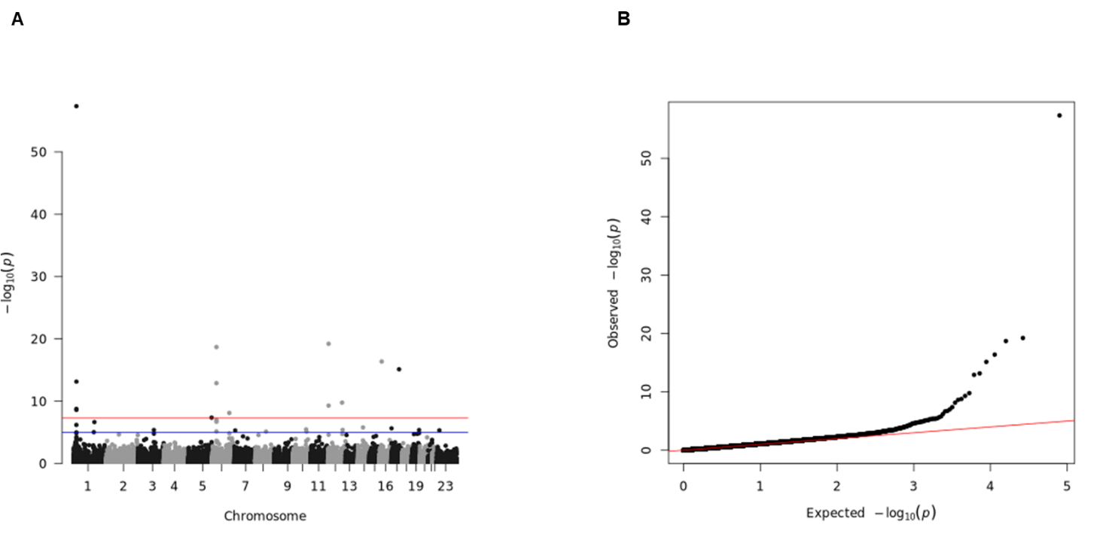

Fig S21. Manhattan plot and Q-Q plot for the single-variant association test for PHOS in the WES base reference dataset (UKB). (A) Manhattan plot. Blue line represents significance threshold at P-value < 0.05. Red line represents genome-wide significance threshold at P-value < 5E-08. (B) Q-Q plot.

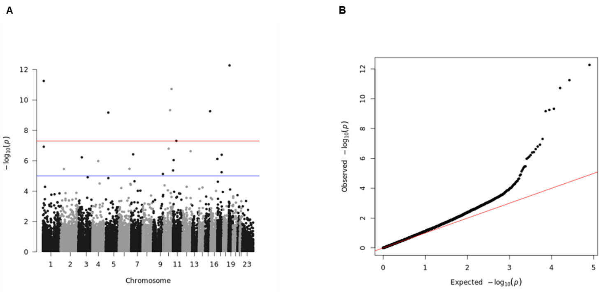

Fig S22. Manhattan plot and Q-Q plot for the single-variant association test for SBP in the WES base reference dataset (UKB). (A) Manhattan plot. Blue line represents significance threshold at P-value < 0.05. Red line represents genome-wide significance threshold at P-value < 5E-08. (B) Q-Q plot. Figure related to Figure 5.

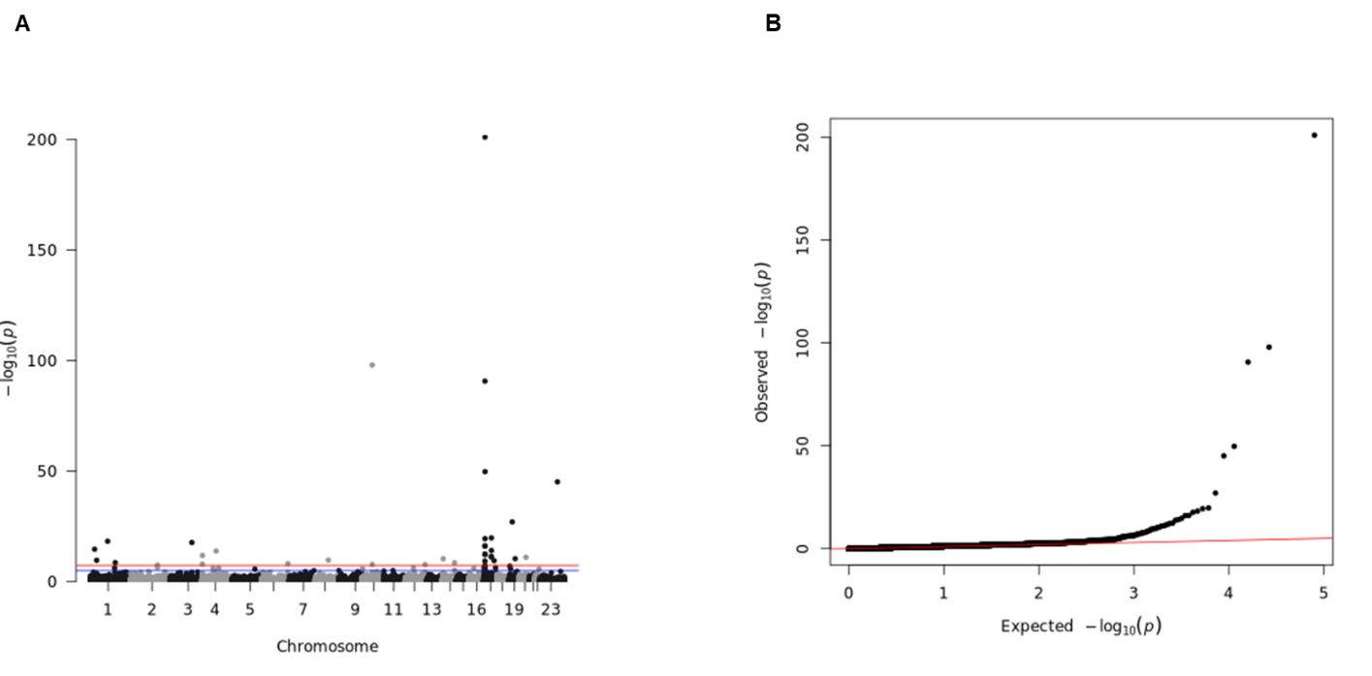

Fig S23. Manhattan plot and Q-Q plot for the single-variant association test for SHBG in the WES base reference dataset (UKB). (A) Manhattan plot. Blue line represents significance threshold at P-value < 0.05. Red line represents genome-wide significance threshold at P-value < 5E-08. (B) Q-Q plot.

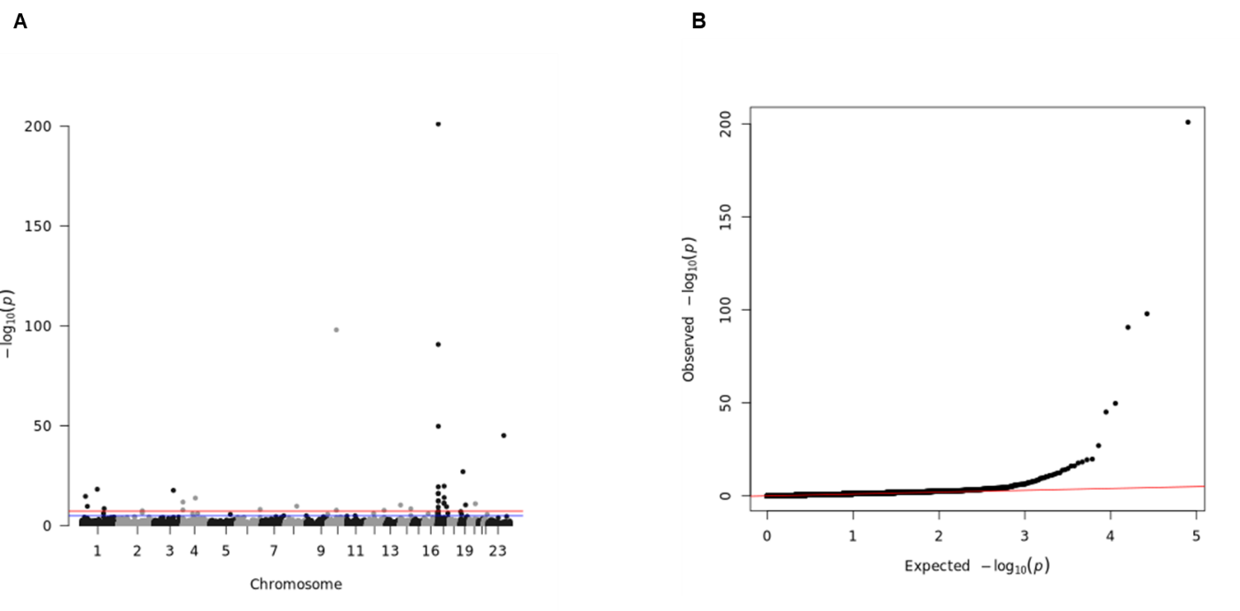

Fig S24. Manhattan plot and Q-Q plot for the single-variant association test for TBIL in the WES base reference dataset (UKB). (A) Manhattan plot. Blue line represents significance threshold at P-value < 0.05. Red line represents genome-wide significance threshold at P-value < 5E-08. (B) Q-Q plot.

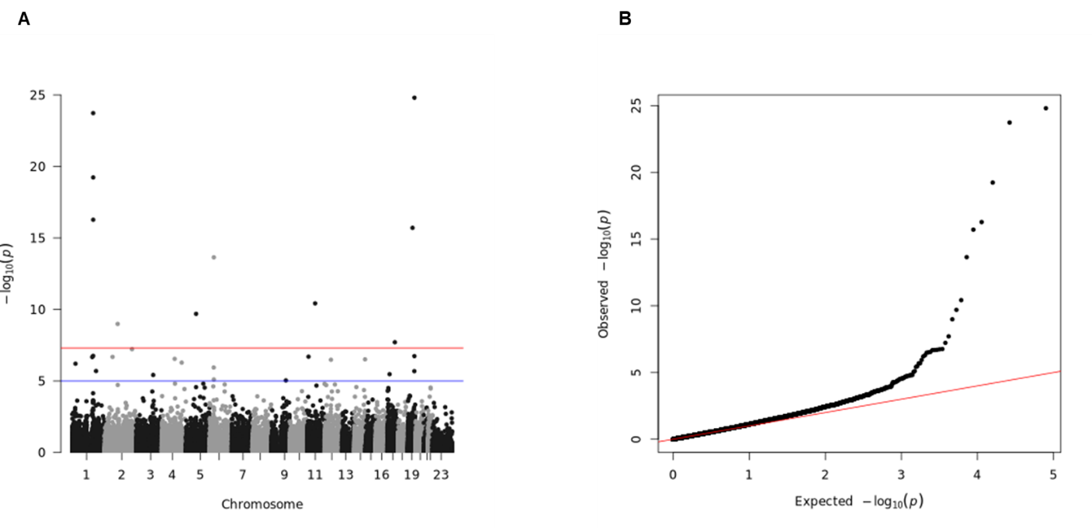

Fig S25. Manhattan plot and Q-Q plot for the single-variant association test for TPROT in the WES base reference dataset (UKB). (A) Manhattan plot. Blue line represents significance threshold at P-value < 0.05. Red line represents genome-wide significance threshold at P-value < 5E-08. (B) Q-Q plot.

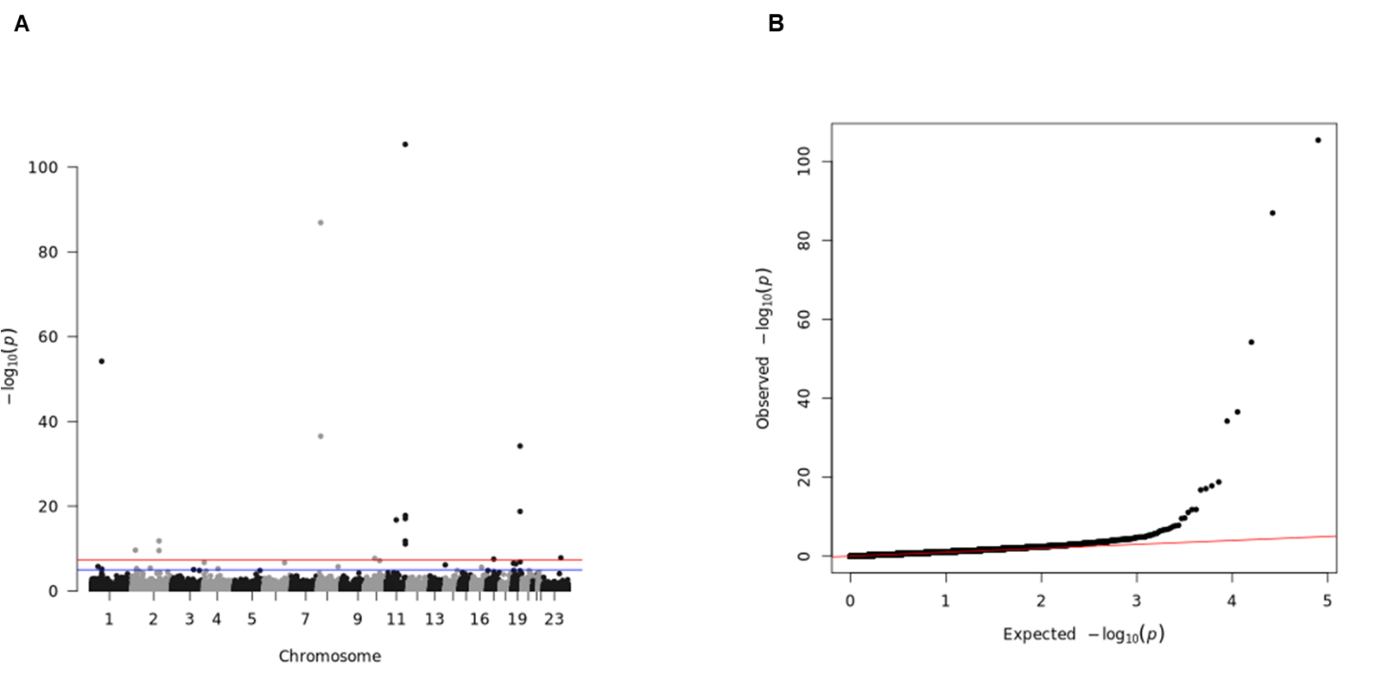

Fig S26. Manhattan plot and Q-Q plot for the single-variant association test for TRIG in the WES base reference dataset (UKB). (A) Manhattan plot. Blue line represents significance threshold at P-value < 0.05. Red line represents genome-wide significance threshold at P-value < 5E-08. (B) Q-Q plot.

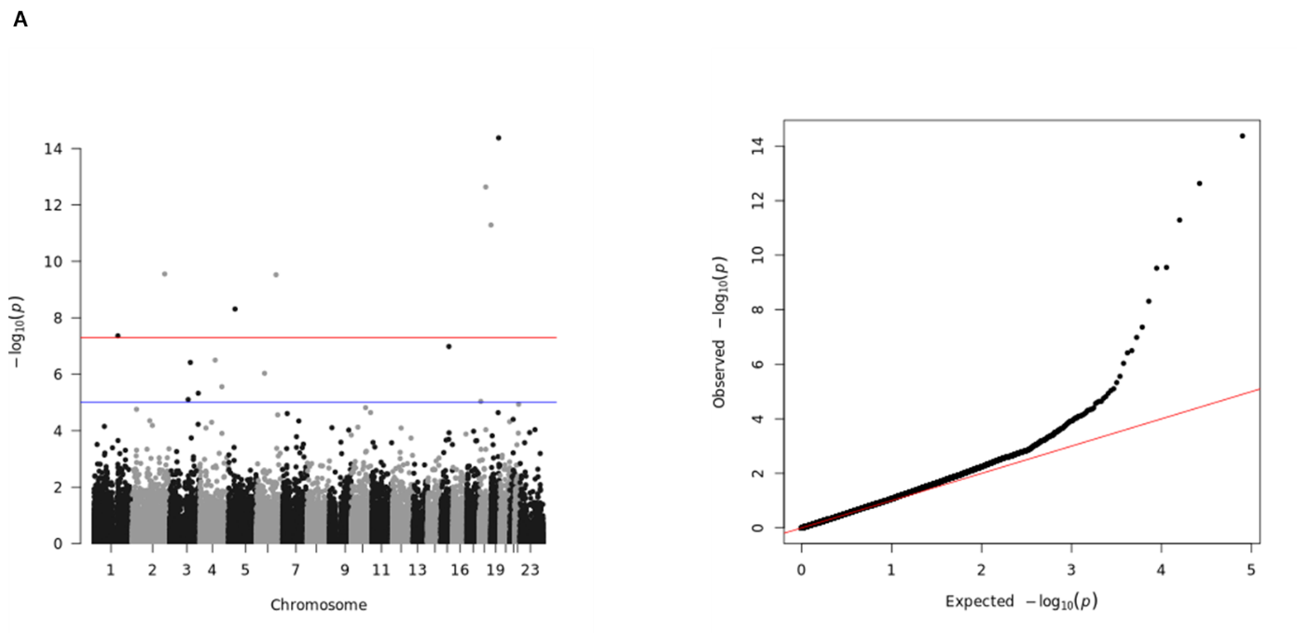

Fig S27. Manhattan plot and Q-Q plot for the single-variant association test for URA in the WES base reference dataset (UKB). (A) Manhattan plot. Blue line represents significance threshold at P-value < 0.05. Red line represents genome-wide significance threshold at P-value < 5E-08. (B) Q-Q plot.

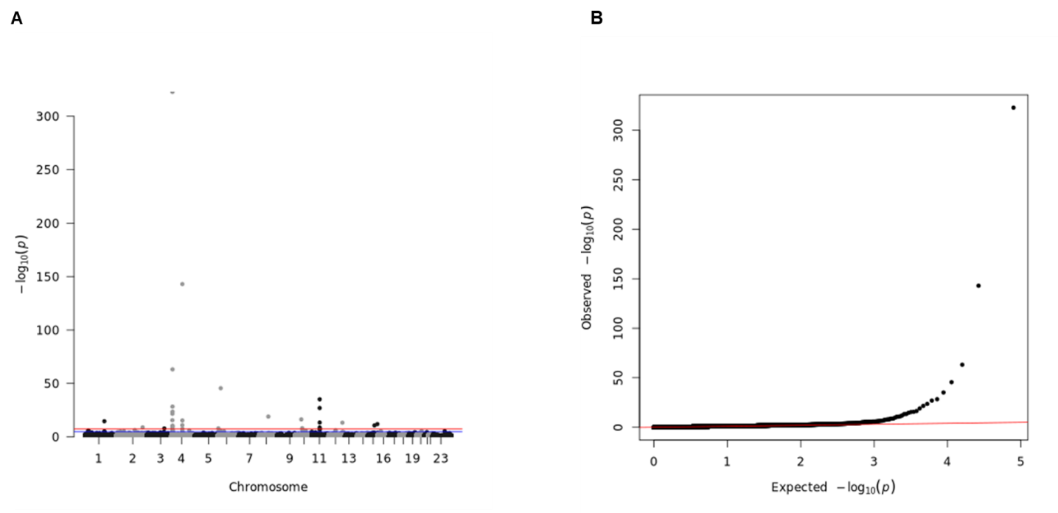

Fig S28. Manhattan plot and Q-Q plot for the single-variant association test for URT in the WES array base reference dataset (UKB). (A) Manhattan plot. Blue line represents significance threshold at P-value < 0.05. Red line represents genome-wide significance threshold at P-value < 5E-08. (B) Q-Q plot.

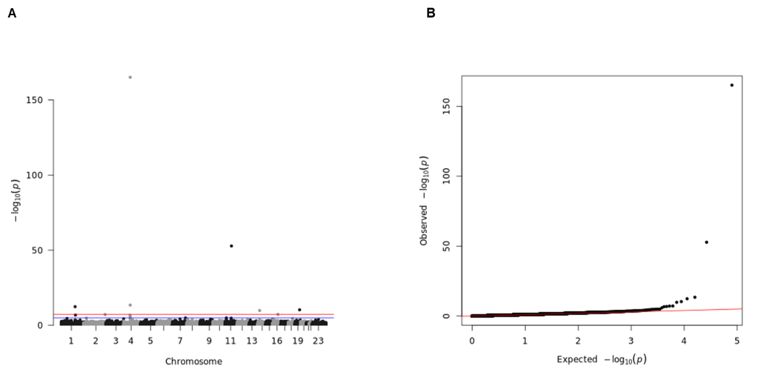

Fig S29. Manhattan plot and Q-Q plot for the single-variant association test for VITD in the WES base reference dataset (UKB). (A) Manhattan plot. Blue line represents significance threshold at P-value < 0.05. Red line represents genome-wide significance threshold at P-value < 5E-08. (B) Q-Q plot.

Fig S30. Circular representation of significant associations mapped to genes obtained from the array-based dataset (UKB). Each dot corresponds to an associated SNPs (maped locus or gene). Larger dots highlights pleiotropic associations or same associated SNP across traits. Top left includes a bar plot of the number of associations per biomarker panel. Figure related to Figure 3.

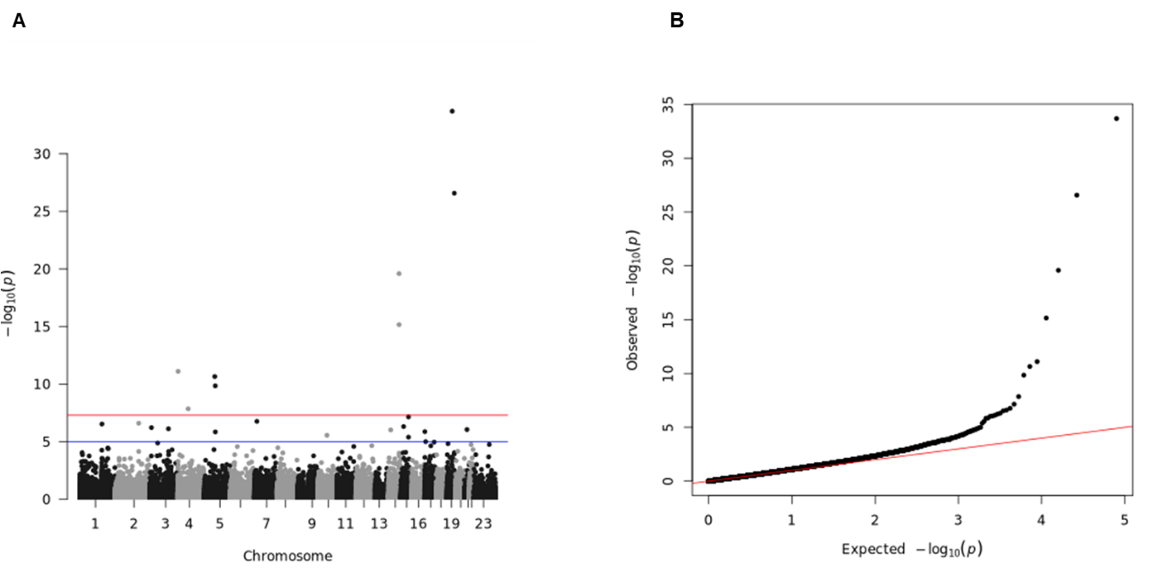

Fig S31. Manhattan plot and Q-Q plot for the single-variant association test for ALB in the imputed genotype array base reference dataset (UKB). (A) Manhattan plot. Blue line represents significance threshold at P-value < 0.05. Red line represents genome-wide significance threshold at P-value < 5E-08. (B) Q-Q plot. Figure related to Figure 5.

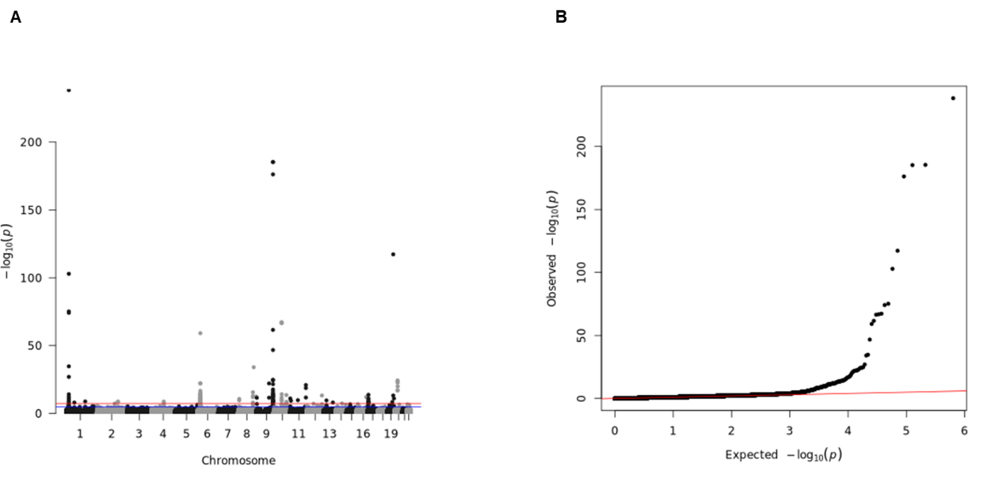

Fig S32. Manhattan plot and Q-Q plot for the single-variant association test for ALP in the imputed genotype array base reference dataset (UKB). (A) Manhattan plot. Blue line represents significance threshold at P-value < 0.05. Red line represents genome-wide significance threshold at P-value < 5E-08. (B) Q-Q plot.

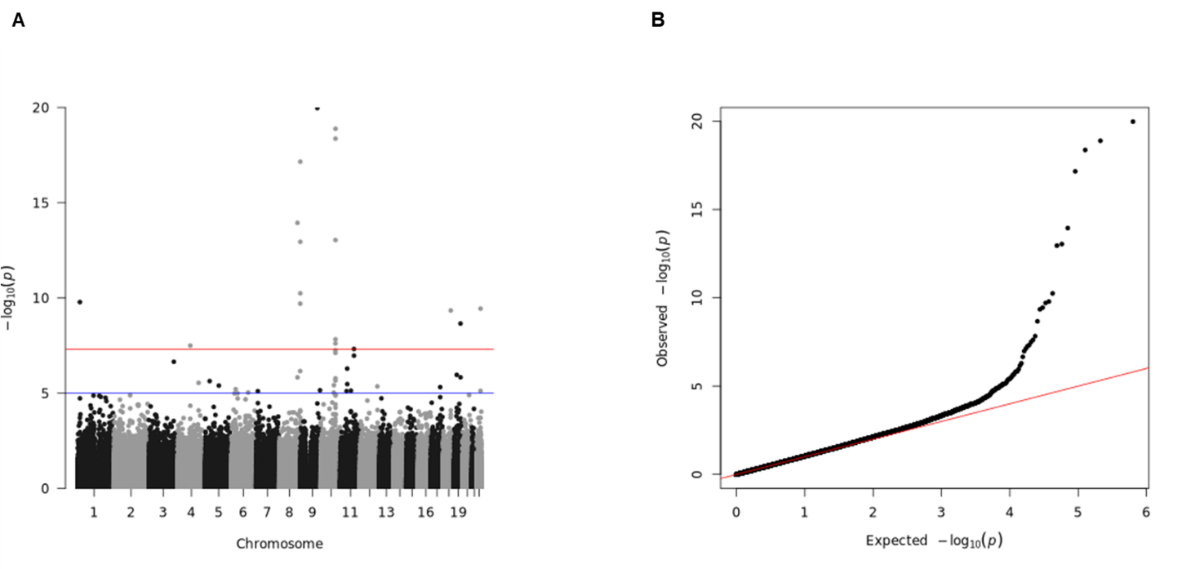

Fig S33. Manhattan plot and Q-Q plot for the single-variant association test for ALT in the imputed genotype array base reference dataset (UKB). (A) Manhattan plot. Blue line represents significance threshold at P-value < 0.05. Red line represents genome-wide significance threshold at P-value < 5E-08. (B) Q-Q plot.

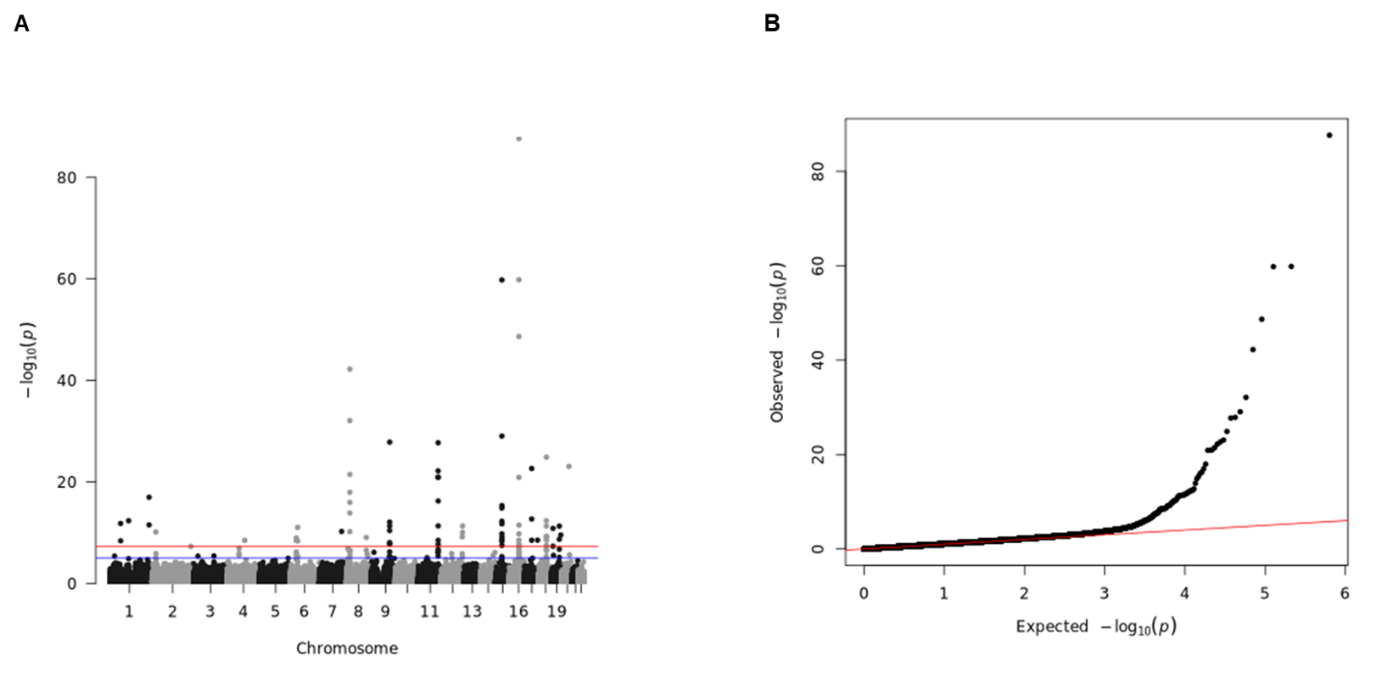

Fig S34. Manhattan plot and Q-Q plot for the single-variant association test for APOA in the imputed genotype array base reference dataset (UKB). (A) Manhattan plot. Blue line represents significance threshold at P-value < 0.05. Red line represents genome-wide significance threshold at P-value < 5E-08. (B) Q-Q plot.

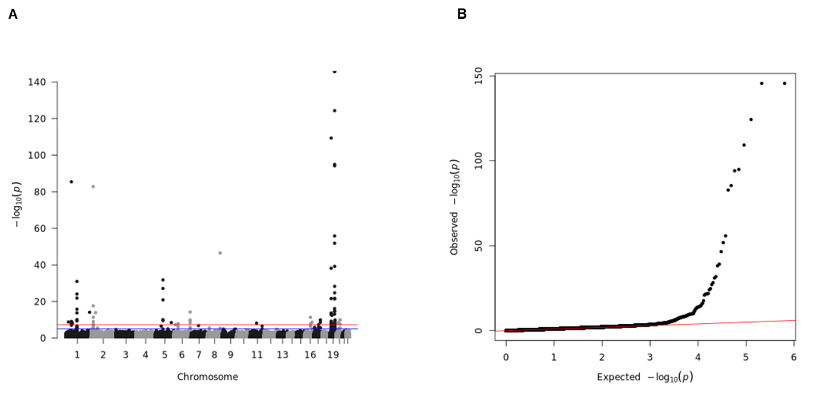

Fig S35. Manhattan plot and Q-Q plot for the single-variant association test for APOB in the imputed genotype array base reference dataset (UKB). (A) Manhattan plot. Blue line represents significance threshold at P-value < 0.05. Red line represents genome-wide significance threshold at P-value < 5E-08. (B) Q-Q plot.

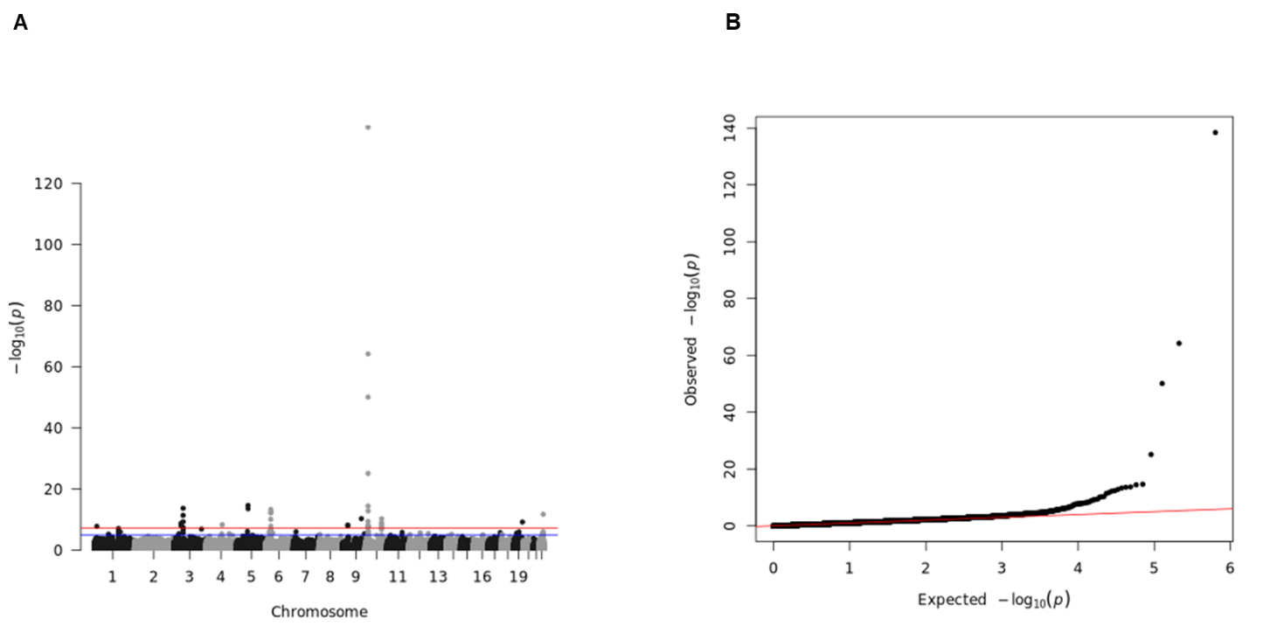
Fig S36. Manhattan plot and Q-Q plot for the single-variant association test for AST in the imputed genotype array base reference dataset (UKB). (A) Manhattan plot. Blue line represents significance threshold at P-value < 0.05. Red line represents genome-wide significance threshold at P-value < 5E-08. (B) Q-Q plot.

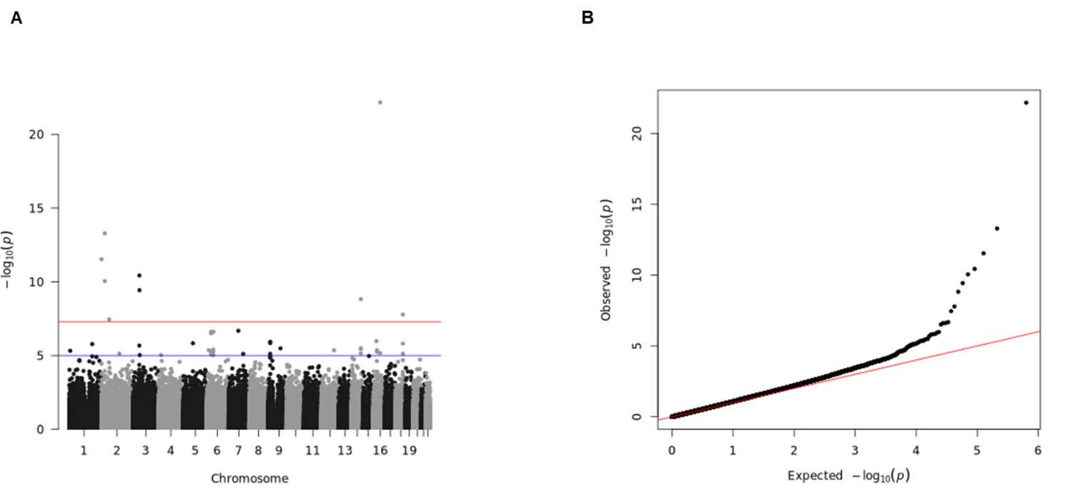

Fig S37. Manhattan plot and Q-Q plot for the single-variant association test for BMI in the imputed genotype array base reference dataset (UKB). (A) Manhattan plot. Blue line represents significance threshold at P-value < 0.05. Red line represents genome-wide significance threshold at P-value < 5E-08. (B) Q-Q plot.

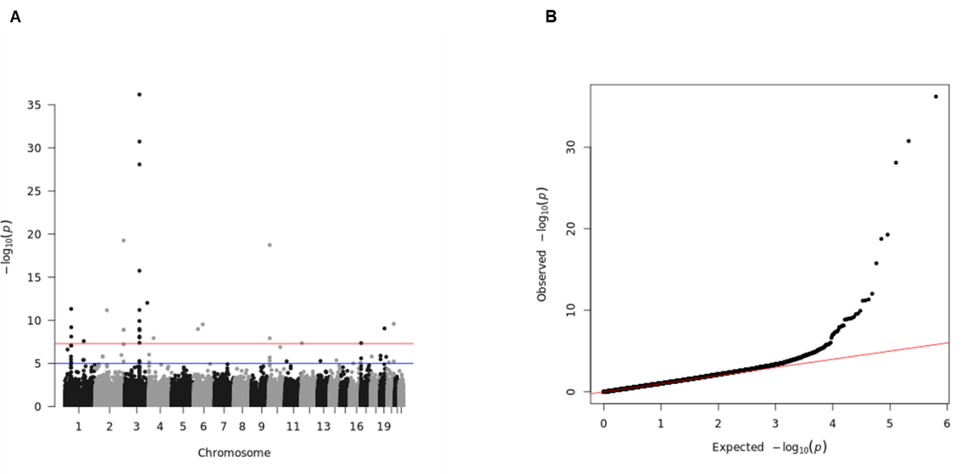

Fig S38. Manhattan plot and Q-Q plot for the single-variant association test for CAL in the imputed genotype array base reference dataset (UKB). (A) Manhattan plot. Blue line represents significance threshold at P-value < 0.05. Red line represents genome-wide significance threshold at P-value < 5E-08. (B) Q-Q plot.

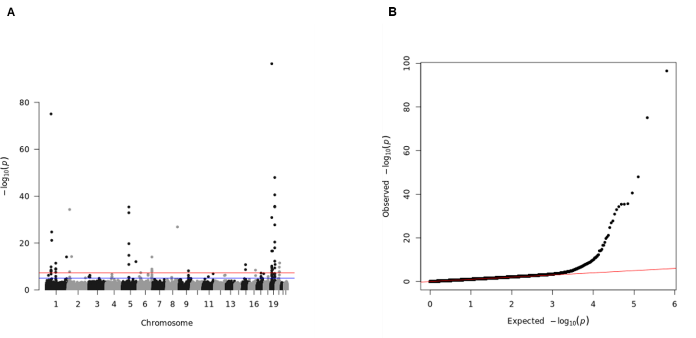

Fig S39. Manhattan plot and Q-Q plot for the single-variant association test for CHO in the imputed genotype array base reference dataset (UKB). (A) Manhattan plot. Blue line represents significance threshold at P-value < 0.05. Red line represents genome-wide significance threshold at P-value < 5E-08. (B) Q-Q plot.

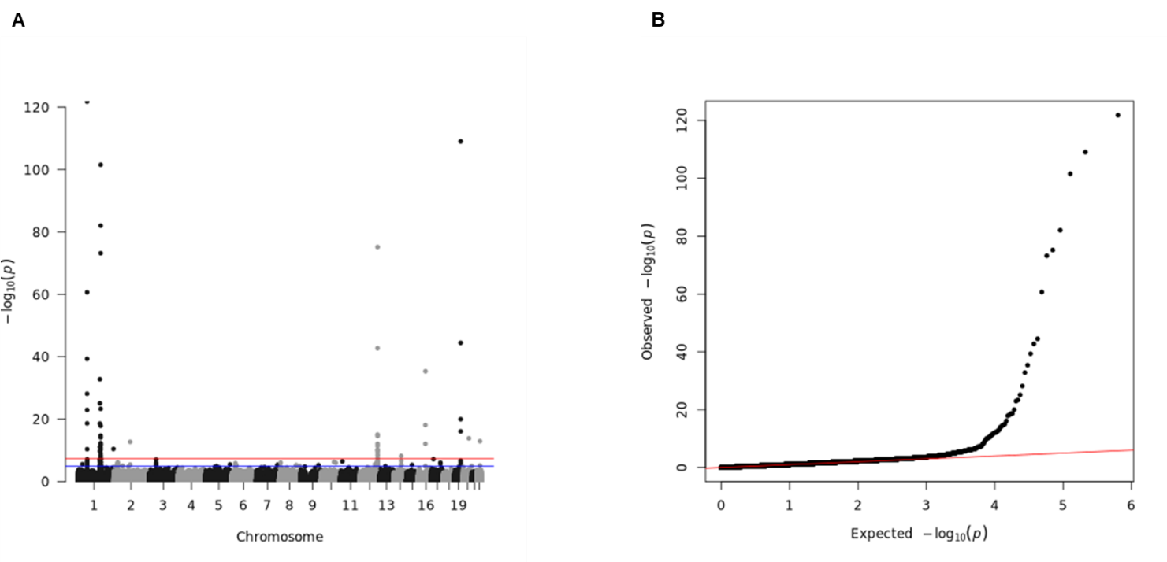

Fig S40. Manhattan plot and Q-Q plot for the single-variant association test for CRP in the imputed genotype array base reference dataset (UKB). (A) Manhattan plot. Blue line represents significance threshold at P-value < 0.05. Red line represents genome-wide significance threshold at P-value < 5E-08. (B) Q-Q plot.

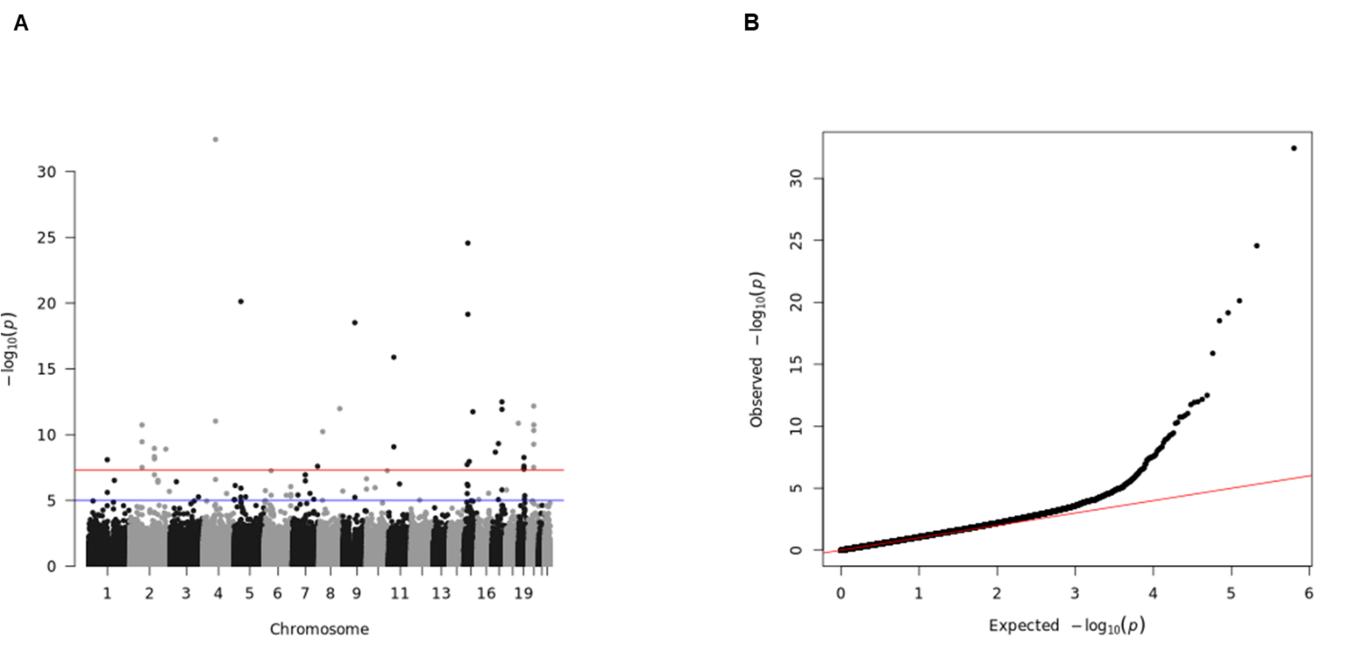

Fig S41. Manhattan plot and Q-Q plot for the single-variant association test for CREA in the imputed genotype array base reference dataset (UKB). (A) Manhattan plot. Blue line represents significance threshold at P-value < 0.05. Red line represents genome-wide significance threshold at P-value < 5E-08. (B) Q-Q plot.

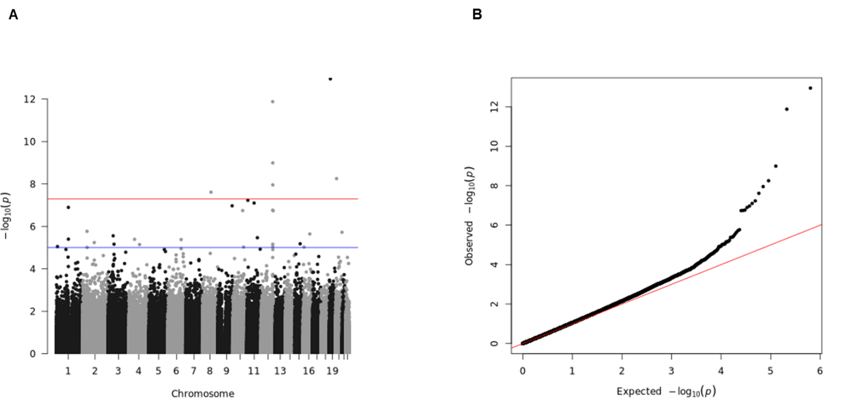

Fig S42. Manhattan plot and Q-Q plot for the single-variant association test for DBP in the imputed genotype array base reference dataset (UKB). (A) Manhattan plot. Blue line represents significance threshold at P-value < 0.05. Red line represents genome-wide significance threshold at P-value < 5E-08. (B) Q-Q plot.

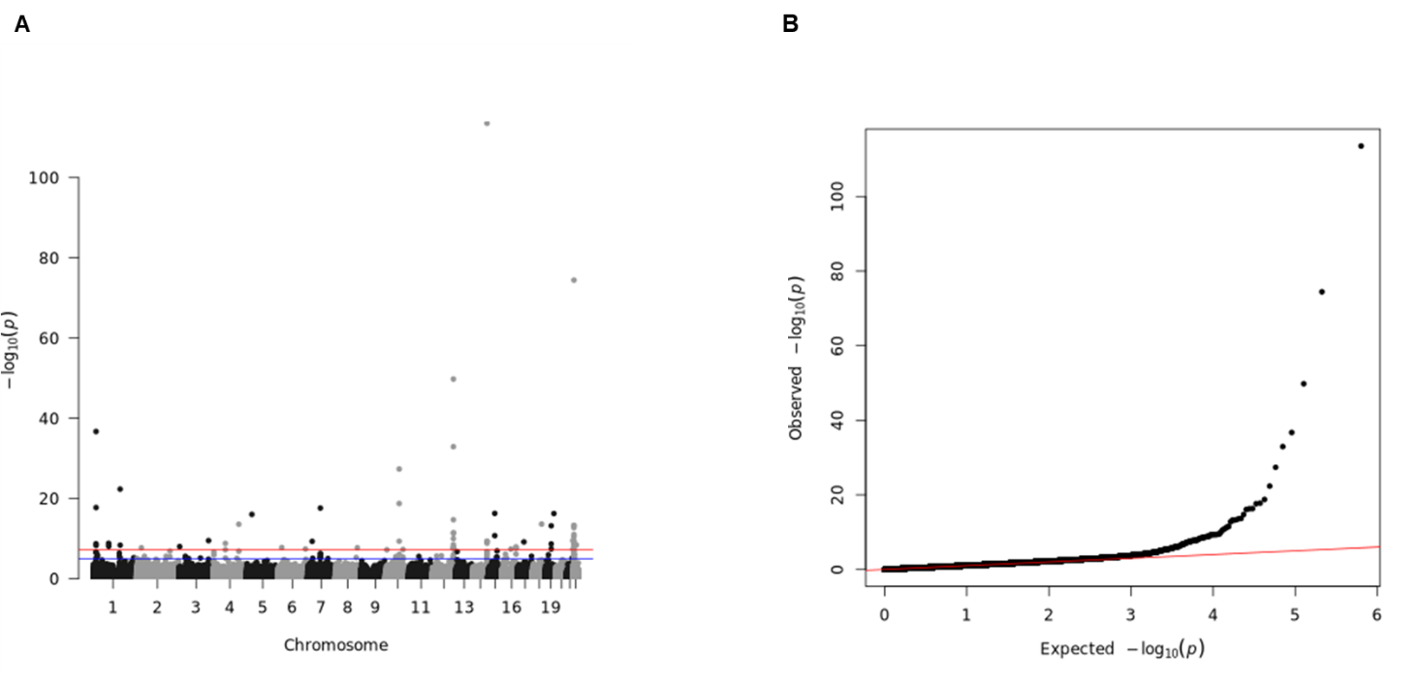

Fig S43. Manhattan plot and Q-Q plot for the single-variant association test for GGT in the imputed genotype array base reference dataset (UKB). (A) Manhattan plot. Blue line represents significance threshold at P-value < 0.05. Red line represents genome-wide significance threshold at P-value < 5E-08. (B) Q-Q plot.

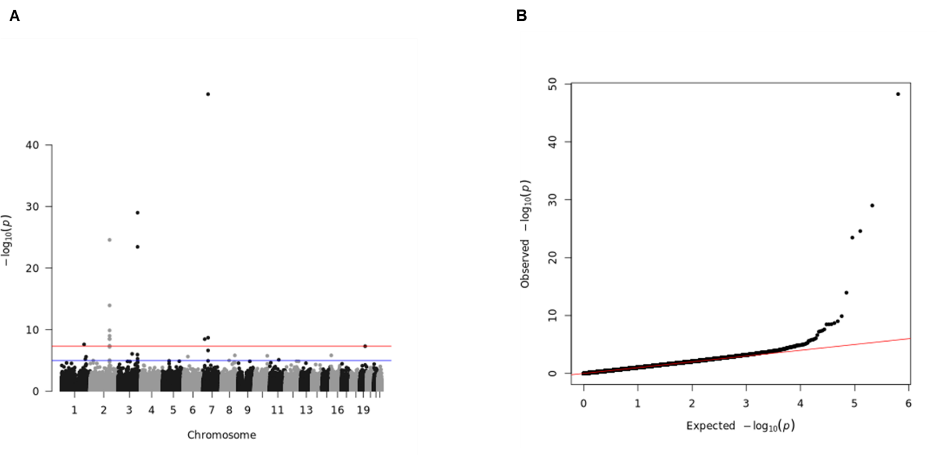

Fig S44. Manhattan plot and Q-Q plot for the single-variant association test for GLUC in the imputed genotype array base reference dataset (UKB). (A) Manhattan plot. Blue line represents significance threshold at P-value < 0.05. Red line represents genome-wide significance threshold at P-value < 5E-08. (B) Q-Q plot.

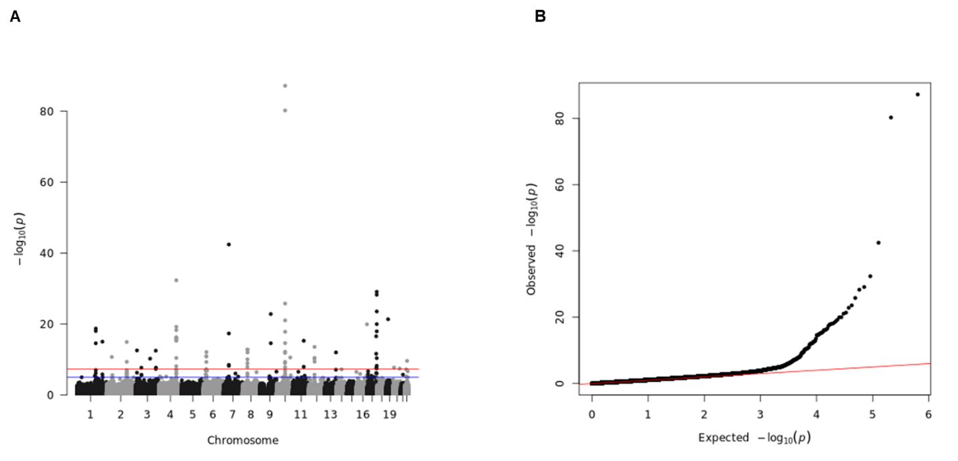

Fig S45. Manhattan plot and Q-Q plot for the single-variant association test for HBA1C in the imputed genotype array base reference dataset (UKB). (A) Manhattan plot. Blue line represents significance threshold at P-value < 0.05. Red line represents genome-wide significance threshold at P-value < 5E-08. (B) Q-Q plot.

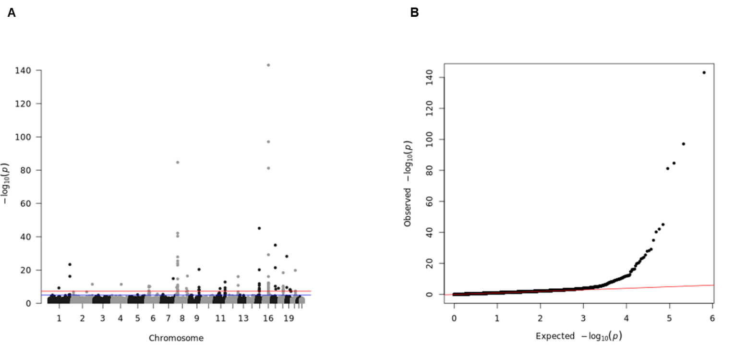

Fig S46. Manhattan plot and Q-Q plot for the single-variant association test for HDL in the imputed genotype array base reference dataset (UKB). (A) Manhattan plot. Blue line represents significance threshold at P-value < 0.05. Red line represents genome-wide significance threshold at P-value < 5E-08. (B) Q-Q plot.

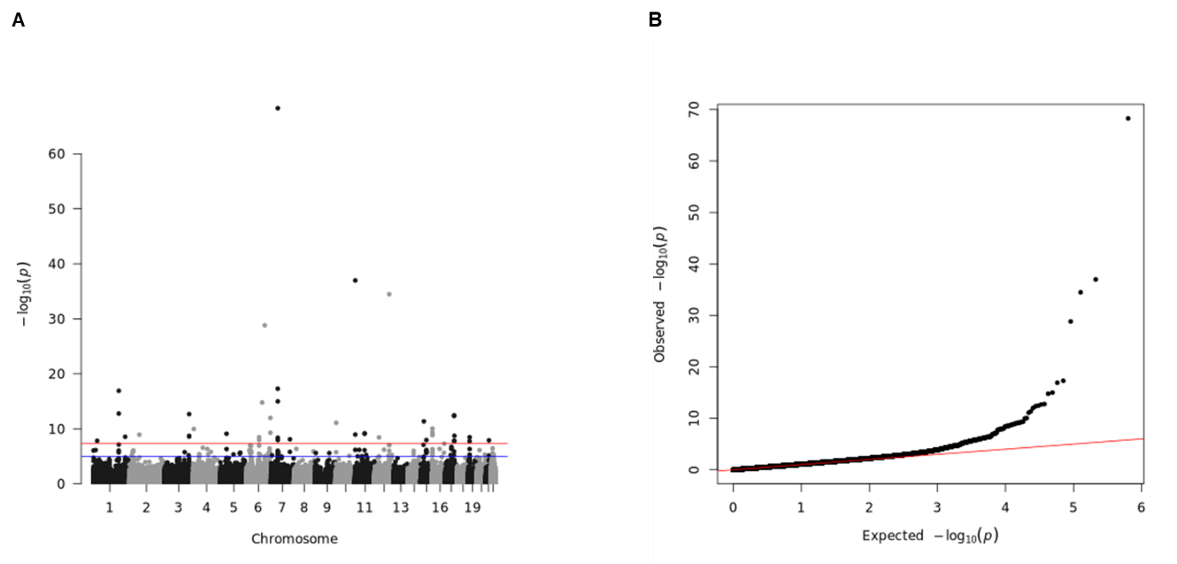

Fig S47. Manhattan plot and Q-Q plot for the single-variant association test for IGF1 in the imputed genotype array base reference dataset (UKB). (A) Manhattan plot. Blue line represents significance threshold at P-value < 0.05. Red line represents genome-wide significance threshold at P-value < 5E-08. (B) Q-Q plot.

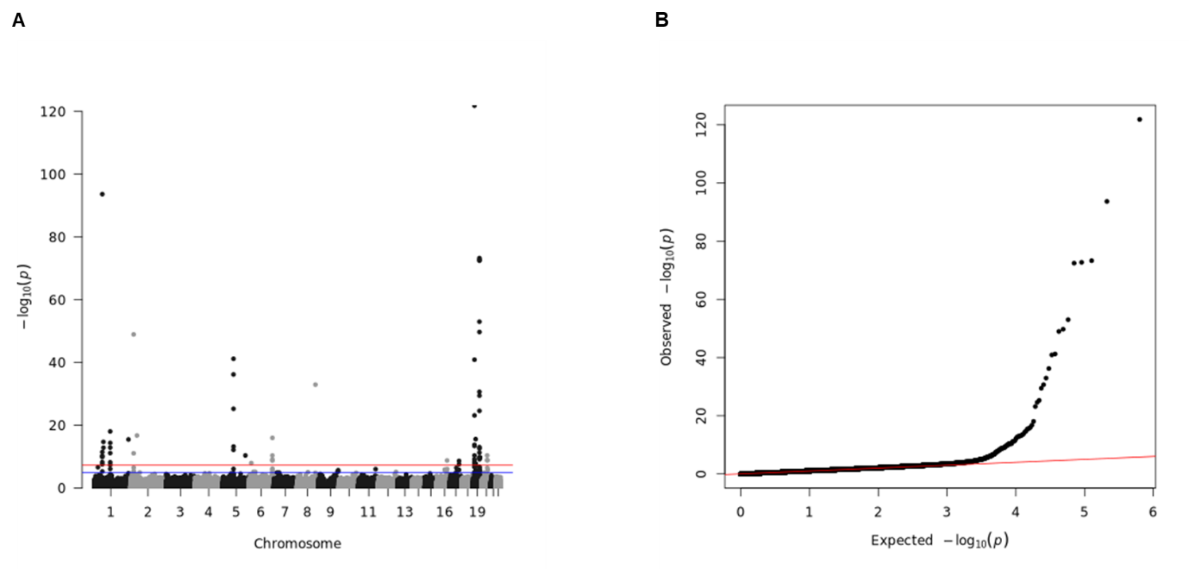

Fig S48. Manhattan plot and Q-Q plot for the single-variant association test for LDL in the imputed genotype array base reference dataset (UKB). (A) Manhattan plot. Blue line represents significance threshold at P-value < 0.05. Red line represents genome-wide significance threshold at P-value < 5E-08. (B) Q-Q plot.

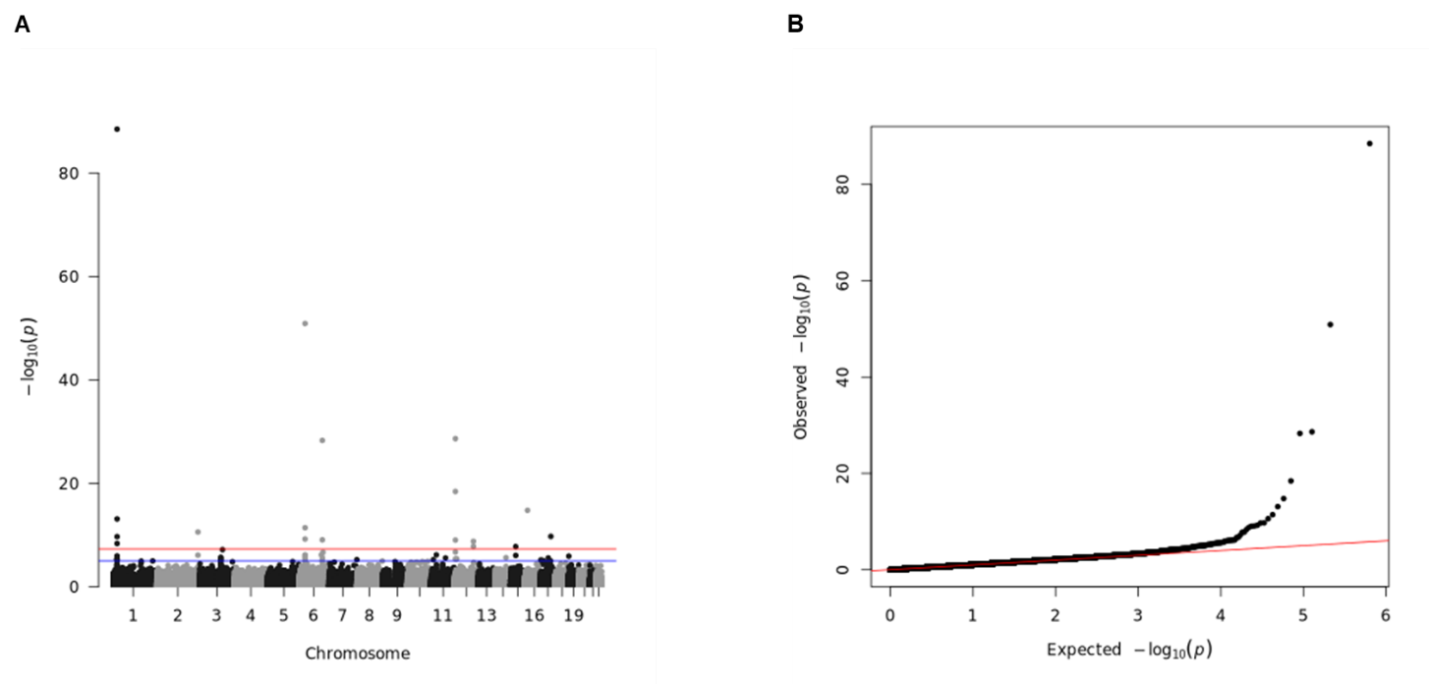

Fig S49. Manhattan plot and Q-Q plot for the single-variant association test for PHOS in the imputed genotype array base reference dataset (UKB). (A) Manhattan plot. Blue line represents significance threshold at P-value < 0.05. Red line represents genome-wide significance threshold at P-value < 5E-08. (B) Q-Q plot.

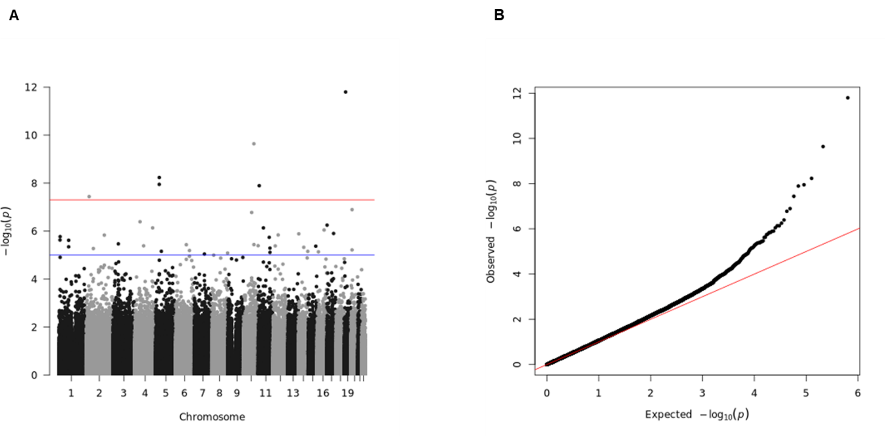

Fig S50. Manhattan plot and Q-Q plot for the single-variant association test for SBP in the imputed genotype array base reference dataset (UKB). (A) Manhattan plot. Blue line represents significance threshold at P-value < 0.05. Red line represents genome-wide significance threshold at P-value < 5E-08. (B) Q-Q plot.

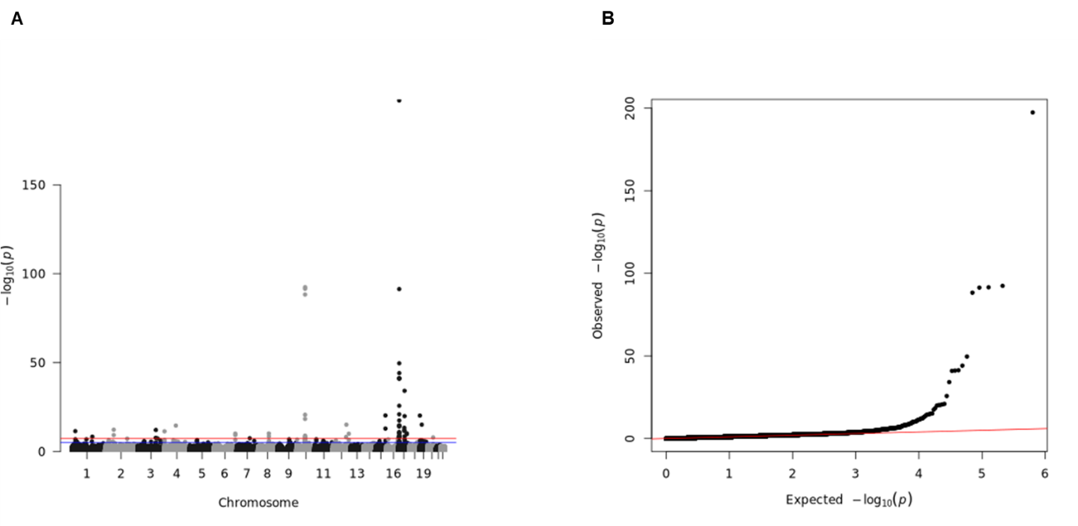

Fig S51. Manhattan plot and Q-Q plot for the single-variant association test for SHBG in the imputed genotype array base reference dataset (UKB). (A) Manhattan plot. Blue line represents significance threshold at P-value < 0.05. Red line represents genome-wide significance threshold at P-value < 5E-08. (B) Q-Q plot.

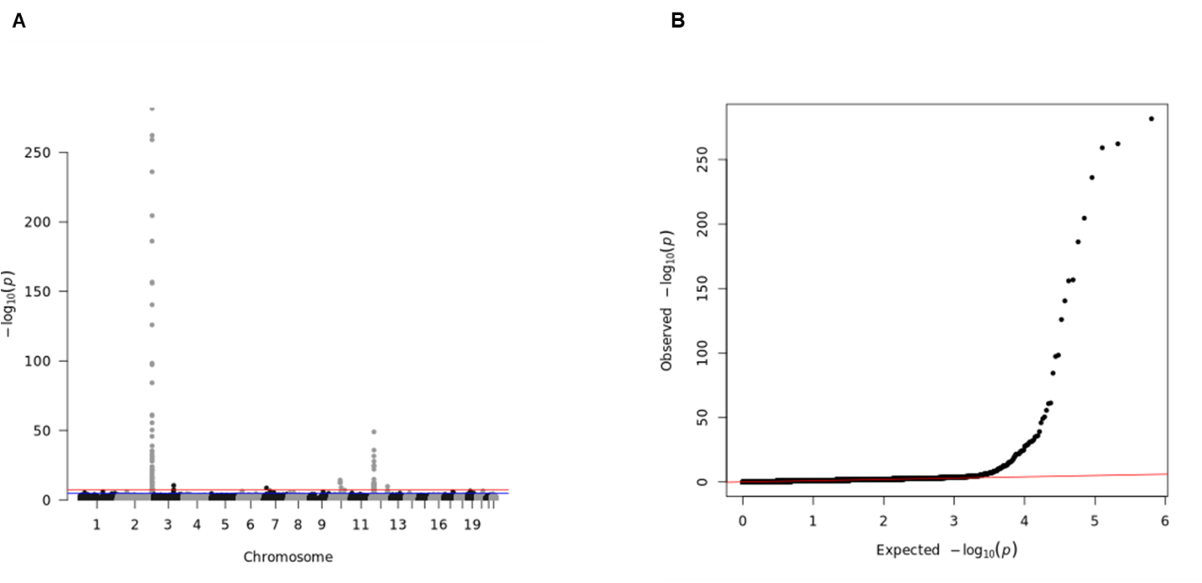

Fig S52. Manhattan plot and Q-Q plot for the single-variant association test for TBIL in the imputed genotype array base reference dataset (UKB). (A) Manhattan plot. Blue line represents significance threshold at P-value < 0.05. Red line represents genome-wide significance threshold at P-value < 5E-08. (B) Q-Q plot.

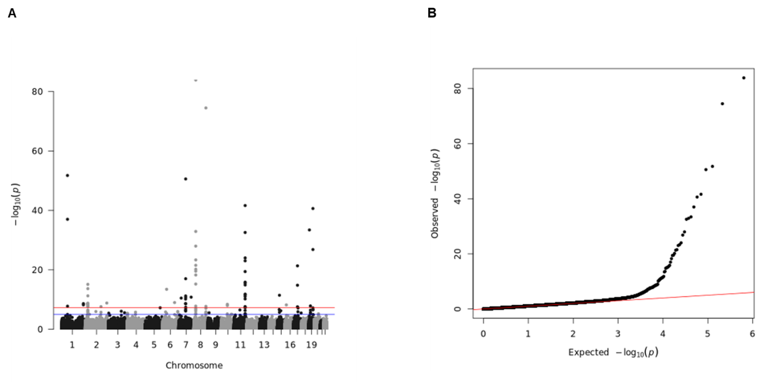

Fig S53. Manhattan plot and Q-Q plot for the single-variant association test for TRIG in the imputed genotype array base reference dataset (UKB). (A) Manhattan plot. Blue line represents significance threshold at P-value < 0.05. Red line represents genome-wide significance threshold at P-value < 5E-08.(B) Q-Q plot.

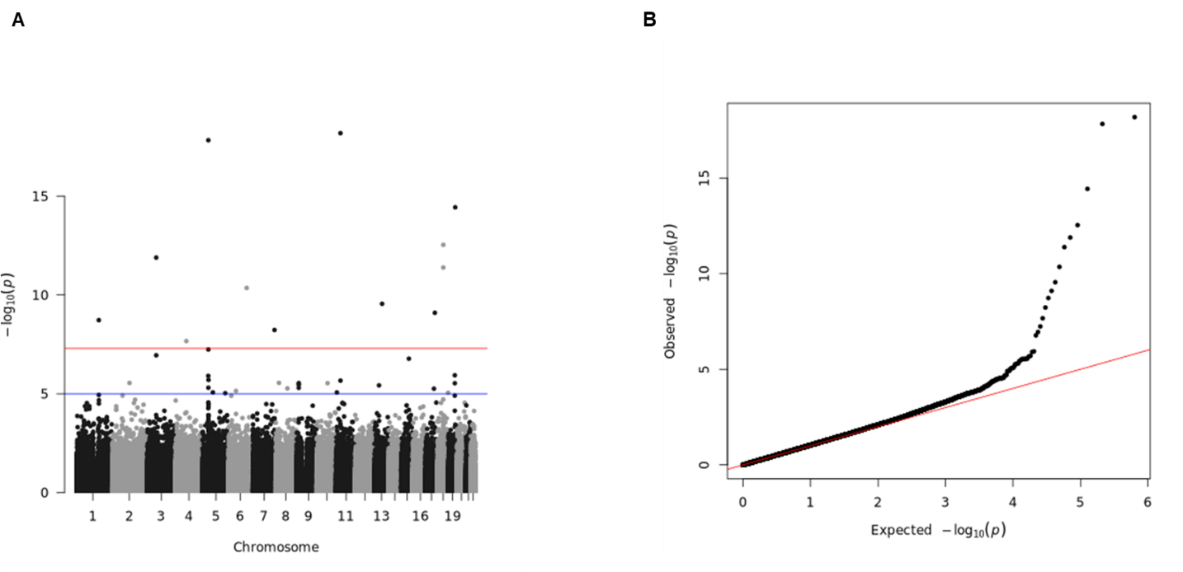

Fig S54. Manhattan plot and Q-Q plot for the single-variant association test for URA in the imputed genotype array base reference dataset (UKB). (A) Manhattan plot. Blue line represents significance threshold at P-value < 0.05. Red line represents genome-wide significance threshold at P-value < 5E-08. (B) Q-Q plot.

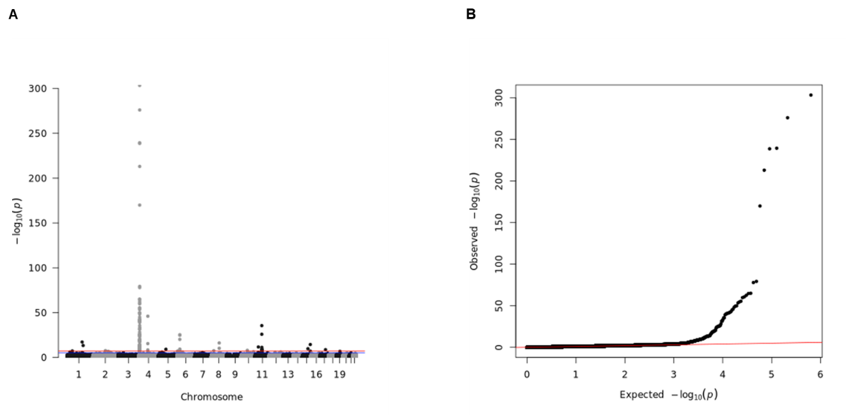

Fig S55. Manhattan plot and Q-Q plot for the single-variant association test for URT in the imputed genotype array base reference dataset (UKB). (A) Manhattan plot. Blue line represents significance threshold at P-value < 0.05. Red line represents genome-wide significance threshold at P-value < 5E-08. (B) Q-Q plot.

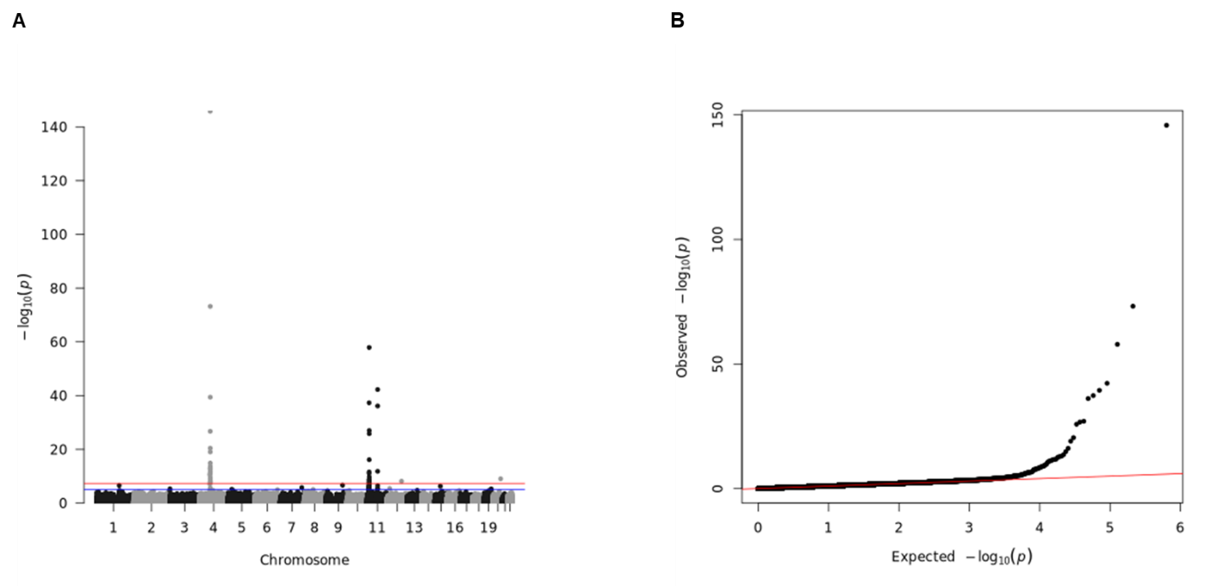

Fig S56. Manhattan plot and Q-Q plot for the single-variant association test for VITD in the imputed genotype array base reference dataset (UKB). (A) Manhattan plot. Blue line represents significance threshold at P-value < 0.05. Red line represents genome-wide significance threshold at P-value < 5E-08. (B) Q-Q plot.

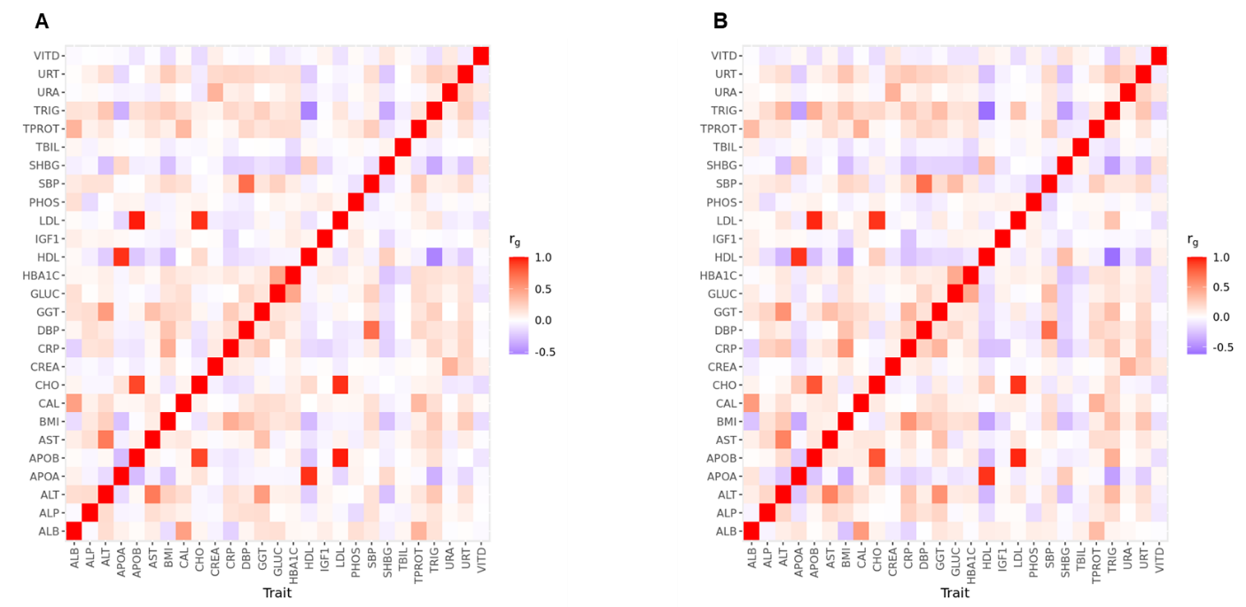

Figure S57. Genetic correlation between traits using the individual-level genotype data of the reference base datasets (UKB) using SCORE. (A) WES base dataset. (B) Imputed genotype array base dataset. No differences were observed between platforms (t-test P-value = 0.81).

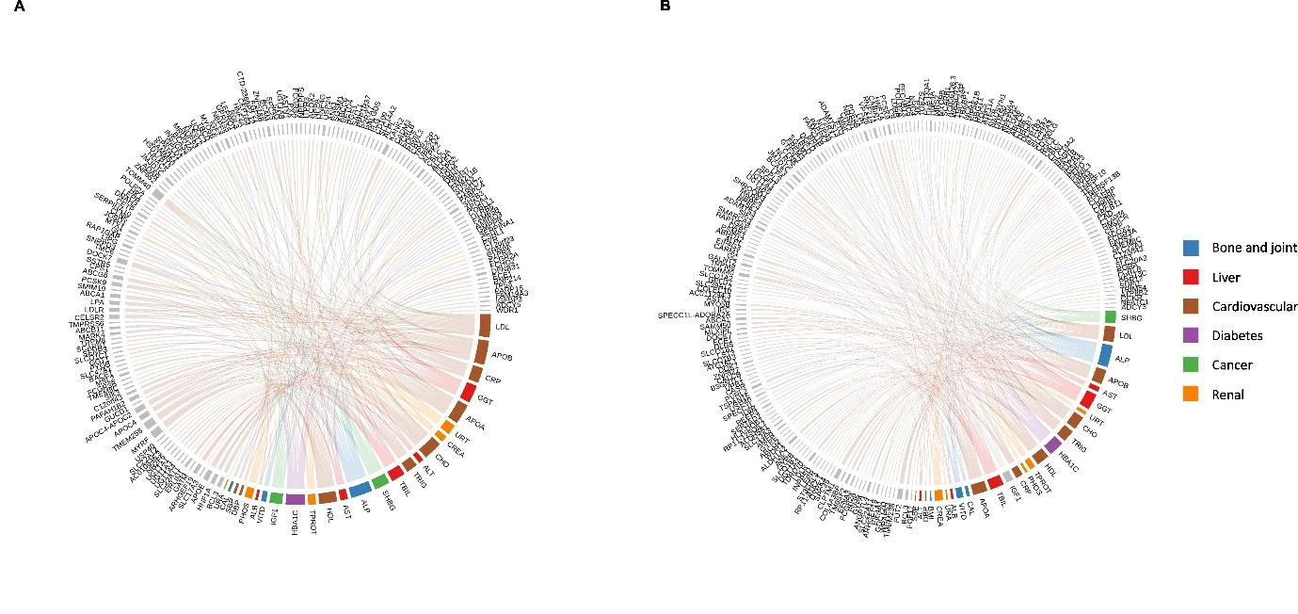

Figure S58. Circular representation of the association results obtained from MAGMA using FUMA. (A) Chord diagram for the WES base dataset at Bonferroni P-value < 3.36E-08. (B) Chord diagrams of the imputed genotype array base dataset Bonferroni P-value < 3.36E-08.

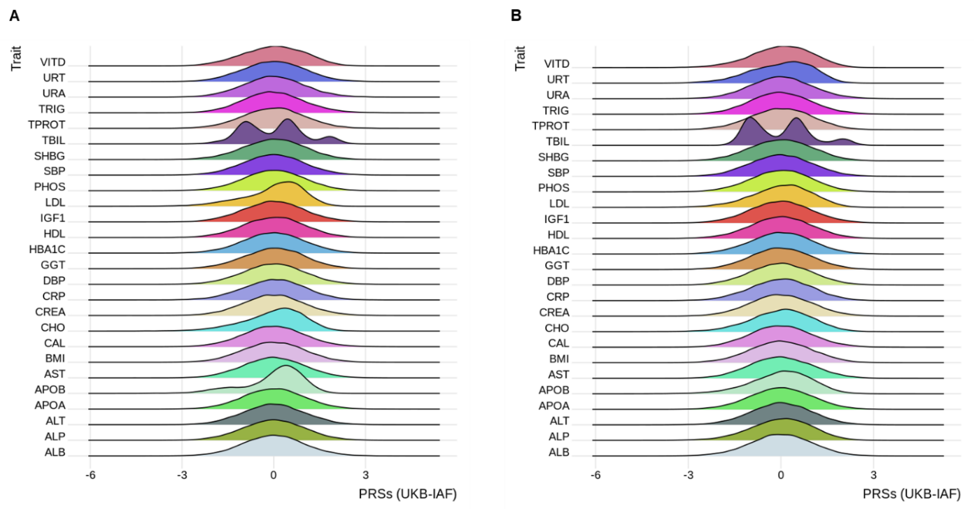

Figure S59. Distribution plots of PRSs for the merged dataset composed by the reference validation set (UKB) and the target cohort (IAF). (A) PRSs estimated using the summary statistics generated from the exome-based reference validation set. (B) PRSs estimated using the summary statistics generated from the imputed array-based refence validation set.

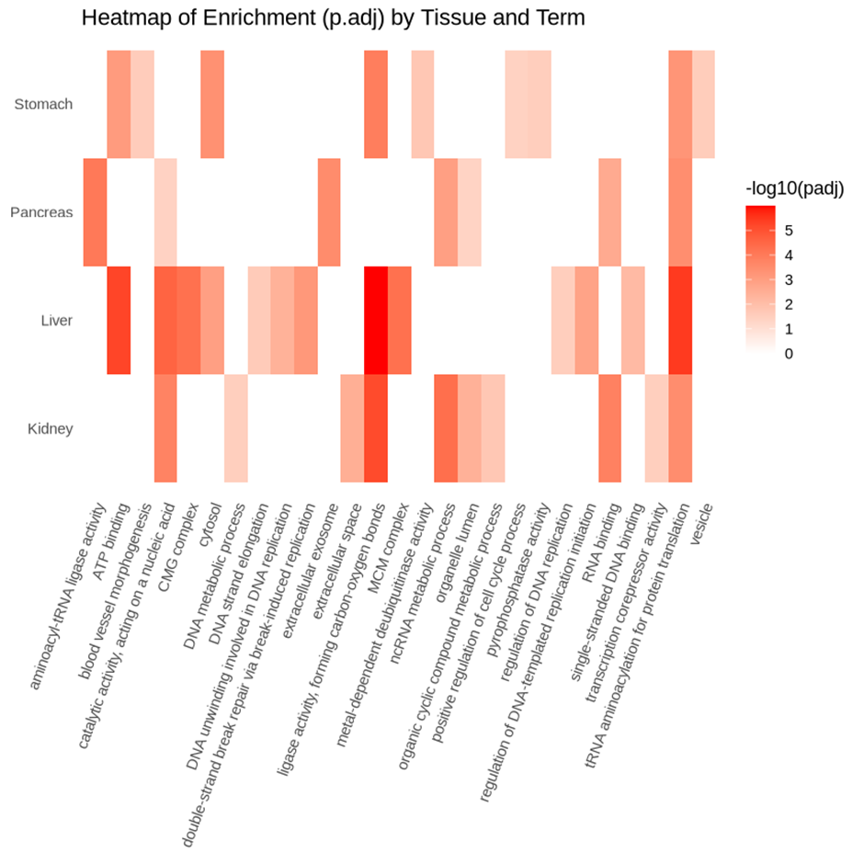

Figure S60. Heatmap from the enrichment analysis on the generated tissue-specific networks.

Supplementary Tables

Table S1. Overview of the clinical biomarkers and disease outcomes analyzed in this study. Definition of the 24 blood biochemistry measurements and three physical measurements used for genetic analyses and polygenic risk modeling, and 17 disease outcomes for association analyses with genetic risk scores and causal inference.

Phenotypes | Identifiers | Type | Panel
Albumin | ALB | Blood biochemistry measurement | Liver
Alkaline phosphatase | ALP | Blood biochemistry measurement | Liver
Alanine transferase | ALT | Blood biochemistry measurement | Liver
Apolipoprotein A | APOA | Blood biochemistry measurement | Cardiovascular
Apolipoprotein B | APOB | Blood biochemistry measurement | Cardiovascular
Aspartate transferase | AST | Blood biochemistry measurement | Liver
Calcium | CAL | Blood biochemistry measurement | Bone and joint
Cholesterol | CHO | Blood biochemistry measurement | Cardiovascular
Creatinine | CREA | Blood biochemistry measurement | Renal
C-reactive protein | CRP | Blood biochemistry measurement | Cardiovascular
γ-Glutamyl transferase | GGT | Blood biochemistry measurement | Liver
Glucose | GLUC | Blood biochemistry measurement | Diabetes
Glycated hemoglobin | HBA1C | Blood biochemistry measurement | Diabetes
HDL cholesterol | HDL | Blood biochemistry measurement | Cardiovascular
Insulin-like growth factor 1 | IGF1 | Blood biochemistry measurement | Cancer
LDL cholesterol | LDL | Blood biochemistry measurement | Cardiovascular
Phosphate | PHOS | Blood biochemistry measurement | Renal
Sex hormone binding globulin | SHBG | Blood biochemistry measurement | Cancer
Total bilirubin | TBIL | Blood biochemistry measurement | Liver
Total protein | TPROT | Blood biochemistry measurement | Renal
Triglycerides | TRIG | Blood biochemistry measurement | Cardiovascular
Urea | URA | Blood biochemistry measurement | Renal
Urate | URT | Blood biochemistry measurement | Renal
Vitamin D | VITD | Blood biochemistry measurement | Bone and joint
Body mass index | BMI | Physical measurement | Anthropometric
Diastolic blood pressure | DBP | Physical measurement | Cardiovascular
Systolic blood pressure | SBP | Physical measurement | Cardiovascular
Depression | DEP | Disease outcome | Mental disorders
Anxiety | ANX | Disease outcome | Mental disorders
Ischemic heart disease | ISC | Disease outcome | Cardiovascular disease
Myocardial infarction | MYO | Disease outcome | Cardiovascular disease
Angina pectoris | ANG | Disease outcome | Cardiovascular disease
Coronary atherosclerosis | CAD | Disease outcome | Cardiovascular disease
Hypertension | HYP | Disease outcome | Cardiovascular disease
Chronic obstructive pulmonary disease | COPD | Disease outcome | Respiratory disease
Breast cancer | BREAST | Disease outcome | Cancer
Prostate cancer | PROST | Disease outcome | Cancer
Osteoarthrosis | OA | Disease outcome | Musculoskeletal
Rheumatoid arthritis | RA | Disease outcome | Musculoskeletal
Dorsopathies | BPAIN | Disease outcome | Musculoskeletal
Cervicalgia | NPAIN | Disease outcome | Musculoskeletal
Type 2 diabetes | T2D | Disease outcome | Diabetes
Obesity | OBS | Disease outcome | Overweight
Pneumonia and influenza-related pneumonia | FLU | Disease outcome | Infectious disease

Table S2. Summary of baseline characteristics for the reference and target cohorts. Overview of the cohorts used in this study. The UK Biobank (N=105,506; quality-controlled) was used as a reference cohort for genetic analyses of clinical biomarkers and estimation of polygenic risk scores. The VITO IAM Frontier (N = 30) study was used as a target cohort for prediction of polygenic risk scores, using a hold-out set from the reference cohort.

Gender | Mean age | Minimum | Maximum | Count | Cohort
Female | 56.48 | 40 | 70 | 64016 | UKB (European-British QC)
Male | 55.72 | 39 | 72 | 41490 | UKB (European-British QC)
Female | 50.67 | 45 | 58 | 15 | IAF
Male | 50.80 | 45 | 58 | 15 | IAF

Table S3. Summary of the biomarker measurements used in this study (reference dataset). Summary statistics of 27 clinical biomarker measurements from the UK Biobank.

Measurement | Units | UKB Data field | Mean | SD | Minimum | Maximum
ALB | gL-1 | 30600 | 45.25 | 2.55 | 28.13 | 59.46
ALP | UL-1 | 30610 | 83.19 | 24.46 | 8.00 | 903.70
ALT | UL-1 | 30620 | 22.55 | 13.21 | 3.01 | 403.91
APOA | gL-1 | 30630 | 1.56 | 0.27 | 0.42 | 2.50
APOB | gL-1 | 30640 | 1.03 | 0.21 | 0.40 | 1.92
AST | UL-1 | 30650 | 25.64 | 9.44 | 4.10 | 400.60
CAL | mmolL-1 | 30680 | 2.38 | 0.09 | 1.60 | 3.57
CHO | mmolL-1 | 30690 | 5.74 | 0.94 | 2.29 | 9.95
CREA | umolL-1 | 30700 | 71.07 | 14.75 | 16.50 | 723.90
CRP | mgL-1 | 30710 | 2.53 | 4.22 | 0.08 | 78.17
GGT | UL-1 | 30730 | 34.23 | 36.20 | 5.00 | 1165.90
GLUC | mmolL-1 | 30740 | 5.04 | 0.98 | 1.30 | 27.19
HBA1C | mmolmol-1 | 30750 | 35.31 | 5.48 | 15.30 | 213.90
HDL | mmolL-1 | 30760 | 1.48 | 0.36 | 0.35 | 3.61
IGF1 | nmolL-1 | 30770 | 21.52 | 5.60 | 2.02 | 108.44
LDL | mmolL-1 | 30780 | 3.59 | 0.74 | 0.81 | 6.68
PHOS | mmolL-1 | 30810 | 1.17 | 0.16 | 0.46 | 4.70
SHBG | nmolL-1 | 30830 | 53.78 | 28.11 | 0.47 | 241.92
TBIL | umolL-1 | 30840 | 9.01 | 4.33 | 1.08 | 66.04
TPROT | gL-1 | 30860 | 72.40 | 3.95 | 53.71 | 110.69
TRIG | mmolL-1 | 30870 | 1.67 | 0.92 | 0.27 | 10.66
URA | mmolL-1 | 30670 | 5.37 | 1.30 | 1.20 | 38.20
URT | umolL-1 | 30880 | 301.69 | 77.45 | 90.90 | 749.90
VITD | nmolL-1 | 30890 | 49.86 | 20.66 | 10.00 | 234.00
BMI | kgm-2 | 21001 | 27.14 | 4.70 | 12.12 | 68.95
DBP | mmHg | 4079 | 81.79 | 9.97 | 43.00 | 147.50
SBP | mmHg | 4080 | 137.36 | 18.25 | 78.00 | 253.00

Table S4. Summary of the biomarker measurements used in this study (target dataset). Summary statistics of 26 clinical biomarker measurements from the IAM Frontier cohort.

Measurement | Units | Mean | SD | Minimum | Maximum
ALB | gL-1 | 45.92 | 2.20 | 42.50 | 50.00
ALP | UL-1 | 67.60 | 15.36 | 41.50 | 95.00
APOA | UL-1 | 1.71 | 0.29 | 1.21 | 2.48
APOB | gL-1 | 0.95 | 0.20 | 0.55 | 1.28
TBIL | gL-1 | 0.75 | 0.20 | 0.46 | 1.23
CAL | UL-1 | 2.42 | 0.15 | 2.30 | 3.11
CHO | mmolL-1 | 208.98 | 29.11 | 150.50 | 269.00
CREA | mmolL-1 | 0.96 | 0.15 | 0.71 | 1.23
CRP | umolL-1 | 1.58 | 1.34 | 0.35 | 5.73
PHOS | mgL-1 | 3.63 | 2.31 | 1.19 | 12.17
GGT | UL-1 | 26.25 | 18.48 | 13.00 | 94.00
HBA1C | mmolL-1 | 35.74 | 3.41 | 29.00 | 44.90
HDL | mmolmol-1 | 60.97 | 15.66 | 32.00 | 102.00
IGF1 | mmolL-1 | 132.57 | 39.83 | 50.00 | 223.00
LDL | nmolL-1 | 124.52 | 26.78 | 73.00 | 175.00
SHBG | mmolL-1 | 57.87 | 35.68 | 12.00 | 159.00
TPROT | mmolL-1 | 72.48 | 3.10 | 67.00 | 77.00
ALT | nmolL-1 | 20.57 | 7.09 | 9.00 | 36.00
AST | umolL-1 | 20.30 | 4.43 | 13.00 | 29.00
TRIG | gL-1 | 109.15 | 51.47 | 45.50 | 258.50
URA | mmolL-1 | 29.83 | 7.06 | 18.00 | 44.00
URT | mmolL-1 | 13.99 | 7.00 | 4.75 | 31.20
VITD | umolL-1 | 23.23 | 8.61 | 11.80 | 42.80
BMI | nmolL-1 | 24.94 | 3.03 | 19.58 | 32.02
SBP | kgm-2 | 120.70 | 13.20 | 98.10 | 154.00
DBP | mmHg | 80.13 | 9.08 | 68.40 | 101.80

Table S5. Summary of the medication data from the reference dataset used for quality control. Summary of the cholesterol-lowering, insulin, and blood pressure medication data from the UK Biobank (Data fields 6177 and 6153). Individuals taking cholesterol-lowering and blood pressure medication were removed from the analysis.

Value | Count
Blood pressure medication | 6584
Do not know | 427
Insulin | 154
None of the above | 42789
Prefer not to answer | 22
Cholesterol-lowering medication | 14512

Table S6. Number of associated variants between datasets and across traits for the reference base datasets. Number of associated variants from the sequencing and genotype summary statistics at genome-wide significance (P-value < 5.00E-08), Bonferroni corrected (P-value < 1.85E-08), and genomic lambda factors.

Measurement | Count genome-wide (WES) | Count Bonferroni corrected (WES) | Genomic lambda factor (WES) | Count genome-wide (Imputed array) | Count Bonferroni corrected (Imputed array) | Genomic lambda factor (Imputed array)
ALB | 8 | 7 | 1.117311914 | 19 | 14 | 1.058205324
ALP | 47 | 38 | 1.147275105 | 121 | 94 | 1.067973345
ALT | 10 | 7 | 1.126247802 | 17 | 12 | 1.042291304
APOA | 46 | 33 | 1.142419878 | 77 | 54 | 1.062847763
APOB | 44 | 38 | 1.124745851 | 80 | 56 | 1.044874948
AST | 12 | 11 | 1.119730138 | 37 | 22 | 1.052483153
BMI | 6 | 3 | 1.169194514 | 9 | 7 | 1.098257867
CAL | 13 | 7 | 1.076207994 | 29 | 20 | 1.048352954
CHO | 39 | 31 | 1.105373826 | 55 | 39 | 1.04481717
CREA | 21 | 14 | 1.149820892 | 37 | 23 | 1.07571003
CRP | 27 | 23 | 1.121280783 | 51 | 45 | 1.066552831
DBP | 7 | 2 | 1.13934025 | 6 | 3 | 1.06855549
GGT | 36 | 28 | 1.140087338 | 65 | 40 | 1.070043779
GLUC | 9 | 9 | 1.058987454 | 14 | 7 | 1.039573614
HBA1C | 31 | 21 | 1.158560202 | 75 | 60 | 1.066580762
HDL | 43 | 33 | 1.172124348 | 84 | 61 | 1.0797288
IGF1 | 27 | 20 | 1.173748521 | 42 | 26 | 1.078158913
LDL | 41 | 35 | 1.109065967 | 63 | 52 | 1.036494105
PHOS | 13 | 10 | 1.073625528 | 18 | 15 | 1.055325571
SBP | 7 | 6 | 1.136216308 | 6 | 2 | 1.072183186
SHBG | 34 | 27 | 1.154831542 | 61 | 46 | 1.068552044
TBIL | 36 | 34 | 1.086904416 | 97 | 84 | 1.047415815
TPROT | 10 | 9 | 1.118349065 | 24 | 16 | 1.066954534
TRIG | 17 | 14 | 1.109264377 | 65 | 44 | 1.074355159
URA | 7 | 5 | 1.072879098 | 12 | 9 | 1.047246689
URT | 29 | 23 | 1.102547069 | 128 | 105 | 1.062788444
VITD | 6 | 6 | 1.06451762 | 39 | 30 | 1.029852109

Table S7. Heritability measurements obtained from the individual-level genotype data from the base datasets. Heritability measurements for the exome-based and imputed-array dataset from the reference dataset (UK Biobank). Measurements were estimated using BOLT-REML(1) (SE: standard error).

Measurement | WES-h²_{g} | SE | Imputed array-h²_{g} | SE
CHO | 0.1107 | 0.0044 | 0.1306 | 0.0081
LDL | 0.1253 | 0.0043 | 0.1362 | 0.0081
HDL | 0.1467 | 0.0046 | 0.2476 | 0.0083
TRIG | 0.0977 | 0.0042 | 0.2065 | 0.0082
APOA | 0.1282 | 0.0043 | 0.2038 | 0.0083
APOB | 0.1716 | 0.0045 | 0.1663 | 0.0082
CRP | 0.1231 | 0.0043 | 0.2210 | 0.0083
SBP | 0.0839 | 0.0042 | 0.1735 | 0.0082
DBP | 0.0780 | 0.0041 | 0.1667 | 0.0082
CREA | 0.1083 | 0.0043 | 0.2073 | 0.0083
TPROT | 0.0874 | 0.0042 | 0.1748 | 0.0082
PHOS | 0.0639 | 0.0040 | 0.1347 | 0.0081
URA | 0.0550 | 0.0040 | 0.1154 | 0.0082
URT | 0.1173 | 0.0043 | 0.2892 | 0.0081
ALB | 0.0753 | 0.0041 | 0.1549 | 0.0082
TBIL | 0.2519 | 0.0047 | 0.4288 | 0.0081
GGT | 0.1361 | 0.0044 | 0.2085 | 0.0083
ALT | 0.0716 | 0.0041 | 0.1177 | 0.0080
AST | 0.0816 | 0.0041 | 0.1563 | 0.0081
ALP | 0.1419 | 0.0044 | 0.2582 | 0.0083
VITD | 0.0505 | 0.0040 | 0.1027 | 0.0079
CAL | 0.0639 | 0.0040 | 0.1362 | 0.0080
SHBG | 0.1250 | 0.0044 | 0.2285 | 0.0083
IGF1 | 0.1238 | 0.0043 | 0.2337 | 0.0082
HBA1C | 0.1200 | 0.0043 | 0.2172 | 0.0083
GLUC | 0.0429 | 0.0039 | 0.0817 | 0.0079
BMI | 0.0878 | 0.0042 | 0.2373 | 0.0082

Table S8. Performances of polygenic risk scores of the clinical biomarker measurements obtained from the validation reference dataset. Summary results for the exome-based and imputed array-based validations set (UK Biobank; N=22,118). Polygenic risk scores were estimated using the methods with the best performance obtained from the training set (LDpred2-grid and LDpred2-auto). Association analysis using linear regression via Bootstrapping (rep=100). Models were adjusted for age, sex, and the 40 principal components obtained from the population structure analysis. Explained variation of polygenic risk scores were estimated using R² values (R² PRS = Full model [PRS + Covariates] – Null model [Covariates]). (SE: standard error, LCI: lower confidence interval, UCI: upper confidence interval).

Measurements | Null model (covariates only) |  |  |  | PRSs model
 | R² | SE | LCI (95%) | UCI (95%) | R² | SE | LCI (95%) | UCI (95%)
CHO | 0.027391 | 0.002129 | 0.023213 | 0.031569 | 0.071019 | 0.004556 | 0.062079 | 0.079959
LDL | 0.023084 | 0.001908 | 0.026827 | 0.026827 | 0.08888 | 0.004598 | 0.079857 | 0.097902
HDL | 0.152019 | 0.004244 | 0.143692 | 0.160347 | 0.056543 | 0.006363 | 0.044057 | 0.069029
TRIG | 0.052714 | 0.002867 | 0.047089 | 0.05834 | 0.027911 | 0.00434 | 0.019395 | 0.036428
APOA | 0.145748 | 0.004141 | 0.137622 | 0.153874 | 0.049216 | 0.006144 | 0.037159 | 0.061272
APOB | 0.02971 | 0.002199 | 0.025396 | 0.034025 | 0.122871 | 0.005022 | 0.113017 | 0.132725
CRP | 0.010338 | 0.001228 | 0.007928 | 0.012748 | 0.013641 | 0.002376 | 0.008978 | 0.018303
SBP | 0.157115 | 0.004429 | 0.148423 | 0.165807 | 0.009471 | 0.006328 | -0.00295 | 0.021889
DBP | 0.067408 | 0.003349 | 0.060836 | 0.073979 | 0.010145 | 0.004787 | 0.000752 | 0.019538
CREA | 0.324597 | 0.01514 | 0.294886 | 0.354307 | 0.01696 | 0.021758 | -0.02574 | 0.059656
TPROT | 0.010331 | 0.001287 | 0.007806 | 0.012855 | 0.020991 | 0.002531 | 0.016025 | 0.025958
PHOS | 0.065355 | 0.003108 | 0.059255 | 0.071454 | 0.014722 | 0.00455 | 0.005793 | 0.023651
URA | 0.078645 | 0.003468 | 0.07184 | 0.08545 | 0.007292 | 0.005326 | -0.00316 | 0.017743
URT | 0.282085 | 0.004874 | 0.272522 | 0.291649 | 0.040684 | 0.006973 | 0.027002 | 0.054367
ALB | 0.041843 | 0.002592 | 0.036756 | 0.04693 | 0.015135 | 0.003883 | 0.007623 | 0.022657
TBIL | 0.066724 | 0.003159 | 0.060525 | 0.072922 | 0.225373 | 0.006155 | 0.213295 | 0.23745
GGT | 0.031791 | 0.003186 | 0.025539 | 0.038043 | 0.017859 | 0.005417 | 0.007229 | 0.028488
ALT | 0.058203 | 0.004261 | 0.049842 | 0.066564 | 0.00648 | 0.006484 | -0.00624 | 0.019204
AST | 0.036692 | 0.003874 | 0.02909 | 0.044294 | 0.007507 | 0.005954 | -0.00418 | 0.019192
ALP | 0.045421 | 0.002757 | 0.040012 | 0.05083 | 0.049 | 0.005875 | 0.037473 | 0.060529
VITD | 0.009235 | 0.001186 | 0.006908 | 0.011562 | 0.01993 | 0.002606 | 0.014816 | 0.025044
CAL | 0.016439 | 0.001599 | 0.0133 | 0.019577 | 0.015932 | 0.002823 | 0.010392 | 0.021473
SHBG | 0.151188 | 0.003539 | 0.144243 | 0.158132 | 0.03212 | 0.005245 | 0.021828 | 0.042412
IGF1 | 0.083084 | 0.003795 | 0.007564 | 0.090531 | 0.031484 | 0.005574 | 0.020545 | 0.042423
HBA1C | 0.056652 | 0.003513 | 0.049758 | 0.063547 | 0.018717 | 0.005364 | 0.008192 | 0.029243
GLUC | 0.015756 | 0.001766 | 0.012291 | 0.019222 | 0.005446 | 0.002651 | 2.43E-05 | 0.010649
BMI | 0.008904 | 0.001154 | 0.006639 | 0.011169 | 0.015794 | 0.002305 | 0.011271 | 0.020318

Table S9. Concordance between polygenic risk scores obtained from the exome-based and imputed array-based validation datasets. Spearman correlation analysis of risk scores from the UK Biobank validation set

PRS | Spearman correlation value (r) | P-value
BMI | 0.318321462 | 0
SBP | 0.305622831 | 0
DBP | 0.315091537 | 0
LDL | 0.627071914 | 0
HBA1C | 0.360161357 | 0
VITD | 0.619380319 | 0
ALT | 0.237696439 | 1.1253E-281
ALB | 0.331122799 | 0
ALP | 0.52932953 | 0
APOA | 0.497048539 | 0
APOB | 0.613467496 | 0
AST | 0.346393213 | 0
CAL | 0.409910214 | 0
CHO | 0.601389642 | 0
CREA | 0.417335975 | 0
CRP | 0.573171696 | 0
GGT | 0.517735017 | 0
HDL | 0.506982034 | 0
IGF1 | 0.380565687 | 0
POS | 0.484074762 | 0
SHBG | 0.576771015 | 0
TBIL | 0.815032997 | 0
TPROT | 0.338413544 | 0
TRIG | 0.4443653 | 0
URA | 0.323775445 | 0
URT | 0.564954633 | 0

Table S10. Phecode definition for targeted phenome-wide association analysis. Phecode mapping for the 17 disease outcomes, and number of cases and controls in the validation set (UK Biobank). Mapping performed with the R package phewas(2).

Outcome | ICD10 code | ICD9 code | Mapped phecode | Cases | Controls | Group | Remarks
T2D | E11.19 | 250.2 | 250.2 | 1113 | 20897 | Diabetes
OBS | E66.9 | 278.1 | 278.1 | 1338 | 20772 | Overweight
ISC | - | 411,413.9,410.9,414.9 | 411 | 1651 | 20467 | Cardiovascular | Mapped using ICD9 codes
ANG | I20.9,I20.8,I20.1 | 413.9 | 411.3 | 818 | 20375 | Cardiovascular
MYO | I25.2,I21,1,I21.9,I21.4,I21.0,I21.3,I22.1,I21.2,I22.9,I51.0,I24.1,I51.3,I22.0,I23.6 | 410.9 | 411.2 | 756 | 20375 | Cardiovascular
CAD | I25.1,Z95.1,Z95.5,I24.0 | - | 411.4 | 1251 | 20375 | Cardiovascular | Mapped using ICD10 codes
HYP | I10,I27.0,K76.6 | 401.9 | 401.1,415.21,571.81 | 5417 | 16698 | Cardiovascular | Portal hypertension not included
BPAIN | M47.9,M47.8,M47.2,M47.1,M40.2,M43.2,M48.9,M53.9 | 721.0,721.1 | 721 | 166 | 21340 | Musculoskeletal
NPAIN | M54.2 | - | 761 | 80 | 22038 | Musculoskeletal | Mapped using ICD10 codes, low number of cases (N < 200)
OA | M16.9,M18.9,M16.3,M16.1,M17.1,M18.0,M18.1,M16.0,M16.7,M17.5,16.6,M18.5,M19.2,M17.4,M15.0,M15.1,M15.2,M13.9,M19.0,M15.4,M15.3 | 715.1,715.9,715.36 | 740 | 1953 | 20165 | Musculoskeletal
RA | M06.9,M05.9,M06.0,M05.1,M05.2,M06.8,J99.0,M05.3,M06.3 | - | 714.11 | 337 | 21518 | Musculoskeletal | Mapped using ICD10 codes
COPD | J44.9,J44.8,J43.2,J43.9,J43.8,J43.1,J42,J41.1,J41.0,J44.0,J44.1 | - | 496,496.1,496.2,496.21 | 1254 | 19480 | Respiratory | Mapped using ICD10 codes
ANX | F41.9,F41.2,F41.8,F41.1 | 300 | 300.1,300.11 | 936 | 18494 | Mental disorders
DEP | F20.4,F32.8,F33.0,F33.1,F33.3,F33.4,F33.8 | - | 296.2 | 0 | 0 | Mental disorders | Mapped using ICD10 codes, No cases in the validation set
FLU | J18.9,J10.10,J18.8,J17.2,J16.8,J11.0 | - | 480 | 445 | 20961 | Infectious | Mapped using ICD9 codes
PROST | C61, D07.5 | - | 185 | 463 | 7454 | Cancer | Males only, mapped using ICD10 codes
BREAST | D05.1,D05.9,D057 | 174.9 | 174.1 | 1068 | 12234 | Cancer | Females only

Table S11. Overview of the outcome data used for the two-sample Mendelian randomization analysis. The outcome datasets were obtained from the MR-Base Platform(3). (NSNPs: number of SNPs)

Disease outcome | Outcome dataset | Trait | Cases | Controls | NSNPs | Ancestry | Consortium | Remarks
ANG | finn-b-I9_ANGINA | Angina pectoros | 18168 | 187840 | 16380426 | European | FinnGen
ANX | finn-b-KRA_PSY_ANXIETY | Anxiety disorders | 20992 | 198800 | 16380466 | European | FinnGen
CAD | finn-b-I9_CORIATHER | Coronary atherosclerosis | 23363 | 187840 | 16380447 | European | FinnGen
COPD | finn-b-J10_COPD | COPD | 6915 | 186723 | 16380382 | European | FinnGen
HYP | finn-b-I9_HYPTENS | Hypertension | 55917 | 162837 | 16380466 | European | FinnGen
ISC | finn-b-I9_ISCHEART | Ischemic heart diseases | 30952 | 187840 | 16380466 | European | FinnGen
MYO | ieu-a-798 | Myorcardial infarction | 43676 | 128199 | 9289492 | Mixed | CARDIoGRAMplusC4D
OA | finn-b-M13_ARTHROSIS | Arthrosis | 37233 | 147221 | 16380382 | European | FinnGen
OBS | ieu-a-90 | Obesity class 1 | 32858 | 65839 | 2380428 | European | GIANT
T2D | finn-b-E4_DM2 | Type 2 diabetes | 32469 | 183185 | 16380440 | European | FinnGen
PROST | finn-b-C3_PROSTATE_EXALLC | Malignant neoplasm of prostate (all cancers excluded) | 6311 | 74685 | 16377987 | European | FinnGen | Males only

Table S12. Summary results of the two-sample Mendelian randomization for the exome-based reference dataset. Two-sample Mendelian randomization analysis for UK Biobank reference dataset. Main and sensitivity analyses. SNPs at genome-wide significance level (P-value < 5.00E-08) associated with the clinical biomarkers (exposure) were used as genetic instruments. Main analysis: inverse-variance weighted (IVW). Analyses performed using the R package twosamplemr(4). Sensitivity analyses: MR-Egger, simple-median, and weighted median (NSNPs: number of SNPs, SE: standard error, FDR: false discovery rate, OR: odds ratio, LCI: lower confidence interval, UCI: upper confidence interval).

Exposure | Outcome | Outcome dataset | Method | NSNPs | Estimate | SE | OR | LCI (OR-95%) | UCI (OR-95%) | P-value | FDR | Disease panel
SBP | ANG | finn-b-I9_ANGINA | IVW | 4 | 1.31003134 | 0.204434935 | 3.706289867 | 2.482680611 | 5.532964858 | 1.47383E-10 | 5.89531E-10 | Cardiovascular
SBP | ANG | finn-b-I9_ANGINA | MR-Egger | 4 | 1.055152325 | 0.652009247 | 2.872412661 | 0.800286253 | 10.30975412 | 0.247006857 | 0.247006857 | Cardiovascular
SBP | ANG | finn-b-I9_ANGINA | Simple-median | 4 | 1.313668435 | 0.265134209 | 3.719794538 | 2.212239574 | 6.254689394 | 7.24308E-07 | 1.44862E-06 | Cardiovascular
SBP | ANG | finn-b-I9_ANGINA | Weighted-median | 4 | 1.271246898 | 0.270928741 | 3.565295352 | 2.096410435 | 6.063378971 | 2.70307E-06 | 3.60409E-06 | Cardiovascular
DBP | ANG | finn-b-I9_ANGINA | IVW | 5 | 1.223166993 | 0.163226696 | 3.397931937 | 2.467591735 | 4.679032305 | 6.6974E-14 | 2.67896E-13 | Cardiovascular
DBP | ANG | finn-b-I9_ANGINA | MR-Egger | 5 | 0.815039315 | 0.53226514 | 2.259264494 | 0.795964766 | 6.412690955 | 0.223211663 | 0.223211663 | Cardiovascular
DBP | ANG | finn-b-I9_ANGINA | Simple-median | 5 | 1.309543297 | 0.259427729 | 3.704481477 | 2.227912277 | 6.159660394 | 4.46891E-07 | 7.11356E-07 | Cardiovascular
DBP | ANG | finn-b-I9_ANGINA | Weighted-median | 5 | 1.095204355 | 0.218435819 | 2.989793602 | 1.948520077 | 4.587515358 | 5.33517E-07 | 7.11356E-07 | Cardiovascular
AST | ANX | finn-b-KRA_PSY_ANXIETY | IVW | 10 | -0.020404647 | 0.109010284 | 0.979802119 | 0.791310534 | 1.213192736 | 0.851518769 | 0.975060782 | Mental disorders
AST | ANX | finn-b-KRA_PSY_ANXIETY | MR-Egger | 10 | -0.009982523 | 0.30951083 | 0.990067137 | 0.539763742 | 1.816040723 | 0.975060782 | 0.975060782 | Mental disorders
AST | ANX | finn-b-KRA_PSY_ANXIETY | Simple-median | 10 | -0.07523685 | 0.130287034 | 0.927523777 | 0.718492914 | 1.197367907 | 0.563622018 | 0.975060782 | Mental disorders
AST | ANX | finn-b-KRA_PSY_ANXIETY | Weighted-median | 10 | -0.093357271 | 0.113785419 | 0.910868015 | 0.72878487 | 1.138443696 | 0.411949485 | 0.975060782 | Mental disorders
CAD | CAD | finn-b-I9_CORIATHER | IVW | 19 | 0.523571924 | 0.095568106 | 1.688046468 | 1.399700712 | 2.035792977 | 4.28894E-08 | 5.71859E-08 | Cardiovascular
CAD | CAD | finn-b-I9_CORIATHER | MR-Egger | 19 | 0.497729116 | 0.12433763 | 1.644981463 | 1.289207077 | 2.098936674 | 0.000921109 | 0.000921109 | Cardiovascular
CAD | CAD | finn-b-I9_CORIATHER | Simple-median | 19 | 0.570520527 | 0.102511689 | 1.769187723 | 1.447152188 | 2.162885993 | 2.61523E-08 | 5.23046E-08 | Cardiovascular
CAD | CAD | finn-b-I9_CORIATHER | Weighted-median | 19 | 0.473803591 | 0.054171938 | 1.606091505 | 1.444302626 | 1.786003762 | 2.20478E-18 | 8.81911E-18 | Cardiovascular
APOB | CAD | finn-b-I9_CORIATHER | IVW | 18 | 0.411817747 | 0.088070614 | 1.509559289 | 1.270231724 | 1.793979165 | 2.92532E-06 | 3.90042E-06 | Cardiovascular
APOB | CAD | finn-b-I9_CORIATHER | MR-Egger | 18 | 0.372654068 | 0.110703497 | 1.451582104 | 1.168446645 | 1.803326334 | 0.003930389 | 0.003930389 | Cardiovascular
APOB | CAD | finn-b-I9_CORIATHER | Simple-median | 18 | 0.616644504 | 0.109935725 | 1.852700869 | 1.493571873 | 2.298182344 | 2.03338E-08 | 4.06677E-08 | Cardiovascular
APOB | CAD | finn-b-I9_CORIATHER | Weighted-median | 18 | 0.349956893 | 0.040459641 | 1.419006379 | 1.310824065 | 1.536116979 | 5.17118E-18 | 2.06847E-17 | Cardiovascular
SBP | CAD | finn-b-I9_CORIATHER | IVW | 4 | 1.278517135 | 0.190494213 | 3.591310347 | 2.472298975 | 5.216808379 | 1.92528E-11 | 7.70113E-11 | Cardiovascular
SBP | CAD | finn-b-I9_CORIATHER | MR-Egger | 4 | 0.557079917 | 0.552732815 | 1.745567848 | 0.590800784 | 5.157418868 | 0.419634473 | 0.419634473 | Cardiovascular
SBP | CAD | finn-b-I9_CORIATHER | Simple-median | 4 | 1.328075046 | 0.263071341 | 3.773772053 | 2.25343387 | 6.31984621 | 4.45652E-07 | 8.91305E-07 | Cardiovascular
SBP | CAD | finn-b-I9_CORIATHER | Weighted-median | 4 | 1.144502332 | 0.27260505 | 3.140877853 | 1.840792959 | 5.359165267 | 2.68819E-05 | 3.58426E-05 | Cardiovascular
CHO | CAD | finn-b-I9_CORIATHER | IVW | 21 | 0.568439669 | 0.134435904 | 1.76551012 | 1.356550793 | 2.297758404 | 2.3543E-05 | 3.13907E-05 | Cardiovascular
CHO | CAD | finn-b-I9_CORIATHER | MR-Egger | 21 | 0.662335146 | 0.182182117 | 1.939315636 | 1.356975325 | 2.771564868 | 0.001760044 | 0.001760044 | Cardiovascular
CHO | CAD | finn-b-I9_CORIATHER | Simple-median | 21 | 0.567690311 | 0.110997263 | 1.764187618 | 1.419260095 | 2.19294403 | 3.14651E-07 | 6.29302E-07 | Cardiovascular
CHO | CAD | finn-b-I9_CORIATHER | Weighted-median | 21 | 0.550251743 | 0.060724876 | 1.733689407 | 1.539151031 | 1.95281613 | 1.28799E-19 | 5.15198E-19 | Cardiovascular
BMI | CAD | finn-b-I9_CORIATHER | IVW | 3 | 0.227216136 | 0.319069782 | 1.255101111 | 0.671554142 | 2.345721213 | 0.476390155 | 0.476390155 | Cardiovascular
BMI | CAD | finn-b-I9_CORIATHER | MR-Egger | 3 | 3.829625326 | 1.748738955 | 46.04528304 | 1.494956298 | 1418.214093 | 0.272700818 | 0.38764877 | Cardiovascular
BMI | CAD | finn-b-I9_CORIATHER | Simple-median | 3 | 0.331628062 | 0.313890979 | 1.393234556 | 0.753069125 | 2.577588781 | 0.290736578 | 0.38764877 | Cardiovascular
BMI | CAD | finn-b-I9_CORIATHER | Weighted-median | 3 | 0.396943249 | 0.27524129 | 1.487271523 | 0.867161817 | 2.550823319 | 0.14925594 | 0.38764877 | Cardiovascular
BMI | COPD | finn-b-J10_COPD | IVW | 3 | 0.468555844 | 0.317322577 | 1.597685219 | 0.857789621 | 2.975785667 | 0.139785151 | 0.483069424 | Respiratory
BMI | COPD | finn-b-J10_COPD | MR-Egger | 3 | -2.716456677 | 2.575681784 | 0.066108584 | 0.000424417 | 10.29727832 | 0.483069424 | 0.483069424 | Respiratory
BMI | COPD | finn-b-J10_COPD | Simple-median | 3 | 0.372917668 | 0.409622662 | 1.451964791 | 0.650546338 | 3.240663476 | 0.362615206 | 0.483069424 | Respiratory
BMI | COPD | finn-b-J10_COPD | Weighted-median | 3 | 0.348542128 | 0.386025238 | 1.417000237 | 0.664934102 | 3.019682201 | 0.366579052 | 0.483069424 | Respiratory
HDL | COPD | finn-b-J10_COPD | IVW | 23 | -0.002539565 | 0.078201228 | 0.997463657 | 0.855718364 | 1.16268832 | 0.974093456 | 0.974093456 | Respiratory
HDL | COPD | finn-b-J10_COPD | MR-Egger | 23 | -0.109360353 | 0.119812352 | 0.896407336 | 0.708792427 | 1.133683263 | 0.371727383 | 0.788205093 | Respiratory
HDL | COPD | finn-b-J10_COPD | Simple-median | 23 | 0.081151765 | 0.145064443 | 1.084535478 | 0.816135778 | 1.441202844 | 0.57587599 | 0.788205093 | Respiratory
HDL | COPD | finn-b-J10_COPD | Weighted-median | 23 | -0.046975173 | 0.087450215 | 0.954111085 | 0.803821866 | 1.132499627 | 0.59115382 | 0.788205093 | Respiratory
TPROT | COPD | finn-b-J10_COPD | IVW | 8 | -0.196293918 | 0.171921745 | 0.821770666 | 0.586688926 | 1.151047852 | 0.253552473 | 0.753900348 | Respiratory
TPROT | COPD | finn-b-J10_COPD | MR-Egger | 8 | -0.311861508 | 0.568385626 | 0.732082909 | 0.240292744 | 2.230385228 | 0.603027757 | 0.753900348 | Respiratory
TPROT | COPD | finn-b-J10_COPD | Simple-median | 8 | -0.074353791 | 0.237172705 | 0.928343197 | 0.583207469 | 1.47772643 | 0.753900348 | 0.753900348 | Respiratory
TPROT | COPD | finn-b-J10_COPD | Weighted-median | 8 | -0.139272397 | 0.218723843 | 0.869991013 | 0.566673982 | 1.335661046 | 0.524287729 | 0.753900348 | Respiratory
SBP | HYP | finn-b-I9_HYPTENS | IVW | 4 | 2.099241491 | 0.187020732 | 8.159978149 | 5.655795976 | 11.77292174 | 3.0862E-29 | 1.23448E-28 | Cardiovascular
SBP | HYP | finn-b-I9_HYPTENS | MR-Egger | 4 | 2.154227934 | 0.677750484 | 8.621231453 | 2.283791467 | 32.5448417 | 0.08635369 | 0.08635369 | Cardiovascular
SBP | HYP | finn-b-I9_HYPTENS | Simple-median | 4 | 2.189958929 | 0.255518436 | 8.934846141 | 5.414837086 | 14.74309832 | 1.02903E-17 | 2.05806E-17 | Cardiovascular
SBP | HYP | finn-b-I9_HYPTENS | Weighted-median | 4 | 2.142104755 | 0.257969634 | 8.517345699 | 5.137077164 | 14.12187815 | 1.00911E-16 | 1.34548E-16 | Cardiovascular
DBP | HYP | finn-b-I9_HYPTENS | IVW | 5 | 1.785506256 | 0.213661086 | 5.962597783 | 3.922505185 | 9.063741319 | 6.44851E-17 | 1.2897E-16 | Cardiovascular
DBP | HYP | finn-b-I9_HYPTENS | MR-Egger | 5 | 1.900289599 | 0.802615629 | 6.687830951 | 1.387027498 | 32.24671673 | 0.098716236 | 0.098716236 | Cardiovascular
DBP | HYP | finn-b-I9_HYPTENS | Simple-median | 5 | 1.992626562 | 0.267299353 | 7.334773724 | 4.343670945 | 12.38558497 | 9.00979E-14 | 1.20131E-13 | Cardiovascular
DBP | HYP | finn-b-I9_HYPTENS | Weighted-median | 5 | 1.630251351 | 0.190123425 | 5.105157746 | 3.517003814 | 7.410465553 | 9.93453E-18 | 3.97381E-17 | Cardiovascular
BMI | HYP | finn-b-I9_HYPTENS | IVW | 3 | 0.028323018 | 0.311387537 | 1.028727929 | 0.558781614 | 1.893908325 | 0.927526396 | 0.987059308 | Cardiovascular
BMI | HYP | finn-b-I9_HYPTENS | MR-Egger | 3 | -0.793138823 | 3.481841847 | 0.45242249 | 0.000491746 | 416.2438211 | 0.85741553 | 0.987059308 | Cardiovascular
BMI | HYP | finn-b-I9_HYPTENS | Simple-median | 3 | 0.138468081 | 0.266874547 | 1.148513022 | 0.680718765 | 1.937778462 | 0.603864766 | 0.987059308 | Cardiovascular
BMI | HYP | finn-b-I9_HYPTENS | Weighted-median | 3 | -0.003350808 | 0.206591809 | 0.996654799 | 0.664798858 | 1.494167413 | 0.987059308 | 0.987059308 | Cardiovascular
SBP | ISC | finn-b-I9_ISCHEART | IVW | 4 | 0.999521714 | 0.164718872 | 2.716982022 | 1.967321013 | 3.752306442 | 1.29476E-09 | 5.17903E-09 | Cardiovascular
SBP | ISC | finn-b-I9_ISCHEART | MR-Egger | 4 | 0.602580034 | 0.487030154 | 1.826825998 | 0.703280777 | 4.745321266 | 0.341550496 | 0.341550496 | Cardiovascular
SBP | ISC | finn-b-I9_ISCHEART | Simple-median | 4 | 1.001135045 | 0.217449178 | 2.721368954 | 1.777014405 | 4.167579599 | 4.14461E-06 | 8.28923E-06 | Cardiovascular
SBP | ISC | finn-b-I9_ISCHEART | Weighted-median | 4 | 0.887612329 | 0.210258112 | 2.429322299 | 1.608828751 | 3.668262908 | 2.42642E-05 | 3.23523E-05 | Cardiovascular
APOB | ISC | finn-b-I9_ISCHEART | IVW | 18 | 0.369426381 | 0.074074842 | 1.446904404 | 1.251370925 | 1.672991048 | 6.12592E-07 | 1.05127E-06 | Cardiovascular
APOB | ISC | finn-b-I9_ISCHEART | MR-Egger | 18 | 0.333582375 | 0.092972547 | 1.395960034 | 1.163410971 | 1.674992297 | 0.002460989 | 0.002460989 | Cardiovascular
APOB | ISC | finn-b-I9_ISCHEART | Simple-median | 18 | 0.479555488 | 0.097111325 | 1.615356197 | 1.335381863 | 1.954029566 | 7.88455E-07 | 1.05127E-06 | Cardiovascular
APOB | ISC | finn-b-I9_ISCHEART | Weighted-median | 18 | 0.287916544 | 0.036079972 | 1.333645999 | 1.242592346 | 1.431371806 | 1.46387E-15 | 5.85548E-15 | Cardiovascular
LDL | MYO | ieu-a-798 | IVW | 19 | 0.356067021 | 0.094793031 | 1.42770323 | 1.185628103 | 1.719203947 | 0.000172473 | 0.000229964 | Cardiovascular
LDL | MYO | ieu-a-798 | MR-Egger | 19 | 0.294176165 | 0.124513804 | 1.342020299 | 1.051406833 | 1.712960604 | 0.030331435 | 0.030331435 | Cardiovascular
LDL | MYO | ieu-a-798 | Simple-median | 19 | 0.432164928 | 0.107735419 | 1.540589181 | 1.247327804 | 1.902799741 | 6.03715E-05 | 0.000120743 | Cardiovascular
LDL | MYO | ieu-a-798 | Weighted-median | 19 | 0.246224067 | 0.045287638 | 1.279186165 | 1.170534283 | 1.397923383 | 5.42175E-08 | 2.1687E-07 | Cardiovascular
APOB | MYO | ieu-a-798 | IVW | 18 | 0.264800982 | 0.083533259 | 1.303171596 | 1.106360495 | 1.534993537 | 0.001524355 | 0.002032473 | Cardiovascular
APOB | MYO | ieu-a-798 | MR-Egger | 18 | 0.222095066 | 0.105414046 | 1.24869008 | 1.015604027 | 1.535270513 | 0.051261868 | 0.051261868 | Cardiovascular
APOB | MYO | ieu-a-798 | Simple-median | 18 | 0.409992313 | 0.091613746 | 1.506806203 | 1.259140533 | 1.803186279 | 7.63302E-06 | 1.5266E-05 | Cardiovascular
APOB | MYO | ieu-a-798 | Weighted-median | 18 | 0.181712153 | 0.03256564 | 1.199268938 | 1.125113027 | 1.278312447 | 2.40693E-08 | 9.62774E-08 | Cardiovascular
CHO | MYO | ieu-a-798 | IVW | 21 | 0.342680078 | 0.129810367 | 1.408718009 | 1.092263073 | 1.816857567 | 0.008294239 | 0.000229964 | Cardiovascular
CHO | MYO | ieu-a-798 | MR-Egger | 21 | 0.424765114 | 0.183393945 | 1.529231183 | 1.067493077 | 2.1906915 | 0.031879513 | 0.030331435 | Cardiovascular
CHO | MYO | ieu-a-798 | Simple-median | 21 | 0.302504078 | 0.087231133 | 1.353243195 | 1.14057333 | 1.605567214 | 0.000524649 | 0.000120743 | Cardiovascular
CHO | MYO | ieu-a-798 | Weighted-median | 21 | 0.302492353 | 0.056852881 | 1.353227328 | 1.210532936 | 1.512742154 | 1.03416E-07 | 2.1687E-07 | Cardiovascular
PHOS | MYO | ieu-a-798 | IVW | 10 | -0.07943234 | 0.135520084 | 0.923640511 | 0.708183736 | 1.204647538 | 0.55778839 | 0.957615207 | Cardiovascular
PHOS | MYO | ieu-a-798 | MR-Egger | 10 | 0.439200838 | 0.297395358 | 1.55146685 | 0.866152696 | 2.779012753 | 0.177969518 | 0.711878073 | Cardiovascular
PHOS | MYO | ieu-a-798 | Simple-median | 10 | -0.002323516 | 0.131679829 | 0.997679181 | 0.77073091 | 1.291454302 | 0.985921903 | 0.985921903 | Cardiovascular
PHOS | MYO | ieu-a-798 | Weighted-median | 10 | 0.042169359 | 0.11686111 | 1.043071118 | 0.829544589 | 1.311559826 | 0.718211405 | 0.957615207 | Cardiovascular
URT | MYO | ieu-a-798 | IVW | 15 | 0.118101592 | 0.087938442 | 1.125358433 | 0.947187933 | 1.337043641 | 0.179271002 | 0.239028003 | Cardiovascular
URT | MYO | ieu-a-798 | MR-Egger | 15 | 0.021709221 | 0.139061469 | 1.021946581 | 0.778138105 | 1.342145831 | 0.878342608 | 0.878342608 | Cardiovascular
URT | MYO | ieu-a-798 | Simple-median | 15 | 0.124799769 | 0.087356561 | 1.132921584 | 0.954641797 | 1.344495203 | 0.153112039 | 0.239028003 | Cardiovascular
URT | MYO | ieu-a-798 | Weighted-median | 15 | 0.076421704 | 0.054328428 | 1.079417673 | 0.970385354 | 1.200700844 | 0.159527804 | 0.239028003 | Cardiovascular
ALB | MYO | ieu-a-798 | IVW | 6 | -0.075314456 | 0.143817048 | 0.927451797 | 0.699635446 | 1.229450053 | 0.600499461 | 0.600499461 | Cardiovascular
ALB | MYO | ieu-a-798 | MR-Egger | 6 | -0.653522564 | 0.355623636 | 0.520210072 | 0.259099042 | 1.044459746 | 0.139974534 | 0.559898136 | Cardiovascular
ALB | MYO | ieu-a-798 | Simple-median | 6 | -0.093981966 | 0.139005937 | 0.910299178 | 0.693202161 | 1.195386628 | 0.49897692 | 0.600499461 | Cardiovascular
ALB | MYO | ieu-a-798 | Weighted-median | 6 | -0.090735484 | 0.12551434 | 0.91325925 | 0.714091916 | 1.167976335 | 0.469735608 | 0.600499461 | Cardiovascular
BMI | OA | finn-b-M19_ARTHROSIS | IVW | 3 | 0.296278732 | 0.167859693 | 1.344844956 | 0.967803444 | 1.868776113 | 0.077557384 | 0.176139364 | Musculoskeletal
BMI | OA | finn-b-M19_ARTHROSIS | MR-Egger | 3 | 0.569901626 | 1.365722334 | 1.768093109 | 0.121612667 | 25.70581939 | 0.748330375 | 0.748330375 | Musculoskeletal
BMI | OA | finn-b-M19_ARTHROSIS | Simple-median | 3 | 0.307844786 | 0.204431956 | 1.360489806 | 0.911337618 | 2.031006374 | 0.132104523 | 0.176139364 | Musculoskeletal
BMI | OA | finn-b-M19_ARTHROSIS | Weighted-median | 3 | 0.308441538 | 0.18563006 | 1.361301923 | 0.946112894 | 1.958691121 | 0.096594483 | 0.176139364 | Musculoskeletal
BMI | RA | finn-b-M13_RHEUMA | IVW | 3 | 0.352756414 | 0.334069433 | 1.422984483 | 0.73932352 | 2.738834602 | 0.290996807 | 0.387995743 | Musculoskeletal
BMI | RA | finn-b-M13_RHEUMA | MR-Egger | 3 | 3.337190264 | 2.712313342 | 28.1399497 | 0.138215131 | 5729.16122 | 0.434473439 | 0.434473439 | Musculoskeletal
BMI | RA | finn-b-M13_RHEUMA | Simple-median | 3 | 0.457595311 | 0.431309082 | 1.580269356 | 0.678568064 | 3.680177968 | 0.288714795 | 0.387995743 | Musculoskeletal
BMI | RA | finn-b-M13_RHEUMA | Weighted-median | 3 | 0.503649293 | 0.377524262 | 1.654748929 | 0.789545148 | 3.468065159 | 0.182176142 | 0.387995743 | Musculoskeletal
BMI | OBS | ieu-a-90 | IVW | 3 | 2.055417471 | 0.2328114 | 7.81009768 | 4.948611968 | 12.32620908 | 1.05918E-18 | 4.23671E-18 | Overweight
BMI | OBS | ieu-a-90 | MR-Egger | 3 | 1.889678165 | 1.853911966 | 6.617238679 | 0.174821594 | 250.4716196 | 0.49391793 | 0.49391793 | Overweight
BMI | OBS | ieu-a-90 | Simple-median | 3 | 2.077021222 | 0.359502076 | 7.980660855 | 3.944795651 | 16.14556324 | 7.58213E-09 | 1.01095E-08 | Overweight
BMI | OBS | ieu-a-90 | Weighted-median | 3 | 2.052774083 | 0.345780572 | 7.789479826 | 3.955251389 | 15.34061682 | 2.90926E-09 | 5.81852E-09 | Overweight
LDL | OBS | ieu-a-90 | IVW | 16 | -0.229536071 | 0.10237999 | 0.794902295 | 0.650378452 | 0.971541502 | 0.024961288 | 0.033281717 | Overweight
LDL | OBS | ieu-a-90 | MR-Egger | 16 | -0.169192549 | 0.222279369 | 0.84434631 | 0.546150821 | 1.305354974 | 0.459185119 | 0.459185119 | Overweight
LDL | OBS | ieu-a-90 | Simple-median | 16 | -0.296840304 | 0.103529707 | 0.743162683 | 0.606677137 | 0.910353695 | 0.004141221 | 0.008282442 | Overweight
LDL | OBS | ieu-a-90 | Weighted-median | 16 | -0.296830684 | 0.095440527 | 0.743169832 | 0.616378463 | 0.896042663 | 0.001870167 | 0.007480668 | Overweight
CHO | OBS | ieu-a-90 | IVW | 19 | -0.221263025 | 0.109035432 | 0.801505836 | 0.647282485 | 0.992474878 | 0.042430149 | 0.056573532 | Overweight
CHO | OBS | ieu-a-90 | MR-Egger | 19 | -0.33185013 | 0.257490554 | 0.717594861 | 0.433210461 | 1.188665628 | 0.214735658 | 0.214735658 | Overweight
CHO | OBS | ieu-a-90 | Simple-median | 19 | -0.273471262 | 0.113246069 | 0.760734198 | 0.609306681 | 0.949795133 | 0.015742076 | 0.031484151 | Overweight
CHO | OBS | ieu-a-90 | Weighted-median | 19 | -0.316699082 | 0.104184147 | 0.728549956 | 0.593985714 | 0.893598997 | 0.002367345 | 0.009469378 | Overweight
APOB | OBS | ieu-a-90 | IVW | 15 | -0.177980604 | 0.083070509 | 0.836958657 | 0.711201987 | 0.984951963 | 0.032151295 | 0.042868393 | Overweight
APOB | OBS | ieu-a-90 | MR-Egger | 15 | -0.122048078 | 0.171008689 | 0.885105813 | 0.633037821 | 1.237544226 | 0.488031738 | 0.488031738 | Overweight
APOB | OBS | ieu-a-90 | Simple-median | 15 | -0.240184412 | 0.097147944 | 0.786482811 | 0.650122559 | 0.951444006 | 0.013422535 | 0.02684507 | Overweight
APOB | OBS | ieu-a-90 | Weighted-median | 15 | -0.241949011 | 0.077280978 | 0.785096207 | 0.674745478 | 0.913494161 | 0.001743483 | 0.006973932 | Overweight
CRP | OBS | ieu-a-90 | IVW | 6 | 0.181618292 | 0.093633935 | 1.199156379 | 0.998097592 | 1.440716852 | 0.052420642 | 0.106752033 | Overweight
CRP | OBS | ieu-a-90 | MR-Egger | 6 | 0.388501663 | 0.182708708 | 1.474769435 | 1.030859165 | 2.109837078 | 0.100620858 | 0.134161144 | Overweight
CRP | OBS | ieu-a-90 | Simple-median | 6 | 0.116965747 | 0.153484979 | 1.124080926 | 0.832048279 | 1.518611311 | 0.446020371 | 0.446020371 | Overweight
CRP | OBS | ieu-a-90 | Weighted-median | 6 | 0.209905266 | 0.10865414 | 1.233561194 | 0.996947819 | 1.526331861 | 0.053376017 | 0.106752033 | Overweight
BMI | T2D | finn-b-E4_DM2 | IVW | 3 | 0.03888385 | 0.177392213 | 1.039649721 | 0.734324031 | 1.471927237 | 0.826496553 | 0.826496553 | Diabetes
BMI | T2D | finn-b-E4_DM2 | MR-Egger | 3 | -0.699909252 | 1.439009801 | 0.49663037 | 0.029588531 | 8.335720527 | 0.711805781 | 0.826496553 | Diabetes
BMI | T2D | finn-b-E4_DM2 | Simple-median | 3 | 0.171436672 | 0.227239033 | 1.18700897 | 0.7603687 | 1.853035632 | 0.450589138 | 0.826496553 | Diabetes
BMI | T2D | finn-b-E4_DM2 | Weighted-median | 3 | 0.092646969 | 0.207367023 | 1.097074366 | 0.730670703 | 1.647215578 | 0.655035547 | 0.826496553 | Diabetes
HBA1C | T2D | finn-b-E4_DM2 | IVW | 14 | 0.284301636 | 0.164368824 | 1.328833694 | 0.962846517 | 1.8339361 | 0.083691632 | 0.29889899 | Diabetes
HBA1C | T2D | finn-b-E4_DM2 | MR-Egger | 14 | 0.120791837 | 0.473138634 | 1.128389999 | 0.446391064 | 2.852350983 | 0.802815322 | 0.802815322 | Diabetes
HBA1C | T2D | finn-b-E4_DM2 | Simple-median | 14 | 0.148210372 | 0.102818289 | 1.159756851 | 0.948082766 | 1.418690438 | 0.149449495 | 0.29889899 | Diabetes
HBA1C | T2D | finn-b-E4_DM2 | Weighted-median | 14 | 0.084175116 | 0.099639384 | 1.087819372 | 0.894833083 | 1.322426504 | 0.398223837 | 0.530965116 | Diabetes
CRP | T2D | finn-b-E4_DM2 | IVW | 5 | 0.239015458 | 0.13903929 | 1.269998168 | 0.967053413 | 1.667845153 | 0.085605311 | 0.171210621 | Diabetes
CRP | T2D | finn-b-E4_DM2 | MR-Egger | 5 | 0.430036972 | 0.27365749 | 1.537314361 | 0.899126352 | 2.62847979 | 0.214118012 | 0.285490683 | Diabetes
CRP | T2D | finn-b-E4_DM2 | Simple-median | 5 | 0.034157561 | 0.149515778 | 1.034747629 | 0.771905331 | 1.387090636 | 0.819292881 | 0.819292881 | Diabetes
CRP | T2D | finn-b-E4_DM2 | Weighted-median | 5 | 0.297214234 | 0.075432897 | 1.346103649 | 1.161097589 | 1.560588062 | 8.14428E-05 | 0.000325771 | Diabetes

Table S13. Heterogeneity test for the IVW and MR-Egger methods for WES-based MR analysis. Cochran’s Q test statistics for heterogeneity in the two-sample Mendelian randomization analysis for the WES-based data (UK Biobank) Analyses performed using the R package twosamplemr(4).(Q: Q-value, DF: degrees 0f freedom).

Exposure | Outcome | Outcome dataset | Method | Q | DF | P-value | Group
SBP | ANG | finn-b-I9_ANGINA | MR-Egger | 2.337429 | 2 | 0.310766 | Cardiovascular
SBP | ANG | finn-b-I9_ANGINA | IVW | 2.539207 | 3 | 0.468247 | Cardiovascular
DBP | ANG | finn-b-I9_ANGINA | MR-Egger | 2.008885 | 3 | 0.570565 | Cardiovascular
DBP | ANG | finn-b-I9_ANGINA | IVW | 2.657861 | 4 | 0.616608 | Cardiovascular
AST | ANX | finn-b-KRA_PSY_ANXIETY | MR-Egger | 15.56481 | 8 | 0.04905 | Mental
AST | ANX | finn-b-KRA_PSY_ANXIETY | IVW | 15.56737 | 9 | 0.076484 | Mental
LDL | CAD | finn-b-I9_CORATHER | MR-Egger | 109.8656 | 17 | 1.28E-15 | Cardiovascular
LDL | CAD | finn-b-I9_CORATHER | IVW | 110.6029 | 18 | 2.43E-15 | Cardiovascular
APOB | CAD | finn-b-I9_CORATHER | MR-Egger | 126.3145 | 16 | 3.32E-19 | Cardiovascular
APOB | CAD | finn-b-I9_CORATHER | IVW | 129.1989 | 17 | 2.67E-19 | Cardiovascular
SBP | CAD | finn-b-I9_CORIATHER | MR-Egger | 1.183447 | 2 | 0.553373 | Cardiovascular
SBP | CAD | finn-b-I9_CORIATHER | IVW | 3.107679 | 3 | 0.375319 | Cardiovascular
CHO | CAD | finn-b-I9_CORIATHER | MR-Egger | 176.791 | 19 | 1.32E-27 | Cardiovascular
CHO | CAD | finn-b-I9_CORIATHER | IVW | 182.354 | 20 | 3.36E-28 | Cardiovascular
BMI | CAD | finn-b-I9_CORIATHER | MR-Egger | 0.099879 | 1 | 0.751975 | Cardiovascular
BMI | CAD | finn-b-I9_CORIATHER | IVW | 4.408568 | 2 | 0.110329 | Cardiovascular
BMI | COPD | finn-b-J10_COPD | MR-Egger | 0.381582 | 1 | 0.536758 | Respiratory
BMI | COPD | finn-b-J10_COPD | IVW | 1.934255 | 2 | 0.380173 | Respiratory
HDL | COPD | finn-b-J10_COPD | MR-Egger | 26.2426 | 21 | 0.197349 | Respiratory
HDL | COPD | finn-b-J10_COPD | IVW | 27.95231 | 22 | 0.177267 | Respiratory
TPROT | COPD | finn-b-J10_COPD | MR-Egger | 5.571674 | 6 | 0.472837 | Respiratory
TPROT | COPD | finn-b-J10_COPD | IVW | 5.617179 | 7 | 0.58509 | Respiratory
SBP | HYP | finn-b-I9_HYPTENS | MR-Egger | 5.626212 | 2 | 0.060018 | Cardiovascular
SBP | HYP | finn-b-I9_HYPTENS | IVW | 5.647107 | 3 | 0.1301 | Cardiovascular
DBP | HYP | finn-b-I9_HYPTENS | MR-Egger | 15.36731 | 3 | 0.001528 | Cardiovascular
DBP | HYP | finn-b-I9_HYPTENS | IVW | 15.48291 | 4 | 0.003798 | Cardiovascular
BMI | HYP | finn-b-I9_HYPTENS | MR-Egger | 7.477528 | 1 | 0.006247 | Cardiovascular
BMI | HYP | finn-b-I9_HYPTENS | IVW | 7.900139 | 2 | 0.019253 | Cardiovascular
SBP | ISC | finn-b-I9_ISCHEART | MR-Egger | 0.757516 | 2 | 0.684711 | Cardiovascular
SBP | ISC | finn-b-I9_ISCHEART | IVW | 1.507579 | 3 | 0.680522 | Cardiovascular
APOB | ISC | finn-b-I9_ISCHEART | MR-Egger | 114.7292 | 16 | 5.63E-17 | Cardiovascular
APOB | ISC | finn-b-I9_ISCHEART | IVW | 117.8338 | 17 | 3.98E-17 | Cardiovascular
LDL | MYO | ieu-a-798 | MR-Egger | 123.7546 | 17 | 2.96E-18 | Cardiovascular
LDL | MYO | ieu-a-798 | IVW | 128.1688 | 18 | 1.19E-18 | Cardiovascular
APOB | MYO | ieu-a-798 | MR-Egger | 140.8065 | 16 | 5.01E-22 | Cardiovascular
APOB | MYO | ieu-a-798 | IVW | 144.9132 | 17 | 2.41E-22 | Cardiovascular
CHO | MYO | ieu-a-798 | MR-Egger | 195.079 | 19 | 3.23E-31 | Cardiovascular
CHO | MYO | ieu-a-798 | IVW | 199.33 | 20 | 1.53E-31 | Cardiovascular
PHOS | MYO | ieu-a-798 | MR-Egger | 18.23566 | 8 | 0.019527 | Cardiovascular
PHOS | MYO | ieu-a-798 | IVW | 26.49618 | 9 | 0.001694 | Cardiovascular
URT | MYO | ieu-a-798 | MR-Egger | 55.26251 | 13 | 3.63E-07 | Cardiovascular
URT | MYO | ieu-a-798 | IVW | 58.69785 | 14 | 1.98E-07 | Cardiovascular
ALB | MYO | ieu-a-798 | MR-Egger | 6.245951 | 4 | 0.181518 | Cardiovascular
ALB | MYO | ieu-a-798 | IVW | 10.92038 | 5 | 0.052982 | Cardiovascular
BMI | OA | finn-b-M19_ARTHROSIS | MR-Egger | 0.005844 | 1 | 0.939067 | Musculoskeletal
BMI | OA | finn-b-M19_ARTHROSIS | IVW | 0.046599 | 2 | 0.97697 | Musculoskeletal
BMI | RA | finn-b-M13_RHEUMA | MR-Egger | 0.018666 | 1 | 0.891328 | Musculoskeletal
BMI | RA | finn-b-M13_RHEUMA | IVW | 1.248037 | 2 | 0.535787 | Musculoskeletal
BMI | OBS | ieu-a-90 | MR-Egger | 0.133987 | 1 | 0.714333 | Overweight
BMI | OBS | ieu-a-90 | IVW | 0.142107 | 2 | 0.931412 | Overweight
LDL | OBS | ieu-a-90 | MR-Egger | 35.47135 | 14 | 0.001251 | Overweight
LDL | OBS | ieu-a-90 | IVW | 35.71252 | 15 | 0.001945 | Overweight
CHO | OBS | ieu-a-90 | MR-Egger | 45.13875 | 17 | 0.000232 | Overweight
CHO | OBS | ieu-a-90 | IVW | 45.74144 | 18 | 0.000324 | Overweight
APOB | OBS | ieu-a-90 | MR-Egger | 29.34355 | 13 | 0.005849 | Overweight
APOB | OBS | ieu-a-90 | IVW | 29.6661 | 14 | 0.008482 | Overweight
CRP | OBS | ieu-a-90 | MR-Egger | 0.644345 | 4 | 0.958011 | Overweight
CRP | OBS | ieu-a-90 | IVW | 2.38314 | 5 | 0.793982 | Overweight
BMI | T2D | finn-b-E4_DM2 | MR-Egger | 0.693726 | 1 | 0.4049 | Diabetes
BMI | T2D | finn-b-E4_DM2 | IVW | 0.961377 | 2 | 0.618357 | Diabetes
HBA1C | T2D | finn-b-E4_DM2 | MR-Egger | 94.06815 | 12 | 8.01E-15 | Diabetes
HBA1C | T2D | finn-b-E4_DM2 | IVW | 95.14334 | 13 | 1.44E-14 | Diabetes
CRP | T2D | finn-b-E4_DM2 | MR-Egger | 16.01166 | 3 | 0.001128 | Diabetes
CRP | T2D | finn-b-E4_DM2 | IVW | 19.62746 | 4 | 0.000591 | Diabetes

Table S14. Egger intercept test for the exome-based two-sample Mendelian randomization analyses. Egger intercept test for horizontal pleiotropy (UK Biobank exome-based analysis).

Exposure | Outcome | Outcome dataset | Intercept | SE | P-value | Disease group
SBP | ANG | finn-b-I9_ANGINA | 0.01021492 | 0.024584 | 0.7181042 | Cardiovascular
DBP | ANG | finn-b-I9_ANGINA | 0.01804381 | 0.022398 | 0.4794144 | Cardiovascular
AST | ANX | finn-b-KRA_PSY_ANXIETY | -0.0005675 | 0.015633 | 0.9719322 | Mental disorders
LDL | CAD | finn-b-I9_CORATHER | 0.00395084 | 0.011697 | 0.7396717 | Cardiovascular
APOB | CAD | finn-b-I9_CORATHER | 0.00758949 | 0.012556 | 0.5540202 | Cardiovascular
SBP | CAD | finn-b-I9_CORIATHER | 0.0288947 | 0.02083 | 0.2997528 | Cardiovascular
CHO | CAD | finn-b-I9_CORATHER | -0.0109998 | 0.014226 | 0.4489081 | Cardiovascular
BMI | CAD | finn-b-I9_CORATHER | -0.1320528 | 0.063617 | 0.2858082 | Cardiovascular
BMI | COPD | finn-b-J10_COPD | 0.11665982 | 0.093623 | 0.4305333 | Respiratory
HDL | COPD | finn-b-J10_COPD | 0.01075882 | 0.009198 | 0.2552347 | Respiratory
TPROT | COPD | finn-b-J10_COPD | 0.00553372 | 0.025941 | 0.8381423 | Respiratory
SBP | HYP | finn-b-I9_HYPTENS | -0.0021964 | 0.025485 | 0.9391727 | Cardiovascular
DBP | HYP | finn-b-I9_HYPTENS | -0.0050665 | 0.033725 | 0.8901157 | Cardiovascular
BMI | HYP | finn-b-I9_HYPTENS | 0.03009497 | 0.126591 | 0.8514122 | Cardiovascular
SBP | ISC | finn-b-I9_ISCHEART | 0.0158742 | 0.018329 | 0.4777512 | Cardiovascular
APOB | ISC | finn-b-I9_ISCHEART | 0.0069361 | 0.010541 | 0.5198965 | Cardiovascular
LDL | MYO | ieu-a-798 | 0.00850016 | 0.010916 | 0.4468625 | Cardiovascular
APOB | MYO | ieu-a-798 | 0.00771869 | 0.011299 | 0.5043065 | Cardiovascular
CHO | MYO | ieu-a-798 | -0.0084526 | 0.013136 | 0.5276211 | Cardiovascular
PHOS | MYO | ieu-a-798 | -0.0352163 | 0.018499 | 0.0934405 | Cardiovascular
URT | MYO | ieu-a-798 | 0.00878529 | 0.009773 | 0.3850214 | Cardiovascular
ALB | MYO | ieu-a-798 | 0.0340259 | 0.019666 | 0.1586464 | Cardiovascular
BMI | OA | finn-b-M19_ARTHROSIS | -0.0100309 | 0.049687 | 0.8731831 | Musculoskeletal
BMI | RA | finn-b-M13_RHEUMA | -0.1093181 | 0.098594 | 0.4671923 | Musculoskeletal
BMI | OBS | ieu-a-90 | 0.0060075 | 0.066666 | 0.9427867 | Overweight
LDL | OBS | ieu-a-90 | -0.003783 | 0.012261 | 0.7622238 | Overweight
CHO | OBS | ieu-a-90 | 0.00591084 | 0.012407 | 0.639838 | Overweight
APOB | OBS | ieu-a-90 | -0.0041966 | 0.011102 | 0.7115196 | Overweight
CRP | OBS | ieu-a-90 | -0.018135 | 0.013753 | 0.2577221 | Overweight
BMI | T2D | finn-b-E4_DM2 | 0.02705739 | 0.0523 | 0.696058 | Diabetes
HBA1C | T2D | finn-b-E4_DM2 | 0.00873715 | 0.023592 | 0.7175757 | Diabetes
CRP | T2D | finn-b-E4_DM2 | -0.0192303 | 0.023364 | 0.4707884 | Diabetes

Table S15. Summary results of the two-sample Mendelian randomization for the imputed array based reference dataset. Two-sample Mendelian randomization analysis for UK Biobank reference dataset. Main and sensitivity analyses. SNPs at genome-wide significance level (P-value < 5.00E-08) associated with the clinical biomarkers (exposure) were used as genetic instruments. Main analysis: inverse-variance weighted (IVW). Analyses performed using the R package twosamplemr(4). Sensitivity analyses: MR-Egger, simple-median, and weighted median (NSNPs: number of SNPs, SE: standard error, FDR: false discovery rate, OR: odds ratio, LCI: lower confidence interval, UCI: upper confidence interval).

Exposure | Outcome | Outcome dataset | Method | NSNPs | Estimate | SE | OR | LCI (OR-95%) | UCI (OR-95%) | P-value | FDR | Disease panel
BMI | ANG | finn-b-I9_ANGINA | IVW | 7 | 0.335818916 | 0.154073723 | 1.39908565 | 1.034413312 | 1.892319668 | 0.029287207 | 0.11714883 | Cardiovascular
BMI | ANG | finn-b-I9_ANGINA | MR-Egger | 7 | -0.249222364 | 0.621232081 | 0.779406642 | 0.230653835 | 2.633707408 | 0.70486216 | 0.70486216 | Cardiovascular
BMI | ANG | finn-b-I9_ANGINA | Simple-median | 7 | 0.252838412 | 0.19971678 | 1.287675187 | 0.870570551 | 1.904621499 | 0.205518516 | 0.274024688 | Cardiovascular
BMI | ANG | finn-b-I9_ANGINA | Weighted-median | 7 | 0.301824938 | 0.193948491 | 1.352324466 | 0.924673937 | 1.977758199 | 0.119657727 | 0.239315453 | Cardiovascular
GGT | ANG | finn-b-I9_ANGINA | IVW | 27 | 0.052363306 | 0.082672311 | 1.05375851 | 0.896125846 | 1.239119485 | 0.526483014 | 0.526483014 | Cardiovascular
GGT | ANG | finn-b-I9_ANGINA | MR-Egger | 27 | 0.154356768 | 0.139326949 | 1.166907128 | 0.888052823 | 1.533323481 | 0.278461497 | 0.526483014 | Cardiovascular
GGT | ANG | finn-b-I9_ANGINA | Simple-median | 27 | 0.09173821 | 0.110307621 | 1.096077842 | 0.882969406 | 1.36062091 | 0.405602043 | 0.526483014 | Cardiovascular
GGT | ANG | finn-b-I9_ANGINA | Weighted-median | 27 | 0.138027683 | 0.077535342 | 1.14800733 | 0.986155147 | 1.336423415 | 0.075044781 | 0.300179125 | Cardiovascular
SHBG | ANG | finn-b-I9_ANGINA | IVW | 23 | -0.123014511 | 0.081494458 | 0.884250831 | 0.753712979 | 1.037396933 | 0.131175358 | 0.52470143 | Cardiovascular
SHBG | ANG | finn-b-I9_ANGINA | MR-Egger | 23 | -0.009384518 | 0.127759255 | 0.990659379 | 0.771211474 | 1.272551094 | 0.942139458 | 0.942139458 | Cardiovascular
SHBG | ANG | finn-b-I9_ANGINA | Simple-median | 23 | -0.112545742 | 0.128208417 | 0.893556473 | 0.695006391 | 1.148828531 | 0.380033664 | 0.655247486 | Cardiovascular
SHBG | ANG | finn-b-I9_ANGINA | Weighted-median | 23 | -0.046751617 | 0.067950239 | 0.954324406 | 0.835325269 | 1.090275975 | 0.491435614 | 0.655247486 | Cardiovascular
BMI | CAD | finn-b-I9_CORIATHER | IVW | 7 | 0.421954986 | 0.140783989 | 1.52493988 | 1.157217443 | 2.009511394 | 0.002724896 | 0.006874623 | Cardiovascular
BMI | CAD | finn-b-I9_CORIATHER | MR-Egger | 7 | 0.018262852 | 0.567817175 | 1.018430638 | 0.334653767 | 3.099325526 | 0.975586273 | 0.975586273 | Cardiovascular
BMI | CAD | finn-b-I9_CORIATHER | Simple-median | 7 | 0.496774514 | 0.183627468 | 1.643411911 | 1.146672967 | 2.355338257 | 0.006823476 | 0.009097967 | Cardiovascular
BMI | CAD | finn-b-I9_CORIATHER | Weighted-median | 7 | 0.503922484 | 0.172242581 | 1.655201053 | 1.180959242 | 2.319885758 | 0.003437312 | 0.006874623 | Cardiovascular
CHO | CAD | finn-b-I9_CORIATHER | IVW | 20 | 0.757666656 | 0.175021202 | 2.133292702 | 1.513803108 | 3.006294364 | 1.49788E-05 | 1.99718E-05 | Cardiovascular
CHO | CAD | finn-b-I9_CORIATHER | MR-Egger | 20 | 0.69422135 | 0.288976369 | 2.002149493 | 1.136357154 | 3.527590404 | 0.027295076 | 0.027295076 | Cardiovascular
CHO | CAD | finn-b-I9_CORIATHER | Simple-median | 20 | 0.760512947 | 0.097952533 | 2.139373325 | 1.765662516 | 2.59218179 | 8.22291E-15 | 1.64458E-14 | Cardiovascular
CHO | CAD | finn-b-I9_CORIATHER | Weighted-median | 20 | 0.706596506 | 0.089380709 | 2.027080348 | 1.701330031 | 2.415201437 | 2.66925E-15 | 1.0677E-14 | Cardiovascular
GGT | CAD | finn-b-I9_CORIATHER | IVW | 27 | 0.108720978 | 0.088630933 | 1.114851239 | 0.937071539 | 1.326359016 | 0.219946345 | 0.293261794 | Cardiovascular
GGT | CAD | finn-b-I9_CORIATHER | MR-Egger | 27 | 0.278382814 | 0.145755137 | 1.320991795 | 0.992729305 | 1.757799746 | 0.067679148 | 0.135358296 | Cardiovascular
GGT | CAD | finn-b-I9_CORIATHER | Simple-median | 27 | -0.053513956 | 0.115594767 | 0.947892712 | 0.755723508 | 1.188927676 | 0.643404187 | 0.643404187 | Cardiovascular
GGT | CAD | finn-b-I9_CORIATHER | Weighted-median | 27 | 0.16484576 | 0.070651491 | 1.179211223 | 1.02671957 | 1.35435142 | 0.019636389 | 0.078545555 | Cardiovascular
APOB | CAD | finn-b-I9_CORIATHER | IVW | 23 | 0.665495573 | 0.143420301 | 1.945454397 | 1.46872075 | 2.576931532 | 3.48111E-06 | 4.64148E-06 | Cardiovascular
APOB | CAD | finn-b-I9_CORIATHER | MR-Egger | 23 | 0.535646958 | 0.2209961 | 1.708553247 | 1.107931322 | 2.634779016 | 0.024475125 | 0.024475125 | Cardiovascular
APOB | CAD | finn-b-I9_CORIATHER | Simple-median | 23 | 0.734334785 | 0.105745063 | 2.084095161 | 1.69396928 | 2.564068127 | 3.80104E-12 | 7.60207E-12 | Cardiovascular
APOB | CAD | finn-b-I9_CORIATHER | Weighted-median | 23 | 0.663912139 | 0.080758268 | 1.942376336 | 1.658023009 | 2.275496667 | 2.01846E-16 | 8.07385E-16 | Cardiovascular
LDL | CAD | finn-b-I9_CORIATHER | IVW | 20 | 0.68043528 | 0.157174593 | 1.974737109 | 1.451174282 | 2.687193879 | 1.49673E-05 | 1.99565E-05 | Cardiovascular
LDL | CAD | finn-b-I9_CORIATHER | MR-Egger | 20 | 0.531810119 | 0.252696431 | 1.702010364 | 1.037200353 | 2.792940893 | 0.049646548 | 0.049646548 | Cardiovascular
LDL | CAD | finn-b-I9_CORIATHER | Simple-median | 20 | 0.769044057 | 0.091019301 | 2.157702628 | 1.805154578 | 2.579103578 | 2.93201E-17 | 1.17281E-16 | Cardiovascular
LDL | CAD | finn-b-I9_CORIATHER | Weighted-median | 20 | 0.626278665 | 0.079403196 | 1.870636347 | 1.601031969 | 2.185640518 | 3.08737E-15 | 6.17474E-15 | Cardiovascular
TRIG | CAD | finn-b-I9_CORIATHER | IVW | 19 | 0.351515677 | 0.086260205 | 1.421220027 | 1.200148952 | 1.683013065 | 4.60021E-05 | 6.13361E-05 | Cardiovascular
TRIG | CAD | finn-b-I9_CORIATHER | MR-Egger | 19 | 0.235703919 | 0.162547051 | 1.265799475 | 0.920453956 | 1.74071533 | 0.165239666 | 0.165239666 | Cardiovascular
TRIG | CAD | finn-b-I9_CORIATHER | Simple-median | 19 | 0.448523669 | 0.096628157 | 1.565998546 | 1.295805465 | 1.892530564 | 3.45472E-06 | 6.90944E-06 | Cardiovascular
TRIG | CAD | finn-b-I9_CORIATHER | Weighted-median | 19 | 0.422214536 | 0.082616498 | 1.525335729 | 1.297301321 | 1.793453108 | 3.21247E-07 | 1.28499E-06 | Cardiovascular
HDL | CAD | finn-b-I9_CORIATHER | IVW | 20 | -0.268354119 | 0.124531107 | 0.764636961 | 0.599035098 | 0.976019074 | 0.03116838 | 0.04155784 | Cardiovascular
HDL | CAD | finn-b-I9_CORIATHER | MR-Egger | 20 | -0.206487452 | 0.24489029 | 0.813436469 | 0.503348543 | 1.314554094 | 0.410191113 | 0.410191113 | Cardiovascular
HDL | CAD | finn-b-I9_CORIATHER | Simple-median | 20 | -0.297599236 | 0.124464467 | 0.742598887 | 0.581845931 | 0.947764826 | 0.016800826 | 0.033601653 | Cardiovascular
HDL | CAD | finn-b-I9_CORIATHER | Weighted-median | 20 | -0.345083311 | 0.111981894 | 0.708161353 | 0.568605832 | 0.881968623 | 0.002058919 | 0.008235675 | Cardiovascular
DBP | CAD | finn-b-I9_CORIATHER | IVW | 4 | 0.956477737 | 0.45472202 | 2.602513573 | 1.067396576 | 6.345417483 | 0.035427853 | 0.047237137 | Cardiovascular
DBP | CAD | finn-b-I9_CORIATHER | MR-Egger | 4 | 8.173001893 | 2.396485501 | 3543.966621 | 32.32659643 | 388525.2639 | 0.076271348 | 0.076271348 | Cardiovascular
DBP | CAD | finn-b-I9_CORIATHER | Simple-median | 4 | 0.913872314 | 0.304553449 | 2.493961259 | 1.372930564 | 4.530340373 | 0.002693633 | 0.005387267 | Cardiovascular
DBP | CAD | finn-b-I9_CORIATHER | Weighted-median | 4 | 1.046142978 | 0.273326963 | 2.846650323 | 1.665994313 | 4.86401304 | 0.000129482 | 0.000517928 | Cardiovascular
BMI | COPD | finn-b-J10_COPD | IVW | 7 | 0.496699727 | 0.20776221 | 1.643289009 | 1.093611799 | 2.469248018 | 0.016815712 | 0.067262846 | Respiratory
BMI | COPD | finn-b-J10_COPD | MR-Egger | 7 | 0.012381249 | 0.838938539 | 1.012458213 | 0.195550174 | 5.241987838 | 0.988795842 | 0.988795842 | Respiratory
BMI | COPD | finn-b-J10_COPD | Simple-median | 7 | 0.440646959 | 0.300198779 | 1.553712081 | 0.862653092 | 2.798368491 | 0.142144808 | 0.202301299 | Respiratory
BMI | COPD | finn-b-J10_COPD | Weighted-median | 7 | 0.383292352 | 0.267389347 | 1.467106879 | 0.868671047 | 2.477810906 | 0.151725975 | 0.202301299 | Respiratory
HDL | COPD | finn-b-J10_COPD | IVW | 20 | 0.064862116 | 0.121812404 | 1.06701189 | 0.840389171 | 1.354746602 | 0.594396732 | 0.792528976 | Respiratory
HDL | COPD | finn-b-J10_COPD | MR-Egger | 20 | 0.280295365 | 0.232126987 | 1.323520677 | 0.839731123 | 2.086033176 | 0.242864155 | 0.792528976 | Respiratory
HDL | COPD | finn-b-J10_COPD | Simple-median | 20 | -0.089892578 | 0.156094596 | 0.914029367 | 0.673115741 | 1.241167949 | 0.564692736 | 0.792528976 | Respiratory
HDL | COPD | finn-b-J10_COPD | Weighted-median | 20 | 0.020182831 | 0.150497311 | 1.020387882 | 0.759730208 | 1.370475227 | 0.893317499 | 0.893317499 | Respiratory
APOA | COPD | finn-b-J10_COPD | IVW | 23 | 0.062919592 | 0.121922894 | 1.064941206 | 0.838576657 | 1.352410376 | 0.605812142 | 0.911778491 | Respiratory
APOA | COPD | finn-b-J10_COPD | MR-Egger | 23 | 0.314298691 | 0.274440127 | 1.369298673 | 0.799631759 | 2.344802884 | 0.264996013 | 0.911778491 | Respiratory
APOA | COPD | finn-b-J10_COPD | Simple-median | 23 | -0.017258549 | 0.15576936 | 0.982889527 | 0.72428777 | 1.333823188 | 0.911778491 | 0.911778491 | Respiratory
APOA | COPD | finn-b-J10_COPD | Weighted-median | 23 | -0.020681436 | 0.152148859 | 0.979530958 | 0.726953183 | 1.319866148 | 0.891877442 | 0.911778491 | Respiratory
ALB | COPD | finn-b-J10_COPD | IVW | 12 | 0.308369791 | 0.153293359 | 1.361204257 | 1.007946212 | 1.83826975 | 0.044258768 | 0.167116446 | Respiratory
ALB | COPD | finn-b-J10_COPD | MR-Egger | 12 | -0.134706532 | 0.329678174 | 0.873972357 | 0.458004737 | 1.667728781 | 0.691445681 | 0.691445681 | Respiratory
ALB | COPD | finn-b-J10_COPD | Simple-median | 12 | 0.386939748 | 0.22361245 | 1.472467769 | 0.94995501 | 2.282383176 | 0.083558223 | 0.167116446 | Respiratory
ALB | COPD | finn-b-J10_COPD | Weighted-median | 12 | 0.253484101 | 0.219675479 | 1.288506894 | 0.837712901 | 1.981884263 | 0.248540113 | 0.331386817 | Respiratory
HBA1C | COPD | finn-b-J10_COPD | IVW | 23 | 0.073192501 | 0.095776272 | 1.075937636 | 0.891786084 | 1.298116015 | 0.444746361 | 0.477630079 | Respiratory
HBA1C | COPD | finn-b-J10_COPD | MR-Egger | 23 | 0.389116108 | 0.273269276 | 1.475675879 | 0.863732925 | 2.521172039 | 0.169156959 | 0.338313919 | Respiratory
HBA1C | COPD | finn-b-J10_COPD | Simple-median | 23 | -0.108879801 | 0.153326042 | 0.89683821 | 0.664049328 | 1.211233474 | 0.477630079 | 0.477630079 | Respiratory
HBA1C | COPD | finn-b-J10_COPD | Weighted-median | 23 | 0.281783892 | 0.142070328 | 1.32549224 | 1.003331587 | 1.751095749 | 0.047321507 | 0.189286029 | Respiratory
SBP | HYP | finn-b-I9_HYPTENS | IVW | 3 | 2.55668701 | 0.272961046 | 12.89303199 | 7.551025336 | 22.01426516 | 7.49844E-21 | 2.99938E-20 | Cardiovascular
SBP | HYP | finn-b-I9_HYPTENS | MR-Egger | 3 | 1.97849307 | 3.558075039 | 7.231836895 | 0.00676946 | 7725.796061 | 0.676927105 | 0.676927105 | Cardiovascular
SBP | HYP | finn-b-I9_HYPTENS | Simple-median | 3 | 2.520194839 | 0.401119658 | 12.43101847 | 5.663263458 | 27.28642617 | 3.32314E-10 | 4.43085E-10 | Cardiovascular
SBP | HYP | finn-b-I9_HYPTENS | Weighted-median | 3 | 2.437614361 | 0.36949978 | 11.44570284 | 5.547763049 | 23.61386243 | 4.19375E-11 | 8.38749E-11 | Cardiovascular
DBP | HYP | finn-b-I9_HYPTENS | IVW | 4 | 1.826931097 | 0.286573748 | 6.21478479 | 3.543966398 | 10.89839622 | 1.82865E-10 | 2.4382E-10 | Cardiovascular
DBP | HYP | finn-b-I9_HYPTENS | MR-Egger | 4 | 4.332126201 | 3.082226056 | 76.10593118 | 0.181040074 | 31993.53952 | 0.295077002 | 0.295077002 | Cardiovascular
DBP | HYP | finn-b-I9_HYPTENS | Simple-median | 4 | 1.779307245 | 0.243624879 | 5.925749902 | 3.675916471 | 9.552587 | 2.80437E-13 | 5.60875E-13 | Cardiovascular
DBP | HYP | finn-b-I9_HYPTENS | Weighted-median | 4 | 1.782598317 | 0.242707074 | 5.945284103 | 3.69467448 | 9.566851763 | 2.06299E-13 | 5.60875E-13 | Cardiovascular
BMI | HYP | finn-b-I9_HYPTENS | IVW | 7 | 0.500381731 | 0.220917888 | 1.649350758 | 1.069704743 | 2.543092326 | 0.023511926 | 0.031349234 | Cardiovascular
BMI | HYP | finn-b-I9_HYPTENS | MR-Egger | 7 | 1.232943341 | 0.916303119 | 3.431314214 | 0.56949187 | 20.6744255 | 0.236238332 | 0.236238332 | Cardiovascular
BMI | HYP | finn-b-I9_HYPTENS | Simple-median | 7 | 0.636309267 | 0.182706081 | 1.889494376 | 1.320757385 | 2.703137637 | 0.000496396 | 0.000992793 | Cardiovascular
BMI | HYP | finn-b-I9_HYPTENS | Weighted-median | 7 | 0.631082209 | 0.165523809 | 1.879643646 | 1.358872814 | 2.599993318 | 0.000137492 | 0.000549968 | Cardiovascular
GGT | HYP | finn-b-I9_HYPTENS | IVW | 27 | 0.084217174 | 0.049012442 | 1.087865124 | 0.988222689 | 1.1975545 | 0.085745279 | 0.171490558 | Cardiovascular
GGT | HYP | finn-b-I9_HYPTENS | MR-Egger | 27 | 0.03956326 | 0.083229672 | 1.040356309 | 0.883762517 | 1.22469694 | 0.638664254 | 0.638664254 | Cardiovascular
GGT | HYP | finn-b-I9_HYPTENS | Simple-median | 27 | 0.177797533 | 0.073739304 | 1.194583433 | 1.033828082 | 1.380335476 | 0.015901709 | 0.063606836 | Cardiovascular
GGT | HYP | finn-b-I9_HYPTENS | Weighted-median | 27 | 0.030260784 | 0.044751506 | 1.030723295 | 0.944167051 | 1.125214557 | 0.498916291 | 0.638664254 | Cardiovascular
BMI | ISC | finn-b-I9_ISCHHEART | IVW | 7 | 0.348139736 | 0.123958706 | 1.416430162 | 1.110911303 | 1.805971726 | 0.004977075 | 0.017163224 | Cardiovascular
BMI | ISC | finn-b-I9_ISCHHEART | MR-Egger | 7 | 0.060307824 | 0.499627122 | 1.062163456 | 0.398933184 | 2.828020461 | 0.908624753 | 0.908624753 | Cardiovascular
BMI | ISC | finn-b-I9_ISCHHEART | Simple-median | 7 | 0.398748141 | 0.163441666 | 1.489958311 | 1.081557872 | 2.052572338 | 0.014699586 | 0.019599448 | Cardiovascular
BMI | ISC | finn-b-I9_ISCHHEART | Weighted-median | 7 | 0.399643335 | 0.152054688 | 1.491292711 | 1.10695848 | 2.009067178 | 0.008581612 | 0.017163224 | Cardiovascular
HDL | ISC | finn-b-I9_ISCHHEART | IVW | 20 | -0.240608184 | 0.107117548 | 0.786149592 | 0.637272086 | 0.969807395 | 0.024690754 | 0.032921005 | Cardiovascular
HDL | ISC | finn-b-I9_ISCHHEART | MR-Egger | 20 | -0.179634299 | 0.210387744 | 0.835575726 | 0.553222903 | 1.26203523 | 0.404422085 | 0.404422085 | Cardiovascular
HDL | ISC | finn-b-I9_ISCHHEART | Simple-median | 20 | -0.247935451 | 0.0981755 | 0.780410316 | 0.643804976 | 0.946001171 | 0.011555647 | 0.023111293 | Cardiovascular
HDL | ISC | finn-b-I9_ISCHHEART | Weighted-median | 20 | -0.34205083 | 0.090346288 | 0.710312099 | 0.595038271 | 0.847917356 | 0.000153093 | 0.000612373 | Cardiovascular
CRP | ISC | finn-b-I9_ISCHHEART | IVW | 13 | -0.055318341 | 0.07881167 | 0.946183891 | 0.810755124 | 1.104234717 | 0.482738125 | 0.643650834 | Cardiovascular
CRP | ISC | finn-b-I9_ISCHHEART | MR-Egger | 13 | -0.157399385 | 0.165532561 | 0.854362771 | 0.617643898 | 1.181806777 | 0.362097326 | 0.643650834 | Cardiovascular
CRP | ISC | finn-b-I9_ISCHHEART | Simple-median | 13 | -0.023119126 | 0.084381154 | 0.977146074 | 0.828195379 | 1.152885506 | 0.784096556 | 0.784096556 | Cardiovascular
CRP | ISC | finn-b-I9_ISCHHEART | Weighted-median | 13 | -0.151917197 | 0.067044874 | 0.859059411 | 0.753274821 | 0.97969964 | 0.023457308 | 0.093829232 | Cardiovascular
DBP | ISC | finn-b-I9_ISCHHEART | IVW | 4 | 0.722930064 | 0.289394684 | 2.060461659 | 1.168494868 | 3.633308424 | 0.012486924 | 0.016649232 | Cardiovascular
DBP | ISC | finn-b-I9_ISCHHEART | MR-Egger | 4 | 5.381344739 | 1.801883059 | 217.31431 | 6.357619049 | 7428.175386 | 0.0962095 | 0.0962095 | Cardiovascular
DBP | ISC | finn-b-I9_ISCHHEART | Simple-median | 4 | 0.720583729 | 0.24619069 | 2.055632794 | 1.268772601 | 3.330483476 | 0.003423223 | 0.006846446 | Cardiovascular
DBP | ISC | finn-b-I9_ISCHHEART | Weighted-median | 4 | 0.862481863 | 0.226544034 | 2.369033018 | 1.519612785 | 3.693254952 | 0.000140591 | 0.000562363 | Cardiovascular
GGT | ISC | finn-b-I9_ISCHHEART | IVW | 27 | 0.071207592 | 0.0728952 | 1.073804115 | 0.930840813 | 1.238724454 | 0.328643994 | 0.438191992 | Cardiovascular
GGT | ISC | finn-b-I9_ISCHHEART | MR-Egger | 27 | 0.160753922 | 0.12296408 | 1.174395941 | 0.922880359 | 1.494457881 | 0.202999163 | 0.405998327 | Cardiovascular
GGT | ISC | finn-b-I9_ISCHHEART | Simple-median | 27 | 0 | 0.100615241 | 1 | 0.82102159 | 1.217994767 | 1 | 1 | Cardiovascular
GGT | ISC | finn-b-I9_ISCHHEART | Weighted-median | 27 | 0.125323885 | 0.061889218 | 1.133515522 | 1.004029113 | 1.279701377 | 0.04287032 | 0.17148128 | Cardiovascular
BMI | MYO | ieu-a-798 | IVW | 7 | 0.531330948 | 0.185494962 | 1.701195005 | 1.182653714 | 2.447093693 | 0.004178059 | 0.005570745 | Cardiovascular
BMI | MYO | ieu-a-798 | MR-Egger | 7 | 0.164583899 | 0.756795014 | 1.178902475 | 0.267473622 | 5.196067696 | 0.836434421 | 0.836434421 | Cardiovascular
BMI | MYO | ieu-a-798 | Simple-median | 7 | 0.716879392 | 0.198724607 | 2.048032123 | 1.387327399 | 3.023392733 | 0.000309279 | 0.001237117 | Cardiovascular
BMI | MYO | ieu-a-798 | Weighted-median | 7 | 0.581859921 | 0.175006608 | 1.789363413 | 1.269784206 | 2.521547683 | 0.000884857 | 0.001769714 | Cardiovascular
GGT | MYO | ieu-a-798 | IVW | 26 | 0.01117547 | 0.065013136 | 1.011238148 | 0.890252386 | 1.148665938 | 0.863519634 | 0.863519634 | Cardiovascular
GGT | MYO | ieu-a-798 | MR-Egger | 26 | 0.068320327 | 0.110611748 | 1.070708231 | 0.862018369 | 1.329920749 | 0.542617096 | 0.863519634 | Cardiovascular
GGT | MYO | ieu-a-798 | Simple-median | 26 | 0.035462155 | 0.083402048 | 1.036098436 | 0.879848223 | 1.220096763 | 0.670694348 | 0.863519634 | Cardiovascular
GGT | MYO | ieu-a-798 | Weighted-median | 26 | 0.049350571 | 0.054235875 | 1.050588593 | 0.944639652 | 1.168420559 | 0.362862138 | 0.863519634 | Cardiovascular
ALB | MYO | ieu-a-798 | IVW | 10 | -0.043687483 | 0.11310599 | 0.957253068 | 0.76691813 | 1.194825628 | 0.699309598 | 0.699309598 | Cardiovascular
ALB | MYO | ieu-a-798 | MR-Egger | 10 | -0.210622476 | 0.245243295 | 0.810079834 | 0.500924777 | 1.310035692 | 0.415424122 | 0.553898829 | Cardiovascular
ALB | MYO | ieu-a-798 | Simple-median | 10 | -0.140433215 | 0.130095422 | 0.868981698 | 0.673396991 | 1.121372982 | 0.280381309 | 0.553898829 | Cardiovascular
ALB | MYO | ieu-a-798 | Weighted-median | 10 | -0.194979842 | 0.113924385 | 0.822851245 | 0.658183417 | 1.028716545 | 0.086991673 | 0.347966691 | Cardiovascular
BMI | OA | finn-b-M13_ARTHROSIS | IVW | 7 | 0.600047168 | 0.109590007 | 1.822204748 | 1.46998288 | 2.258822322 | 4.36568E-08 | 1.74627E-07 | Musculoskeletal
BMI | OA | finn-b-M13_ARTHROSIS | MR-Egger | 7 | 0.778001805 | 0.442350934 | 2.177117611 | 0.914840061 | 5.18105983 | 0.138940007 | 0.138940007 | Musculoskeletal
BMI | OA | finn-b-M13_ARTHROSIS | Simple-median | 7 | 0.565661967 | 0.163206347 | 1.760612864 | 1.278615085 | 2.424308688 | 0.000528399 | 0.000704531 | Musculoskeletal
BMI | OA | finn-b-M13_ARTHROSIS | Weighted-median | 7 | 0.616605629 | 0.143607762 | 1.852628848 | 1.398128303 | 2.454877454 | 1.75737E-05 | 3.51473E-05 | Musculoskeletal
BMI | OBS | ieu-a-90 | IVW | 6 | 2.052616369 | 0.470700426 | 7.78825141 | 3.095791266 | 19.59333005 | 1.29605E-05 | 1.72807E-05 | Overweight
BMI | OBS | ieu-a-90 | MR-Egger | 6 | 5.791831446 | 1.57844468 | 327.6124799 | 14.85118818 | 7227.026937 | 0.021403794 | 0.021403794 | Overweight
BMI | OBS | ieu-a-90 | Simple-median | 6 | 1.24981149 | 0.285055944 | 3.489685054 | 1.995913497 | 6.10141762 | 1.16283E-05 | 1.72807E-05 | Overweight
BMI | OBS | ieu-a-90 | Weighted-median | 6 | 1.193668672 | 0.267082294 | 3.299162578 | 1.954603531 | 5.568635043 | 7.84791E-06 | 1.72807E-05 | Overweight
DBP | OBS | ieu-a-90 | IVW | 3 | 0.12449763 | 0.425021105 | 1.132579337 | 0.492360683 | 2.605276981 | 0.769582495 | 0.769582495 | Overweight
DBP | OBS | ieu-a-90 | MR-Egger | 3 | 2.367875555 | 4.879915687 | 10.67469039 | 0.000749009 | 152132.9825 | 0.71240004 | 0.769582495 | Overweight
DBP | OBS | ieu-a-90 | Simple-median | 3 | -0.201850023 | 0.358915868 | 0.817217483 | 0.40441038 | 1.65140275 | 0.573851607 | 0.769582495 | Overweight
DBP | OBS | ieu-a-90 | Weighted-median | 3 | -0.214049067 | 0.366570255 | 0.807308772 | 0.393558023 | 1.656039045 | 0.559271634 | 0.769582495 | Overweight
CRP | OBS | ieu-a-90 | IVW | 11 | -0.015568064 | 0.066919683 | 0.984552492 | 0.863526542 | 1.122540606 | 0.816042482 | 0.816042482 | Overweight
CRP | OBS | ieu-a-90 | MR-Egger | 11 | -0.075368684 | 0.12494195 | 0.927401505 | 0.72596396 | 1.184733126 | 0.561248125 | 0.780907538 | Overweight
CRP | OBS | ieu-a-90 | Simple-median | 11 | 0.090622201 | 0.122836022 | 1.094855292 | 0.860590583 | 1.392890109 | 0.460666746 | 0.780907538 | Overweight
CRP | OBS | ieu-a-90 | Weighted-median | 11 | -0.04637191 | 0.085069536 | 0.954686838 | 0.808068698 | 1.127907765 | 0.585680654 | 0.780907538 | Overweight
SHBG | PROST | finn-b-C3_PROSTATE_EXALLC | IVW | 23 | 0.128510027 | 0.103712017 | 1.137132823 | 0.927961044 | 1.393454031 | 0.2153068 | 0.287075734 | Cancer
SHBG | PROST | finn-b-C3_PROSTATE_EXALLC | MR-Egger | 23 | 0.221871165 | 0.165700406 | 1.248410529 | 0.90221572 | 1.727445902 | 0.194888723 | 0.287075734 | Cancer
SHBG | PROST | finn-b-C3_PROSTATE_EXALLC | Simple-median | 23 | 0.136110538 | 0.15692441 | 1.145808542 | 0.842432865 | 1.558435419 | 0.385742759 | 0.385742759 | Cancer
SHBG | PROST | finn-b-C3_PROSTATE_EXALLC | Weighted-median | 23 | 0.165998279 | 0.099215373 | 1.18057107 | 0.971937427 | 1.433989487 | 0.094305552 | 0.287075734 | Cancer
BMI | T2D | finn-b-E4_DM2 | IVW | 7 | 0.957551068 | 0.343809974 | 2.60530843 | 1.328012572 | 5.111120301 | 0.005350838 | 0.007134451 | Diabetes
BMI | T2D | finn-b-E4_DM2 | MR-Egger | 7 | 2.318698534 | 1.383894385 | 10.16243962 | 0.674533147 | 153.1061586 | 0.15468862 | 0.15468862 | Diabetes
BMI | T2D | finn-b-E4_DM2 | Simple-median | 7 | 0.721638989 | 0.256274231 | 2.057803165 | 1.245256454 | 3.400547615 | 0.004864294 | 0.007134451 | Diabetes
BMI | T2D | finn-b-E4_DM2 | Weighted-median | 7 | 0.715558321 | 0.231307688 | 2.045328313 | 1.299780304 | 3.218519234 | 0.001977875 | 0.007134451 | Diabetes
HBA1C | T2D | finn-b-E4_DM2 | IVW | 23 | 0.431404566 | 0.134211422 | 1.53941822 | 1.183350922 | 2.002625267 | 0.001307331 | 0.002614663 | Diabetes
HBA1C | T2D | finn-b-E4_DM2 | MR-Egger | 23 | -0.01800497 | 0.382275237 | 0.982156151 | 0.464281405 | 2.077685419 | 0.962878981 | 0.962878981 | Diabetes
HBA1C | T2D | finn-b-E4_DM2 | Simple-median | 23 | 0.418098436 | 0.111603858 | 1.519070198 | 1.220615055 | 1.890501234 | 0.000179482 | 0.000717927 | Diabetes
HBA1C | T2D | finn-b-E4_DM2 | Weighted-median | 23 | 0.165784758 | 0.096992813 | 1.18031902 | 0.97597222 | 1.42745148 | 0.087405048 | 0.116540064 | Diabetes
DBP | T2D | finn-b-E4_DM2 | IVW | 3 | 0.007562507 | 0.213431212 | 1.007591175 | 0.663144298 | 1.530948812 | 0.971734476 | 0.971734476 | Diabetes
DBP | T2D | finn-b-E4_DM2 | MR-Egger | 3 | 1.945997037 | 1.996248448 | 7.000608243 | 0.139924831 | 350.2488828 | 0.508114489 | 0.971734476 | Diabetes
DBP | T2D | finn-b-E4_DM2 | Simple-median | 3 | -0.178800364 | 0.271134785 | 0.836272833 | 0.491533815 | 1.422795808 | 0.509605589 | 0.971734476 | Diabetes
DBP | T2D | finn-b-E4_DM2 | Weighted-median | 3 | -0.078432653 | 0.2480144 | 0.924564325 | 0.568621154 | 1.503319363 | 0.751818578 | 0.971734476 | Diabetes
DBP | T2D | finn-b-E4_DM2 | IVW | 4 | 0.370185837 | 0.262505397 | 1.448003682 | 0.865606605 | 2.422248921 | 0.158479819 | 0.317326109 | Diabetes
DBP | T2D | finn-b-E4_DM2 | MR-Egger | 4 | 2.001912454 | 3.054622307 | 7.403200854 | 0.018589706 | 2948.265107 | 0.579536739 | 0.579536739 | Diabetes
DBP | T2D | finn-b-E4_DM2 | Simple-median | 4 | 0.259132201 | 0.199644749 | 1.295805101 | 0.876190711 | 1.916376012 | 0.194298836 | 0.317326109 | Diabetes
DBP | T2D | finn-b-E4_DM2 | Weighted-median | 4 | 0.245802429 | 0.208304643 | 1.278646925 | 0.850037621 | 1.923371294 | 0.237994581 | 0.317326109 | Diabetes
URA | T2D | finn-b-E4_DM2 | IVW | 8 | 0.005930804 | 0.102492619 | 1.005948426 | 0.822871909 | 1.22975669 | 0.95385563 | 0.95385563 | Diabetes
URA | T2D | finn-b-E4_DM2 | MR-Egger | 8 | -0.217594654 | 0.225111762 | 0.804451457 | 0.517464835 | 1.250601204 | 0.371069936 | 0.95385563 | Diabetes
URA | T2D | finn-b-E4_DM2 | Simple-median | 8 | 0.091470843 | 0.154029307 | 1.095784826 | 0.810238526 | 1.481964072 | 0.552610104 | 0.95385563 | Diabetes
URA | T2D | finn-b-E4_DM2 | Weighted-median | 8 | -0.022978311 | 0.141688485 | 0.97728368 | 0.740308904 | 1.290114688 | 0.871168153 | 0.95385563 | Diabetes

Table S16. Heterogeneity test for the IVW and MR-Egger methods for imputed array-based MR analysis. Cochran’s Q test statistics for heterogeneity in the two-sample Mendelian randomization analysis for the array-based data (UK Biobank) Analyses performed using the R package twosamplemr(4).(Q: Q-value, DF: degrees 0f freedom).

Exposure | Outcome | Outcome dataset | Method | Q | DF | P-value | Group
BMI | finn-b-I9_ANGINA | ANG | MR-Egger | 1.701713 | 5 | 0.888684 | Cardiovascular
BMI | finn-b-I9_ANGINA | ANG | IVW | 2.646721 | 6 | 0.851699 | Cardiovascular
GGT | finn-b-I9_ANGINA | ANG | MR-Egger | 69.51703 | 25 | 4.54E-06 | Cardiovascular
GGT | finn-b-I9_ANGINA | ANG | IVW | 71.82518 | 26 | 3.59E-06 | Cardiovascular
SHBG | finn-b-I9_ANGINA | ANG | MR-Egger | 52.64802 | 21 | 0.000154 | Cardiovascular
SHBG | finn-b-I9_ANGINA | ANG | IVW | 55.95907 | 22 | 8.67E-05 | Cardiovascular
BMI | finn-b-I9_CORIATHER | CAD | MR-Egger | 2.646536 | 5 | 0.754283 | Cardiovascular
BMI | finn-b-I9_CORIATHER | CAD | IVW | 3.1851 | 6 | 0.785282 | Cardiovascular
CHO | finn-b-I9_CORIATHER | CAD | MR-Egger | 201.2819 | 18 | 5.55E-33 | Cardiovascular
CHO | finn-b-I9_CORIATHER | CAD | IVW | 202.1591 | 19 | 1.27E-32 | Cardiovascular
GGT | finn-b-I9_CORATHER | CAD | MR-Egger | 91.80764 | 25 | 1.45E-09 | Cardiovascular
GGT | finn-b-I9_CORATHER | CAD | IVW | 99.51907 | 26 | 1.54E-10 | Cardiovascular
APOB | finn-b-I9_CORATHER | CAD | MR-Egger | 201.5786 | 21 | 1.77E-31 | Cardiovascular
APOB | finn-b-I9_CORATHER | CAD | IVW | 207.3809 | 22 | 4.06E-32 | Cardiovascular
LDL | finn-b-I9_CORATHER | CAD | MR-Egger | 200.2048 | 18 | 9.12E-33 | Cardiovascular
LDL | finn-b-I9_CORATHER | CAD | IVW | 206.5726 | 19 | 1.67E-33 | Cardiovascular
TRIG | finn-b-I9_CORATHER | CAD | MR-Egger | 42.46323 | 17 | 0.000575 | Cardiovascular
TRIG | finn-b-I9_CORATHER | CAD | IVW | 44.23963 | 18 | 0.000533 | Cardiovascular
HDL | finn-b-I9_CORATHER | CAD | MR-Egger | 68.94868 | 18 | 6.8E-08 | Cardiovascular
HDL | finn-b-I9_CORATHER | CAD | IVW | 69.28432 | 19 | 1.21E-07 | Cardiovascular
DBP | finn-b-I9_CORIATHER | CAD | MR-Egger | 2.751169 | 2 | 0.252692 | Cardiovascular
DBP | finn-b-I9_CORIATHER | CAD | IVW | 15.34677 | 3 | 0.001543 | Cardiovascular
BMI | finn-b-J10_COPD | COPD | MR-Egger | 1.526585 | 5 | 0.909982 | Respiratory
BMI | finn-b-J10_COPD | COPD | IVW | 1.881634 | 6 | 0.930256 | Respiratory
HDL | finn-b-J10_COPD | COPD | MR-Egger | 28.47698 | 18 | 0.055158 | Respiratory
HDL | finn-b-J10_COPD | COPD | IVW | 30.35068 | 19 | 0.047502 | Respiratory
APOA | finn-b-J10_COPD | COPD | MR-Egger | 32.23907 | 21 | 0.055366 | Respiratory
APOA | finn-b-J10_COPD | COPD | IVW | 33.84303 | 22 | 0.050959 | Respiratory
ALB | finn-b-J10_COPD | COPD | MR-Egger | 8.805713 | 10 | 0.550636 | Respiratory
ALB | finn-b-J10_COPD | COPD | IVW | 11.10425 | 11 | 0.434572 | Respiratory
HBA1C | finn-b-J10_COPD | COPD | MR-Egger | 22.07707 | 21 | 0.39508 | Respiratory
HBA1C | finn-b-J10_COPD | COPD | IVW | 23.67378 | 22 | 0.364558 | Respiratory
SBP | finn-b-I9_HYPTENS | HYP | MR-Egger | 4.105739 | 1 | 0.042738 | Cardiovascular
SBP | finn-b-I9_HYPTENS | HYP | IVW | 4.215416 | 2 | 0.121516 | Cardiovascular
DBP | finn-b-I9_HYPTENS | HYP | MR-Egger | 8.649002 | 2 | 0.01324 | Cardiovascular
DBP | finn-b-I9_HYPTENS | HYP | IVW | 11.53392 | 3 | 0.009163 | Cardiovascular
BMI | finn-b-I9_HYPTENS | HYP | MR-Egger | 24.78273 | 5 | 0.000153 | Cardiovascular
BMI | finn-b-I9_HYPTENS | HYP | IVW | 28.15797 | 6 | 8.77E-05 | Cardiovascular
GGT | finn-b-I9_HYPTENS | HYP | MR-Egger | 56.57298 | 25 | 0.000305 | Cardiovascular
GGT | finn-b-I9_HYPTENS | HYP | IVW | 57.58183 | 26 | 0.000351 | Cardiovascular
BMI | finn-b-I9_ISCHHEART | ISC | MR-Egger | 2.319798 | 5 | 0.803355 | Cardiovascular
BMI | finn-b-I9_ISCHHEART | ISC | IVW | 2.673451 | 6 | 0.848573 | Cardiovascular
HDL | finn-b-I9_ISCHHEART | ISC | MR-Egger | 65.61097 | 18 | 2.46E-07 | Cardiovascular
HDL | finn-b-I9_ISCHHEART | ISC | IVW | 66.03145 | 19 | 4.15E-07 | Cardiovascular
CRP | finn-b-I9_ISCHHEART | ISC | MR-Egger | 32.18691 | 11 | 0.000712 | Cardiovascular
CRP | finn-b-I9_ISCHHEART | ISC | IVW | 33.64453 | 12 | 0.000767 | Cardiovascular
DBP | finn-b-I9_ISCHHEART | ISC | MR-Egger | 1.244076 | 2 | 0.536849 | Cardiovascular
DBP | finn-b-I9_ISCHHEART | ISC | IVW | 7.99321 | 3 | 0.046152 | Cardiovascular
GGT | finn-b-I9_ISCHHEART | ISC | MR-Egger | 83.3879 | 25 | 3.33E-08 | Cardiovascular
GGT | finn-b-I9_ISCHHEART | ISC | IVW | 86.12558 | 26 | 2.31E-08 | Cardiovascular
BMI | ieu-a-798 | MYO | MR-Egger | 15.23165 | 5 | 0.009417 | Cardiovascular
BMI | ieu-a-798 | MYO | IVW | 15.99978 | 6 | 0.013755 | Cardiovascular
GGT | ieu-a-798 | MYO | MR-Egger | 68.05099 | 24 | 4.3E-06 | Cardiovascular
GGT | ieu-a-798 | MYO | IVW | 69.22207 | 25 | 5.02E-06 | Cardiovascular
ALB | ieu-a-798 | MYO | MR-Egger | 13.78212 | 8 | 0.087624 | Cardiovascular
ALB | ieu-a-798 | MYO | IVW | 14.80904 | 9 | 0.096317 | Cardiovascular
BMI | finn-b-M13_ARTHROSIS | OA | MR-Egger | 2.806539 | 5 | 0.729782 | Musculoskeletal
BMI | finn-b-M13_ARTHROSIS | OA | IVW | 2.978962 | 6 | 0.811483 | Musculoskeletal
BMI | ieu-a-90 | OBS | MR-Egger | 22.7008 | 4 | 0.000145 | Overweight
BMI | ieu-a-90 | OBS | IVW | 56.05028 | 5 | 7.94E-11 | Overweight
DBP | ieu-a-90 | OBS | MR-Egger | 4.285801 | 1 | 0.038432 | Overweight
DBP | ieu-a-90 | OBS | IVW | 5.203021 | 2 | 0.074161 | Overweight
CRP | ieu-a-90 | OBS | MR-Egger | 8.998849 | 9 | 0.43738 | Overweight
CRP | ieu-a-90 | OBS | IVW | 9.320089 | 10 | 0.502019 | Overweight
SHBG | finn-b-C3_PROSTATE_EXALLC | PROST | MR-Egger | 36.67455 | 21 | 0.018341 | Cancer
SHBG | finn-b-C3_PROSTATE_EXALLC | PROST | IVW | 37.59905 | 22 | 0.020312 | Cancer
BMI | finn-b-E4_DM2 | T2D | MR-Egger | 43.52282 | 5 | 2.89E-08 | Diabetes
BMI | finn-b-E4_DM2 | T2D | IVW | 52.4945 | 6 | 1.48E-09 | Diabetes
HBA1C | finn-b-E4_DM2 | T2D | MR-Egger | 138.13 | 21 | 3.07E-19 | Diabetes
HBA1C | finn-b-E4_DM2 | T2D | IVW | 148.4621 | 22 | 9.33E-21 | Diabetes
SBP | finn-b-E4_DM2 | T2D | MR-Egger | 0.005755 | 1 | 0.939528 | Diabetes
SBP | finn-b-E4_DM2 | T2D | IVW | 0.959575 | 2 | 0.618915 | Diabetes
DBP | finn-b-E4_DM2 | T2D | MR-Egger | 6.53467 | 2 | 0.038108 | Diabetes
DBP | finn-b-E4_DM2 | T2D | IVW | 7.476124 | 3 | 0.058175 | Diabetes
SBP | finn-b-E4_DM2 | T2D | MR-Egger | 0.005755 | 1 | 0.939528 | Diabetes
SBP | finn-b-E4_DM2 | T2D | IVW | 0.959575 | 2 | 0.618915 | Diabetes

Table S17. Egger intercept test for the imputed array-based two-sample Mendelian randomization analyses. Egger intercept test for horizontal pleiotropy (UK Biobank imputed array-based analysis).

Exposure | Outcome | Outcome dataset | Intercept | SE | P-value | Disease group
BMI | ANG | finn-b-I9_ANGINA | 0.02209775 | 0.022732 | 0.37564 | Cardiovascular
GGT | ANG | finn-b-I9_ANGINA | -0.0070998 | 0.007793 | 0.3709548 | Cardiovascular
SHBG | ANG | finn-b-I9_ANGINA | -0.0098255 | 0.00855 | 0.2633885 | Cardiovascular
BMI | CAD | finn-b-I9_CORATHER | 0.01524656 | 0.020776 | 0.4959768 | Cardiovascular
CHO | CAD | finn-b-I9_CORATHER | 0.00611331 | 0.021827 | 0.7826085 | Cardiovascular
GGT | CAD | finn-b-I9_CORATHER | -0.0118331 | 0.008166 | 0.1597386 | Cardiovascular
APOB | CAD | finn-b-I9_CORATHER | 0.01349354 | 0.017356 | 0.4455486 | Cardiovascular
LDL | CAD | finn-b-I9_CORATHER | 0.01661032 | 0.021952 | 0.4590504 | Cardiovascular
TRIG | CAD | finn-b-I9_CORATHER | 0.0098291 | 0.011655 | 0.4107626 | Cardiovascular
HDL | CAD | finn-b-I9_CORATHER | -0.0038077 | 0.012863 | 0.7706083 | Cardiovascular
DBP | CAD | finn-b-I9_CORIATHER | -0.2469313 | 0.081604 | 0.0940568 | Cardiovascular
BMI | COPD | finn-b-J10_COPD | 0.018283 | 0.030683 | 0.5772151 | Respiratory
HDL | COPD | finn-b-J10_COPD | -0.0132887 | 0.012211 | 0.2908293 | Respiratory
APOA | COPD | finn-b-J10_COPD | -0.0138636 | 0.013563 | 0.3183414 | Respiratory
ALB | COPD | finn-b-J10_COPD | 0.02312154 | 0.015251 | 0.1604499 | Respiratory
HBA1C | COPD | finn-b-J10_COPD | -0.015643 | 0.012693 | 0.2314196 | Respiratory
SBP | HYP | finn-b-I9_HYPTENS | 0.01682649 | 0.102951 | 0.8968619 | Cardiovascular
DBP | HYP | finn-b-I9_HYPTENS | -0.0856915 | 0.104915 | 0.4998753 | Cardiovascular
BMI | HYP | finn-b-I9_HYPTENS | -0.0276702 | 0.033531 | 0.4468233 | Cardiovascular
GGT | HYP | finn-b-I9_HYPTENS | 0.00311154 | 0.00466 | 0.5104462 | Cardiovascular
BMI | ISC | finn-b-I9_ISCHHEART | 0.01087214 | 0.018282 | 0.5779404 | Cardiovascular
HDL | ISC | finn-b-I9_ISCHHEART | -0.0037532 | 0.011051 | 0.7380556 | Cardiovascular
CRP | ISC | finn-b-I9_ISCHHEART | 0.00884676 | 0.012534 | 0.4949922 | Cardiovascular
DBP | ISC | finn-b-I9_ISCHHEART | -0.1594018 | 0.061358 | 0.1217028 | Cardiovascular
GGT | ISC | finn-b-I9_ISCHHEART | -0.0062221 | 0.006868 | 0.3736051 | Cardiovascular
BMI | MYO | ieu-a-798 | 0.01408968 | 0.028059 | 0.6368942 | Cardiovascular
GGT | MYO | ieu-a-798 | -0.0040067 | 0.006235 | 0.5265369 | Cardiovascular
ALB | MYO | ieu-a-798 | 0.0090339 | 0.011701 | 0.4622698 | Cardiovascular
BMI | OA | finn-b-M13_ARTHROSIS | -0.0067191 | 0.016181 | 0.6951852 | Musculoskeletal
BMI | OBS | ieu-a-90 | -0.1367504 | 0.056412 | 0.0724398 | Overweight
DBP | OBS | ieu-a-90 | -0.0743323 | 0.160678 | 0.7241552 | Overweight
CRP | OBS | ieu-a-90 | 0.00491874 | 0.008678 | 0.5847197 | Overweight
SHBG | PROST | finn-b-C3_PROSTATE_EXALLC | -0.0080412 | 0.011052 | 0.4749048 | Cancer
BMI | T2D | finn-b-E4_DM2 | -0.0513973 | 0.050626 | 0.3565778 | Diabetes
HBA1C | T2D | finn-b-E4_DM2 | 0.02225159 | 0.017754 | 0.2238662 | Diabetes
SBP | T2D | finn-b-E4_DM2 | -0.0563674 | 0.057716 | 0.5075243 | Diabetes
DBP | T2D | finn-b-E4_DM2 | -0.0558295 | 0.104007 | 0.6451365 | Diabetes
URA | T2D | finn-b-E4_DM2 | 0.01099551 | 0.009901 | 0.3092638 | Diabetes

Table S18 MR-PRESSO results for the exome-based two sample Mendelian randomization analysis. Outlier correction results using the R package MRPRESSO(5) (UK Biobank exome-based analysis).

Exposure | Outcome | MR-analysis | Estimate | SD | T-value | P-value | Group | Remarks
SBP | ANG | IVW | 1.3100313403898 | 0.188080416751194 | 6.96527242452251 | 0.00607202514705131 | Cardiovascular
SBP | ANG | Outlier-corrected | NA | NA | NA | NA | Cardiovascular | No outliers found
DBP | ANG | IVW | 1.2231669925931 | 0.133053804604731 | 9.19302530451363 | 0.000777699904411885 | Cardiovascular
DBP | ANG | Outlier-corrected | NA | NA | NA | NA | Cardiovascular | No outliers found
AST | ANX | IVW | -0.0204046473783361 | 0.10901028390181 | -0.187180939705793 | 0.855670483136667 | Mental
AST | ANX | Outlier-corrected | NA | NA | NA | NA | Mental | No outliers found
LDL | CAD | IVW | 0.523571924365277 | 0.0955681059543074 | 5.47852151235063 | 3.33563325542481e-05 | Cardiovascular
LDL | CAD | Outlier-corrected | 0.598016575772264 | 0.0529057324241942 | 11.3034362888583 | 2.00738211100177e-08 | Cardiovascular
APOB | CAD | IVW | 0.411817746746716 | 0.0880706137740256 | 4.67599496698605 | 0.000216986582109571 | Cardiovascular
APOB | CAD | Outlier-corrected | 0.510280162568416 | 0.0634744337804727 | 8.03914477336227 | 3.57649833548213e-06 | Cardiovascular
SBP | CAD | IVW | 1.27851713515713 | 0.190494213324856 | 6.71157991018254 | 0.00675045049973008 | Cardiovascular
SBP | CAD | Outlier-corrected | NA | NA | NA | NA | Cardiovascular | No outliers found
CHO | CAD | IVW | 0.568439668637573 | 0.134435904154583 | 4.22833224659941 | 0.000412472606048498 | Cardiovascular
CHO | CAD | Outlier-corrected | 0.544363767959939 | 0.0661741931135885 | 8.22622448944009 | 2.49170967495083e-07 | Cardiovascular
HDL | COPD | IVW | -0.00253956487422105 | 0.0782012275031094 | -0.0324747443909378 | 0.974386287194436 | Respiratory
HDL | COPD | Outlier-corrected | NA | NA | NA | NA | Respiratory | No outliers found
TPROT | COPD | IVW | -0.196293917670356 | 0.154007166481199 | -1.27457651585531 | 0.243135923291373 | Respiratory
TPROT | COPD | Outlier-corrected | NA | NA | NA | NA | Respiratory | No outliers found
SBP | HYP | IVW | 2.09924149118261 | 0.187020732375721 | 11.2246458695567 | 0.0015159359386209 | Cardiovascular
SBP | HYP | Outlier-corrected | NA | NA | NA | NA | Cardiometabolic | No outliers found
DBP | HYP | IVW | 2.09924149118261 | 0.187020732375721 | 11.2246458695567 | 0.0015159359386209 | Cardiovascular
DBP | HYP | Outlier-corrected | NA | NA | NA | NA | Cardiometabolic | No outliers found
SBP | ISC | IVW | 2.09924149118261 | 0.187020732375721 | 11.2246458695567 | 0.0015159359386209 | Cardiovascular
SBP | ISC | Outlier-corrected | NA | NA | NA | NA | Cardiovascular | No outliers found
APOB | ISC | IVW | 0.369426380709421 | 0.0740748421401439 | 4.98720442779337 | 0.000112552531423065 | Cardiovascular
APOB | ISC | Outlier-corrected | 0.391937593729852 | 0.0554525829305514 | 7.06797723418427 | 2.07753829054852e-05 | Cardiovascular
LDL | MYO | IVW | 0.356067020512465 | 0.0947930313186364 | 3.75625734887183 | 0.00144564811117376 | Cardiovascular
LDL | MYO | Outlier-corrected | 0.414321231682179 | 0.0746280168761231 | 5.55181886140592 | 5.54135023166808e-05 | Cardiovascular
APOB | MYO | IVW | 0.264800982487034 | 0.083533259091671 | 3.17000659816752 | 0.00559717401188899 | Cardiovascular
APOB | MYO | Outlier-corrected | 0.2970222133448 | 0.0813261723955996 | 3.65223401760478 | 0.00292482551258201 | Cardiovascular
CHO | MYO | IVW | 0.264800982487034 | 0.083533259091671 | 3.17000659816752 | 0.00559717401188899 | Cardiovascular
CHO | MYO | Outlier-corrected | 0.2970222133448 | 0.0813261723955996 | 3.65223401760478 | 0.00292482551258201 | Cardiovascular
PHOS | MYO | IVW | -0.0794323399772692 | 0.135520084059659 | -0.5861296539803 | 0.572192756171483 | Cardiovascular
PHOS | MYO | Outlier-corrected | 0.0357923298202631 | 0.112356760880971 | 0.318559644649963 | 0.760857729661477 | Cardiovascular
URT | MYO | IVW | 0.118101591839379 | 0.0879384422973155 | 1.3430030002133 | 0.20063950257939 | Cardiovascular
URT | MYO | Outlier-corrected | 0.0867827495984809 | 0.0571414114623479 | 1.5187365411102 | 0.152768488929204 | Cardiovascular
ALB | MYO | IVW | 0.264800982487034 | 0.083533259091671 | 3.17000659816752 | 0.00559717401188899 | Cardiovascular
ALB | MYO | Outlier-corrected | 0.2970222133448 | 0.0813261723955996 | 3.65223401760478 | 0.00292482551258201 | Cardiovascular
LDL | OBS | IVW | -0.229536071157086 | 0.102379989815395 | -2.24200130876132 | 0.0405053039869722 | Overweight
LDL | OBS | Outlier-corrected | -0.214891381105948 | 0.0741409360550114 | -2.89841742686526 | 0.0124456657032846 | Overweight
CHO | OBS | IVW | -0.221263025375306 | 0.109035431893781 | -2.02927636945442 | 0.0574831004995179 | Overweight
CHO | OBS | Outlier-corrected | -0.250025331693681 | 0.0684559115688043 | -3.6523555959427 | 0.00235843116146771 | Overweight
APOB | OBS | IVW | -0.17798060436354 | 0.0830705086122965 | -2.14252455337916 | 0.0502109373490302 | Overweight
APOB | OBS | Outlier-corrected | -0.167358234727244 | 0.0490150630549172 | -3.41442455230005 | 0.00513113765949314 | Overweight
CRP | OBS | IVW | -0.17798060436354 | 0.0830705086122965 | -2.14252455337916 | 0.0502109373490302 | Overweight
CRP | OBS | Outlier-corrected | -0.167358234727244 | 0.0490150630549172 | -3.41442455230005 | 0.00513113765949314 | Overweight
HBA1C | T2D | IVW | 0.284301635638997 | 0.164368824394027 | 1.7296566832982 | 0.107346367857643 | Diabetes
HBA1C | T2D | Outlier-corrected | 0.154844265121671 | 0.102756368434225 | 1.50690674924726 | 0.166102322033656 | Diabetes
CRP | T2D | IVW | 0.239015458096731 | 0.139039289556619 | 1.71904976542188 | 0.160728700749473 | Diabetes
CRP | T2D | Outlier-corrected | NA | NA | NA | NA | Diabetes | No outliers found

Table S19. MR-PRESSO results for the imputed array-based two sample Mendelian randomization analysis. Outlier correction results using the R package MRPRESSO(5) (UK Biobank imputed array-based analysis).

Exposure | Outcome | MR-analys | Estimate | SD | T-value | P-value | Group | Remarks
BMI | ANG | IVW | 0.335818915949715 | 0.102330964810573 | 3.28169402654764 | 0.0167870118241996 | Cardiovascular
BMI | ANG | Outlier corrected | NA | NA | NA | NA | Cardiovascular | No outliers found
GGT | ANG | IVW | 0.0523633058191332 | 0.0826723107354137 | 0.633383842224005 | 0.532015532844089 | Cardiovascular
GGT | ANG | Outlier corrected | 0.0519300433629597 | 0.0712020202368335 | 0.729333847413725 | 0.472855851486063 | Cardiovascular
SHBG | ANG | IVW | -0.123014511003798 | 0.0814944577657294 | -1.50948315230744 | 0.145404673009696 | Cardiovascular
SHBG | ANG | Outlier corrected | -0.105470160024124 | 0.0689652490508915 | -1.52932326752412 | 0.141847443687483 | Cardiovascular
BMI | CAD | IVW | 0.421954986044872 | 0.102574443821047 | 4.1136463462675 | 0.00626069226579092 | Cardiovascular
BMI | CAD | Outlier corrected | NA | NA | NA | NA | Cardiovascular | No outliers found
CHO | CAD | IVW | 0.757666655559105 | 0.175021202198905 | 4.32899926431796 | 0.000361681534296666 | Cardiovascular
CHO | CAD | Outlier corrected | 0.723399105153683 | 0.0762646112375227 | 9.48538376339046 | 9.96760800254246e-08 | Cardiovascular
GGT | CAD | IVW | 0.10872097785147 | 0.0886309329818376 | 1.22667080435392 | 0.230939399565342 | Cardiovascular
GGT | CAD | Outlier corrected | 0.0737726836911568 | 0.0974668449160348 | 0.756900295220494 | 0.457518299193332 | Cardiovascular
APOB | CAD | IVW | 0.665495572931956 | 0.143420300714093 | 4.64017694579107 | 0.000126339437923976 | Cardiovascular
APOB | CAD | Outlier corrected | 0.694703934964204 | 0.0565927588390289 | 12.2754915861268 | 3.4988039428117e-10 | Cardiovascular
LDL | CAD | IVW | 0.680435279940693 | 0.157174592660507 | 4.32916840071229 | 0.000361542259941903 | Cardiovascular
LDL | CAD | Outlier corrected | 0.672768474628645 | 0.0643263492624221 | 10.4586764575129 | 2.76106302997545e-08 | Cardiovascular
TRIG | CAD | IVW | 0.351515676682862 | 0.0862602047356826 | 4.07506193336744 | 0.000710578446344474 | Cardiovascular
TRIG | CAD | Outlier corrected | 0.385395494398161 | 0.074030096062758 | 5.20592995140041 | 7.13837611457368e-05 | Cardiovascular
HDL | CAD | IVW | -0.268354118651922 | 0.124531106517075 | -2.15491635911166 | 0.0442079305197426 | Cardiovascular
HDL | CAD | Outlier corrected | -0.322672787471135 | 0.117573258383749 | -2.74444029115837 | 0.0133294822743222 | Cardiovascular
DBP | CAD | IVW | 0.956477736737671 | 0.454722020081784 | 2.10343395414553 | 0.126152245256795 | Cardiovascular
DBP | CAD | Outlier corrected | 1.08111131037352 | 0.474817836090897 | 2.27689700806976 | 0.263453371545554 | Cardiovascular
BMI | COPD | IVW | 0.496699727017193 | 0.116347894437496 | 4.26909081095599 | 0.0052683312805984 | Respiratory
BMI | COPD | Outlier corrected | NA | NA | NA | NA | Respiratory | No outliers found
HDL | COPD | IVW | 0.0648621160250242 | 0.121812403675806 | 0.532475462824373 | 0.600569192697889 | Respiratory
HDL | COPD | Outlier corrected | NA | NA | NA | NA | Respiratory | No outliers found
APOA | COPD | IVW | 0.0648621160250242 | 0.121812403675806 | 0.532475462824373 | 0.600569192697889 | Respiratory
APOA | COPD | Outlier corrected | NA | NA | NA | NA | Respiratory | No outliers found
ALB | COPD | IVW | 0.308369791373324 | 0.153293359362803 | 2.01163176705847 | 0.0694059820169806 | Respiratory
ALB | COPD | Outlier corrected | NA | NA | NA | NA | Respiratory | No outliers found
HBA1C | COPD | IVW | 0.0731925010982306 | 0.0957762718336219 | 0.764202862535485 | 0.452865478052801 | Respiratory
HBA1C | COPD | Outlier corrected | NA | NA | NA | NA | Respiratory | No outliers found
DBP | HYP | IVW | 0.50038173068555 | 0.220917888242743 | 2.2650122842734 | 0.0641052792228053 | Cardiovascular
DBP | HYP | Outlier corrected | 0.590118360243641 | 0.188515126206575 | 3.13035018525245 | 0.0351733716947598 | Cardiovascular
BMI | HYP | IVW | 0.50038173068555 | 0.220917888242743 | 2.2650122842734 | 0.0641052792228053 | Cardiovascular
BMI | HYP | Outlier corrected | 0.590118360243641 | 0.188515126206575 | 3.13035018525245 | 0.0351733716947598 | Cardiovascular
GGT | HYP | IVW | 0.665495572931956 | 0.143420300714093 | 4.64017694579107 | 0.000126339437923976 | Cardiovascular
GGT | HYP | Outlier corrected | 0.651783030089582 | 0.0637562450924826 | 10.2230460583764 | 3.68468825771915e-09 | Cardiovascular
BMI | ISC | IVW | 0.348139735928573 | 0.0827441935104566 | 4.20742194900453 | 0.00563922879181839 | Cardiovascular
BMI | ISC | Outlier corrected | NA | NA | NA | NA | Cardiovascular | No outliers found
HDL | ISC | IVW | -0.240608183560392 | 0.107117548338056 | -2.24620696882502 | 0.0367757511687747 | Cardiovascular
HDL | ISC | Outlier corrected | -0.298988067439012 | 0.0938935971477633 | -3.18432860729028 | 0.00513636491479101 | Cardiovascular
CRP | ISC | IVW | -0.0553183411606804 | 0.0788116698059177 | -0.701905457616973 | 0.496126997713179 | Cardiovascular
CRP | ISC | Outlier corrected | -0.128189538535504 | 0.0463266887796709 | -2.76707750785237 | 0.0198867843237717 | Cardiovascular
DBP | ISC | IVW | 0.722930063872132 | 0.28939468418369 | 2.49807651412581 | 0.0878555314101001 | Cardiovascular
DBP | ISC | Outlier corrected | NA | NA | NA | NA | Cardiovascular | No outliers found
GGT | ISC | IVW | 0.071207591623857 | 0.0728952002765418 | 0.976848837148639 | 0.337646083087221 | Cardiovascular
GGT | ISC | Outlier corrected | -0.00730831929816284 | 0.0861674669897329 | -0.0848152969267816 | 0.933142192367804 | Cardiovascular
BMI | MYO | IVW | 0.531330948167135 | 0.18549496155126 | 2.86439558101046 | 0.028636380890586 | Cardiovascular
BMI | MYO | Outlier corrected | NA | NA | NA | NA | Cardiovascular | No outliers found
GGT | MYO | IVW | 0.0111754696260684 | 0.0650131355961632 | 0.171895564236221 | 0.864903540874595 | Cardiovascular
GGT | MYO | Outlier corrected | -0.00707689990622276 | 0.0554684335215681 | -0.127584275540628 | 0.899540979577877 | Cardiovascular
ALB | MYO | IVW | -0.0436874832257716 | 0.113105989933835 | -0.386252604758846 | 0.708282288993139 | Cardiovascular
ALB | MYO | Outlier corrected | NA | NA | NA | NA | Cardiovascular | No outliers found
BMI | OA | IVW | 0.600047167810025 | 0.0772196404991344 | 7.77065477035925 | 0.000239018261742023 | Musculoskeletal
BMI | OA | Outlier corrected | NA | NA | NA | NA | Musculoskeletal | No outliers found
BMI | OBS | IVW | 2.05261636871821 | 0.470700426445415 | 4.36077014890115 | 0.00728498150771467 | Overweight
BMI | OBS | Outlier corrected | 1.45040383506852 | 0.293957614474319 | 4.93405771326 | 0.0159622663246506 | Overweight
CRP | OBS | IVW | -0.0155680643139857 | 0.064604667720745 | -0.240974295870989 | 0.814443818578481 | Overweight
CRP | OBS | Outlier corrected | NA | NA | NA | NA | Overweight | No outliers found
SHBG | OBS | IVW | 0.128510026636892 | 0.103712016600168 | 1.23910450157696 | 0.228364029854651 | Cancer
SHBG | OBS | Outlier corrected | 0.151757815781021 | 0.0908934239726871 | 1.6696237103646 | 0.109834312862841 | Cancer
BMI | T2D | IVW | 0.957551067558105 | 0.343809974293305 | 2.7851171843584 | 0.0317816083757408 | Diabetes
BMI | T2D | Outlier corrected | 0.962764769295617 | 0.15172277547741 | 6.34555205219642 | 0.00791654391549401 | Diabetes
HBA1C | T2D | IVW | 0.431404566007888 | 0.134211422083878 | 3.2143655086098 | 0.00399450337122411 | Diabetes
HBA1C | T2D | Outlier corrected | 0.371658262605943 | 0.107020647308436 | 3.47277158149508 | 0.00313895712902237 | Diabetes | Not concordant with weighted median
DBP | T2D | IVW | 0.370185836986064 | 0.26250539677294 | 1.41020276739782 | 0.253279315956183 | Diabetes
DBP | T2D | Outlier corrected | NA | NA | NA | NA | Diabetes | No outliers found
URA | T2D | IVW | 0.00593080385863491 | 0.102492619022612 | 0.0578656679397222 | 0.955472822139657 | Diabetes
URA | T2D | Outlier corrected | NA | NA | NA | NA | Diabetes | No outliers found

Table S20. Concordance between polygenic risk scores obtained from target dataset (exome-based and imputed array-based summary statistics) Spearman correlation analysis of risk scores from the IAM Frontier cohort. PRSs estimated with the summary statistics generated from the reference dataset (UK Biobank).

PRSs | Spearman correlation value (r) | P-value
BMI | 0.191991101 | 0.308049971
SBP | 0.478531702 | 0.008096275
DBP | 0.486095662 | 0.007047215
LDL | 0.788209121 | 1.49622E-06
HBA1C | 0.130144605 | 0.491452978
VITD | 0.549721913 | 0.001943169
ALT | 0.539043382 | 0.002451828
ALB | 0.477641824 | 0.008228024
ALP | 0.585761958 | 0.000838454
APOA | 0.596440489 | 0.000641899
APOB | 0.741045606 | 5.94719E-06
AST | 0.145717464 | 0.440657324
CAL | 0.270745273 | 0.147582285
CHO | 0.752614016 | 3.91753E-06
CREA | 0.481201335 | 0.007711765
CRP | 0.690322581 | 3.88674E-05
GGT | 0.750389321 | 4.23516E-06
HDL | 0.639599555 | 0.000197645
IGF1 | 0.33971079 | 0.066828507
PHOS | 0.353948832 | 0.05566903
SHBG | 0.728587319 | 9.50634E-06
TBIL | 0.846496107 | 7.42457E-07
TPROT | 0.511012236 | 0.00437066
TRIG | 0.434927697 | 0.017101152
URA | -0.224471635 | 0.232063203
URT | 0.52080089 | 0.003589996

Table S21. Correlation between PRSs from the target cohort (exome-based summary statistics) and clinical measurements. Spearman correlation analysis between risk scores and measurements from the IAM Frontier cohort. PRSs estimated with the summary statistics generated from the reference dataset (UK Biobank).

Measurement | Spearman correlation value (r) | P-value
ALB | 0.136698303 | 0.471337294
ALP | 0.077737 | 0.683046281
ALT | 0.126573993 | 0.505088597
APOA | 0.366874525 | 0.046127745
APOB | 0.617336187 | 0.000278945
AST | 0.000892163 | 0.996266768
BMI | -0.179087875 | 0.34217654
CAL | 0.254485035 | 0.174745871
CHO | 0.334445936 | 0.070852755
CREA | 0.102849533 | 0.588624037
CRP | 0.376015132 | 0.040574721
DBP | 0.313014461 | 0.092436294
GGT | 0.416909814 | 0.021907714
HBA1C | -0.081450989 | 0.668737715
HDL | 0.293698625 | 0.115194676
IGF1 | 0.278241557 | 0.136536085
LDL | 0.432973637 | 0.016852464
PHOS | 0.178197998 | 0.344612479
SBP | 0.366852058 | 0.046888988
SHBG | 0.279038725 | 0.135369553
TBIL | 0.347429369 | 0.059948867
TPROT | 0.178792803 | 0.344493342
TRIG | 0.402759245 | 0.027336422
URA | 0.103206511 | 0.587323767
URT | 0.000222469 | 1
VITD | 0.040266963 | 0.832531759

Table S22 Correlation between PRSs from the target cohort (imputed array-based summary statistics) and clinical measurements. Spearman correlation analysis between risk scores and measurements from the IAM Frontier cohort. PRSs estimated with the summary statistics generated from the reference dataset (UK Biobank).

Measurement | Spearman correlation value (r) | P-value
ALB | 0.457154981 | 0.011091466
ALP | 0.342354639 | 0.064042322
ALT | 0.328468425 | 0.076362524
APOA | 0.345503194 | 0.061477728
APOB | 0.369645063 | 0.044384293
AST | -0.00869859 | 0.963612791
BMI | -0.082091212 | 0.665221389
CAL | -0.12612831 | 0.506601488
CHO | 0.144859817 | 0.445011612
CREA | 0.343277013 | 0.063282527
CRP | 0.471020139 | 0.008609463
DBP | 0.034482759 | 0.856447839
GGT | 0.413340763 | 0.023185254
HBA1C | 0.196506075 | 0.297984572
HDL | 0.248942428 | 0.184649909
IGF1 | 0.1351141 | 0.476539604
LDL | 0.180442764 | 0.339985549
PHOS | -0.146607341 | 0.437844892
SBP | 0.29432703 | 0.114442026
SHBG | 0.398531385 | 0.029155937
TBIL | 0.466058359 | 0.009437411
TPROT | 0.387309909 | 0.034466775
TRIG | 0.097908325 | 0.606749587
URA | 0.145203965 | 0.443919252
URT | 0.176863181 | 0.348286237
VITD | -0.061179088 | 0.747446977

Table S23. Associated PRS-genes from the generated tissue-specific networks mapped from the Cardiovascular Disease Knowledge Portal.

Gene | CVD KP Group | Phenotypes | Huge Score | Evidence
AARS1 | CARDIOVASCULAR | PulsePress, DescAortaDiam, SBP, AscAortaDiam, AscAortaDiamInd | 3, 3, 3, 3, 3 | Moderate, Moderate, Moderate, Moderate, Moderate
AARS1 | LIPIDS | ApoB, CHOL, LDL, TG, nonHDL | 3, 3, 3, 3, 3 | Moderate, Moderate, Moderate, Moderate, Moderate
AK2 | LIPIDS | LDL, CHOL | 3, 3 | Moderate, Moderate
APOH | CARDIOVASCULAR | CRP, CK, PulseRate, DBP, PulsePress, DCM_broad, DCM, LVESVI, LVESV, LVEF, HR, SBP | 350, 45, 45, 5.82, 3, 3, 3, 3, 3, 3, 3, 3 | Compelling, Very strong, Very strong, Moderate, Moderate, Moderate, Moderate, Moderate, Moderate, Moderate, Moderate, Moderate
APOH | LIPIDS | LDL, CHOL, LipoproteinA, ApoB, TG, TGnonT2D, nonHDL, Dyslipid | 2105.12, 902.78, 350, 350, 350, 350, 45, 3 | Compelling, Compelling, Compelling, Compelling, Compelling, Compelling, Very strong, Moderate
ATIC | CARDIOVASCULAR | MI, SBP, PulsePress, CAD | 3, 3, 3, 3 | Moderate, Moderate, Moderate, Moderate
ATIC | LIPIDS | LDL, ApoB, CHOL, nonHDL | 3, 3, 3, 3 | Moderate, Moderate, Moderate, Moderate
ATP5F1B | CARDIOVASCULAR | PulseRate, HYPERTENSION, CRP, DBP | 3, 3, 3, 3 | Moderate, Moderate, Moderate, Moderate
ATP5F1B | LIPIDS | nonHDL, TG, TGnonT2D | 3, 3, 3 | Moderate, Moderate, Moderate
BUD13 | CARDIOVASCULAR | MI, AbAA, DBP, PulsePress, CAD, SBP, HYPERTENSION, DescAortaDiam | 20.25, 20, 3, 3, 3, 3, 3, 3 | Strong, Strong, Moderate, Moderate, Moderate, Moderate, Moderate, Moderate
BUD13 | LIPIDS | CHOL, Dyslipid, TGnonT2D, TGtoHDL, LDL, TG, ApoB, HDL, nonHDL, VLDLchol, ApoA, TGinT2D, FAw6, PUFA, n6FA182, XXLVLDLpart, RemnantC, HDL2chol, ApoA1, MUFA, SFA | 45, 45, 45, 45, 45, 45, 20, 20, 20, 20, 20, 20, 3, 3, 3, 3, 3, 3, 3, 3, 3 | Very strong, Very strong, Very strong, Very strong, Very strong, Very strong, Strong, Strong, Strong, Strong, Strong, Strong, Moderate, Moderate, Moderate, Moderate, Moderate, Moderate, Moderate, Moderate, Moderate
CA12 | CARDIOVASCULAR | PulseRate, PulsePress | 3, 3 | Moderate, Moderate
CA12 | LIPIDS | nonHDL, TGtoHDL, ApoA, TGnonT2D, LDL, HDL, TG, CHOL, ApoB | 3, 3, 3, 3, 3, 3, 3, 3, 3 | Moderate, Moderate, Moderate, Moderate, Moderate, Moderate, Moderate, Moderate, Moderate
CCT7 | CARDIOVASCULAR | SBP, DBP | 3.34, 3 | Moderate, Moderate
CCT8 | CARDIOVASCULAR | HF, CAD, DCM, CK, DCM_broad, PulsePress | 3, 3, 3, 3, 3, 3 | Moderate, Moderate, Moderate, Moderate, Moderate, Moderate
CCT8 | LIPIDS | HDL | 3 | Moderate
CDC6 | CARDIOVASCULAR | VaricoseVeins | 3 | Moderate
CDC6 | LIPIDS | HDL | 3 | Moderate
CELSR2 | CARDIOVASCULAR | CRP, AorticStenosis, AbAA, MI, CAD, HF | 45, 45, 45, 45, 45, 3 | Very strong, Very strong, Very strong, Very strong, Very strong, Moderate
CELSR2 | LIPIDS | TG, HDL, Dyslipid, ApoA, TGtoHDL, TGnonT2D, LDL, nonHDL, CHOL, ApoB, LipoproteinA | 45, 45, 45, 45, 45, 45, 45, 20, 20, 20, 3 | Very strong, Very strong, Very strong, Very strong, Very strong, Very strong, Very strong, Strong, Strong, Strong, Moderate
CSE1L | CARDIOVASCULAR | DBP, SBP | 3, 3 | Moderate, Moderate
CSE1L | LIPIDS | CHOL, nonHDL, LDL | 3, 3, 3 | Moderate, Moderate, Moderate
EIF3F | CARDIOVASCULAR | DBP | 3.64 | Moderate
EIF4G1 | CARDIOVASCULAR | PulseRate, HYPERTENSION, HR, PulsePress, DBP | 20, 20, 3, 3, 3 | Strong, Strong, Moderate, Moderate, Moderate
EIF4G1 | LIPIDS | ApoA, HDL | 20, 3 | Strong, Moderate
ELOC | LIPIDS | LDL, nonHDL, TG, HDL, CHOL, ApoB | 45, 3, 3, 3, 3, 3 | Very strong, Moderate, Moderate, Moderate, Moderate, Moderate
FGFR1 | CARDIOVASCULAR | DBP, PulsePress, SBP | 3, 3, 3 | Moderate, Moderate, Moderate
FGFR1 | LIPIDS | TG, HDL | 45, 45 | Very strong, Very strong
FKBP4 | LIPIDS | ApoA, HDL | 350, 350 | Compelling, Compelling
GARS1 | LIPIDS | LDL, CHOL, TG | 3, 3, 3 | Moderate, Moderate, Moderate
GNA11 | CARDIOVASCULAR | SBP, DBP | 45, 45 | Very strong, Very strong
GNA11 | LIPIDS | TG | 45 | Very strong
HSPD1 | LIPIDS | CHOL | 3 | Moderate
LDLR | CARDIOVASCULAR | CAD, MI, PVD, HF, HYPERTENSION, DBP, DPAcmInd, PulseRate, PAcmInd, PulsePress, AbAA, AscAortaStrain, SBP, HR, PAtoARsys, PAcm, DescAortaStrain | 6960, 1044, 348, 45, 34.86, 3.17, 3, 3, 3, 3, 3, 3, 3, 3, 3, 3, 3 | Compelling, Compelling, Extreme, Very strong, Very strong, Moderate, Moderate, Moderate, Moderate, Moderate, Moderate, Moderate, Moderate, Moderate, Moderate, Moderate, Moderate
LDLR | LIPIDS | ApoB, LDL, CHOL, IDLchol, IDLpart, Dyslipid, nonHDL, TGtoHDL, ApoA, TG, LipoproteinA, HDL, TGnonT2D | 6960, 4823.07, 762.81, 350, 350, 45, 20, 3, 3, 3, 3, 3, 3 | Compelling, Compelling, Compelling, Compelling, Compelling, Very strong, Strong, Moderate, Moderate, Moderate, Moderate, Moderate, Moderate
MCM4 | CARDIOVASCULAR | HR, PulseRate | 3, 3 | Moderate, Moderate
MCM5 | CARDIOVASCULAR | CK | 3 | Moderate
MCM5 | LIPIDS | CHOL, nonHDL, LDL, ApoB | 3, 3, 3, 3 | Moderate, Moderate, Moderate, Moderate
MCM7 | CARDIOVASCULAR | DBP, PulseRate, CRP, HYPERTENSION, HR, CAD | 20, 20, 3, 3, 3, 3 | Strong, Strong, Moderate, Moderate, Moderate, Moderate
MCM7 | LIPIDS | CHOL, ApoB, LDL, nonHDL | 20, 20, 20, 3 | Strong, Strong, Strong, Moderate
NOP56 | LIPIDS | CHOL | 45 | Very strong
NUDC | CARDIOVASCULAR | DBP, HYPERTENSION, CAD, CRP, SBP | 78.42, 3.6, 3, 3, 3 | Very strong, Moderate, Moderate, Moderate, Moderate
NUDC | LIPIDS | LipoproteinA, HDL, ApoA, CHOL, nonHDL, LDL, TG, TGnonT2D, ApoB, TGtoHDL | 45, 3, 3, 3, 3, 3, 3, 3, 3, 3 | Very strong, Moderate, Moderate, Moderate, Moderate, Moderate, Moderate, Moderate, Moderate, Moderate
PA2G4 | CARDIOVASCULAR | DBP, SBP | 3, 3 | Moderate, Moderate
PA2G4 | LIPIDS | HDL, TG | 3, 3 | Moderate, Moderate
PHB1 | CARDIOVASCULAR | SBP, CAD, CRP, HYPERTENSION, DBP, MI | 45, 45, 3, 3, 3, 3 | Very strong, Very strong, Moderate, Moderate, Moderate, Moderate
PHB1 | LIPIDS | TG, HDL, TGtoHDL, ApoB, TGnonT2D | 3, 3, 3, 3, 3 | Moderate, Moderate, Moderate, Moderate, Moderate
PLCG1 | CARDIOVASCULAR | HR, CRP, DBP, PulseRate, CAD | 20, 20, 20, 20, 3 | Strong, Strong, Strong, Strong, Moderate
PLCG1 | LIPIDS | nonHDL, CHOL, ApoB, TG, LDL, TGnonT2D, HDL | 45, 45, 20, 20, 20, 3, 3 | Very strong, Very strong, Strong, Strong, Strong, Moderate, Moderate
POC5 | CARDIOVASCULAR | AscAortaDiamInd, DBP, PulseRate, PulsePress, HYPERTENSION, CAD, HR | 350, 350, 350, 350, 4.16, 3, 3 | Compelling, Compelling, Compelling, Compelling, Moderate, Moderate, Moderate
POC5 | LIPIDS | HDL, CHOL, ApoB, LDL, nonHDL, Dyslipid | 374.92, 20, 20, 20, 20, 3 | Compelling, Strong, Strong, Strong, Strong, Moderate
PRMT1 | LIPIDS | LDL, nonHDL, HDL, TGnonT2D, ApoA, ApoB, TG, CHOL | 3, 3, 3, 3, 3, 3, 3, 3 | Moderate, Moderate, Moderate, Moderate, Moderate, Moderate, Moderate, Moderate
PSMD14 | CARDIOVASCULAR | PulsePress, HYPERTENSION, DBP, SBP | 3, 3, 3, 3 | Moderate, Moderate, Moderate, Moderate
PTPRF | CARDIOVASCULAR | CRP, HR, PulsePress, DBP, SBP, PulseRate, HYPERTENSION | 45, 3, 3, 3, 3, 3, 3 | Very strong, Moderate, Moderate, Moderate, Moderate, Moderate, Moderate
PTPRF | LIPIDS | HDL | 3 | Moderate
RABEPK | CARDIOVASCULAR | SBP, PulsePress | 20, 20 | Strong, Strong
RANBP1 | CARDIOVASCULAR | HR, HYPERTENSION, SBP, PulseRate, PulsePress | 45, 3.28, 3, 3, 3 | Very strong, Moderate, Moderate, Moderate, Moderate
RANBP1 | LIPIDS | LDL | 3 | Moderate
RUVBL2 | CARDIOVASCULAR | SBP, DBP, PulsePress | 3, 3, 3 | Moderate, Moderate, Moderate
RUVBL2 | LIPIDS | LDL, CHOL, HDL, ApoB | 3.03, 3.02, 3, 3 | Moderate, Moderate, Moderate, Moderate
SARS1 | CARDIOVASCULAR | CAD, AbAA, AorticStenosis, CRP, HF, MI | 3, 3, 3, 3, 3, 3 | Moderate, Moderate, Moderate, Moderate, Moderate, Moderate
SARS1 | LIPIDS | CHOL, LDL, ApoB, nonHDL, TGtoHDL, LipoproteinA, HDL, ApoA, TGnonT2D, Dyslipid, TG | 20, 20, 20, 20, 3, 3, 3, 3, 3, 3, 3 | Strong, Strong, Strong, Strong, Moderate, Moderate, Moderate, Moderate, Moderate, Moderate, Moderate
SMARCA4 | CARDIOVASCULAR | CAD, MI, AbAA, AscAortaStrain, PAcmInd, SBP, DBP, PulseRate, HR, HF, PAtoARsys, PulsePress, DescAortaStrain, DPAcmInd, PAcm, HYPERTENSION | 45, 45, 45, 3, 3, 3, 3, 3, 3, 3, 3, 3, 3, 3, 3, 3 | Very strong, Very strong, Very strong, Moderate, Moderate, Moderate, Moderate, Moderate, Moderate, Moderate, Moderate, Moderate, Moderate, Moderate, Moderate, Moderate
SMARCA4 | LIPIDS | ApoB, LipoproteinA, CHOL, nonHDL, LDL, IDLpart, IDLchol, TGtoHDL, TG, HDL, TGnonT2D, ApoA, Dyslipid | 45, 45, 45, 45, 20, 3, 3, 3, 3, 3, 3, 3, 3 | Very strong, Very strong, Very strong, Very strong, Strong, Moderate, Moderate, Moderate, Moderate, Moderate, Moderate, Moderate, Moderate
SNRPA1 | CARDIOVASCULAR | PulsePress, DescAortaDisten, DBP | 3, 3, 3 | Moderate, Moderate, Moderate
SNRPA1 | LIPIDS | LDL, CHOL, TGnonT2D, TG, ApoB, ApoA, HDL | 3, 3, 3, 3, 3, 3, 3 | Moderate, Moderate, Moderate, Moderate, Moderate, Moderate, Moderate
SRM | CARDIOVASCULAR | PulsePress | 3 | Moderate
SRM | LIPIDS | HDL | 3.12 | Moderate
TOMM40 | CARDIOVASCULAR | CRP, PulseRate, HR, cIMTmean, HYPERTENSION, CAD, MI, SBP, cIMTmax, PulsePress, AAC, AbAA, CAC, cIMT | 12892.5, 3, 3, 3, 3, 3, 3, 3, 3, 3, 3, 3, 3, 3 | Compelling, Moderate, Moderate, Moderate, Moderate, Moderate, Moderate, Moderate, Moderate, Moderate, Moderate, Moderate, Moderate, Moderate
TOMM40 | LIPIDS | ApoB, SM, IDLchol, IDLpart, CHOL, LDL, TG, HDL, TGtoHDL, nonHDL, TGnonT2D, RemnantC, TGinT2D, ApoA, LipoproteinA, ApoA1, Dyslipid, LDL_CALCULATED | 6960, 45, 45, 45, 45, 20.02, 20, 20, 20, 20, 3, 3, 3, 3, 3, 3, 3, 3 | Compelling, Very strong, Very strong, Very strong, Very strong, Strong, Strong, Strong, Strong, Strong, Moderate, Moderate, Moderate, Moderate, Moderate, Moderate, Moderate, Moderate
TUBG1 | CARDIOVASCULAR | CRP, CAD, VaricoseVeins, PulsePress | 3, 3, 3, 3 | Moderate, Moderate, Moderate, Moderate
TUBG1 | LIPIDS | TGtoHDL, ApoA, nonHDL, TGnonT2D, ApoB, TG, LDL, CHOL, HDL | 3, 3, 3, 3, 3, 3, 3, 3, 3 | Moderate, Moderate, Moderate, Moderate, Moderate, Moderate, Moderate, Moderate, Moderate
VARS1 | CARDIOVASCULAR | SBP, DBP, CRP, PulsePress, DescAortaDiam, CAD, HYPERTENSION | 350, 20, 20, 20, 3, 3, 3 | Compelling, Strong, Strong, Strong, Moderate, Moderate, Moderate
VARS1 | LIPIDS | CHOL, ApoA, nonHDL, TG, LDL, HDL, ApoB, TGtoHDL, TGnonT2D | 668.93, 20, 20, 20, 10.19, 3, 3, 3, 3 | Compelling, Strong, Strong, Strong, Strong, Moderate, Moderate, Moderate, Moderate
XRCC6 | CARDIOVASCULAR | CRP, PulsePress | 3, 3 | Moderate, Moderate
XRCC6 | LIPIDS | CHOL, LDL, HDL | 3, 3, 3 | Moderate, Moderate, Moderate
YARS1 | LIPIDS | HDL | 3 | Moderate

References

1. E. J. Orliac, D. T. Banos, S. E. Ojavee, K. Läll, R. Mägi, P. M. Visscher, M. R. Robinson, Improving GWAS discovery and genomic prediction accuracy in biobank data. Proc. Natl. Acad. Sci. U. S. A. 119, 1–8 (2022).
2. R. J. Carroll, L. Bastarache, J. C. Denny, R PheWAS: Data analysis and plotting tools for phenome-wide association studies in the R environment. Bioinformatics 30, 2375–2376 (2014).
3. G. Hemani, J. Zheng, B. Elsworth, K. H. Wade, V. Haberland, D. Baird, C. Laurin, S. Burgess, J. Bowden, R. Langdon, V. Y. Tan, J. Yarmolinsky, H. A. Shihab, N. J. Timpson, D. M. Evans, C. Relton, R. M. Martin, G. Davey Smith, T. R. Gaunt, P. C. Haycock, The MR-base platform supports systematic causal inference across the human phenome. Elife 7, 1–29 (2018).
4. J. Bowden, F. Del Greco M, C. Minelli, G. Davey Smith, N. Sheehan, J. Thompson, A framework for the investigation of pleiotropy in two-sample summary data Mendelian randomization. Stat. Med. 36, 1783–1802 (2017).
5. M. Verbanck, C. Y. Chen, B. Neale, R. Do, Detection of widespread horizontal pleiotropy in causal relationships inferred from Mendelian randomization between complex traits and diseases. Nat. Genet. 50, 693–698 (2018).

