Morphological and chemical characterization of nanoplastics in human tissue

Aaron Erdely^{1*}, Vamsi Kodali¹, Marcus A. Garcia², Kristin Bunker³, Long Li³, Jim Marquis³, Alan Levine³, Michael Deible³, Tracy Eye¹, Alexander J. Nihart², Natalie L. Adolphi⁴, Daniel F. Gallego⁴, Eliane El Hayek², Matthew J. Campen^{2*}
¹Health Effects Laboratory Division, National Institute for Occupational Safety and Health, Morgantown, WV, USA
²Department of Pharmaceutical Sciences, College of Pharmacy, University of New Mexico Health Science, Albuquerque, NM, USA
³RJ Lee Group, Pittsburgh, PA, USA
⁴Office of the Medical Investigator, University of New Mexico, Albuquerque, NM, USA

* Corresponding Authors:
Aaron Erdely, Ph.D., National Institute for Occupational Safety and Health; MS L-2015; 1000 Frederick Lane, Morgantown WV, 26508; 304.285.5903; efi4@cdc.gov
Matthew J. Campen, Ph.D., Department of Pharmaceutical Sciences, MSC09 5360, 1 University of New Mexico, Albuquerque, NM 87131-0001; 505.272.5569; mcampen@salud.unm.edu

Running Title: Dimensional profiling of nanoplastics in human tissues
Keywords: nanoplastics, microplastics, brain, kidney, liver, dimensions
Statement of Interests: The authors declare no conflicts of interest with the content of this manuscript.
Disclaimer: The findings and conclusions in this report are those of the authors and do not necessarily represent the official position of the National Institute for Occupational Safety and Health, Centers for Disease Control and Prevention. Mention of any company or product does not constitute endorsement by the National Institute for Occupational Safety and Health, Centers for Disease Control and Prevention.

Supp Table 1: Demographics available for the five decedents of which tissue was obtained.
Study ID | Age | Sex | Race | Ethnicity | Cause of Death
Subj A | 38 | Male | White | Hispanic | Substance Use
Subj B | 46 | Female | White | Hispanic | Natural
Subj C | 56 | Female | American Indian | Non-Hispanic | Natural
Subj D | 19 | Female | White | Non-Hispanic | Accident/Trauma
Subj E | 76 | Female | White | Hispanic | Natural

Supp Fig 1: Relative mass (A) and speciation (B) of polymer for the brain, kidney, and liver used for analyses in this study.
Data and methods were adapted from Nihart et al., 2025. Total and microplastic speciation mass (µg/g) determined by pyrolysis gas chromatography-mass spectrometry indicated the brain has greatest mass of plastic compared to kidney or liver. When examining by relative polymer content, PE, PP, and PVC were the most prominent with N66, N6, and SBR evident.
Abbreviations: PE (polyethylene); PP (polypropylene); PVC (polyvinyl chloride); SBR (styrene-butadiene rubber); N66 (nylon 66); N6 (nylon 6); PMMA (poly(methyl methacrylate)); PET (polyethylene terephthalate); ABS (acrylonitrile butadiene styrene); PC (polycarbonate); PU (polyurethane); PS (polystyrene).
Supp Fig 2: Additional high-resolution transmission electron microscopy images of nanoparticulates isolated from brain tissue.
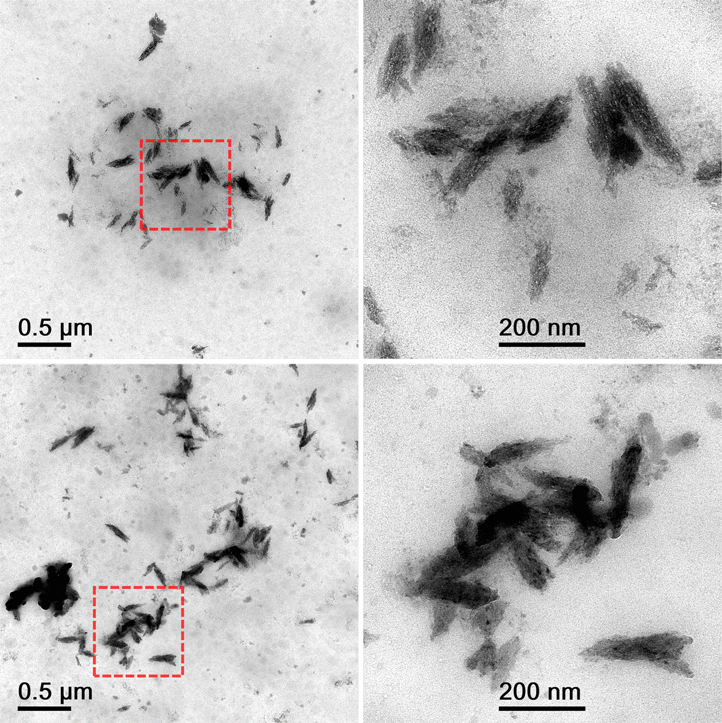
Supp Fig 3: Additional high-resolution transmission electron microscopy images of nanoparticulates isolated from kidney tissue.
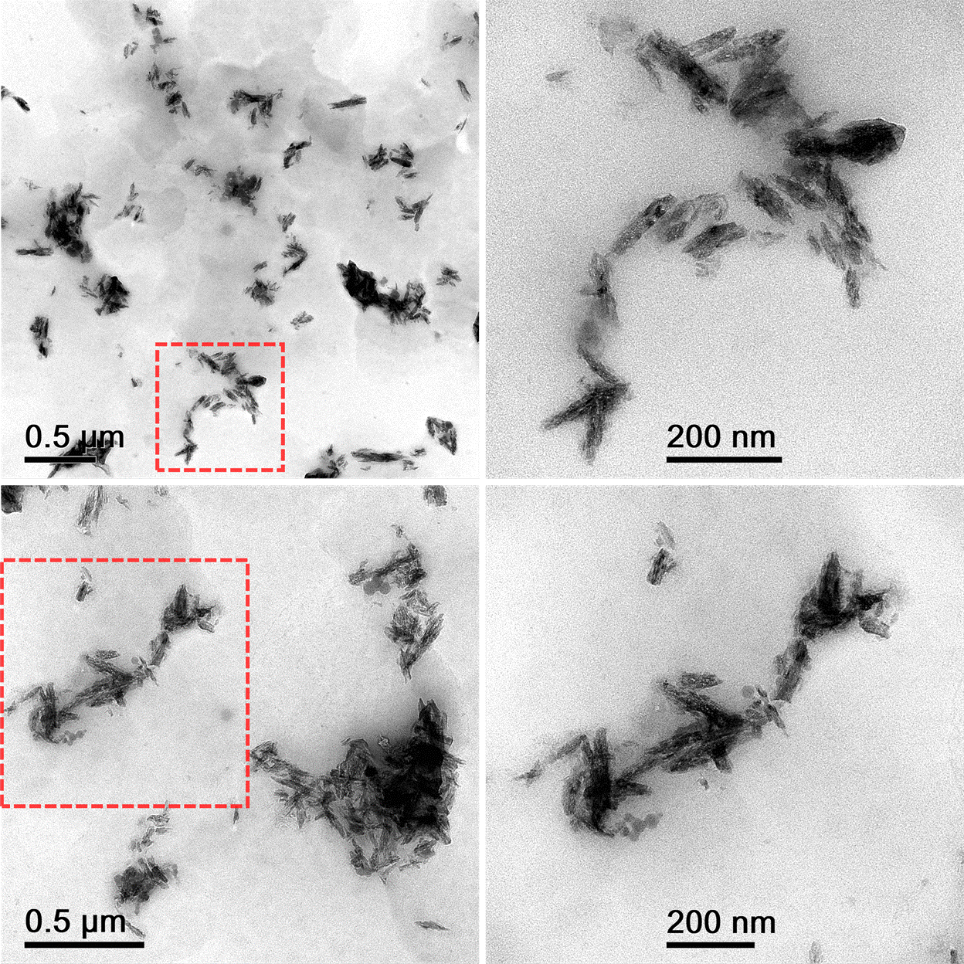
Supp Fig 4: Additional high-resolution transmission electron microscopy images of nanoparticulates isolated from liver tissue.
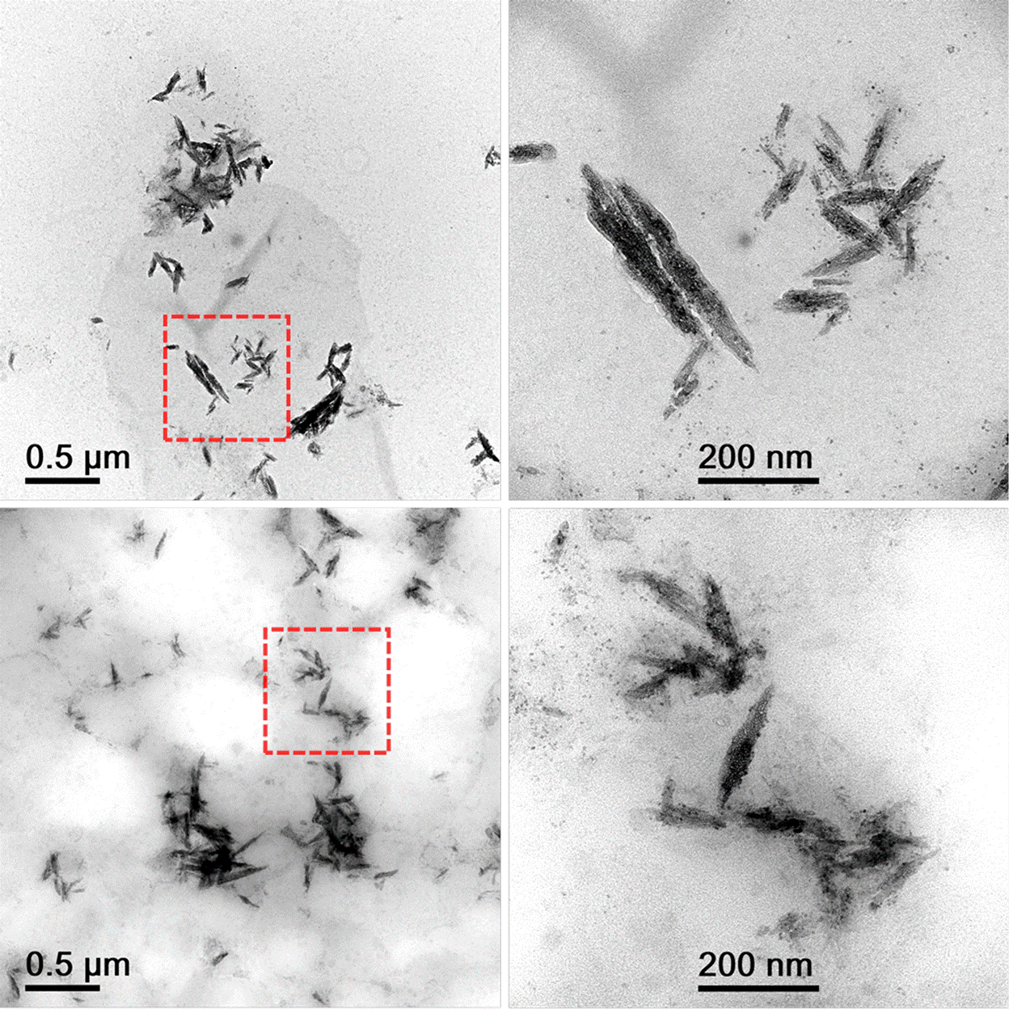
Supp Fig 5: Energy-dispersive X-ray spectroscopy (EDS) of the nanoparticulates.
Isolated particles from liver were imaged and EDS spectra were collected in a JEOL JEM-1400flash LaB₆ transmission electron microscope (TEM) equipped with a Bruker EDS system using a 60 mm² SDD detector to collect elemental spectra. The EDS acquisition conditions included 4,096 channels, 0-20 kV, and a throughput 60 kcps. It was clear that areas of fragments were rich in carbon and oxygen as compared to areas without (smaller carbon peaks were due to the TEM grid). Copper and gold were associated with the TEM holder and grid. Also evident were salts as part of the digestion process. As a test, samples dispersed in isopropanol and filtered through a 100 nm filter illustrated reduction of salts with retention of particles (data not shown).
Representative Location #1:
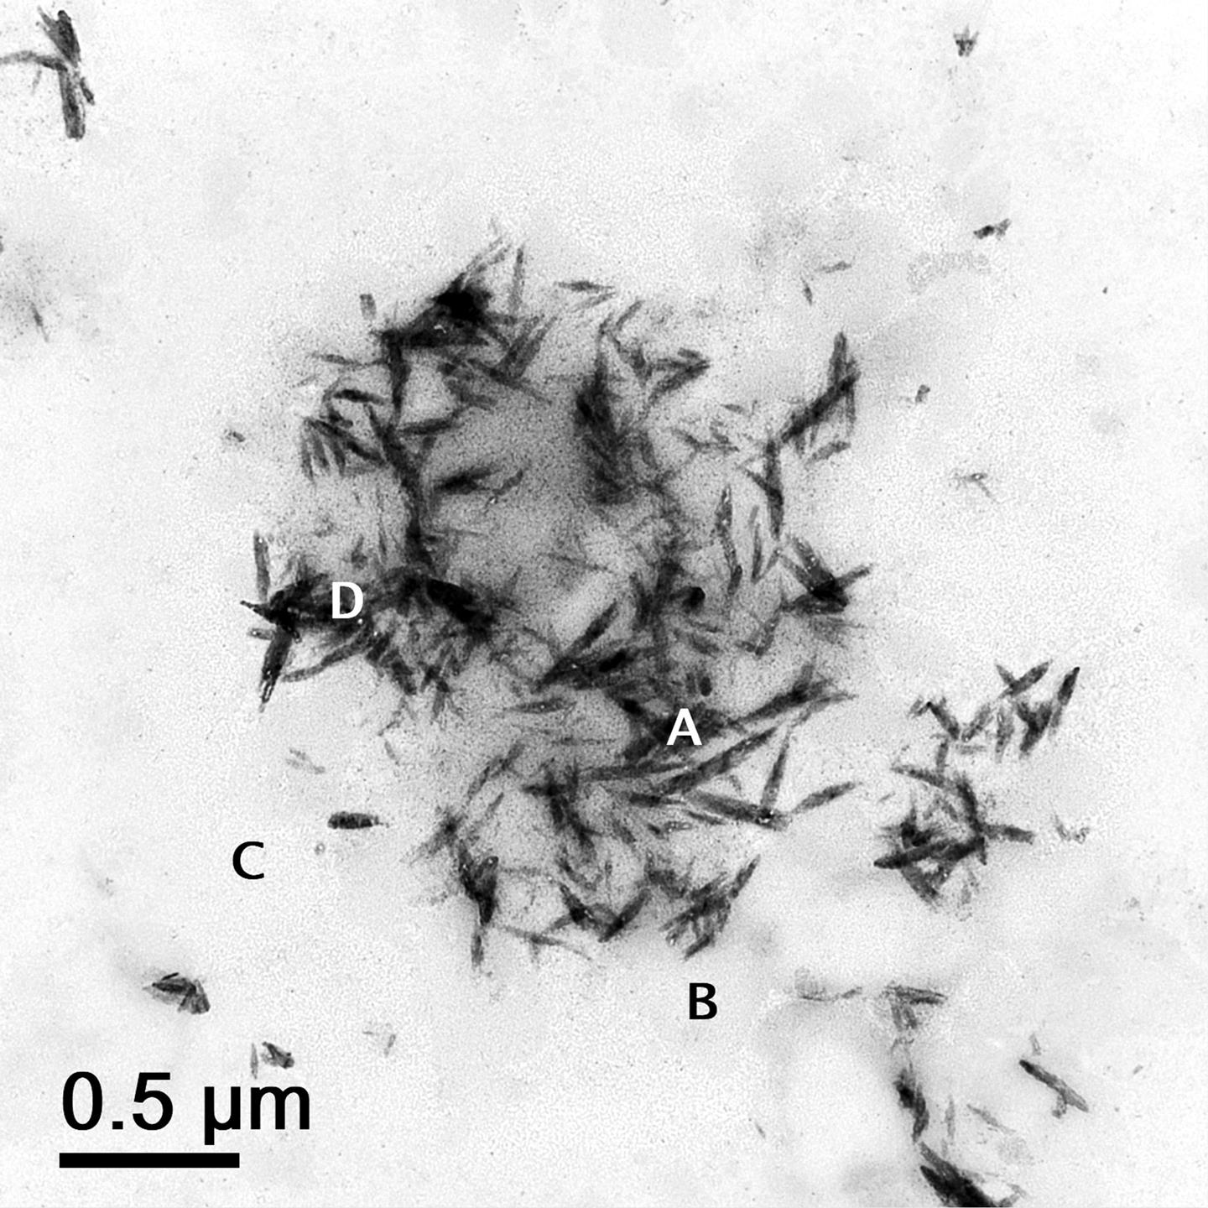

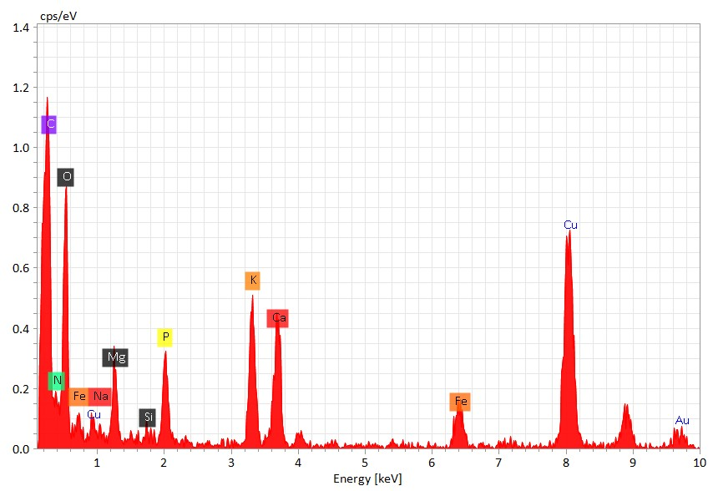
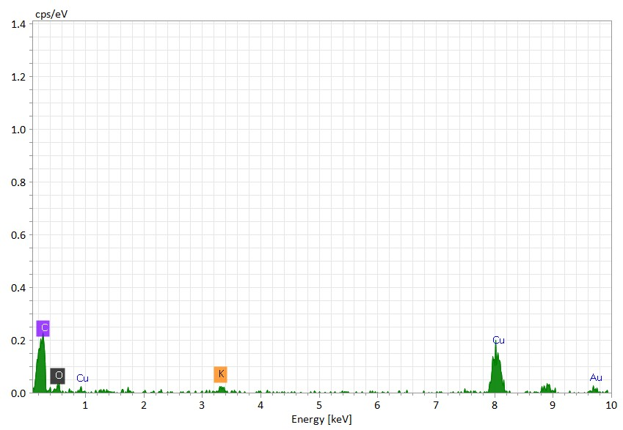
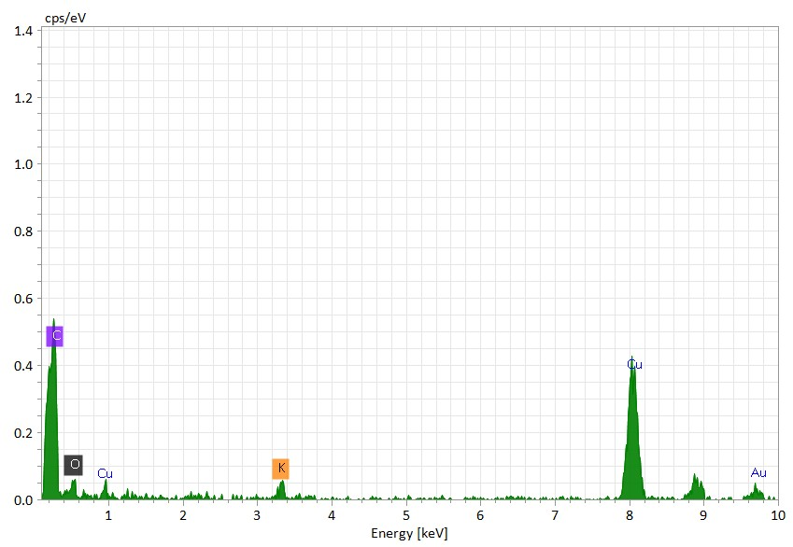
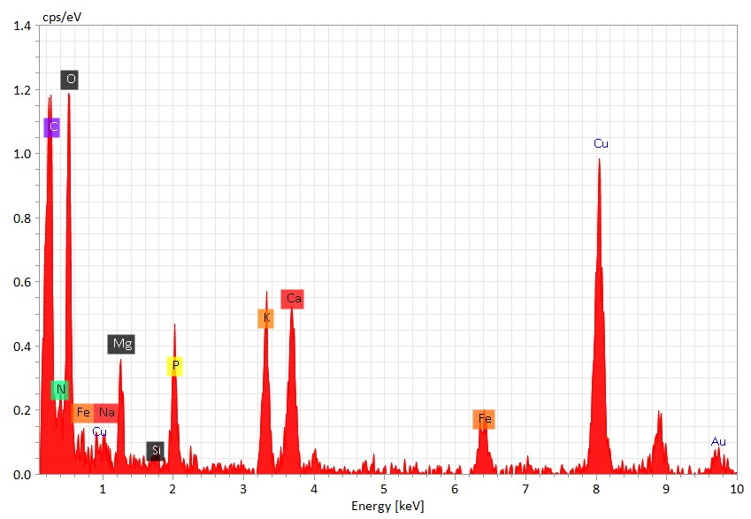
A
B
D
C
Representative Locations #2:
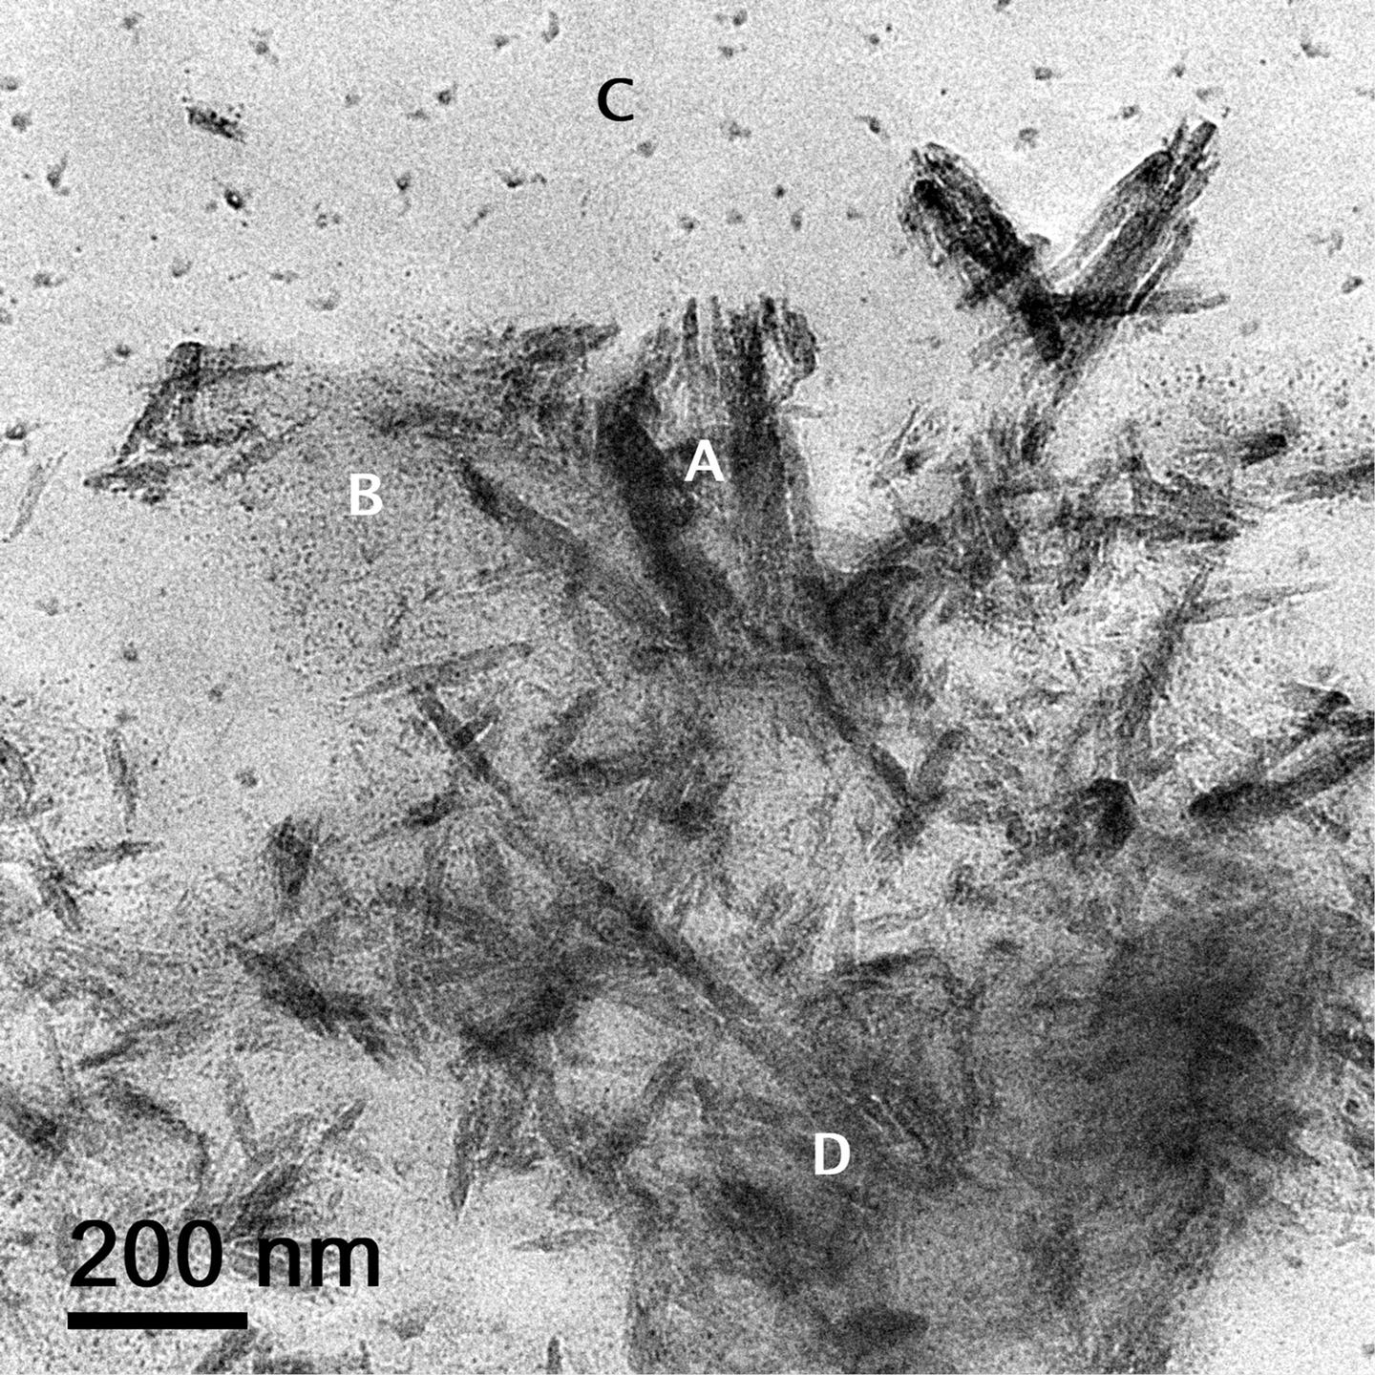

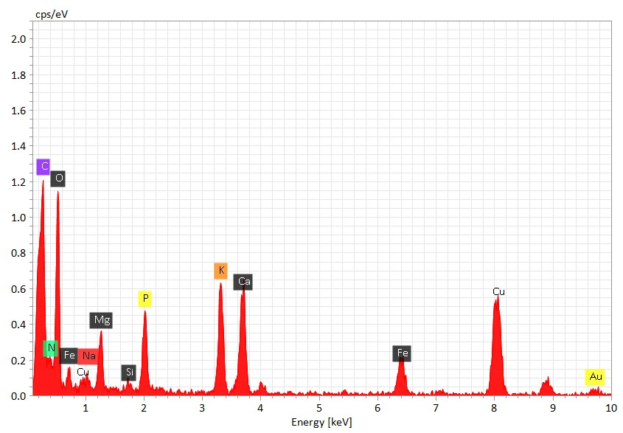
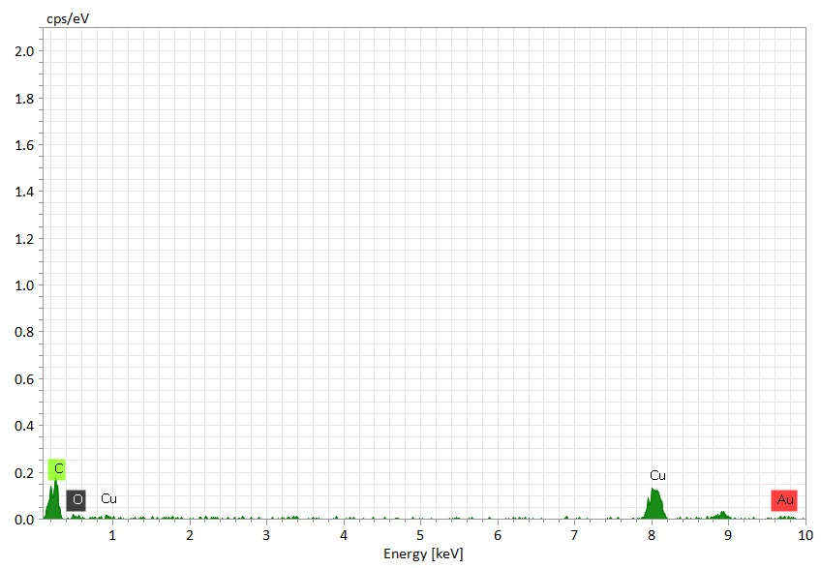
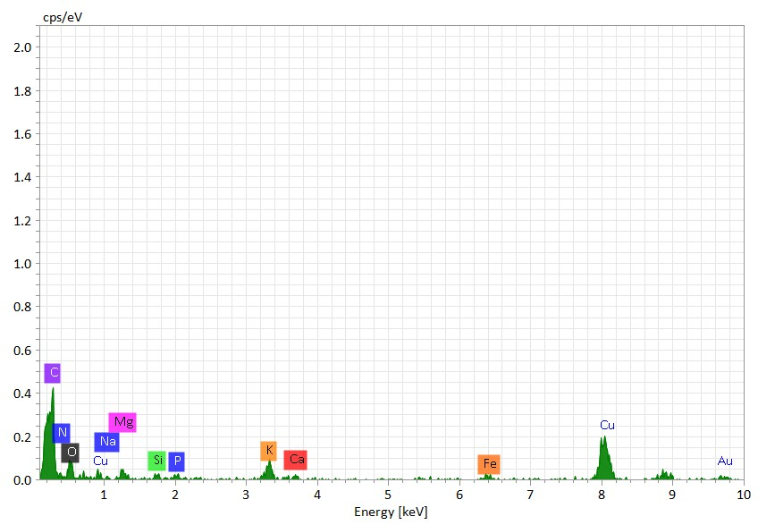
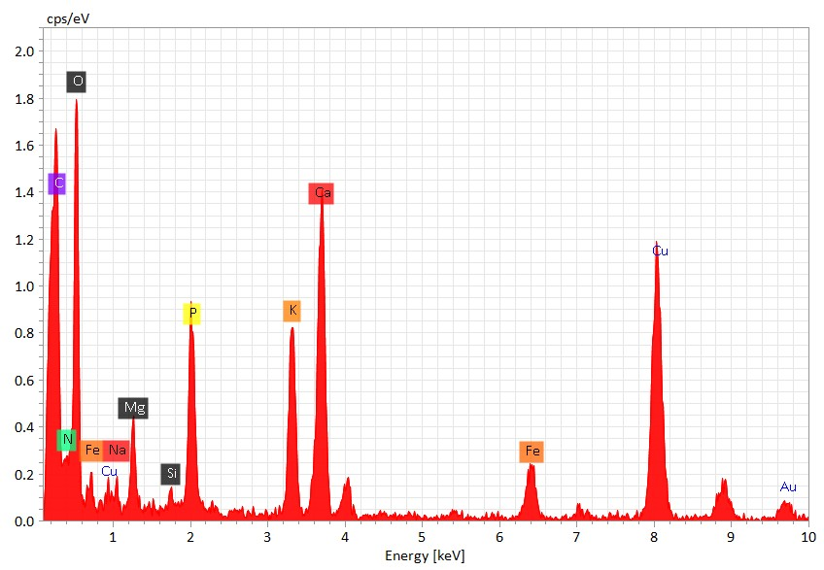
A
B
D
C
Supp Fig 6: Effects of benzene solution on the nanoparticulates.
Isolated particles from liver dispersed in isopropanol (originally incubated for six weeks) were incubated in equal volume of benzene (250 µl isopropanol + 250 µl benzene) at room temperature for one week. Benzene was chosen due to its ability to severely effect polyethylene, the most abundant percentage plastic as determined by Py-GC-MS (Supp Fig 1). Reference samples were given an additional 250 µl of isopropanol (250 µl isopropanol + 250 µl isopropanol). The incubation in isopropanol had no effect on the integrity of the particles (A). There was an effect of the benzene on the particles in terms of aiding dissolution (B and C). The benzene also appeared to influence the structure and morphology of the particles.
A: Isopropanol only B: Benzene (example 1) C: Benzene (example 2)
Supp Fig 7: Effects of chloroform and benzene vapor dissolution on the nanoparticulates. Vapor dissolution was used to allow relocation with transmission electron microscopy (TEM) of specific areas over time.
TEM grids with particles were prepared in the same manner as described previously. Images of individual particles were acquired by TEM in specific grid openings and mapped to enable relocation after exposure to the solvent vapors. Chloroform and benzene were selected because they have moderate to severe effects on polyethylene, which was identified as the highest concentration of polymer in the pellets. A piece of foam is placed into a glass petri dish with a tight-fitting lid. The solvent is then added to the petri dish so that the foam becomes saturated. The TEM grid is placed onto a support pad on top of the foam to prevent direct contact with the foam which may damage the carbon film on the TEM grid. The lid is placed on the glass petri dish and the TEM grid remains in the solvent vapors at room temperature until post-exposure examination in the TEM. The chloroform vapor test was conducted for 24 hours, whereas the benzene vapor test was conducted for an extended period of 471 hours. Benzene was examined longer as it is considered to have a more severe effect on polyethylene compared to chloroform. The TEM grid exposed to benzene was removed after 24, 96, 189, 283, and 471 hours for TEM examination of the specific particles. The glass petri dish was checked daily to maintain sponge saturation with benzene.
Chloroform: The same TEM grid preparation used to collect images of the particles in the brain in Figure 1 was used in the chloroform vapor test. The grid was exposed to chloroform vapors for 24 hours. Particles imaged prior to vapor exposure (left) were relocated and imaged post-exposure (right) to document particle changes. The chloroform vapor clearly had an effect on the fragments.

Benzene: Benzene vapor exposure to nanoparticulates from the liver was evaluated temporally by relocating particles identified prior to any exposure to benzene and after each vapor exposure at 24, 96, 189, 283, and 471 hours. Singlet and particles appearing to be lighter/thinner are most affected as compared to darker/thicker or more agglomerated. Benzene clearly affects the particles, and the dissolution can take weeks using this method. Two different locations of particles are presented below.

Example 1:
A: Initial B: 24 hours C: 96 hours
D: 189 hours E: 283 hours F: 471 hours

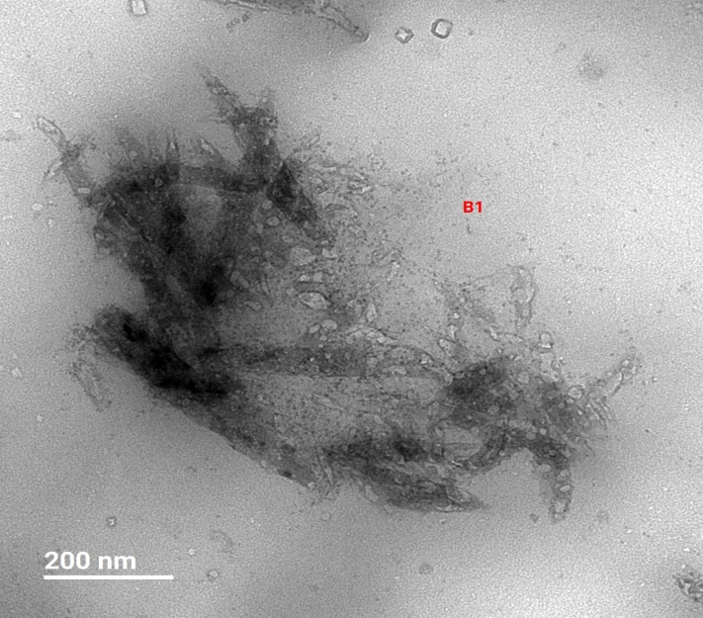
Before
504 hours

Example 2:
A: Initial B: 24 hours C: 96 hours
D: 189 hours E: 283 hours F: 471 hours
Supp Fig 8: Analysis of nanoparticulates using Raman spectroscopy.
The sample for Raman spectroscopy was prepared by using particles dispersed in equal volumes of isopropanol and benzene. The vial was heated in a heating block at a temperature of approximately 78° Cand monitored by a thermocouple. A temperature of 78° C was chosen because the boiling point of benzene is 80° C. Several drops were deposited onto an aluminum coated slide.
Raman spectroscopy indicates similarities between the particles dispersed in isopropanol and benzene and high-density polyethylene. Samples were analyzed using a Horiba LabRam HR with an Olympus BX41 microscope with a 50x LWD lens. Analysis was conducted using a 632 nm excitation source and 600 gr/mm grating. (A). PE represents the largest measured polymer type in the pellets (Supplemental Figure 1). To complement Figure 2, the sample was compared to the different PE types contained in the Hawaii Pacific University Polymer Kit 1.0 (A). The sample was also compared to the Wiley KnowItAll Spectral Library for HDPE (B).

- From top to bottom: Nanoparticulates sample, and standards including HDPE1, HDPE2, LDPE1, LDPE2, LLDPE1, LLDPE2, MDPE

Orange: HDPE standard in Wiley KnowItAll Spectral Library. Black: Spectra collected from nanoparticulate sample. The y-axis represents intensity (a.u.).

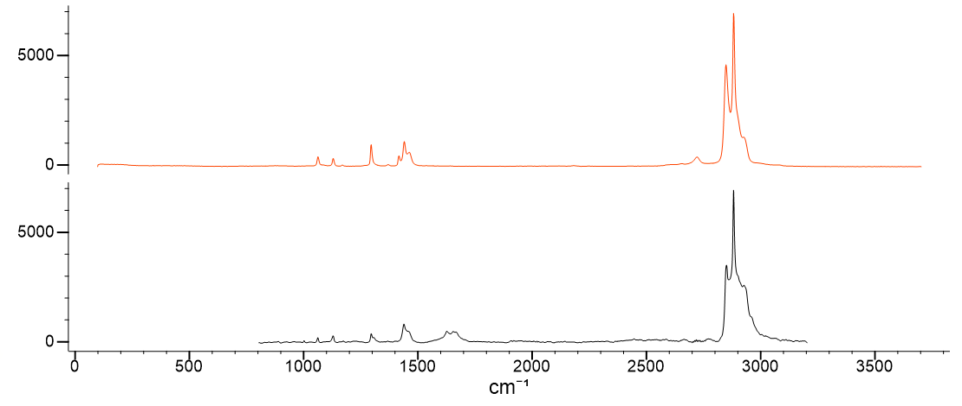
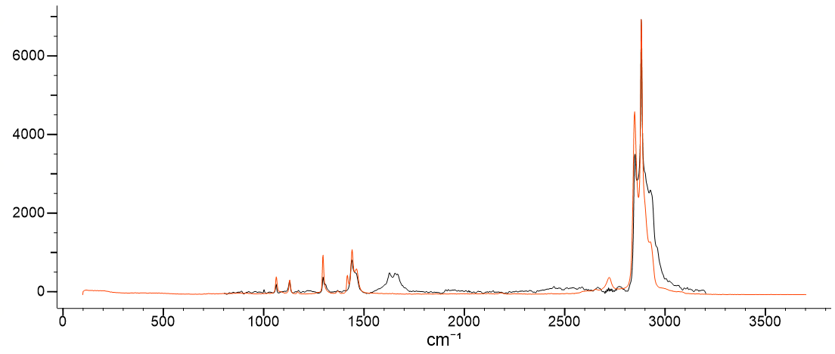

Supp Fig 9: Analysis of nanoparticulates using Fourier-transform infrared spectroscopy (FTIR).
The sample for FTIR was prepared by using particles dispersed in equal volumes of isopropanol and benzene. The vial was heated in a heating block at a temperature of approximately 78° C and monitored with a thermocouple. A temperature of 78° C was chosen because the boiling point of benzene is 80° C. Several drops were deposited onto a low emissivity slide.
FITR spectra were collected in reflectance mode using a Brucker Tensor 27 FTIR with a Hyperion microscope attachment. Collected spectra were baseline corrected and a CO₂ peak from atmospheric interference was removed. Comparison of isolated particles and polyethylene from the Wiley KnowItAll library. Orange line is polyethylene and black line is nanoparticulates isolated from tissues. The y-axis represents intensity (a.u.).

Supp Fig 10: Evaluating the presence of nanoparticulates using a digestion method without KOH.
Independent preparation and visualization were performed to produce the particles observed without KOH digestion. Approximately 500 mg of brain tissues were digested with 1 ml of hydrogen peroxide (H₂O₂) at 60-70 °C for 6 hours, followed by the addition of 1 ml of 5% nitric acid. The samples were left at room temperature for 24 hours, then heated again at 40 °C for 2 hours. After adding 1 ml of distilled water, the samples were ultracentrifuged at 100,000 g for 4 hours and washed in 100% ethanol. The pellets were suspended in 100% ethanol and deposited on copper transmission electron microscopy (TEM) mesh grids with a holey carbon support film. The grids were examined in a Hitachi TEM at 80 kV, and images were captured using an AMT XR16M digital camera. Very similar particles were observed as seen with KOH digestion.
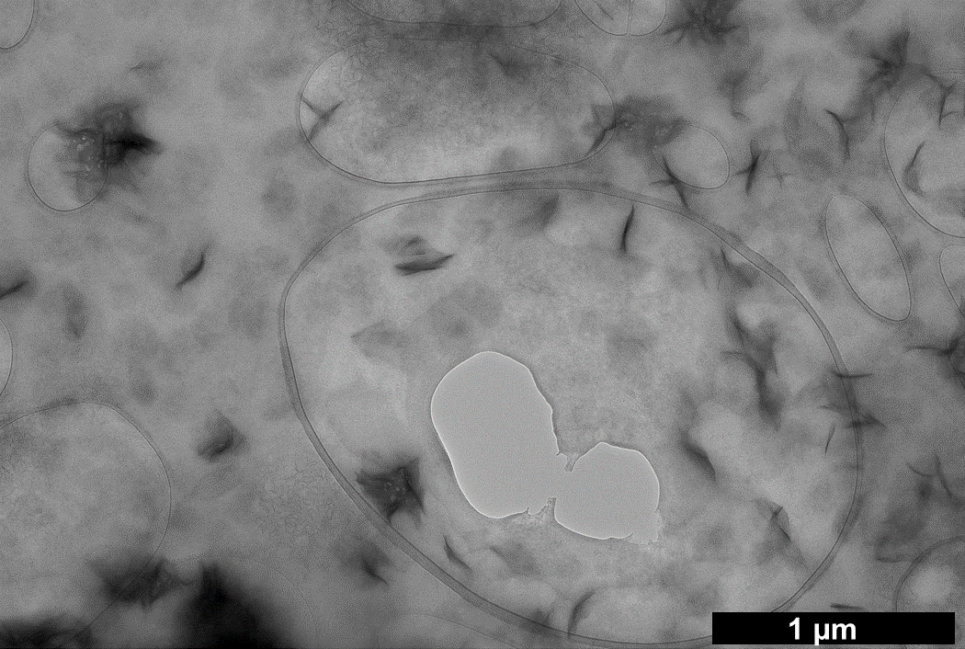

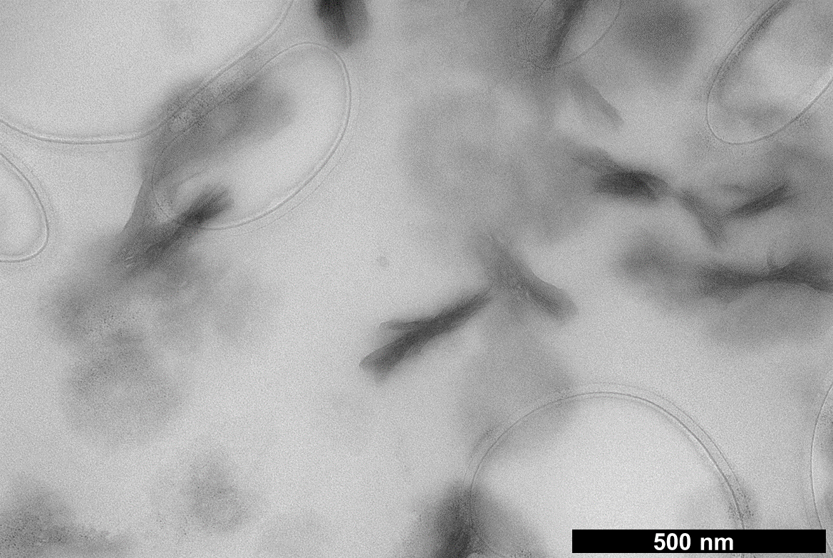
Supp Figure 11: (A) Size distribution patterns of nanoparticulates isolated from human brain, kidney, and liver for each decedent. (B) Stacked histogram representation of all 3251 measured samples.
Supp Fig 12: Pellets obtained after tissue digestion and ultracentrifugation. These pellets, or portions of the pellet, were subsequently dispersed in isopropanol.
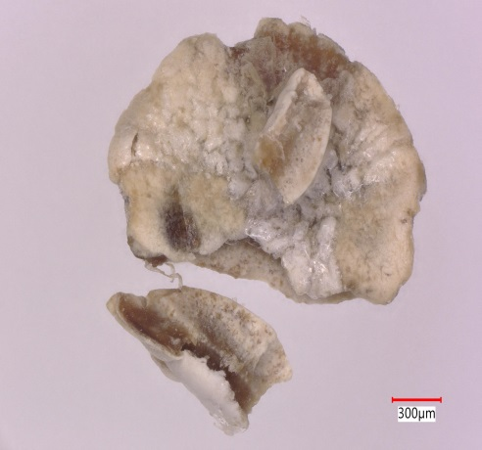
Brain
Kidney
Liver

