Supplemental Figure

Supplementary Figure S1. Rainfall classification, drop number and diameter for Case 3 in Serpong (lowland) area.
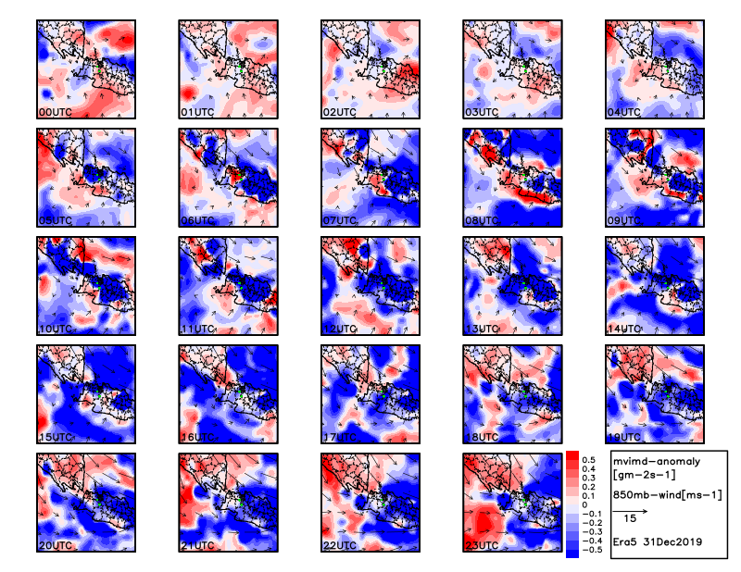
Supplementary Figure S2. Mean Vertical Integrated Moisture Divergence (MVIMD) hourly anomaly (shaded) overlay with u;v wind vector at 850 mb during 31 December 2019.
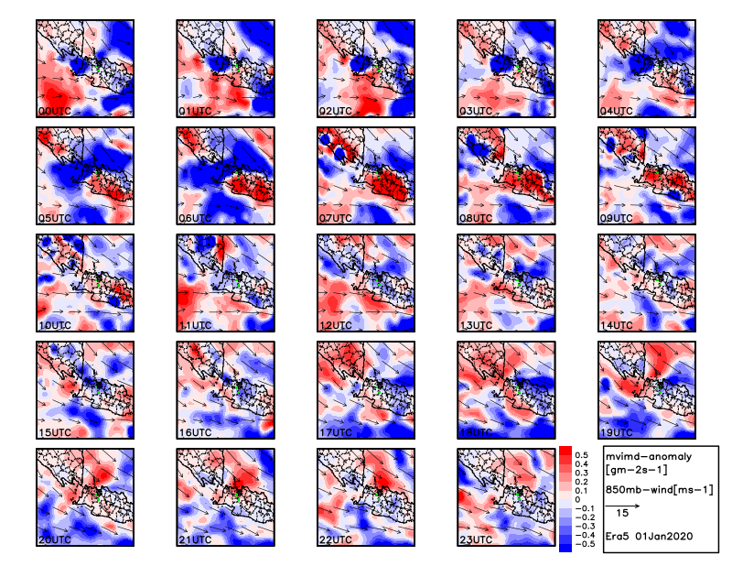
Supplementary Figure S3. Mean Vertical Integrated Moisture Divergence (MVIMD) hourly anomaly (shaded) overlay with u;v wind vector at 850 mb during 01 Januari 2020.
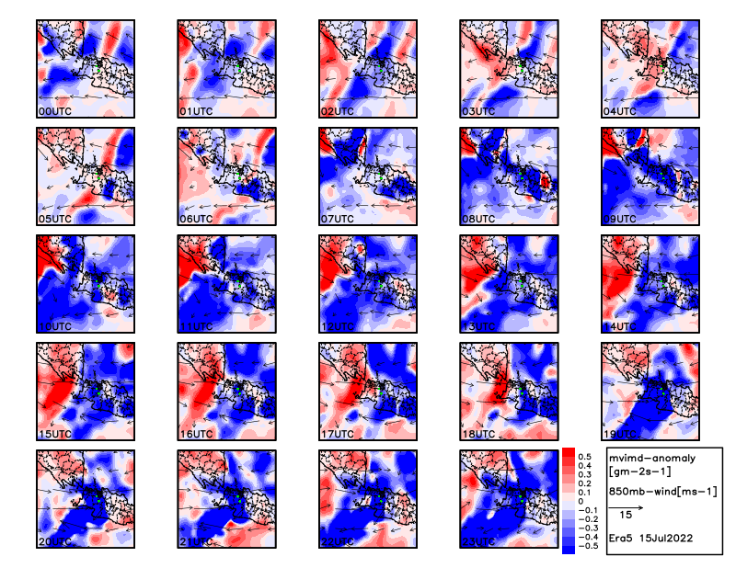
Supplementary Figure S4. Mean Vertical Integrated Moisture Divergence (MVIMD) hourly anomaly (shaded) overlay with u;v wind vector at 850 mb during 15 July 2022.
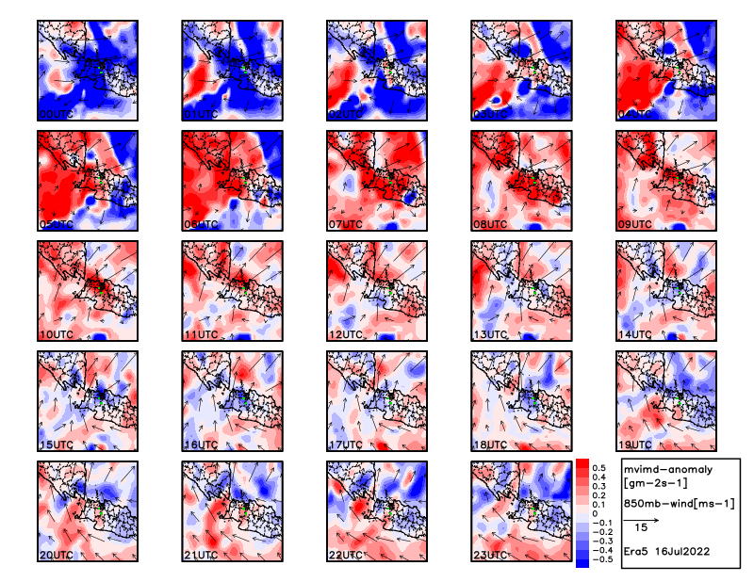
Supplementary Figure S5. Mean Vertical Integrated Moisture Divergence (MVIMD) hourly anomaly (shaded) overlay with u;v wind vector at 850 mb during 16 July 2022.
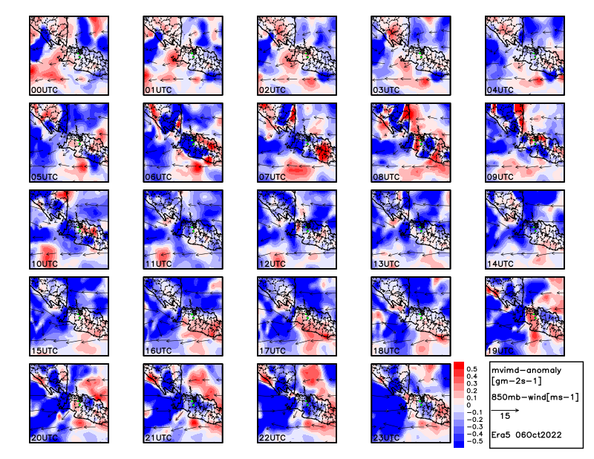
Supplementary Figure S6. Mean Vertical Integrated Moisture Divergence (MVIMD) hourly anomaly (shaded) overlay with u;v wind vector at 850 mb during 06 October 2022.
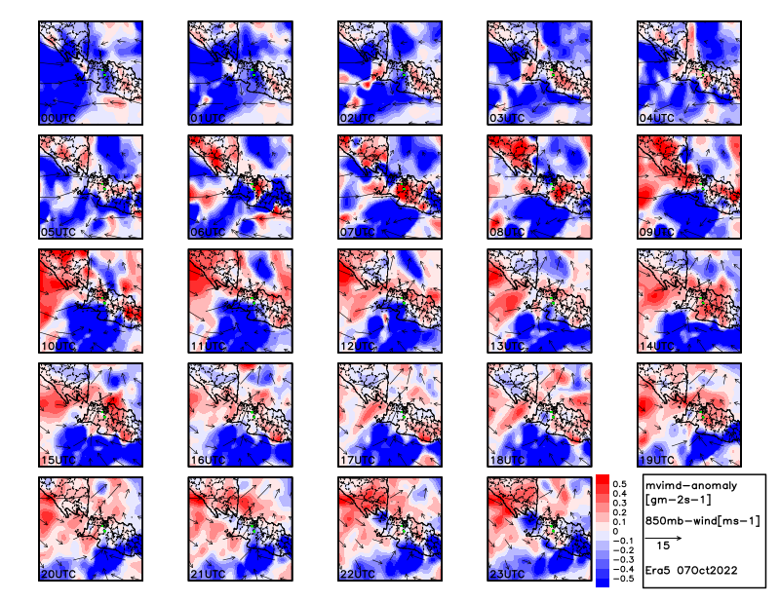
Supplementary Figure S7. Mean Vertical Integrated Moisture Divergence (MVIMD) hourly anomaly (shaded) overlay with u;v wind vector at 850 mb during 07 October 2022.
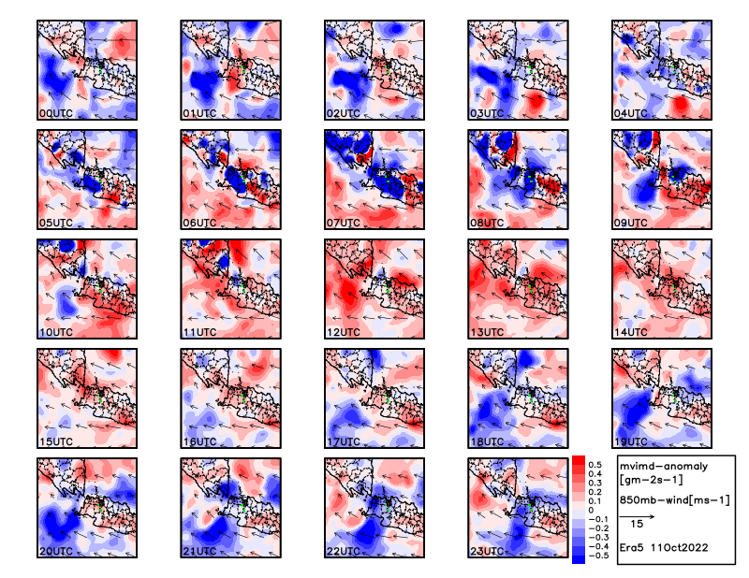
Supplementary Figure S8. Mean Vertical Integrated Moisture Divergence (MVIMD) hourly anomaly (shaded) overlay with u;v wind vector at 850 mb during 11 October 2022.
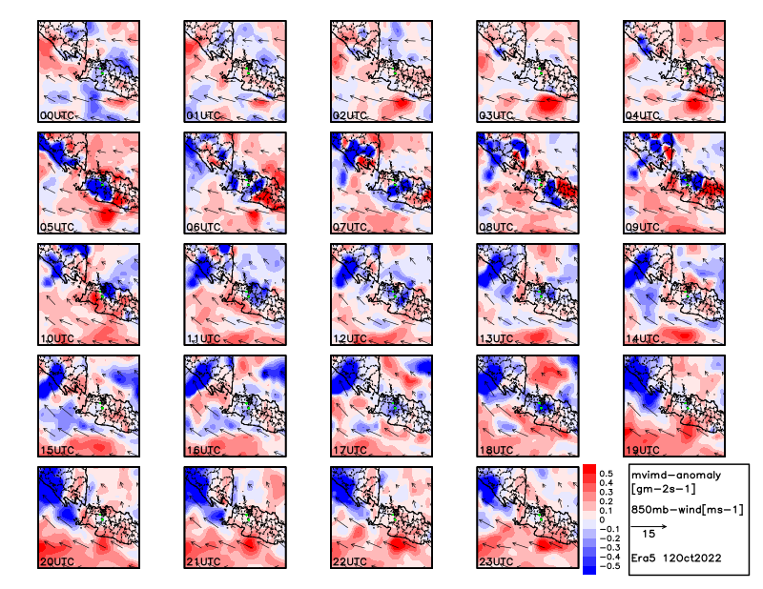
Supplementary Figure S9. Mean Vertical Integrated Moisture Divergence (MVIMD) hourly anomaly (shaded) overlay with u;v wind vector at 850 mb during 12 October 2022.
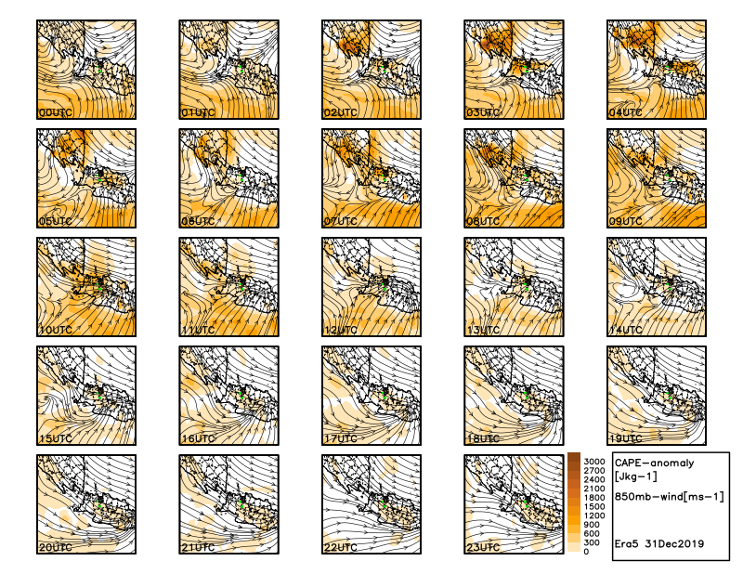
Supplementary Figure S10. Convective Available Potential Energy (CAPE) hourly anomaly (shaded) overlay with u;v wind streamline at 850 mb during 31 December 2019.
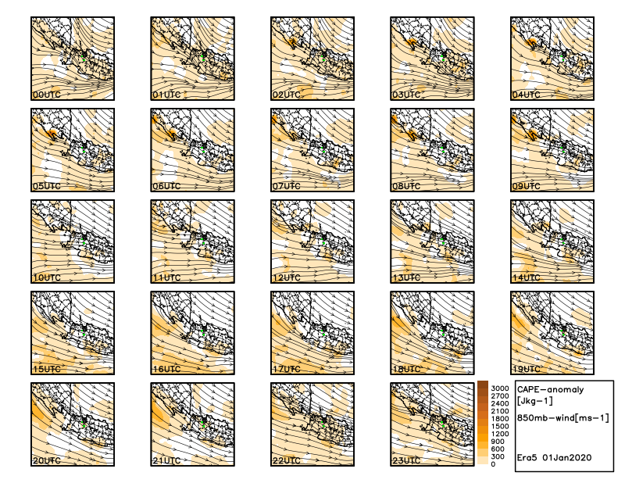
Supplementary Figure S11. Convective Available Potential Energy (CAPE) hourly anomaly (shaded) overlay with u;v wind streamline at 850 mb during 01 January 2020.
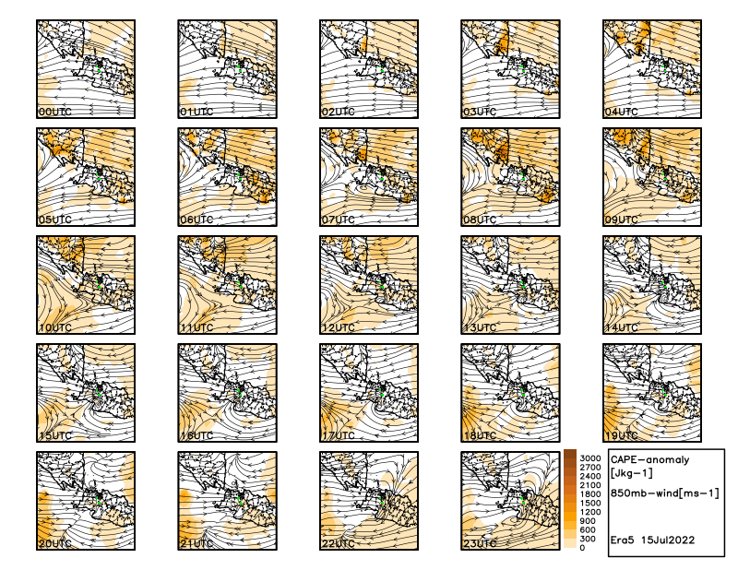
Supplementary Figure S12. Convective Available Potential Energy (CAPE) hourly anomaly (shaded) overlay with u;v wind streamline at 850 mb during 15 July 2022.
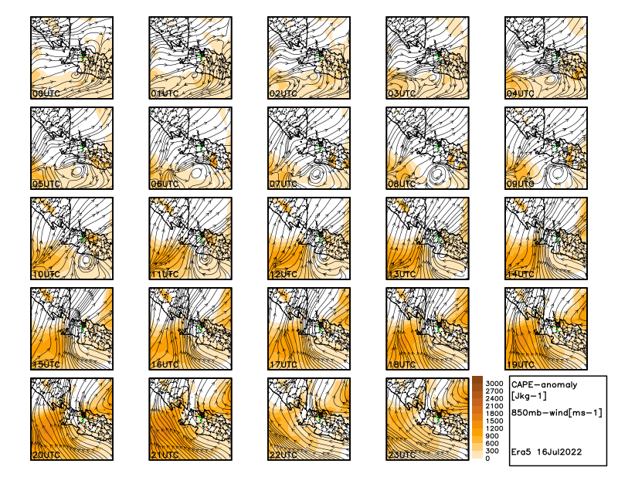
Supplementary Figure S13. Convective Available Potential Energy (CAPE) hourly anomaly (shaded) overlay with u;v wind streamline at 850 mb during 16 July 2022.
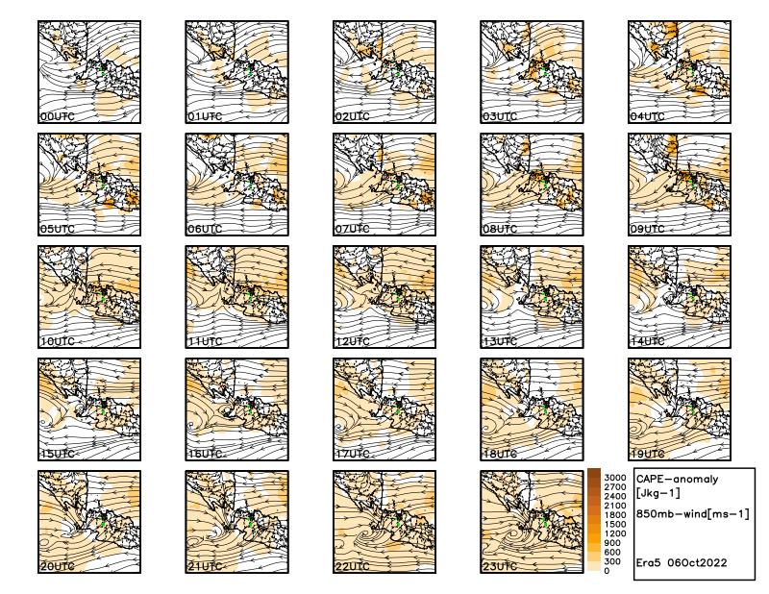
Supplementary Figure S14. Convective Available Potential Energy (CAPE) hourly anomaly (shaded) overlay with u;v wind streamline at 850 mb during 06 October 2022.
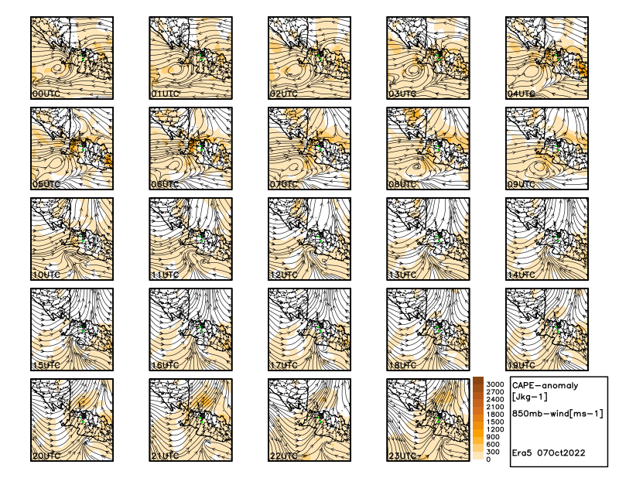
Supplementary Figure S15. Convective Available Potential Energy (CAPE) hourly anomaly (shaded) overlay with u;v wind streamline at 850 mb during 07 October 2022.
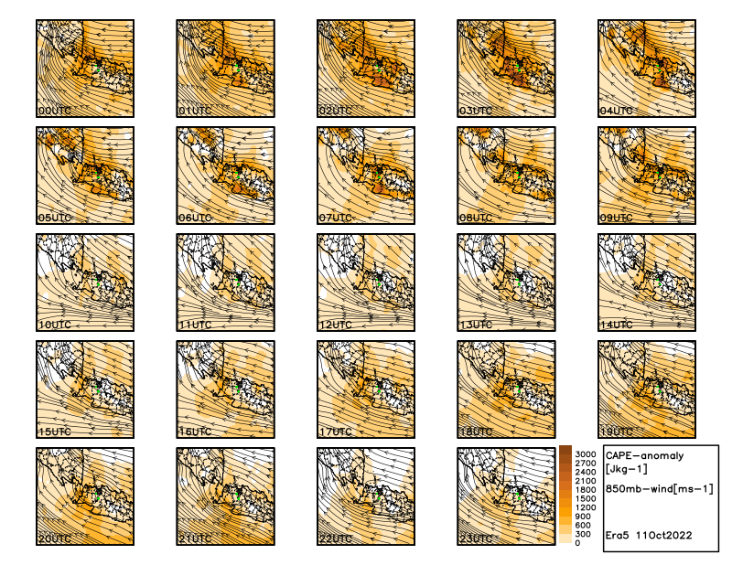
Supplementary Figure S16. Convective Available Potential Energy (CAPE) hourly anomaly (shaded) overlay with u;v wind streamline at 850 mb during 11 October 2022.
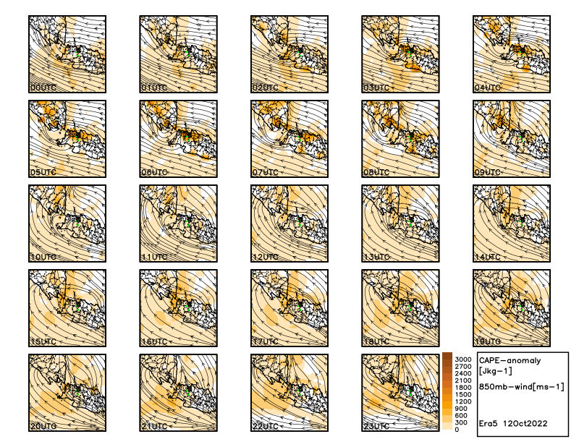
Supplementary Figure S17. Convective Available Potential Energy (CAPE) hourly anomaly (shaded) overlay with u;v wind streamline at 850 mb during 12 October 2022.
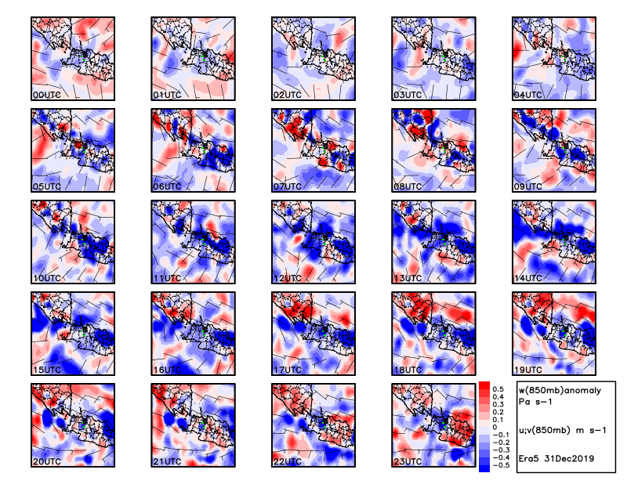
Supplementary Figure S18. Vertical Velocity (w) hourly anomaly (shaded) overlay with u;v wind barb at 850 mb during 31 December 2019.
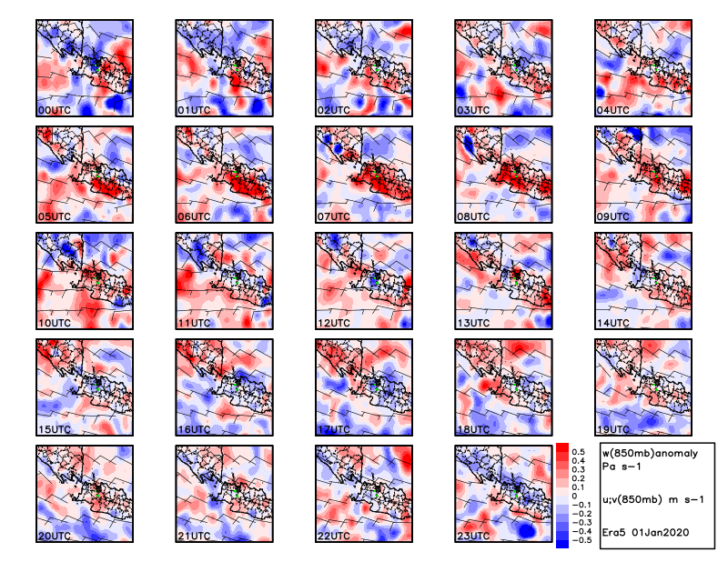
Supplementary Figure S19. Vertical Velocity (w) hourly anomaly (shaded) overlay with u;v wind barb at 850 mb during 01 January 2020.
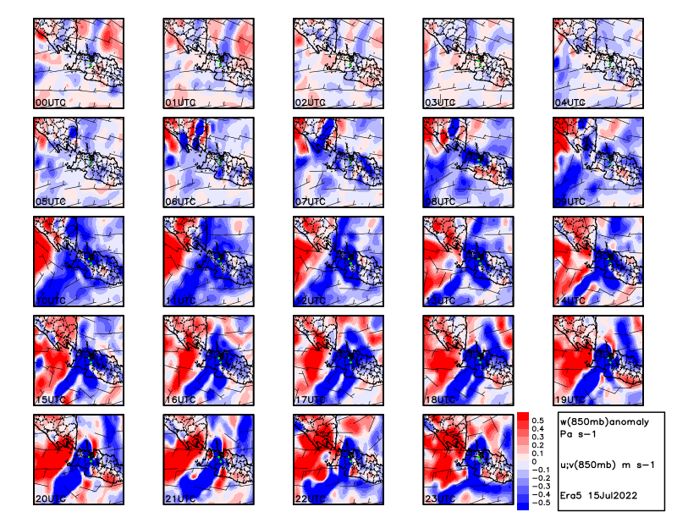
Supplementary Figure S20. Vertical Velocity (w) hourly anomaly (shaded) overlay with u;v wind barb at 850 mb during 15 July 2022.
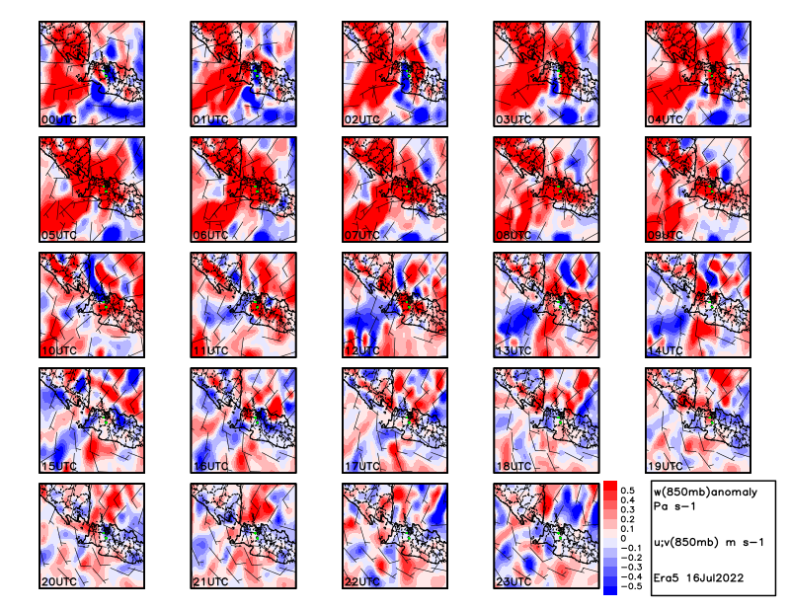
Supplementary Figure S21. Vertical Velocity (w) hourly anomaly (shaded) overlay with u;v wind barb at 850 mb during 16 July 2022.
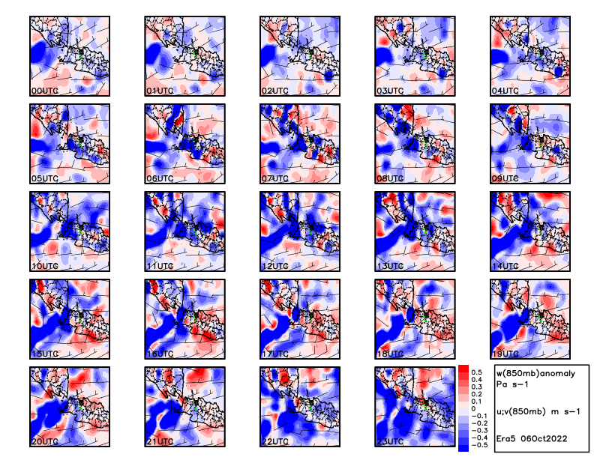
Supplementary Figure S22. Vertical Velocity (w) hourly anomaly (shaded) overlay with u;v wind barb at 850 mb during 06 October 2022.
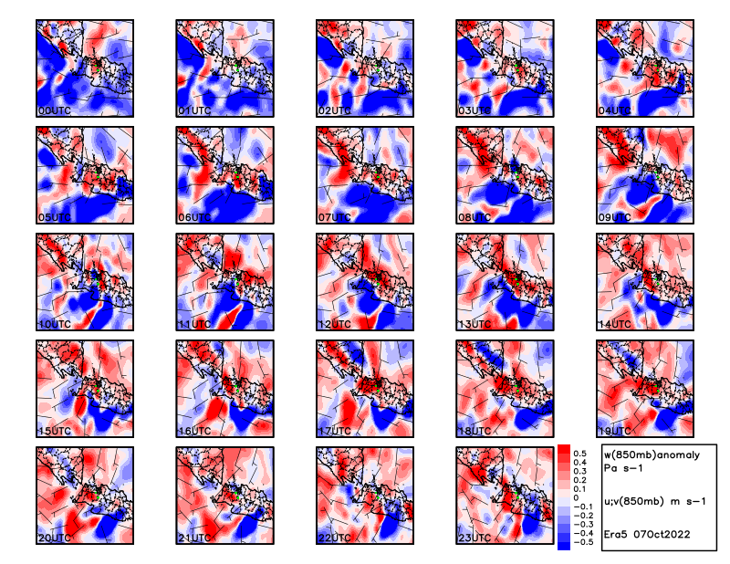
Supplementary Figure S23. Vertical Velocity (w) hourly anomaly (shaded) overlay with u;v wind barb at 850 mb during 07 October 2022.
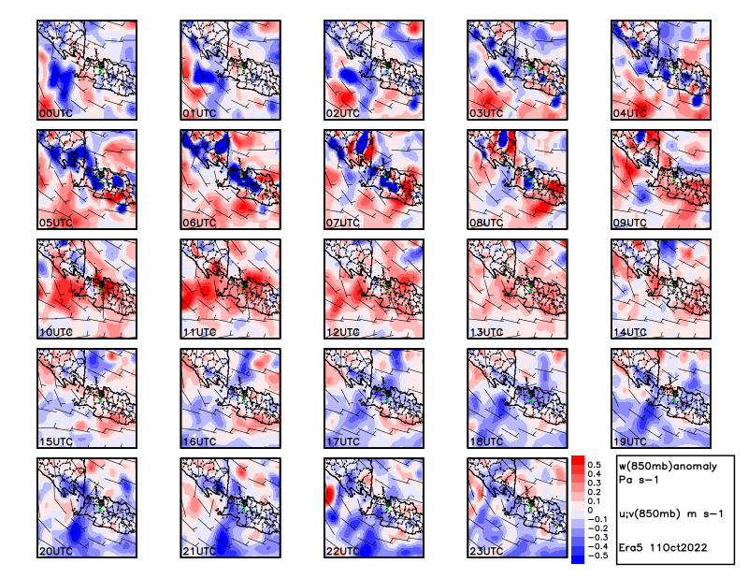
Supplementary Figure S24. Vertical Velocity (w) hourly anomaly (shaded) overlay with u;v wind barb at 850 mb during 11 October 2022.
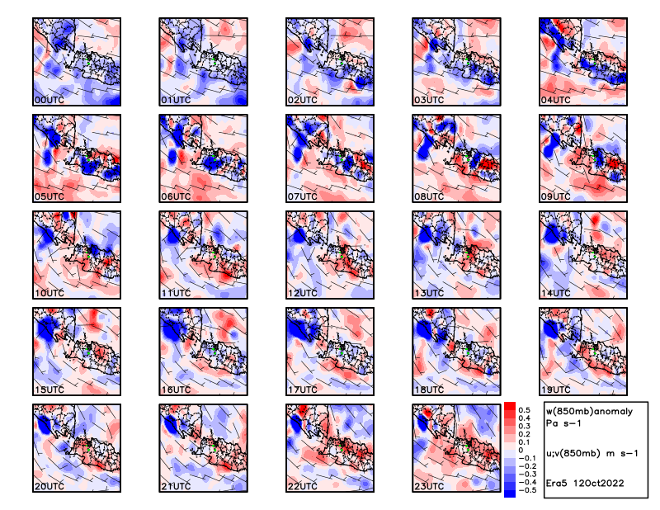
Supplementary Figure S25. Vertical Velocity (w) hourly anomaly (shaded) overlay with u;v wind barb at 850 mb during 12 October 2022.

