Supplementary Materials

Title: Decadal Progress of Ocean Acidification over the Southern Ocean

Authors
B. F. Li,¹* X. L. Pan,¹ Y. W. Watanabe¹
Affiliations
¹ Faculty of Environmental Earth Science, Hokkaido University, Sapporo, Japan

Corresponding author: B. F. Li (mikolee@ees.hokudai.ac.jp)

1. Gridding of data
According to the Ocean Data View (ODV) software, we used the weighted-average method to interpolate our data onto a common grid (c.f. Ocean Data View User’s Guide Version 5.2.0, 16.6.1, https://odv.awi.de/documentation/) ²⁷. Thus, we constructed grids over the SO. The resolution of the grid can be assigned as per the requirement. The three-dimensional (3D) grid of the entire SO was constructed with a horizontal resolution of 1° $×$× 1° (latitude × longitude) and 43 layers with vertical resolution having 50-m thickness from the surface to 500 m, 100-m thickness from 600 m to 1500 m, and 200-m thickness from 1700 m to the sea floor ²⁰.

We used a simple weighted-averaging scheme in the ODV to calculate the property estimation at every grid point (Eq. (S1)).

$c_{e}=\sum_{i}{α_{i}}∙d_{i}/\sum_{i}{α_{i}}$ c_{e} = ∑_{i} (a_{i}・d_{i}) / ∑_{i} a_{i} (S1)

The weights of the data points a_{i} decrease exponentially with increasing distance between the data point and grid point: a₁ = e^{-r}$α_{i}=e^{-r}$, with r = (∆x / L_{x})² + (∆y / L_{y})²$r={(∆x/L_{x})}^{2}+{(∆y/L_{y})}^{2}$, where ∆x and ∆y are the distances between the data point and grid point in the X and Y directions, respectively, and L_{x} and L_{y} are the separate averaging length-scales in the X and Y directions, respectively. The length scale of the latitude and longitude in the 3D grid of the estimation in this study was 50 per mille, and the depth scale was 50 m.

2. Uncertainties of our parameterization with the gridding estimation
Considering the uncertainties of DIC_{pred} (RMSE = 5.5 µmol kg⁻¹) and pH_{pred} (RMSE = 0.012), and the propagation of uncertainty from the calculation (Eqs. (1–5)), ΔDIC_{pred} and ∆pH_{pred} have uncertainties of 7.8 µmol kg⁻¹ and 0.017 pH, respectively.

The mapping and gridding errors can be estimated from the objective mapping calculations but are also difficult to assess quantitatively since the mapping errors are highly correlated both vertically and horizontally. Uncertainties for the inventory calculation were given by the standard error of gridding estimation (Table S3). Here we estimate the inventories in the area out of the parameterization constraint conditions (shown in Table S1) as the products of average inventories of each sector and the fraction of the area to each sector (the fraction of the area within constraint conditions to the total surface area of SO was 30%).

Owing to the severe environment of the SO, most of the GLODAP data we used were collected in the warm period (for convenience, we call it summertime). The seasonal differences between different cruises may affect our estimation. In order to verify whether there was a significant difference between the data for cold period (wintertime) and warm period, we used the data of wintertime (April to October) and summertime (January to March), and drew the vertical profile of the average DIC and pH for these two durations (Fig. S8). At the upper 100 m, we can find that the differences of both DIC and pH between the two seasons were largest at 9.0 µmol kg⁻¹ and 0.024 pH, suggesting that there is significant seasonality (Fig. S8). Below 100 m depth, the differences of DIC and pH between the two seasons were within the RMSEs of our parameterizations (Fig. S8). We here focused on the decadal variation of DIC and pH over the SO rather than the seasonal change of the SO. Therefore, the uncertainties from the seasonal change of the DIC and pH can be included in the decadal variation. Thus, we concluded that the seasonal difference in the observational data does not significantly affect the spatiotemporal distributions of ΔDIC_{anth} and ΔpH_{anth} along with the total water column inventory.

To clarify the extent of the difference between the interpolated grid data and the actual observational data, we chose three repeat observational line of GLODAP and draw the vertical section of T, S and AOU of GLODAP and grid data (Fig. S9–14). From the vertical sections, there are no significant differences between GLODAP and grid data.

Additionally, we compared the interpolated grid data (T and S) to surrounding Biogeochemical-Argo (BGC-Argo) data in each basin such as Pacific, Indian, and Atlantic. We chose six positions in Pacific, Indian, and Atlantic sectors of the SO (where were far from the observation stations of GLODAP) during 2005–2019 (Fig. S2b). The difference of T and S between interpolated grid data and Argo data can result in differences of DIC_{pred} and pH_{pred} within the decadal change of DIC and pH (Table S4). See details of the BGC-Argo we used in Table S5. The results from the gridding of GLODAP data were within the standard error of our estimation (7.8 µmol kg⁻¹ for ΔDIC_{anth} and 0.017 pH for ∆pH_{anth}), even though the gridding of the GLODAP data would lead an uncertainty of our estimation.
Table S1. Constraint conditions for parameterization of pH in the SO.
Constraints |  | Remarks
Bottom depth | > 1,500 m | Removing continental shelf
Mixed layer depth | ΔT > 0.5 ºC ª | ΔT ≤ 0.5 ºC was not used
Salinity | 34–35
AOU | Except  (AOU > 165 µmol kg⁻¹  and  Depth > 1,000 m)
Water masses | Except NADW ^{b}, SASW ^{c} | NADW: 34.8 < S < 35  1.5 ºC < T < 4 ºC  SASW: T > 8 ºC ²⁸
ª Mixed layer depth: the depth at which temperature (T) changes by a given threshold value (ΔT; here, ΔT = 0.5 ºC) relative to the temperature at the surface ²⁹.
^{b} North Atlantic Deep Water
^{c} Subantarctic Surface Water; we only removed the north part of SASW in the Pacific sector.
Table S2. Details of parameterization of pH in our study. AOU: apparent oxygen utilization (µmol kg⁻¹), T: temperature (ºC), S: salinity, Pr: pressure (dbar).
Parameter |  | F ª | B ^{b} | VIF ^{c}
pH_{pred} | Intercept | – | 4.416 | –
pH_{pred} | AOU | 223,687 | –1.294 ×10^{–3} | 2.12
pH_{pred} | T | 58,151 | 9.064 ×10⁻² | 1.89
pH_{pred} | S | 39,275 | 9.638 ×10⁻² | 1.76
pH_{pred} | Pr | 4,556 | 4.374 ×10⁻⁶ | 1.61
ª F-value; significant when F-value over 2.4
^{b} Regression coefficient
^{c} Variance Inflation Factor; indicates no multicollinearity when VIF is < 10.
Table S3. Uncertainties of the estimations of ΔDIC_{anth} and ∆DIC water column inventory in the SO.
 |  | Pacific Sector | Indian Sector | Atlantic Sector | Southern  Ocean
Grid number ª |  | 5,309 | 4,365 | 2,802 | 12,476
ΔDIC_{anth} | Average ^{b} | 0.00011 | 0.00052 | 0.0010 | 0.00048
ΔDIC_{anth} | SE ^{c} | 0.000020 | 0.000021 | 0.000038 | 0.000015
ΔDIC_{anth} | Uncertainty ^{d} | 18% | 4% | 3% | 3%
∆DIC | Average | 0.00059 | 0.0011 | 0.0015 | 0.00096
∆DIC | SE | 0.000016 | 0.000021 | 0.000033 | 0.000013
∆DIC | Uncertainty | 3% | 2% | 2% | 1%
ª Grid number in each sector when calculated the ΔDIC and ΔDIC_{anth} water column inventory.
^{b} Average of the inventory value of each grid point in unit of Pg-C.
^{c} Standard error of the inventory value of each grid point in unit of Pg-C.
^{d} Uncertainties of the ΔDIC and ΔDIC_{anth} water column inventory, which is calculated by SE/average in each sector.

Position |  | ∆T (ºC) ª | ∆S ª | ∆DIC (µmol kg⁻¹) ^{b} | ∆pH ^{b}
Pacific | 126ºW, 53ºS | 0.4 ± 0.5 | -0.02 ± 0.04 | -3.6 | 0.002
Pacific | 177ºE, 59ºS | 0.4 ± 0.7 | -0.08 ± 0.06 | -5.9 | -0.004
Indian | 46ºE, 53ºS | -0.4 ± 0.8 | 0.05 ± 0.05 | 5.1 | 0.001
Indian | 102ºE, 50ºS | 0.3 ± 0.7 | -0.09 ± 0.07 | -5.6 | 0.006
Atlantic | 12ºW, 48ºS | 0.6 ± 0.8 | -0.08 ± 0.09 | -7.9 | -0.002
Atlantic | 18ºW, 49ºS | 0.3 ± 0.9 | -0.06 ± 0.09 | -4.6 | -0.003
Table S4. Comparison of BGC-Argo data and our interpolated grid data.

ª Difference between BGC-Argo data and our interpolated grid data. The values were estimated by subtracting our interpolated grid data from BGC-Argo data.
^{b} Differences of DIC and pH based on ∆T and ∆S in this table. Applying ∆T and ∆S to parameterizations of DIC and pH, we obtained ∆DIC and ∆pH.
^{c} The detail information of BGC-Argo we used are shown in Table S5.
Table S5. BGC-Argo data used in Table S4.
Position |  | Number ª | WMO ID ^{b} | Date
Pacific | 126ºW, 53ºS | 10 | 5901046 (141, 142)  5901647 (164, 165, 173, 174, 175, 179, 180)  5901699 (199) | 2008. Oct  2012. May-Jun  2014. Jun
Pacific | 177ºE, 59ºS | 7 | 5903719 (27, 28, 29, 30, 31)  5901178 (159, 260) | 2012. Aug-Sep  2011. Apr
Indian | 41ºE, 50ºS | 7 | 5901492 (19, 20, 21)  5901659 (118, 119, 120, 121) | 2012. May  2009. Jun-Jul
Indian | 102ºE, 50ºS | 8 | 5901437 (74, 75, 79, 80)  5901596 (59, 60, 61)  5902378 (53) | 2009. May-Jun  2010. Apr  2011. Oct
Atlantic | 12ºW, 48ºS | 8 | 5901444 (181, 182, 183, 184, 158)  5901455 (170, 171, 172) | 2011. Mar-Apr  2010. Dec
Atlantic | 18ºW, 49ºS | 6 | 5901452 (147)  5901455 (153, 154, 155)  5901444 (156, 157) | 2010. Apr  2010. Aug  2010. Sep
ª Cycle numbers used in one grids
^{b} ID number of World Meteorological Organization (WMO) for BGC-Argo. The cycle name are shown in the parenthesis.
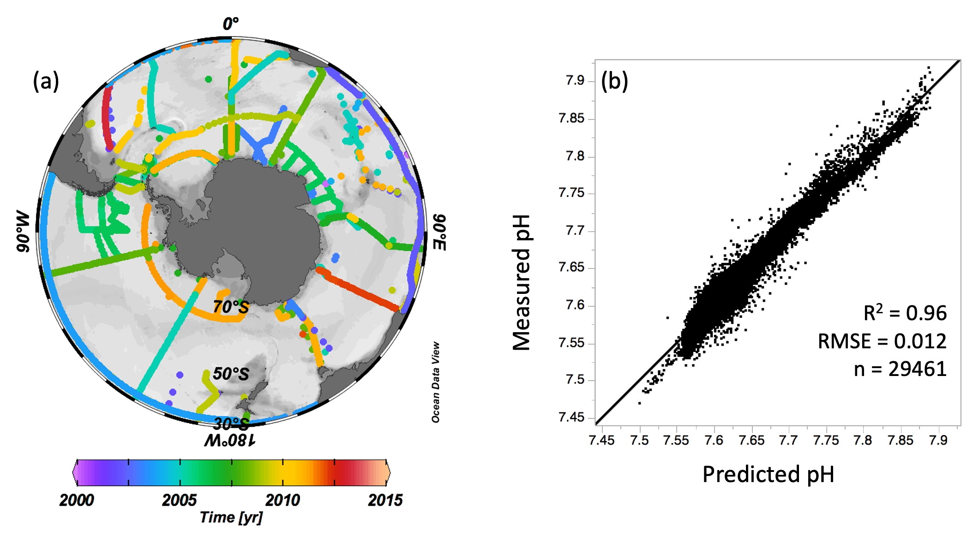
Figure S1. (a) Map of cruise data used to construct the parameterization of pH in the SO (Pacific Sector: 150°E – 60°W; Indian Sector: 20°E – 150°E; Atlantic Sector: 60°W – 20°E). The color shows the observation year of each cruise. This figure was created using Ocean Data View ²⁷. (b) Relationship between predicted pH and measured pH from surface mixed layer to bottom depth. The notation ‘n’, R² and RMSE indicate the number of data points, the coefficient of determination and the root-mean-square error, respectively.
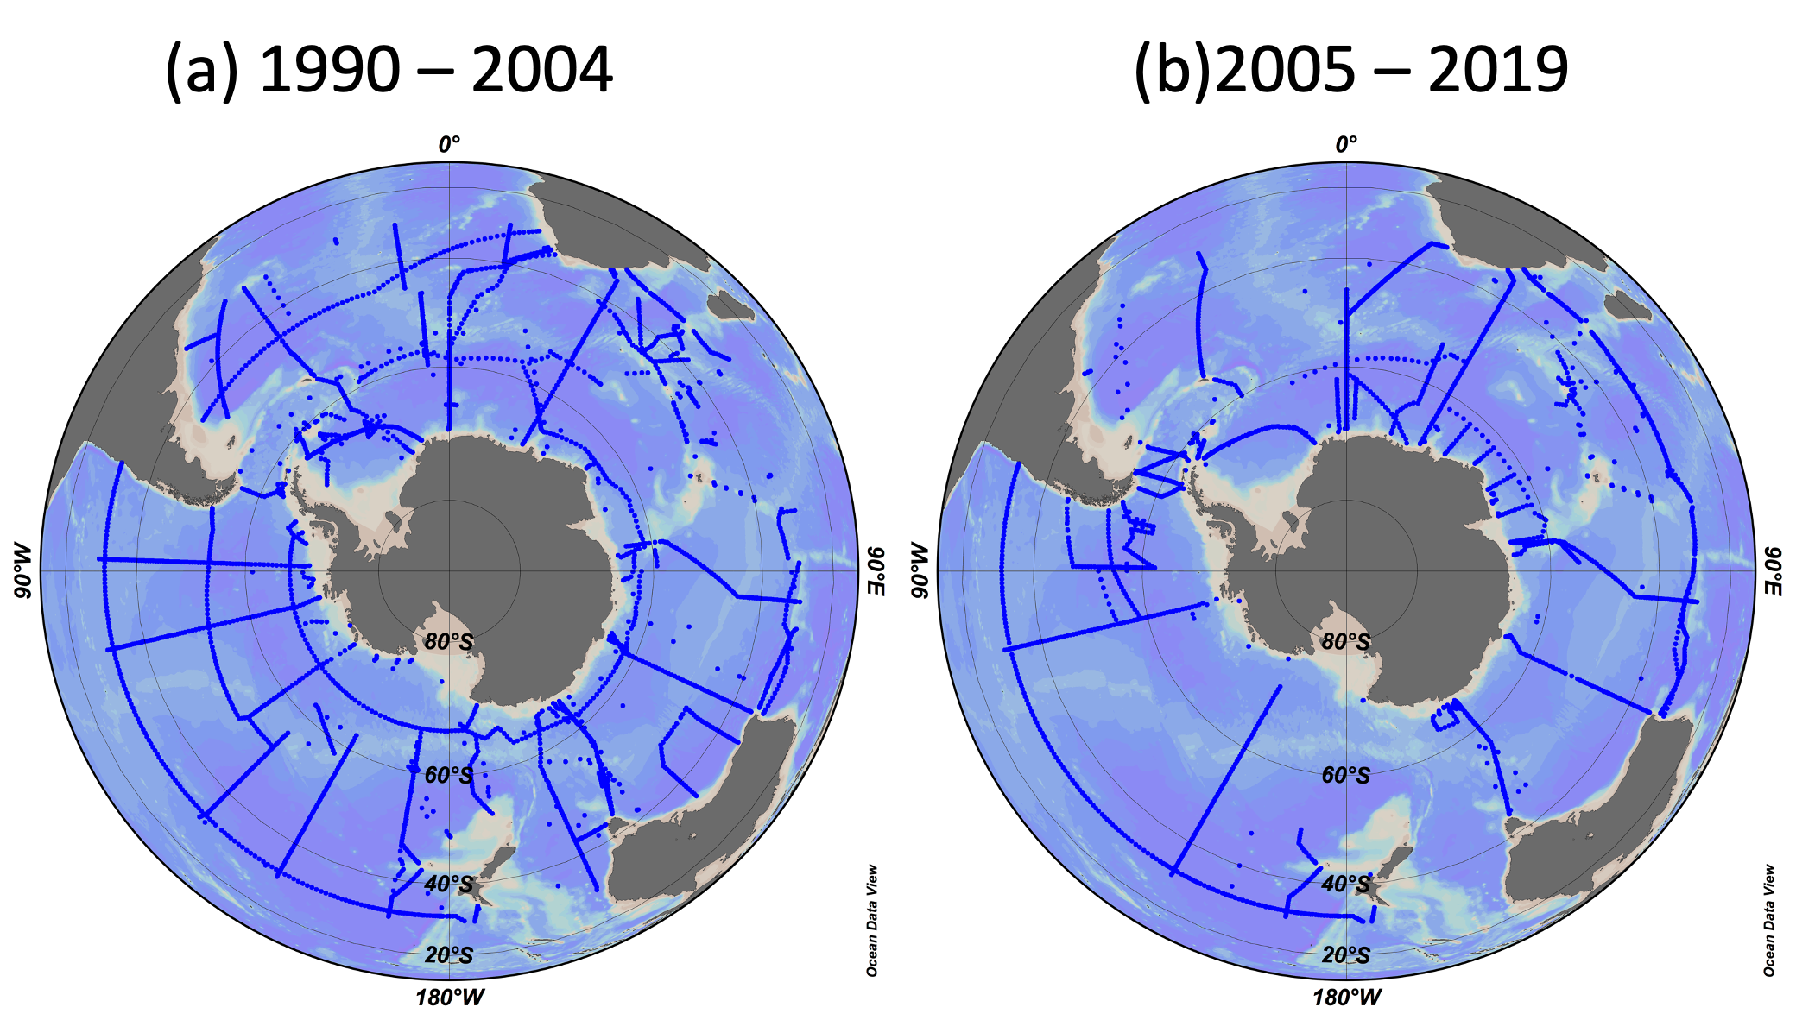
Figure S2. Map of cruise data used to estimate the decadal variations of natural and anthropogenic components. (a) Data during 1990‒2004, (b) Data during 2005‒2019. These figures were created using Ocean Data View ²⁷.
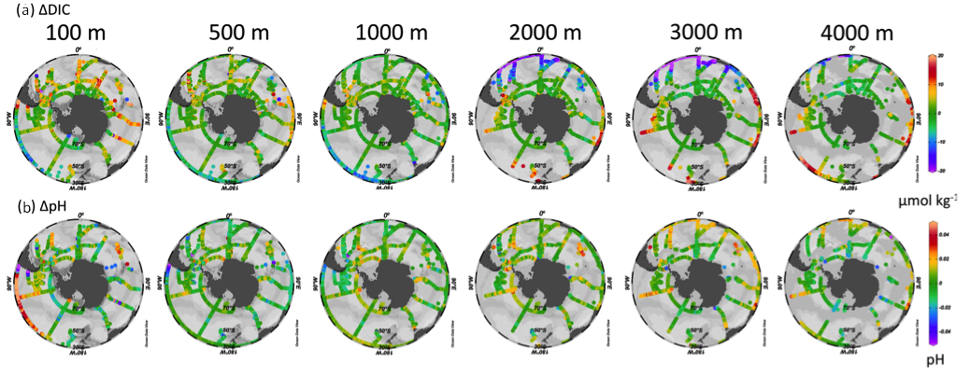
Figure S3. Comparisons of predicted values and observed values for (a) DIC and (b) pH using data in Fig. S1(a).
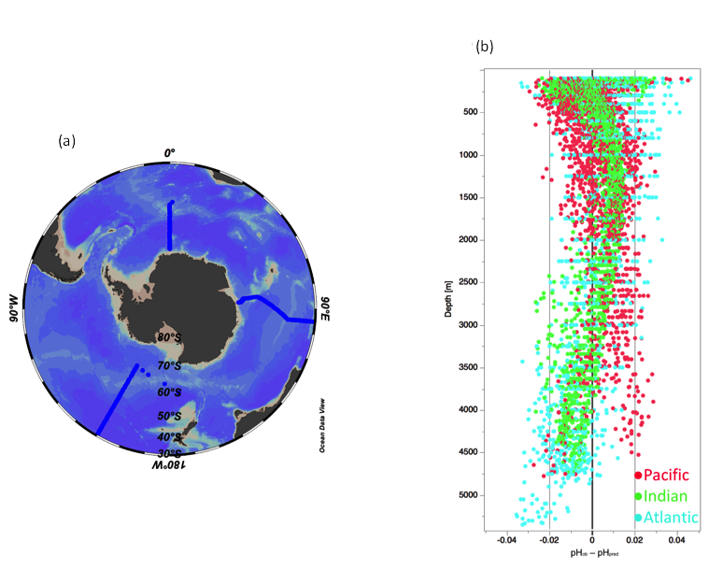
Figure S4. The differences between the observed pH (pH_{ob}) and the predicted pH (pH_{pred}) (pH_{ob} – pH_{pred}) for the data used in three independent cruises. (a) Map of the three independent cruises. (b) pH_{ob} – pH_{pred.} Red, green and blue dots showed the data from the cruises of the Pacific, Indian and Atlantic, respectively.
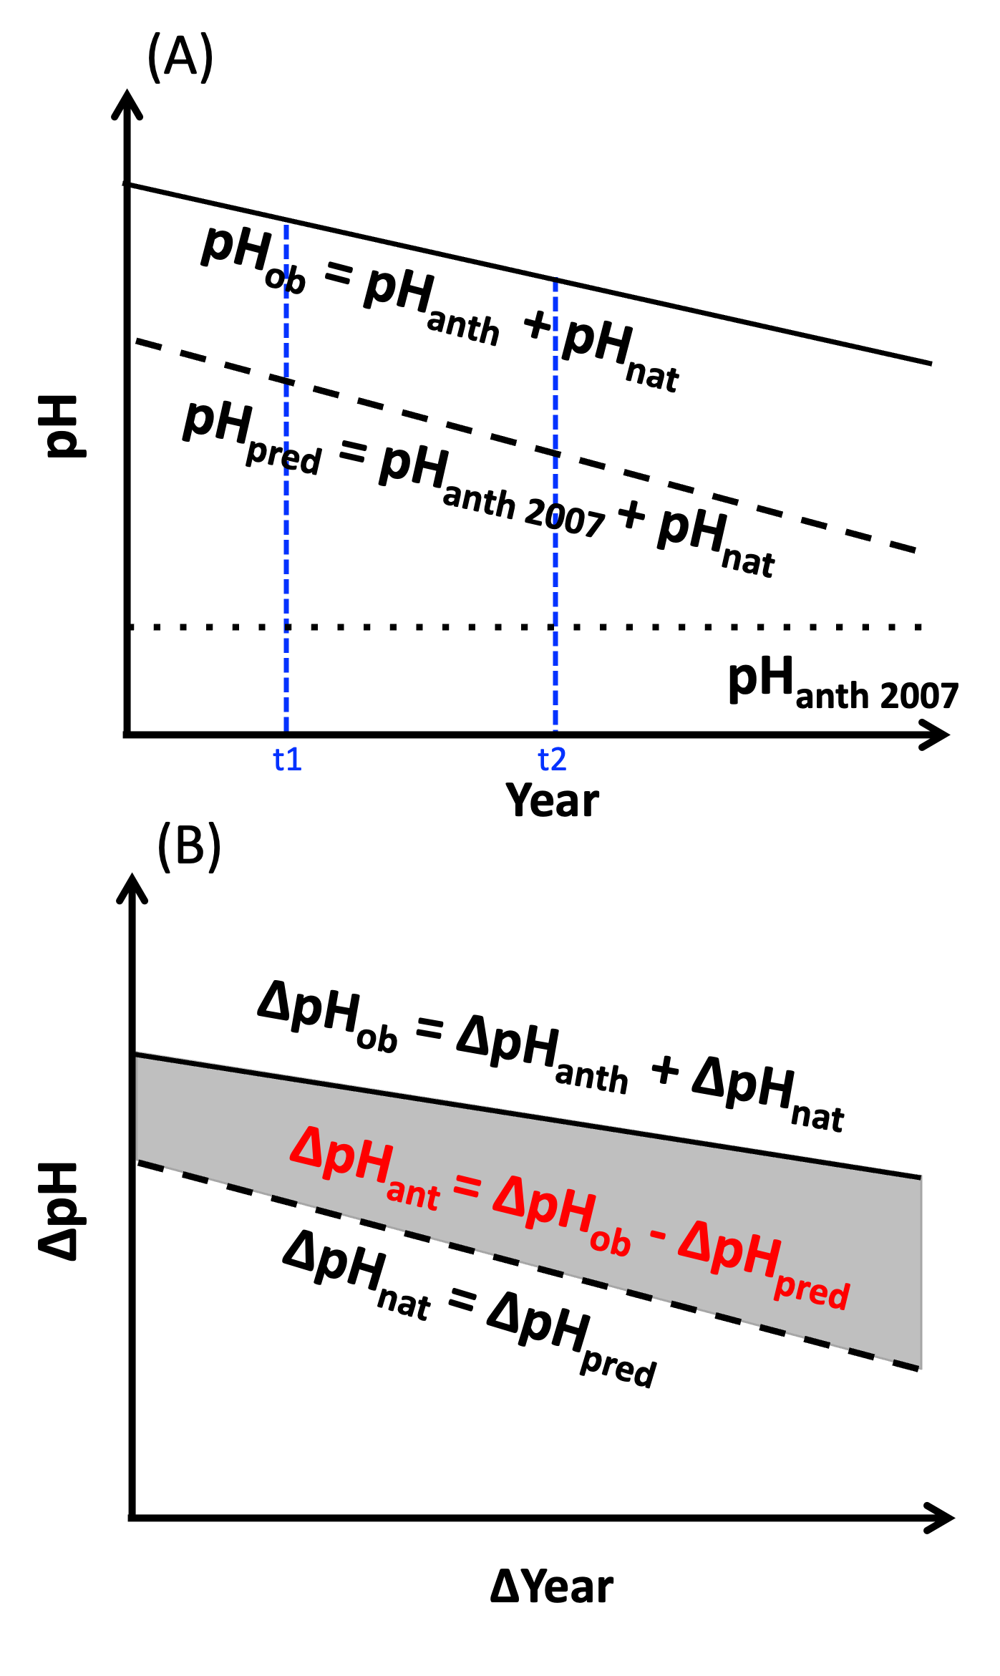
Figure S5. Schematic illustration of the method used to distinguish anthropogenic pH (pH_{anth}) and natural pH (pH_{nat}). In (a), the solid line indicates the observed pH (pH_{ob}); the dashed line indicates the predicted pH (pH_{pred}); the short-dashed line indicates the pH_{anth} in 2007 (pH_{anth, 2007}), which can be assumed to be constant with time. In (b), the solid line indicates the change in observed pH (ΔpH_{ob}) between arbitrary different years; the dashed line indicates the change in pH_{nat} (ΔpH_{pred}) between arbitrary different years; the shadowed area between the solid and dashed lines shows the change in pH_{anth} (ΔpH_{anth}) (the difference between ΔpH_{ob} and ΔpH_{pred}) between arbitrary different years.
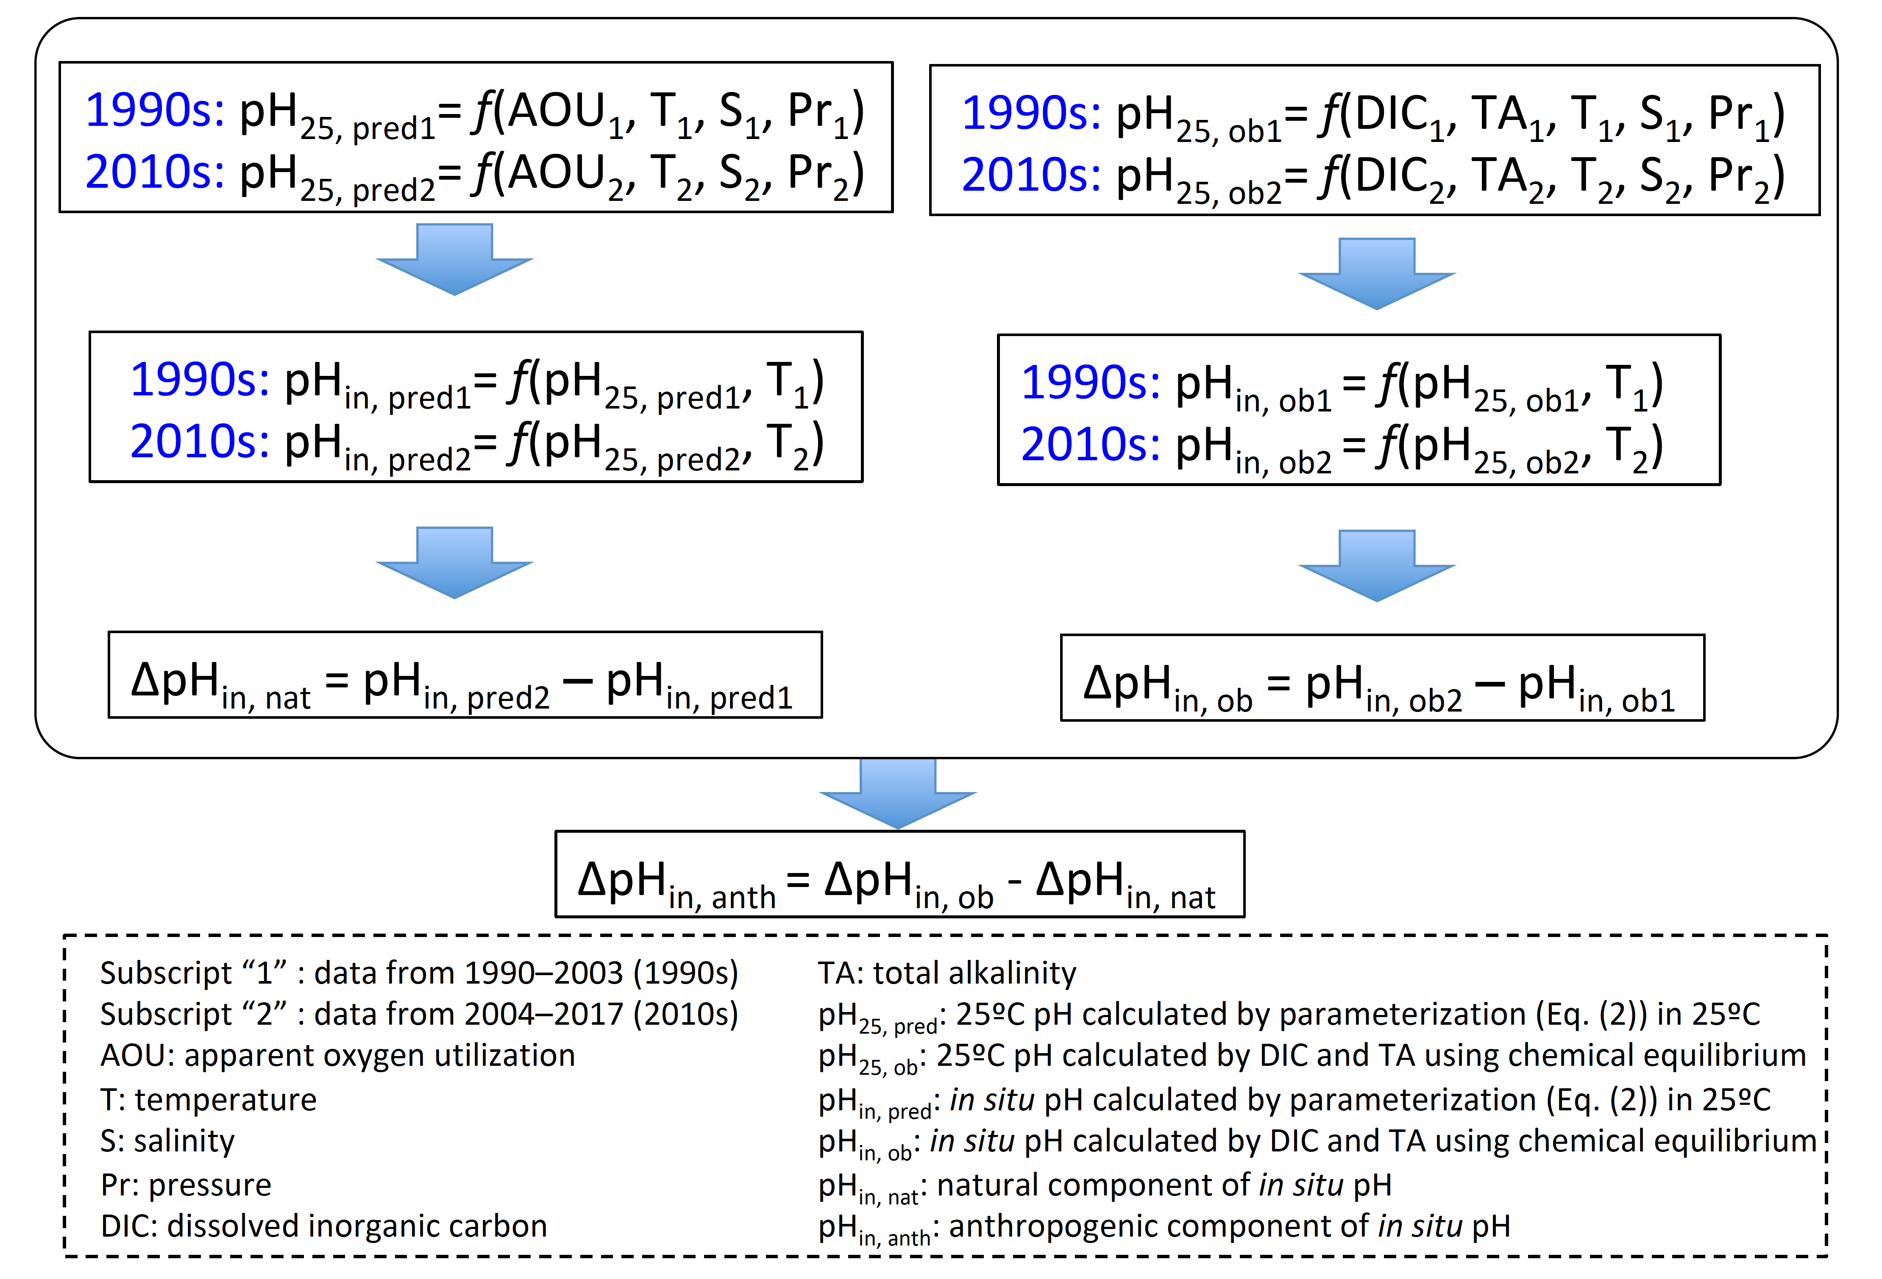
Figure S6. Flowchart for calculating anthropogenic in situ pH (pH_{in, anth}). The abbreviations of each parameter were introduced in the bottom of this figure.
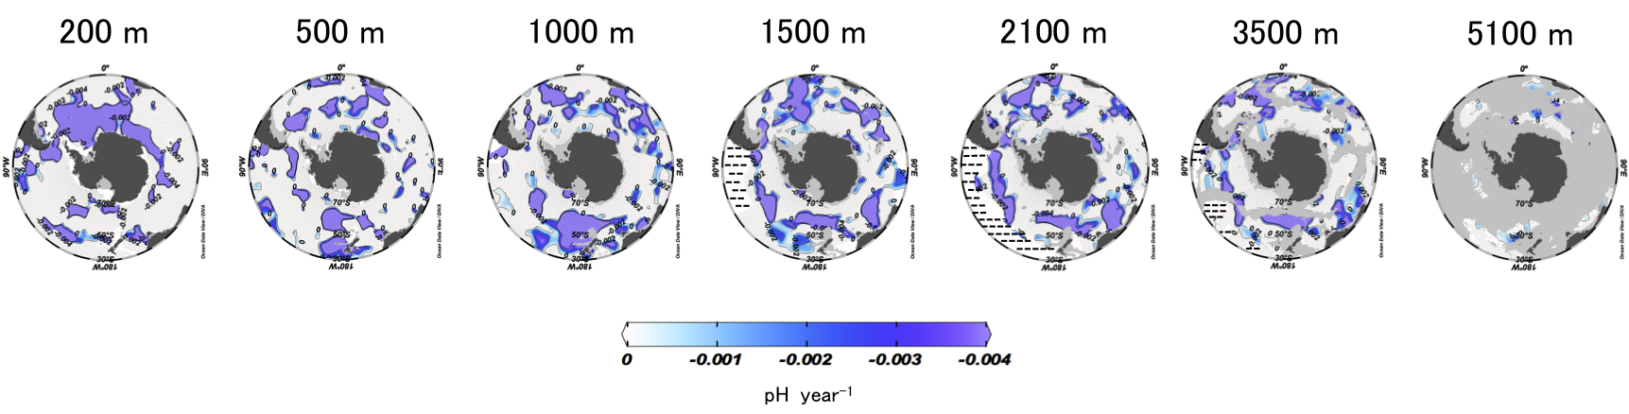
Figure S7. Horizontal distributions of the annual rate of change in pH_{in anth} (∆pH_{in anth}/∆t, pH unit year⁻¹) during 1990s to 2010s. See the calculation procedure in Fig. S6. These figures were created using Ocean Data View ²⁷.
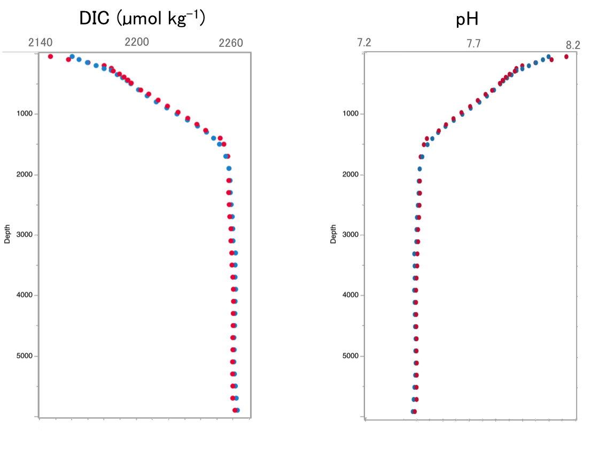
Figure S8. Vertical distributions of average DIC and pH for summertime (red circle) and wintertime (blue circle) based on the data during periods from 2000 to 2017 south of 30°S. Differences between summertime and wintertime indicate seasonal variations.
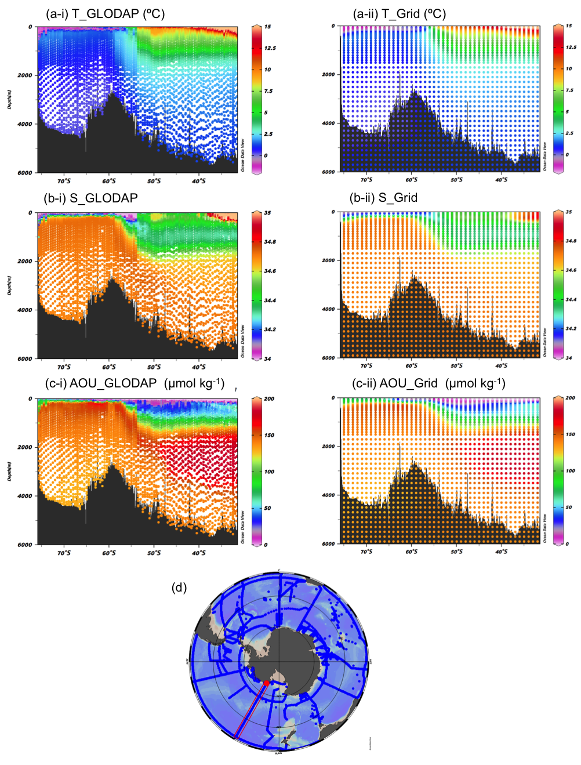
Figure S9. Vertical section of (a) T (ºC), (b) S, and (c) AOU (µmol kg⁻¹) along (d) GLODAP repeat line (150ºW). (i) GLODAP data and (ii) Grid data. These figures were created using Ocean Data View ²⁷
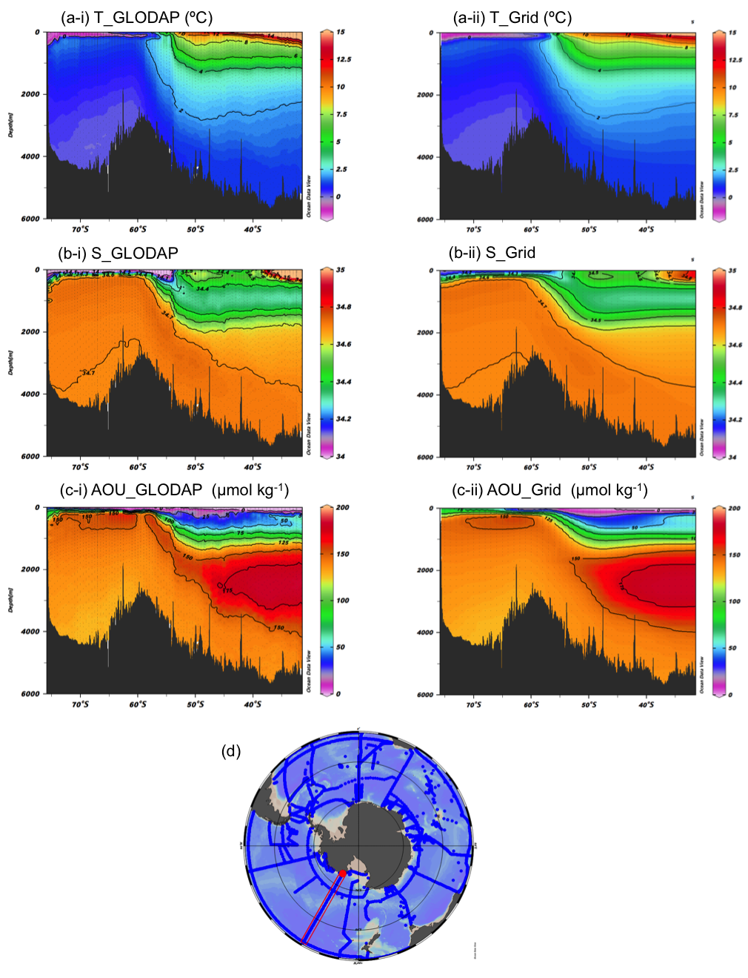
Figure S10. Vertical section of (a) T (ºC), (b) S, and (c) AOU (µmol kg⁻¹) along (d) GLODAP repeat line (150ºW). (i) GLODAP data and (ii) Grid data. These figures were interpreted based on original data of Fig. S13. These figures were created using Ocean Data View ²⁷.
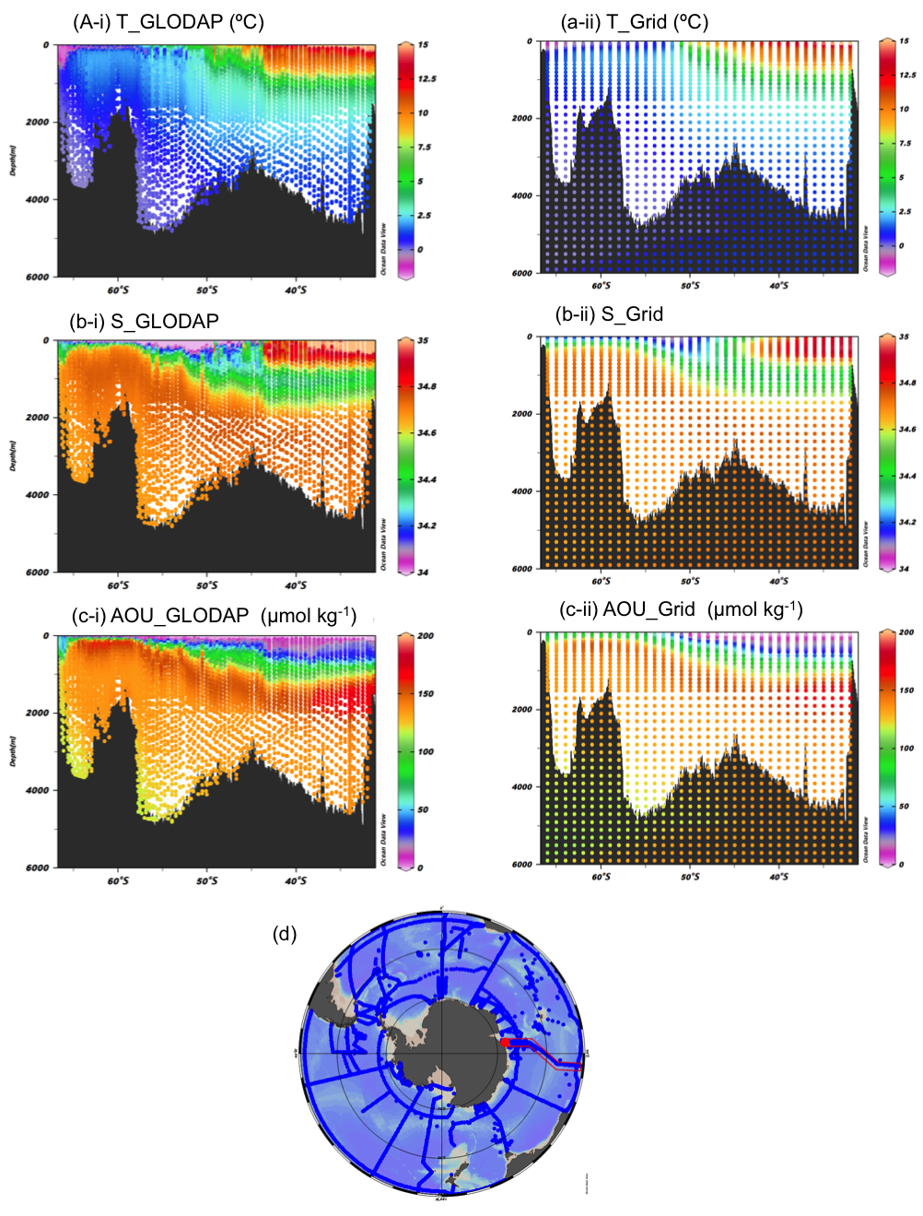
Figure S11. Vertical section of (a) T (ºC), (b) S, and (c) AOU (µmol kg⁻¹) along (d) GLODAP repeat line (90ºE). (i) GLODAP data and (ii) Grid data. These figures were created using Ocean Data View ²⁷.
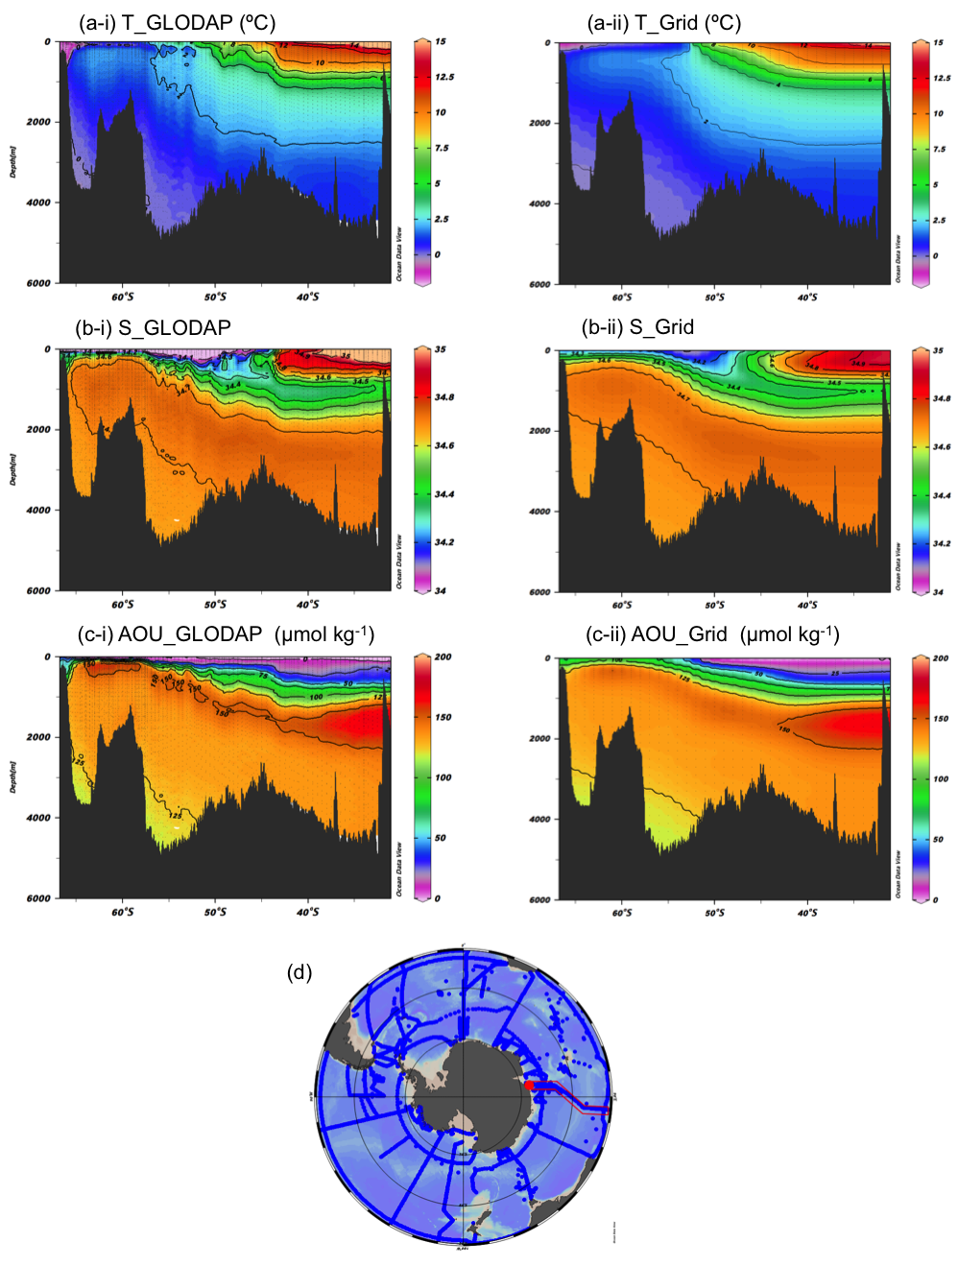
Figure S12. Vertical section of (a) T (ºC), (b) S, and (c) AOU (µmol kg⁻¹) along (d) GLODAP repeat line (90ºE). These figures were interpreted based on original data of Fig. S11. (i) GLODAP data and (ii) Grid data. These figures were created using Ocean Data View ²⁷.
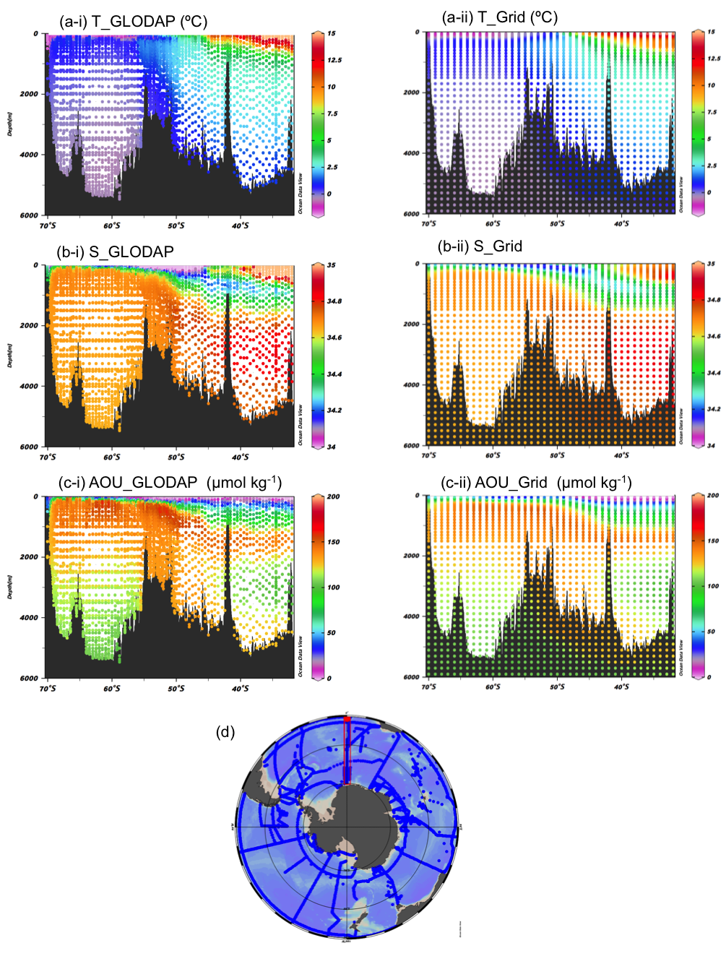
Figure S13. Vertical section of (a) T (ºC), (b) S, and (c) AOU (µmol kg⁻¹) along (d) GLODAP repeat line (0ºE). (i) GLODAP data and (ii) Grid data. These figures were created using Ocean Data View ²⁷.
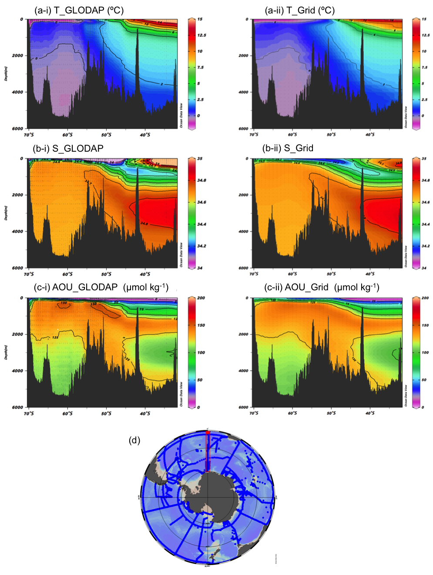
Figure S14. Vertical section of (a) T (ºC), (b) S, and (c) AOU (µmol kg⁻¹) along (d) GLODAP repeat line (0ºE). GLODAP data and (ii) Grid data. These figures were interpreted based on original data of Fig. S9. These figures were created using Ocean Data View ²⁷.

