Supplementary Figures

Fig. S1 Quality control summary for scRNA-seq and scATAC-seq. (A) Violin plots showing distributions of QC metrics for scRNA-seq. Median (points) and 25th and 75th quantiles (whiskers and narrow bars) are overlaid on violin plots. Median values are also in Supplementary Table S2. From left to right are QC plots for percent of mitochondrial gene reads, percent of ribosomal gene reads, number of transcripts per cell, number of genes per cell, and complexity (number of genes detected per UMI). The QC metrics indicate the high quality of scRNA-seq data. (B) UMAP colored by samples (left) and cell types (right) in the scRNA-seq cells from all the samples. scRNA-seq cells are diffused evenly across the sample space, demonstrating a good integration across samples without batch effect. (C) Violin plots showing distributions of QC metrics for scATAC-seq. Median (points) and 25th and 75th quantiles (whiskers and narrow bars) are overlaid on violin plots. Median values are also in Supplementary Table S2. From left to right are QC plots for percent of mitochondrial gene reads, fraction of reads in TSS, fraction of reads in peaks, number of unique fragments per cell, and TSS enrichment. The QC metrics indicate the high quality of scATAC-seq data. (D) UMAP colored by samples (left) and cell types (right) in the scATAC-seq cells from all the samples. Color palette is the same as Fig. S1B. scATAC-seq cells are diffused evenly across the sample space, demonstrating a good integration across samples without batch effect. (E) Cluster purity of each cluster across cell types. Cluster purity is the percentage of the cells of most abundant cell type. B naive, CD14 Mono, CD16 Mono, MAIT, and NK displayed the highest purity while purity scores for T cell subsets were more diverse across clusters and relatively lower.
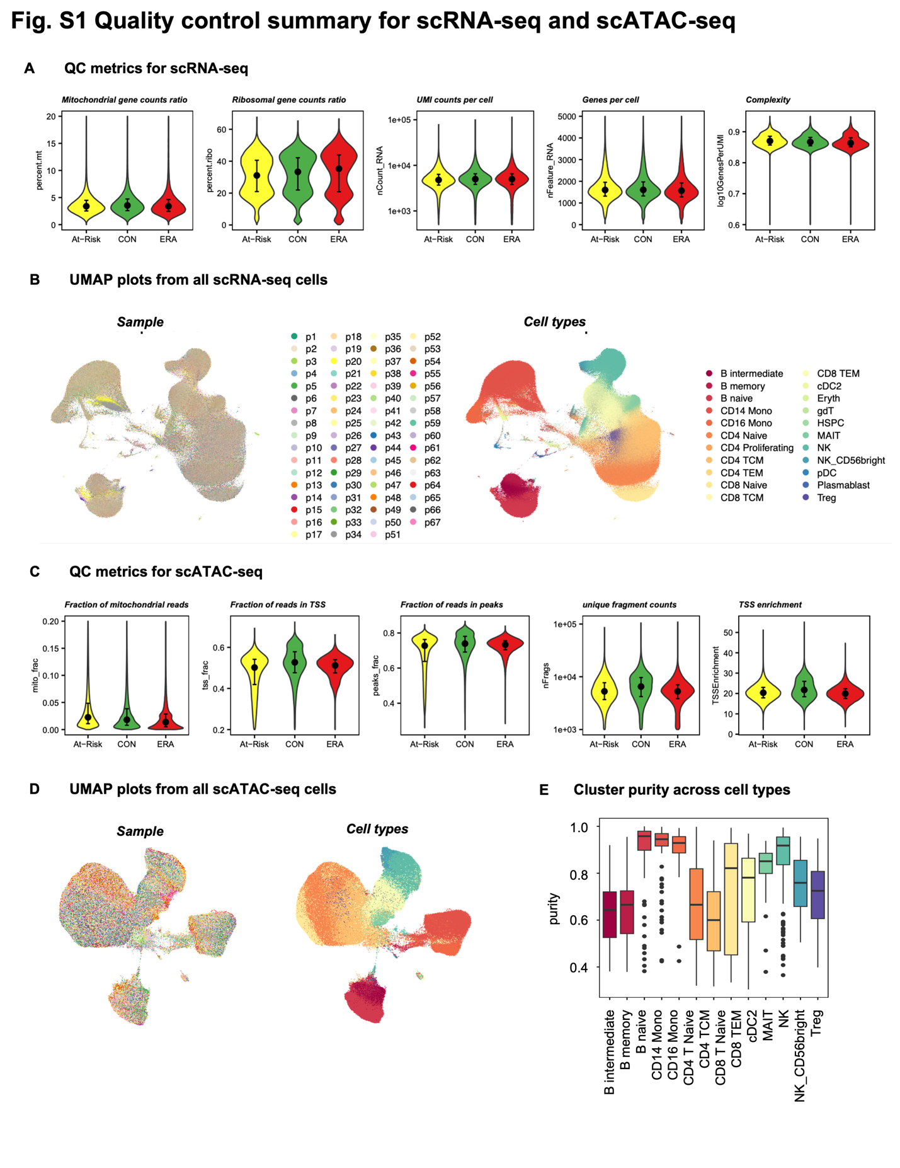

Fig. S2 Unsupervised clustering shows distinct TF regulatory patterns. (A) PCA for dimension reduction of the TF score matrix. The cumulative proportion of variance explained increased with a larger number of principal components (PCs). The first 300 PCs were kept according to the “elbow” method, which explained 85% variance. (B) First and second PCs of all clusters with color coded by cell types and shape coded by disease state. Circle represents ERA; triangle represents CON and square represents At-Risk. Each point is one cluster. Clusters are mostly separated by cell types instead of disease states. (C) Selecting the best distance metric and number of K according to the Silhouette metric. The Pearson correlation was chosen and K=5 was the ideal number, marked as the red point in the figure. (D) PageRank scores heatmap of all TFs across all clusters. TFs in rows (z-normalized), clusters in columns ordered by Kmeans group, and color of the cell in the matrix indicates the normalized PageRank scores with red displaying high scores. A group of TFs are significantly active in G2. (E) Intersection size of Kmeans group-specific TFs. Each group has its own unique set of active TFs. (F) Overlap of G2-specific TFs between At-Risk and ERA group. (G) Overlap of top 20 enriched pathways between At-Risk and ERA group. (H) G2 clusters per cell type of the total clusters per cell type in CON and At-Risk/ERA respectively. Labels within the bar follow the following format: number of G2 clusters (percentage of the total clusters).
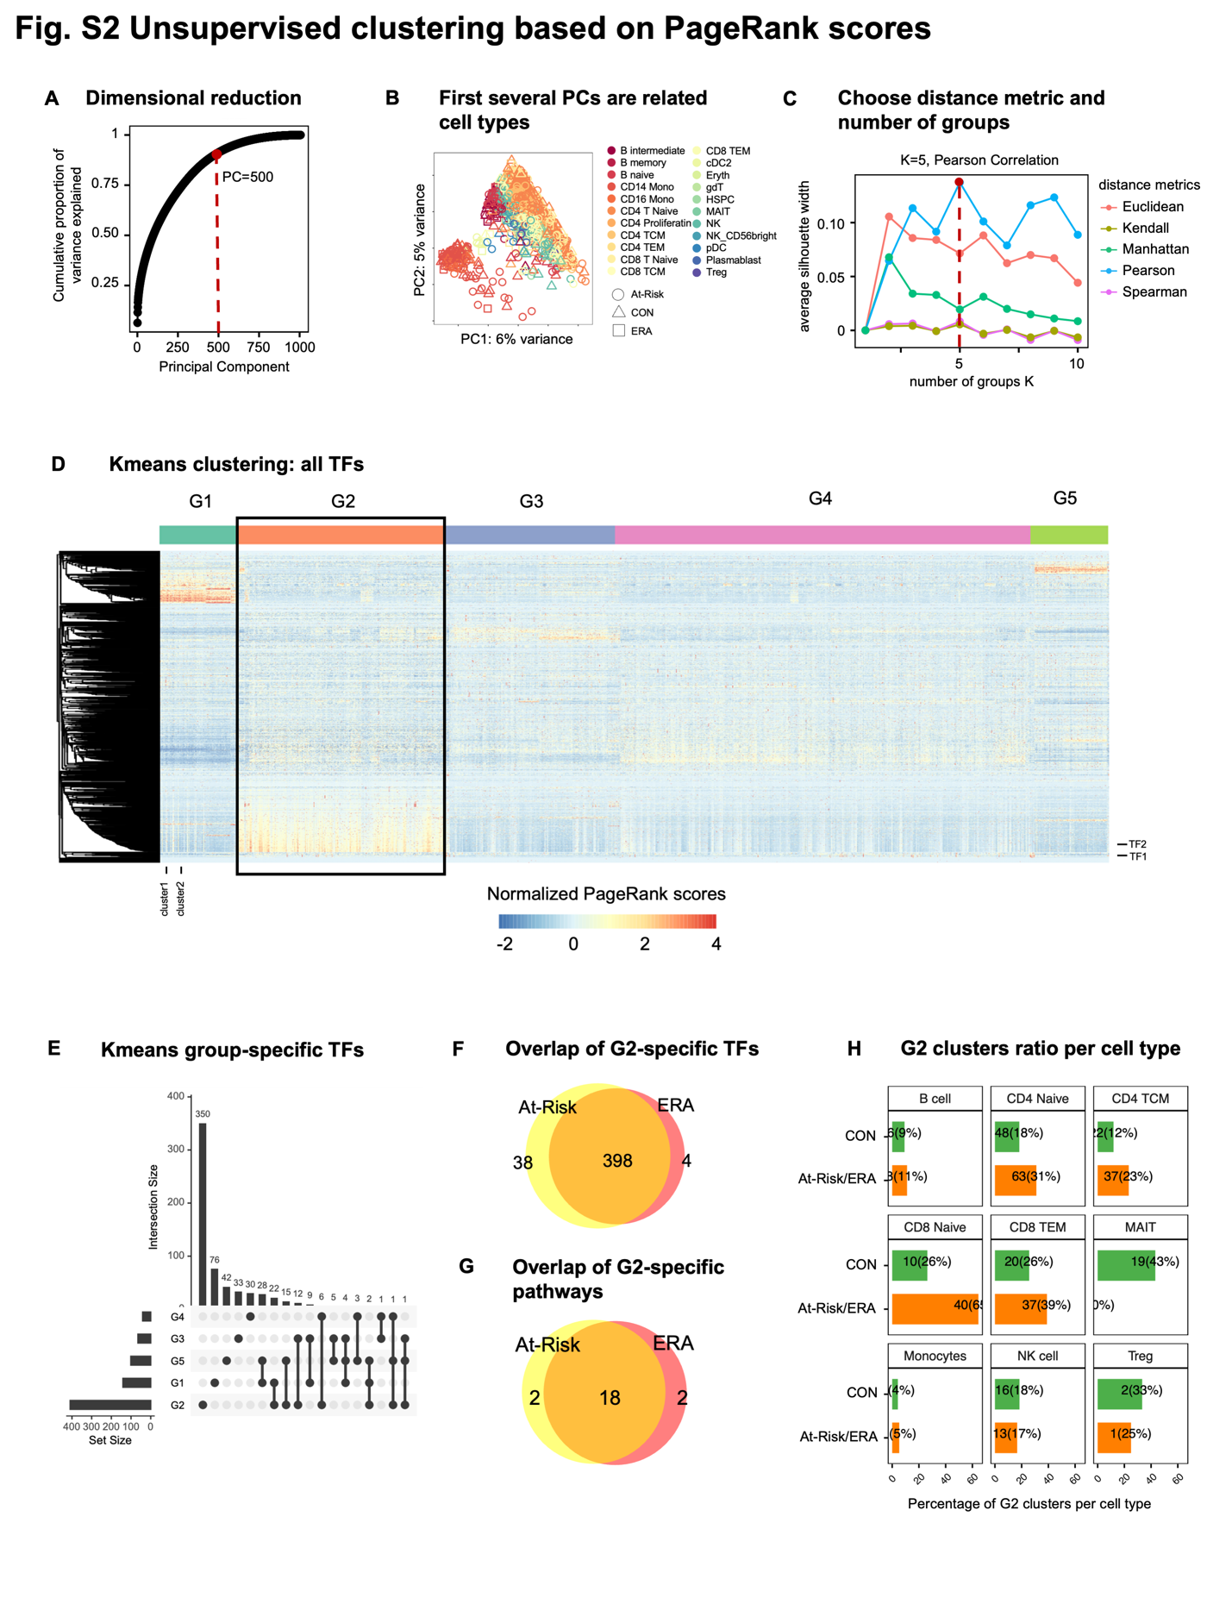

Fig. S3 At-Risk/ERA signature is shared across multiple cell types. (A) G2-specific TFs whose regulatees are enriched in At-Risk/ERA signature pathways. The horizontal axis represents TFs, and the vertical axis represents signature pathways. (B) Heatmap of all participants in G2 across cell types. The horizontal axis shows the individual participants and the vertical axis shows each cell type. Top bar represents the disease states of participants. Color represents the percent of clusters per total clusters per cell type for each participant. All the At-Risk and ERA participants had the signature in at least one cell type but not all CON participants had the signature. MAIT and Treg cells showed higher enrichment in CON while other T cells showed higher enrichment in At-Risk/ERA. (C) Reactome pathways enriched in the top 500 downstream genes of SUMOylation-related G2-specific TFs. The horizontal axis represents TFs and the vertical axis represents pathways. Circle size represents the number of regulatees in the pathway and color represents the adjusted p-values. (D) Intersection of TFs enriched in 5 representative signature pathways. The side horizontal bars are the original size of each pathway. RUNX2 pathway shared 3 TFs with NOTCH3 pathway, 2 TFs with SUMO pathway, and 1 TF with Wnt pathway. YAP1 has its own distinct set of TFs and have no overlap with other signature pathways.

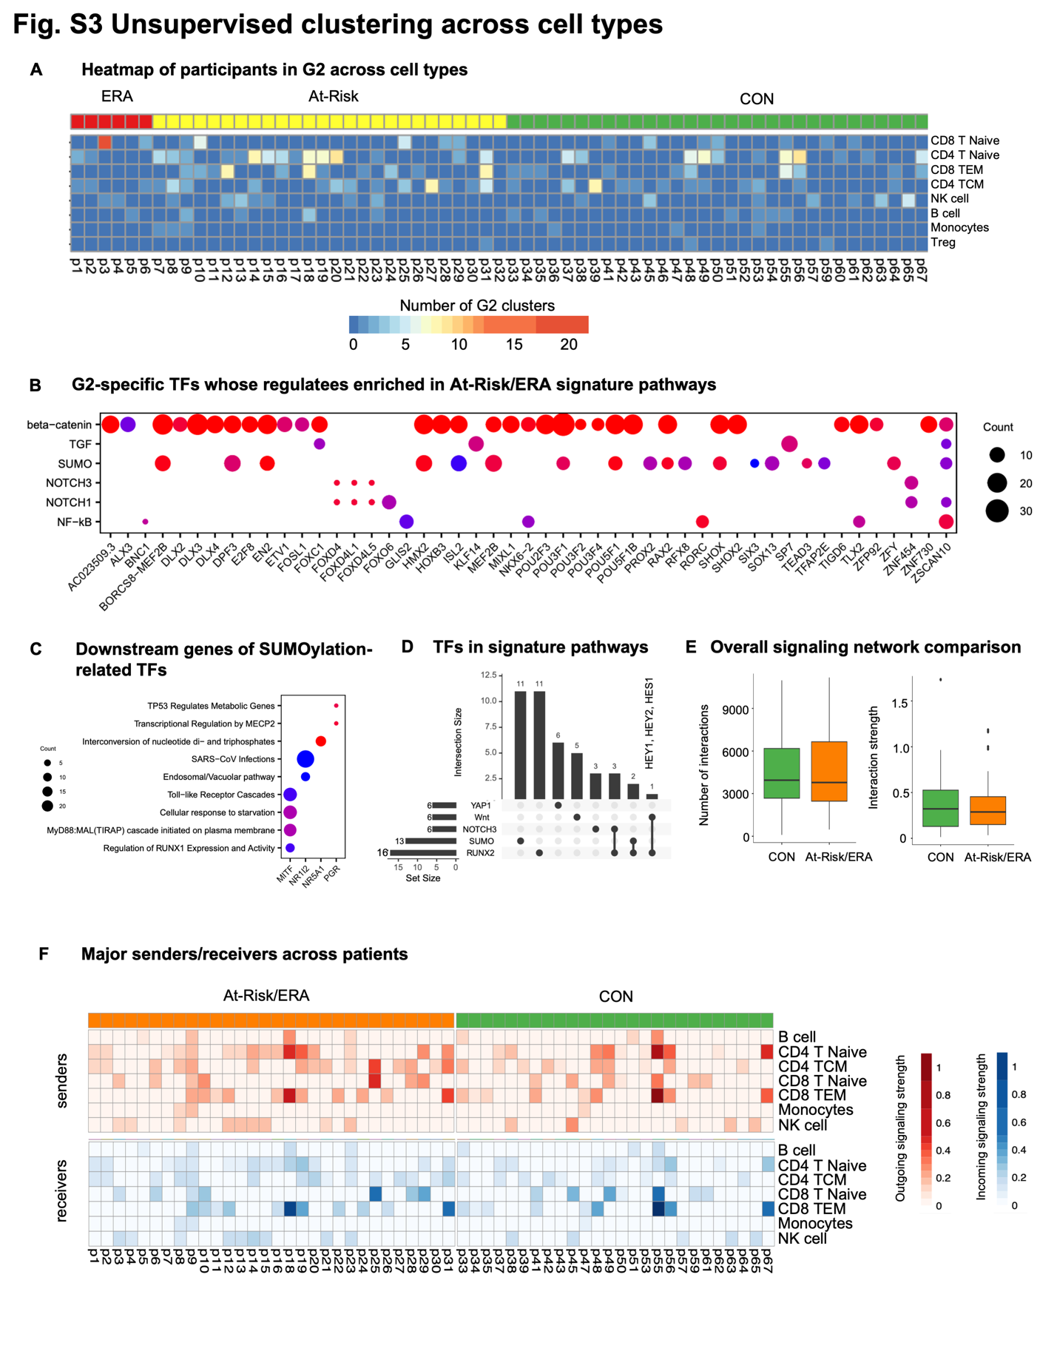

Fig. S4 Cellular network comparison between two groups. (A) Comparison of overall intercellular interactions between control and At-Risk/ERA groups, which didn’t show any significant difference on account of number and intensity of interactions. (B) Sum of outgoing and incoming signaling strength across all signaling pathways in control and At-Risk/ERA groups. The horizontal axis represents the cell types and the vertical axis represents each individual. Gradient red colors represent the total outgoing signaling strength with red displaying higher values. Gradient blue colors represent the total incoming signaling strength with blue displaying higher values. At-Risk/ERA has higher outgoing and incoming signals compared to control. (C) Representative TGF-β signaling networks within signature clusters in control and At-Risk patients. (D) Outgoing and incoming signaling strength of TGF-β pathway across cell types in control and At-Risk/ERA groups. (E) Representative CD160 signaling networks within signature clusters in control and At-Risk patients. (F) Outgoing and incoming signaling strength of CD160 pathway across cell types in control and At-Risk/ERA groups; Wilcoxon rank-sum test, *p < 0.1, **p < 0.05, ***p < 0.01.

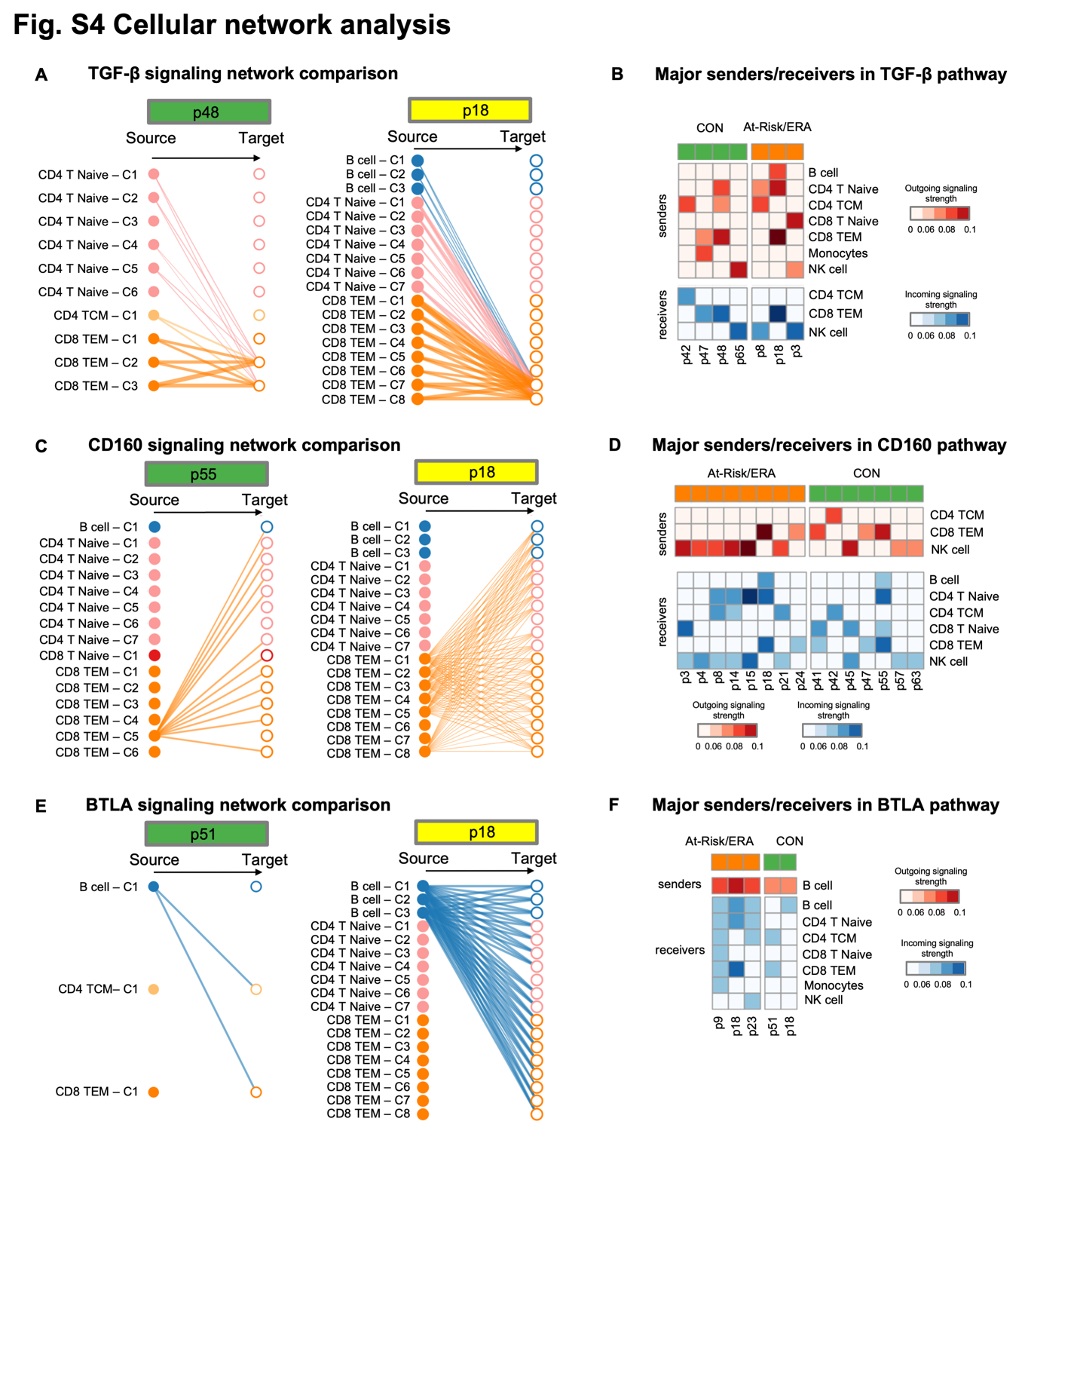

Fig. S5 Kmeans clustering based on gene expression. (A) Performance of random forest classification model to distinguish controls and At-Risk/ERAs. x-axis represents the number of predictors and y-axis represents the accuracy with dot as mean and the error bar as standard deviation. The test performance was monotonically increasing with more predictors. (B) Row-wise normalized probability of cell types having the maximum expression of each gene in At-Risk/ERAs. Rows represent genes and columns represent cell types. Red cell represents a higher probability of the high gene expression in the specific cell type. Each cell type has its own set of highly expressed genes. For instance, ADAMTSL4 and CXCL16 in monocytes, NOTCH1 in Treg cells. (C) TGFB1 gene expression levels in diverse cell types across At-Risk/ERAs. (D) Selecting the best distance metric and number of Kmeans group according to the Silhouette width. The Pearson correlation was chosen and K=5 was the ideal number, marked as the red point in the figure. (E) Mosaic plot showing the association between disease state and Kmeans groups. G1 has slightly higher enrichment in At-Risk/ERA but not statically significant. The disease state and Kmeans groups didn’t have clear association. (F) Normalized gene expression values heatmap of all TFs across all clusters. TFs in rows (z-normalized), clusters in columns. Both columns and rows are hierarchically clustered, and color of the cell in the matrix indicates the normalized gene expression with red displaying high expression values. Different groups displayed different TF activity patterns.

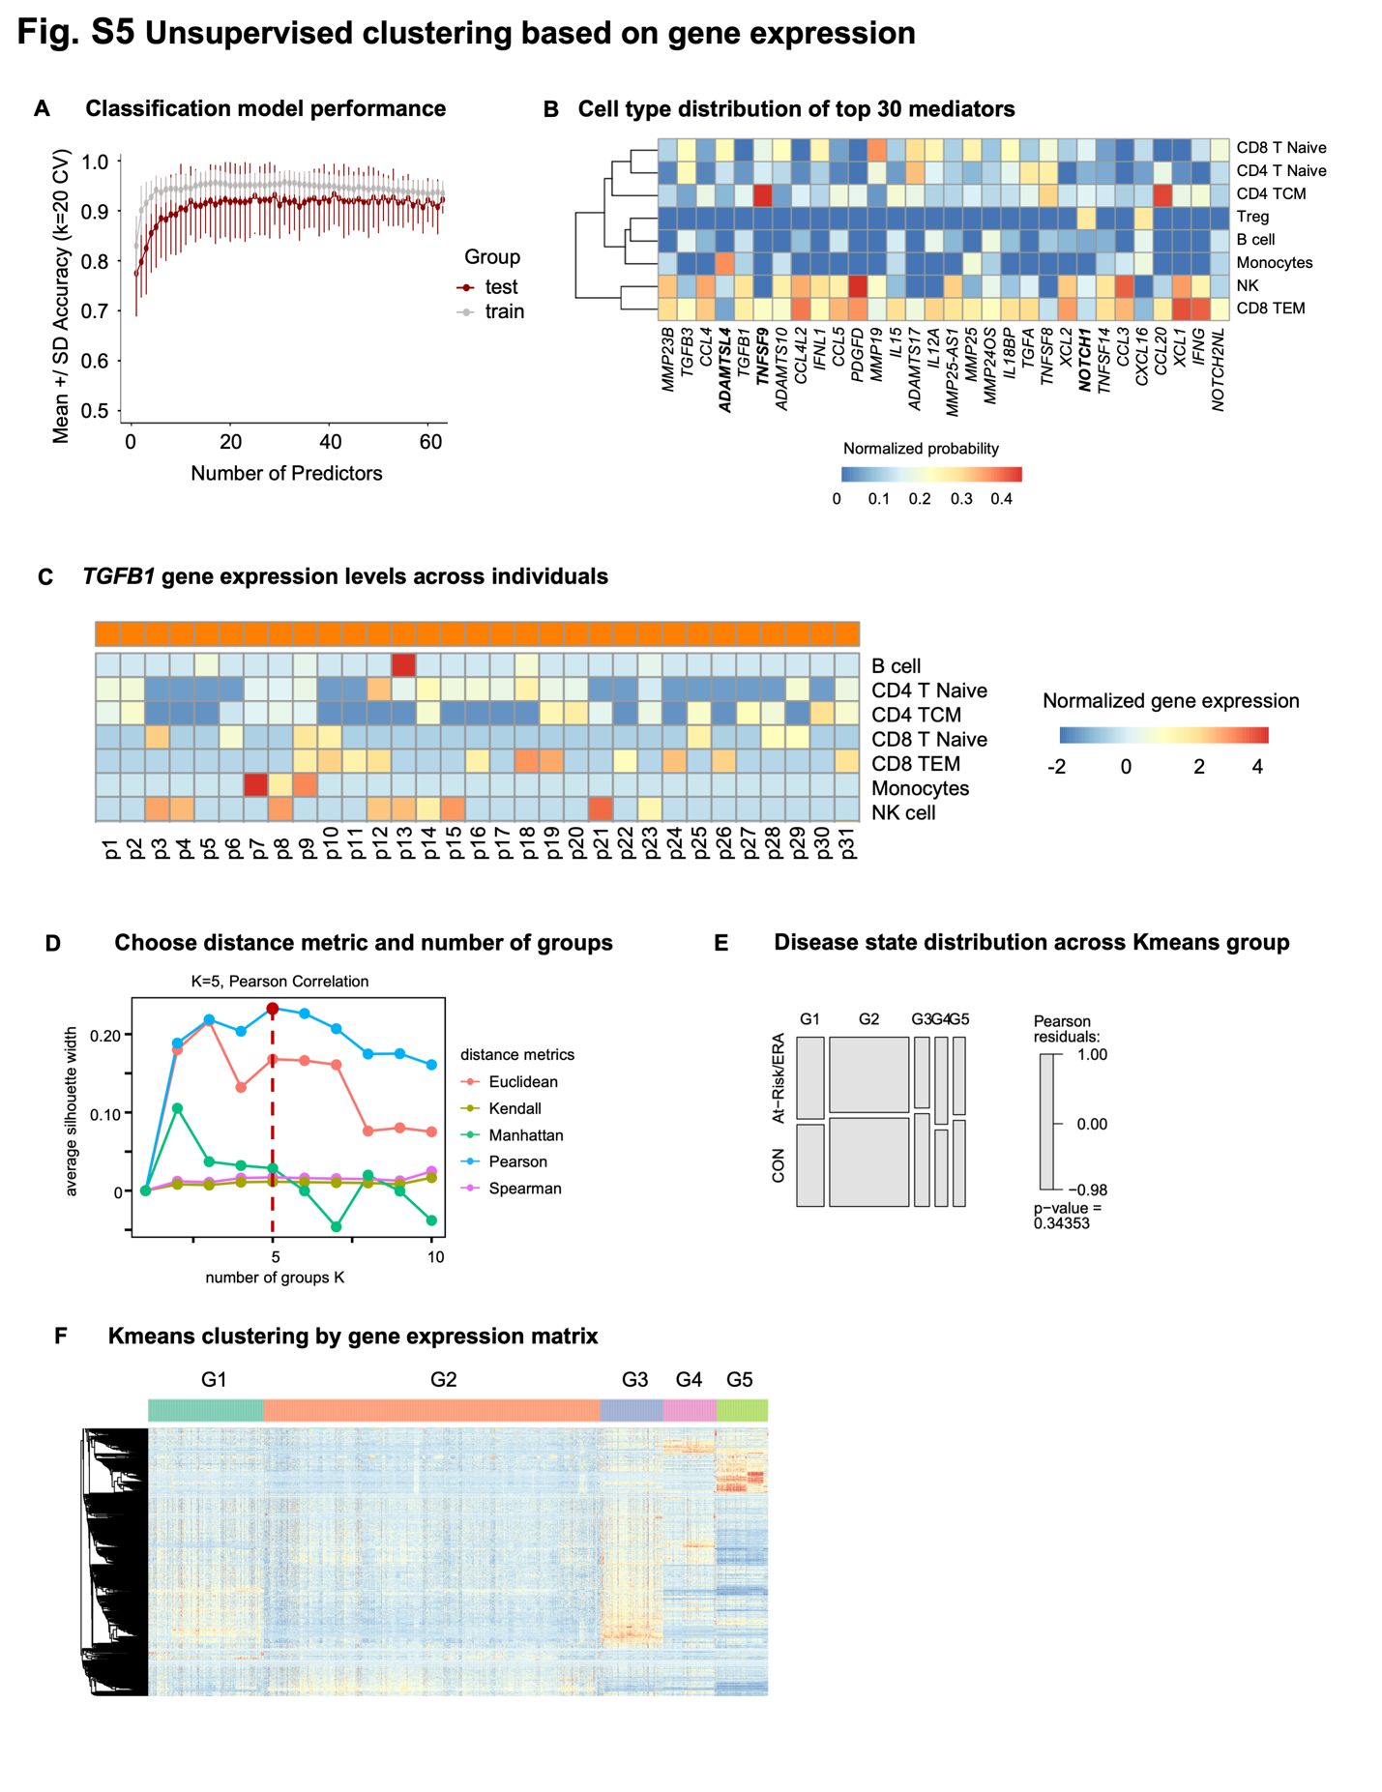

Supplementary Tables

Supplementary Table S1. Summary of cohort information

Supplementary Table S2. QC metrics summary for each sample

Supplementary Table S3. Cell counts in samples across different cell types

Supplementary Table S4. Co-embedded cluster distribution in Kmeans groups

Supplementary Table S5. Identified Kmeans group-specific TFs

Supplementary Table S6. Co-embedded cluster counts in Kmeans groups across disease states

Supplementary Table S7. Co-embedded cluster counts in Kmeans groups across cell types

Supplementary Table S8. Identified signature pathways with signature TFs and its representative downstream genes.

Supplementary Table S9. Curated pathogenic gene list

Supplementary Table S10. Pathway enrichment statistics for the identified Kmeans group-specific TFs (p.adjust<0.05)

Supplementary Table S11. Heatmap statistics for the comparison with AMP study in figure 6.

Supplementary Notes

Advantages of Taiji framework
We measured single cell chromatin accessibility and transcriptomic profiles of PBMCs of At-Risk individuals, ERA patients and controls. Rather than relying on individual technologies and datasets to understand important pathways, we used a novel integrative analysis (Taiji)¹² to identify potential pathogenic pathways and cell types. This method uses chromatin accessibility for TF motifs and transcription of the putatively regulated genes to prioritize TFs based on their functional relevance in a particular cell.

Taiji was previously used by our group to identify critical TFs in primary fibroblast-like synoviocytes isolated from RA synovium⁴⁴. We were able to stratify RA patients into two groups based on divergent functions of multiple TFs and pathways. Extensive biologic validation confirmed the Taiji computational predictions related to TFs like RARA and showed that individual TFs could have diametrically opposed functions in individual patients.

Using this integrative analysis, we now report that distinctive TF profiles are significantly enriched in At-Risk and ERA individuals compared to controls in multiple cell types, especially in CD8 and CD4 T cells. This is the first time that Taiji framework has been applied to integrative single cell analysis.

Unsupervised clustering of our data based on Taiji prediction delineated five groups of individuals with distinctive TF activity profiles. At-Risk/ERA-enriched signature pathways were found in G2. Of interest, CON-enriched pathways were found in G4 and included pathways like RUNX3 that can be protective. It’s worth noting that unsupervised clustering using solely gene expression profiles failed to reveal significant cohort enrichment and demonstrates the importance of integrating multiple omics data types (Supplementary Fig. S5D-F). These results support the importance of PageRank over individual gene expression or open chromatin analyses to delineate TF activities and differences across cohorts.

G2 At-Risk/ERA TF signature is enriched for pathways implicated in RA pathogenesis
A complete review of the biology of each pathway enriched in the TF signature is beyond the scope, but it is useful to point out some of the key features and genes and their potential relationship to RA.

Sumoylation pathway. Sumoylation plays important regulatory roles in synovial fibroblast biology including cell survival, inflammatory responses, and matrix metabolism¹⁸. Several SUMO related pathways including SUMOylation, SUMO E3 ligases SUMOylate target proteins, and SUMOylation of intracellular receptors were enriched in G2 (Supplementary Table S10). For example, several NR family members (NR1I2, NR5A1, PGR) and MITF were found in G2 (Supplementary Table S10). These TFs also regulate genes significantly enriched in RA-related pathways including RUNX1, Toll-like receptors, MECP2, and TP53 pathways (Supplementary Fig. S3C). NR1I2 regulates HLA-G, which plays an important role in RA susceptibility and regulation.

RUNX2 and NOTCH3 pathways. While most signature pathways possessed distinctive sets of active TFs, the RUNX2 pathway shared 37.5% TFs with other signature pathways, particularly with the NOTCH3 pathway (Supplementary Fig. S3D), which suggests the interdependence between RUNX2 and other signature pathways. For instance, three TFs (HEY1, HEY2, and HES1) were identified in both NOTCH3 and RUNX2 pathways and regulate osteoblast function⁴⁵. NOTCH genes and signaling also play a critical role in the differentiation of synovial fibroblasts into pathogenic cells⁴⁶.

YAP1 pathway. Recent evidence suggests a critical regulatory role of the Hippo pathway in the RA pathogenesis. As one of the key components, YAP promotes the localization of SMAD3 in RA fibroblast-like synoviocytes and enhances aggressiveness⁴⁷. Unlike RUNX2 and NOTCH3 pathways, YAP1 pathway did not share any TFs with other signature pathways (Supplementary Fig. S3D). Multiple TEAD family members were also identified as important in the YAP1/TAZ pathway by binding and promoting gene expression. Previous studies indicate that inhibiting YAP-TEAD interaction reduces RA synoviocytes invasion²⁰.

β-catenin pathway. Although only a few TFs were enriched in β-catenin pathways, many of the TFs including DLX3, MEF2B, POU3F1, RAX2, TLX2 from different families had regulatees involved in β-catenin-related pathways (Supplementary Fig. S3B). For example, PAX4 regulates many functional genes including BCL9L, CARD11, AURKB, NR3C1, and BIRC2 that are significantly enriched in the signature pathways.

Other pathways. Besides of the signature pathways which are well known to be involved in RA pathogenesis, we also found some novel pathways of potential interest in RA (Supplementary Table S10). For example, regulation of beta-cell development was ranked as one of the top G2-specific pathways, in which many TFs from HNF and NKX families are involved. Other examples are transcriptional regulation of pluripotent stem cells pathway and regulation of gene expression in late-stage pancreatic bud precursor cells pathway.

G4 is significantly enriched in the CON cohort (32% higher in CON, p-value < 0.0001; Chi-squared test) (Fig. 2C). β-catenin, Wnt, and RUNX related pathways were enriched in both G2 and G4 (Fig. 3E), suggesting potential multifaceted roles for specific signature pathways across different participant groups. However, the genes implicated in G4 were distinct from G2. For example, the former was enriched in the formation of the β-catenin:TCF transactivating complex while latter was associated with the deactivation of the β-catenin transactivating complex. This is consistent with the observations that Wnt/β-catenin signaling can exert either anti-inflammatory and proinflammatory functions depending on the context⁴⁸. Similarly, RUNX3, which is also a pathway associated with CON, is chondroprotective in preclinical models of arthritis⁴⁹.

