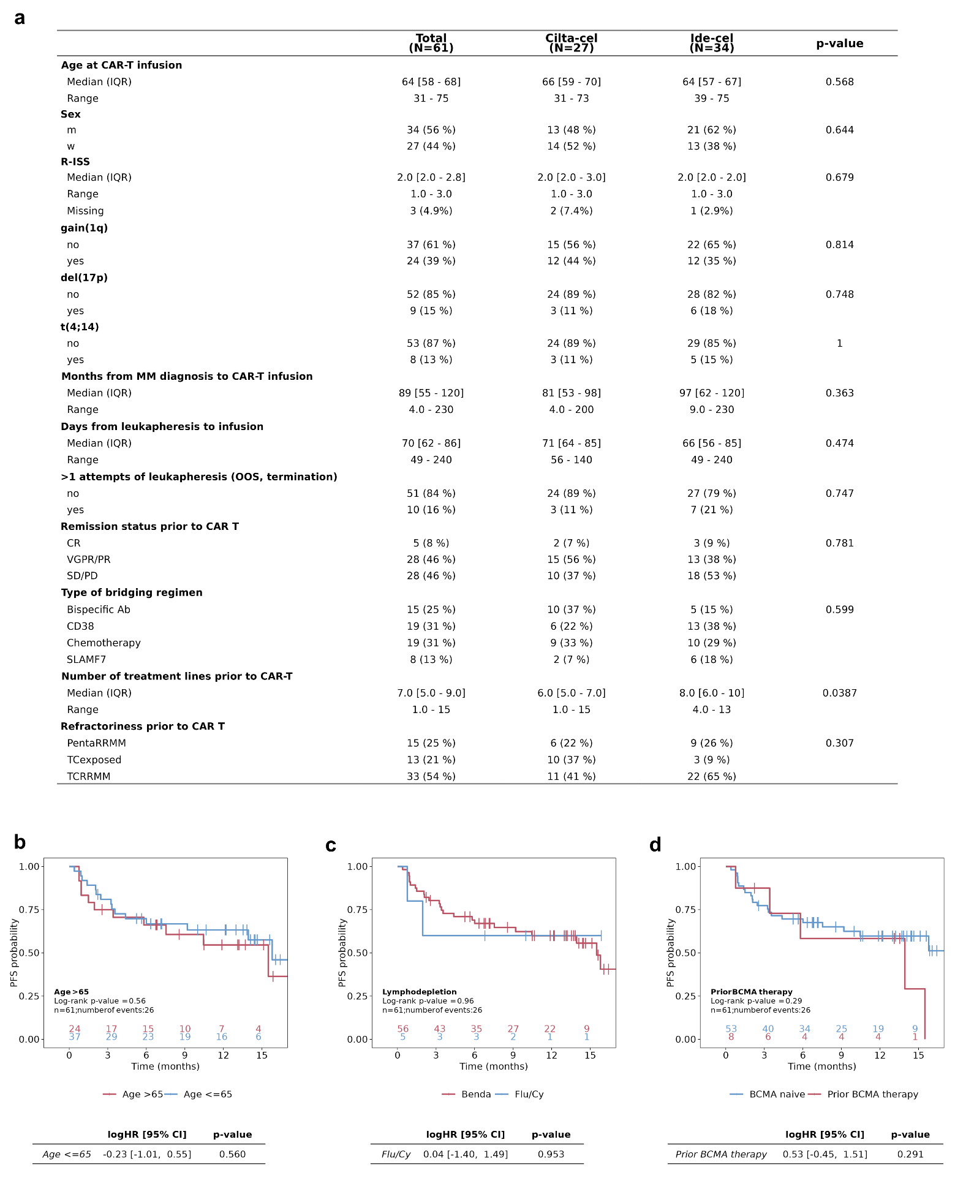

Extended Data Fig. 1 | Patient characteristics and survival analysis. a, Descriptive table of clinical characteristics of all participants and stratified by CAR-T cell product. P-values for discrete covariates were obtained by Fisher's exact test and for continuous covariates by Wilcoxon's rank-sum test. b-c, Kaplan-Meier curves showing the impact of age greater than 65 years, type of lymphodepleting chemotherapy and prior administration of BCMA targeted therapy (excluding during bridging therapy) on progression-free survival (PFS). Log-rank tests were performed to evaluate probabilities of PFS between two patient groups. The tables show the estimated log hazard ratios (logHR) using a univariate Cox-regression analysis. Statistical significance was estimated using the Wald test. CI = confidence interval.

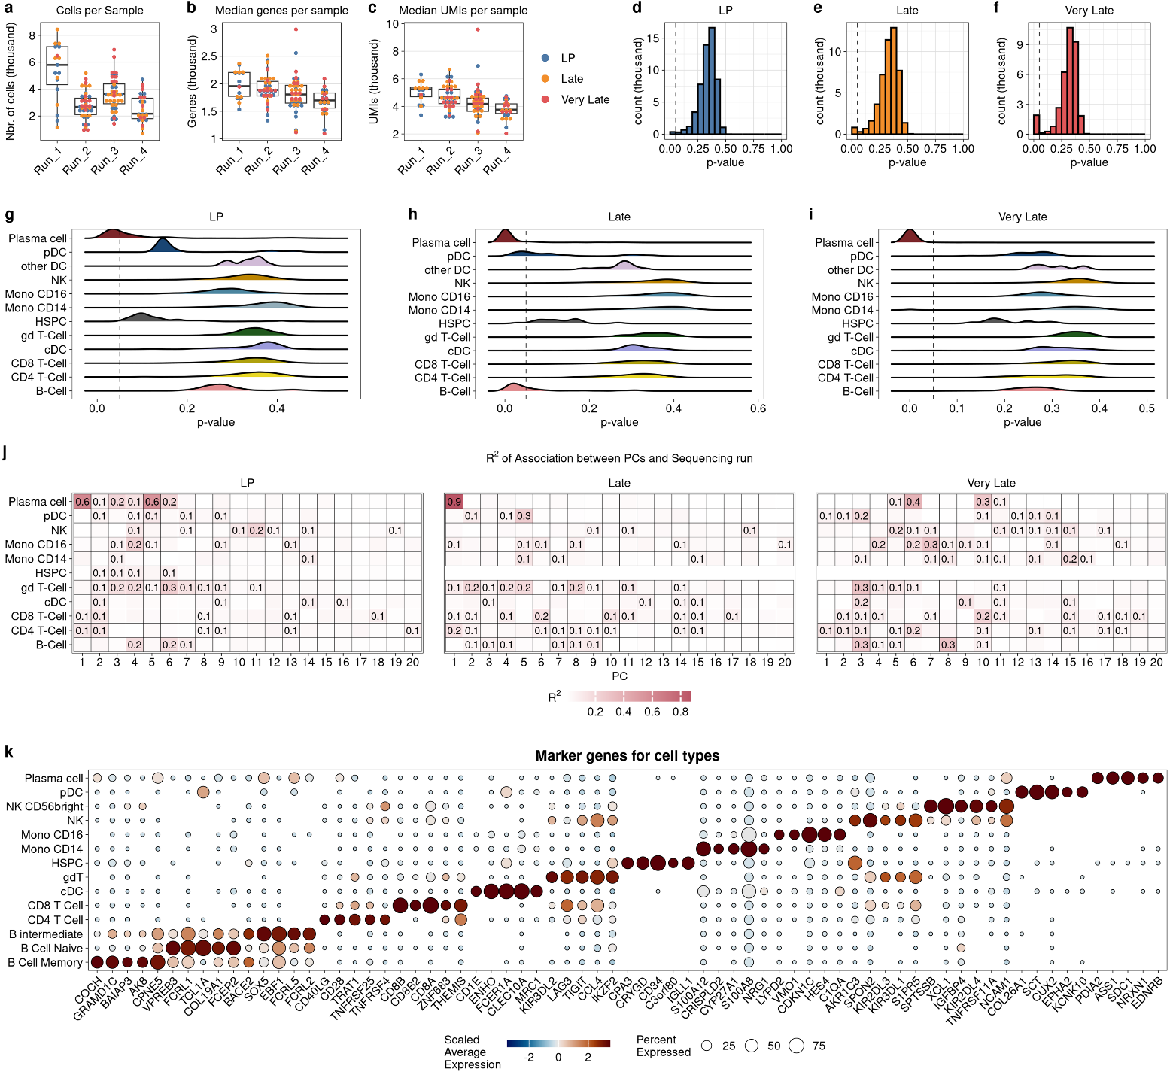
Extended Data Fig. 2 | Metrics for quality control of analyzed samples. a, The number of cells for each sample, grouped by sequencing run and colored by timepoint. b, Median number of expressed genes. c, Median number of UMI counts per sample. d-e, Potential batch effect between the sequencing runs were evaluated with the smoothed cms mixing metric using the R package CellMixS. The cms scores are p-values from hypothesis testing. Smoothed cms scores represent the weighted mean of the cms within each cell’s neighborhood (k = 200). An increased number of small p-values indicates the presence of a batch-specific bias within data. g-i, Smoothed cms scores were grouped by cell type. j, The first 20 principal components (PC) were calculated for each time point and cell type (if >100 cells available). We then regressed these PCs (response variable) against the factor “sequencing run”. For a better overview, the estimated coefficients of determination were rounded to one decimal place (only R-squared > 0.1 are depicted). k, DE protein-coding genes for each cell identity were determined using a two-sided Wilcoxon rank-sum test. Genes with an FDR <0.05 and an absolute fold change >1.25 were considered statistically significant. For each cell identity, 5 significant genes (ranked by log2FC) are shown. The dot size indicates the percentage of expressing cells within each cell identity of the corresponding genes.
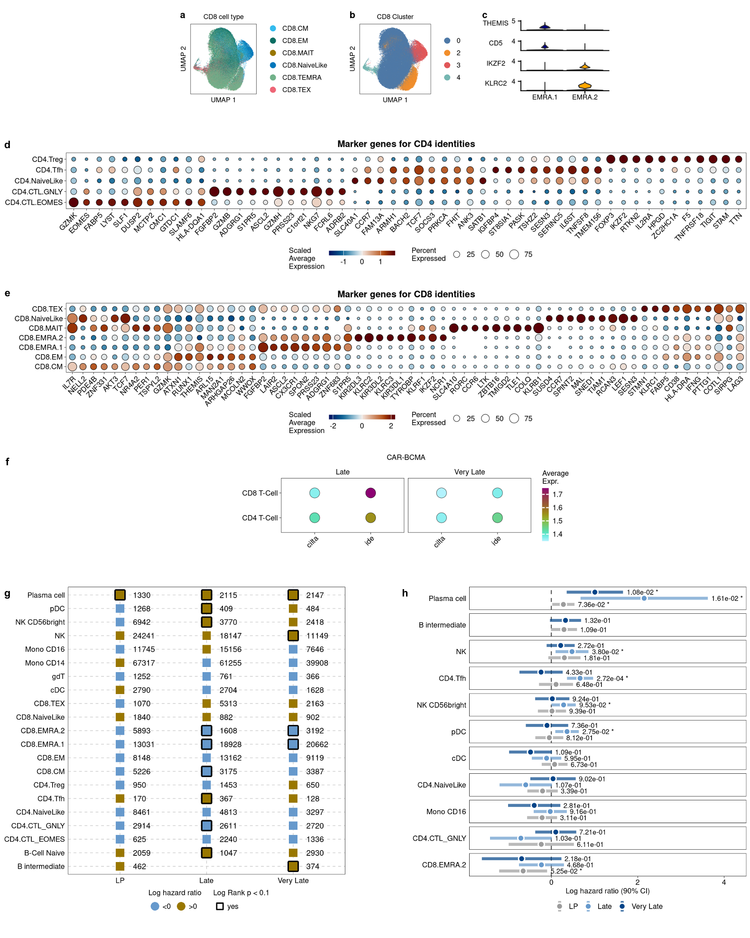

Extended Data Fig. 3 | T cell marker and survival analysis. a and b, Cell types and cluster assignment estimated by the FindCluster function (resolution = 0.1) with Seurat for all CD8 cells. Normalized expression for most prominent marker genes between cluster 0 (labeled as EMRA.1) and 2 (s EMRA.2) is shown in c. d and e, Significantly differentially expressed protein-coding genes for CD4 and CD8 T cells were determined using a Wilcoxon rank-sum test. Genes with an FDR <0.05 and an absolute fold change >1.25 were considered statistically significant. Only test genes that are detected in a minimum fraction of 25% cells in either of the two groups were considered for the test. For each cell identity, 10 significant genes (ranked by log2FC) are shown. The color intensity indicates the standardized average expression level in a cell identity. The dot size indicates the percentage of expressing cells within each cell identity of the corresponding genes. f, Average expression values of the CAR construct for each CAR product for CD4 and CD8 cells, grouped by time point. g, Log-rank tests were performed for each cell type and time point to evaluate probabilities of PFS between patients with scaled cell type proportion > 0 compared to patients with proportion ≤ 0. Log hazard ratios (logHR) were estimated by Cox-regression with standardized cell type fraction on a continuous scale. h, Forest plot of the overall logHRs and corresponding 90% confidence intervals (90% CI) estimated by multivariate Cox-regression with standardized cell type fraction on a continuous scale and CAR product as covariate. logHRs with a p-value < 0.1 are highlighted with an asterisk.

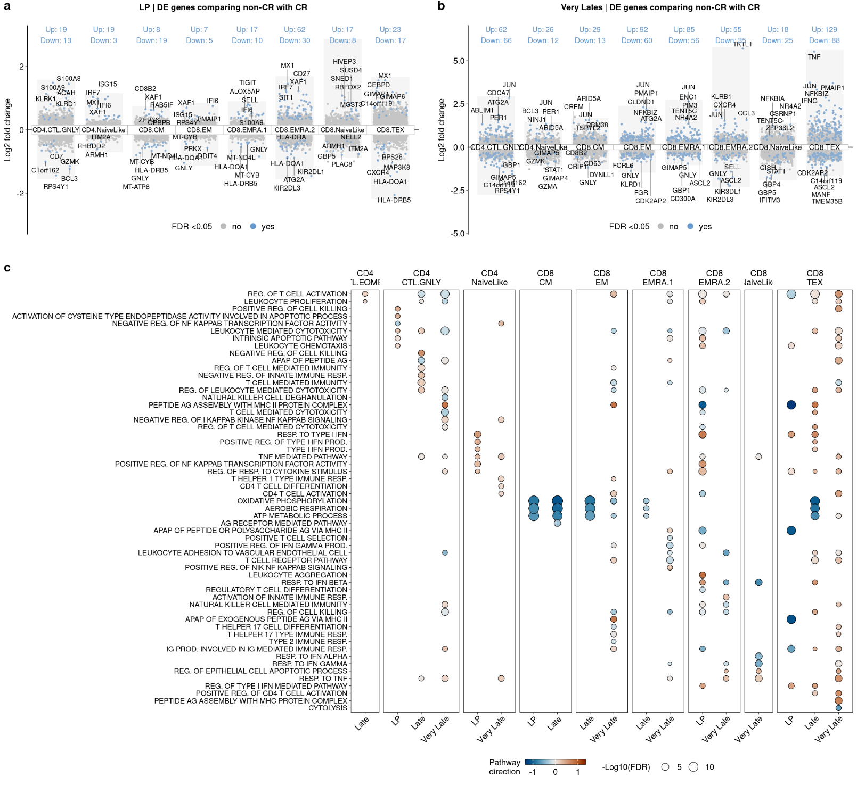
Extended Data Fig. 4 | Analysis of T cell landscape following CAR T cell infusion. a and b, Differential gene expression analysis for T cell subtypes comparing non-CR with CR at time of leukapheresis and very late time points. Only subtypes with significant (FDR < 0.05) changes in gene expression are shown. A positive log2 fold change indicates upregulation in patients with non-CR. c, Gene ontology term (for biological processes) enrichment analysis for significantly differentially expressed (DE) genes from all three time points. Terms are ranked by rich factor, which is the number of DE genes in the term divided by the number of background genes in that term. The dot plot depicts the most enriched GO terms (FDR < 0.05). The color indicates the term direction, which is the number of DE genes with a log fold change of >0 minus the number of DE genes with a log fold change of <0 divided by the square root of the number of term-associated genes

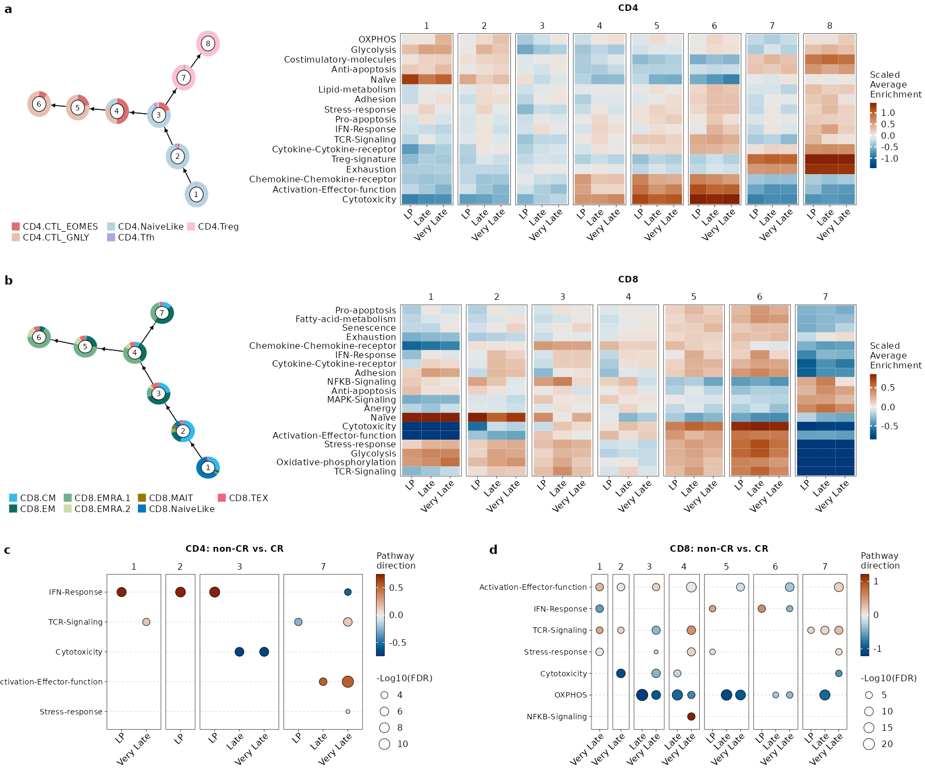
Extended Data Fig. 5 | Analysis of T cell trajectories. a and b, For enrichment analysis, the R package UCell with CD8 and CD4 gene sets from Chu et al.​ (PMID: 37248301) as reference were used. An average enrichment score was calculated for each gene set and each cell cluster (and each time point). c, For each cell cluster, differential expression of cells from non-CR was compared with CR, followed by enrichment analysis for corresponding DE genes with CD8 and CD4 gene sets. Pathways are ranked by rich factor, which is the number of DE genes in the term divided by the number of background genes in that term. The dot plot depicts the most enriched pathways (FDR < 0.05). The color indicates the pathway direction, which is the number of DE genes with a log fold change of >0 minus the number of DE genes with a log fold change of <0 divided by the square root of the number of pathway-associated genes.

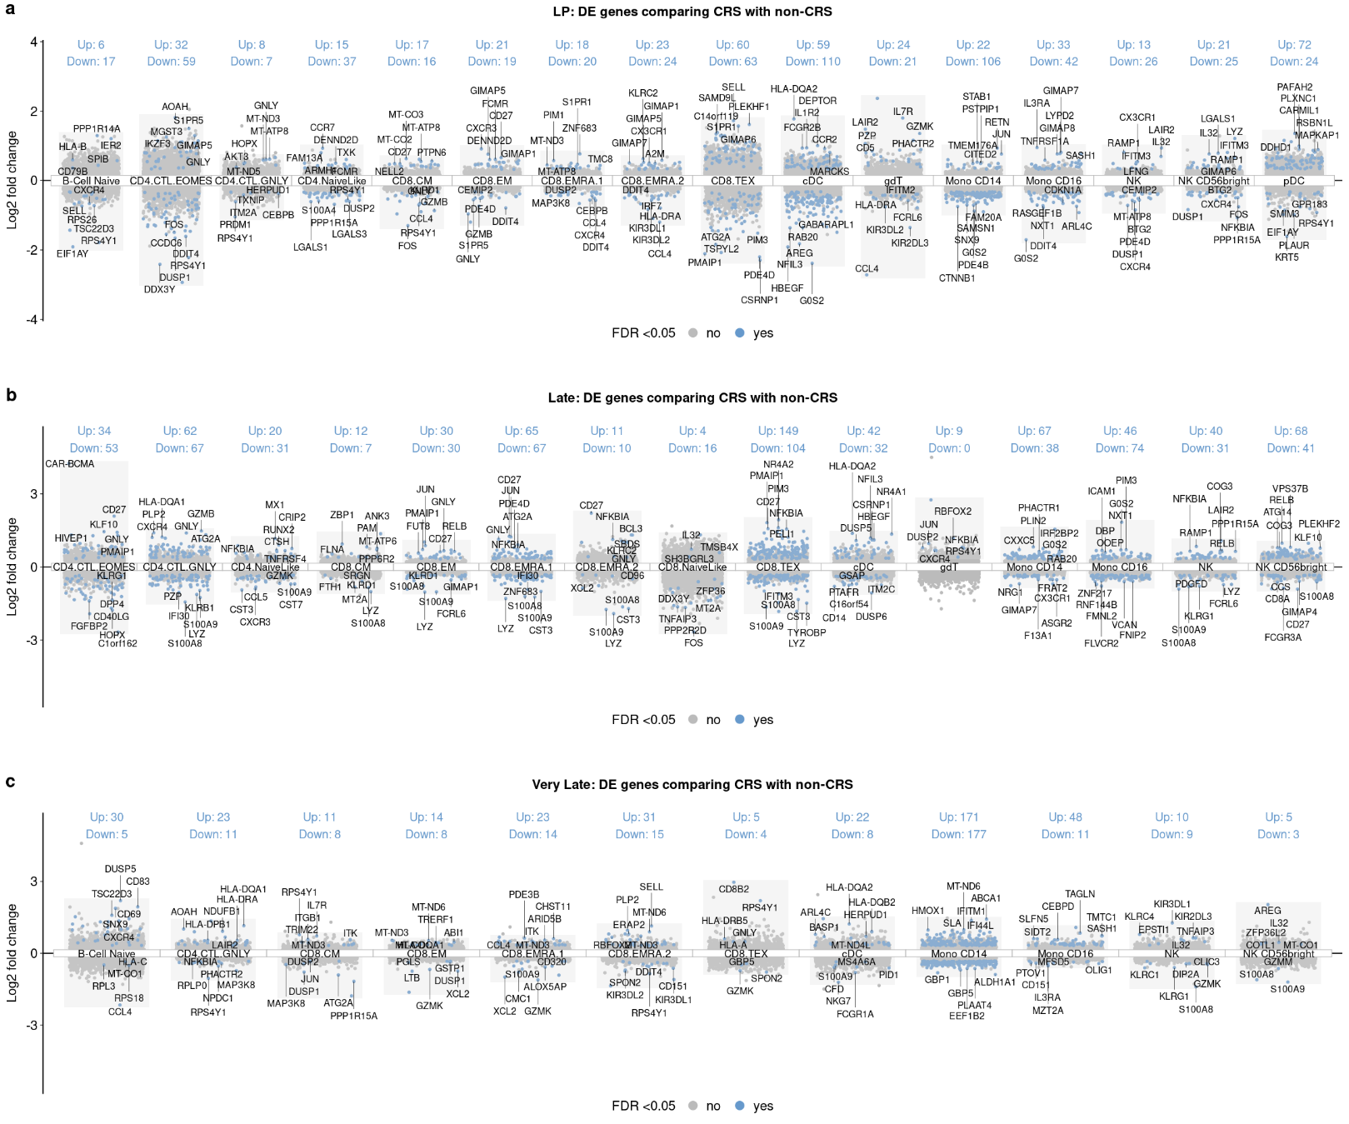
Extended Data Fig. 6 | Differential gene expression analysis for all cell types and time points comparing CRS with non-CRS patients. Only cell types with significant (FDR < 0.05) changes in gene expression are shown. A positive log2 fold change indicates upregulation in patients with CRS

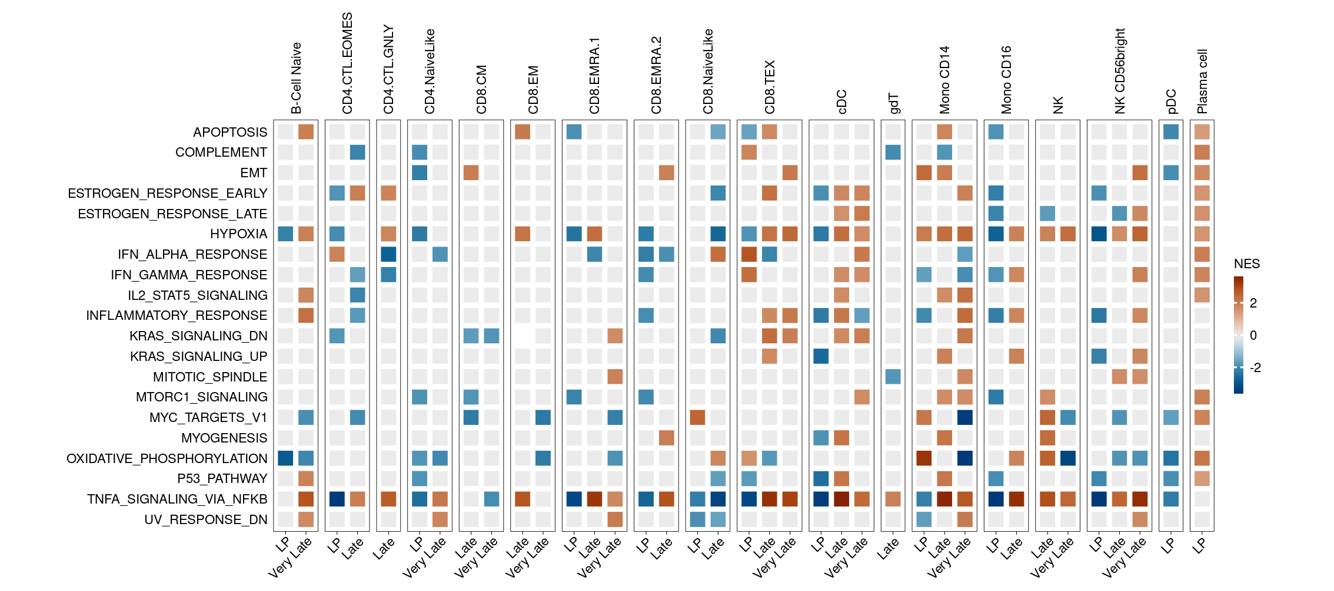
Extended Data Fig. 7 | Gene set enrichment analysis (GSEA) for all cell types and time points comparing CRS with non-CRS patients. GSEA based on estimated log2 fold change from the differential gene expression analysis (CRS vs, non-CRS). GSEA was performed with the fgsea function from the R package fgsea using the Hallmarks of Cancer gene sets from MSigDb as reference. Positive normalized enrichment scores (NES) indicate hallmarks that are enriched in patients with CRS. Only significantly enriched hallmarks are shown (FDR < 0.1).

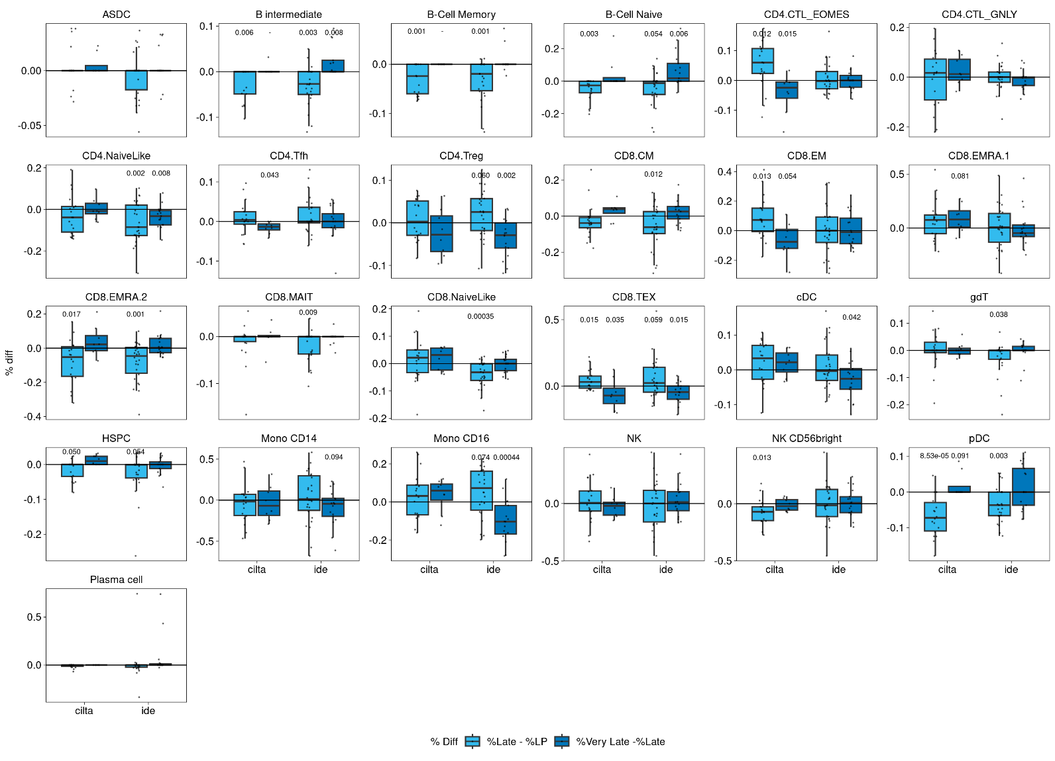
Extended Data Fig. 8 | Differential abundance analysis. ​ Differences in the cell type proportions between time points for patients treated with Cilta-cel or Ide-cel are shown (y-axis). P-values were estimated using the speckle package. Here, the design matrix takes the pairing information (Patient ID) into account. Shown are p-values < .1

Extended Data Fig. 9 | Analysis of BCMA expressing cell types. a Two-dimensional embedding of B- and plasma cells as presented in Fig. 6a. Cells are color coded for hallmark genes of B-cell differentiation (PMID: 36861964). In b the distribution of plasma cells per patient and time point is shown. Only patients with ≥50 cells (highlighted by a dashed gray line) were included. c, Expression of therapeutic target genes in MM in circulating plasma cells separately for each patient and time point. Only patients with ≥50 cells are shown. d, illustrates the composition of B-cells subtypes derived from scRNA-seq data for each time point. e, Comparison of the proportion of B-cells derived from scRNA-seq between patients without infections, early infections (<20 days after CAR-T infusion) and late infections (≥20 days after CAR-T infusion) for all time points. No significant differences were observed (Kruskal-Wallis test: p>0.05 for all timepoints). f, The number of B-cells per µl from routine blood work is compared between patients with CR and non-CR separately for patients treated with Ide-cel (top) and Cilta-cel (bottom). Thin lines represent individual patients. B-cell levels were linearly interpolated between -10 days up to 200 days after CAR-T infusion with a step size of 10 (highlighted by circles) and compared by Wilcoxon rank-sum tests (ns: p>0.05; *: 0.01<p≤0.05; **: p≤0.01). For Cilta-cel, the number of non-CR patients with available data was too small to allow a meaningful determination of statistical significance. g, Spearman correlation between sBCMA levels at day 0, day 30 and fold change between day30 and day 0, CRP baseline (CRP_BASE), maximal CRP levels (CRP_MAX) and the CRP fold change, maximal CAR-T expansion (maximal proportion of CAR+ cells among all CD3+ cells in percent) and CRS grade. Non-significant correlations (p>0.05) are marked by gray crosses.

