Supplementary Information

Supplementary Methods

Pan-cancer tumor-normal meta-cell atlas
Normalized scRNA-Seq date were download from Kang et al.¹ covering 30 different cancer types across 104 datasets. A total of 4.9 million cells from 1,070 tumors and 493 normal samples from 999 donors were collected by the authores. To reduce the size of the single-cell data, we have generated meta-cells for each sample and cell type. A meta-cell represents the transcriptomes of a group of highly similar cells. We used the R package SuperCell v1.0² with additional parameter (γ = 15) to calculate approximately 300,000 meta-cells. The data was processed as decribed in the method section ” Integration and dimension reduction”.
For Supplementary Fig. 1d, we calculated a specificity score. Since the atlas is composed of multiple studies, which leads to potential batch effects, we evaluated genes independently of their gene expression for the classification of a cell type. For each gene and cell type (and tissue), we calculated the diagnostic odds ratio (DOR), binarizing the expression values. Any detection of a gene in a meta-cell (normalized expression value >0) is considered positive, otherwise negative. The DOR is defined as follows:
$$DOR=\log\left(\frac{\text{(TruePositives + 0.5) / (FalsePositives + 0.5)}}{\text{(FalseNegatives + 0.5) / (TrueNegatives + 0.5)}}\right)$$
where TruePositives represents the number of meta-cells within a cell type detected expressing the gene, FalsePositives represents the number of meta-cells outside of the cell type detected expressing the gene, FalseNegatives represents the number of meta-cells within the cell type with no detected expression, and TrueNegatives represents the number of meta-cells outside of the cell type with no detected expression of the gene. To avoid undefined values, pseudocounts of 0.5 was used. The Specificity Score is defined as follows:
$$Specificity score=\frac{DOR}{max⁡(DOR)}$$
where max(DOR) is obtained if TruePositives is maximum and FalsePositives is zero (e.g. cell type A has 500 meta-cells and all these cells express the gene). This keeps the DOR in a range between -1 and 1. A value of -1 means that the expression of the gene was detected in all cells outside the cell type and the TruePositives value is zero.

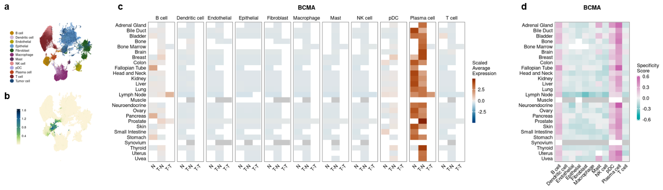
Supplementary Fig. 1 | Pan-cancer tumor-normal landscape at meta-cell resolution. a, Meta-cells colored by cell types. b, Meta-cells were summarized to hexabins using the R package schex. The color code represents the average BCMA expression of these bins. c, Scaled average BCMA expression grouped by organ and cell type. N: Normal Tissue, T-N: Tumor tissue, Normal cells, T-T: Tumor tissue, Tumor cells. d, Specificity scores for BCMA grouped by organ and cell type. For a and b, Grey tiles: <10 meta-cells expressing the gene (>0 counts) across all cell types or the average expression is zero across all cell types. White tiles: No data available

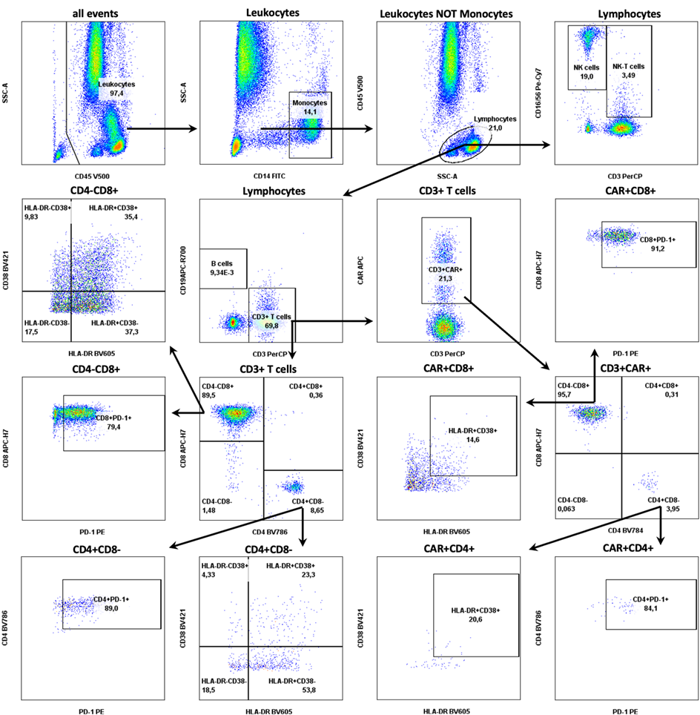
Supplementary Fig. 2 Gating strategy for CD4+ and CD8+ (CAR) T cells. Arrows indicate the order of the respective gating steps to delineate CAR from non-CAR CD4+ and CD8+ T cells. Leukocytes were identified by the expression of CD45, utilizing a SSC^{low} gate to effectively exclude debris. Monocytes were excluded from the lymphocyte population based on CD14 expression and subsequently excluded from the lymphocyte gate. Within the lymphocyte population, natural killer (NK) cells (CD16⁺CD56⁺), natural killer T (NKT) cells (CD3⁺CD16⁺CD56⁺), B cells (CD19⁺) and T cells (CD3⁺) were differentiated. CAR⁺ and CAR⁻ T cells were further categorized into T helper cells (CD4⁺) and cytotoxic (CD8⁺). The activation states of each T cells subpopulation was assessed using die expression of HLA-DR/CD38 and PD-1, respectively.

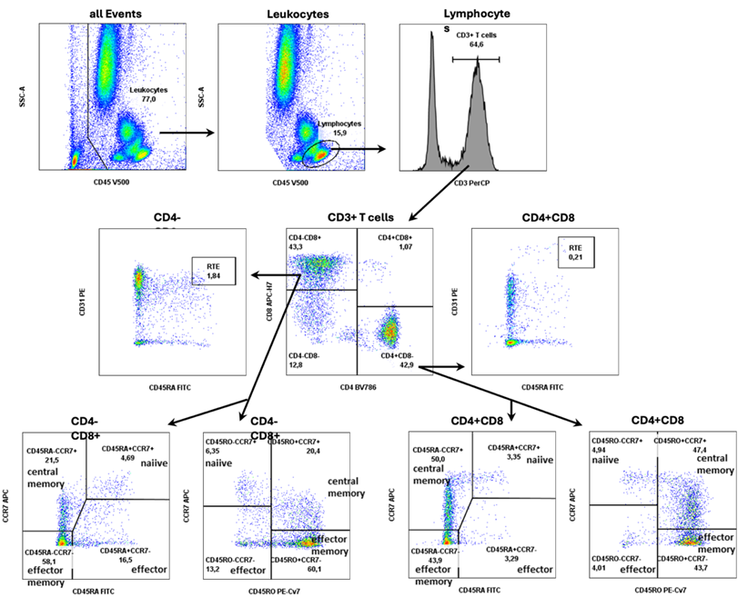
Supplementary Fig. 3 Gating strategy for CD4⁺ and CD8⁺ T cell subpopulations. Arrows indicate the order of the respective gating steps. Originating from the lymphocyte gate (CD45⁺ SSC^{low}), T-cells (CD3⁺), T-helper cells (CD3⁺CD4⁺) and cytotoxic T cells (CD3⁺CD8⁺) were separated. Recent thymic emigrants (RTE) of CD4⁺ and CD8⁺ T cells have been characterized as naïve T-cells with additionally surface expression of CD31+ (CD45RA⁺⁺CD31⁺⁺). T-helper and cytotoxic T cell subpopulations were further divided into naïve (CCR7⁺CD45RA⁺CD45RO⁻), central memory (CCR7⁺CD45RA⁻CD45RO⁺), effector (CCR7-CD45RA+CD45RO-) and effector memory (CCR7⁻CD45RA⁻CD45RO⁺) CD4⁺ or CD8⁺ T-cells. At the end, relative cell numbers were calculated by mathematical AND-operation (for example naïve CD4⁻cells: CD4⁺ AND CCR7⁺CD45RO⁻ AND CCR7⁺CD45RA⁺ cells).
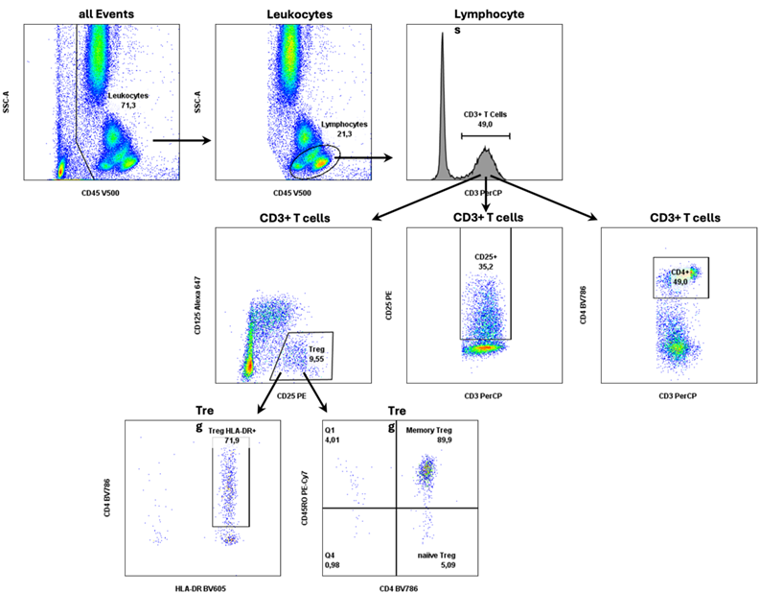
Supplementary Fig. 4 Gating strategy for regulatory T-cells. Arrows indicate the order of the respective gating steps. From the lymphocyte gate (CD45⁺ SSC^{low}), T-cells (CD3⁺) and following T-helper cells (CD3⁺CD4⁺) were separated. Regulatory T-cells were then identified through the expression of CD25⁺CD127^{low}, where activated regulatory T cells were assessed by anti-HLA-DR. Additionally, CD4⁺ T-cell activation was estimated based on CD25 surface marker expression. Regulatory T-cells can be further divided in naïve and memory regulatory T-cells (calculated by mathematical AND-operation: CD3⁺CD4⁺ AND CD25⁺CD127^{low} AND CD45RO (high/low).

References
1. Kang, J. et al. Systematic dissection of tumor-normal single-cell ecosystems across a thousand tumors of 30 cancer types. Nature communications 15, 4067; 10.1038/s41467-024-48310-4 (2024).
2. Bilous, M. et al. Metacells untangle large and complex single-cell transcriptome networks. BMC bioinformatics 23, 336; 10.1186/s12859-022-04861-1 (2022).

