Extended data

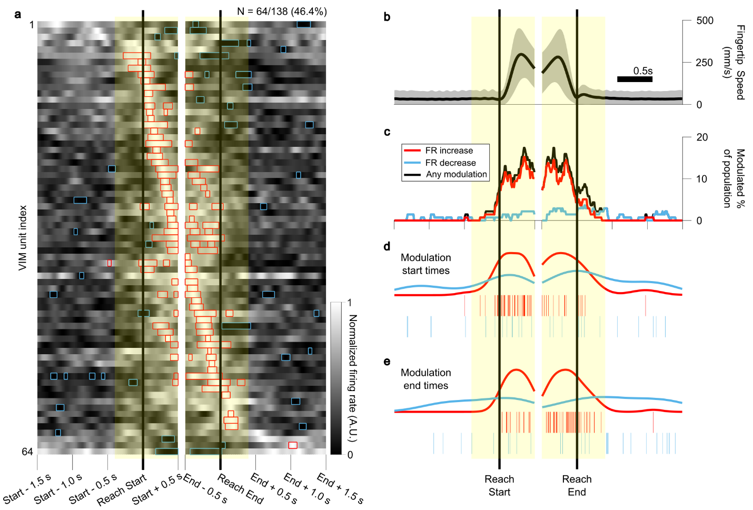
Extended Data Fig. 1: Peri-reach modulation aligned separately to Reach Start and Reach End. Panels are analogous to those in Fig. 3, but with data aligned independently to Reach Start (left) and Reach End (right). Samples after Reach Start and before Reach End here represent real time 10 ms samples, without the time-stretching method used to simultaneously align to both Reach Start and Reach End (as shown in Fig. 3).

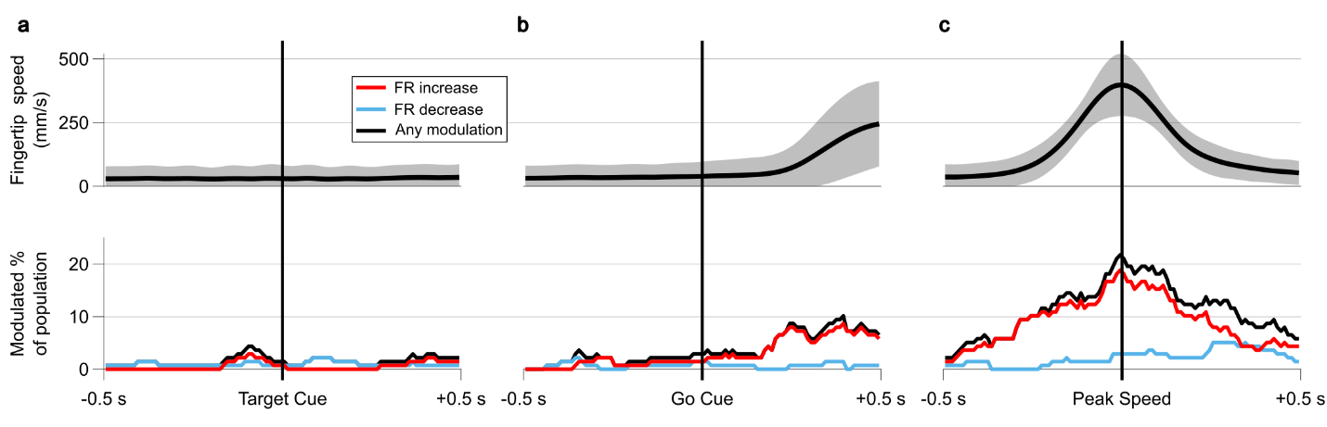
Extended Data Fig. 2: Firing rate modulation aligned to alternative behavioral events.
a, Mean fingertip speed (top) and the proportion of units concurrently displaying significant positive (red), negative (blue), or any (black) FR modulation (observed mean FR greater or less than 99.5% of random expected mean FRs [α = 0.01], 10,000 shuffles for at least 5 consecutive samples [50 ms]) in a 1 s wide window around the time of Target Cue (the time when an arrow was shown over the center target to indicate the location of the next outer target). Limited FR modulation is noted during this cue phase. b, Same as in a, but aligned to the Go Cue (the time when the current target was extinguished and the new target appeared). c, Same as in a and b, but aligned to the time of peak observed fingertip speed in each reach.

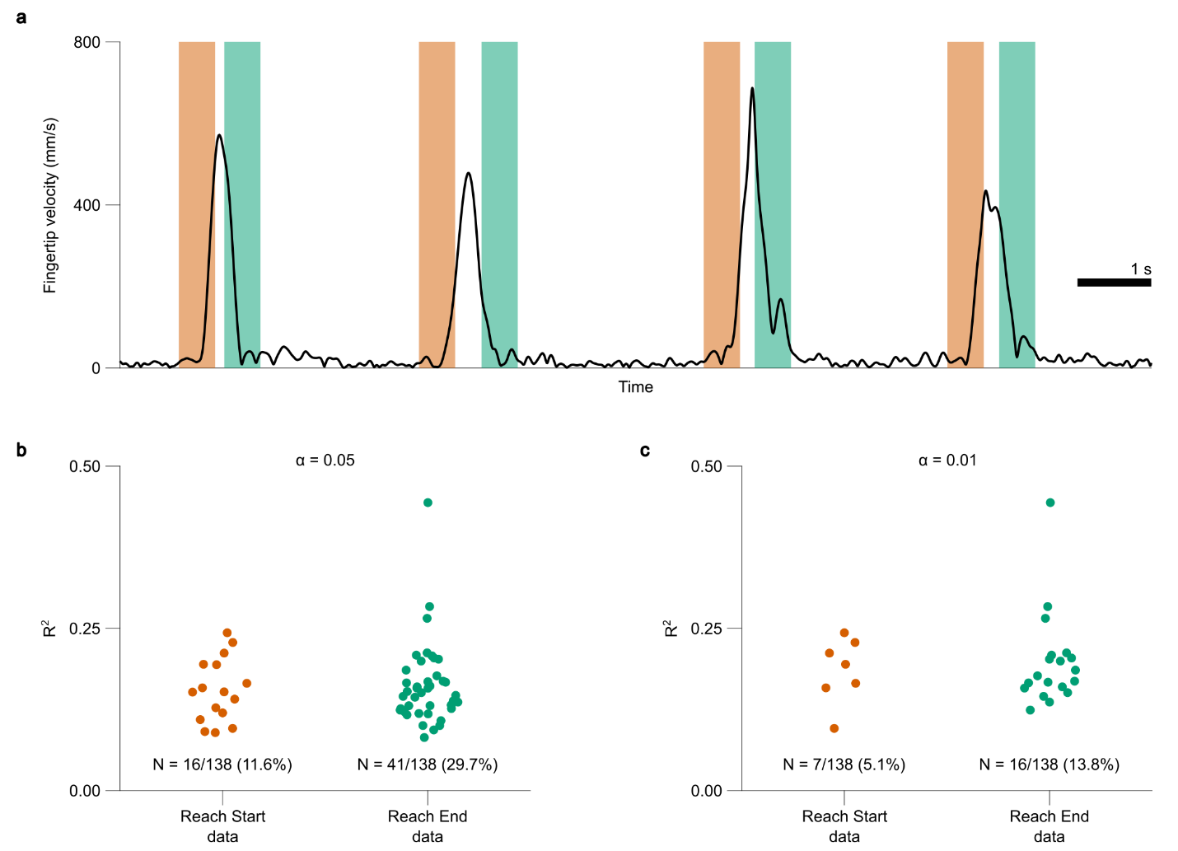
Extended Data Fig. 3: Kinematic and error encoding is more common around Reach Ends than Reach Starts. a, Fingertip speed in 4 example reaches from procedure S.02.R session 2 displaying the time windows used to extract kinematic and error term data from 500 ms windows centered at either Reach Starts (orange patches) or Reach Ends (green patches). b, R-square values for regressions of ventral intermediate nucleus unit firing rates on kinematic and error terms from 500 ms windows around Reach Starts (orange markers) or Reach Ends (green markers). Colors correspond to the time windows shown in a. Only those units with significant regression fits (R-square greater than 95% [α = 0.05, one-sided] of random expected R-squares generated by randomly shifting neural timestamps relative to kinematics 10,000 times) are displayed. N denotes the number of units with significant regression fits in each category. c, Same as in b, but with a regression fit significance threshold of α = 0.01.

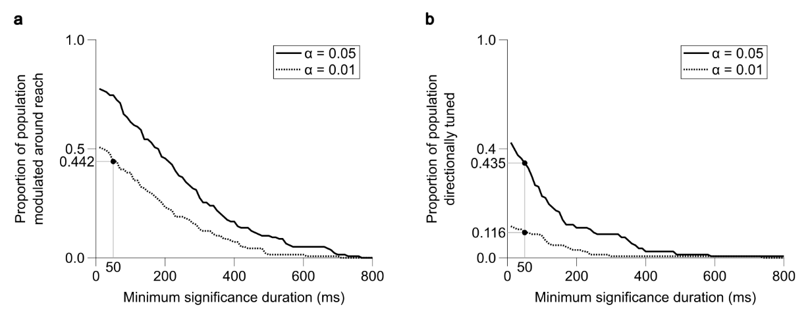
Extended Data Fig. 4: Peri-reach modulation and directional tuning durations. a, The proportion of units displaying significant peri-reach FR modulation at two different α-levels when altering the required minimum duration of significant modulation periods. The marker denotes the level selected for analysis and display in the main text (Fig. 3), for which units were required to sustain significant FR modulation for at least 50 ms to be considered a peri-reach modulated unit. b, Same as in a, but displaying the proportion of directionally tuned units at differing α levels and minimum significance durations. The markers coincide with the levels selected for display in the main text (Fig. 4).

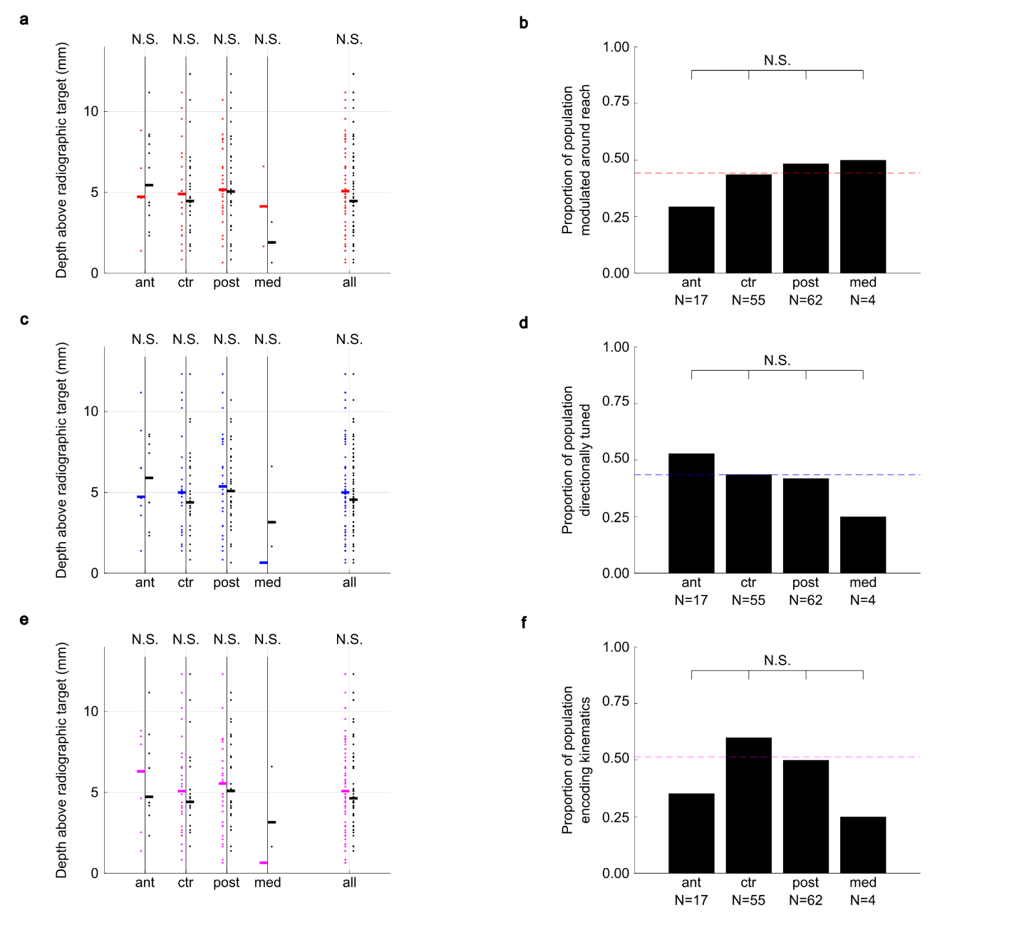
Extended Data Fig. 5: Recording locations of units with significant movement-related activity. a, Recording depths and electrode tracks for units which displayed significant peri-reach FR modulation (red), compared with those which were not peri-reach modulated (black). Unit locations are shown separately for each electrode track location (ant: anterior, ctr: center, post: posterior, med: medial) as well as for all tracks combined. Horizontal thickened bars denote median depths. b, The proportion of units recorded in each electrode track which displayed significant peri-reach FR modulation, along with the overall proportion of units displaying peri-reach modulation (red dashed line). c and d¸ Same as in a and b, but displaying the location and proportion of units that were significantly tuned to direction. e and f¸ Same as in a and b, but displaying the location and proportion of units that significantly encoded kinematics. In a, c and e, medians depths for significant units and non-significant units were compared using Wilcoxon Rank Sum tests (two-sided, α = 0.05). In b, d, and f, proportions on all pairs of tracks were compared using a chi-square test (α = 0.05). No significant effects of depth or electrode track location were observed on the likelihood of recording units with significant movement-related activity.

