Supplementary Material
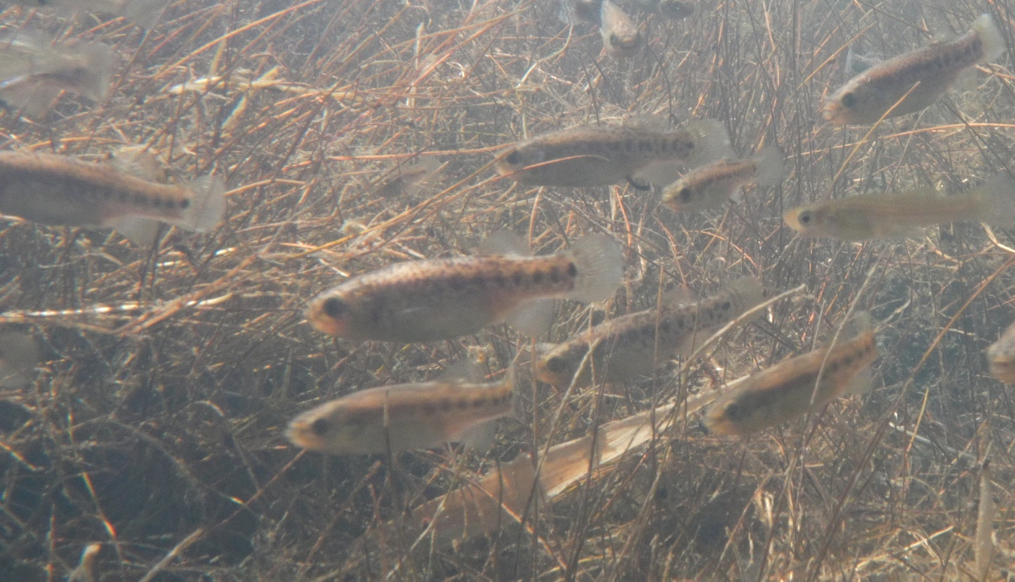
Fig. S1 Image showing several females with the morphotype with the row of large black spots along the lateral line in the posterior half of the trunk

Table S1. Fish species identified in the surveyed locations (in addition to the one where we found the aphaniid fish that appears to be A. saourensis). When present, the native species, L. pallaryi, is listed first, followed by the exotic species, which are listed alphabetically by genus name.
Location | Geographic coordinates | Fish species
Guir river valley
Djorf Torba | 31° 32' 20.87" N  2° 44' 20.22" W | Luciobarbus pallaryi  Alburnus alburnus  Carassius carassius  Cyprinus carpio  Gambusia holbrooki  Hypophthalmichthys molitrix  Hypophthalmichthys nobilis  Lepomis gibbosus  Oreochromis niloticus  Pseudorasbora parva
Chebka | 31° 31' 23.26" N  2° 45' 36.27" W | Luciobarbus pallaryi  Cyprinus carpio  Gambusia holbrooki  Lepomis gibbosus  Oreochromis niloticus
Cascade Guettara | 31° 25' 12.28" N  2° 54' 21.52" W | None
Abadla dam | 31° 9' 36.48" N  2° 48' 3.72" W | Luciobarbus pallaryi  Cyprinus carpio  Gambusia holbrooki  Lepomis gibbosus  Oreochromis niloticus
Oued Abadla | 31° 0' 18.41" N  2° 42' 35.89" W | Luciobarbus pallaryi  Gambusia holbrooki  Lepomis gibbosus  Oreochromis niloticus
Dayet Toyor, Hbassa | 30° 51' 40.95" N  2° 25' 21.69" W | None
Location | Geographic coordinates | Fish species
Zouzfana river valley
Fendi | 31° 50' 26.64" N  1° 28' 27.19" W | Luciobarbus pallaryi
Taghit | 30° 49' 15.53" N  2° 0' 9.38" W | Luciobarbus pallaryi  Gambusia holbrooki
Béchar river valley
Kénadsa | 31° 32' 56.16" N  2° 29' 25.00" W | None
Lahmar | 31° 54' 8.27" N  2° 18' 32.22" W | None
Boukaïs | 31° 55' 27.91" N  2° 27' 58.01" W | Gambusia holbrooki
Mogheul | 32° 1' 9.12" N  2° 13' 0.83" W | Gambusia holbrooki
Djebel Elbabor, Boukaïs | 32° 2' 40.14" N  2° 30' 40.54" W | None
Oued Béchar | 31° 37' 3.15" N  2° 12' 36.84" W | Luciobarbus pallaryi
Saoura river valley
Igli | 30° 26' 43.11" N  2° 16' 50.34" W | Gambusia holbrooki  Lepomis gibbosus  Oreochromis niloticus
Mazzer | 30° 19' 25.00" N  2° 17' 20.11" W | Gambusia holbrooki
Béni Abbès | 30° 6' 12.46" N  2° 9' 45.42" W | Gambusia holbrooki
Marhouma | 29° 59' 56.35" N  2° 4' 28.36" W | None
Tamtert | 29° 54' 44.50" N  1° 53' 53.97" W | None
Location | Geographic coordinates | Fish species
Kerzaz | 29° 26' 46.82" N  1° 24' 24.41" W | Gambusia holbrooki
Messaoud river valley
Adrar | 27° 49' 54.51" N  0° 20' 39.08" W | None
Fenoughil | 27° 36' 39.58" N  0° 20' 1.03" W | None
Tidmaine | 27° 3' 24.45" N  0° 7' 19.90" W | None
Tabelbala | 29° 24' 59.30" N  3° 14' 57.15" W | None

