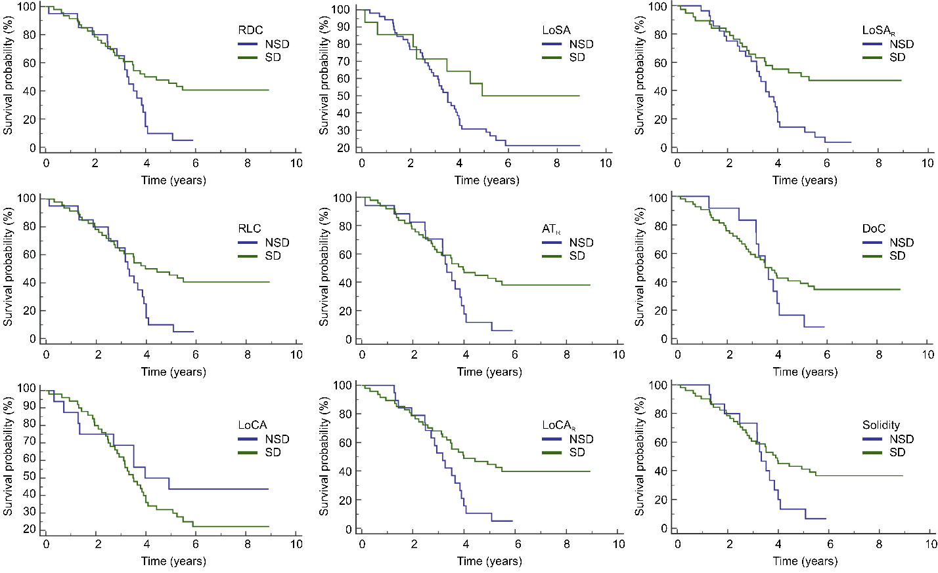
Supplementary Fig 1. The survival distribution is plotted as KM curves using each of the proposed biomarkers as a risk factor. The comparison groups are given as patients clustered into solid-dominant (SD) and non-solid dominant (NSD) tumor groups.

