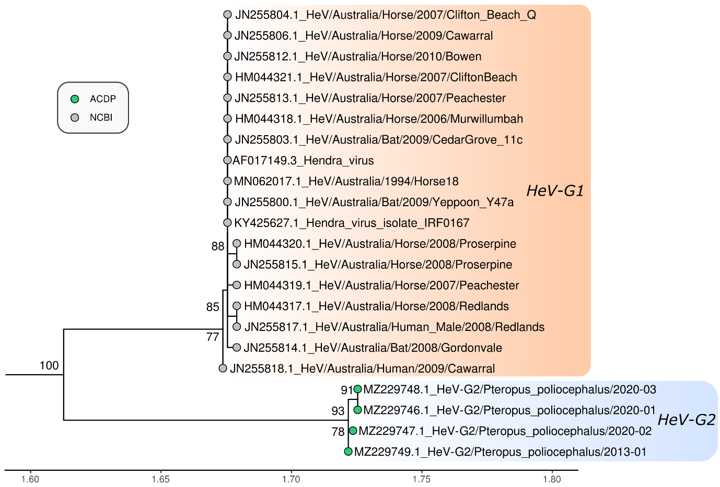
Figure S2. Maximum likelihood phylogenetic tree of 568 bp of the G gene (recovered in all samples). The HKY model with empirical base frequencies and allowing for a proportion of invariant sites was used as the best fit by IQ-TREE v.2.0.6. The results from 1000 bootstrap replicates are given on the nodes (if greater than 70) and the scale represents the number of nucleotide substitutions per site. The tree was drawn with Nipah virus outgroups which were removed for visualisation.

