Supplement 1
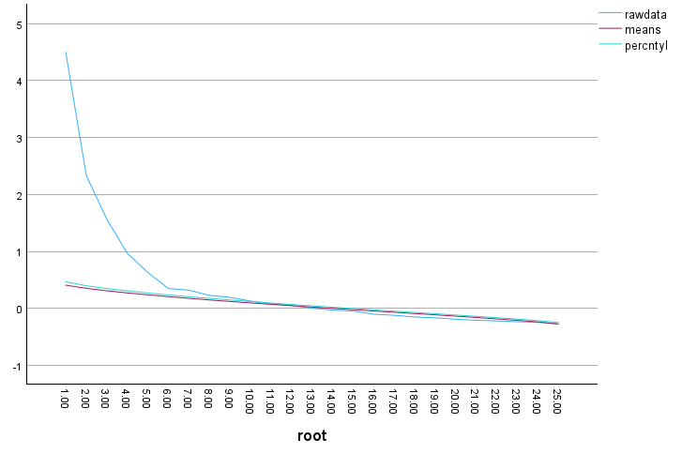
Figure 1.
Scree plot for the IPAQ Items, based on both MO and MNO with results for the scree plot based on the raw data
as well as results for the parallel analysis

