Supplementary information

Cross-species comparison of single-cell landscapes reveals conservation and innovation in chicken immune systems

Authors: Fei Wang^{1†}, Jilong Ren^{1†}, Yaqi Zhou^{1†}, Wuqiang Huo^{1†}, Huichao Liu^{2†}, Mumu Qin^{3†}, Yi Jing^{3†}, Zhongtao Yin⁴, Tao Shi¹, Huiquan Shan¹, Guanghui Tan¹, Haoping Wang¹, Xi Guo¹, Junpu Mei³, Zhen Yue³, Zhuocheng Hou⁴, Huaijun Zhou⁵, Jiuzhou Song⁶, Søren Egedal Degn⁷, Lin Lin⁷, Yonglun Luo⁷, Feilong Meng⁸, Xiaodong Fang^{3,9*}, Haihan Zhang^{2*}, Xi He^{2*}, Lingzhao Fang^{10*}, Yu Jiang^{1*}

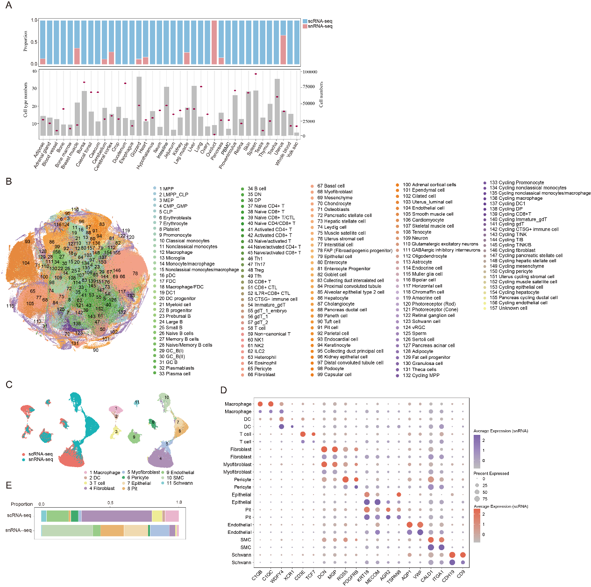 Supplementary Fig. 1. Overview of the chicken cell atlas. A, Upper panel: The proportion of cell numbers dissociated by scRNA-seq and snRNA-seq across various tissues. Lower panel: The number of cell types identified in each tissue (red dot) and cell numbers after filtering in each tissue (grey bar frame). B, T-SNE visualization of all clusters colored by major cell types. C, Co-embedding of gizzard snRNA-seq and scRNA-seq datasets. D, Dot plot showing the expression level of marker genes in each cell type of the gizzard comparing snRNA-seq and scRNA-seq methods. E, Stacked bar plot representing the ratio of each cell type detected in the gizzard from either snRNA-seq or scRNA-seq.
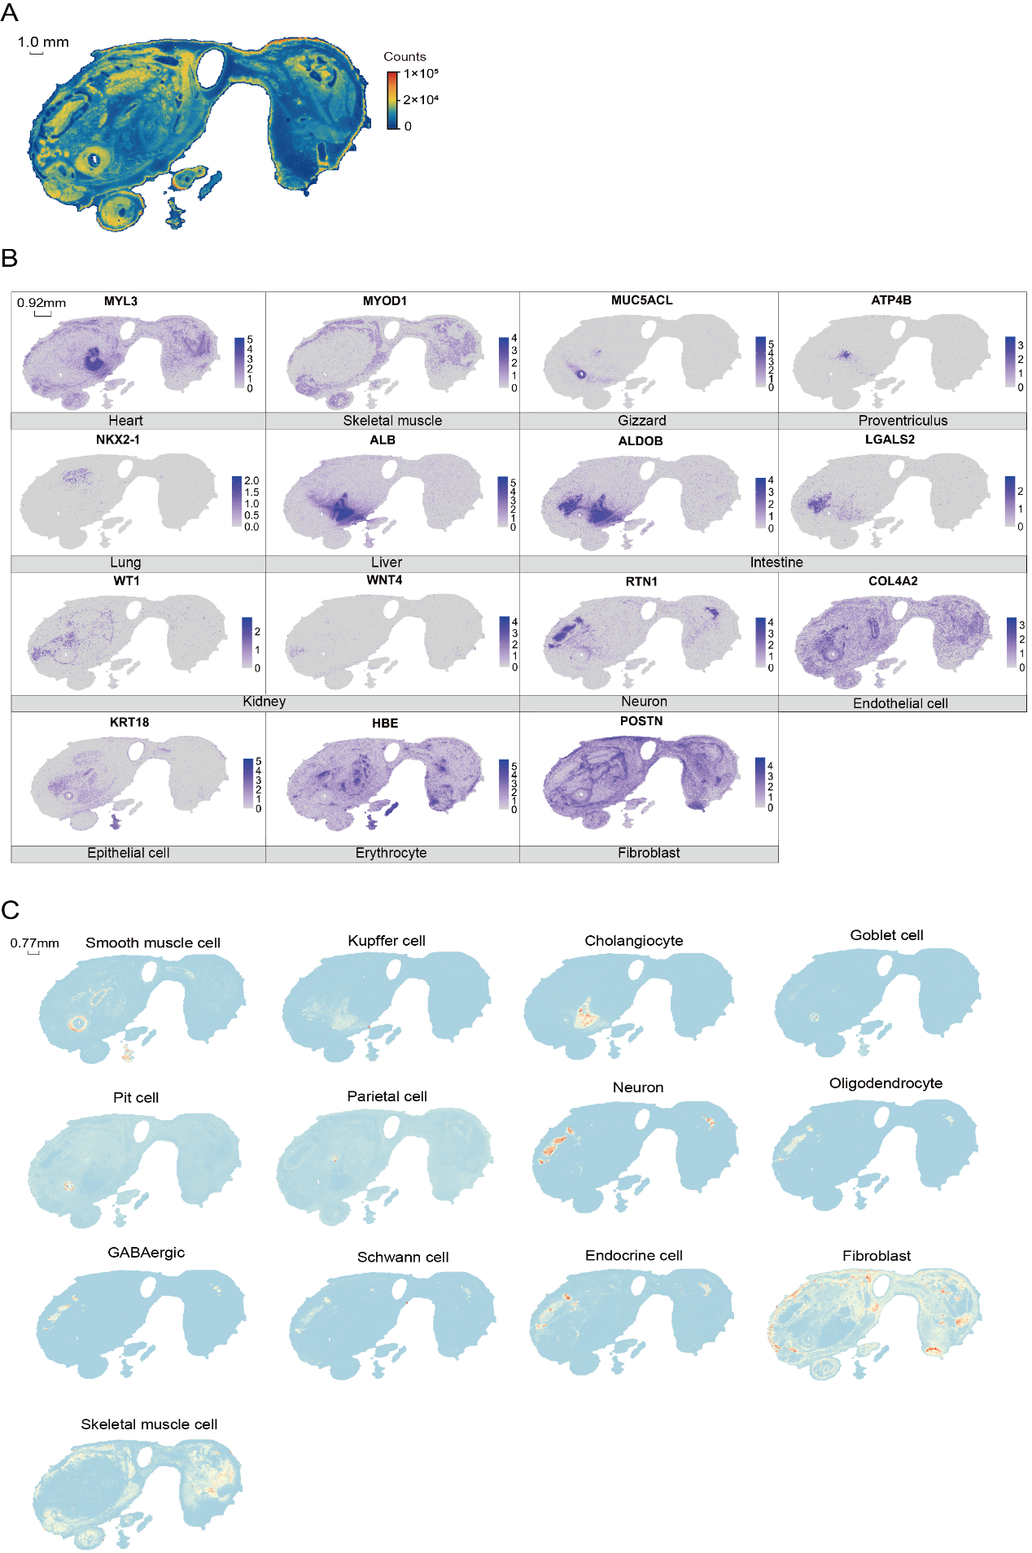 Supplementary Fig. 2. Overview of the chicken spatial transcriptomics. A, Heatmap representation of the counts detected in the chicken embryo. B, Spatial visualization of the indicated gene expression in the chicken embryo. C, Spatial visualization of the indicated major cell types annotated using deconvolution in the chicken embryo.

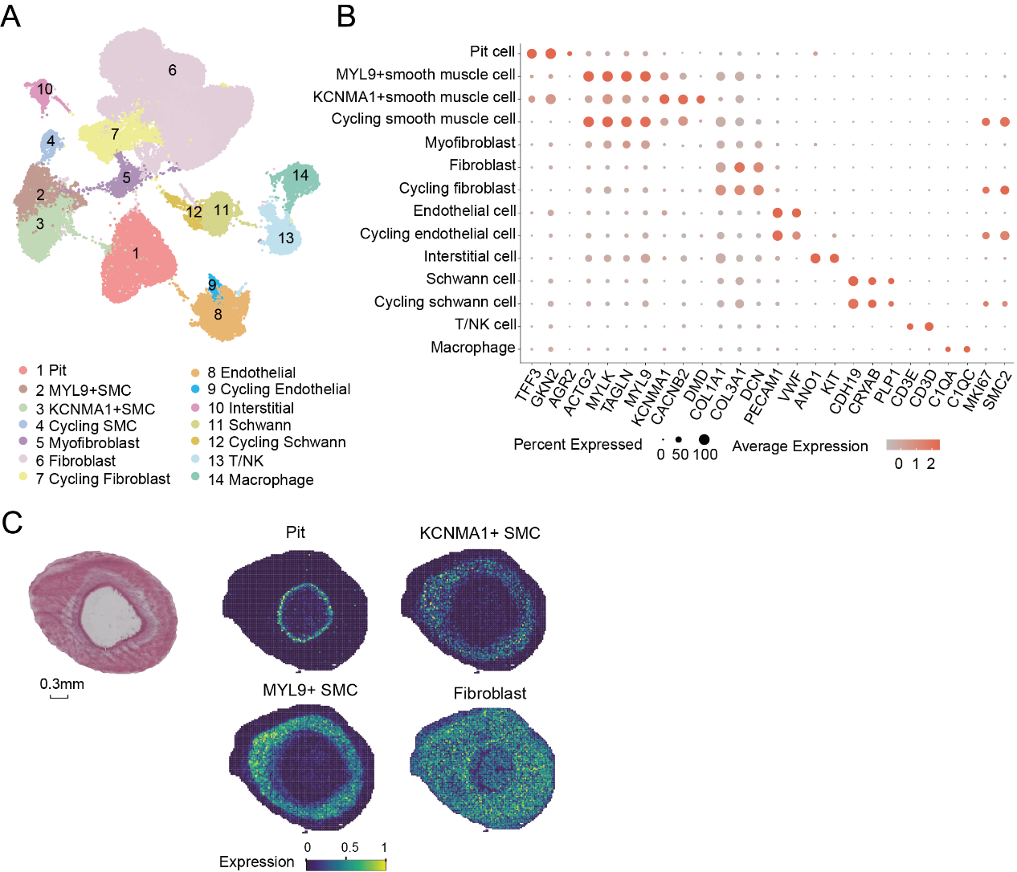
Supplementary Fig. 3. ScRNA-seq profiling and spatial visualization of cell clusters in the gizzard of the chicken embryo. A, UMAP visualization of all clusters colored by major cell types. B, Dot plot for expression of marker genes of the identified cell populations in chicken gizzard. C, Spatial visualization of cells in gizzard of the chicken embryo.
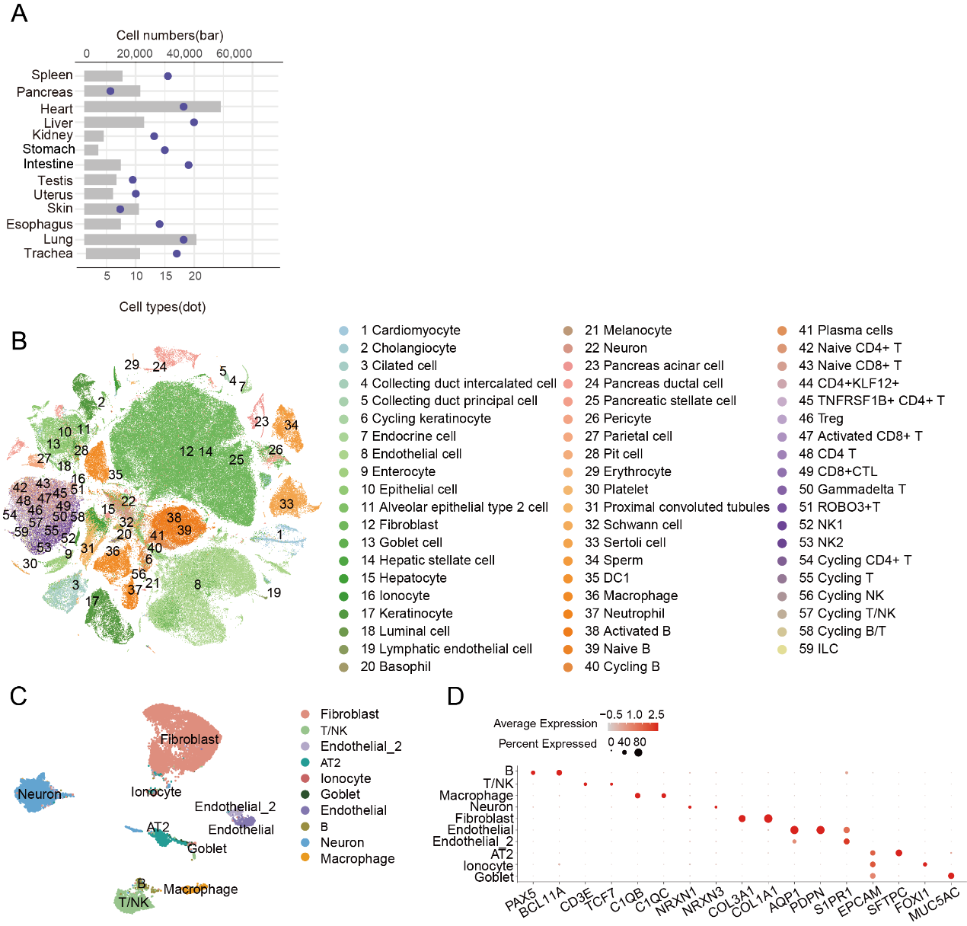
Supplementary Fig. 4. Overview of the turtle cell atlas. A, The number of cell types identified in each tissue (red dot) and cell numbers after filtering in each tissue (grey bar frame). B, T-SNE visualization of all clusters colored by major cell types. C, UMAP visualization of all clusters colored by major cell types in turtle lung. D, Dot plot for expression of marker genes of the identified populations in turtle lung.
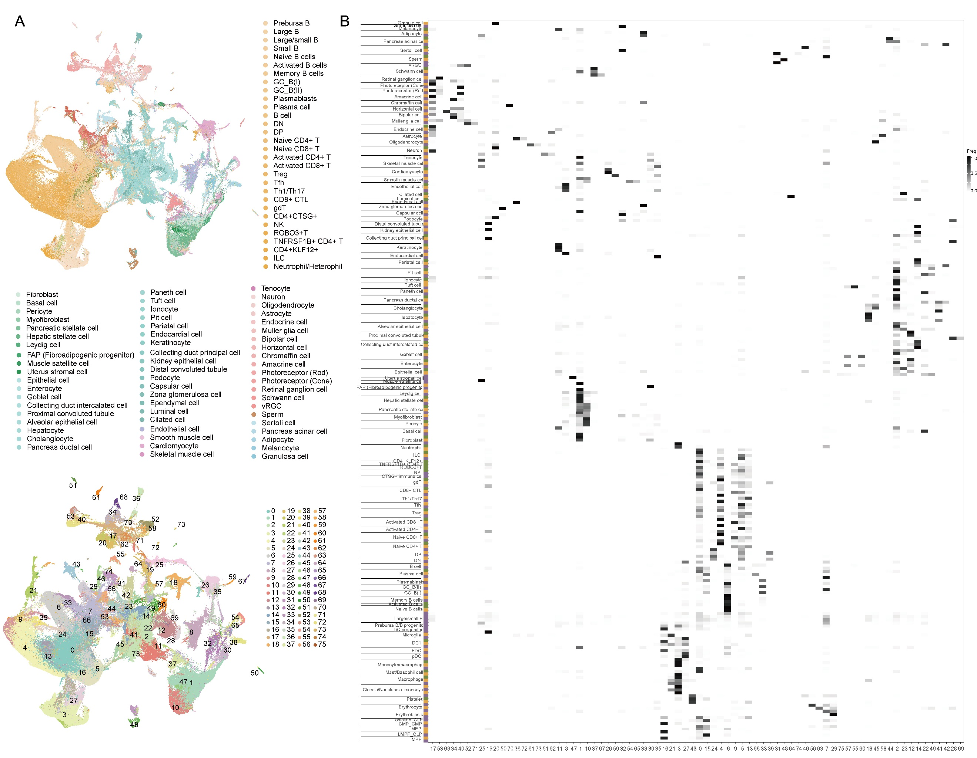
Supplementary Fig 5. Cross-species comparison of cell landscapes. A, UMAP plot after integration of scRNA-seq data from the turtle, chicken and human. Top: UMAP visualization of all clusters colored by major cell types. Bottom: UMAP visualization of all clusters colored by integrated clusters. B, Percentage of cells from the original species-specific clusters (rows) in the integrated clusters (columns).

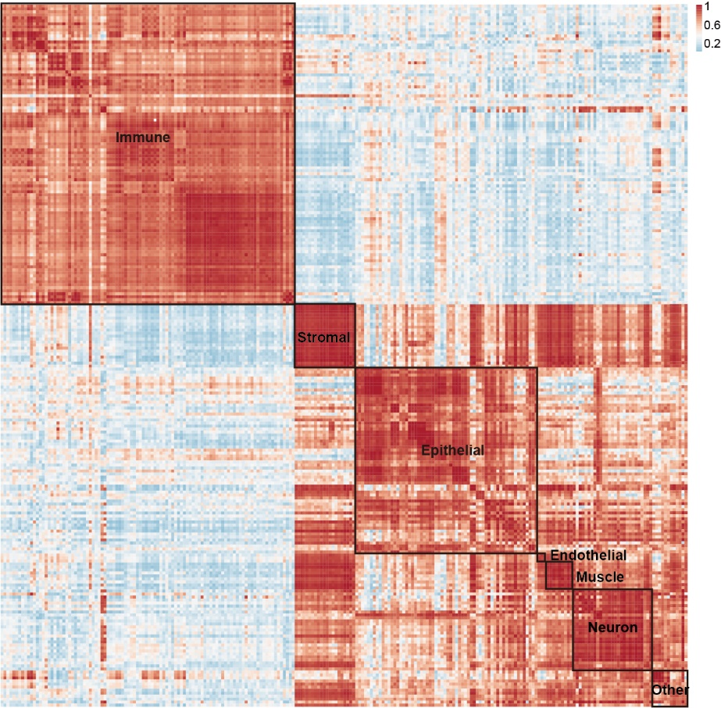
Supplementary Fig. 6. Correlation of orthologous gene expression between turtle, chicken and human cell types. AUROC scores were used to measure the similarity of cell types.
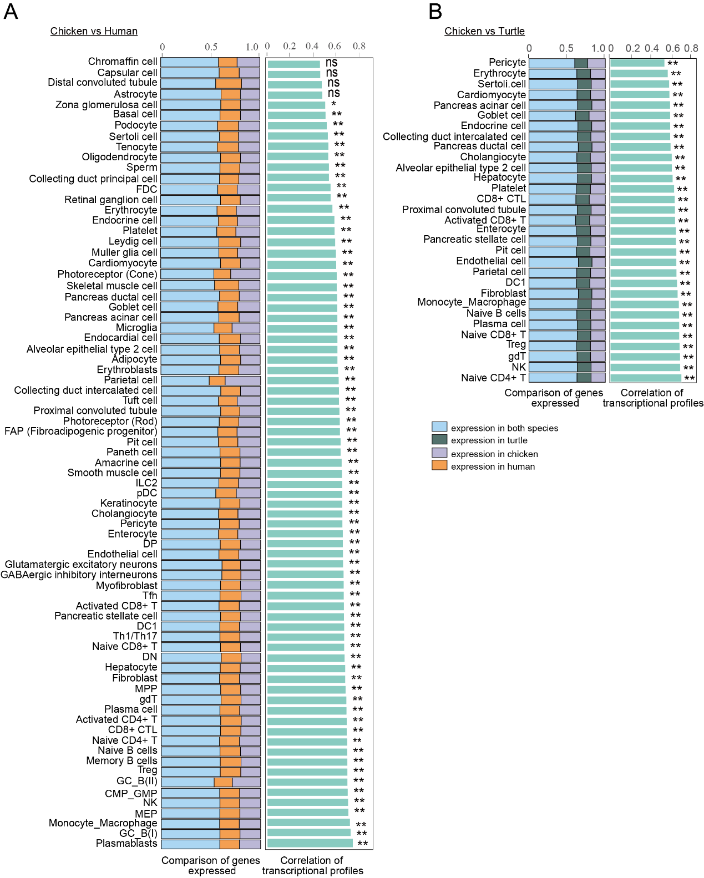 Supplementary Fig. 7. Transcriptional similarity of cell types in chicken compared to human and turtle. Left: The proportion of orthologous genes expressed in both species and a particular species. Right: Transcriptional similarity of the same cell type. Ns indicated no statistically significant correlations and dot indicated statistically significant correlations.
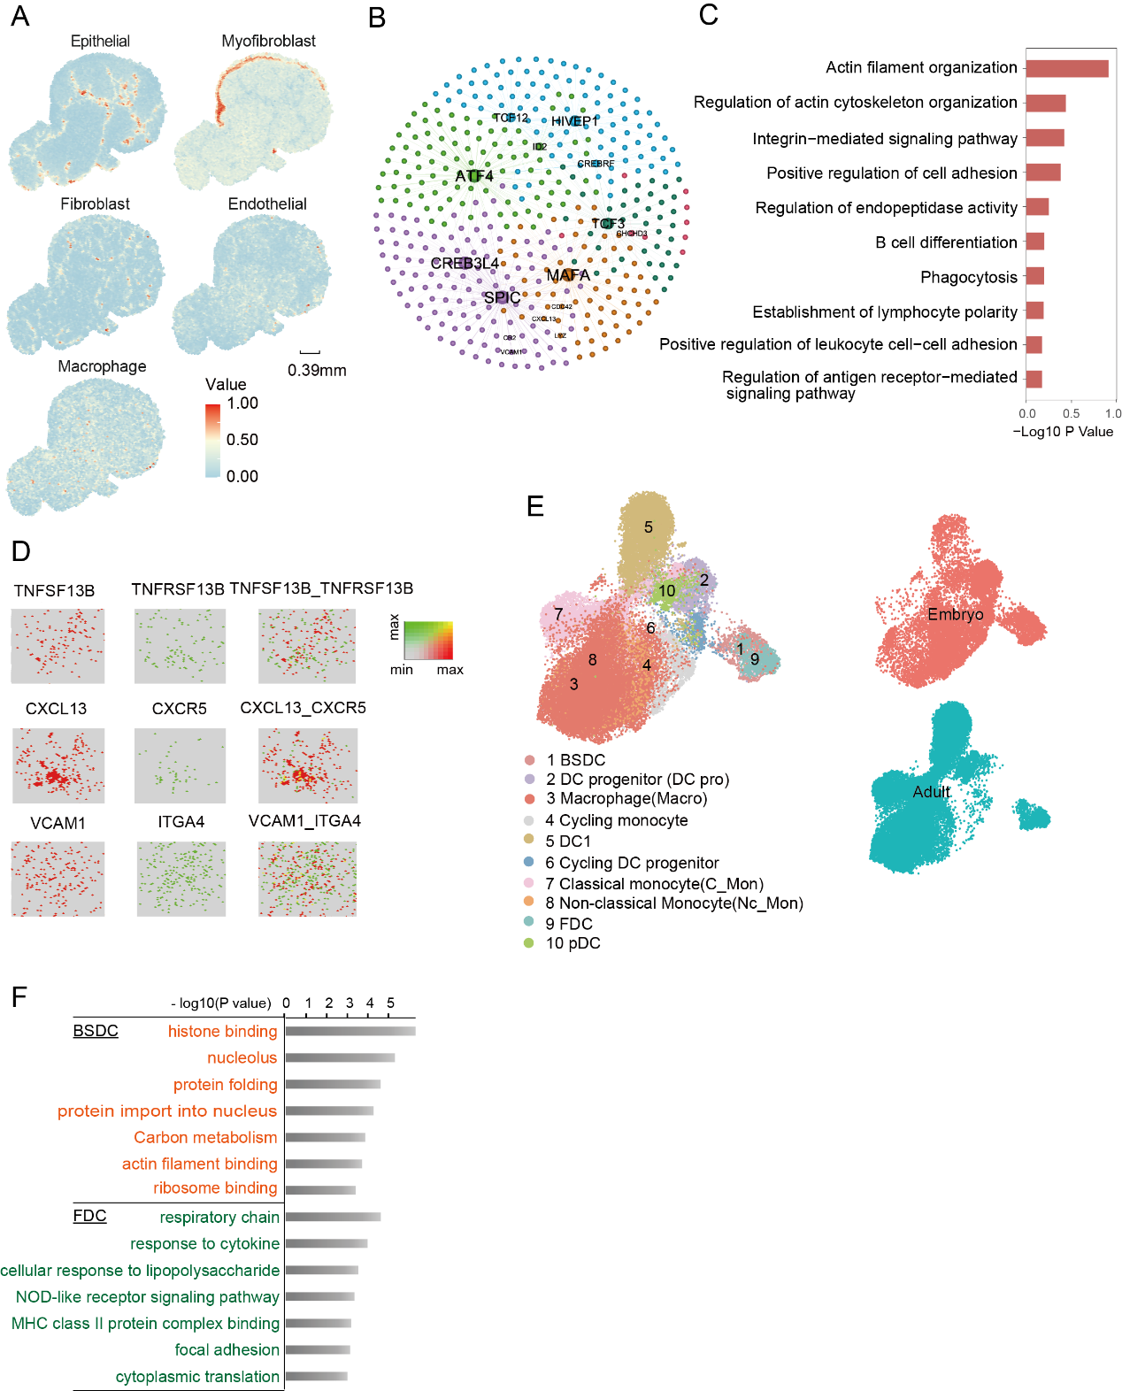 Supplementary Fig. 8. Comparison of BSDC and FDCs in chicken embryo and adult. A, Spatial visualization of cell populations in the caecal tonsil of the adult chicken. B, Transcriptional regulatory network of BSDC cells in chicken. C, Gene ontology analysis of up-regulated genes in BSDC cells. D, Heatmap showing spatial proximity enrichment of cell-type pairs and cell-cell interactions in bursa of Fabricius in chicken embryo. E, Left: UMAP visualization of all clusters coloured by major cell types. Right: Distribution of chicken mononuclear phagocyte from different ages. F, Gene set enrichment analysis results for differentially expressed genes in embryonic BSDC and adult FDC.

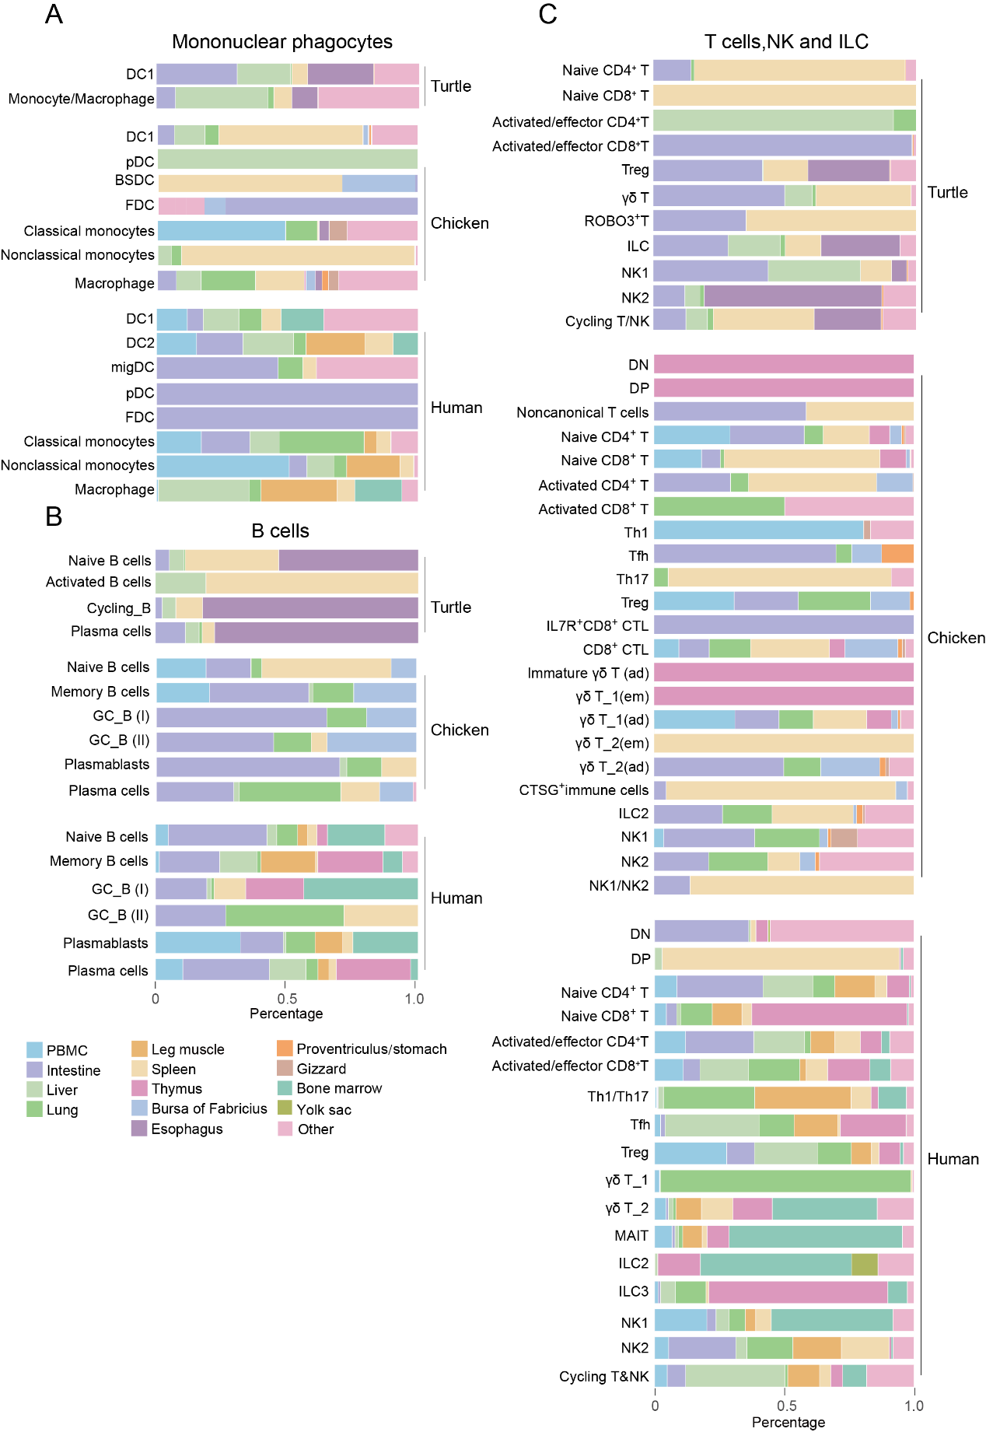 Supplementary Fig. 9. Distribution of annotated mononuclear phagocyte populations and lymphoid populations across organs in turtle, chicken and human.
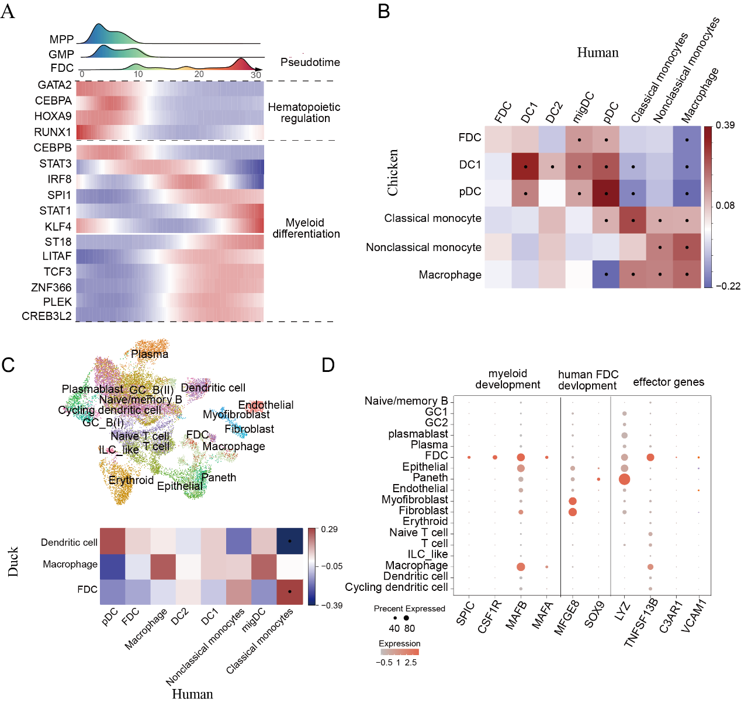
Supplementary Fig. 10. Molecular architecture of FDCs in birds and mammals. A, Top: Ridge plots showing the distribution of cell types (MPP, GMP, and FDCs) along the pseudotime axis. The x-axis represents pseudo-temporal ordering, while the y-axis represents the density of cells at each pseudotime point. Bottom: Heatmaps of differentially expressed genes along the trajectories of the FDCs. Dot plot for expression of marker genes of the identified mononuclear phagocyte populations in turtle, chicken and human. B, Pairwise correlations of mononuclear phagocytes in chicken and human, calculated from highly variable genes. C, Top: UMAP visualization of cell types in duck spleen and bursa of Fabricius. Bottom: Pairwise correlations of mononuclear phagocytes in duck and human, calculated from highly variable genes. D, Dot plot of crucial genes for chicken and human FDC cell in duck cell types.
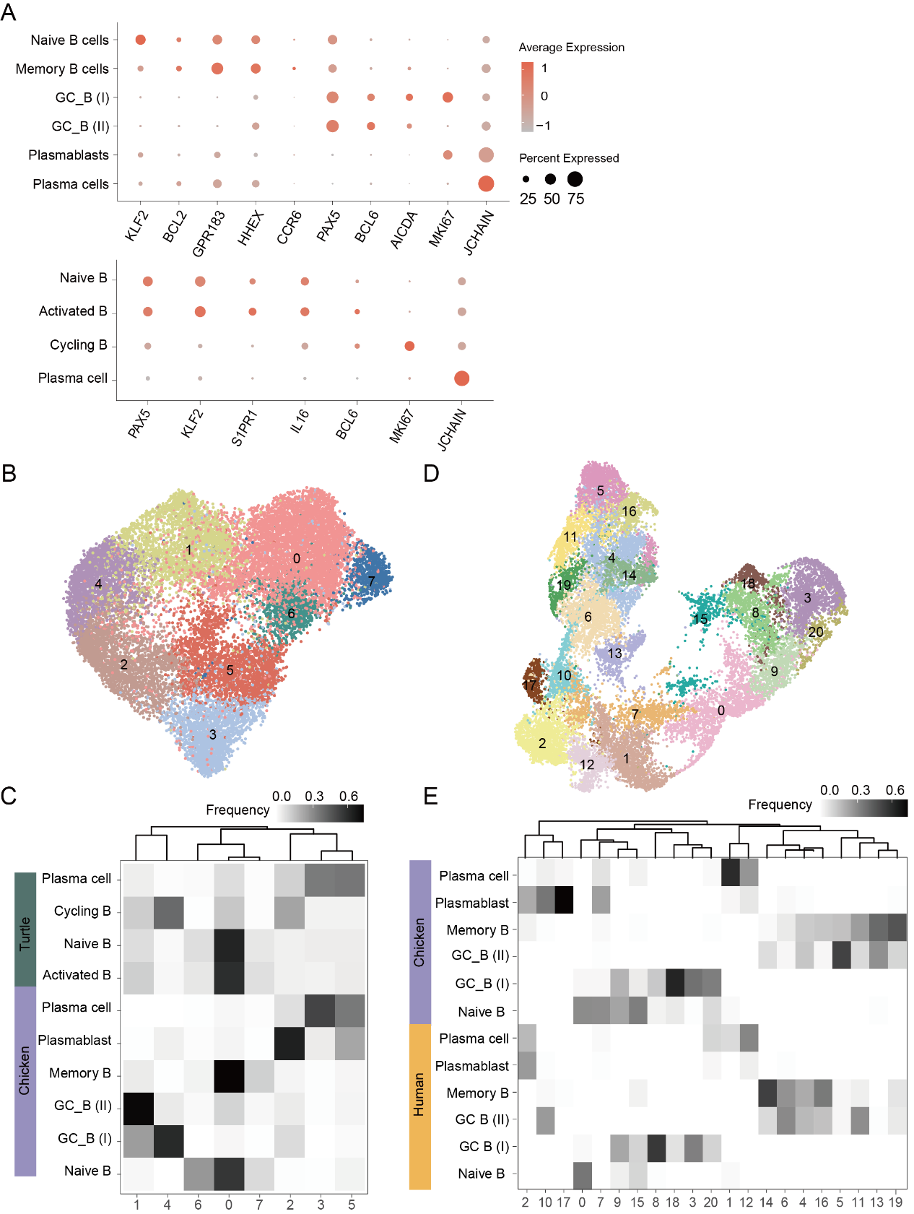
Supplementary Fig. 11 Comparative analysis of B cells across amniotes. A, Dot plot for expression of marker genes of the identified B cell populations in chicken(top) and turtle(bottom). B, D, UMAP plot after integration of scRNA-seq data from B cells of chicken with turtle(B) and human(D). C, E, percentage of cells from the original species-specific clusters (rows) in the integrated clusters (columns) of B and D.

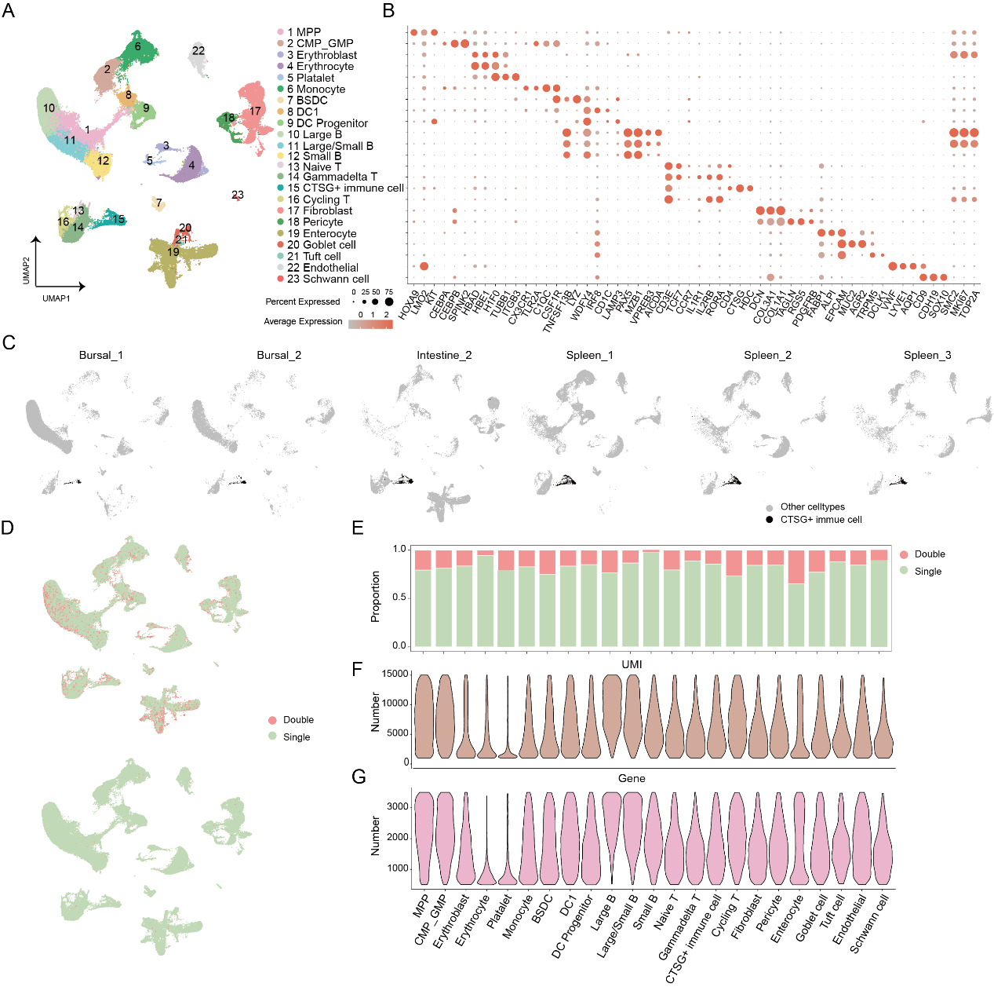Supplementary Fig. 12. Comparison of UMI and gene numbers between CTSG+ immune cells and other cells. A, UMAP visualization of all annotated cell types from the bursa of Fabricius, intestine, and spleen samples containing CTSG+ immune cells. Cells are color-coded according to cell types. B, Dot plot of marker genes of the identified cell types. C, UMAP plots of the integrated dataset showing CTSG+ immune cells from each sample highlighted in black. D, The distribution of doublets inferred by DoubletFinder and Scrublet. E, The proportion of doublets in each cell type. F-G, Violin plot indicating the number of UMI and genes detected in each cell type.
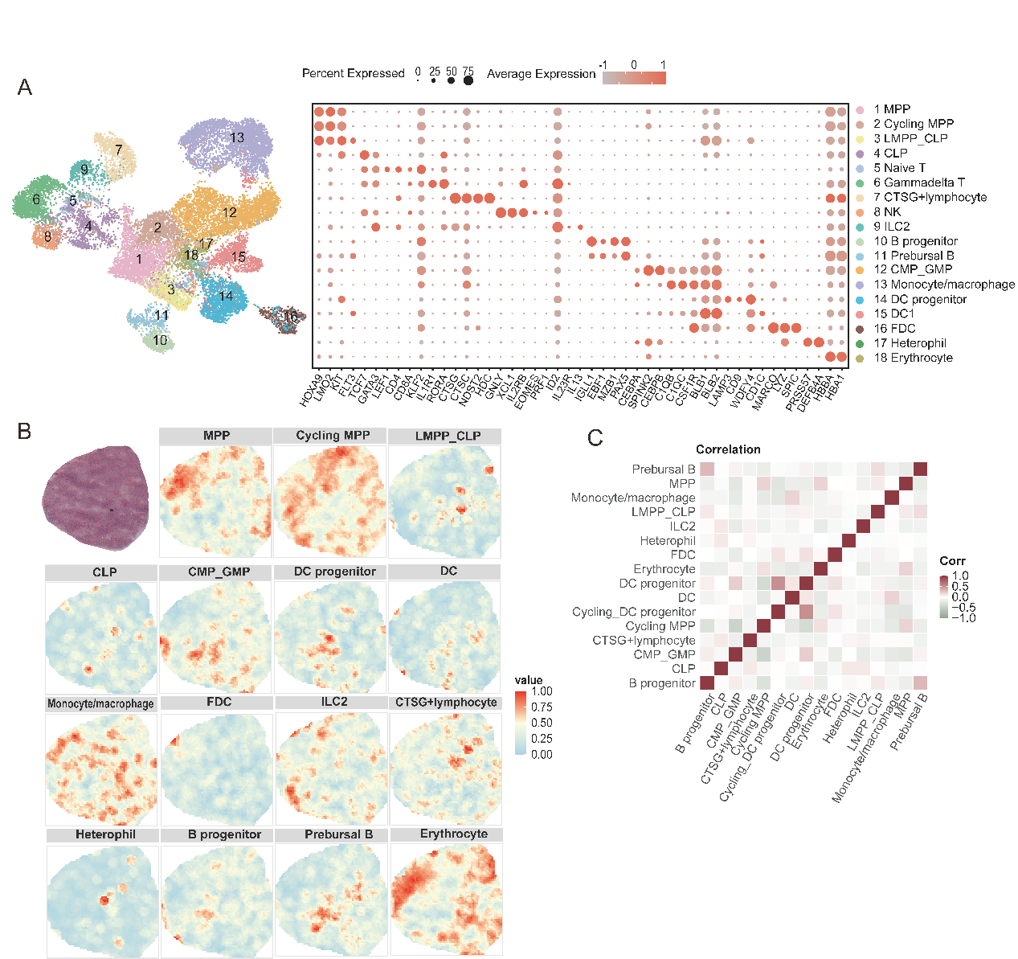 Supplementary Fig. 13. ScRNA-seq profiling and spatial visualization of cell clusters in the spleen of the chicken embryo. A, UMAP visualization of cell populations and dot plot for expression of marker genes of the these populations in the spleen. B, Hematoxylin and Eosin (H&E) staining of the spleen, along with spatial visualization of the indicated cell types within the spleen. C, Heatmap showing spatial proximity of cell-type pairs in the spleen.
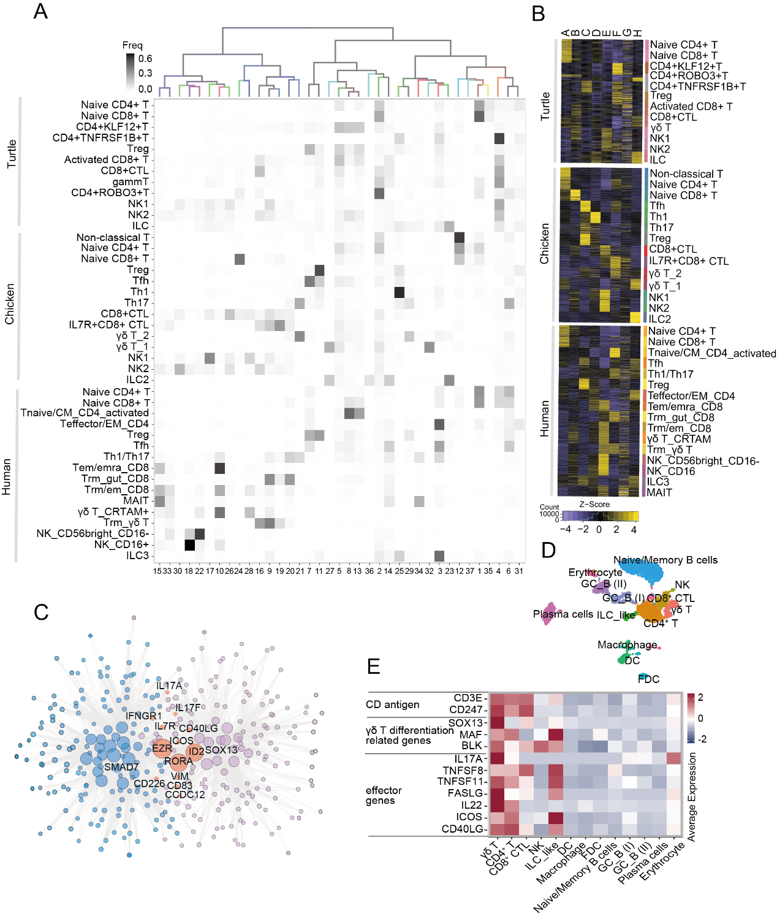
Supplementary Fig. 14. Comparison of gene expression in T cells and innate lymphoid cells among amniotes. A, Top: hierarchical clustering of the average expression profiles of integrated clusters; branches were colored by species mixture. Bottom: percentage of cells from the original species-specific clusters (rows) in the integrated clusters (columns). B, Expression of module eigengenes of gene modules obtained from turtle, chicken and human T/NK/ILC cells with WGCNA. C, Illustration of the union of chicken γδ T_2 and Th17 high expression gene networks. Nodes: genes; edges: high-ranking gene-gene correlations. D, UMAP visualization of all clusters colored by cell types in adult duck intestine. E, Heatmap showing the expression of effect genes in cell types in adult duck intestine.
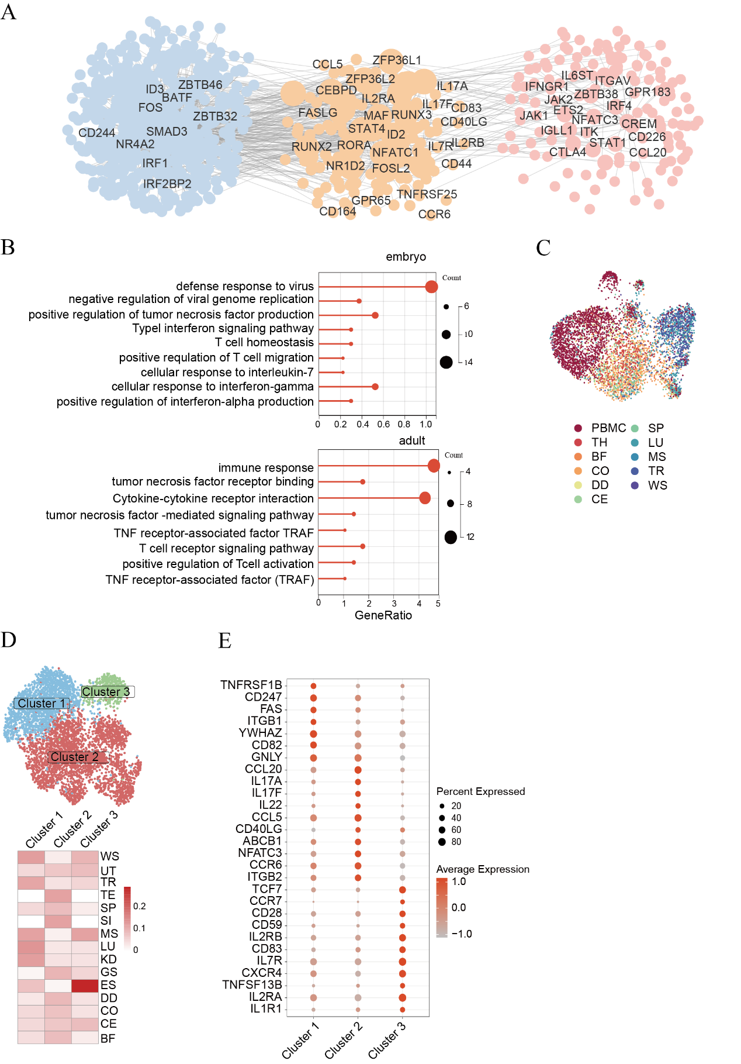
Supplementary Fig. 15. Heterogeneity of γδ across developmental stages and tissues. A, Similarities and differences in gene regulatory networks of γδ T_2 across embryo and adult chicken. B, Gene set enrichment analysis results for differentially expressed genes in embryonic and adult γδ T_2. C, UMAP visualization of the adult γδ T_1 cells in chicken colored by tissues. D, UMAP visualization of adult γδ T_2 subtypes in chicken(upper) and proportion of adult γδ T_2 subtypes in each tissue(lower). E, Dot plot for differentially expressed genes of γδ T_2 subtypes in adult chicken.

