Emergent Nonreciprocal Dual Circularly Polarized Luminescence from an Iridescent Cellulose Nanocrystalline Film
Daikun Jia, Ruixin Zhu, Yuting Tian, Xinling Wang*, and Dandan Zhu*
School of Chemistry and Chemical Engineering, Shanghai Jiao Tong University, Shanghai 200240, People’s Republic of China
E-mail: xlwang@sjtu.edu.cn of Xinling Wang; zhudan@sjtu.edu.cn of Dandan Zhu

Figure S1. Fundamental parameters of as-prepared CNC suspensions. (a) Nanoparticle size distribution. (b) Atomic force microscopy (AFM) morphology, and (c) representative particle sizes from AFM.
Figure S1 gives that the rod-like CNC particles obtained by acid hydrolysis have an average statistical length of 185 nm, which is consistent with the result of AFM. The electric potential of -60.8mV indicates that the negatively charged CNC has excellent water dispersibility.
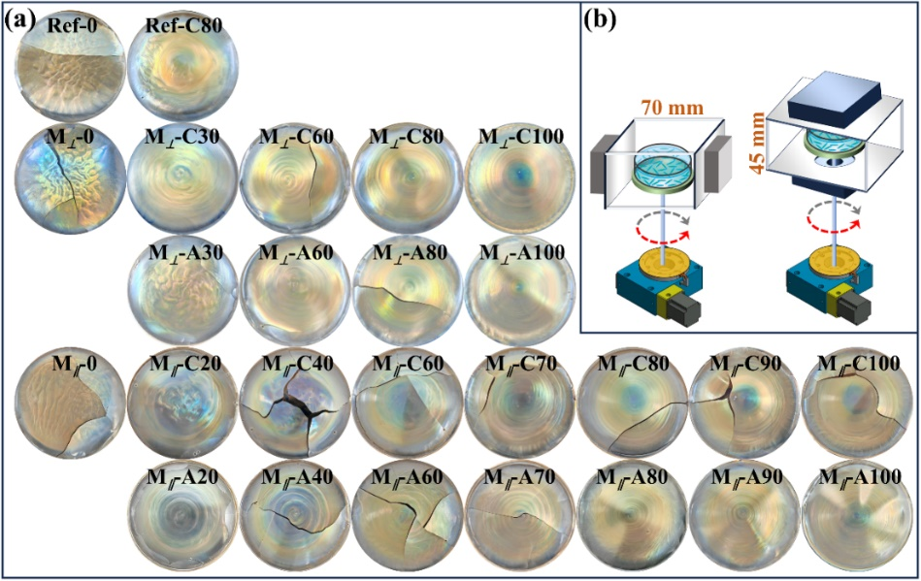
Figure S2. (a) Digital photos and (b) schematic rotating setup with parallel (M∥) and perpendicular (M⊥) magnetic field of as-prepared CNC films.
Figure S2a shows that the CNC films fabricated via the evaporation-induced self-assembly method combined with rotation exhibit concentric appearances with blue central area and the orange outer area. CNC film is fabricated as shown in Figure S2b, where two NdFeB magnets are used to offer a weak magnetic field (less than 3500 Gs).

Figure S3. Apparent CD for both sides of the as-prepared CNC films. The CD curves were recorded by rotating the CNC films around the optical axis at an interval of 45° from 0°~315°.
Figure S3 is the apparent CDs recorded by rotating around the optical axis or flipping the CNC films. The CD signs of films without rotating are positive, rotation causes the CD signs to transition from positive to negative at longer wavelengths, and the CD profiles of both sides are significantly different, showing nonreciprocal characteristics.

Figure S4. Absorption and linear dichroism (LD) spectra recorded during CD testing.
Figure S4 illustrates that CNC films can absorb specific wavelengths of visible light to a certain extent, thereby exhibiting apparent CD signals. Meanwhile, significant LD of film fabricated via rotation is also observed, indicating significant anisotropy.
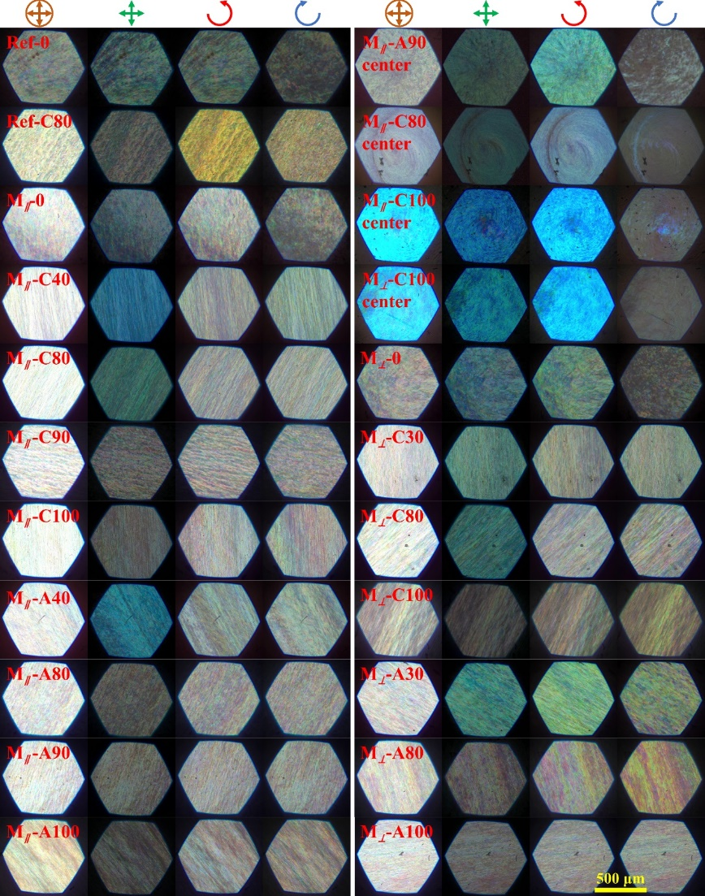
Figure S5. Polarized optical images (POM) taken from different optical channels of CNC films. The optical channels were unpolarized, orthogonal polarized, left- and right-handed CP (L-CP and R-CP) light, respectively from left to right.
Figure S5 presents the POM under unpolarized, orthogonal polarized, left- and right-handed CP light channels, which reveals not only optical birefringence of CNC, but also ambidextrous reflections of left- and right-handed CP light. Different from the orange outer area, the blue central area strongly reflects L-CP light and hardly reflects R-CP light, being a typical feature of left-handed cholestatic structure.

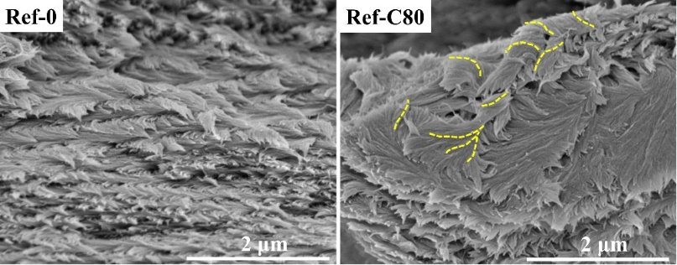
Figure S6. Scanning electron microscope (SEM) images for the CNC films without magnetic field. The yellow dashed line displays the twisted right-handed helical structure.

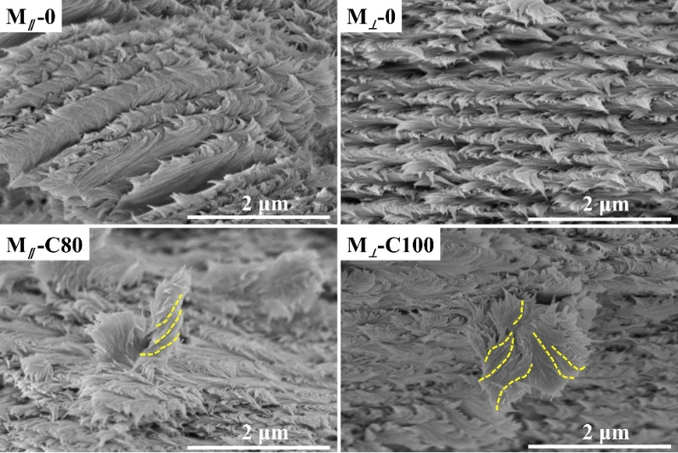
Figure S7. Scanning electron microscope (SEM) images for the CNC films with parallel and perpendicular magnetic field. The yellow dashed line displays the twisted right-handed helical structure.
Scanning electron microscope (SEM) images (Figure S6 and S7) present layered structures of Ref-0, Ref-C80, M∥-0 and M⊥-0, no any right-handed helix is observed, while, all the three samples of Ref-C80, M∥-C80 and M⊥-C100 show twisted right-handed helixes (yellow dashed line) stemmed from rotation.

Figure S8. Reflectance spectra of the as-prepared CNC films under unpolarized light
Reflectance spectra (Figure S8) reveal that the as-prepared CNC films are iridescent due to clear reflectance peak, and the reflected wavelength with maximum reflectivity λ_{max} can shift to shorter or longer wavelength as increasing rotation rate.

Figure S9. In-plane and out-of-plane wide-angle X-ray scattering curve of CNC films.
WAXS in Figure S9 indicates the features of Iβ crystal in cellulose, where the peaks at about q = 1.61 Å⁻¹ are attributable to 200 lattice plane of CNC. The in-plane scattering signals are consistent with each other, while out-of-plane the results are different due to distinguishing orientation caused by rotation.

Figure S10. Apparent CD for both sides of the CNC films with different thickness (mass), temperature, ionic strength (0.01 M NaCl), and pH. The CD curves were recorded by rotating the CNC films around the optical axis at an interval of 45° from 0°~315°.
Figure S10 shows variable apparent CDs regulated via film thickness, temperature, ionic strength, and pH for both sides of CNC films, obvious negative signals and nonreciprocal results can be observed from Figure S10. This indicates tunable chiroptical behavior of CNC film fabricated via the evaporation-induced self-assembly method combined with rotation.

