Additional Information
Supplementary Data Files 1 to 4 available as separate files:
• S1 Historical: Estimates, rounded values, and sources for baseline historical AFOLU emissions data.
• S2 Baselines: AFOLU mitigation values with adjustments to flat historical baselines.
• S3 Crosswalk: Crosswalk from NCS pathways³⁶ into categories.
• S4 PMR: Protect, Manage, and Restore mitigation pathways from 2024-2050.

Corresponding Author
Michael Wolosin, mwolosin@conservation.org

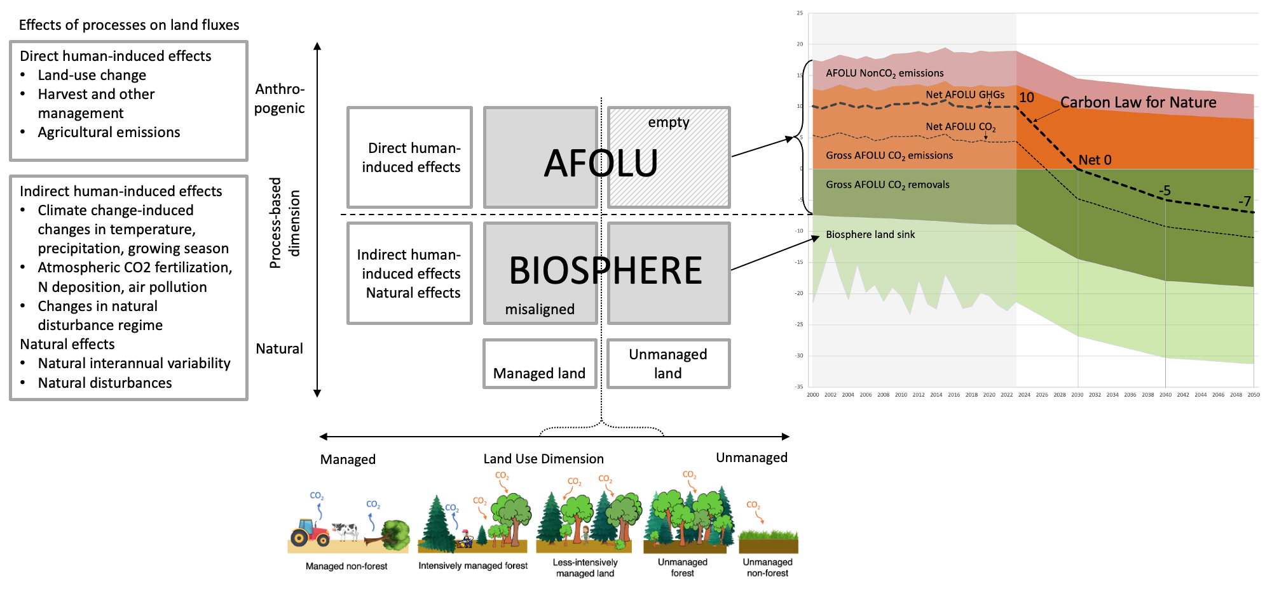

Extended Data Fig. 1
Model-based land flux accounting separates direct human-induced effects from indirect human-induced effects and natural effects, which are together considered to be the global land sink or biosphere response. Countries are allowed by IPCC reporting guidelines to apply the “managed land proxy” – a distinction between managed and unmanaged land along the land use dimension – to divide anthropogenic fluxes from natural fluxes in national greenhouse gas inventories (NGHGIs), which results in NGHGIs including some of the biosphere response on managed land. Our analyses use model-based land flux accounting conventions that exclude indirect human-induced effects and natural effects from AFOLU.

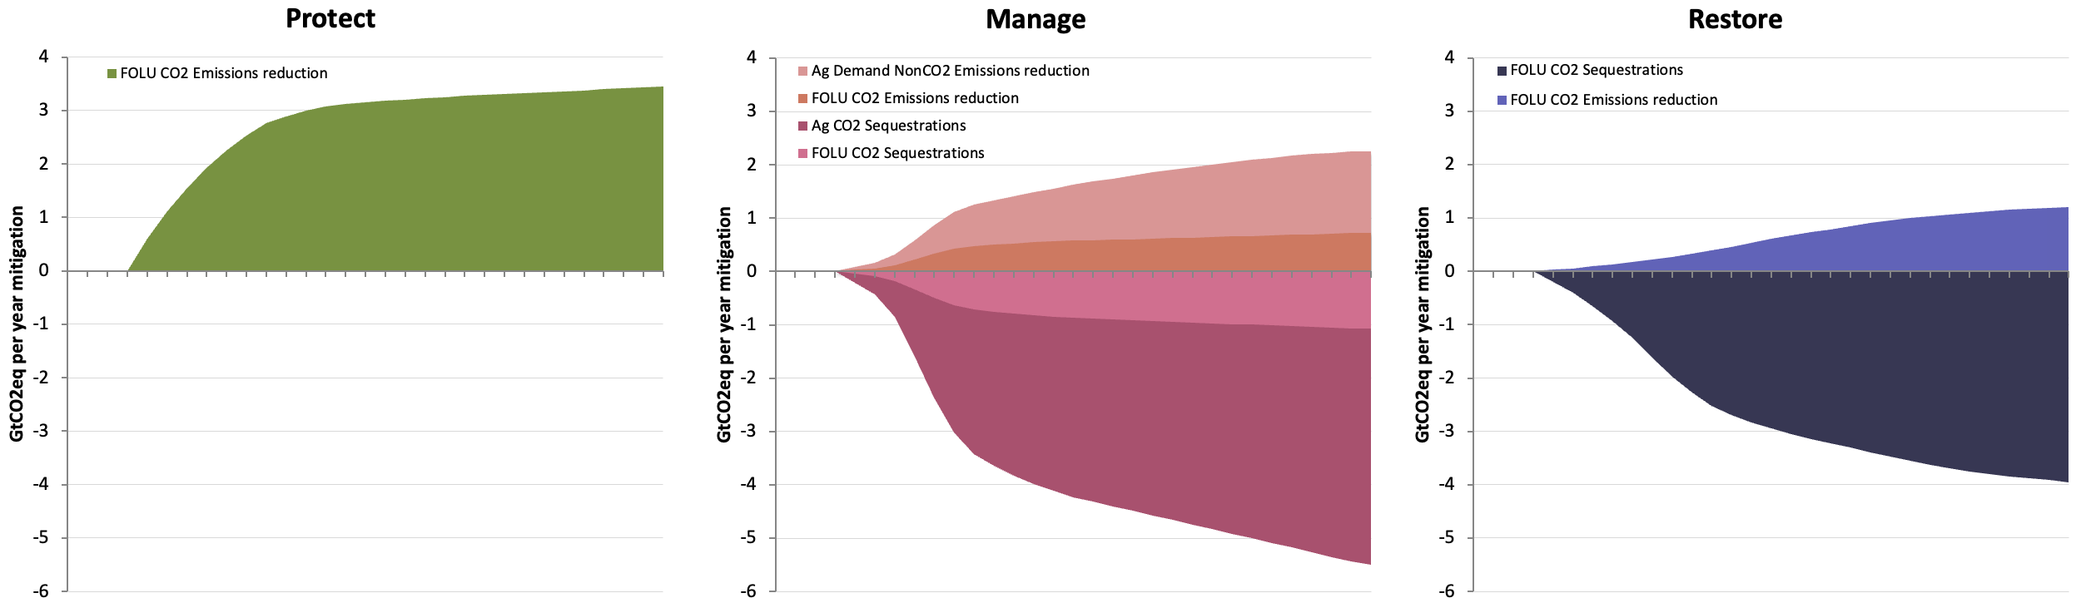

Extended Data Fig. 2
Mitigation acceleration curves from ecosystem protection, changes in working lands management, and ecosystem restoration that collectively deliver on the Carbon Law for Nature pathway.

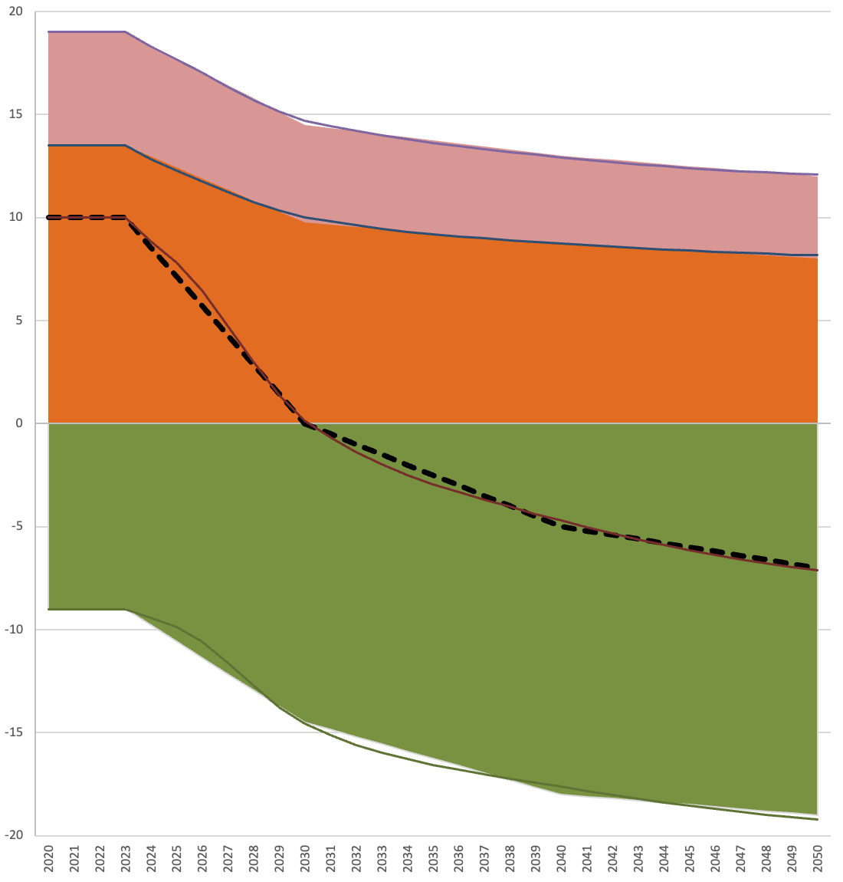

Extended Data Fig. 3
Total mitigation from the acceleration curves closely tracks the Carbon Law for Nature.

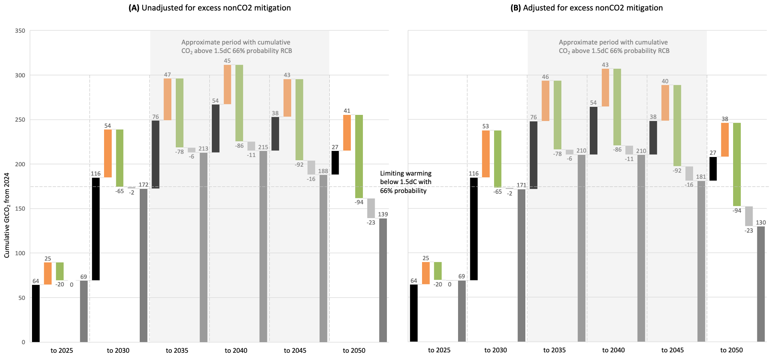

Extended Data Fig. 4
Alternative versions of main text Figure 2(B). Cumulative net anthropogenic CO₂-only emissions and removals from January 1, 2024, at 5-year intervals compared to the 66% probability 1.5°C RCB, showing a period of overshoot from approximately 2031 to 2045. (A) CO₂-only emissions and removals without adjustment for excess nonCO₂ mitigation; (B) CO₂-only emissions and removals after subtracting excess nonCO₂ mitigation from cumulative AFOLU gross CO₂ emissions.

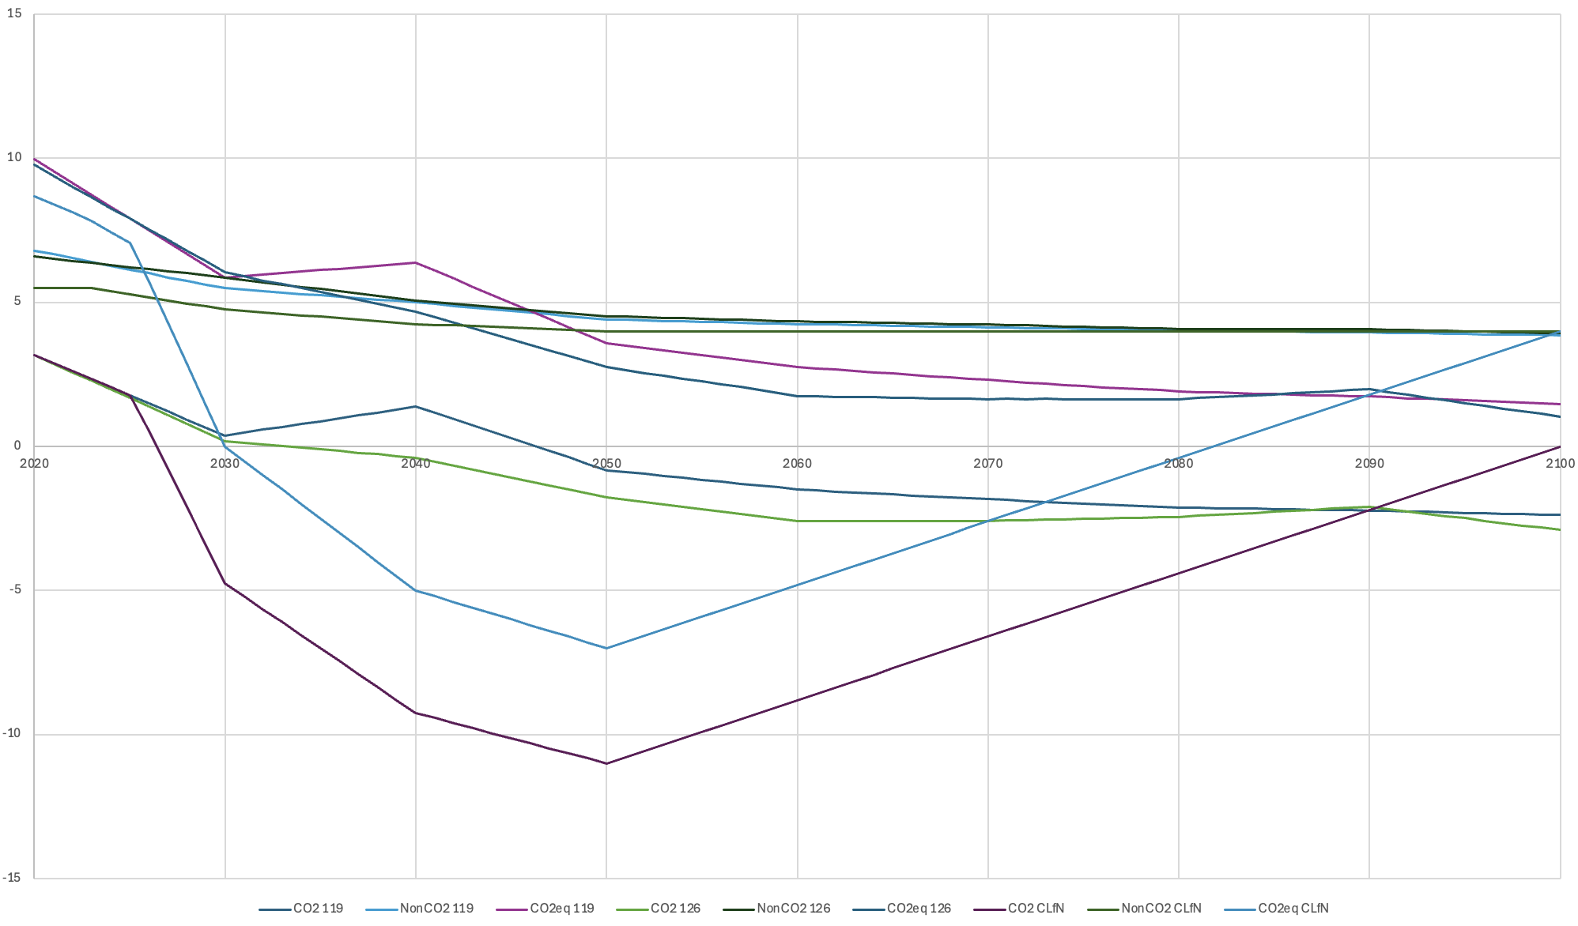Extended Data Fig. 5
Emissions pathways input into MAGICC7 to assess the Carbon Law for Nature’s impact on temperature anomalies from SSP119 and SSP126.

Extended Data Table 1
Values are period total GtCO₂e emissions for 2024 to 2050 inclusive.
S1.a. Spending Down the 1.5°C RCB from Jan 1 2024 to Dec 31 2050 |  | 50% | 66%
 | Remaining Carbon Budget | 275 | 175
 | Carbon Law Pathway for Fossil Fuels | 376
 | Carbon Law Pathway for Negative Emissions Technologies | -57
 | Carbon Law Pathway for FFl plus NETs | 319
 | RCB Overshoot without considering AFOLU | 44 | 144
b. AFOLU All Gases Adjustment for RCB comparisons
 | NonCO₂ AFOLU emissions in 1.5°C Scenarios (C1 & C2) | 131
 | NonCO₂ AFOLU mitigation in 1.5°C Scenarios (C1 & C2) | 18
c. AFOLU at Current Emissions Levels
 | AFOLU Net Emissions, All Gases | 270
 | AFOLU Net Emissions, CO₂ only | 122
 | AFOLU Net Emissions, nonCO₂ only | 149
 | AFOLU Net Emissions for RCB comparison (adjusted) | 139
 | FFl + NETs + AFOLU net emissions for RCB comparison (adjusted) | 458
 | RCB Overshoot at current levels of AFOLU emissions | 183 | 283
d. Carbon Law for Nature |  |  |  | Mitigation
 | CLfN AFOLU Net Emissions, All Gases | -59 |  | 329
 | CLfN AFOLU Net Emissions, CO₂ only | -180 |  | 301
 | CLfN AFOLU Net Emissions, nonCO₂ only | 121 |  | 27
 | CLfN AFOLU Net Emissions for RCB comparison (adjusted) | -189 |  | 329
 | FFl + NETs + AFOLU net emissions for RCB comparison (adjusted) | 130
 | RCB Buffer with CLfN AFOLU Pathway | 145 | 45
e. Roe et al (2021): 27 years at Adjusted Averages
 | AFOLU Net Emissions, All Gases | -56 |  | 326
 | AFOLU Net Emissions, CO₂ only | -187 |  | 309
 | AFOLU Net Emissions, nonCO₂ only | 131 |  | 17
 | AFOLU Net Emissions for RCB comparison (adjusted) | -186 |  | 326
 | FFl + NETs + AFOLU net emissions for RCB comparison (adjusted) | 133
 | RCB Buffer with Roe Average AFOLU | 142 | 42
f. Protect-Manage-Restore Curves
 | PMR Adj Avg AFOLU, All Gases | -59 |  | 329
 | PMR Adj Avg AFOLU, CO₂ only | -179 |  | 301
 | PMR Adj Avg AFOLU, nonCO₂ only | 120 |  | 29
 | Adjusted PMR AFOLU Net Emissions for RCB | -190 |  | 329
 | FFl + NETs + AFOLU net emissions for RCB comparison (adjusted) | 129
 | RCB Buffer with PMR Curve Pathways | 146 | 46

Extended Data Table 2
Baseline emissions estimates and rounded values by gas, sector, and sources.
 |  | FOLU |  | Ag |  | AFOLU |  | Source | Period
 | Units | value | rounded | value | rounded | value | rounded
CO₂ (net) | GtCO₂ | 4.67 | 4.5 | 0.00 | 0.0 | 4.7 | 4.50 | (25) | 2013-2022
CO₂ gross e- | GtCO₂ | 13.37 | 13.5 | 0.00 | 0.0 | 13.4 | 13.50 | (25) | 2013-2022
CO₂ gross s+ | GtCO₂ | -8.70 | -9.0 | 0.00 | 0.0 | -8.7 | -9.00 | (25) | 2013-2022
CH₄ | GtCO₂e | 0.39 | NA | 3.19 | NA | 3.6 | NA | (56, 17) | 2012-2021
N₂O | GtCO₂e | 0.08 | NA | 1.86 | NA | 1.9 | NA | (56, 17) | 2012-2021
Total nonCO₂ | GtCO₂e | 0.47 | 0.5 | 5.05 | 5.0 | 5.5 | 5.50 | Calculated | 2012-2021
Total net e- | GtCO₂e | 5.14 | 5.0 | 5.05 | 5.0 | 10.2 | 10.00 | Calculated | mix
Total gross e- | GtCO₂e | 13.85 | 14.0 | 5.05 | 5.0 | 18.9 | 19.00 | Calculated | mix
Total s+ | GtCO₂e | -8.70 | -9.0 | 0.00 | 0.0 | -8.7 | -9.00 | Calculated | mix
Note that in Extended Data Fig. 1 we use EDGAR estimates of AFOLU nonCO₂ emissions for the historical period; EDGAR estimates are somewhat higher than those in (56) at ~6.0 GtCO₂e per year from 2012-2021, with 0.3 GtCO₂e from FOLU and 5.7 GtCO₂e from Agriculture.

