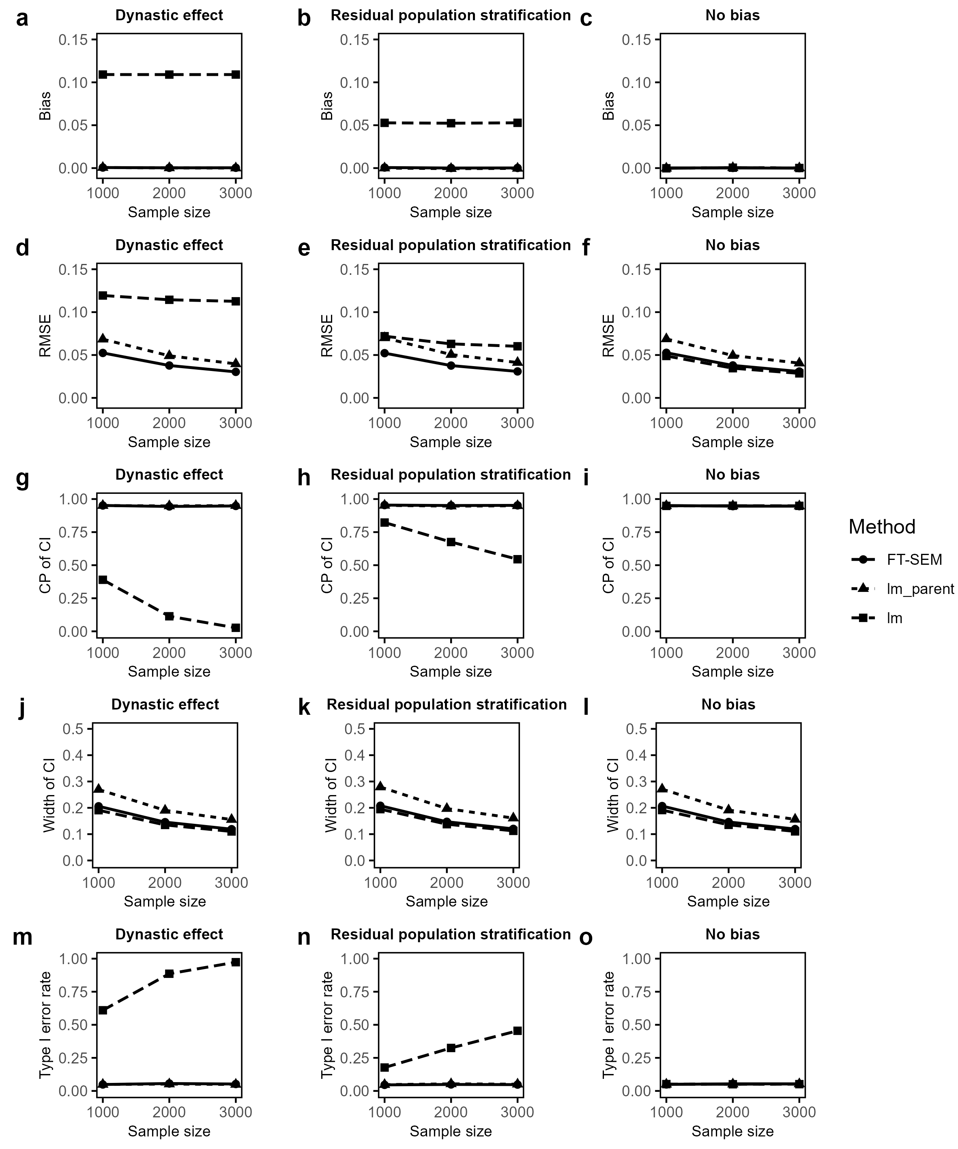
Supplementary Figures
Supplementary Figure 1: Simulated biases and RMSEs, CPs and average widths of the corresponding 95% CIs and type I error rates of offspring effect estimates for FT-SEM, lm_parent and lm with MAF of 0.3 when the sample size is fixed at 1,000, 2,000 and 3,000, with the PVE of offspring’s phenotype explained by offspring’s genotype being set to be 0, and the residual correlation being set to be 0.3 under dynastic effect, residual population stratification and no bias. a-c Biases of offspring effect estimates for FT-SEM, lm_parent and lm under dynastic effect, residual population stratification and no bias, respectively. d-f RMSEs of offspring effect estimates for FT-SEM, lm_parent and lm under dynastic effect, residual population stratification and no bias, respectively. g-i CPs of offspring effect estimates for FT-SEM, lm_parent and lm under dynastic effect, residual population stratification and no bias, respectively. j-l Average widths of offspring effect estimates for FT-SEM, lm_parent and lm under dynastic effect, residual population stratification and no bias, respectively. m-o Type I error rates of offspring effect estimates for FT-SEM, lm_parent and lm under dynastic effect, residual population stratification and no bias, respectively.
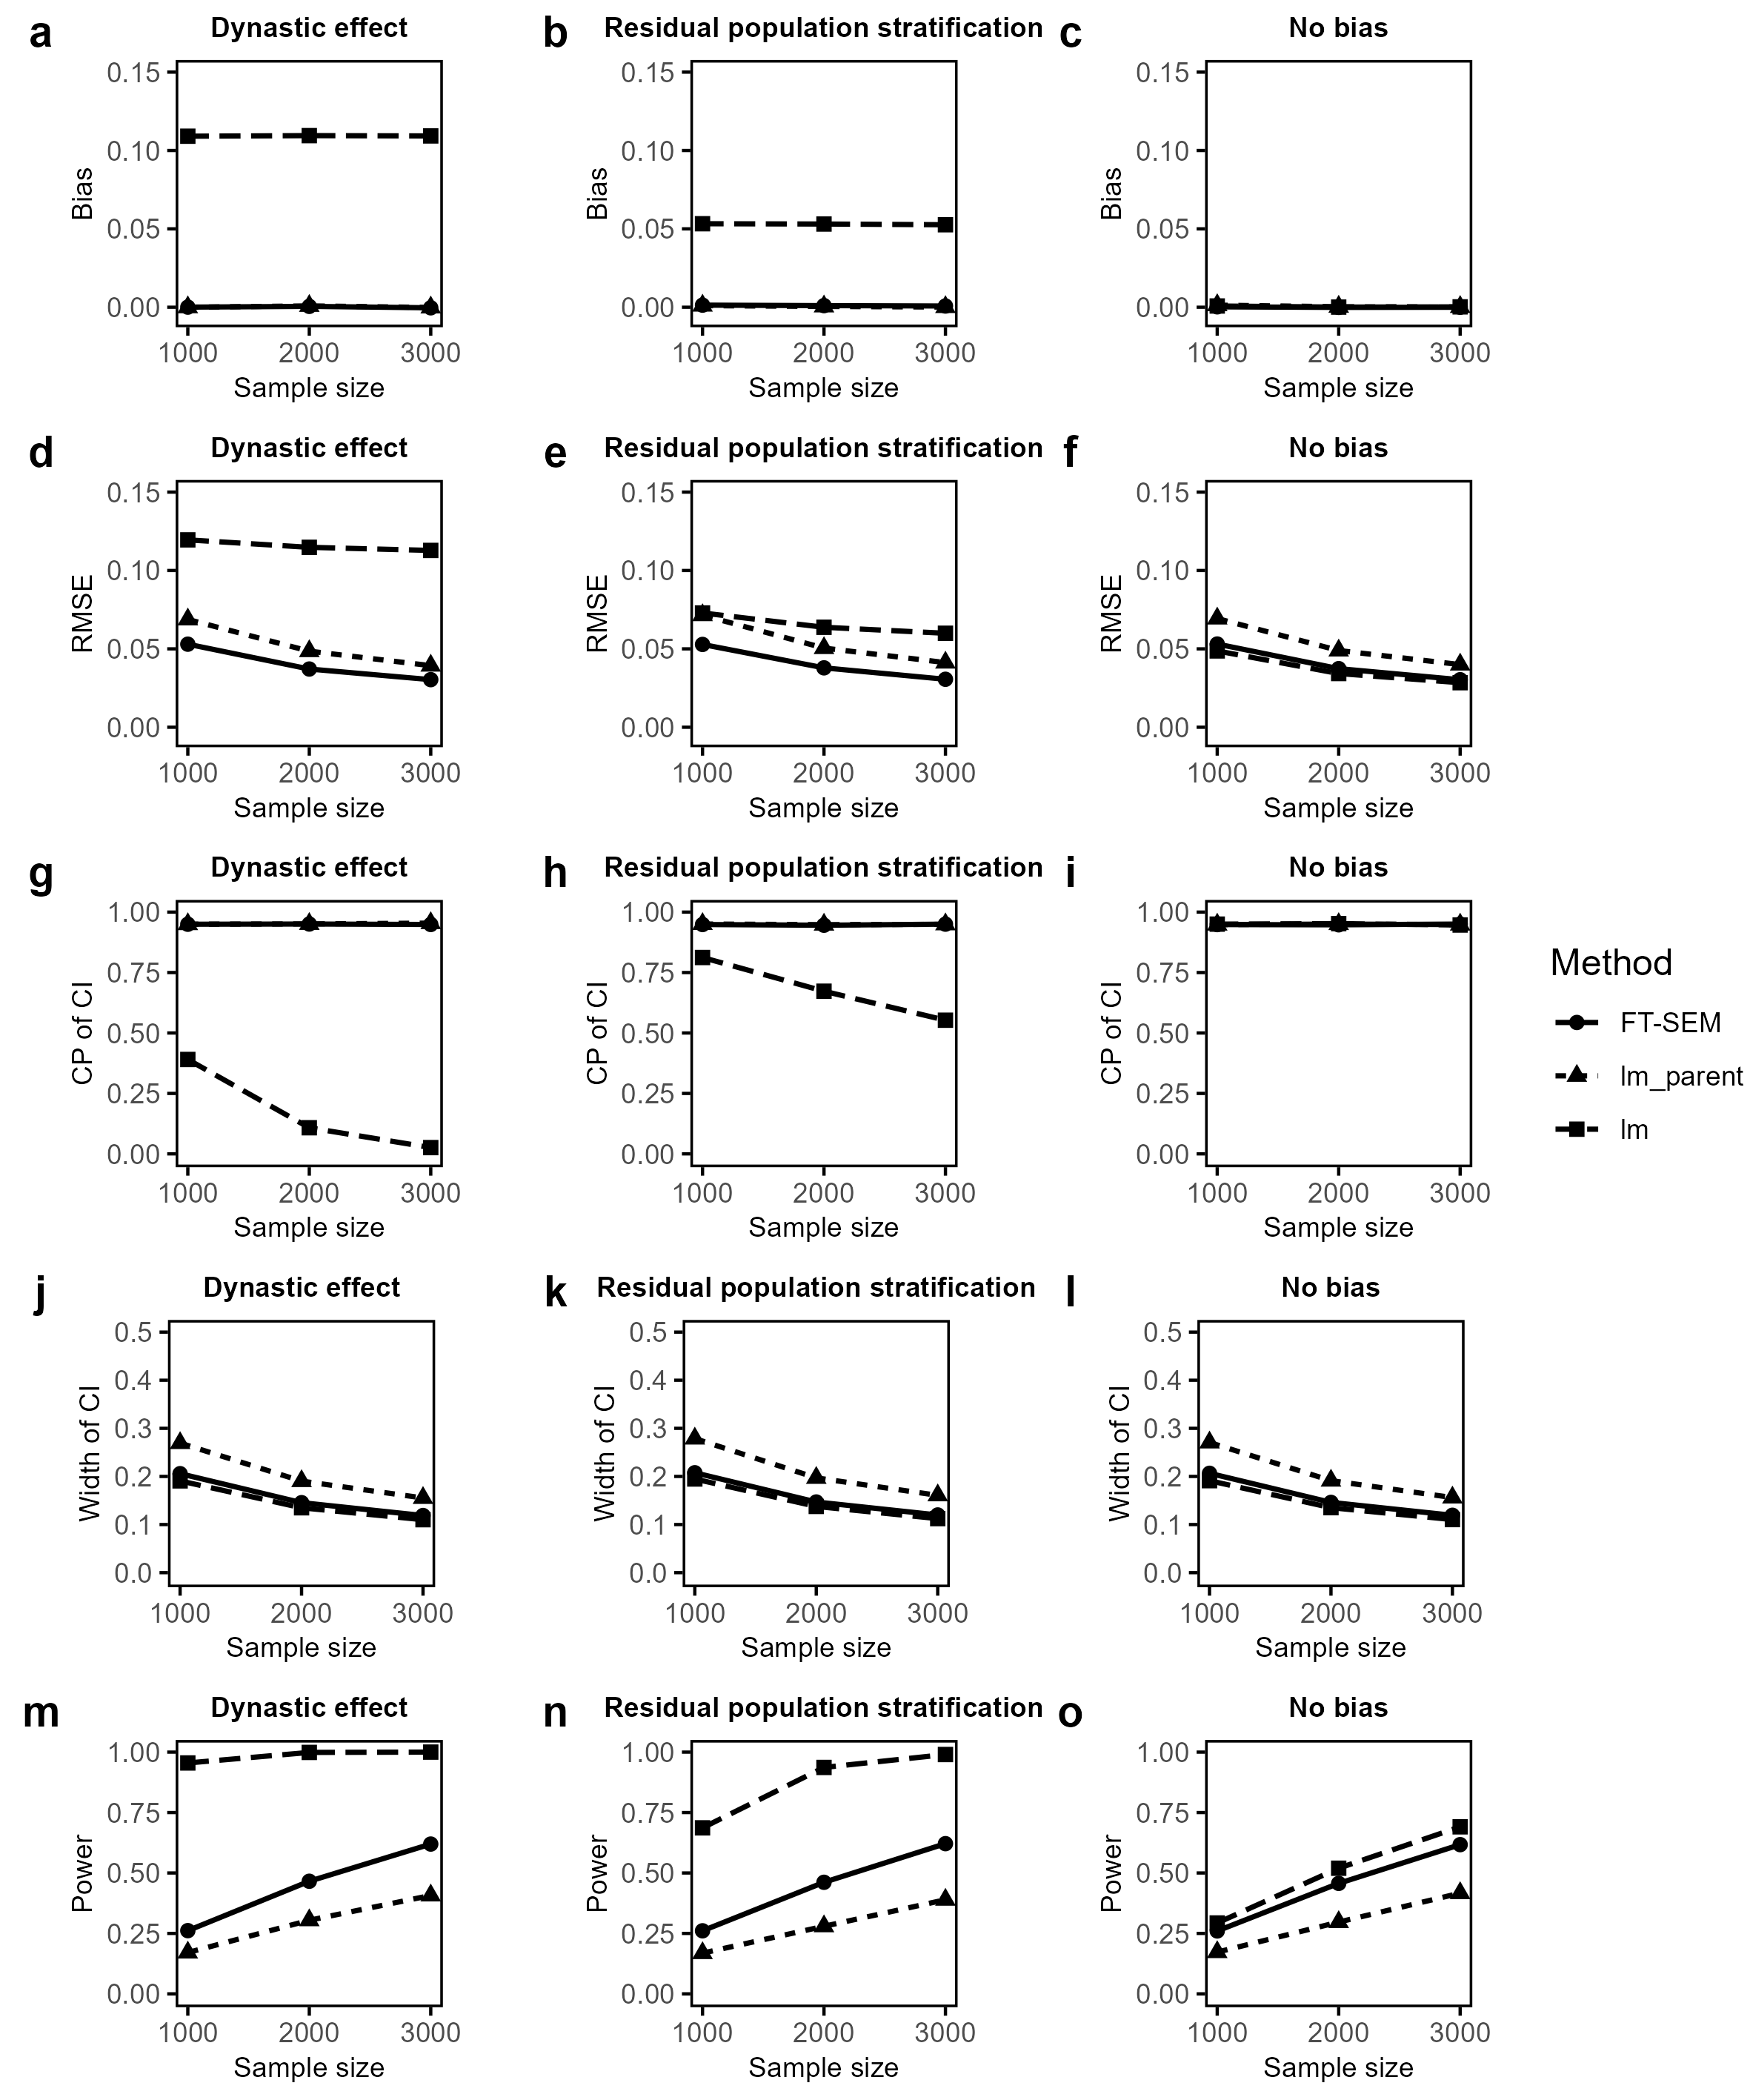
Supplementary Figure 2: Simulated biases and RMSEs, CPs and average widths of the corresponding 95% CIs and powers of offspring effect estimates for FT-SEM, lm_parent and lm with MAF of 0.3 when the sample size is fixed at 1,000, 2,000 and 3,000, with the PVE of offspring’s phenotype explained by offspring’s genotype being set to be 0.2%, and the residual correlation being set to be 0.3 under dynastic effect, residual population stratification and no bias. a-c Biases of offspring effect estimates for FT-SEM, lm_parent and lm under dynastic effect, residual population stratification and no bias, respectively. d-f RMSEs of offspring effect estimates for FT-SEM, lm_parent and lm under dynastic effect, residual population stratification and no bias, respectively. g-i CPs of offspring effect estimates for FT-SEM, lm_parent and lm under dynastic effect, residual population stratification and no bias, respectively. j-l Average widths of offspring effect estimates for FT-SEM, lm_parent and lm under dynastic effect, residual population stratification and no bias, respectively. m-o Test power of offspring effect estimates for FT-SEM, lm_parent and lm under dynastic effect, residual population stratification and no bias, respectively.
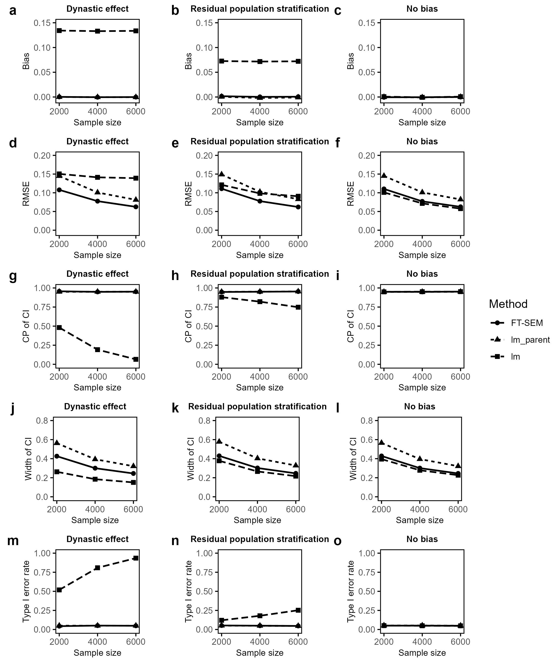
Supplementary Figure 3: Simulated biases and RMSEs, CPs and average widths of the corresponding 95% CIs and type I error rates of causal effect estimates of offspring’s exposure on offspring’s outcome for FT-SEM, lm_parent and lm with MAF of 0.3, and the residual correlation being set to be 0.3 under the null hypothesis when the sample size is fixed to be 2,000, 4,000 and 6,000. a-c Biases of causal effect estimates for FT-SEM, lm_parent and lm using the ratio method under dynastic effect, residual population stratification and no bias, respectively. d-f RMSEs of causal effect estimates for FT-SEM, lm_parent and lm using the ratio method under dynastic effect, residual population stratification and no bias, respectively. g-i CPs of causal effect estimates for FT-SEM, lm_parent and lm using the ratio method under dynastic effect, residual population stratification and no bias, respectively. j-l Average widths of causal effect estimates for FT-SEM, lm_parent and lm using the ratio method under dynastic effect, residual population stratification and no bias, respectively. m-o Type I error rates of causal effect estimates for FT-SEM, lm_parent and lm using the ratio method under dynastic effect, residual population stratification and no bias, respectively.
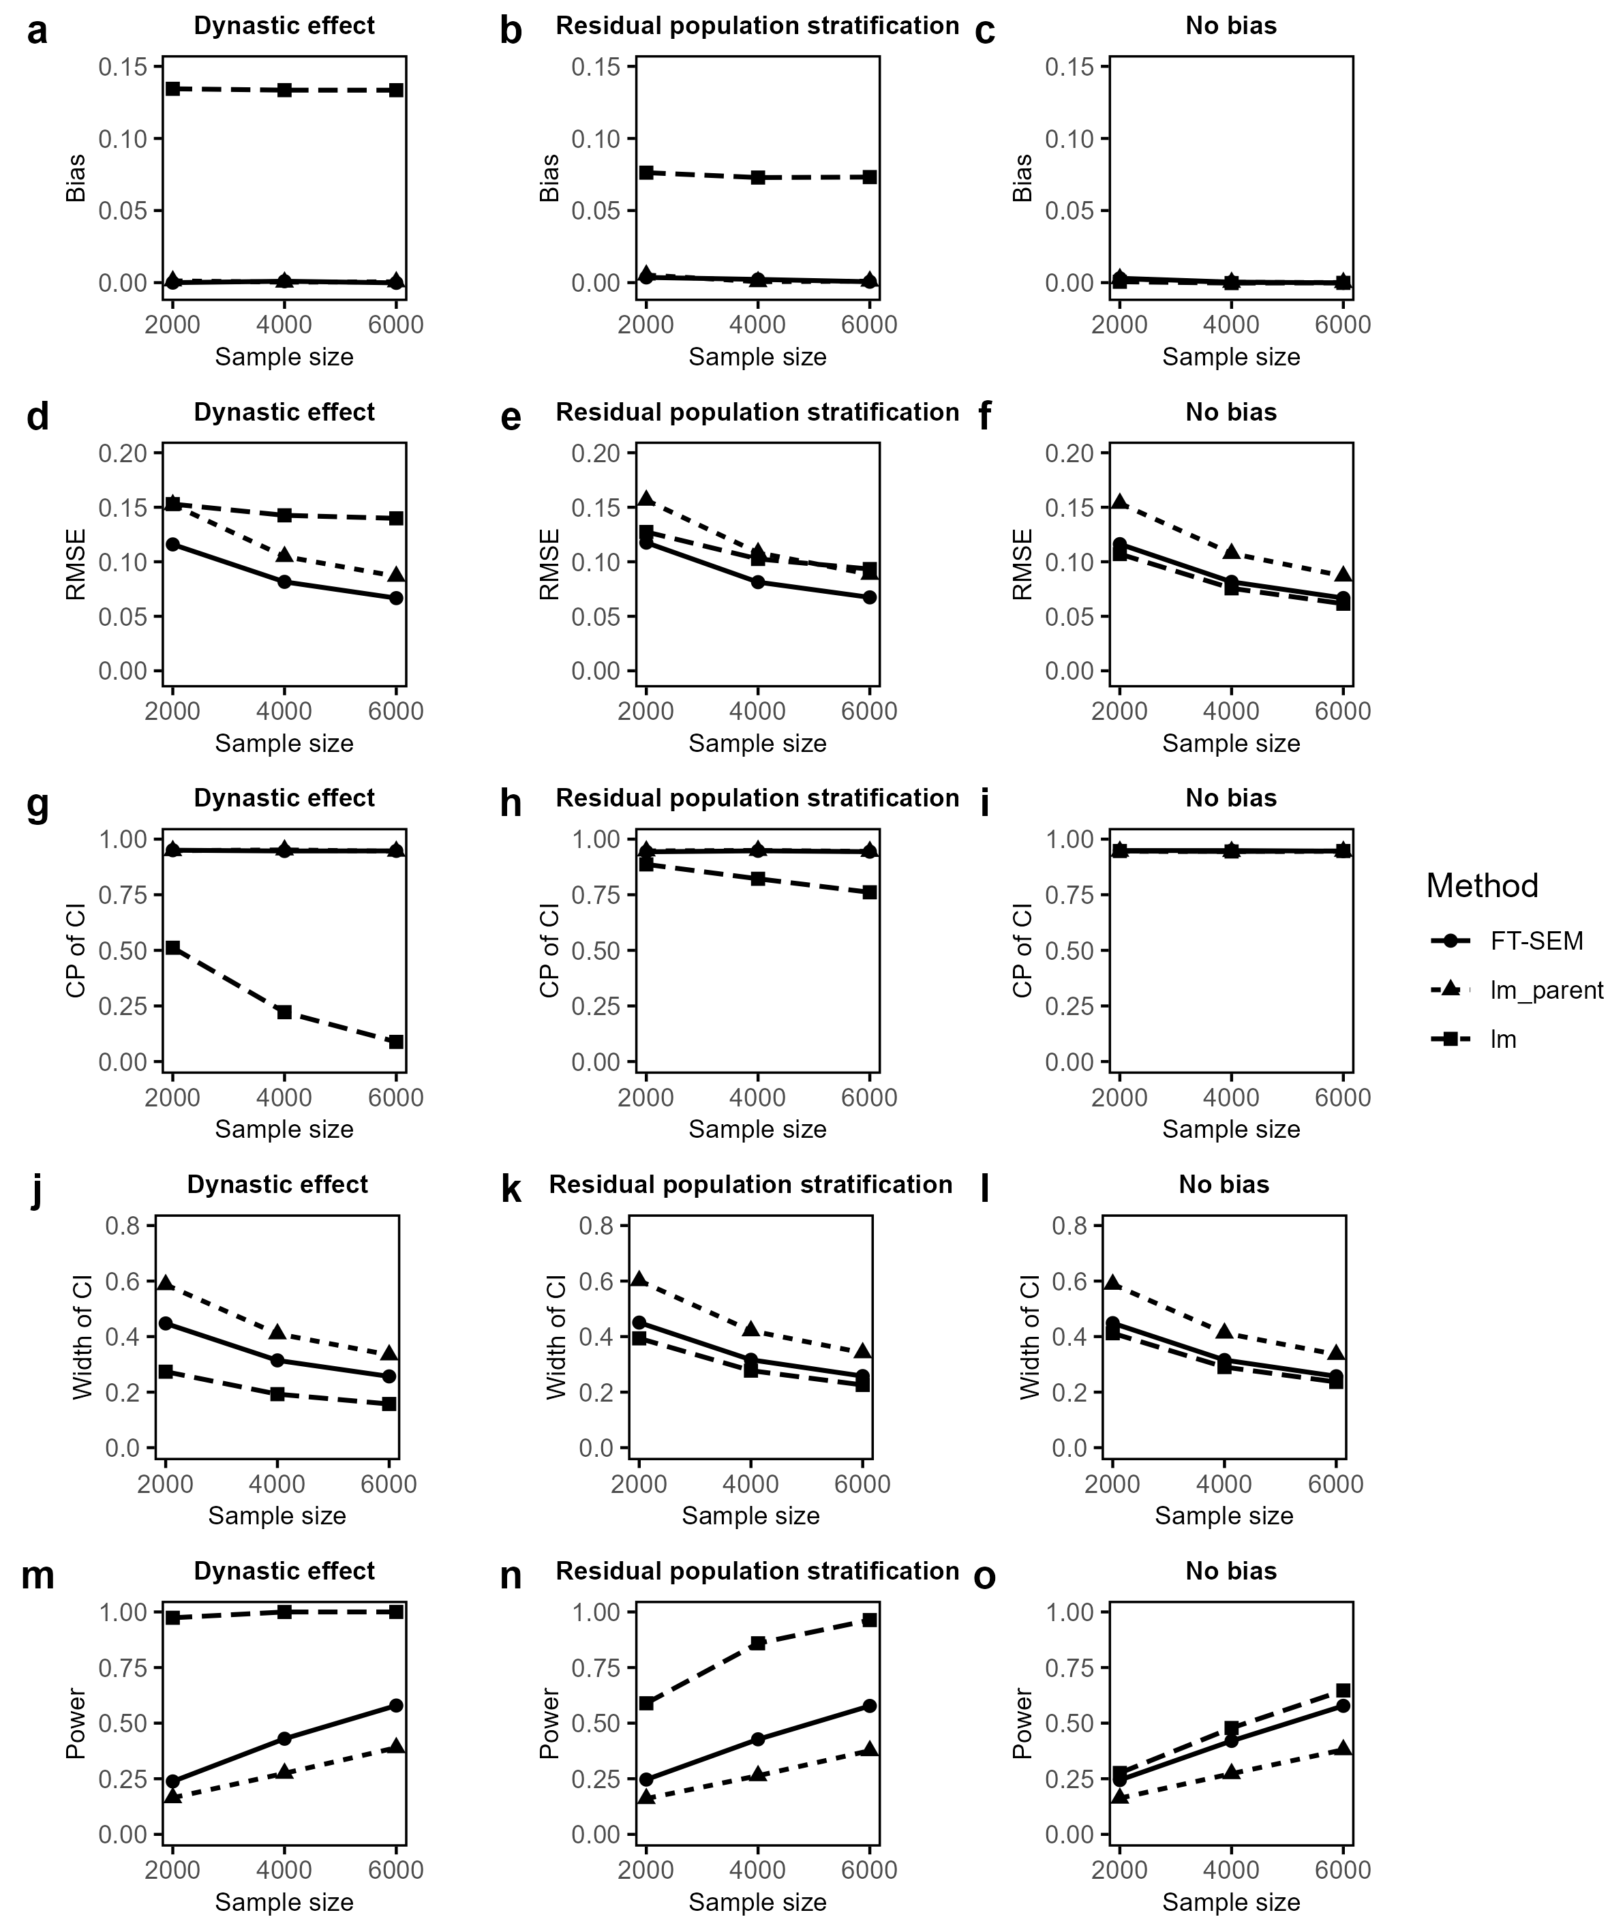
Supplementary Figure 4: Simulated biases and RMSEs, CPs and average widths of the corresponding 95% CIs and powers of causal effect estimates of offspring’s exposure on offspring’s outcome for FT-SEM, lm_parent and lm with MAF of 0.3, and the residual correlation being set to be 0.3 under the alternative hypothesis when the sample size is fixed to be 2,000, 4,000 and 6,000. a-c Biases of causal effect estimates for FT-SEM, lm_parent and lm using the ratio method under dynastic effect, residual population stratification and no bias, respectively. d-f RMSEs of causal effect estimates for FT-SEM, lm_parent and lm using the ratio method under dynastic effect, residual population stratification and no bias, respectively. g-i CPs of causal effect estimates for FT-SEM, lm_parent and lm using the ratio method under dynastic effect, residual population stratification and no bias, respectively. j-l Average widths of causal effect estimates for FT-SEM, lm_parent and lm using the ratio method under dynastic effect, residual population stratification and no bias, respectively. m-o Test power of causal effect estimates for FT-SEM, lm_parent and lm using the ratio method under dynastic effect, residual population stratification and no bias, respectively.
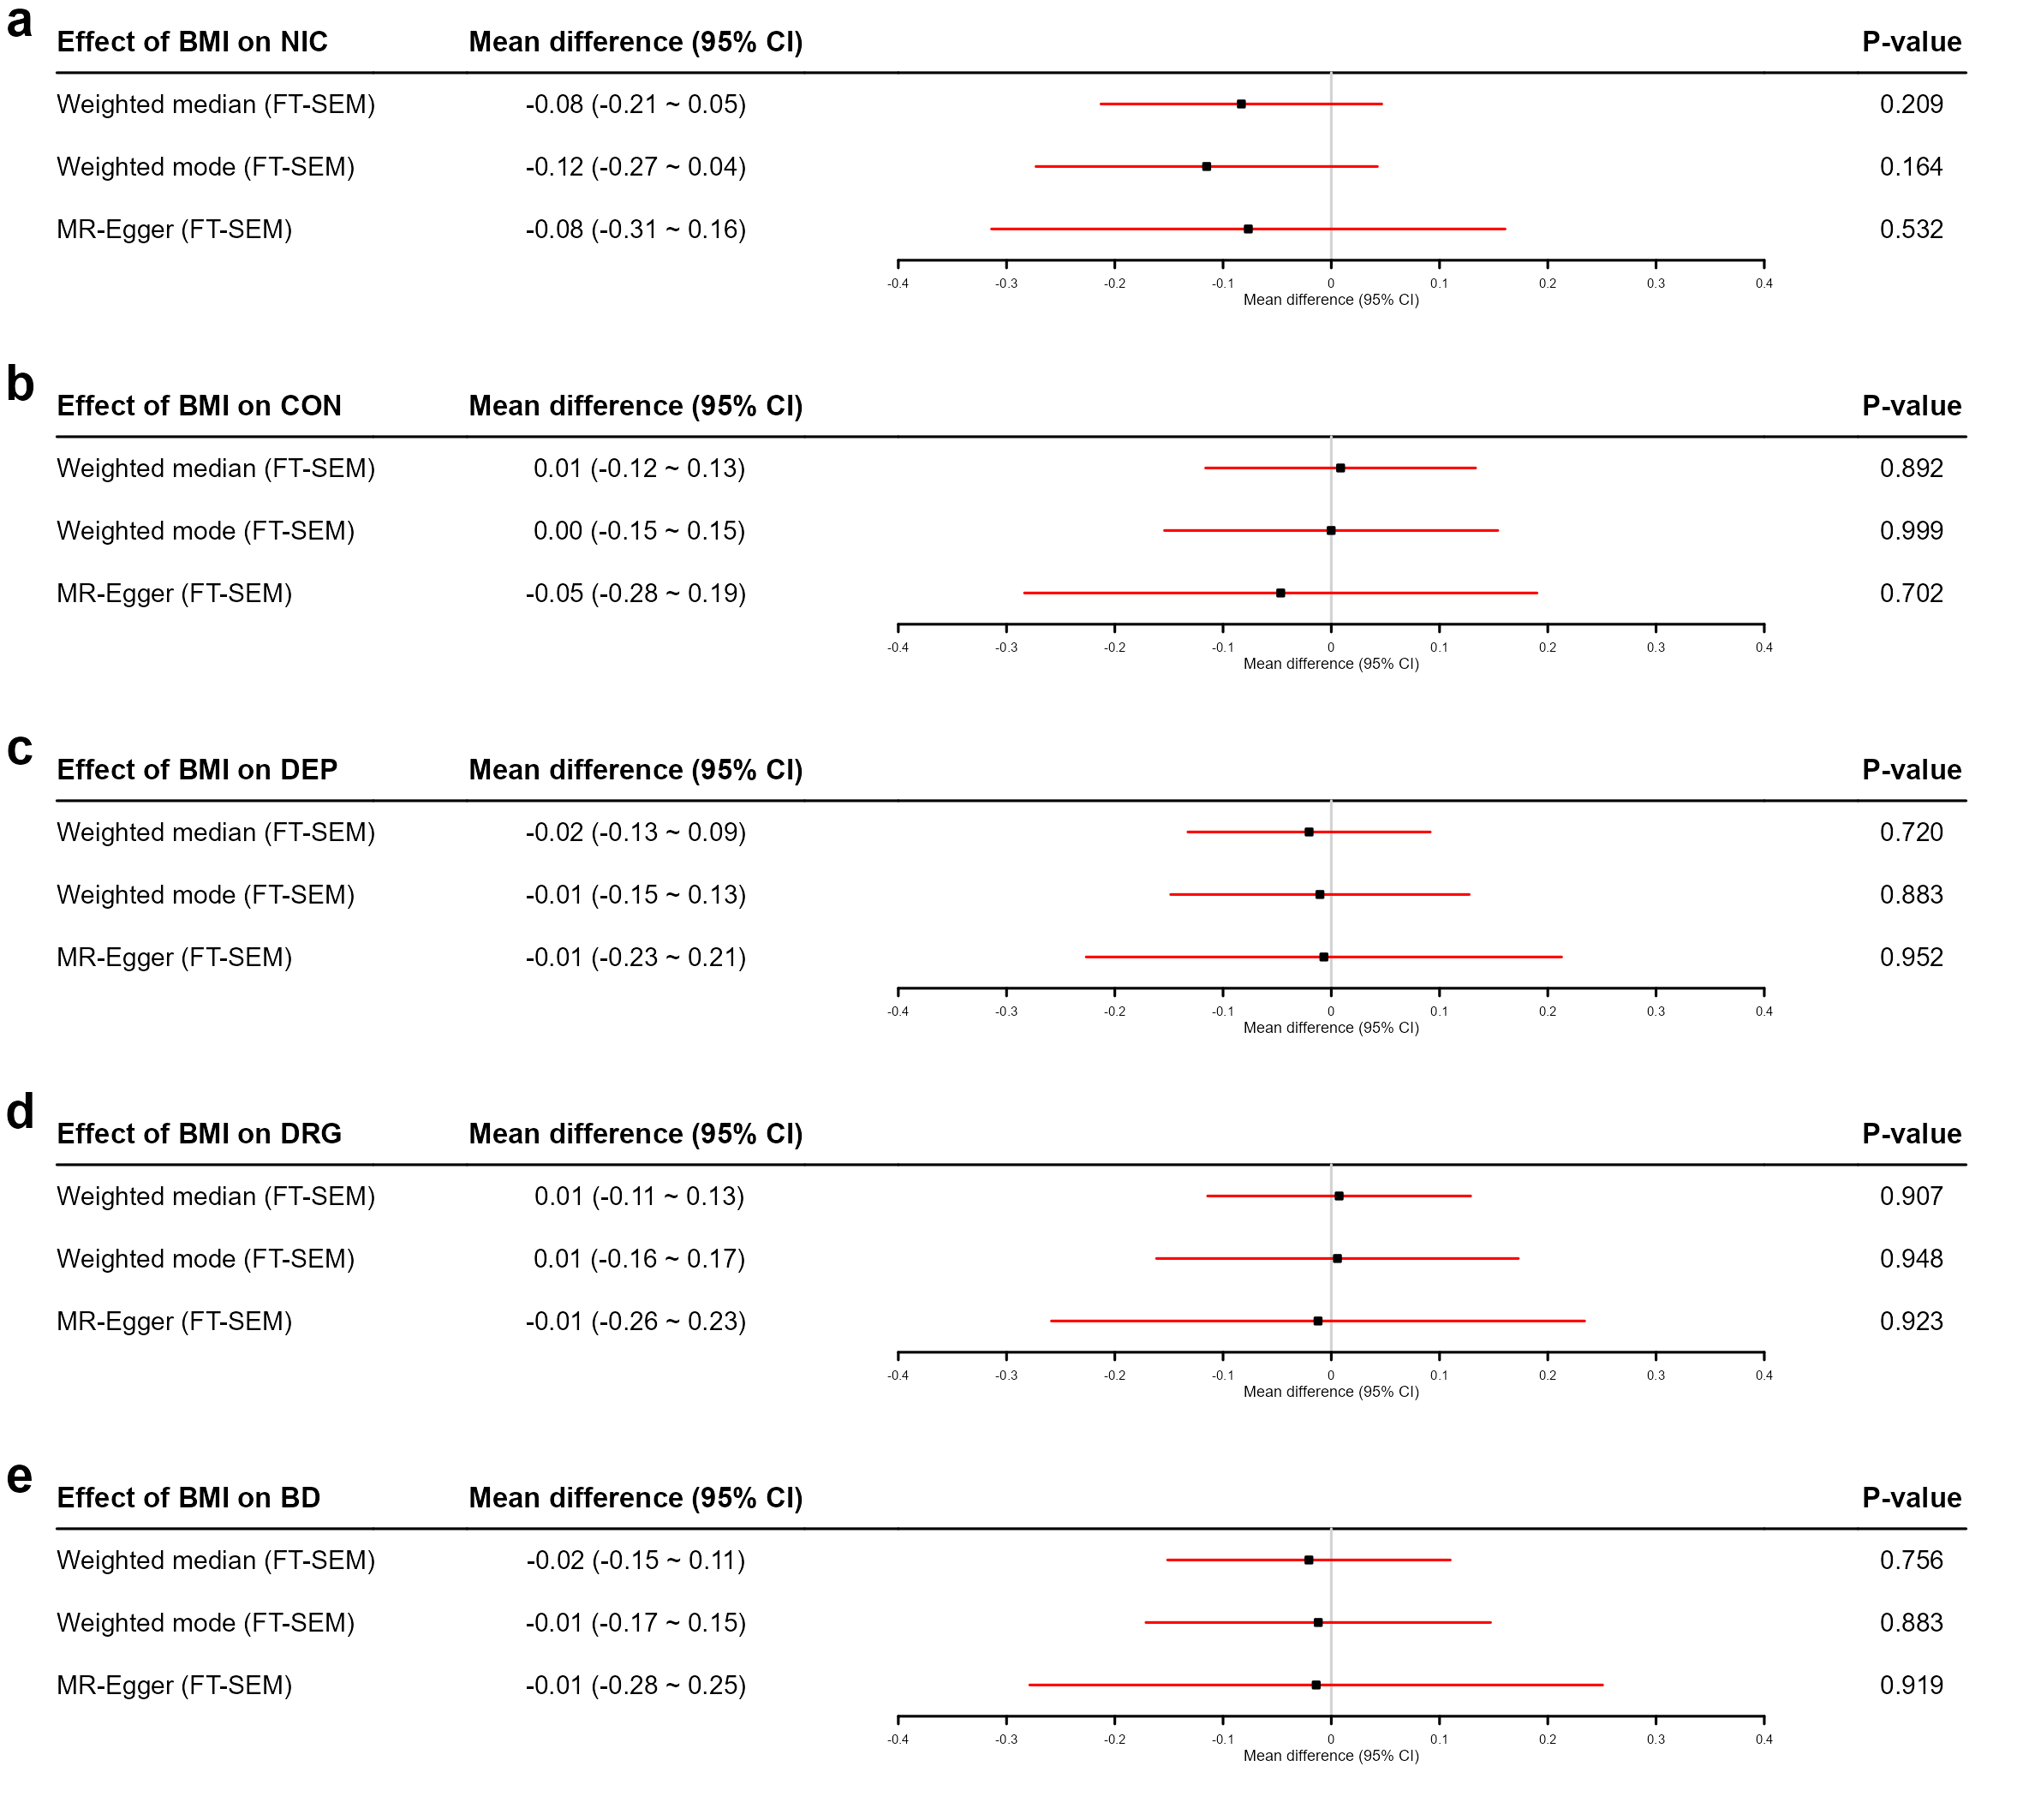
Supplementary Figure 5: Point estimates, 95% CIs and p-values for the causal effect of offspring’s BMI on offspring’s NIC, CON, DEP, DRG and BD using the weighted median, weighted mode and MR-Egger methods based on the sibling-based GWAS summary data for BMI¹ and the GWAS summary data derived from FT-SEM for NIC, CON, DEP, DRG and BD. The sample size for the two-sample MR is N = 101,185, which is the sum of the sample sizes used in the two stages.
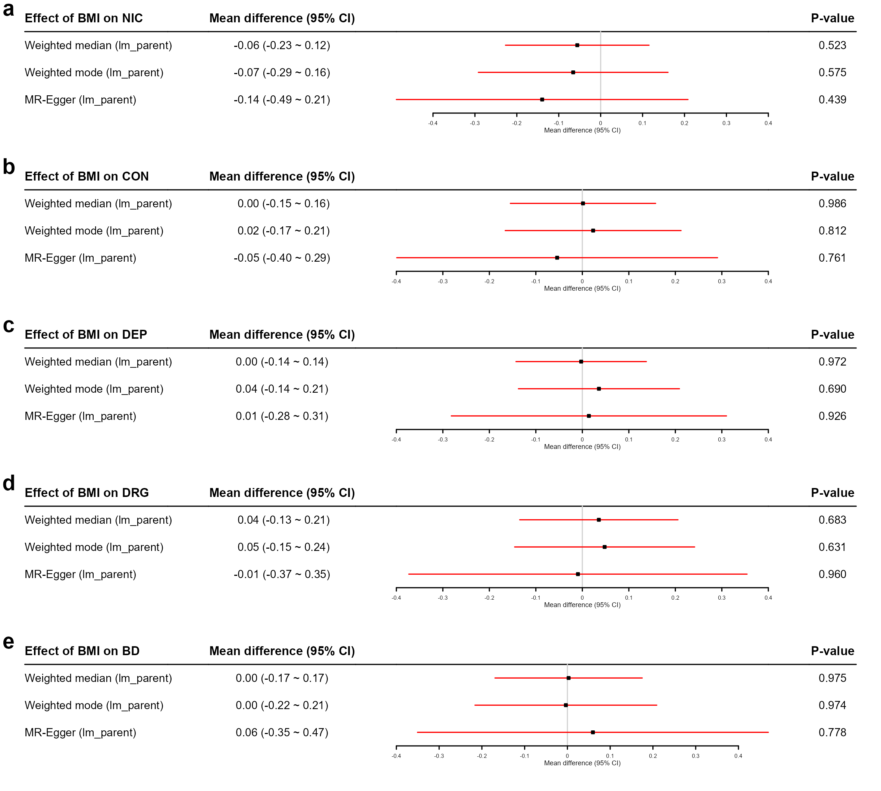
Supplementary Figure 6: Point estimates, 95% CIs and p-values for the causal effects of offspring’s BMI on offspring’s NIC, CON, DEP, DRG and BD using the weighted median, weighted mode and MR-Egger methods based on the sibling-based GWAS summary data for BMI¹ and the GWAS summary data derived from lm_parent for NIC, CON, DEP, DRG and BD. The sample size for the two-sample MR is N = 101,185, which is the sum of the sample sizes used in the two stages.
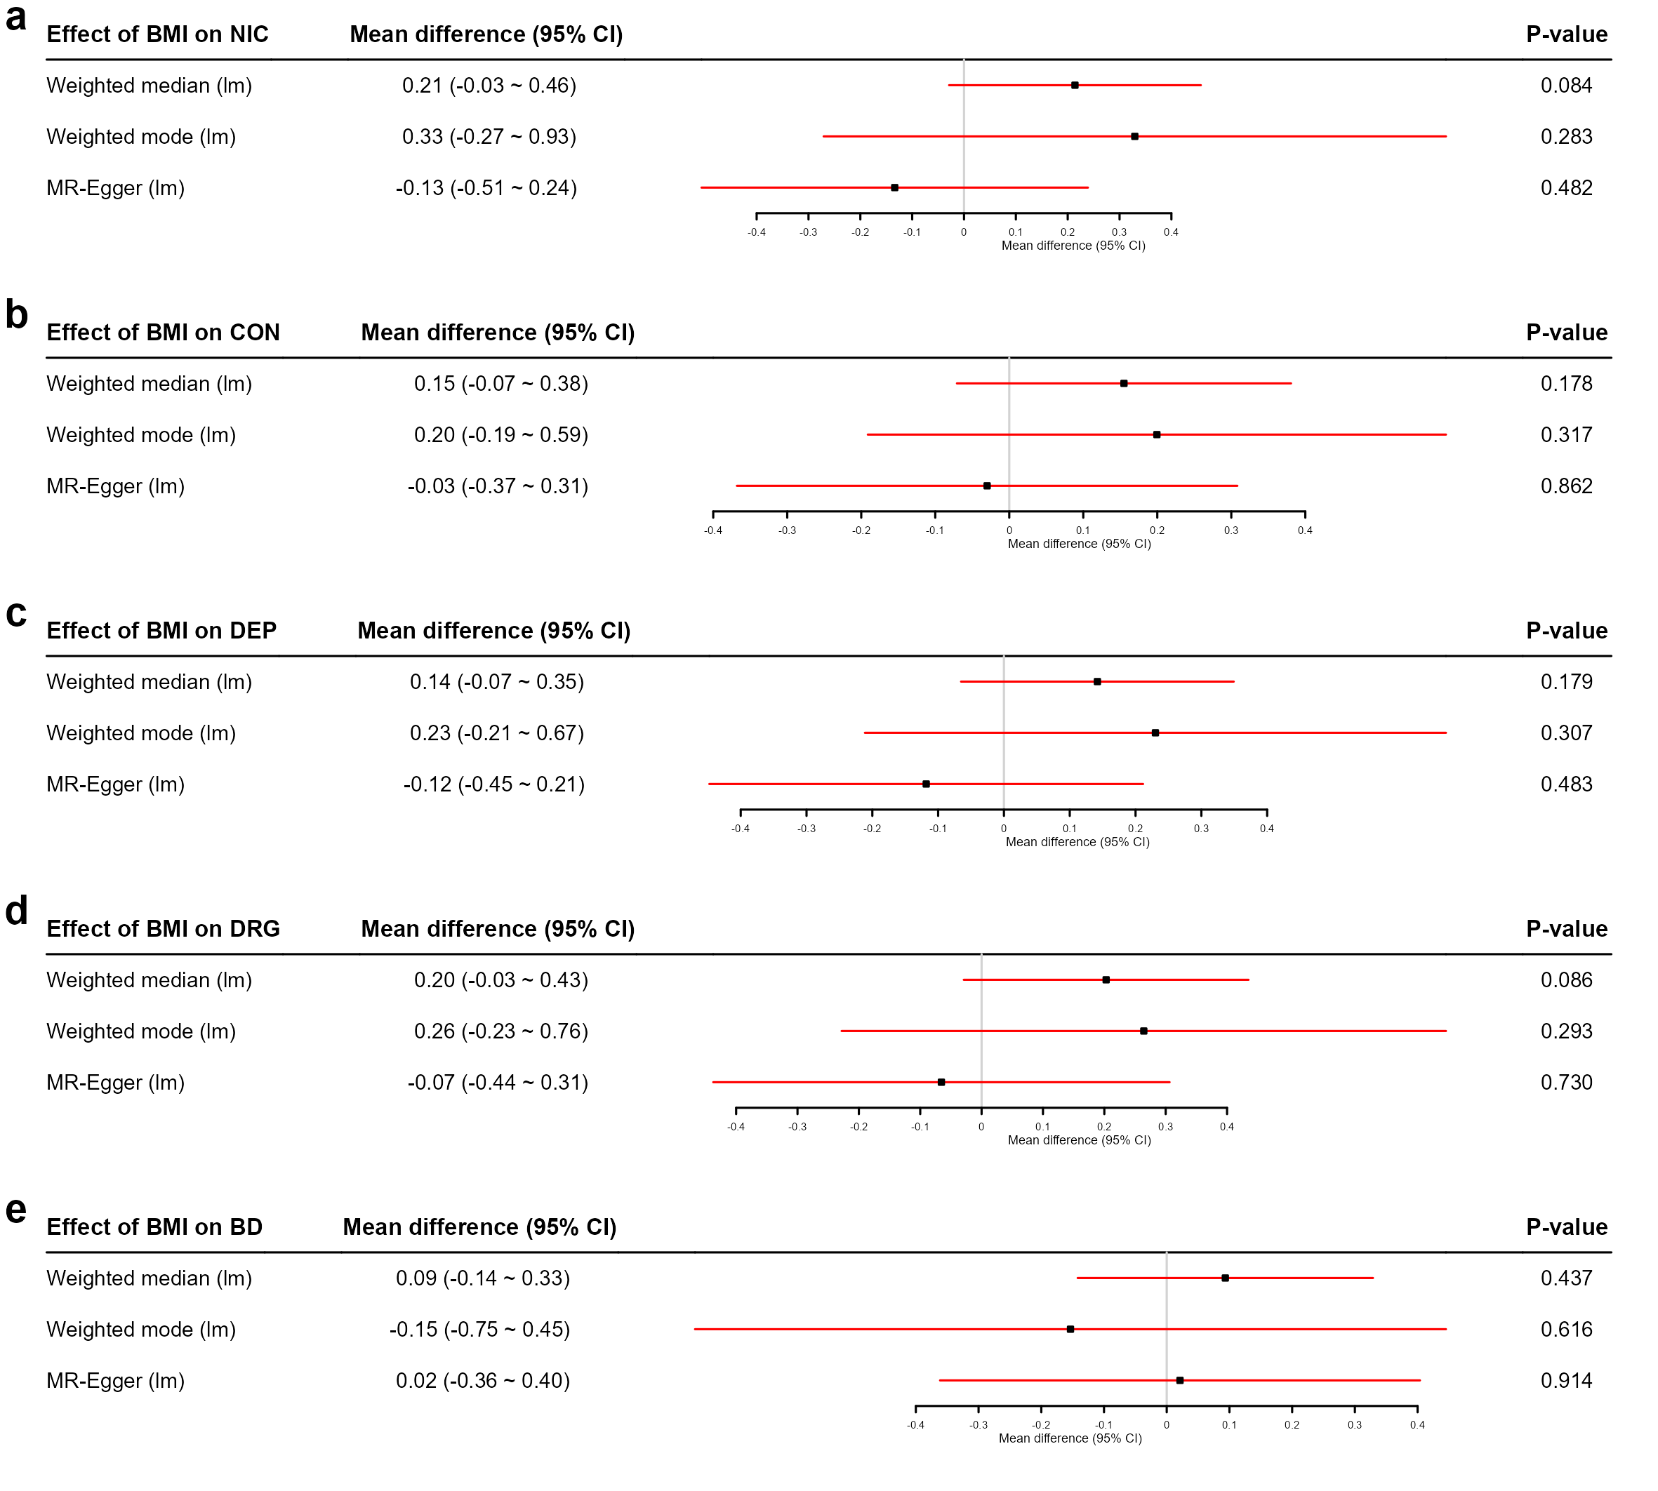
Supplementary Figure 7: Point estimates, 95% CIs and p-values for the causal effects of offspring’s BMI on offspring’s NIC, CON, DEP, DRG and BD using the weighted median, weighted mode and MR-Egger methods. These analyses utilize the GWAS summary data based on independent individuals for BMI² and the GWAS summary data derived from lm for NIC, CON, DEP, DRG and BD. The sample size for the two-sample MR is N = 683,458, which is the sum of the sample sizes used in the two stages.
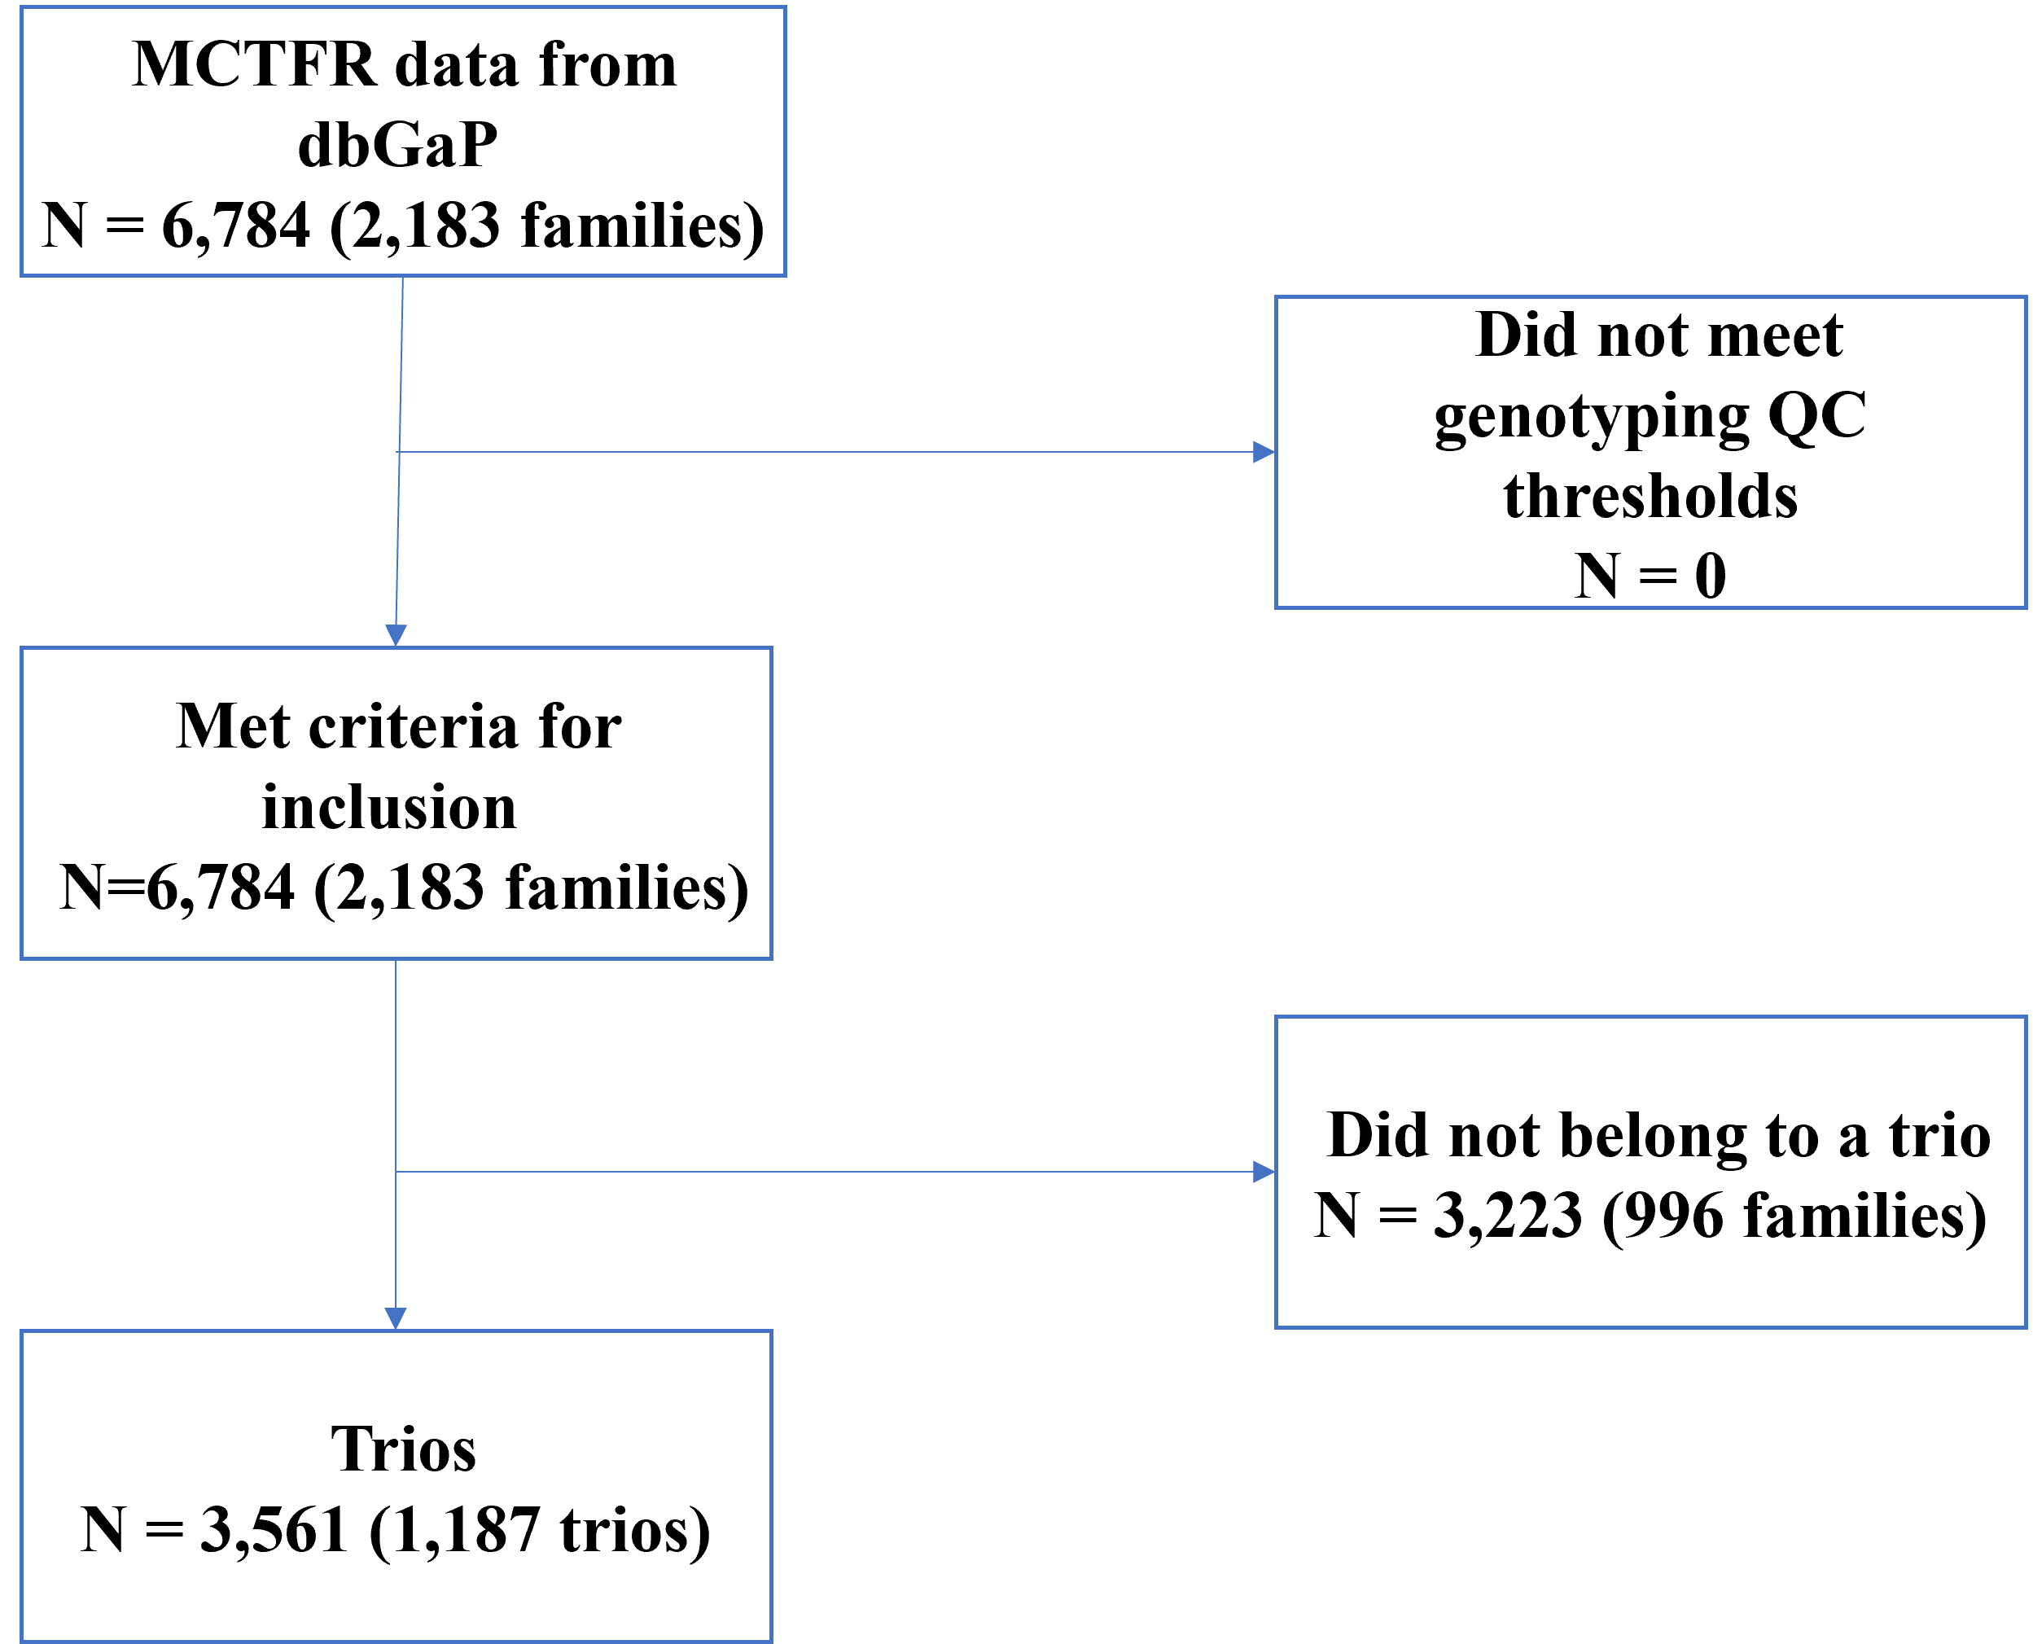
Supplementary Figure 8: Flow chart of screening family trios from the MCTFR dataset for FT-SEM and lm_parent.
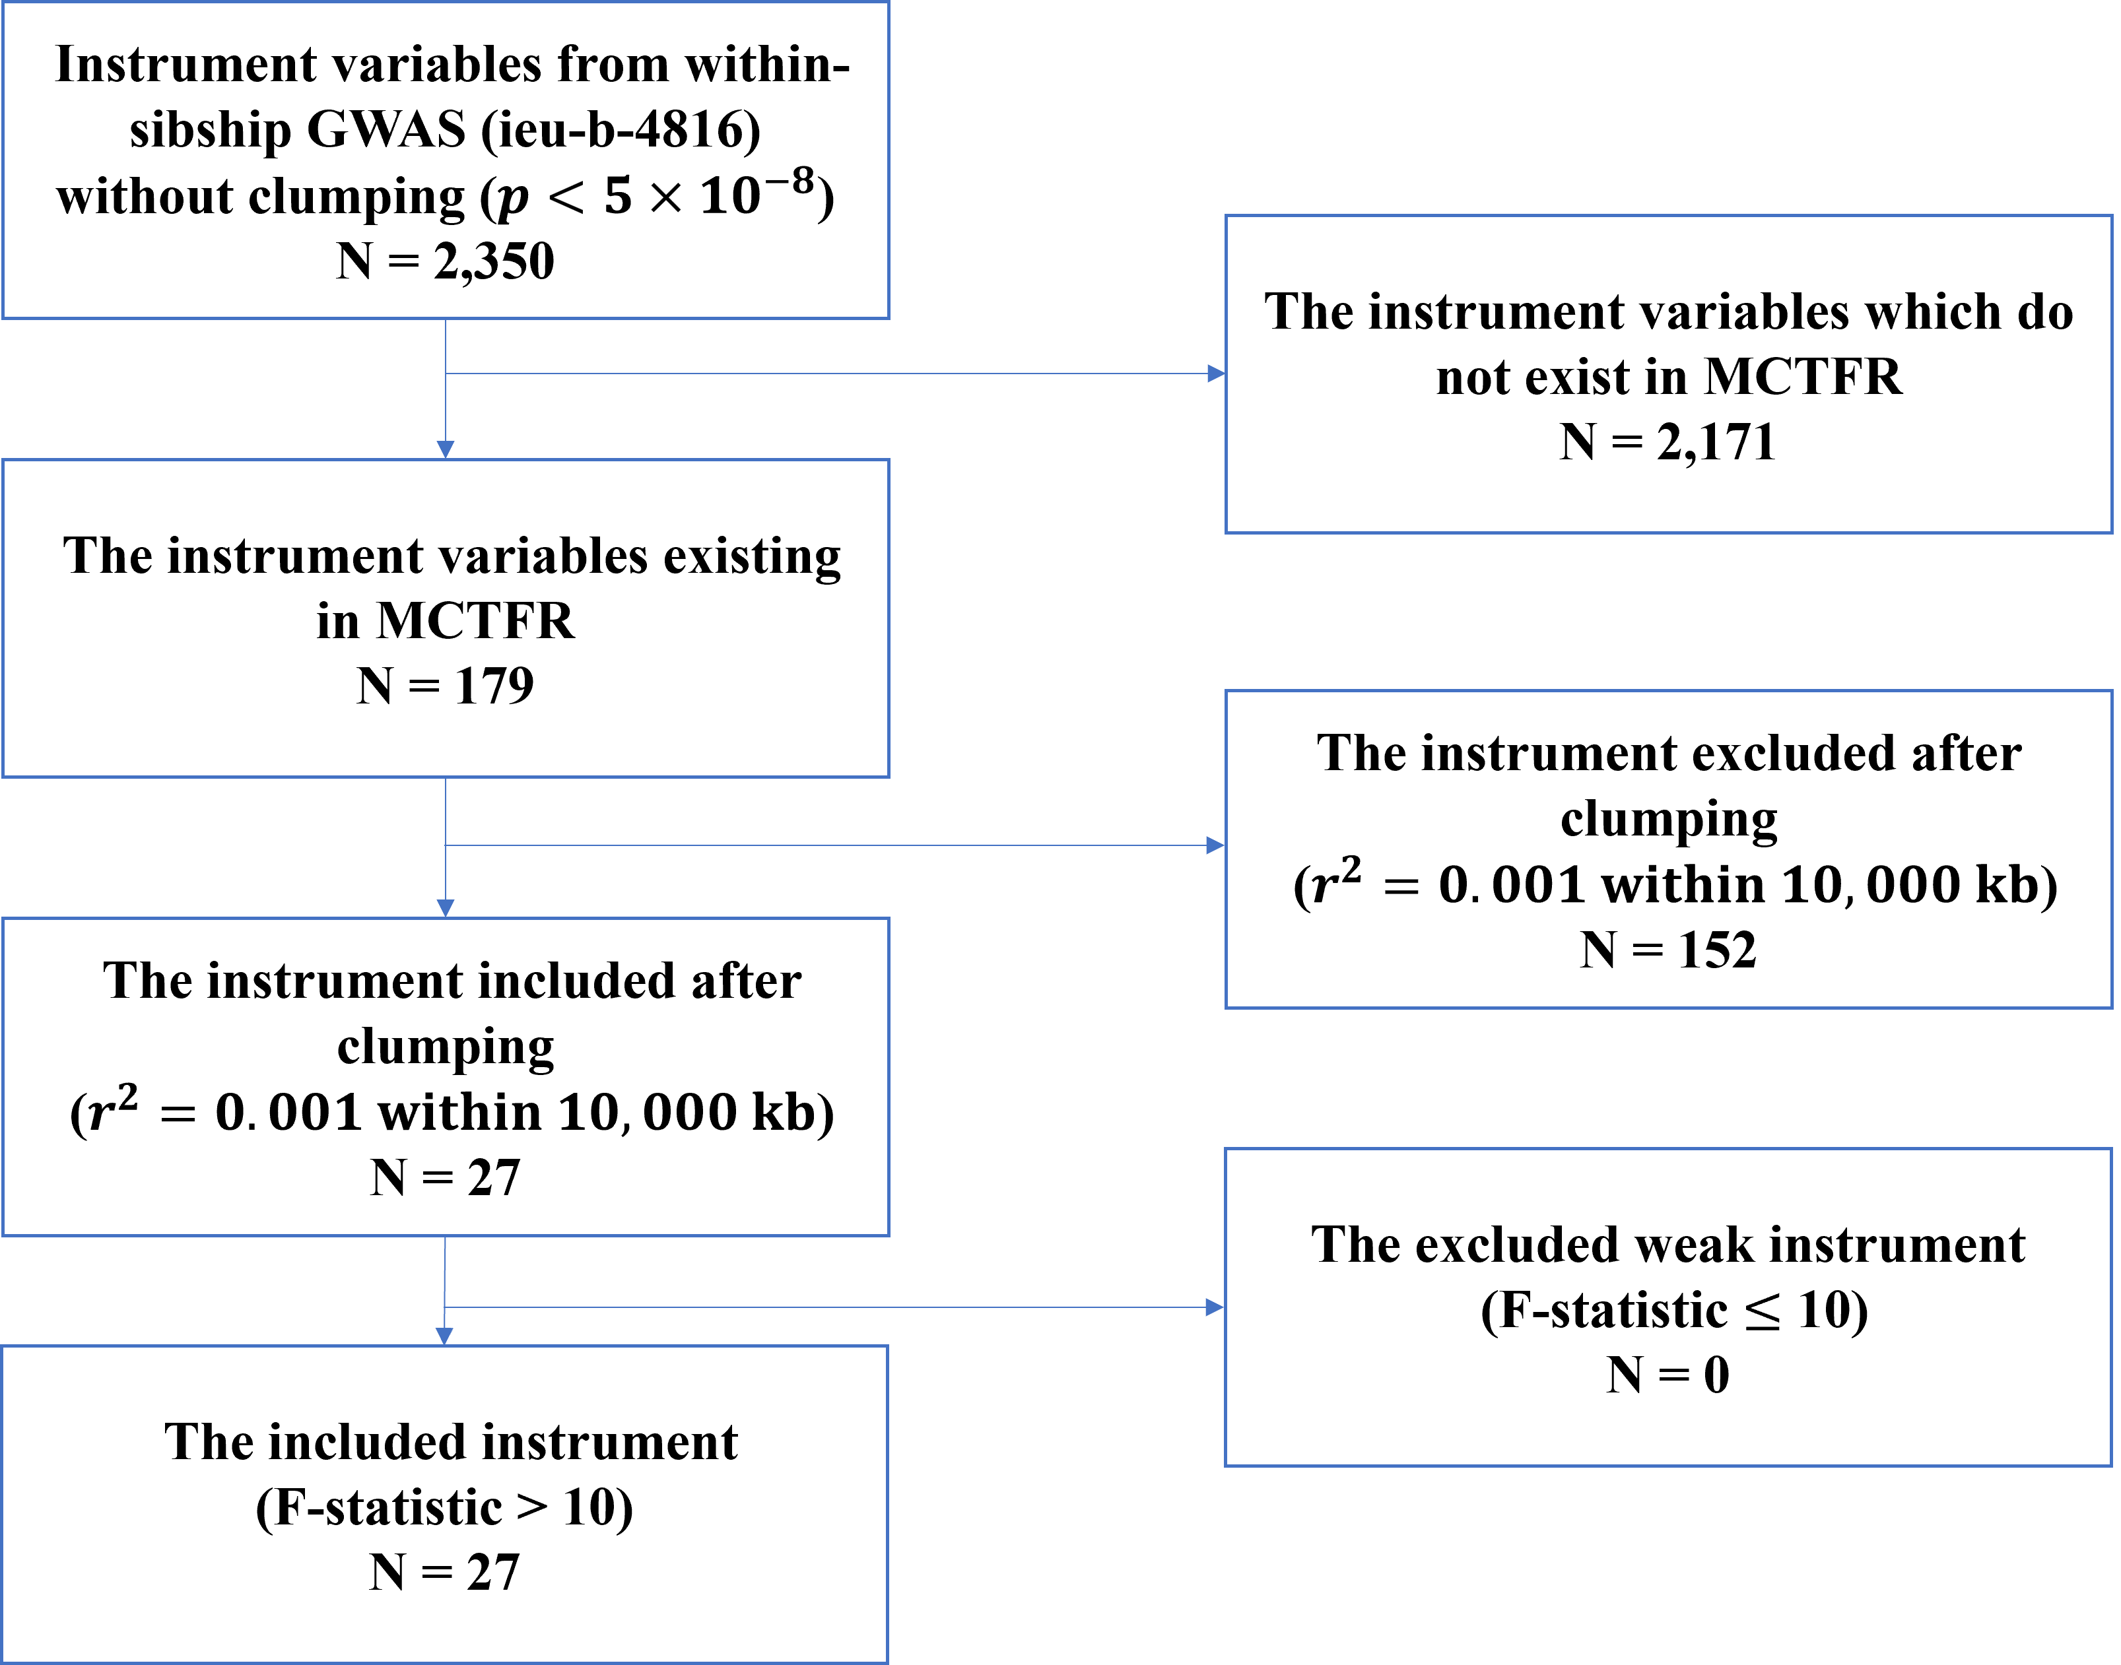
Supplement Figure 9: Instrument variable selection for two-sample MR analysis using the results of sibling-based GWAS for BMI¹ and the GWAS results obtained from FT-SEM and lm_parent based on the MCTFR data set.
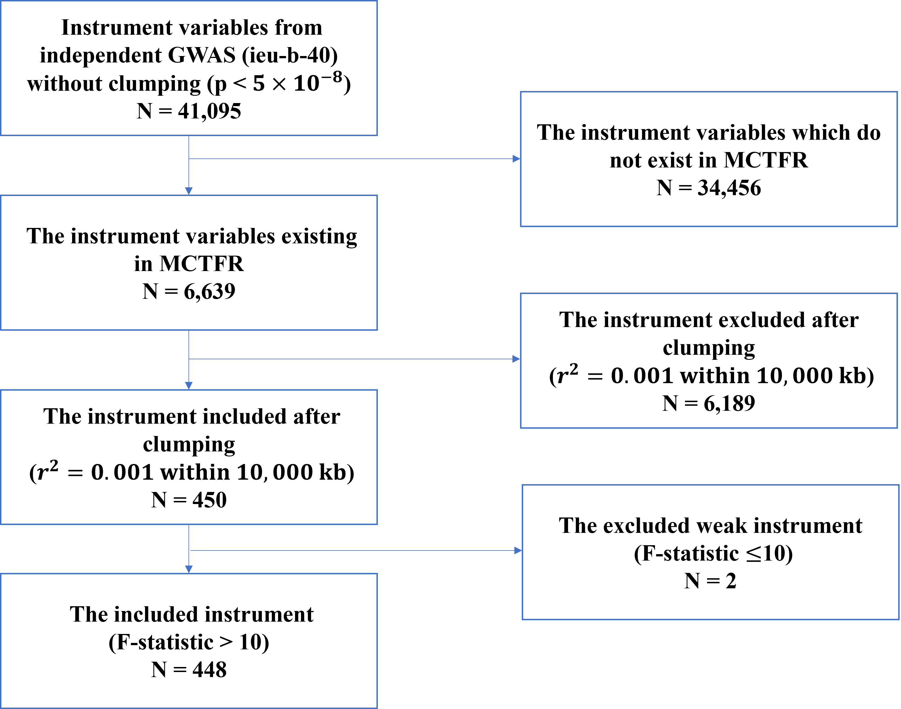
Supplement Figure 10: Instrument variable selection for two-sample MR analysis using the GWAS results based on independent individuals for BMI² and the GWAS results obtained from lm based on the MCTFR data set.

Supplementary Tables
Supplementary Table 1: P-values at SNPs having significant offspring effects on NIC, CON, DEP, DRG and BD identified by FT-SEM based on the significance criteria³: p-value at the SNP is less than $1×{10}^{-5}$ for one phenotype and p-value at the SNP is less than $1×{10}^{-3}$ for at least one additional phenotype.
SNP | Chr | A1 | A2 | MAF | P-value
 |  |  |  |  | NIC | CON | DEP | DRG | BD
rs4949548 | 1 | G | A | 0.244 | 3.497E-04 | 1.040E-01 | 5.613E-02 | 7.348E-06 | 1.209E-05
rs8179714 | 2 | G | A | 0.173 | 4.430E-03 | 4.286E-06 | 8.531E-05 | 8.833E-05 | 1.598E-05
rs1168697 | 3 | A | G | 0.299 | 4.039E-02 | 3.352E-04 | 3.012E-06 | 1.090E-02 | 2.026E-03
rs2298419 | 3 | A | G | 0.345 | 1.081E-04 | 6.989E-05 | 4.462E-04 | 6.003E-06 | 3.191E-06
rs118182 | 4 | A | G | 0.083 | 2.537E-05 | 7.232E-06 | 4.026E-04 | 4.821E-05 | 1.203E-02
rs4868933 | 5 | G | A | 0.087 | 4.367E-04 | 5.404E-04 | 3.284E-04 | 2.615E-06 | 5.602E-04
rs4713922 | 6 | C | A | 0.435 | 4.723E-03 | 7.530E-07 | 3.339E-06 | 1.670E-04 | 3.060E-05
rs6906061 | 6 | A | G | 0.361 | 1.183E-03 | 9.746E-06 | 1.521E-04 | 9.740E-04 | 5.398E-04
rs12210807 | 6 | A | C | 0.111 | 4.925E-04 | 3.631E-04 | 1.625E-06 | 4.975E-04 | 8.108E-05
rs428394 | 6 | G | A | 0.130 | 1.119E-03 | 4.070E-04 | 2.882E-06 | 2.301E-03 | 1.036E-03
rs374336 | 6 | A | G | 0.130 | 1.134E-03 | 4.054E-04 | 2.956E-06 | 2.377E-03 | 1.121E-03
rs9349391 | 6 | A | C | 0.404 | 1.645E-03 | 1.187E-04 | 4.516E-06 | 5.381E-02 | 1.178E-02
rs12673414 | 7 | A | C | 0.048 | 4.334E-06 | 8.210E-04 | 1.775E-03 | 2.695E-04 | 1.669E-02
rs477516 | 8 | A | G | 0.275 | 4.130E-06 | 4.768E-03 | 8.059E-03 | 7.795E-04 | 7.866E-03
rs588564 | 8 | A | C | 0.364 | 2.373E-06 | 7.793E-03 | 5.367E-03 | 1.185E-04 | 1.566E-03
rs6470161 | 8 | G | A | 0.182 | 9.652E-05 | 4.660E-06 | 6.628E-04 | 8.022E-05 | 4.932E-05
rs113123 | 9 | A | G | 0.266 | 7.407E-05 | 6.074E-03 | 9.854E-05 | 6.288E-06 | 3.529E-03
rs7098860 | 10 | G | A | 0.330 | 4.885E-06 | 2.833E-06 | 4.211E-04 | 1.723E-05 | 5.045E-07
rs10748725 | 10 | A | G | 0.375 | 1.996E-07 | 4.759E-07 | 4.096E-05 | 2.625E-07 | 6.089E-07
rs10886654 | 10 | A | C | 0.211 | 1.355E-06 | 4.367E-02 | 1.478E-02 | 1.375E-04 | 1.672E-02
rs11199264 | 10 | G | A | 0.183 | 3.361E-06 | 1.537E-01 | 3.514E-02 | 6.555E-04 | 2.638E-02
rs2901224 | 10 | A | G | 0.183 | 3.764E-06 | 1.444E-01 | 3.516E-02 | 6.875E-04 | 2.672E-02
rs1926559 | 10 | G | A | 0.068 | 7.865E-03 | 8.602E-06 | 2.565E-04 | 1.154E-02 | 5.924E-03
rs7975999 | 12 | C | A | 0.499 | 1.555E-04 | 1.117E-06 | 9.964E-05 | 1.206E-05 | 5.849E-04
rs7965596 | 12 | A | G | 0.049 | 2.768E-04 | 8.500E-04 | 3.467E-07 | 2.543E-04 | 1.388E-03
rs7304198 | 12 | G | A | 0.251 | 2.760E-03 | 9.146E-05 | 8.903E-06 | 5.280E-04 | 4.477E-05
rs4964575 | 12 | G | A | 0.247 | 1.686E-03 | 9.386E-05 | 6.186E-06 | 3.951E-04 | 4.979E-05
rs16944293 | 12 | C | A | 0.123 | 2.837E-03 | 2.939E-05 | 4.560E-06 | 3.128E-02 | 1.899E-02
rs7332682 | 13 | A | G | 0.207 | 1.454E-02 | 5.629E-04 | 4.321E-06 | 4.762E-04 | 4.678E-03
rs9559361 | 13 | G | A | 0.232 | 4.240E-03 | 2.454E-04 | 2.635E-06 | 9.645E-05 | 2.259E-03
rs1952202 | 14 | A | G | 0.155 | 9.765E-04 | 2.444E-06 | 2.675E-03 | 1.917E-04 | 1.228E-06
rs1275849 | 14 | A | G | 0.167 | 5.365E-03 | 3.455E-06 | 2.485E-03 | 5.582E-04 | 1.144E-05
rs1275844 | 14 | A | C | 0.168 | 5.463E-03 | 3.588E-06 | 2.454E-03 | 5.483E-04 | 1.144E-05
rs2126439 | 14 | A | G | 0.358 | 1.234E-05 | 1.870E-06 | 3.040E-04 | 1.641E-04 | 4.738E-05
rs9895992 | 17 | A | G | 0.438 | 3.708E-04 | 9.429E-06 | 4.095E-04 | 3.510E-04 | 4.111E-05
rs17408919 | 20 | A | C | 0.224 | 4.896E-02 | 8.671E-06 | 8.105E-05 | 5.858E-03 | 4.030E-04
rs2836747 | 21 | G | A | 0.461 | 2.443E-06 | 7.888E-03 | 1.258E-03 | 2.428E-04 | 1.996E-03
rs5754249 | 22 | G | A | 0.452 | 6.408E-03 | 1.317E-03 | 4.880E-04 | 2.449E-03 | 7.653E-06
Chr: Chromosome; A1: Minor allele; A2: Major allele; MAF: Minor allele frequency; NIC: Nicotine composite score; CON: Alcohol consumption composite score; DEP: Alcohol dependence composite score; DRG: Illicit drug composite score; BD: Behavioral disinhibition composite score. The locus marked in bold is identified as significant by both FT-SEM and lm_parent.
Supplementary Table 2: P-values at SNPs having significant offspring effects on NIC, CON, DEP, DRG and BD identified by lm_parent based on the significance criteria³: p-value at the SNP is less than $1×{10}^{-5}$ for one phenotype and p-value at the SNP is less than $1×{10}^{-3}$ for at least one additional phenotype.
SNP | Chr | A1 | A2 | MAF | P-value
 |  |  |  |  | NIC | CON | DEP | DRG | BD
rs3867319 | 1 | A | G | 0.068 | 1.286E-03 | 7.992E-07 | 2.695E-05 | 9.277E-05 | 4.381E-03
rs10798939 | 1 | G | A | 0.208 | 2.742E-04 | 8.922E-04 | 7.572E-05 | 8.570E-06 | 1.905E-04
rs4650720 | 1 | A | G | 0.304 | 3.122E-04 | 5.158E-05 | 1.625E-03 | 9.897E-06 | 2.208E-04
rs13408063 | 2 | G | A | 0.258 | 6.874E-06 | 1.397E-02 | 5.898E-04 | 2.436E-04 | 4.729E-04
rs10520020 | 4 | A | G | 0.127 | 5.218E-06 | 1.235E-03 | 1.428E-03 | 6.074E-04 | 4.706E-03
rs10044695 | 5 | G | A | 0.013 | 1.483E-03 | 1.601E-04 | 6.702E-06 | 1.491E-04 | 3.521E-04
rs9328087 | 6 | A | G | 0.166 | 6.609E-06 | 7.938E-04 | 9.481E-05 | 1.450E-05 | 2.093E-04
rs2505658 | 6 | A | G | 0.163 | 3.965E-06 | 1.058E-03 | 1.851E-04 | 7.916E-06 | 5.958E-05
rs9349391 | 6 | A | C | 0.404 | 1.442E-02 | 2.923E-04 | 8.980E-08 | 9.212E-04 | 3.099E-03
rs1990130 | 7 | A | G | 0.095 | 4.476E-04 | 3.881E-06 | 2.863E-03 | 7.880E-05 | 1.106E-02
rs17699960 | 7 | A | G | 0.049 | 9.801E-03 | 2.846E-02 | 1.874E-03 | 9.232E-06 | 9.653E-05
rs37267 | 7 | G | A | 0.116 | 1.903E-05 | 4.085E-04 | 3.885E-04 | 4.948E-05 | 2.801E-07
rs12553421 | 9 | C | A | 0.072 | 2.582E-05 | 3.968E-05 | 9.846E-06 | 1.639E-06 | 2.153E-04
Chr: Chromosome; A1: Minor allele; A2: Major allele; MAF: Minor allele frequency; NIC: Nicotine composite score; CON: Alcohol consumption composite score; DEP: Alcohol dependence composite score; DRG: Illicit drug composite score; BD: Behavioral disinhibition composite score. The locus marked in bold is identified as significant by both FT-SEM and lm_parent.

Supplementary Table 3: P-values at SNPs having significant offspring effects on NIC, CON, DEP, DRG and BD identified by lm based on the significance criteria³: p-value at the SNP is less than $1×{10}^{-5}$ for one phenotype and p-value at the SNP is less than $1×{10}^{-3}$ for at least one additional phenotype.
SNP | Chr | A1 | A2 | MAF | P-value
 |  |  |  |  | NIC | CON | DEP | DRG | BD
rs11583646 | 1 | A | G | 0.104 | 2.101E-04 | 5.602E-04 | 4.900E-05 | 5.176E-06 | 8.221E-05
rs6699612 | 1 | G | A | 0.086 | 6.190E-04 | 6.085E-02 | 4.036E-04 | 7.699E-05 | 9.523E-06
rs9650554 | 8 | A | G | 0.424 | 4.749E-06 | 4.096E-03 | 2.334E-03 | 8.693E-04 | 2.758E-03
rs10510066 | 10 | A | G | 0.177 | 1.202E-01 | 5.793E-03 | 1.730E-04 | 1.131E-02 | 7.389E-06
rs4131955 | 12 | A | G | 0.329 | 2.632E-03 | 8.129E-03 | 1.366E-03 | 1.692E-06 | 2.715E-06
rs12315638 | 12 | A | G | 0.327 | 3.198E-03 | 9.392E-03 | 1.703E-03 | 2.454E-06 | 3.282E-06
rs10161414 | 12 | G | A | 0.326 | 3.273E-03 | 9.627E-03 | 1.799E-03 | 2.655E-06 | 3.458E-06
rs6572667 | 14 | A | G | 0.187 | 6.268E-04 | 4.464E-03 | 8.232E-03 | 4.353E-06 | 1.701E-03
rs17836777 | 14 | G | A | 0.011 | 7.290E-03 | 9.265E-04 | 1.557E-03 | 4.938E-05 | 2.200E-06
rs16944491 | 15 | A | G | 0.110 | 4.743E-03 | 6.111E-04 | 2.945E-06 | 1.397E-04 | 1.422E-04
rs11073519 | 15 | A | G | 0.251 | 8.271E-04 | 6.569E-04 | 4.433E-05 | 2.446E-04 | 5.243E-06
rs7222222 | 17 | A | G | 0.029 | 3.460E-04 | 1.151E-02 | 1.407E-05 | 1.448E-04 | 5.924E-07
rs9954094 | 18 | G | A | 0.062 | 7.205E-06 | 1.347E-02 | 8.093E-04 | 1.972E-03 | 1.896E-03
rs2226692 | 18 | G | A | 0.062 | 7.205E-06 | 1.347E-02 | 8.093E-04 | 1.972E-03 | 1.896E-03
rs753719 | 19 | G | A | 0.401 | 3.491E-02 | 2.468E-04 | 5.765E-06 | 2.737E-03 | 8.097E-04
rs8112380 | 19 | G | A | 0.440 | 1.195E-04 | 1.814E-05 | 2.907E-06 | 3.203E-04 | 1.702E-04
rs6074043 | 20 | A | G | 0.234 | 2.181E-05 | 4.135E-06 | 6.060E-04 | 1.067E-03 | 8.246E-06
Chr: Chromosome; A1: Minor allele; A2: Major allele; MAF: Minor allele frequency; NIC: Nicotine composite score; CON: Alcohol consumption composite score; DEP: Alcohol dependence composite score; DRG: Illicit drug composite score; BD: Behavioral disinhibition composite score.

Supplementary Table 4: P-values at SNPs having significant paternal effects on NIC, CON, DEP, DRG and BD identified by FT-SEM based on the significance criteria³: p-value at the SNP is less than $1×{10}^{-5}$ for one phenotype and p-value at the SNP is less than $1×{10}^{-3}$ for at least one additional phenotype.
SNP | Chr | A1 | A2 | MAF | P-value
 |  |  |  |  | NIC | CON | DEP | DRG | BD
rs4504959 | 1 | A | C | 0.102 | 6.540E-06 | 8.560E-06 | 2.320E-05 | 2.020E-06 | 6.390E-05
rs1890843 | 1 | G | A | 0.084 | 9.970E-05 | 9.030E-05 | 1.320E-03 | 6.810E-06 | 8.090E-04
rs2552517 | 2 | A | G | 0.488 | 3.030E-06 | 1.100E-04 | 4.200E-04 | 2.220E-04 | 9.270E-04
rs1399781 | 3 | A | G | 0.355 | 7.740E-06 | 1.630E-04 | 4.690E-05 | 5.270E-04 | 1.080E-03
rs10068457 | 5 | G | A | 0.444 | 1.370E-03 | 3.160E-04 | 3.810E-06 | 1.200E-03 | 2.620E-03
rs2237077 | 5 | G | A | 0.278 | 1.210E-03 | 6.510E-04 | 7.030E-03 | 3.590E-06 | 4.130E-05
rs10508540 | 10 | G | A | 0.119 | 1.190E-06 | 1.020E-03 | 9.780E-04 | 1.750E-03 | 1.650E-04
rs11012099 | 10 | C | A | 0.207 | 5.120E-06 | 2.840E-03 | 4.500E-06 | 6.110E-05 | 6.550E-05
rs7946537 | 11 | G | A | 0.128 | 1.560E-02 | 4.200E-06 | 5.470E-03 | 9.950E-04 | 1.740E-02
rs7965596 | 12 | A | G | 0.049 | 6.490E-03 | 2.000E-04 | 3.050E-06 | 3.370E-04 | 2.230E-03
rs4788008 | 16 | G | A | 0.218 | 8.600E-04 | 4.700E-04 | 4.810E-05 | 3.450E-04 | 6.810E-07
rs12969361 | 18 | A | G | 0.203 | 1.670E-02 | 1.880E-04 | 2.930E-03 | 3.430E-03 | 9.520E-06
Chr: Chromosome; A1: Minor allele; A2: Major allele; MAF: Minor allele frequency; NIC: Nicotine composite score; CON: Alcohol consumption composite score; DEP: Alcohol dependence composite score; DRG: Illicit drug composite score; BD: Behavioral disinhibition composite score. The loci marked in bold are identified as significant by both FT-SEM and lm_parent.

Supplementary Table 5: P-values at SNPs having significant paternal effects on NIC, CON, DEP, DRG and BD identified by lm_parent based on the significance criteria³: p-value at the SNP is less than $1×{10}^{-5}$ for one phenotype and p-value at the SNP is less than $1×{10}^{-3}$ for at least one additional phenotype.
SNP | Chr | A1 | A2 | MAF | P-value
 |  |  |  |  | NIC | CON | DEP | DRG | BD
rs1176387 | 1 | C | A | 0.381 | 7.390E-06 | 1.060E-03 | 1.910E-04 | 1.920E-03 | 1.020E-02
rs1176385 | 1 | A | G | 0.257 | 7.620E-06 | 3.890E-04 | 5.830E-04 | 4.080E-04 | 1.390E-02
rs3867319 | 1 | A | G | 0.068 | 4.320E-03 | 2.110E-06 | 1.200E-04 | 6.040E-04 | 4.240E-03
rs13214624 | 6 | A | G | 0.059 | 7.050E-07 | 8.170E-05 | 3.820E-06 | 8.140E-06 | 2.680E-05
rs13249656 | 8 | A | C | 0.291 | 3.940E-05 | 5.920E-04 | 9.690E-06 | 2.720E-06 | 5.820E-06
rs4072799 | 9 | C | A | 0.172 | 6.360E-04 | 8.820E-06 | 8.490E-06 | 1.500E-04 | 6.530E-04
rs11012099 | 10 | C | A | 0.207 | 4.570E-06 | 4.590E-04 | 8.600E-07 | 3.610E-07 | 5.560E-06
rs4917962 | 10 | A | C | 0.124 | 8.670E-05 | 9.740E-04 | 8.620E-06 | 2.090E-06 | 8.560E-04
rs2219872 | 12 | A | G | 0.063 | 1.290E-04 | 7.430E-04 | 2.220E-06 | 3.350E-05 | 4.090E-04
rs7965596 | 12 | A | G | 0.049 | 5.630E-03 | 5.440E-04 | 7.920E-06 | 5.160E-04 | 4.400E-03
rs1885950 | 13 | A | C | 0.436 | 1.420E-03 | 7.010E-06 | 8.420E-05 | 6.740E-04 | 5.820E-04
rs13379892 | 15 | A | G | 0.074 | 5.440E-05 | 3.160E-04 | 4.510E-03 | 6.400E-06 | 4.690E-05
rs2586163 | 15 | G | A | 0.132 | 1.400E-03 | 6.460E-03 | 7.430E-04 | 7.330E-04 | 5.130E-06
rs12924565 | 16 | A | G | 0.344 | 7.470E-04 | 3.670E-06 | 1.940E-04 | 1.210E-05 | 5.310E-04
rs4788008 | 16 | G | A | 0.218 | 4.410E-03 | 6.310E-03 | 7.680E-04 | 1.260E-03 | 9.660E-06
rs9896483 | 17 | G | A | 0.462 | 1.640E-04 | 5.720E-05 | 8.460E-06 | 1.050E-05 | 1.500E-05
rs4622543 | 17 | G | A | 0.483 | 1.110E-04 | 1.610E-05 | 6.140E-05 | 2.790E-06 | 4.540E-06
Chr: Chromosome; A1: Minor allele; A2: Major allele; MAF: Minor allele frequency; NIC: Nicotine composite score; CON: Alcohol consumption composite score; DEP: Alcohol dependence composite score; DRG: Illicit drug composite score; BD: Behavioral disinhibition composite score. The loci marked in bold are identified as significant by both FT-SEM and lm_parent.

Supplementary Table 6: P-values at SNPs having significant maternal effects on NIC, CON, DEP, DRG and BD identified by FT-SEM based on the significance criteria³: p-value at the SNP is less than $1×{10}^{-5}$ for one phenotype and p-value at the SNP is less than $1×{10}^{-3}$ for at least one additional phenotype.
SNP | Chr | A1 | A2 | MAF | P-value
 |  |  |  |  | NIC | CON | DEP | DRG | BD
rs6696763 | 1 | G | A | 0.197 | 5.420E-06 | 6.120E-02 | 3.470E-03 | 9.810E-04 | 1.950E-03
rs12712127 | 2 | A | G | 0.405 | 1.110E-05 | 3.350E-06 | 1.760E-04 | 1.160E-05 | 1.130E-05
rs12643950 | 4 | A | G | 0.056 | 1.620E-03 | 3.500E-03 | 5.820E-04 | 1.090E-04 | 8.010E-06
rs3733797 | 5 | A | G | 0.179 | 1.160E-02 | 8.640E-04 | 9.580E-05 | 6.240E-06 | 5.260E-05
rs2166373 | 5 | A | G | 0.375 | 4.470E-03 | 1.240E-03 | 1.930E-04 | 3.760E-06 | 2.710E-04
rs4502873 | 5 | A | G | 0.387 | 6.690E-03 | 1.320E-04 | 2.270E-03 | 6.950E-06 | 1.260E-02
rs4719188 | 7 | G | A | 0.068 | 4.820E-04 | 5.050E-05 | 1.180E-06 | 2.930E-03 | 4.080E-03
rs11196125 | 10 | G | A | 0.411 | 1.080E-04 | 1.520E-03 | 5.370E-04 | 4.190E-05 | 7.480E-06
rs708812 | 12 | G | A | 0.086 | 8.550E-06 | 2.260E-04 | 2.680E-04 | 2.580E-04 | 1.780E-06
rs7299766 | 12 | G | A | 0.427 | 8.480E-03 | 5.950E-07 | 4.990E-04 | 1.140E-02 | 3.830E-03
rs7309476 | 12 | A | C | 0.426 | 1.050E-02 | 9.020E-07 | 5.560E-04 | 1.700E-02 | 5.390E-03
rs7975999 | 12 | C | A | 0.499 | 1.280E-03 | 4.910E-06 | 2.710E-04 | 3.220E-04 | 1.400E-03
rs996211 | 14 | G | A | 0.339 | 9.950E-04 | 5.190E-06 | 1.310E-06 | 1.610E-04 | 2.120E-04
rs2334242 | 16 | A | G | 0.424 | 2.620E-06 | 4.080E-06 | 9.890E-05 | 8.330E-07 | 6.490E-07
rs7262634 | 20 | G | A | 0.046 | 1.020E-05 | 8.240E-05 | 2.770E-05 | 9.980E-06 | 1.740E-05
Chr: Chromosome; A1: Minor allele; A2: Major allele; MAF: Minor allele frequency; NIC: Nicotine composite score; CON: Alcohol consumption composite score; DEP: Alcohol dependence composite score; DRG: Illicit drug composite score; BD: Behavioral disinhibition composite score. The loci marked in bold are identified as significant by both FT-SEM and lm_parent.

Supplementary Table 7: P-values at SNPs having significant maternal effects on NIC, CON, DEP, DRG and BD identified by lm_parent based on the significance criteria³: p-value at the SNP is less than $1×{10}^{-5}$ for one phenotype and p-value at the SNP is less than $1×{10}^{-3}$ for at least one additional phenotype.
SNP | Chr | A1 | A2 | MAF | P-value
 |  |  |  |  | NIC | CON | DEP | DRG | BD
rs6823490 | 4 | A | C | 0.107 | 1.853E-06 | 2.922E-05 | 2.715E-05 | 9.427E-06 | 1.428E-04
rs17381249 | 6 | G | A | 0.095 | 3.482E-04 | 6.765E-06 | 1.590E-04 | 7.366E-05 | 4.187E-03
rs11253380 | 10 | G | A | 0.457 | 1.641E-04 | 4.854E-04 | 2.600E-04 | 1.440E-06 | 1.276E-06
rs7299766 | 12 | G | A | 0.427 | 9.216E-03 | 5.750E-07 | 1.437E-04 | 1.293E-03 | 1.322E-03
rs7309476 | 12 | A | C | 0.426 | 1.055E-02 | 7.031E-07 | 1.507E-04 | 1.800E-03 | 1.675E-03
rs10507627 | 13 | A | G | 0.079 | 9.460E-03 | 9.287E-06 | 8.353E-04 | 4.029E-03 | 2.986E-03
rs7176717 | 15 | A | G | 0.423 | 1.019E-02 | 5.188E-04 | 4.616E-02 | 2.143E-03 | 5.236E-06
rs2334242 | 16 | A | G | 0.424 | 6.434E-07 | 1.250E-06 | 1.020E-04 | 5.804E-07 | 1.420E-06
rs6022419 | 20 | G | A | 0.332 | 5.895E-05 | 4.466E-04 | 4.639E-05 | 7.184E-06 | 1.943E-05
Chr: Chromosome; A1: Minor allele; A2: Major allele; MAF: Minor allele frequency; NIC: Nicotine composite score; CON: Alcohol consumption composite score; DEP: Alcohol dependence composite score; DRG: Illicit drug composite score; BD: Behavioral disinhibition composite score. The loci marked in bold are identified as significant by both FT-SEM and lm_parent.

Supplementary Table 8: P-values of the MR-Egger method for testing horizontal pleiotropy where the exposure is BMI.
Method | Outcome | Egger_intercept | Egger_se | P-value
FT-SEM | NIC | 0.012 | 0.021 | 0.557
FT-SEM | CON | 0.010 | 0.021 | 0.632
FT-SEM | DEP | -0.002 | 0.019 | 0.922
FT-SEM | DRG | 0.011 | 0.022 | 0.607
FT-SEM | BD | 0.007 | 0.023 | 0.753
FT-SEM | FSIQ | -0.005 | 0.024 | 0.833
lm_parent | NIC | 0.019 | 0.031 | 0.547
lm_parent | CON | 0.001 | 0.030 | 0.966
lm_parent | DEP | -0.010 | 0.026 | 0.708
lm_parent | DRG | 0.004 | 0.032 | 0.908
lm_parent | BD | -0.007 | 0.036 | 0.857
lm_parent | FSIQ | -0.016 | 0.035 | 0.655
lm | NIC | 0.006 | 0.003 | 0.056
lm | CON | 0.004 | 0.003 | 0.192
lm | DEP | 0.004 | 0.003 | 0.135
lm | DRG | 0.003 | 0.003 | 0.297
lm | BD | 0.003 | 0.003 | 0.367
lm | FSIQ | -0.001 | 0.003 | 0.678

References
1. Howe, L. J. et al. Within-sibship genome-wide association analyses decrease bias in estimates of direct genetic effects. Nat Genet 54, 581–592 (2022).
2. Yengo, L. et al. Meta-analysis of genome-wide association studies for height and body mass index in ∼700000 individuals of European ancestry. Hum Mol Genet 27, 3641–3649 (2018).
3. McGue, M. et al. A genome-wide association study of behavioral disinhibition. Behav Genet 43, 363–373 (2013).

