Supplementary
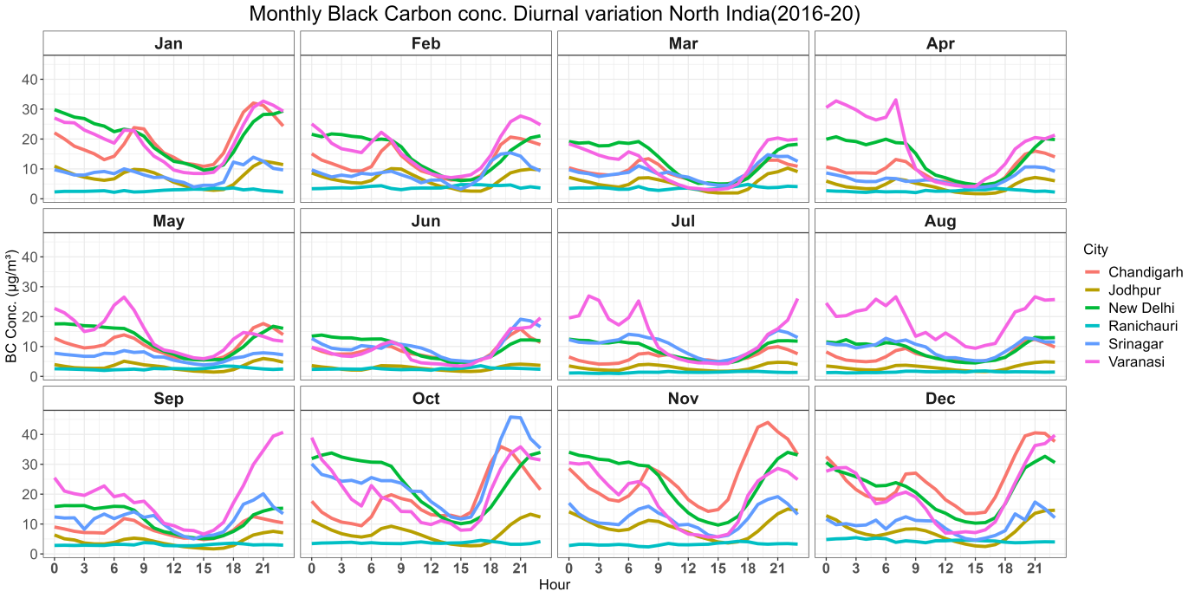
S1: BC370 monthly variation in North India
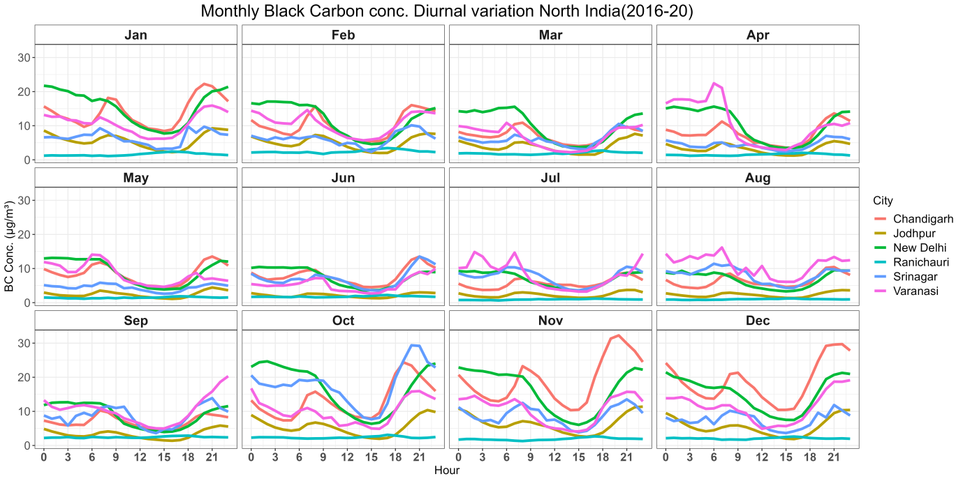
S2: BC880 monthly variation in North India

