Figure S1. QQ Plot of GWAS Summary Statistics for Allergic Disorders
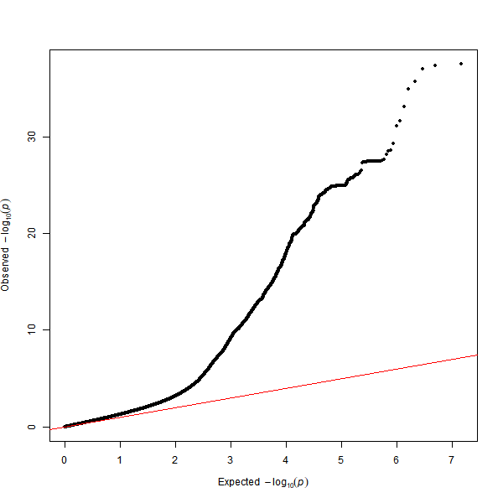

Figure S2. Manhattan Plot of GWAS Results for Allergic Disorders from MAGMA Analysis

Figure S3. Pathway Enrichment Analysis Using Catalog Gene Enrichment from the MSigDB Database

Figure S4. Disease Enrichment Analysis from the MendelVar Database
