SUPPLEMENTARY INFORMATION
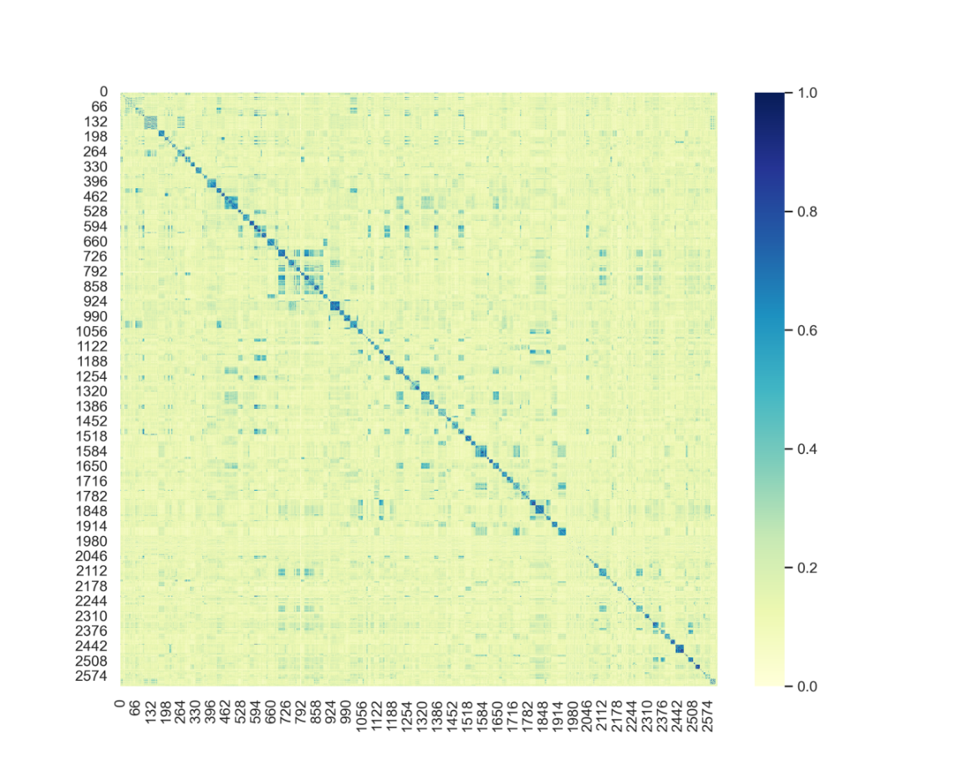
Figure S1: Heatmap representing the similarity matrix of SSRIs.

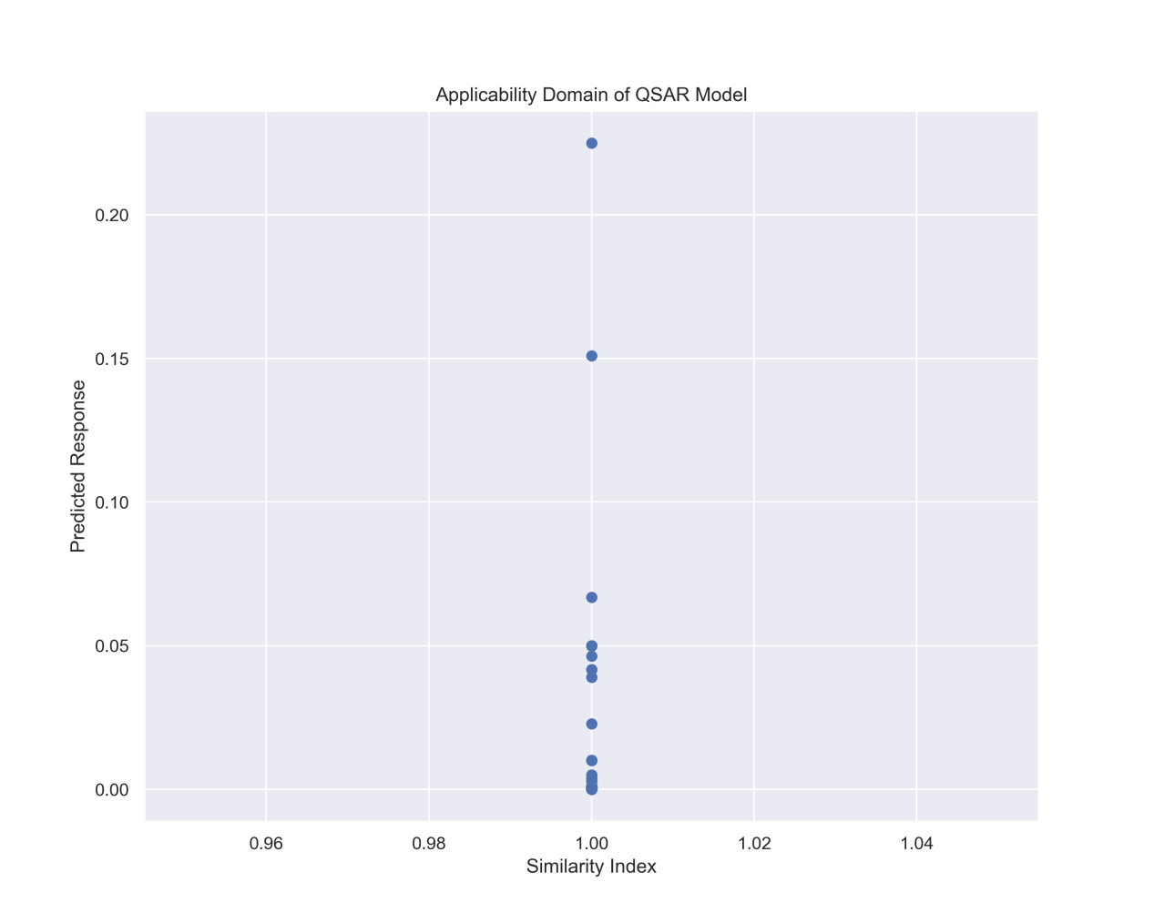
Figure S2: Correlation between predicted Ki and similarity index.
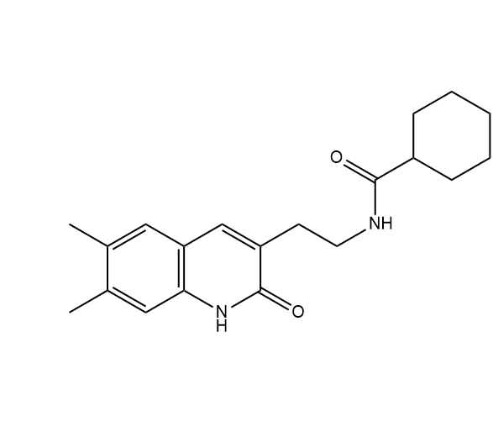
Figure S3 2D representation of Screened Molecule ZINC000000427761
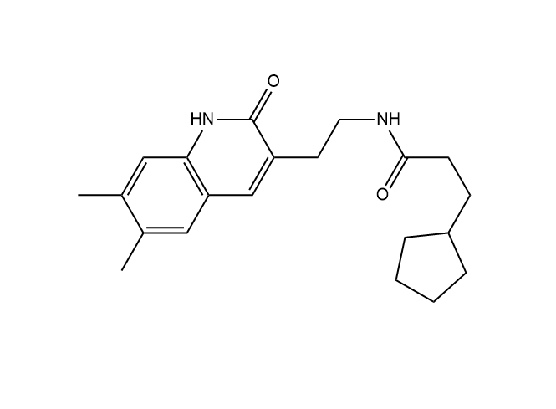
Figure S4 2D representation of Screened Molecule ZINC000000427764
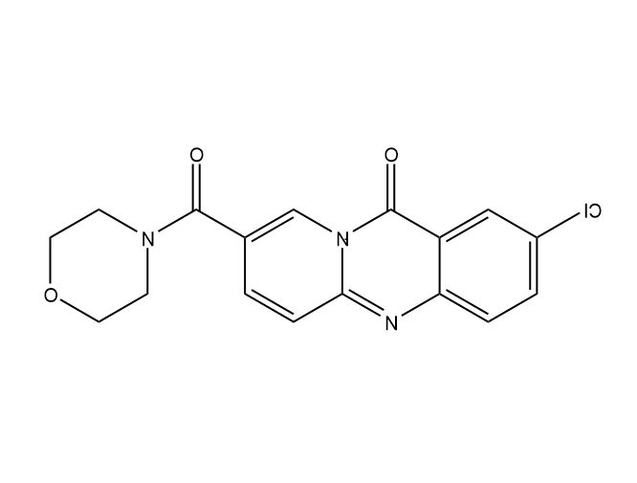
Figure S5: 2D representation of Screened Molecule ZINC000000425581
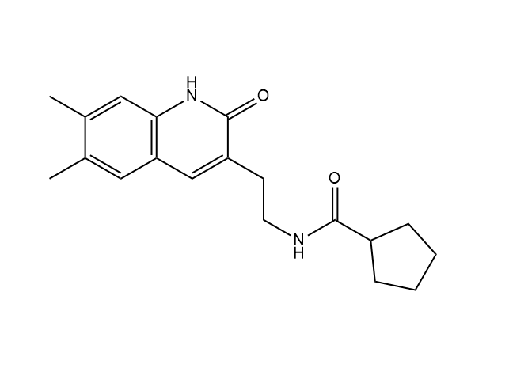
Figure S6 2D representation of Screened Molecule ZINC000000427746

Table S1: RMSE combined result
Table S2: R2
Table S3: ADMET
Table S4: Docking Score

Table S1: RMSE combined result
Table S1: RMSE combined result
Models | Atom Pairs 2D | Atom Pairs 2D Count | E State | Finger printer | Finger printer Extended | Finger printer Graph Only | Klekota Roth | Klekota Roth Count | MACCS | Pub Chem | Sub-structure | Sub structure Count
AdaBoost Regressor | 0.025296 | 0.035692 | 0.0209 | 0.023835 | 0.023021 | 0.019413 | 0.037361 | 0.039902 | 0.028361 | 0.044553 | 0.028888 | 0.029485
Bagging Regressor | 0.019913 | 0.033998 | 0.022799 | 0.030036 | 0.022311 | 0.026599 | 0.024774 | 0.042974 | 0.02408 | 0.028878 | 0.024856 | 0.025199
Decision Tree Regressor | 0.02060 | 0.038103 | 0.031318 | 0.04718 | 0.023251 | 0.018077 | 0.01368 | 0.014536 | 0.032875 | 0.016357 | 0.024299 | 0.0216
ExtraTrees Regressor | 0.020866 | 0.035281 | 0.028373 | 0.032555 | 0.017052 | 0.018059 | 0.014298 | 0.01579 | 0.021469 | 0.034662 | 0.024295 | 0.021829
Gradient Boosting Regressor | 0.020525 | 0.023348 | 0.041711 | 0.024359 | 0.022812 | 0.016265 | 0.019025 | 0.014229 | 0.027171 | 0.031799 | 0.027023 | 0.02667
Hist Gradient Boosting Regressor | 0.029108 | 0.029728 | 0.034295 | 0.02873 | 0.027459 | 0.031532 | 0.029913 | 0.029777 | 0.02988 | 0.030395 | 0.036391 | 0.03546
Linear SVR | 0.050674 | 0.045932 | 0.052681 | 0.041777 | 0.043405 | 0.031777 | 0.023375 | 0.037864 | 0.050843 | 0.035925 | 0.027366 | 0.034524
Linear Regression | 2.9E+10 | 70581167 | 0.053375 | 0.045057 | 0.044246 | 9.97E+09 | 5.77E+08 | 41380260 | 4.14E+08 | 2.03E+09 | 1.27E+09 | 12826124
Voting Regressor | 9.66E+09 | 23527056 | 0.033446 | 0.029976 | 0.027779 | 3.32E+09 | 1.92E+08 | 13793420 | 1.38E+08 | 6.78E+08 | 4.22E+08 | 4275375
Stacking Regressor | 0.028667 | 0.042602 | 0.043569 | 0.047753 | 0.039737 | 0.037395 | 0.034542 | 0.028903 | 0.043857 | 0.042572 | 0.030549 | 0.035801

Table S2: R² Combined Result
Models | Atom Pairs 2D | Atom Pairs 2D Count | E State | Finger printer | Finger printer Extended | Finger printer Graph Only | Klekota Roth | Klekota Roth Count | MACCS | Pub Chem | Sub structure | Sub structure Count
Ada Boost Regressor | 0.767882 | 0.537893 | 0.841542 | 0.79391 | 0.807752 | 0.863287 | 0.493664 | 0.422436 | 0.708217 | 0.27996 | 0.697268 | 0.68464
Bagging Regressor | 0.856165 | 0.580721 | 0.811443 | 0.672741 | 0.819423 | 0.743353 | 0.777359 | 0.33009 | 0.789667 | 0.697483 | 0.77589 | 0.76966
Decision Tree Regressor | 0.845984 | 0.473355 | 0.644199 | 0.192535 | 0.80389 | 0.881466 | 0.932114 | 0.923349 | 0.60794 | 0.902942 | 0.78582 | 0.830757
Extra Trees Regressor | 0.842068 | 0.548461 | 0.707975 | 0.615551 | 0.894517 | 0.881697 | 0.925845 | 0.909562 | 0.832801 | 0.564174 | 0.78589 | 0.827145
Gradient Boosting Regressor | 0.847188 | 0.802251 | 0.368869 | 0.784766 | 0.81123 | 0.904033 | 0.868706 | 0.926553 | 0.732194 | 0.633187 | 0.735111 | 0.741974
Hist Gradient Boosting Regressor | 0.692656 | 0.679418 | 0.573359 | 0.700571 | 0.726495 | 0.63932 | 0.675413 | 0.678353 | 0.676129 | 0.664872 | 0.519616 | 0.543881
Linear SVR | 0.068524 | 0.234692 | -0.00673 | 0.366877 | 0.316588 | 0.633691 | 0.801802 | 0.479924 | 0.062299 | 0.531828 | 0.728337 | 0.567639
Linear Regression | -3.04E+23 | -1.81E+18 | -0.03345 | 0.263558 | 0.289839 | -3.60E+22 | -1.21E+20 | -6.21E+17 | -6.23E+19 | -1.50E+21 | -5.82E+20 | -5.97E+16
Voting Regressor | -3.38E+22 | -2.01E+17 | 0.594202 | 0.67405 | 0.720084 | -4.01E+21 | -1.34E+19 | -6.90E+16 | -6.92E+18 | -1.67E+20 | -6.47E+19 | -6.6E+15
Stacking Regressor | 0.701899 | 0.341628 | 0.311405 | 0.172815 | 0.42721 | 0.492728 | 0.567188 | 0.696971 | 0.302258 | 0.342556 | 0.661473 | 0.535065

Table S3: Lipinski evaluation for the compounds from zinc database
Molecule ID | Molecule SMILE | Molecular weight (g/mol) | Hydrogen Bond Acceptor | Hydrogen Bond Donor | Rotatable Bond | LogP Partition Coefficient | Lipinski Status
ZINC00287783 | c1cc(c(cc1C(=O)N2CCSC2=S)Cl)Cl | 292.212 | 3 | 0 | 1 | 3.4673 | PASS
ZINC00373068 | COc1ccc(cc1C(=O)N(CC#N)CC#N)Cl | 263.684 | 4 | 0 | 4 | 1.83796 | PASS
ZINC00321324 | Cn1cccc1CN(C2CC2)C(=O)c3ccc(c(c3)Cl)Cl | 323.223 | 2 | 0 | 4 | 4.1367 | PASS
ZINC00145150 | Cc1cc(ccc1NC(=S)N(CCO)N)Cl | 259.762 | 3 | 3 | 3 | 1.51322 | PASS
ZINC00029883 | C=CCN(CC=C)C(=O)c1ccc(c(c1)Cl)Cl | 270.159 | 1 | 0 | 5 | 3.8076 | PASS
ZINC00120009 | CNc1ccc(cc1C(=O)NCCc2ccccc2)Cl | 288.778 | 2 | 2 | 5 | 3.3542 | PASS
ZINC00614575 | c1cc(oc1)CNC(=O)[C@H]2CC(=NO2)c3ccc(c(c3)Cl)Cl | 339.178 | 4 | 1 | 4 | 3.3958 | PASS
ZINC00346296 | CC(C)COc1ccc(cc1Cl)CNC(=[NH2+])N | 256.757 | 1 | 3 | 5 | 0.5382 | PASS
ZINC00122608 | Cc1cc(ccc1OCC(=O)NCc2ccco2)Cl | 279.723 | 3 | 1 | 5 | 2.93662 | PASS
ZINC00543430 | CC(=O)Nc1ccc(cc1)N2Cc3cc(ccc3OC2)Cl | 302.761 | 3 | 1 | 2 | 3.6549 | PASS
ZINC00441511 | C=CCN(CC=C)C(=O)c1cc(ccc1[N+](=O)[O-])Cl | 280.711 | 3 | 0 | 6 | 3.0624 | PASS
ZINC00614576 | c1cc(oc1)CNC(=O)[C@@H]2CC(=NO2)c3ccc(c(c3)Cl)Cl | 339.178 | 4 | 1 | 4 | 3.3958 | PASS
ZINC00060713 | c1cc(c(cc1Cl)C(=O)N(CC#N)CC#N)Cl | 268.103 | 3 | 0 | 3 | 2.48276 | PASS
ZINC00375666 | Cc1cc(ccc1OCC(=O)NCc2cccs2)Cl | 295.791 | 3 | 1 | 5 | 3.40512 | PASS
ZINC00060712 | C=CCN(CC=C)C(=O)c1cc(ccc1Cl)Cl | 270.159 | 1 | 0 | 5 | 3.8076 | PASS
ZINC00116077 | CCc1ccc(cc1)[C@@H]2C(=C(NC(=O)N2)C)C(=O)OC[C@@H]3CCCO3 | 344.411 | 4 | 2 | 5 | 2.5991 | PASS
ZINC00427746 | Cc1cc2cc(c(=O)[nH]c2cc1C)CCNC(=O)C3CCCC3 | 312.413 | 2 | 2 | 4 | 2.99384 | PASS
ZINC00427761 | Cc1cc2cc(c(=O)[nH]c2cc1C)CCNC(=O)C3CCCCC3 | 326.44 | 2 | 2 | 4 | 3.38394 | PASS
ZINC00116063 | CCc1ccc(cc1)[C@@H]2C(=C(NC(=O)N2)C)C(=O)OC[C@H]3CCCO3 | 344.411 | 4 | 2 | 5 | 2.5991 | PASS
ZINC00116070 | CCc1ccc(cc1)[C@H]2C(=C(NC(=O)N2)C)C(=O)OC[C@@H]3CCCO3 | 344.411 | 4 | 2 | 5 | 2.5991 | PASS
ZINC00116051 | CCc1ccc(cc1)[C@H]2C(=C(NC(=O)N2)C)C(=O)OC[C@H]3CCCO3 | 344.411 | 4 | 2 | 5 | 2.5991 | PASS
ZINC00427764 | Cc1cc2cc(c(=O)[nH]c2cc1C)CCNC(=O)CCC3CCCC3 | 340.467 | 2 | 2 | 6 | 3.77404 | PASS
ZINC00202301 | CCN(CC)C(=O)[C@@H]1CCC[NH+](C1)Cc2ccc(o2)Br | 344.273 | 2 | 1 | 5 | 1.7054 | PASS
ZINC00973914 | CC1(CC(CC([NH+]1C)(C)C)NC(=O)c2cc[nH]n2)C | 265.381 | 2 | 3 | 2 | 0.3738 | PASS
ZINC00131506 | c1cc(ccc1[C@H]2C[C@@]23C(=O)C4CC[NH+]3CC4)C(F)(F)F | 296.312 | 1 | 1 | 1 | 1.8091 | PASS
ZINC00181407 | COc1cccc(c1)N2C(=O)C[C@@H](C2=O)[NH+]3CCC(CC3)C(=O)N | 332.38 | 4 | 2 | 4 | -0.8927 | PASS
ZINC00088514 | C[C@@]12C(c3ccccc3N1CC(=O)N2CC=C)(C)C | 256.349 | 2 | 0 | 2 | 2.5286 | PASS
ZINC00131502 | c1cc(ccc1[C@H]2C[C@]23C(=O)C4CC[NH+]3CC4)C(F)(F)F | 296.312 | 1 | 1 | 1 | 1.8091 | PASS
ZINC00448379 | COc1ccccc1C[C@H]2/C(=N/O)/C3CC[NH+]2CC3 | 261.345 | 3 | 2 | 3 | 0.745 | PASS
ZINC00202297 | CCN(CC)C(=O)[C@H]1CCC[NH+](C1)Cc2ccc(o2)Br | 344.273 | 2 | 1 | 5 | 1.7054 | PASS
ZINC00077502 | c1ccc(c(c1)N2C(=O)C[C@@H](C2=O)[NH+]3CCC(CC3)C(=O)N)F | 320.344 | 3 | 2 | 3 | -0.7622 | PASS
ZINC00404802 | C=C[C@H]1C[NH+]2CC[C@H]1C[C@@H]2[C@@H](c3ccnc4c3cccc4)O | 295.406 | 2 | 2 | 3 | 1.7475 | PASS
ZINC00199521 | CCN(CC)C(=O)[C@@H]1CCC[NH+](C1)Cc2ccoc2 | 265.377 | 2 | 1 | 5 | 0.9429 | PASS
ZINC00199517 | CCN(CC)C(=O)[C@H]1CCC[NH+](C1)Cc2ccoc2 | 265.377 | 2 | 1 | 5 | 0.9429 | PASS
ZINC00088515 | C[C@]12C(c3ccccc3N1CC(=O)N2CC=C)(C)C | 256.349 | 2 | 0 | 2 | 2.5286 | PASS
ZINC00049419 | c1ccc(c(c1)N2C(=O)C[C@@H](C2=O)[NH+]3CCC(CC3)C(=O)[O-])F | 320.32 | 4 | 1 | 3 | -1.4976 | PASS
ZINC00309819 | COc1ccccc1N2C(=O)C[C@@H](C2=O)[NH+]3CCC(CC3)C(=O)N | 332.38 | 4 | 2 | 4 | -0.8927 | PASS
ZINC00345627 | CC[C@H]1C[C@H]2CC[NH+]1[C@@H](C2)[C@@H](c3ccnc4c3cccc4)O | 297.422 | 2 | 2 | 3 | 2.114 | PASS
ZINC00140039 | CC(=O)N1[C@H]2C[C@@H](C1(C(F)(F)F)C(F)(F)F)C=C2 | 273.176 | 1 | 0 | 0 | 2.6566 | PASS
ZINC00140041 | CC(=O)N1[C@@H]2C[C@H](C1(C(F)(F)F)C(F)(F)F)C=C2 | 273.176 | 1 | 0 | 0 | 2.6566 | PASS
ZINC00062524 | c1cc(ccc1N2C(=O)C[C@@H](C2=O)[NH+]3CCC(CC3)C(=O)[O-])Cl | 336.775 | 4 | 1 | 3 | -0.9833 | PASS
ZINC00062531 | c1cc(cc(c1)Cl)N2C(=O)C[C@@H](C2=O)[NH+]3CCC(CC3)C(=O)N | 336.799 | 3 | 2 | 3 | -0.2479 | PASS
ZINC00062619 | COc1ccc(cc1)N2C(=O)C[C@@H](C2=O)[NH+]3CCC(CC3)C(=O)[O-] | 332.356 | 5 | 1 | 4 | -1.6281 | PASS
ZINC00315900 | CCC[NH+](CC1CC1)[C@@H]2CC(=O)N(C2=O)c3ccccc3 | 287.383 | 2 | 1 | 6 | 1.0234 | PASS
ZINC00064035 | COC(=O)N1[C@H]2C[C@@H](C1(C(F)(F)F)C(F)(F)F)C=C2 | 289.175 | 2 | 0 | 0 | 2.8765 | PASS
ZINC00064037 | COC(=O)N1[C@@H]2C[C@H](C1(C(F)(F)F)C(F)(F)F)C=C2 | 289.175 | 2 | 0 | 0 | 2.8765 | PASS
ZINC00425581 | c1cc2c(cc1Cl)c(=O)n3cc(ccc3n2)C(=O)N4CCOCC4 | 343.77 | 5 | 0 | 1 | 1.9735 | PASS
ZINC00056950 | C=C[C@@H]1C[NH+]2CC[C@@H]1C[C@H]2[C@@H](c3ccnc4c3cccc4)O | 295.406 | 2 | 2 | 3 | 1.7475 | PASS
ZINC00586523 | C=C[C@@H]1C[NH+]2CC[C@@H]1C[C@H]2[C@H](c3ccnc4c3cccc4)O | 295.406 | 2 | 2 | 3 | 1.7475 | PASS
ZINC00967791 | C=C[C@@H]1C[NH+]2CC[C@@H]1C[C@@H]2[C@@H](c3ccnc4c3cccc4)O | 295.406 | 2 | 2 | 3 | 1.7475 | PASS

Table S4: Docking score result for SSRI SERT binding with the potential inhibitors.
Ligand | Binding Affinity (kcal/mol) 7LWD | Interactions | Distance $(Å)$
ZINC00427761 | -10.9 | LEU 99, ILE 172, PHE 335, PHE 341, VAL 343 | 5.28, 3.21, 3.67, ( 4.21, 4.02), 3.93
ZINC00427746 | -10.8 | ASP 98, LEU 99, GLY 100, ILE 172, TYR 176, PHE 335, PHE 341, VAL 343 | 3.07, 4.93, 2.50, 5.20, 5.43, 2.98, ( 4.10, 4.19), 4.07
ZINC00425581 | -10.6 | ASP 98, LEU 99, TRP 103, ALA 169, PHE 335 | ( 3.3, 3.7), ( 4.17, 5.50), 5.49, 3.79, 1.88
ZINC00427764 | -10.1 | ILE 172, TYR 176, PHE 341 | ( 5.25, 5.48, 4.07, ( 3.98, 4.24)
Escitalopram | -10.1 | TYR 95, ASP 98, ALA 169, ILE 172, PHE 341 | 2.02, 4.82, 5.43, ( 5.10, 5.12), ( 3.07, 3.28)
Paroxetine | -10.1 | ASP 98, ILE 172 SER 438, THR 439, GLY 442 | 3.39, 4.99, 3.21, 3.61, ( 2.09, 3.16)
ZINC00131506 | -9.9 | ASP 98, ALA 169, ILE 172, PHE 335, PHE 341-, GLY 442 | 4.29, 3.98, 5.21, 2.51, ( 3.07, 3.28), ( 3.07, 3.28)
ZINC00056950 | -9.8 | ASP 98, ALA 169, ILE 172, PHE 335, SER 438 | 2.55, 5.32, ( 3.94, 5.41), ( 4.07, 3.28), 3.75
ZINC00404802 | -9.7 | ASP 98, ALA 169, ILE 172, PHE 335, PHE 341, VAL 501 | ( 2.96, 2.00), ( 4.81, 4.83, 4.41), ( 4.28, 2.99), ( 4.25, 4.83), 3.81  4.83,
ZINC00586523 | -9.7 | TYR 95, ASP 98, ALA 169, ILE 172, ALA 173, TYR 176, PHE 335, PHE 341 | 2.2, ( 4.33, 3.31), 5.14, ( 3.57, 4 .66), 5.39, 5.11, 3.73, 4.83  4.83,
ZINC00967791 | -9.6 | ASP 98, ALA 169, ILE 172, TYR 176, PHE 335, PHE 341, VAL 501 | 3.07, 5.04, 3.78, 4.75, ( 4.32, 3.37), 4.21, 3.83
ZINC00309819 | -9.5 | ASP 98, PHE 335, PHE 341, GLY 442 | ( 4.67, 4.54), 4.74, 2.45, 3.51
ZINC00077502 | -9.4 | ASP 98, ILE 172, PHE 341, THR 497 | ( 5.14, 3.92), 5.17, 2.14
ZINC00116063 | -9.4 | TYR 95, ASP 98, ALA 169, ILE 172, PHE 341, GLY 442 | 2.26, 2.75, 4.59, ( 4.00, 4.88), ( 3.98, 5.14), 3.48
ZINC00062531 | -9.3 | ASP 98, PHE 335, ILE 172, PHE 341, GLY 442 | ( 3.49, 4.58), 4.72, 2.37
ZINC00120009 | -9.3 | TYR 95, ILE 172, ALA 173, TYR 176, PHE 335, PHE 341, VAL 501 | ( 2.54, 4.70), ( 4.71, 5.12), 4.41, 5.35, ( 4.26, 3.67), ( 3.86, 4.43), 4.34
ZINC00614576 | -9.3 | LEU 99, ILE 165, ILE 168, ALA 169, ILE 172, TYR 176, PHE 341, VAL 343, GLU 493 | 4.85, 5.26, 4.93, 3.94, ( 4.42, 5.35), 5.23, ( 4.41, 5.35), 4 .22, 4.29
Citalopram (ZINC000003794601) | -9.3 | TYR 95, ASP 98, ILE 172, TYR 176, PHE 341, SER 438, THR 439 | 2.74, 4.47, 5.15, 4.90, ( 3.41, 5.32,), 3.25, 2.40
ZINC00062524 | -9.2 | ASP 98, ARG 104, ALA 169, ILE 172, GLU 493 | 5.42, 5.28, 3.98, 4.14, 4.99, 2.16
ZINC00088514 | -9.2 | ALA 169, ILE 172, ALA 173, PHE 335, PHE 341 | 5.42, 5.28, 3.98, 4.14, 4.99, 2.16
ZINC00181407 | -9.2 | ASP 98, ARG 104, TYR 176, GLN 332, PHE 335 | 2.29, 2.66, 4.62, 3.43, 4.62
ZINC00543430 | -9.2 | ASP 98, ARG 104, ALA 169, ILE 172, ALA 173 PHE 341, LEU 443 | 3.8, 4.75, ( 5.25, 3.62), ( 3.75, 4.85, 4.97), 4.20, ( 5.13, 3.41), 5.15
ZINC00614575 | -9.2 | ILE 165, ILE 168, ALA 169, ILE 172, PHE 341, VAL 343 | 5.33, 5.34, 4.08, ( 4.88, 4.32), ( 4.44, 4.32), 4.34  5
ZINC00049419 | -9.1 | ASP 98, ARG 104, ILE 172, GLU 493 | 4.91, 3.27, 5.21, 1.87
ZINC00116077 | -9.1 | TYR 95, ASP 98, ILE 172 | 2.29, 2.32, 5.36
ZINC00131502 | -9.1 | ASP 98, ILE 172, PHE 341 | ( 3.13, 3.79) ( 4.50, 5.11), 3.89
ZINC00345627 | -9.1 | ASP 98, ALA 169, ILE 172, TYR 175, PHE 335, PHE 341, VAL 501 | ( 3.7, 5.42), ( 4.71, 5.12), 4.41, 5.35, (4.26, 3.67), ( 3.86, 4.43), 4.34
Fluoxetine (ZINC000001530637) | -9.1 | TYR 95, ALA 169, ILE 172, PHE 335, SER 336, PHE 341 | 4.24, 4.54, ( 5.56, 5.95), 5.71, 4.99, 5.56
Sertraline (ZINC000001853550) | -9.1 | TYR 95, ALA 96, ASP 98, ALA 169, ILE 172, ALA 173, TYR 176, PHE 335, SER 336, LEU 443 | 5.36, 3.68, 2.76, 3.78, 3.67, (3.33, 3.68), 5.71, 2.11, 3.11, 3.33
ZINC00062619 | -9 | ASP 98, ARG 104, ILE 165, ALA 169, ILE 172, PHE 341, GLU 493 | 5.26, 4.96, 4.68, 3.76, 3.94, 5.04, 2.37
ZINC00116051 | -9 | ILE 172, PHE 341, SER 438, THR 439, GLY 442 | 5.05, 4.54, 2.18, 3.76
ZINC00116070 | -9 | ALA 169, ILE 172, ALA 173, PHE 335, GLY 338, PHE 341, SER 438, LEU 443 | ( 3.7, 5.42), ( 5.13, 5.36), 4.38, 2.98, 3.64, 4.52, 2.24, 5.22
ZINC00122608 | -8.6 | TYR 95, ILE 165, ILE 168, ALA 169, ILE 172, ALA 173, PHE 341, SER 438, THR 439, GLY 442 | 2.26, 4.72, 5.45, 3.46, ( 5.33, 5.23), 4.64, ( 4.38, 3.73), 2.31, 3.94
ZINC00346296 | -8.6 | ALA 96, ASP 98, ILE 172, ALA 173, PHE 335, SER 336, LEU 337, PHE 341, GLY 442, LEU 443 | ( 2.33, 2.5), ( 2.6, 2.9, 4.9), ( 4.30, 5.48), 2.77, ( 2.16, 2.71), 2.78, 4.09, 3.32, 3.99
ZINC00375666 | -8.6 | TYR 95, ILE 165, ILE 168, ILE 169, ILE 172, ALA 173, TYR 176, PHE 341, SER 438 | 2.33, 4.71, 5.38, 3.54, ( 3.89, 5.34), 4.54, 5.62, ( 3.78, 4.35), 2.26
ZINC00088515 | -8.5 | TYR 95, ALA 169, ILE 172, ALA 173, PHE 341, GLY 442, | 2.37, 5.26, 5.07, 4.57, 4.54, 4.16
ZINC00448379 | -8.5 | TYR 95, ASP 98, ILE 172, TYR 175, PHE 336, PHE 341, GLU 493 | 5.13, ( 3.05, 5.27), 4.35, 1.82, ( 2.41, ), 4.82, 5.12
ZINC00315900 | -8.4 | TYR 95, ASP 98, ALA 169, ILE 172, PHE 335, PHE 341, | ( 2.24, 3.75), ( 1.94, 5.29), 4.43, ( 2.24, 5.29), 4.52, ( 3.94, 3.98)
ZINC00973914 | -8.4 | ASP 98 | 1.98
ZINC00321324 | -8.3 | TYR 95, ASP 98, ALA 169, ILE 172, ALA 173, TYR 176, PHE 335, PHE 341, SER 438 | 4.07, 3.70, 1.94, 4.82, 4.27, 4.5, 4.93, 5.06, 4.21, 2.19)
ZINC00064037 | -8 | TYR 95, ASP 98, ALA 169, ILE 172, TYR 176, PHE 341, SER 438, GLY 442, | 5.13, 3.10, 3.68, ( 4.93, 5.09), 3.96, 4.00, ( 2.13, 2.79), 3.17
ZINC00140041 | -8 | TYR 95, ILE 172, TYR 176, PHE 341, VAL 343, GLY 442 | ( 2.17, 5.14), 4.56, 5.27,( 3.52, 4.32, 4.32), 4.66, 3.16
ZINC00287783 | -7.9 | TYR 95, ASP 98, ILE 172, ALA 173, PHE 335, PHE 341, SER 438, LEU 443 | 4.60, 3.51, ( 5.14, 5.46), 3.94, 4.95, 5.28, 1.85, 5.12
ZINC00064035 | -7.8 | ALA 169, ILE 172, PHE 341, VAL 343, GLY 442 | ( 3.52, 3.56), ( 4.30, 5.01), ( 3.09, 4.75, 5.11), 4.49, ( 2.99, 3.22)
ZINC00140039 | -7.8 | TYR 95, ASP 98, ILE 172, PHE 341, SER 438, GLY 442 | 4.94, ( 2.95, 3.27, 3.46, 3.69), ( 5.13, 4.85), 3.65, ( 2.28, 3.32), 3.74,
ZINC00202297 | -7.8 | ASP 98, ILE 172, ALA 173, PHE 335, PHE | 4.56, 5.27,( 3.52, 4.32, 4.32
ZINC00202301 | -7.8 | ILE 168, ALA 169, ILE 172, PHE 341, | 3.98, 4.14, 4.99, 2.16
ZINC00060713 | -7.7 | ILE 172, ALA 173, PHE 335 PHE 341, SER 438, VAL 501 | ( 4.04, 4.95), 3.03, ( 4.03, 4.35), 1.95, 4.23
ZINC00373068 | -7.7 | TYR 95, ASP 98, ILE 172, ALA 173, PHE 335 PHE 341, SER 438 | 2.20, 3.50, 4.92, 3.06, 4.04, ( 4.53, 3.97), 2.06
ZINC00199521 | -7.6 | TYR 95, ALA 169, ILE 172, PHE 335 PHE 341, GLY 442 | 4.19, 4.06, 4.81, 4.87, 4.41, 4.19
ZINC00145150 | -7.5 | TYR 95, ASP 98, ILE 165, ILE 168, ALA 169, ILE 172, VAL 343, PHE 341, VAL 446, | ( 2.11, 2.54), 5.28, 4.28, 5.37, 3.27, 5.37, 4.47, ( 3.63, 4.57, 5.37), 5.45
ZINC00441511 | -7.4 | TYR 95, ALA 169, ILE 172, ALA 173, TYR 176, PHE 341, SER 438, GLY 442, LEU 443, | 4.00, 3.62, 3.68, ( 3.52, 4.78), ( 4.23, 4.78), 2.01, 3.61, 4.36
ZINC00029883 | -7.3 | TYR 95, ALA 169, ILE 172, ALA 173, TYR 176, PHE 341, SER 438, LEU 443 | 4.38, 3.95, 3.64, 3.47, ( 2.97, 5.36), 4.38, 2.41, 4.48
ZINC00060712 | -7.2 | ALA 169, ILE 172, ALA 173, TYR 176, PHE 335, PHE 341, LEU 443, VAL 501 | 4.08, (4.02, 4.34), 4.07, 3.36, 4.09, (4.02,4.34), 5.19, 4.25
ZINC00199517 | -7.2 | ASP 98, LEU 99, ALA 169, ILE 172, TYR 175, TYR 176, PHE 335, PHE 341 | 5.29, 5.04, 4.72, 4.89, 3.51, 5.06, 3.46, 4.55,

Salt bridge Alkyl or Pi-Alkyl Pi-Sigma Carbon Hydrogen Bond Conventional Hydrogen Bond Pi-Pi

Pi-Anion Attractive Charge Halogen Pi-Cation

Pi
Pi

