Supplementary Information for
A trade-based Forest Club as a path to halting Tropical deforestation
Etienne Berthet^{1,2,3,*}, Ilaria Fusacchia⁴, Alessandro Antimiani^{5,}, Jennifer Morris¹, and Alexis Laurent^{2,3}

Affiliations:
¹ MIT Center for Sustainability Science and Strategy, Massachusetts Institute of Technology; Cambridge, MA 02139, USA
² Department of Environmental and Resource Engineering, Technical University of Denmark; Kongens Lyngby, 2800, Denmark.
³ Center for Absolute Sustainability, Technical University of Denmark; Kongens Lyngby, 2800, Denmark.
⁴ Department for Humanistic, Scientific, and Social Innovation, University of Basilicata; Potenza, 85100, Italy.
⁵ Directorate-General for Trade, European Commission; Brussels, 1000, Belgium.

Corresponding author:
*Corresponding author. Email: etber@mit.edu
- Overview
This document provides extended methodological details and data workflows underpinning our study. It is intended to supplement the main text by:
- Describing the HILDA+ dataset extraction (states vs. transitions) and the associated Python/Alteryx workflows.
- Explaining the mapping of deforestation to agricultural commodities for both the Multi‐Regional Input‐Output (MRIO) model and the Computable General Equilibrium (CGE) framework, including partial examples of mapping tables.
- Detailing the MRIO calculation that links deforestation to final consumption.
- Detailing the GTAP-AEZ model adaptation (including detail on the subnational agro-ecological zones, or AEZs)
- Describing the counterfactual analysis, detailing the baseline scenario and scenario implementations (tariff measures, “Forest Club” membership logic).
- Referring to the additional scripts, parameter files, and code files replicating the results.
- Providing additional modeling results.
Where the main text introduces the conceptual approach and top‐level results, the sections below flesh out data sources, transformations, and computational steps used in our analyses. Throughout this document, all additional files within the Supporting Information (SI) are referred to in italics, while folder paths appear in bold.
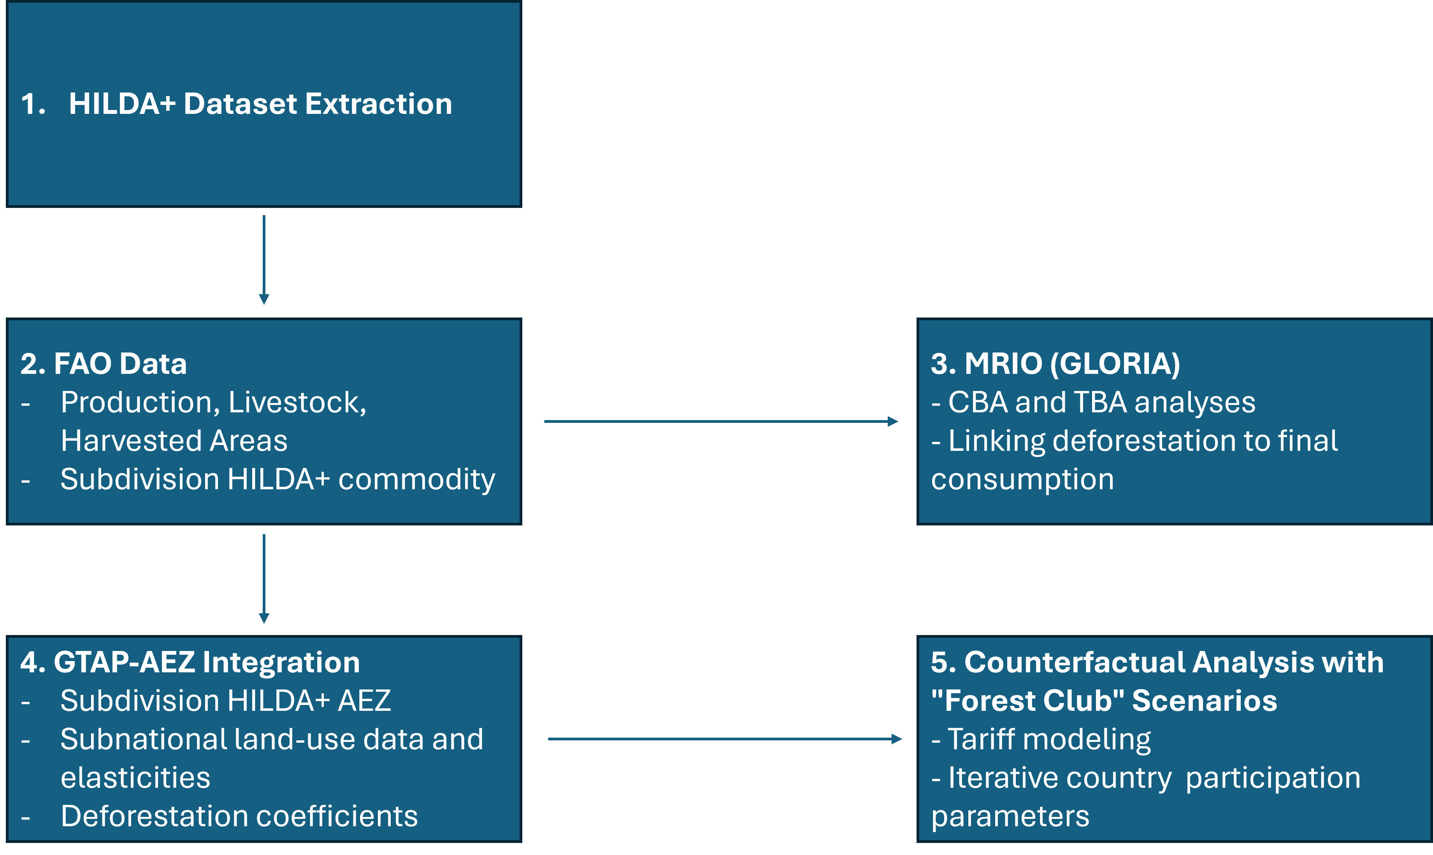
Fig. S0 | Schematic overview of the main data and modeling steps. We first extract land‐use transitions from HILDA+ (1) and combine them with FAO agricultural data (2) to derive commodity‐level deforestation estimates. These data are then integrated into a multi‐regional input‐output (MRIO) framework, where they are measured via different accounting frameworks: consumption‐based accounting (CBA) and throughflow-based accounting (TBA) frameworks (3), further disaggregated by agro‐ecological zones (AEZs) using GTAP–AEZ (4) and finally used to simulate tariff and membership scenarios in the Forest Club (5).

- HILDA+ Data Extraction
We utilize the HIstoric Land Dynamics Assessment+ (HILDA+) dataset¹, a global 1 × 1 kilometer (km) product spanning 1960–2019. HILDA+ uniquely tracks land‐use transitions (for instance, from forest to cropland or pasture) in addition to the static “states” of land use. This fine-grained spatiotemporal detail for our study of tropical deforestation is invaluable, as it helps link deforestation events to subsequent agricultural land uses.
We primarily extracted data for tropical areas located over the period 2012–2019 to get the last structural trends of deforestation and to avoid any distortion related to the 2008-2009 economic crisis. Regarding the forest definition, we are consistent with the HILDA+ dataset with “>5m tree height at ≥10% canopy cover”, as we have voluntarily excluded grass/shrublands, wetlands, and bare or sparse vegetation categories.
HILDA+ provides two primary netCDF files:
- hildaplus_GLOB-2-1-crop_states.nc: Contains each cell’s current land‐use/cover classification at each year.
- hildaplus_GLOB-2-1-crop_transitions.nc: Encodes how each cell changes from one year to the next (e.g., “forest to cropland” or “forest to pasture”).
We developed a Python script (1_HILDA_code_extraction.py) to batch‐process the netCDF files, applying bounding boxes to reduce file size for our regions of interest (South America, Africa, Southeast Asia) and filtering specific land‐use/land‐cover (LULC) codes. The key steps are:
- NetCDF Reading: Accesses year, latitude, longitude, and the main data variable (states or transitions).
- Iterating Over Years: Matching the netCDF index corresponding to that year.
- Spatial Slicing: Based on latitude/longitude bounding boxes for targeted tropical regions (South America, Africa, Southeast Asia).
- Filtering LULC Codes:
  - “States” data keep [22, 23, 24, 33] (codes indicating land type, e.g. forest, cropland, etc).
  - “Transitions” data keep [2222, 2323, …, 5555] (multi‐digit codes indicating from→to transitions). See Winkler et al, 2021 for further information.
- CSV Output: Each region‐year combination is saved to a CSV file named HILDA_V2_1_All_{prefix}_{region}_{year}.csv, where {prefix} is “States” or “Transition.”
We stored the netCDF HILDA+ (v2.1) data and the Python script in ...\1. Data\1. HILDA data\1. Extracting_ntcdf_data\1. HILDA_NTCDF_data. The resulting CSV files are stored in the designated sub-folder: “…\1. Data\1. HILDA data\1. Extracting_ntcdf_data”.
To assign each record to its respective country, we perform a spatial matching in Alteryx, appending country names via a world boundaries shapefile (World_Countries.shp) in …\1. Data\1. HILDA data\1. Extracting_ntcdf_data\Ext_World_Countries_Shp_Files.
Finally, we save the matched dataset as a text file labelled “limited” in an Alteryx database and export the points in a centroid-based polygon format for the geospatial reference. These outputs reside in …\1. Data\1. HILDA data\2. Aggregating_data.
- Integrating HILDA+ extracted data with a Multi‐Regional Input‐Output model

3.1 Motivation and Literature
MRIO modeling is an established approach to track economic flows between sectors at both national and international scales, enabling the attribution of each stage in a good’s production—from the primary producer to the final consumer—to specific countries and industries^{2,3}. This framework is commonly used to map the externalities, including deforestation, linked to the consumption of globally traded commodities, and several studies link agricultural deforestation to agricultural commodity production, trade and consumption using Environmentally Extended Multi-Regional Input Output (EE-MRIO) data^{4–6}.
In line with this literature, we employ the GLORIA database, a time‐series MRIO system developed with the Global MRIOLab⁷. We selected GLORIA because it encompasses 120 commodities and 165 countries—including key low- and middle-income regions—thus allowing a more precise assessment of deforestation drivers compared with other MRIO datasets (e.g., Exiobase, WIOD, and EORA26, among others).
To integrate HILDA+ land‐use transition data (which distinguishes only “cropland” vs. “pasture” for agricultural land use) with GLORIA's more detailed agricultural categories, we used annual statistics from the Food and Agriculture Organization (FAO) on harvested areas and livestock head counts. The integration process is described in the main manuscript from equations 1-4, with additional details in the following section, and performed in the Alteryx workflow: A_FAO_annual_evolution_per_GLORIA_sector.yxmd
Consequently, we obtain a more granular mapping of deforestation to specific agricultural supply chains. Using the MRIO structure, we can quantify—at the sectoral level—how much deforestation is ultimately driven by each consumer region, while accounting for intermediate processing, re‐export flows, and final consumption.

3.2 Land coverage annual evolution and HILDA+ deforestation per GLORIA sector
HILDA+ reports agricultural land use as just cropland or pasture, whereas GLORIA differentiates multiple agricultural sectors (e.g., cereals, oilseeds etc.). We, therefore, allocate newly deforested areas (derived from HILDA+) to the finer GLORIA categories by referencing FAO annual production and harvested-area data. These steps are formalized [Eqs. 1–4 in the main text] and detailed below.
Equations (1) and (2) in the main text describe how we aggregated FAO‐reported land‐use expansions for each FAO commodity 𝑖 and year 𝑦 into its broader GLORIA economic sector 𝑗. Table S1 provides a partial example of the specific mapping between FAO commodities and these GLORIA sectors, ensuring that each incremental area is consistently attributed to the correct aggregated category. The complete mapping table is available in the supplementary Excel file: A‐1_FAO_Cropland_mapping_GLORIA.xlsx.
Cattle statistics in the FAO database are reported in terms of the number of heads rather than the land area occupied. To allocate cattle‐related deforestation consistent with other commodities, we retrieve the Animal Unit Equivalent (AUE) for each species to get the average number of hectares per head. This conversion required additional parameters detailed in the Excel file A‐2_Head_per_ha.xlsx. By applying these proxies, we translated FAO “head” counts into land‐use equivalents and ensured consistency across all agricultural sectors included in our analyses.
Table S1: Example from the FAO–GLORIA mapping and FAO-GTAP mapping at the sector level (excerpt).
FAO commodity | GTAP sector | GLORIA sector
Pomelos and grapefruits | Veg & Fruit: vegetables, fruit and nuts, edible roots and tubers, pulses | Growing fruits and nuts
Wheat | Wheat: seed, other | Growing wheat
Unmanufactured tobacco | Other Crops: stimulant; spice, aromatic crops; forage products; plants used in perfumery, pharmacy, etc. | Growing tobacco
Anise, badian, coriander, cumin, caraway, fennel and juniper berries, raw | Other Crops: stimulant; spice, aromatic crops; forage products; plants used in perfumery, pharmacy, etc. | Growing spices, aromatic, drug and pharmaceutical crops
Mangoes, guavas and mangosteens | Veg & Fruit: vegetables, fruit and nuts, edible roots and tubers, pulses | Growing fruits and nuts
Linseed | Oil Seeds: oil seeds and oleaginous fruit | Growing leguminous crops and oil seeds
Broad beans and horse beans, green | Veg & Fruit: vegetables, fruit and nuts, edible roots and tubers, pulses | Growing cereals n.e.c
Chillies and peppers, dry (Capsicum spp., Pimenta spp.), raw | Other Crops: stimulant; spice, aromatic crops; forage products; plants used in perfumery, pharmacy, etc. | Growing spices, aromatic, drug and pharmaceutical crops
Natural rubber in primary forms | Other Crops: stimulant; spice, aromatic crops; forage products; plants used in perfumery, pharmacy, etc. | Growing crops n.e.c.
Cow peas, dry | Veg & Fruit: vegetables, fruit and nuts, edible roots and tubers, pulses | Growing vegetables, roots, tubers
Pigeon peas, dry | Veg & Fruit: vegetables, fruit and nuts, edible roots and tubers, pulses | Growing vegetables, roots, tubers
Oranges | Veg & Fruit: vegetables, fruit and nuts, edible roots and tubers, pulses | Growing fruits and nuts
Cassava leaves | Veg & Fruit: vegetables, fruit and nuts, edible roots and tubers, pulses | Growing vegetables, roots, tubers
Mixed grain | Other Grains: maize (corn), sorghum, barley, and other cereals | Growing cereals n.e.c
Tea leaves | Other Crops: stimulant; spice, aromatic crops; forage products; plants used in perfumery, pharmacy, etc. | Growing beverage crops (coffee, tea etc)
Raspberries | Veg & Fruit: vegetables, fruit and nuts, edible roots and tubers, pulses | Growing fruits and nuts
Cashewapple | Veg & Fruit: vegetables, fruit and nuts, edible roots and tubers, pulses | Growing fruits and nuts
Other sugar crops n.e.c. | Cane & Beet: sugar crops | Growing sugar beet and cane
Other nuts (excluding wild edible nuts and groundnuts), in shell, n.e.c. | Veg & Fruit: vegetables, fruit and nuts, edible roots and tubers, pulses | Growing fruits and nuts
Plantains and cooking bananas | Veg & Fruit: vegetables, fruit and nuts, edible roots and tubers, pulses | Growing fruits and nuts
Lupins | Veg & Fruit: vegetables, fruit and nuts, edible roots and tubers, pulses | Growing vegetables, roots, tubers
… | … | …

As detailed in the main text [Eq. 3 in the main text], some FAO‐reported commodities exhibit large year‐to‐year variations in harvested areas. To moderate these fluctuations, we apply a three‐year Simple Moving Average (SMA). Figure S1 illustrates this procedure for soy cultivation in Brazil over the past decade, comparing the raw annual data with the smoothed trend used in our analysis.
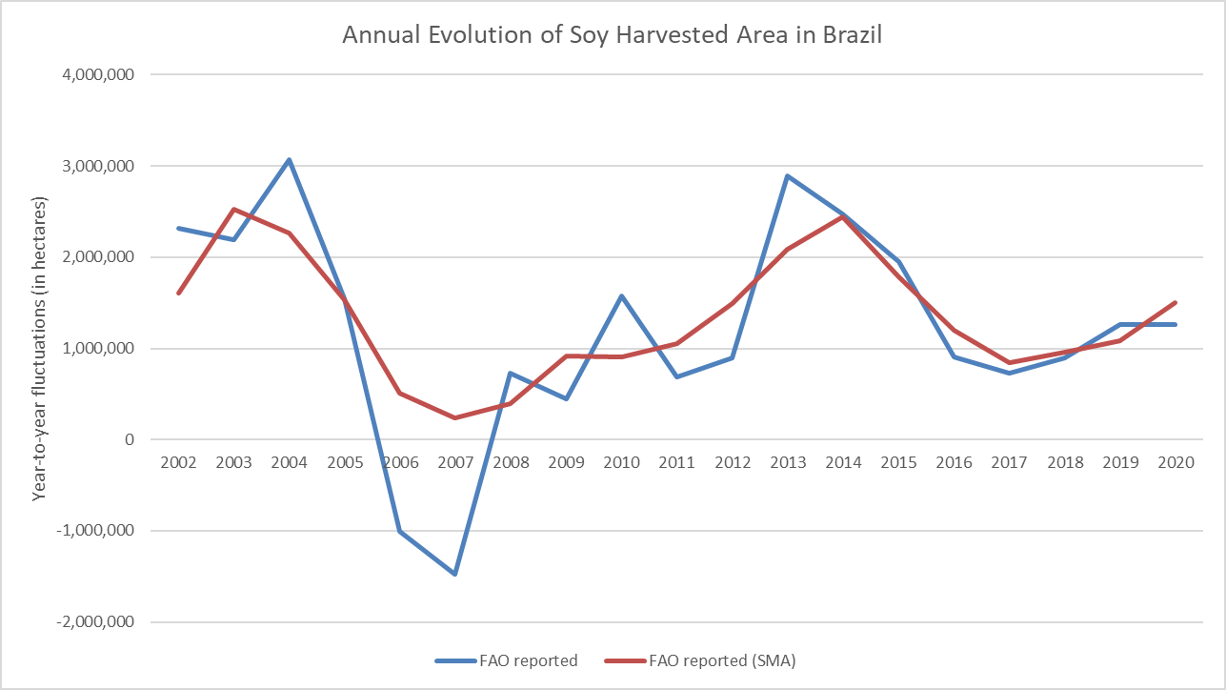
Fig. | S1 Annual Evolution of Soy Harvested Area in Brazil. Year‐to‐year fluctuations (blue line) in FAO‐reported soybean harvested area, and the corresponding three‐year Simple Moving Average (SMA) trend (red line). This smoothing approach (see Equation (3) in the main text) reduces short‐term volatility and provides a more stable data series for subsequent analyses.
The different steps detailed in this paragraph are executed in the following Alteryx workflows:
- A_FAO_annual_evolution_per_GLORIA_sector.yxmd (loads FAO data, applies 3-year smoothing, and aggregates to broad GLORIA categories).
- B_GLORIA_Satellite_data.yxmd (produces final CSV “satellite” files used by GLORIA).
Last, the raw FAO data have been downloaded from the FAO website and are located in the SI folder …\1. Data\2. FAO data\1. Production_Crops_Livestock_E_All_Data_(Normalized). The preparation of the commodities ready to be used by the MRIO Gloria (also called satellite data) are stored as csv files in the folder: 2. MRIO\GLORIA\commodity\HILDA\V_2_1
- Consumption-Based accounting and Throughflow‐Based Accounting
To quantify deforestation linked to agricultural goods, we first perform consumption‐based accounting (CBA) using the Python script CBA_TBA_script.py (found in …\2. MRIO\GLORIA\output\CBA). This script:
- Loads each year's MRIO GLORIA matrices (Z, Y), plus region/sector labels.
- Builds the technical coefficients matrix (A).
- Computes the Leontief inverse via Lower-Upper factorization (for efficiency).
- Integrates HILDA+ deforestation intensities.
- Allocates direct/indirect deforestation to final demand.
The Leontief inverse matrix was computed using Lower-Upper (LU) factorization for efficiency (rather than direct matrix inverse). Prepared deforestation data from HILDA v2.1 (see section 3.2) are integrated and normalized by sector output, yielding direct (e) and indirect (m) impacts. Multiplying the indirect impacts by final demand locates where deforestation is ultimately ‘consumed.’ The script optionally aggregates countries in the GLORIA list to remove intra-trade (in our case, we have removed the EU27 intra-trade). Detailed instructions on the required data and script execution are listed in the ReadMe file within the script folder.
To visualize CBA results, it is necessary to run the Alteryx workflow 1_HILDA_v2-1_CBA results.yxmd, which generates CBA_Results_Full.csv. These data can then be examined in Tableau using the CBA_Visualisation.twb file. Together, these outputs produce Table 1 of the main manuscript and Figure S2 presented below.
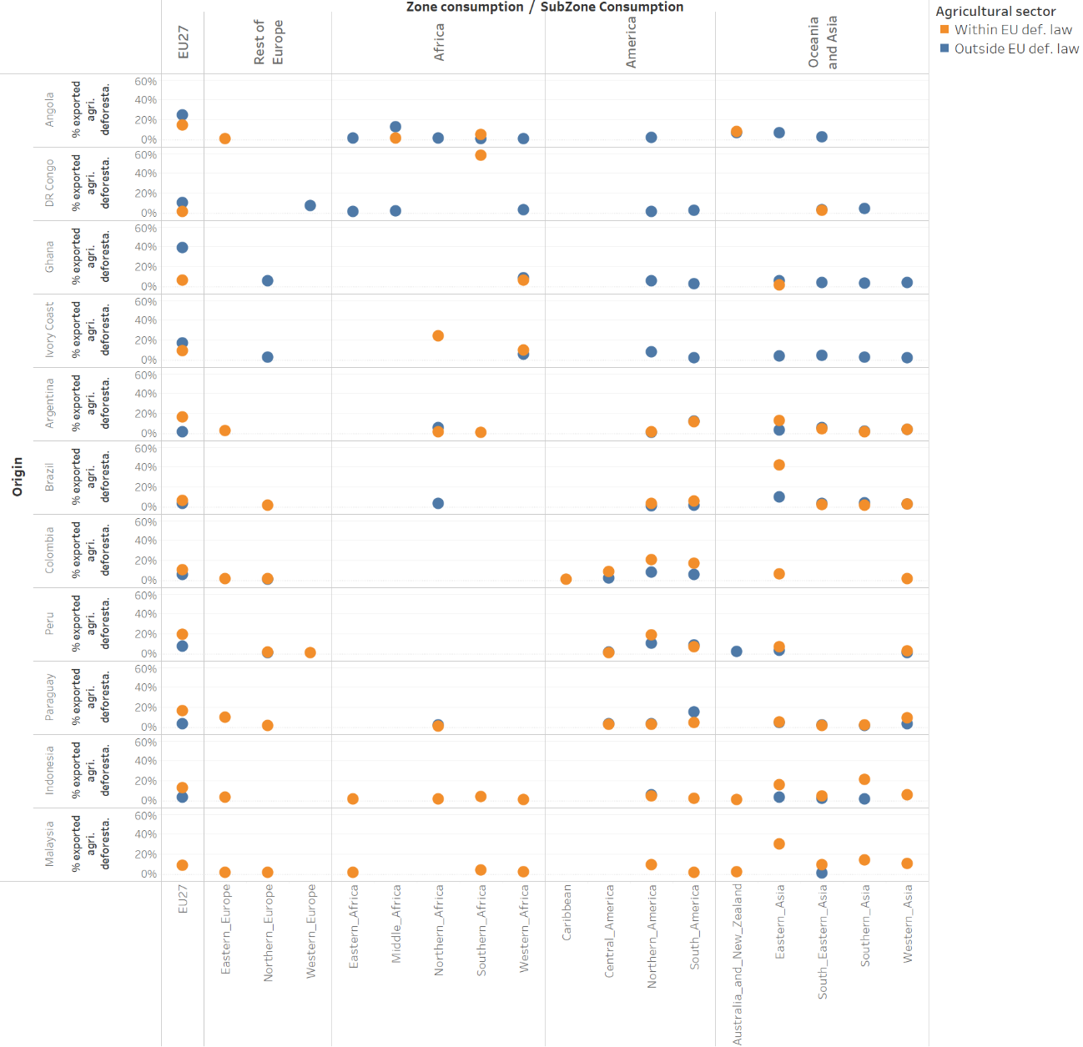
Fig. | S2 Geographic distribution of deforestation embodied in exports. The results are grouped by region of consumption and whether these sectors are covered by EU deforestation legislation (see main text). Each line represents the distribution of total exported agricultural deforestation, summing to 100%. Subregions under 1% are omitted for the sake of clarity.

We applied the Throughflow-Based Accounting (TBA)⁸, alongside conventional CBA to capture agriculture-driven deforestation impacts that “pass through” each country or region in the GLORIA database. “Passing through” denotes commodities originating in one country (e.g., soy from Brazil produced from deforestation), then exported and processed in an intermediary country before being re-exported to a third final consumer. TBA thus identifies the proportion of deforestation embodied in global value chains (GVCs) transiting via each territory, effectively quantifying how intermediate processing or re-export in one country contributes to overall deforestation footprints.
Combining CBA and TBA allows the calculation of both direct consumption (where a product is exported directly from its producing country to its final user) and indirect consumption (where a product is re-exported following processing in an intermediary country). For three countries with tropical deforestation (Brazil, Indonesia, and the Democratic Republic of the Congo), aggregate results are presented in the main text (Figure 1). The annual results detailed at the sector level and country level are presented in the folder …\2. MRIO\GLORIA\output\TBA\. For the remaining countries, including tropical deforestation within the scope of our analysis (Argentina, Bolivia, Chile, etc.), results are detailed at the sector level for the EU27 only and provided in Table S2.
TBA calculations leverage the Hypothetical Extraction Method ⁹ to avoid double counting within each individual country’s TBA assessment. Nevertheless, when the TBA is performed iteratively for multiple countries, certain supply chains may be counted more than once if they pass through multiple territories (e.g., a GVC Brazil → EU → Turkey → China will appear in the indirect consumption of China but will be counted within GVCs going through the EU and in the GVCs going through Turkey, and thus double counted). Thus, some flows in Figure 1 in the main text are double-counted. To limit this distortion, satellite deforestation data were compiled separately for each producer–year pair (e.g., Brazil 2012, Colombia 2012 etc.), also keeping the sector level disaggregation while the main TBA results were iteratively computed individually rather than aggregated. We verified that any discrepancy between total “transiting” deforestation and overall production-to-consumption deforestation remained below 1% (cell B211 in the SI file Structure explanation.xlsx).
However, this approach to limit at the maximum the double counting is computationally intensive. The need to compute a Leontief inverse matrix for each combination of producer country, year, and supply chain structure results in high computational demand, especially with GLORIA’s detailed country–sector disaggregation (GORIA Z matrices are 6.1 GiB). For instance, analyzing just the three producer countries in Figure 1 across eight years and 138 intermediaries required generating ~3,300 different Leontief matrices. Even on a high-performance computing (HPC) cluster (192 vCPUs, 1,536 GiB RAM), these computations took ~80 hours in total. Consequently, we focus on three major producing countries for full TBA detail in Figure 1, while the remaining countries in our scope (e.g., Peru, Argentina etc.) are only included at the EU27 sector level in Table S2 (directory: output/TBA-EU-only). All CBA and TBA results, including CSV files by producer, region, sector, and year—are available in the output/CBA and output/TBA directories, respectively.
Interestingly, even if this tropical agricultural deforestation “transiting” via EU27 is relatively marginal compared to the entire annual tropical deforestation (app. 12,000 Ha annually representing 0.6% of the annual tropical agricultural deforestation), more than half of this “transiting” deforestation is concentrated in eight GVCs:
- Paraguay → EU→ Rest of Europe, sector Oil seeds (1,286 Ha)
- Paraguay → EU→ Oceana and Asia, sector: Oil seeds (967 Ha)
- Brazil → EU→ Rest of Europe, sector: Oil seeds (808 Ha)
- Brazil → EU→ Oceana and Asia, sector: Oil seeds (757 Ha)
- Paraguay → EU→ America, sector Oil seeds (733 Ha)
- Brazil→ EU→ America, sector Oil seeds (598 Ha)
- Ghana → EU→ Rest of Europe, sector: Fruits and Nuts (494 Ha)
- Indonesia→ EU→ Rest of Europe, sector: Oil Seeds (352 Ha)
Table S2: Detailed consumption of agricultural tropical deforestation embodied within Global Values Chains imported within the EU territory before being re-exported to be consumed in another place, results detail by area of production and sector of production (values are expressed in Ha and represent the average 2012-2019). The entire database is available in the SI files: Deforestation_Transiting_EU27_2012-2019.xlsx
 | Global Value Chains transiting through EU27 before arriving for final consumption in a country outside EU27 |  |  |  |  |  |  |  |  | Total
 | Africa |  | America |  | Asia & Oceania | EU27 |  | Rest of Europe |  | Total
Argentina
EUDR agri. sector | 4 | 10 |  | 18 |  |  | 0 |  | 22 | 76
Not EUDR agri. sector | 2 | 5 |  | 5 |  |  | 0 |  | 7 | 76
Brazil
EUDR agri. sector | 238 | 613 |  | 777 |  |  | 0 |  | 829 | 3,400
Not EUDR agri. sector | 77 | 249 |  | 276 |  |  | 0 |  | 341 | 3,400
Paraguay
EUDR agri. sector | 339 | 865 |  | 1158 |  |  | 0 |  | 1,562 | 3,773
Not EUDR agri. sector | 31 | 96 |  | 91 |  |  | 0 |  | 106 | 3,773
Peru
EUDR agri. sector | 7 | 29 |  | 39 |  |  | 0 |  | 40 | 182
Not EUDR agri. sector | 5 | 15 |  | 21 |  |  | 0 |  | 24
Colombia
EUDR agri. sector | 14 | 49 |  | 60 |  |  | 0 |  | 67 | 236
Not EUDR agri. sector | 4 | 11 |  | 14 |  |  | 0 |  | 17
DR Congo
EUDR agri. sector | 0 | 0 |  | 1 |  |  | 0 |  | 0 | 19
Not EUDR agri. sector | 2 | 6 |  | 5 |  |  | 0 |  | 5 | 19
Angola
EUDR agri. sector | 0 | 0 |  | 0 |  |  | 0 |  | 0 | 10
Not EUDR agri. sector | 1 | 3 |  | 3 |  |  | 0 |  | 3 | 10
Ivory Coast
EUDR agri. sector | 12 | 39 |  | 37 |  |  | 0 |  | 53 | 1,357
Not EUDR agri. sector | 36 | 114 |  | 145 |  |  | 0 |  | 181
Ghana
EUDR agri. sector | 19 | 71 |  | 89 |  |  | 0 |  | 106 | 1,559
Not EUDR agri. sector | 94 | 270 |  | 367 |  |  | 0 |  | 543
Indonesia
EUDR agri. sector | 94 | 287 |  | 395 |  |  | 0 |  | 393 | 1,478
Not EUDR agri. sector | 39 | 65 |  | 102 |  |  | 0 |  | 103 | 1,478
Malaysia
EUDR agri. sector | 26 | 86 |  | 131 |  |  | 0 |  | 112 | 373
Not EUDR agri. sector | 1 | 5 |  | 6 |  |  | 0 |  | 6 | 373
- Integrating HILDA+ within a Computable General Equilibrium model

5.1 The Global Trade Analysis Project Agro-Ecological Zones
The counterfactual analysis in this study is based on the Global Trade Analysis Project (GTAP) model—a perfectly competitive, computable general equilibrium (CGE) framework widely employed and documented in the economic literature^{10,11}. Built on general equilibrium theory with a robust microeconomic foundation, GTAP is designed to assess interregional, economy-wide impacts of policy changes, capturing commodity-specific effects while accounting for inter-industry linkages¹².
The GTAP model features a symmetric structure, with homogeneous production and utility functions across regions. Nevertheless, utility functions differ by sector, and regional heterogeneity stems from variations in product shares within each region’s output. A representative regional household—receiving factor rewards—allocates income among private consumption, government spending, and savings via a Cobb–Douglas utility function. This utility function is nested, first aggregating over distinct goods or sectors, then splitting between domestic and imported commodities.
On the production side, the GTAP framework assumes separable, constant returns-to-scale technologies. Following standard CGE practice, production is characterized by nested constant elasticity of substitution (CES) functions to capture substitution possibilities among various inputs. Firms employ a composite of value-added and intermediate inputs in fixed proportions (a Leontief-type specification), while their conditional demand for each value-added component depends on relative factor prices. Imported intermediates are treated as separable from domestically produced inputs.
The CES functional form is frequently used to represent both production and preference functions. The Armington specification allocates domestic consumption between domestic and imported goods, assuming exogenous product differentiation by geographic origin. Under Armington trade, each sector’s output is a region-specific variety; final and intermediate goods are consumed in CES composites of domestic and partner-region varieties. This assumption explains bilateral cross-hauling of similar products and allows the tracking of bilateral trade flows. Finally, transaction costs (e.g., transport services) are explicitly modeled to reflect the economic impact of moving goods across regions.
In a CGE framework, the counterpart to the CES is the constant elasticity of transformation (CET). While CES is widely used to model input demands in production, CET is used for sluggish endowment supply. The functional forms are mathematically similar, differing mainly in their curvature/concavity¹³. In GTAP, land is considered a sluggish endowment commodity because it is imperfectly mobile and heterogeneous in quality, leading to different prices across sectors. Thus, a CET functional form is used to allocate land supply across various land uses.
We conduct our counterfactual analysis using the GTAP model extended to include Agro-Ecological Zones (AEZ)¹⁴. This GTAP–AEZ framework subdivides each region into distinct zones based on climate, soil, and terrain characteristics, enabling subnational tracking of land-use changes (see Figure S3 for the illustration of CET in those global AEZs).
Like the conventional GTAP model, GTAP–AEZ is a perfectly competitive CGE framework applied to evaluate prospective policy impacts. Nevertheless, by differentiating land productivity and land-use allocation across AEZs, the model captures how policy and economic factors—such as tariffs, output changes, and policy shocks—can drive shifts in land use at a more granular level than the standard GTAP model.
This heightened spatial resolution at the sector level enables further environmental impact assessments, including deforestation trends that follow agricultural expansion. By coupling economic trade flows with land-use dynamics, GTAP–AEZ facilitates evaluations of the environmental consequences of trade liberalization, climate change mitigation strategies, and other policy interventions. All parameterization and behavioural assumptions (e.g., elasticity values) align with standard CGE modelling principles, while zone-specific data on productivity and land availability guide land-use responsiveness.
The agro-ecological zoning approach allows each AEZ within a region to exhibit a unique productive potential for agriculture and forestry, reflecting heterogeneity in resource endowments and productivity. As a result, land allocation among crops, livestock, and forestry can be simulated in greater detail, clarifying how changes in relative prices, trade policies, or environmental regulations affect land-use decisions (see Figure S3).
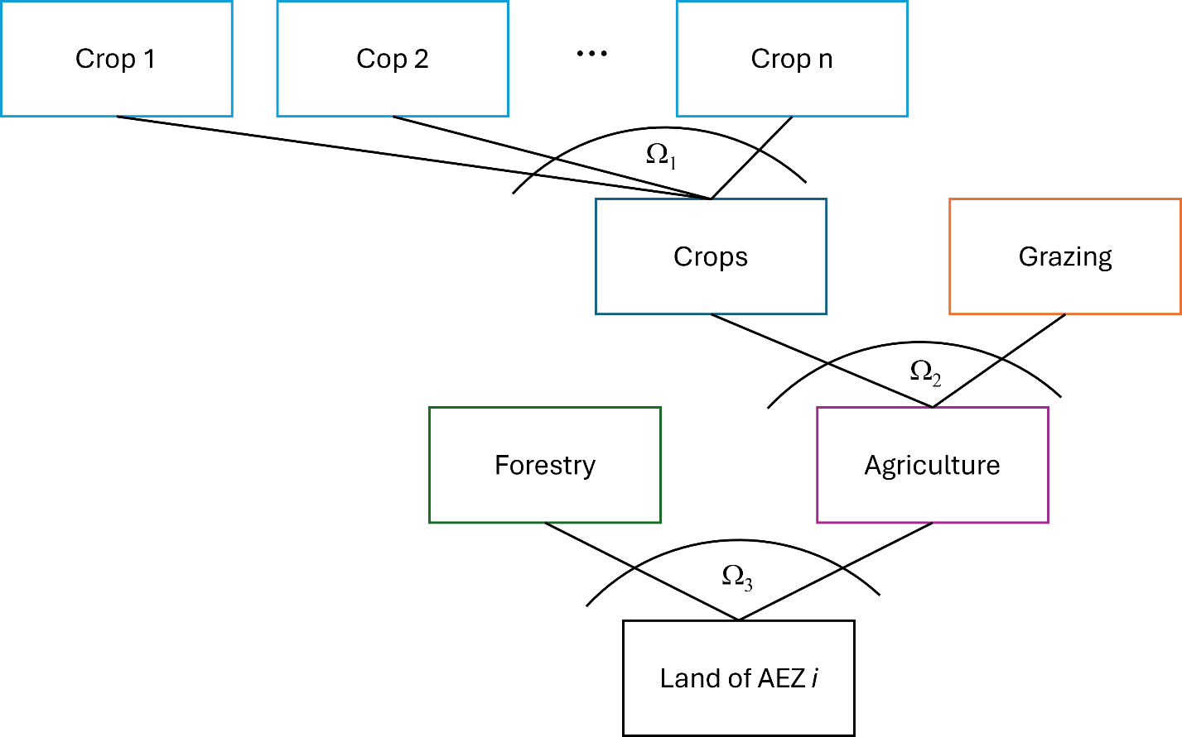
Fig. S3 | Three-Tier Structure of AEZ-Specific Land Supply in the original GTAP-AEZ model. This figure illustrates the nested constant elasticity of transformation (CET, Ω structure by which land in each AEZ is allocated among forestry, pasture, and cropland. AEZs are defined according to climate, soil, and terrain characteristics, allowing for heterogeneity in land productivity and conversion costs. In the original GTAP–AEZ, “inaccessible forest” remains outside the competing original GTAP-AEZ land base, potentially underestimating forest conversion under increasing commodity prices¹⁵.
As mentioned in the caption of Figure S3, land competition in GTAP–AEZ occurs among cropland, pasture, and forestry, while land deemed “unmanaged” or “inaccessible” is excluded in the original formulation¹⁶. Consequently, the standard GTAP–AEZ version may underestimate forest conversion in response to price changes, since inaccessible forest is not considered convertible¹⁵. A key innovation in our study is to incorporate subnational (AEZ-level) land supply elasticities that capture the responsiveness of forest-to-agriculture conversion when commodity prices rise. We draw on recent estimates¹⁷, which employ a fractional response model to link AEZ-level agricultural land shares to various socioeconomic (e.g., commodity prices, population density), biophysical (e.g., rainfall, growing season length), and governance (e.g., corruption, protected areas) factors.
Miranda et al. define “agricultural land” to include both cropland and pasture, recognizing that tropical deforestation often stems from pasture expansion. Using globally consistent land-cover data, the authors aggregate pixel-level classifications into cropland, pasture, forest, and other land uses at the AEZ-country level. By modeling agricultural land share (bounded between 0 and 1) with a fractional response approach, they address corner solutions (i.e., zero agriculture in some AEZs) and potential endogeneity of commodity prices (via a shift-share instrumental variable strategy). Those empirically derived elasticities, which vary by AEZ and region, are central to our simulations. When integrated into the GTAP–AEZ framework, they enable more realistic predictions of how price and policy shocks—such as changes in tariffs or output demand—can drive deforestation and other land-use changes.
The updated parameters from Miranda et al., are located in the SI file: defaut.prm and can be accessed via the variable ETRAEL1: “elasticity of transformation between Forestry and Agriculture”.

5.2 Integration of HILDA+ data into GTAP-AEZ
We use HILDA+ v2.1 data to compute the deforestation coefficient for each country–AEZ–commodity combination [Eqs. 6–11 in the main text]. This coefficient is defined as the fraction of agricultural land-use change (2010–2018) attributable to deforestation. For instance, a coefficient of 0.08 for Brazil’s AEZ 5 for the agricultural sector oil seeds (mainly soy in Brazil) indicates that 8% of the land expansion in that Brazilian AEZ over 2010–2018 for the production of soy resulted from deforestation.
For most cases, the HILDA+ v2.1 data align with prior findings from literature¹⁸, supporting the validity of our approach and the disaggregation of agricultural production per AEZ using GTAP-AEZ data [Eqs.6–11 in the main text]. However, a few coefficients slightly exceed 100%, likely reflecting inaccuracies or mismatches between HILDA+ v2.1 or in the GTAP-AEZ values at the root of our disaggregation procedure. Refining these estimates—by improving HILDA+ data or using a more straightforward approach by obtaining FAO production statistics directly at the AEZ level—remains an area for future work. Last, we adjusted those deforestation coefficients to the original cultivated areas from GTAP-AEZ data. The procedure is detailed in the SI file: Database_Forest_Intensity_GTAPAEZ_shocks.xlsx.
It is worth noting that the AEZ-level granularity is particularly important, as these deforestation coefficients can vary substantially across both zones and commodities. For instance, cattle coefficients approach 100% in certain tropical AEZs, yet also remain significant in some temperate areas (e.g., southeastern Brazil). Additionally, some agricultural sectors, such as the growth of oil seed, may show more deforested areas in absolute value in the temperate zone, but a lower deforestation coefficient.
Table S3 offers a partial illustration of the deforestation coefficients for oilseeds (osd), cattle (ctl), and fruits/vegetables (v_f) in different Brazilian AEZs. Coefficients above 100% are capped. The complete dataset is available in the Excel file Database_Forest_Intensity_GTAPAEZ_shocks.xlsx.

Table S3: Deforestation coefficients derived from HILDA+ data, partially illustrated for the different Brazilian AEZs, for oil seeds (osd, mainly soy in Brazil), cattle (ctl, mainly beef in Brazil) and fruits and vegetables (v_f). The AEZ details appear in Table S4. Coefficients exceeding 100% are capped at 100%. The complete dataset is provided in the SI Excel file: Database_Forest_Intensity_GTAPAEZ_shocks.xlsx.
Country | Agro-Ecological Zone | Name | Agricultural land-use change (HILDA+ measured  2010-2018 in Ha) | Agricultural deforestation (HILDA+ measured  2010-2018 in Ha) | Deforestation coefficient
Brazil | AEZ11 | v_f | 5,825 | 66 | 1%
Brazil | AEZ11 | osd | 10,328 | 106 | 1%
Brazil | AEZ11 | ctl | 1,900 | 300 | 16%
Brazil | AEZ12 | v_f | 108,561 | 6,660 | 6%
Brazil | AEZ12 | osd | 4,259,442 | 291,776 | 7%
Brazil | AEZ12 | ctl | 55,600 | 112,100 | 100%
Brazil | AEZ3 | v_f | 65,125 | 1,544 | 2%
Brazil | AEZ3 | osd | 50,563 | 492 | 1%
Brazil | AEZ3 | ctl | 11,700 | 300 | 3%
Brazil | AEZ4 | v_f | 137,574 | 8,450 | 6%
Brazil | AEZ4 | osd | 849,360 | 43,404 | 5%
Brazil | AEZ4 | ctl | 153,600 | 178,300 | 100%
Brazil | AEZ5 | osd | 5,590,894 | 603,821 | 11%
Brazil | AEZ5 | v_f | 172,331 | 13,591 | 8%
Brazil | AEZ5 | ctl | 1,151,500 | 1,156,400 | 100%
Brazil | AEZ6 | v_f | 99,490 | 3,972 | 4%
Brazil | AEZ6 | osd | 1,984,857 | 80,131 | 4%
Brazil | AEZ6 | ctl | 1,679,200 | 1,433,500 | 85%
… | … | … | …. | … | …

The GTAP–AEZ framework divides each region into 18 AEZs based on climatic zone (tropical, temperate, or cold) and length of growing period (LGP) intervals of 60 days (Table S4). Although FAO Agro-Ecological Zone version 4 includes up to 52 zones¹⁹, it is not possible to directly map those to the original 18 GTAP–AEZ zones. Instead, we rely on FAO-provided maps of LGP and moisture (MST)—specifically, the files lgd_CRUTS32_Hist_0010.tif and mc3_CRUTS32_Hist_8110.tif—combined in ArcGIS Pro to delineate the 18 GTAP–AEZ zones (see Table S4 and folder ...\1. Data\1. HILDA data\3. Split_AEZ).
Once we establish these AEZ boundaries at the country level (see Figure S4), we spatially overlay the HILDA+ deforestation data on the AEZ polygons, ensuring each grid cell is assigned to the correct AEZ for subsequent analysis. Figure S5 illustrates this workflow, showing how we link HILDA+ deforestation layers (green pixels) to polygons (red outlines) corresponding to a specific AEZ (e.g., AEZ4 in Brazil).
The global results and intermediate outputs are stored in A-4_aez_global_grid_polygons.yxmd and visualized in Figure S4 and Figure S5, which demonstrate how AEZ boundaries intersect with national borders and HILDA+ deforestation points.

Table S4: Global Agro-Ecological Zones (AEZ) classification used in this study. These 18 AEZs align with the GTAP–AEZ framework, combining length of growing period (LGP) intervals and climatic zones (tropical, temperate, cold).
Length Growing Period | Climate Zone | Moisture zone | Agro Ecological Zone
0-59 | Tropics | Arid | AEZ1
60-119 | Tropics | Dry semi-arid | AEZ2
120-179 | Tropics | Moist semi-arid | AEZ3
180-239 | Tropics | Sub-humid | AEZ4
240-299 | Tropics | Humid | AEZ5
>300 | Tropics | Humid; year-round growing season | AEZ6
0-59 | Temperate | Arid | AEZ7
60-119 | Temperate | Dry semi-arid | AEZ8
120-179 | Temperate | Moist semi-arid | AEZ9
180-239 | Temperate | Sub-humid | AEZ10
240-299 | Temperate | Humid | AEZ11
>300 | Temperate | Humid; year-round growing season | AEZ12
0-59 | Cold | Arid | AEZ13
60-119 | Cold | Dry semi-arid | AEZ14
120-179 | Cold | Moist semi-arid | AEZ15
180-239 | Cold | Sub-humid | AEZ16
240-299 | Cold | Humid | AEZ17
>300 | Cold | Humid; year-round growing season | AEZ18

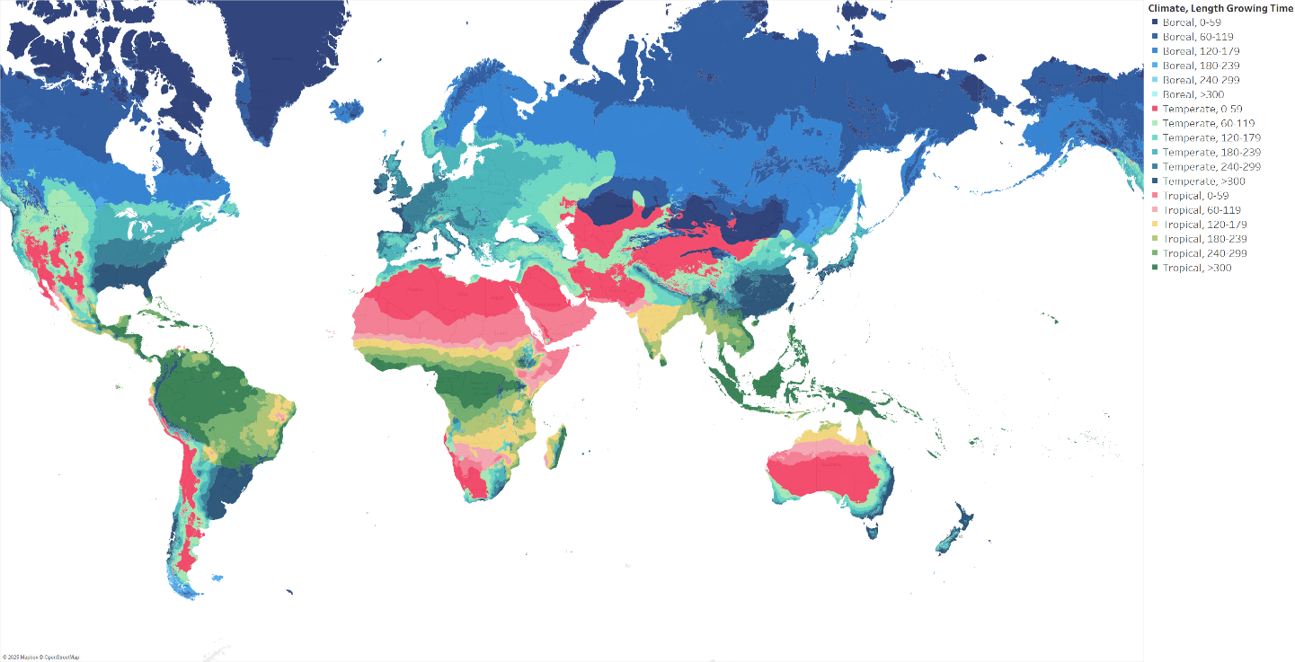
Fig. | S4: Global AEZ-country observations. The map shows the delineation of the Global Agro-Ecological Zones (GAEZ) boundaries used in our analysis.

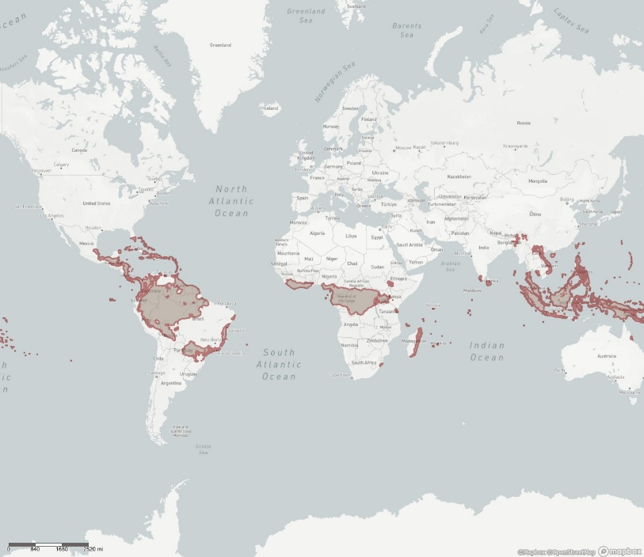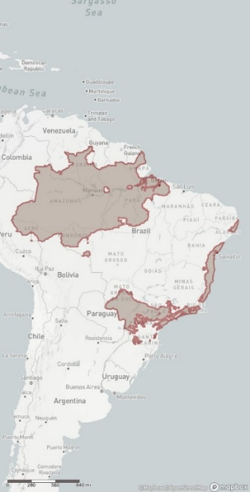
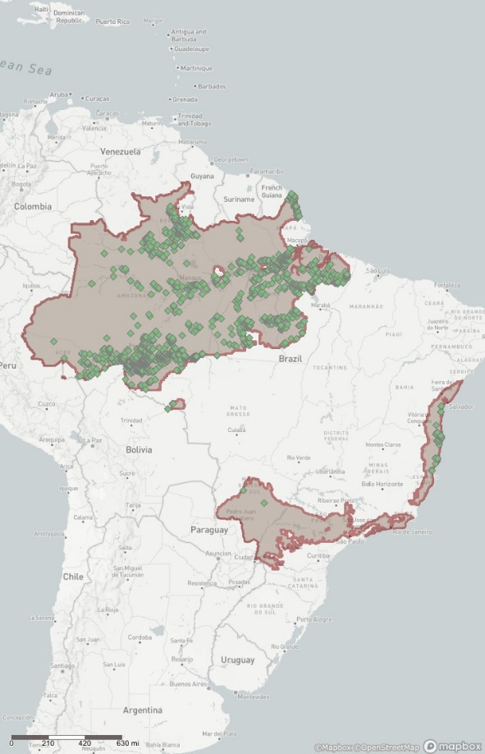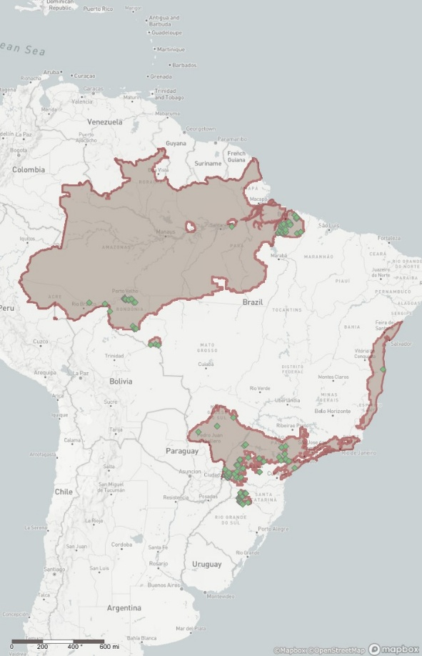
Fig. S5 | (Top left) Global delineation of the AEZ6 performed in Alteryx. (Top right) Focus on Brazil, highlighting the AEZ5 polygons delineating this AEZ. (Bottom left) Spatial overlay of HILDA+ cattle deforestation data for 2014 (green dots) and AEZ5 boundary cells (red) within Brazil territory. (Bottom right) Spatial overlay of HILDA+ non-cattle deforestation data for 2014 (green dots) and AEZ5 boundary cells (red) within Brazil territory.

- Counterfactual analysis
We designed a counterfactual analysis where the baseline scenario involves trade frictions (tariffs) introduced by the EU on worldwide agricultural commodities that contribute to tropical deforestation. For each country where tropical deforestation occurs (hereafter “producer country”), the EU implements tariffs on specific agricultural commodities linked to the area deforested for their production. Table S5 summarizes the list of producer countries, non-producer countries, the level of geographical aggregation and affected commodities and the results of this baseline scenario are detailed in Fig. S6.
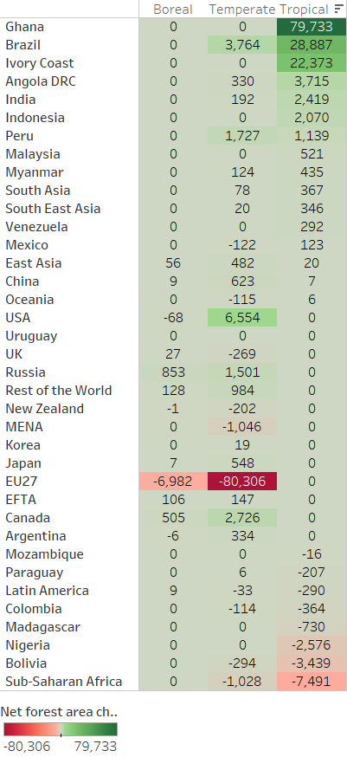
Fig. S6 | Baseline results of net national / zone forest area change compared to initial situation. Results are expressed in hectares and detailed by climate type. Abbreviations: MENA, Middle East and North Africa; EFTA, European Free Trade Association.

Table S5: Overview of Producer and Non-Producer Countries and GTAP–AEZ Sectors included in our analysis. This table lists countries where deforestation occurs (“producer countries”) and those that do not (“non-producer countries”). It also identifies the corresponding GTAP–AEZ commodity sectors subject to any tariffs. See Table S1 for further information on the mapping of agricultural commodities and GTAP economic sectors. The abbreviations for individual countries follow the convention of the International Organization for Standardization (ISO).
Non-producer countries (with detailed ISO with the aggregation) | Producer countries (with detailed ISO with the aggregation) | GTAP AEZ sector targeted
East Asia (HKG, MAC, PRK, TWN, MNG, BRN) | Angola & DRC (AGO, DRC) | Rice: seed, paddy (not husk) (pdr)
Nigeria (NGR) | Ivory Coast (CIV) | Wheat: seed, other (wheat)
Mozambique (MOZ) | Ghana (GHA) | Other Grains: maize (corn), sorghum, barley, rye, oats, millets, other cereals (gro)
Madagascar (MDG) | Bolivia (BOL) | Veg & Fruit: vegetables, fruit and nuts, edible roots and tubers, pulses (v_f)
Sub-Saharan Africa (SDN, SSD, BDI, COM, DJI, ERI, ETH, KEN, MWI, MUS, MYT, RWA, SYC, SOM, UGA, TZA, ZMB, ZWE, CMR, CAF, TCD, COG, GNQ, GAB, STP, BWA, SWZ, LSO, NAM, ZAF, BEN, BFA, CPV, GMB, GIN, GNB, LBR, MLI, MRT, NER, SHN, SEN, SLE, TGO) | Indonesia (IDN) | Oil Seeds: oil seeds and oleaginous fruit (osd)
Myanmar (MMR) | Paraguay (PRY) | Cane & Beet: sugar crops (c_b)
South Asia (AFG, BGD, BTN, MDV, NPL, PAK, LKA) | Colombia (COL) | Fibres crops (pfb)
India (IND) | Brazil (BRA) | Other Crops (ocr)
Southeast Asia (KHM, LAO, PHL, SGP, THA, TLS, VNM) | Peru (PER) | Cattle (ctl)
Latin America (AIA, ATG, ABW, BHS, BRB, VGB, CYM, CUB, DMA, DOM, GRD, HTI, JAM, MSR, PRI, KNA, LCA, VCT, TTO, TCA, VIR, BLZ, CRI, SLV, GTM, HND, NIC, PAN, CHL, ECU, FLK, GUF, GUY, SGS, SUR, URY) | Argentina (ARG)
China (CHN) | Malaysia (MYS)
MENA (DZA, EGY, LBY, MAR, TUN, ESH, IRN, IRQ, ISR, JOR, KWT, LBN, OMN, QAT, SAU, SYR, TUR, ARE, YEM)
Rest of the World (IOT, ATF, BVT, BMU, GRL, SPM, ATA, KAZ, KGZ, TJK, TKM, UZB, ARM, AZE, GEO, BLR,MDA, UKR, GGY, JEY, FRO, IMN, ALB, AND, BIH, GIB, VAT, MNE, MKD, SMR, SRB, LIE, MCO)
Mexico (MEX)
Venezuela (VEN)
Uruguay (URY)
Russia (RUS)
Oceania (AUS, FJI, NCL, PNG, SLB, VUT, GUM, KIR, MHL, FSM, NRU, MNP, PLW, UMI, ASM, COK, PYF, NIU, PCN, WSM, TKL, TON, TUV, WLF)
EU27 (AUT, BEL, BGR, HRV, CYP, CZE, DNK, EST, FIN, FRA, DEU, GRC, HUN, IRL, ITA, LVA, LTU, LUX, MLT, NLD, POL, PRT, ROU, SVK, SVN, ESP, SWE, REU', 'GLP', 'MTQ')
Korea (KOR)
Japan JPN
USA USA
UK GBR
Canada CAN
New Zealand NZL
European Free Trade Agreement 'ISL', 'NOR', 'CHE' LIE

Then, the counterfactual analysis follows three main steps. First, we set targets for land use reduction in exports using the average incremental deforestation on land use by sector for the period 2010-2018 (see previous section and Table S3). Second, we estimate the level of tariffs preventing trade on goods embodying deforestation. These increases in trade costs, if applied by all countries in the world, meet the target in the first step. Third, we conduct the counterfactual economic analysis by applying tariffs following an iterative sequential country-participation scheme (i.e. the Forest Club).

6.1 Calculation of tariff proportional to deforestation exports
We first compute the necessary tariffs to lower each producer country’s exports by the share of production linked to deforestation. Under GTAP’s default setting, policy variables (e.g., tariffs) are exogenous, and outcome variables (e.g., export quantities) are endogenous. By issuing a swap command, we reverse this relationship. In the example case of Brazil:
- swap qxw("osd","Brasil")=tmf_f("osd","Brasil");
- shock qxw("osd","Brasil")=-4.2319637034518;
Here, qxw("osd","Brasil") (the exported quantity of oil seeds (mainly soy) from Brazil) becomes exogenous, while tmf_f("osd",”Brasil") (the oil seed import tariff) becomes endogenous. Imposing a 4.23% reduction in soy exports (e.g., the deforestation coefficient) then prompts GTAP to calculate the tariff needed to achieve that specific decline. It is important to note that this 4.23% figure does not appear explicitly in Table S3, because export reductions occur at the national level, whereas Table S3 provides AEZ‐level data. Since Brazil exports soy as a single national entity, the 4.23% reduction represents a weighted average of the AEZ‐specific deforestation coefficients shown in Table S3.
We repeat this procedure for all relevant commodities and producer countries, with swap and shock commands detailed in the Excel file: Database_Forest_Intensity_GTAPAEZ_shocks.xlsx, tab “Shocks_GlobalTarf_qxw”. The resulting tariff values are reported after running the simulation with GTAP-AEZ in the same SI file the Excel file: Database_Forest_Intensity_GTAPAEZ_shocks.xlsx, tab “Shocks_tmf_f”.
This tariff simulation is available in the SI and can be recomputed using the “\5. Tariff_SIM” folder (name of the experiment: qxwGlobT “aggregate shock on qxw for global tariffs”), which yields the average tariff required to curtail each export flow in proportion to its deforestation footprint.
We explore three different implementations of this approach, applying the shock to different quantity variables:
- qoes: Decreases the AEZ‐level output of deforestation‐linked commodities (as used for the results shown in the main text).
- qo: Decreases the national output of commodities produced through deforestation.
- qxw: Decreases the national exports of commodities derived from deforestation (as in the example above).
Different tariff values (and shock files) are created for each shock implementation.

6.2 Iterative negotiation process
The baseline scenario is the EU27 applying the tariffs calculated in the previous section to the producer country. From this baseline scenario, we develop an iterative process where, at the end of each iteration, countries can choose to join or leave the club. The rules of the Forest Club are as follows:
- The EU27 is the only permanent member across different iterations.
- Both producer and non-producer countries can join the Club, provided they adhere to its rules.
- All countries inside the Club apply the same tariffs on the goods and services listed in Table S5 imported from countries outside the Club.
- For each country, the decision to join, remain, or leave the Club at each iteration is based on the change in welfare (or economic well-being, e.g. GDP) in relation to the Club's composition from the previous iteration:
  - For countries outside the Club:
    - If their welfare increases, remain outside the Club.
    - If their welfare decreases by a certain amount, join the Club.
  - For countries inside the Club:
    - If their welfare increases, remain inside the Club.
    - If their welfare decreases by a certain amount, leave the Club.
- If a producer country joins the club, its agricultural production is adjusted in order to produce no deforestation. This is done via one of the three options presented above:
  - Shock on qoes or,
  - Shock on qo or,
  - Shock on qxw
The selection of specific parameters significantly influences a country's ability or willingness to join or remain in the Club, thereby affecting the overall system dynamics. Future research should explore this further, but preliminary observations indicate that two critical parameters are: the acceptable loss thresholds for a country to remain in the Club (which we call Exit threshold) and the Loss thresholds at which a country would join the Club.
Regarding the first one, allowing countries to exit the Club based on any negative welfare fluctuation introduces instability into the system. In the absence of any thresholds, the system either exhibits an unstable spiral or oscillates between several states. Minimal thresholds lead to a stable spiral, whereas high thresholds result in a stable system. Practically, it is unlikely for a country to exit an international coalition over a minor welfare decrease (such as $10 million USD). However, excessively high thresholds can skew results and artificially maintain some countries within the Club. To mitigate this, we have set the Exit threshold for leaving the Club at a minimum, aligning them on the countries’ contribution to an international organization such as the United Nations. Additionally, emphasizing the importance of social and environmental justice in sustainability, we calculated these thresholds as a minor percentage of GDP, ranging from 0% to 0.05%, and inversely proportional to the Human Development Index (HDI) score. For example, the Exit threshold for Mozambique (HDI = 0.433) is set at $49.2 million (0.0028% of GDP), while for New Zealand (HDI = 0.930), it is $123.9 million (0.0486% of GDP).
The second critical parameter is the Loss thresholds. This threshold is the one at which a country would join the Club. The system dynamics oscillate between a stable spiral for low threshold values and a lack of dynamics for extremely high values. Selecting the appropriate value for this loss threshold is challenging due to its dependence on the diplomatic relationships between the EU and individual countries. A friendly country might be easily convinced to participate, while an unfriendly country would require more substantial incentives.
We have modeled three main approaches: Realistic-with-China, Realistic-without-China and Diplomatic. and a fourth complimentary one: Utopic
- In the Utopic approach, the Loss thresholds are minimal, fixed at $5 million. This implies that any country outside the Club losing more than $5 million per round due to the Club's activities would want to join the Club. However, this approach is largely theoretical, as some countries will never join the Club regardless of monetary incentives due to geopolitical factors.
- In the Realistic approach, we define certain countries that will never join the Club and model the probability of other countries joining based on their assumed relationship with the EU.
- Last, the Diplomatic approach builds on the realistic one, incorporating the assumption that the EU undertakes significant diplomatic efforts with certain deforestation countries and starts the initial Club with them. This last scenario assumes a proactive diplomatic strategy by the EU to foster participation from a broader range of countries.
All the different thresholds and scenarios are summarized in Table S6.
Table S6. Key Parameters Influencing Country Participation in the Forest Club. This table summarizes the critical parameters that determine a country’s decision to join or remain in the Forest Club. It includes the loss thresholds for non-member countries, representing the economic loss level at which a country decides to join the Club, and the exit thresholds for member countries, indicating the maximum allowable annual economic loss to maintain membership. These parameters are essential for understanding the dynamics of participation in the Forest Club and its impact on deforestation policies. Countries or regions in bold are designated as “producer” countries. For areas grouping several countries, Human Development Index (HDI) values are calculated as population-weighted averages. Exit thresholds for member countries are comparable to each country's annual contributions to international organizations, such as the United Nations, and were set between USD 50 million and USD 900 million to ensure realism. Abbreviations: MENA, Middle East and North Africa; EFTA, European Free Trade Association.
Country and Areas | HDI | Diplomatic Position Regarding the Forest Club | Exit Thresholds (in millions of $) | Loss thresholds (in millions of $)
 |  |  |  | Utopic | Realistic |  | Diplomatic
 |  |  |  |  | With China | Without China | Diplomatic
East Asia | 0.258 | Unfriendly | 50 | 5 | 1,500 | 1,500 | 1,500
Nigeria | 0.370 | Truly Neutral | 50 | 5 | 50 | 50 | 50
Mozambique | 0.433 | Unfriendly | 50 | 5 | 1,500 | 1,500 | 1,500
Angola & DRC | 0.484 | Unfriendly | 50 | 5 | 1,500 | 1,500 | 1,500
Ivory Coast | 0.502 | Truly Neutral | 50 | 5 | 50 | 50 | 0
Madagascar | 0.502 | Tepid | 50 | 5 | 150 | 150 | 150
Sub-Saharan Africa | 0.506 | Unfriendly | 134 | 5 | 4,012 | 4,012 | 4,012
Myanmar | 0.553 | Unfriendly | 50 | 5 | 1,500 | 1,500 | 1,500
Ghana | 0.600 | Truly Neutral | 50 | 5 | 50 | 50 | 0
South Asia | 0.604 | Unfriendly neutral | 508 | 5 | 4,060 | 4,060 | 4,060
India | 0.614 | Tepid | 283 | 5 | 850 | 850 | 850
Bolivia | 0.684 | Unfriendly Neutral | 50 | 5 | 400 | 400 | 0
Indonesia | 0.687 | Ambivalent | 198 | 5 | 297 | 297 | 297
Southeast Asia | 0.705 | Tepid | 314 | 5 | 942 | 942 | 942
Latin America | 0.712 | Unfriendly neutral | 304 | 5 | 2,435 | 2,435 | 2,435
Paraguay | 0.716 | Truly Neutral | 50 | 5 | 50 | 50 | 0
China | 0.725 | Friendly or Hostile | 900 | 5 | 100 | N/A permanently outside
MENA | 0.730 | Unfriendly | 900 | 5 | 27,000 | 27,000 | 27,000
Rest of the World | 0.749 | Tepid | 181 | 5 | 543 | 543 | 543
Colombia | 0.750 | Friendly | 84 | 5 | 2 | 2 | 2
Brazil | 0.754 | Ambivalent | 458 | 5 | 687 | 687 | 0
Peru | 0.755 | Friendly Neutral | 65 | 5 | 16 | 16 | 16
Mexico | 0.764 | Friendly | 389 | 5 | 10 | 10 | 10
Venezuela | 0.766 | Hostile | 50 | 5 | N/A permanently outside
Malaysia | 0.792 | Unfriendly neutral | 124 | 5 | 995 | 995 | 995
Uruguay | 0.808 | Friendly Neutral | 50 | 5 | 13 | 13 | 0
Russia | 0.818 | Hostile | 663 | 5 | N/A permanently outside
Oceania | 0.818 | Friendly | 604 | 5 | 15 | 15 | 15
Argentina | 0.846 | Unfriendly neutral | 189 | 5 | 1516 | 1516 | 0
EU27 | 0.891 | N/A permanently inside
Korea | 0.906 | Friendly | 755 | 5 | 19 | 19 | 19
Japan | 0.914 | Friendly | 900 | 5 | 23 | 23 | 23
USA | 0.919 | Friendly | 900 | 5 | 23 | 23 | 23
UK | 0.924 | Friendly | 900 | 5 | 23 | 23 | 23
Canada | 0.925 | Friendly | 900 | 5 | 23 | 23 | 23
New Zealand | 0.930 | Friendly | 124 | 5 | 3 | 3 | 3
EFTA | 0.952 | Friendly | 658 | 5 | 16 | 16 | 16

  - How to practically run the GTAP-AEZ simulation within the game theory
Running the GTAP_AEZ model in the game-theoretic framework requires GEMPACK (General Equilibrium Modelling PACKage), a suite of economic modelling software, especially suitable for computable general equilibrium (CGE) models. It also requires the Source-code GEMPACK (not the Executable-Image GEMPACK) with a complete license as well as a working Fortran compiler, such as GFortran, to compile and execute the simulation code.
The main script of the model runs with R: CGE_Game_Theory_GTAPAEZ.R.
Several R Packages are required: devtools, xlsx, readxl, dplyr, tidyr, writexl. As well as HARr Package²⁰: This custom package processes HAR files generated by the GEMPACK simulation (installation via devtools::install_git("https://github.com/USDA-ERS/MTED-HARr.git")
In the external data folder, the following can be easily modified: the tariff values, the shock values for qo, qoes, qxw, and the different Exit and Loss thresholds (the Excel file Thresholds_GTAPAEZ_Game_theory.xlsx lists exit and loss thresholds for each country/region and is detailed per scenario).
The outputs are HAR‐formatted results and text-formatted results processed in R with the HARr package. Depending of the number of shock and swap, each iteration takes between 1minute and 1 hour with 64 GiB of RAM
Finally, we aggregate the multi-round results in Alteryx workflows DB_GTAPAEZ_all.yxmd and DB_GTAPAEZ_aggregate.yxmd, and visualize them in Tableau.
- Additional results from the counterfactual analysis

7.1 Iterative process
All the results provided in this section are available within the following files, part of the SI:
- Database_GTAPAEZ_all_results_2024.csv
- Database_GTAPAEZ_all_results_2024_agg.csv
- Database_GTAPAEZ_all_results_2024_agg_pivot.csv
- DB_GTAPAEZ_EV_2024.csv
- DB_GTAPAEZ_Forest_2024.csv
- DB_GTAPAEZ_Humidity_2024.csv
- DB_Main_Figure_areas_Global_Results.xlsx
- DB_GTAPAEZ_ISO-Code_2024.csv
- List_GTAP_countries.xlsx
- List_producers.xlsx
Figure S7 provides an illustrative example of the iterative negotiation process for different modelling scenarios, detailing (i) the number of countries within the Forest Club at each iteration and (ii) the sum of welfare, measured as Equivalent Variation (EV), for countries inside versus outside the Club. Our results show that only the following combinations reach a stable equilibrium—typically within four or five iterations:
- qo under Realistic-with-China and Realistic-without-China scenarios
- qoes under Diplomatic, Realistic-with-China and Realistic-with-China scenarios​
- qxw under Utopic, Realistic-with-China and Realistic-with-China scenarios
By contrast, qo and qxw under the Diplomatic scenario led to an oscillation state. For clarity, Figure S7 only displays the first 50 iterations of this behavior. Notably, depending on Exit and Loss thresholds, such oscillations can persist for ~200–300 iterations before suddenly diverging into a new stable state. We have not investigated this pseudo‐oscillation phenomenon in detail; it may arise from minor numerical variations accumulating over repeated solution cycles.
Finally, the Utopic scenario under qo and qxw produces neither an equilibrium nor a stable oscillation but instead results in a structural singularity that precludes solving the model given the currently selected thresholds (see Table S5). While not inherently unsolvable in a broader sense, the model’s solution procedures are incompatible with those specific parameter configurations.
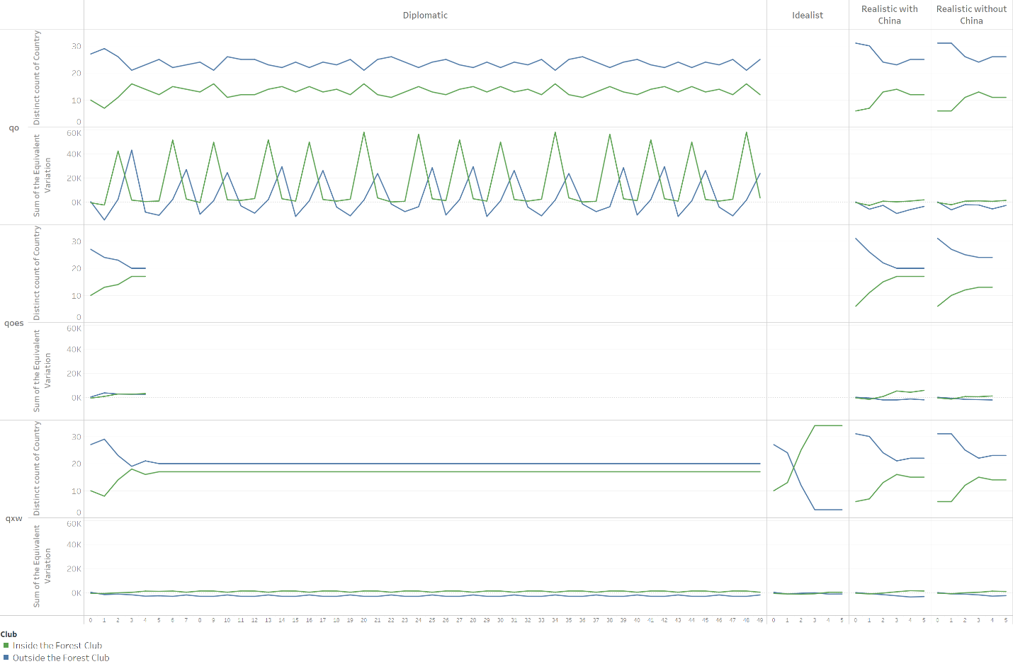
Fig. S7 | Iterative negotiation outcomes under different scenario specifications. Each panel shows (i) the number of countries participating in the Forest Club across successive iterations (upper axis) and (ii) the total welfare, measured as Equivalent Variation (EV), of countries inside (green line) and outside (blue line) the Forest Club (lower axis). Panels correspond to varying parameter configurations for qo, qoes and qxw under “diplomatic,” “realistic with China,” “realistic without China,” and “utopic” scenario settings. Only the first 50 iterations are displayed for scenarios leading to oscillations. Scenarios converging to a stable equilibrium typically do so within four or five iterations. Structural singularities observed in the “utopic” scenario for qo and qoes parameter sets prevent the solver from finding a unique solution.
Further examination of these oscillatory dynamics is warranted, particularly in scenarios where one country experiences disproportionately large gains. For instance, under the diplomatic scenario with qo parameter, Paraguay’s windfall can exceed $55 billion, a stark contrast to the more modest benefits of other members or non‐members. Such an imbalance undermines incentives for continued cooperation and destabilizes the coalition. A similar pattern occurs under the qxw parameterization in which the EU and USA see large gains while the Ivory Coast sees large losses (see Figure S8). These extreme gains and losses highlight how asymmetric outcomes can disrupt coalition equilibrium, prompting participants to reassess membership decisions.
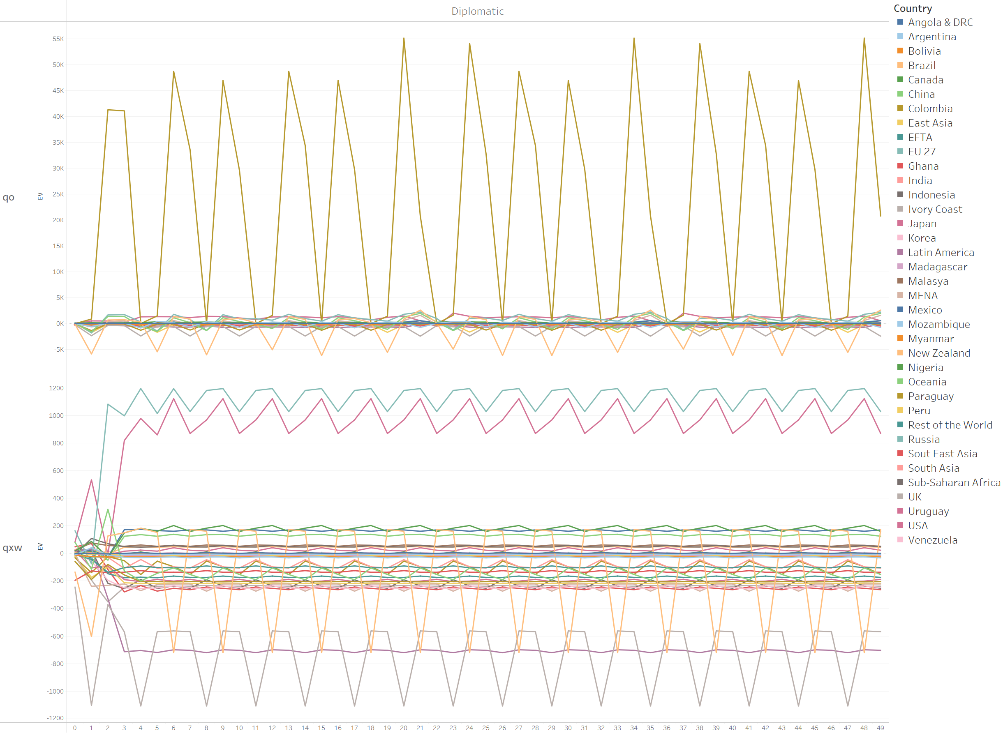
Fig. S8 | Disproportionate gains or losses causing instability in select scenarios. Panels depict the welfare trajectories for each country at each iteration under the diplomatic scenario under qo and qxw parameters. Both cases show extraordinarily high windfall gains and losses for a limited number of countries (Paraguay sees large gains under qo, while under qxw the EU and USA see large gains, and Ivory Coast sees large losses). Such large differentials distributed in a small number of countries create imbalances in incentives, contributing to oscillatory or divergent negotiation outcomes.
In addition to Figure 3 (main text), Figure S9 presents the national net changes in forested area at each iteration, illustrating how forest cover fluctuates under different parameter configurations and negotiation outcomes.
Notably, in all configurations that reach an equilibrium, no country that ultimately gains forest cover undergoes a previous iteration of significant forest contraction. This observation is especially important for tropical forests, where even a temporary but substantial decline in forest area can push ecosystems beyond critical tipping points, leading to irreversible biodiversity losses. Because forests and biodiversity are not standard commodities, partial or delayed reforestation does not negate the ecological damage that occurs in the interim—once biodiversity is destroyed, it cannot be fully restored.
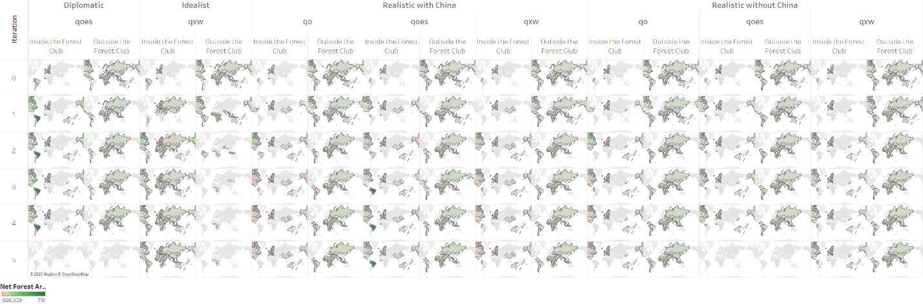
Fig. S9 | Forest area variation over iterative rounds. Detailed iteration results for each scenario and parameter leading to an equilibrium state. The panels show the iterative changes in net forest area (in Ha), by country or region. Positive values indicate national net forest expansion, whereas negative values denote net forest contraction. These data complement Figure 3 (main text) revealing the evolution of the Forest Club as countries opt in or out at each iteration.

7.2 Additional results for qo and qxw scenarios
Beyond the qoes results reported within the main text, we report here additional outcomes for forest preservation across the different scenarios under qo​ and qxw parameter settings at their respective stable equilibria.
Figure S10 details both net and gross changes in forest area. We observe that only the utopic scenario with qxw and the “realistic with China” scenarios (for both qo and qxw) surpass the baseline in terms of net forest conservation. By contrast, the “realistic without China” scenario for qo and qxw results in additional deforestation—an extra 41,121 ha for qo and 13,152 ha for qxw —largely driven by leakage into temperate forest zones (see Figure S10b).

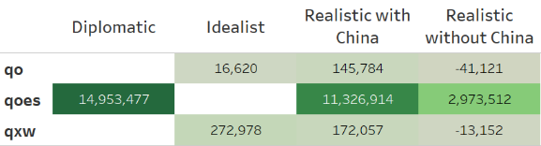
A
B
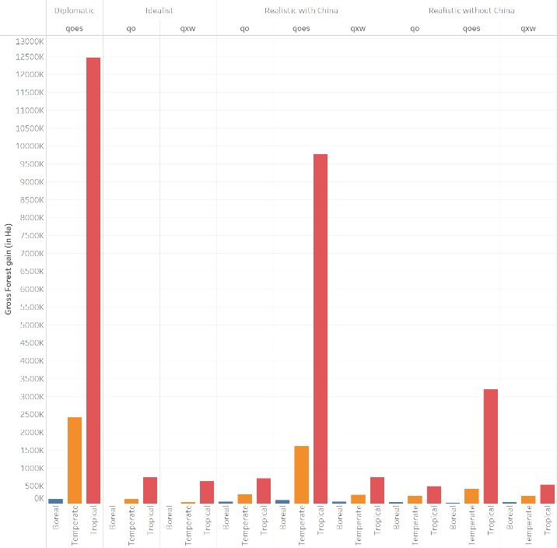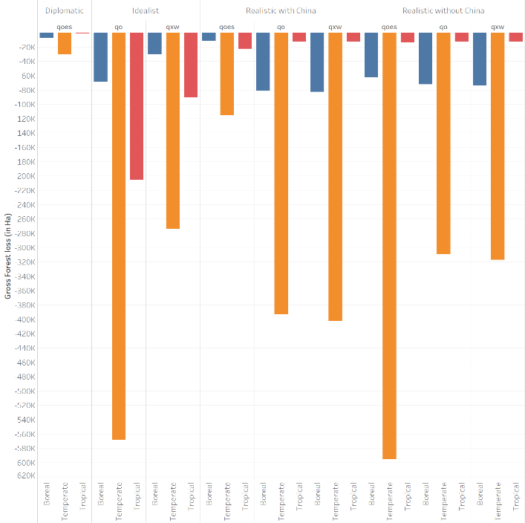

Fig. | S10: Net and gross forest area change detailed by scenario, parameter and type of forest. a, Global net forest area change under the different combination scenarios/parameters reaching a stable equilibrium state (in hectares). b, Outcomes across the different combination scenarios/parameters reaching a stable equilibrium state, showing global gross forest gains (left panel) and global gross forest loss (right panel) detail by climate type (boreal, temperate, tropical), scenario and parameters.
In every scenario that converges to an equilibrium, the Equivalent Variation (EV) used to measure the welfare change (in percentage of the GDP) remains modest. At the equilibrium, the sum of the EV never exceeds +$3.6 billion or drops below –$1.2 billion across any region (Fig. S10). As a share of GDP, these welfare changes are comparatively small—particularly under qoes—suggesting that the corresponding economic impacts would be manageable in real‐world contexts.
However, parameter settings can lead to markedly different distributional outcomes. In Fig. S13, we compare the preserved forest area at equilibrium, the relative GDP (or welfare) changes, and each region’s initial forest endowment. Results show that qoes yields no major losers outside the Forest Club, as no country experiences a GDP loss exceeding 1%. By contrast, under qo and qxw, even if the total EV magnitude is similar, at least one external country (in that specific case Ivory Coast) consistently incurs GDP losses above 1%. Moreover, Fig. S13 indicates no deforestation leakage among producer countries under qoes, whereas leakage persists for qo. These findings underscore the comparative advantages of the qoes parameterization in mitigating both forest loss and negative welfare spillovers. This pattern is further illustrated by the GDP change maps in Fig. S11, where Ivory Coast stands out under qo and qxw, and in Fig. S12, which shows greater forest leakage in the EU and North America under those parameterizations.
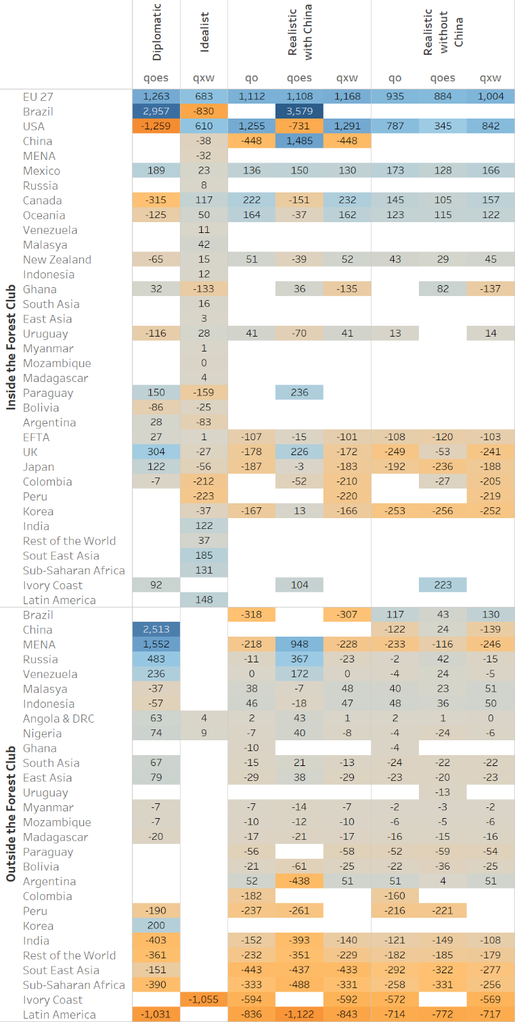
Fig. | S11: Forest club composition, GDP change in absolute value for the different scenarios / parameterizations at the equilibrium state (expressed in millions of USD compared to the baseline situation).
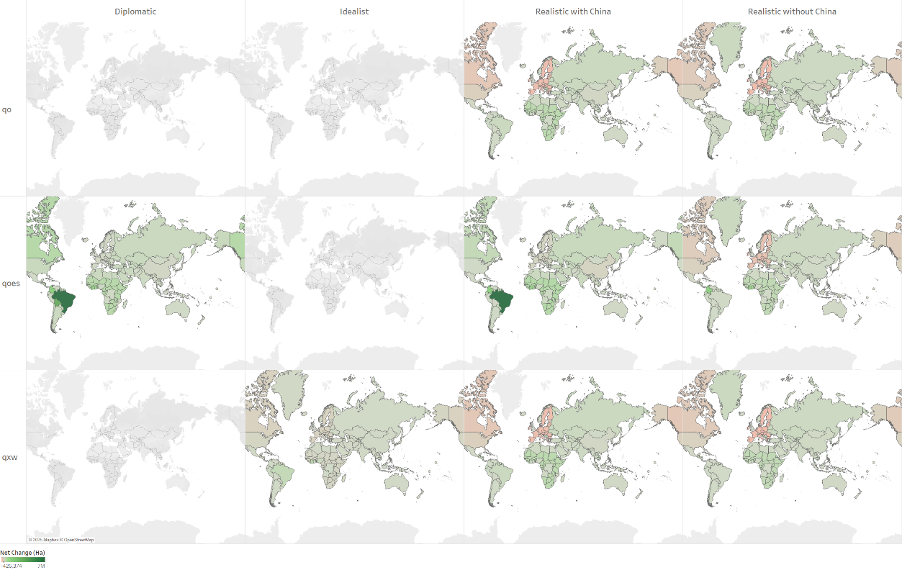
Fig. | S12: Forest area change at the equilibrium state. Detailed results for each scenario and parameterization leading to an equilibrium state. The panels show the changes in net forest area (in Ha), by country or region. Positive values indicate national net forest expansion, whereas negative values denote net forest contraction. The changes are expressed compared to the baseline situation.

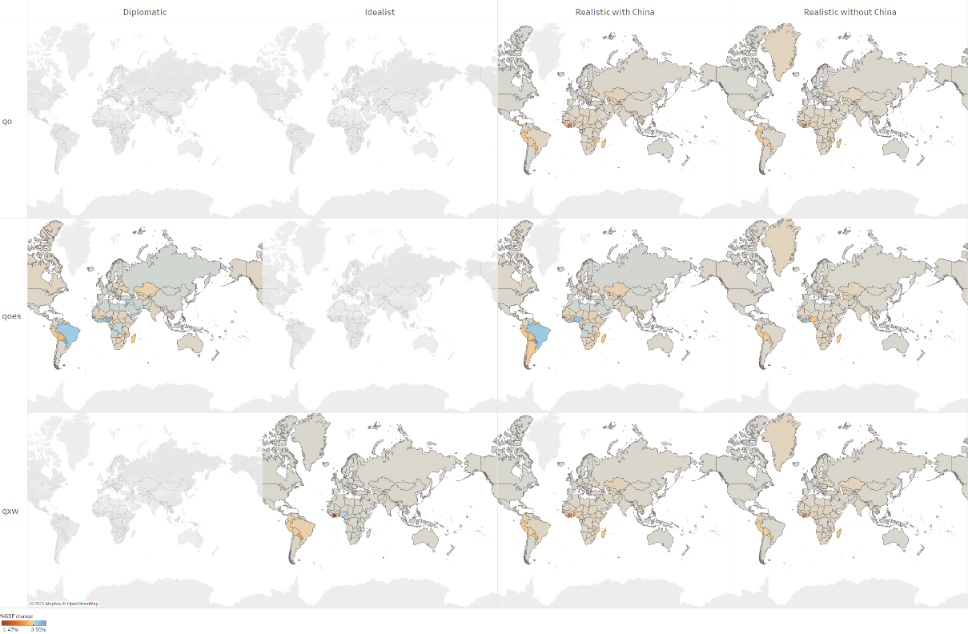
Fig. | S13: GDP change at the equilibrium state. Detailed results for each scenario and parameterization leading to an equilibrium state. The panels show the changes in GDP (in percentage of GDP), by country or region (expressed compared to the baseline situation).

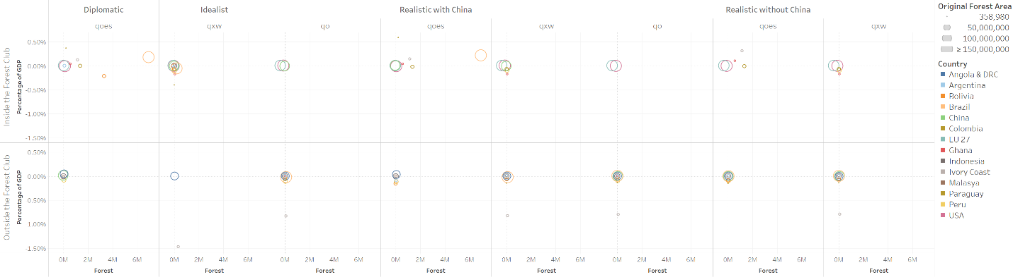
Fig. | S14: Detailed results for each scenario and parameterization leading to an equilibrium state, compared to the basline, forest area preserved (horizontal axis), percentage change in GDP (vertical axis), and original forest area (circle size) for each country. The x-axis indicates the total forest area preserved (in millions of hectares) relative to the baseline, and the y-axis plots the resulting percentage change in GDP compared to the baseline. Circles are sized according to each country’s initial forest endowment (according to GTAP-AEZ data), and circle color denotes the country or country-group. The arrangement highlights how different parameter settings influence both forest protection outcomes and GDP impacts—revealing, for instance, which countries achieve higher forest preservation with minimal negative GDP effects, and which scenarios prompt greater trade-offs.

As shown in Figures S7–S12, multiple Exit and Loss thresholds can lead to an equilibrium, and neither the smallest nor the largest threshold invariably promotes this outcome. Two factors play an important role.
First, when incremental gains or losses are relatively modest at each iteration—so even if the total becomes significant by the final round, no single step ever breaches the threshold. For instance, in Figure S10, Brazil remains within the Forest Club despite incurring a cumulative loss of −$830 million, which exceeds its nominal exit threshold of $400 million. Because the loss never reached $400 million in any single iteration, Brazil never left the coalition.
Second, shocks on qoes (reducing AEZ‐level output of deforestation‐linked commodities) consistently produce better outcomes—in terms of forest preservation and economic impacts—than shocks on qo (national output) or qxw (national exports). While these other shocks help validate the modeling approach, they do not match the performance of qoes for minimizing deforestation and economic disruption.
Finally, although a deeper exploration of shock sequencing and parameter choices would be valuable, these results demonstrate how carefully calibrated thresholds can guide the system toward a stable equilibrium, maximizing forest gains while limiting adverse economic effects.

7.3 Additional spatially explicit results and suitability of those results
To validate the land‐use allocations implied by our stable equilibrium outcomes, we examined where cropland expands by country and AEZ, ensuring any newly cultivated area is agronomically feasible (i.e., rated as “moderately,” “highly,” or “extremely” suitable for the targeted crop). If the model were to place a new crop in a clearly unsuitable area, it would indicate a potential miscalibration of land‐use elasticities (see Fig. S3 for details on elasticity hierarchies by AEZ).
For each AEZ in all producer countries, we used high‐resolution suitability data from Zabel (2022)—which ranks suitability from 0 (“not suitable”) to 100 (“highly suitable”). Zabel’s analysis covers 23 crops under multiple climate scenarios and time periods; here, we select the 1980–2019 period under rainfed conditions, extracting only the relevant data layers. We then aggregate these crop‐ and AEZ‐specific suitability scores to check whether the model’s newly expanded cropland aligns with feasible production areas. This approach aims to confirm that our final equilibrium allocations are agronomically plausible, reinforcing the validity of the qoes scenario.

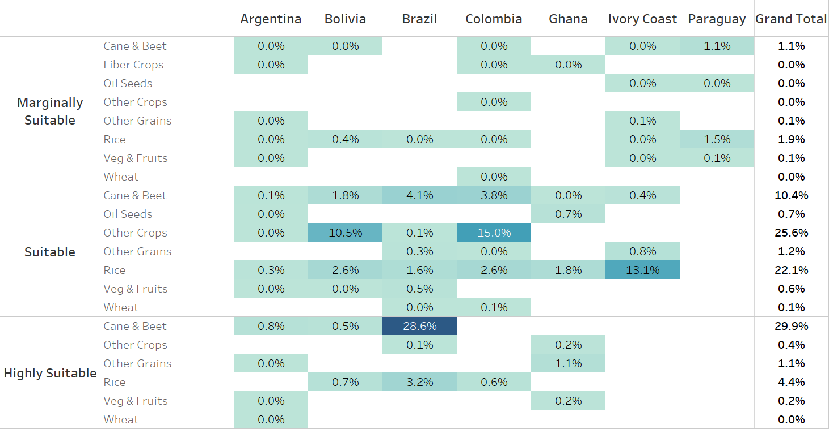
Fig. | S15: Agronomic suitability of new cropland under the “diplomatic” scenario (qoes) at equilibrium. Squares show the distribution of 1,704,595 ha of newly allocated agricultural area across different suitability classes, expressed as a percentage of the total new hectares. Suitable zones account for 97%, with the remaining 3% in marginally suitable regions—mainly in Paraguay. This outcome supports the validity of the qoes scenario, indicating that modeled land‐use changes predominantly occur for crop in locations well‐suited for the cultivation of those crops.
Figure S15 illustrates the results from this procedure under the diplomatic scenario with qoes at equilibrium, where an additional 1,704,595 ha of agricultural area emerges. Notably, 97% of this newly expanded acreage lies in zones rated at least “moderately suitable,” leaving about 3% in marginally suitable areas—primarily located in Paraguay. Consequently, the resulting land‐use distribution aligns with prevailing agronomic conditions, requiring limited extra irrigation or management. As discussed in the main text, these outcomes could be further enhanced if part of the tariff revenues were directed toward local infrastructure (e.g., water management) or agronomic improvements, thus promoting long‐term sustainability.

References of the Supplementary Information
1. Winkler, K., Fuchs, R., Rounsevell, M. & Herold, M. Global land use changes are four times greater than previously estimated. Nature Communications 12, 2501 (2021).
2. Johnson, R. C. Measuring Global Value Chains. Annual Review of Economics 10, 207–236 (2018).
3. Miller, R. E. & Blair, P. D. Input-Output Analysis: Foundations and Extensions. (Cambridge University Press, Cambridge, 2009). doi:10.1017/CBO9780511626982.
4. Hoang, N. T. & Kanemoto, K. Mapping the deforestation footprint of nations reveals growing threat to tropical forests. Nature Ecology & Evolution 5, 845–853 (2021).
5. Pendrill, F. et al. Agricultural and forestry trade drives large share of tropical deforestation emissions. Global Environmental Change 56, 1–10 (2019).
6. Wiedmann, T. & Lenzen, M. Environmental and social footprints of international trade. Nature Geosci 11, 314–321 (2018).
7. Lenzen, M. et al. The Global MRIO Lab – charting the world economy. Economic Systems Research 29, 158–186 (2017).
8. Beaufils, T., Berthet, E., Ward, H. & Wenz, L. Beyond production and consumption : using throughflows to untangle the virtual trade of externalities. Economic Systems Research (2023).
9. Dietzenbacher, E., Burken, B. van & Kondo, Y. Hypothetical extractions from a global perspective. Economic Systems Research 31, 505–519 (2019).
10. Corong, E. The Standard GTAP Model: Version 7. Journal of Global Economic Analysis 2, 1–118 (2017).
11. Hertel, T. W. Global trade analysis: modeling and applications. 428 (1997).
12. Hertel, T. Global Applied General Equilibrium Analysis Using the Global Trade Analysis Project Framework. Handbook of Computable General Equilibrium Modeling vol. 1 (Elsevier, 2013).
13. Arrow, K. J., Chenery, H. B., Minhas, B. S. & Solow, R. M. Capital-Labor Substitution and Economic Efficiency. The Review of Economics and Statistics 43, 225–250 (1961).
14. Hertel, T., Lee, H.-L., Rose, S. & Sohngen, B. Modelling land use related greenhouse gas sources and sinks and their mitigation potential. in Economic Analysis of Land Use in Global Climate Change Policy (eds. Hertel, T. W., Rose, S. K. & Tol, R. S. J.) (Routledge, 2009). doi:10.4324/9780203882962.
15. Gouel, C. & Hertel, T. W. Introducing Forest Access Cost Functions into a General Equilibrium Model. 10 (2006).
16. Golub, A. A. & Hertel, T. W. MODELING LAND-USE CHANGE IMPACTS OF BIOFUELS IN THE GTAP-BIO FRAMEWORK. Source: Climate Change Economics 3, 1–30 (2012).
17. Miranda, J., Britz, W. & Börner, J. Impacts of commodity prices and governance on the expansion of tropical agricultural frontiers. Scientific Reports 1–13 (2024) doi:10.1038/s41598-024-59446-0.
18. Pendrill, F. et al. Disentangling the numbers behind agriculture-driven tropical deforestation. Science 377, (2022).
19. Günther, F. et al. Global Agro-Ecological Zone V4 – Model Documentation. Global agro-ecological zone V4 – Model documentation (FAO, 2021). doi:10.4060/cb4744en.
20. Ivanic, M. GEMPACK simulations in R: A demonstration of running the GTAP model and processing its results entirely in R using packages HARr and tabloToR. Journal of Global Economic Analysis 8, 1–20 (2023).

https://www.copsmodels.com/gpprice.htm

