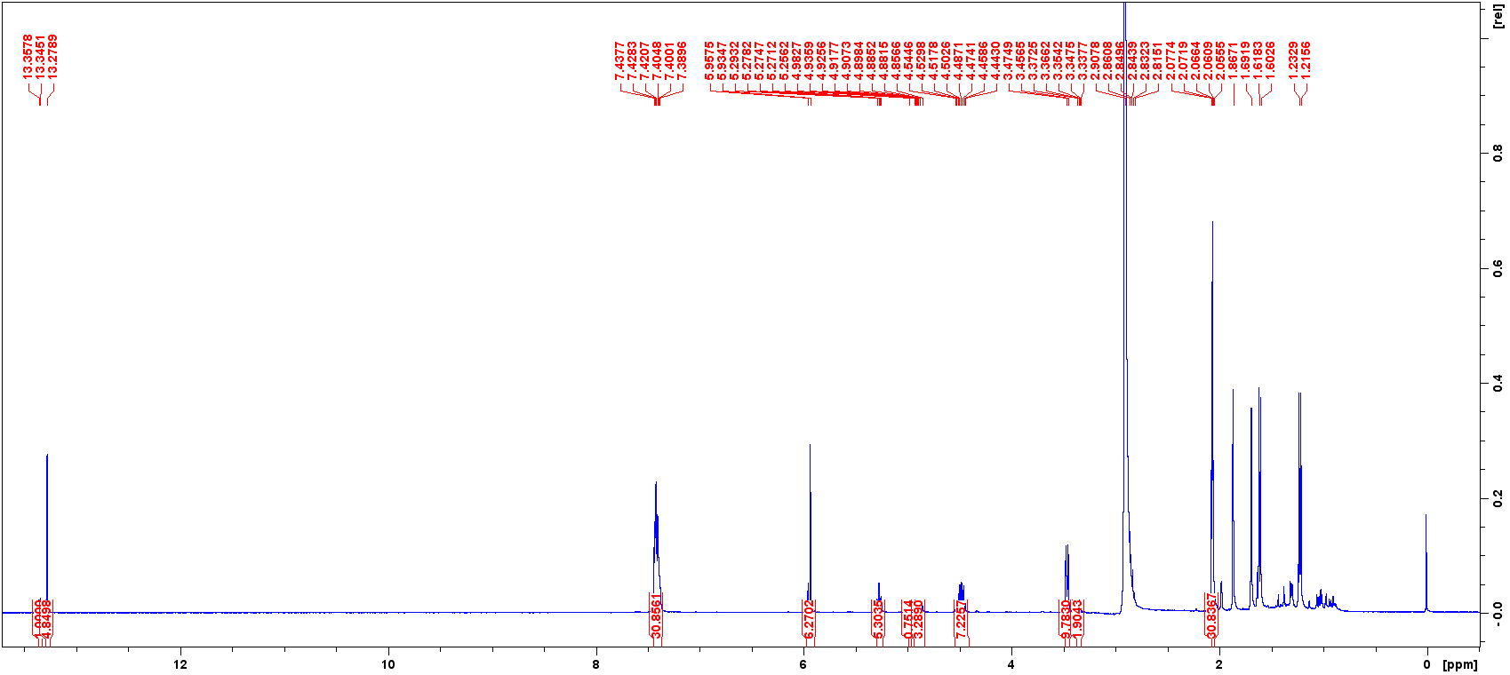
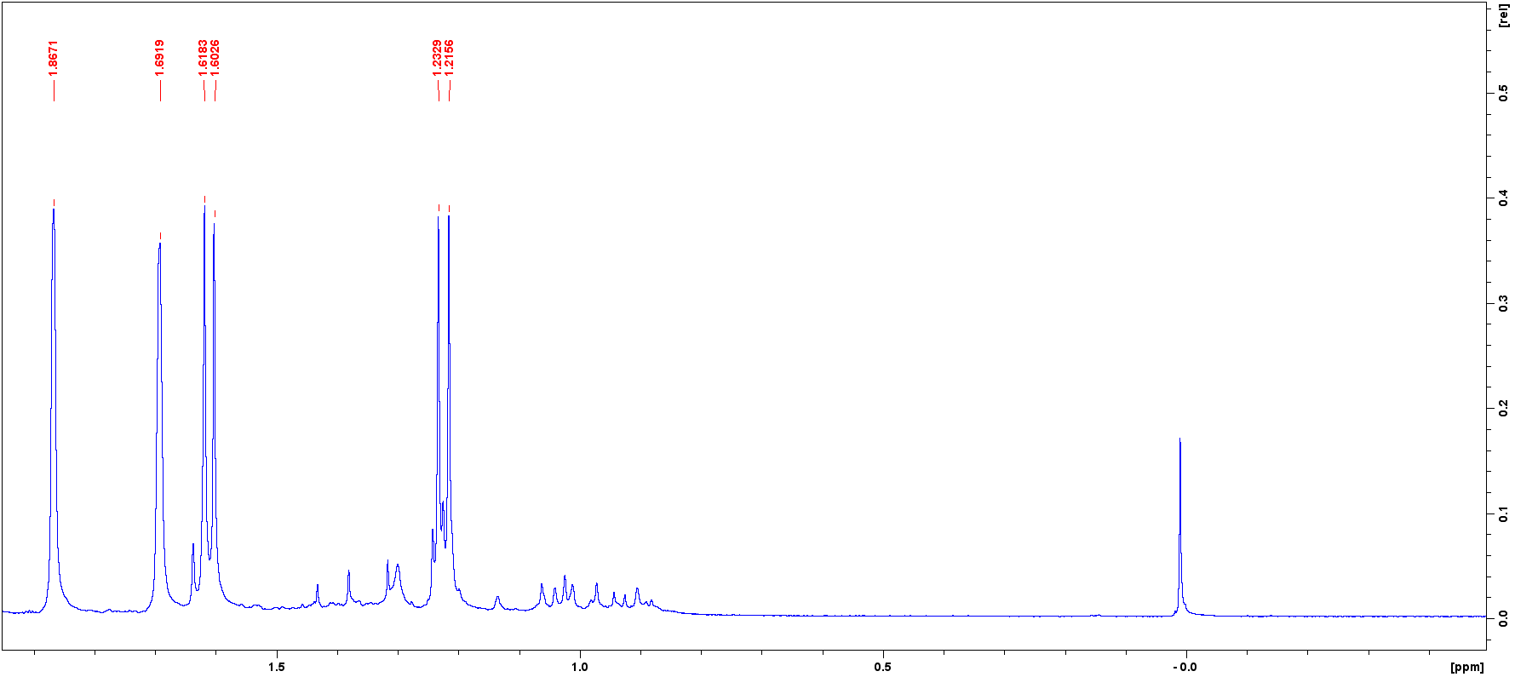
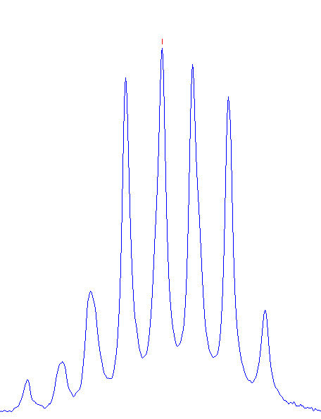
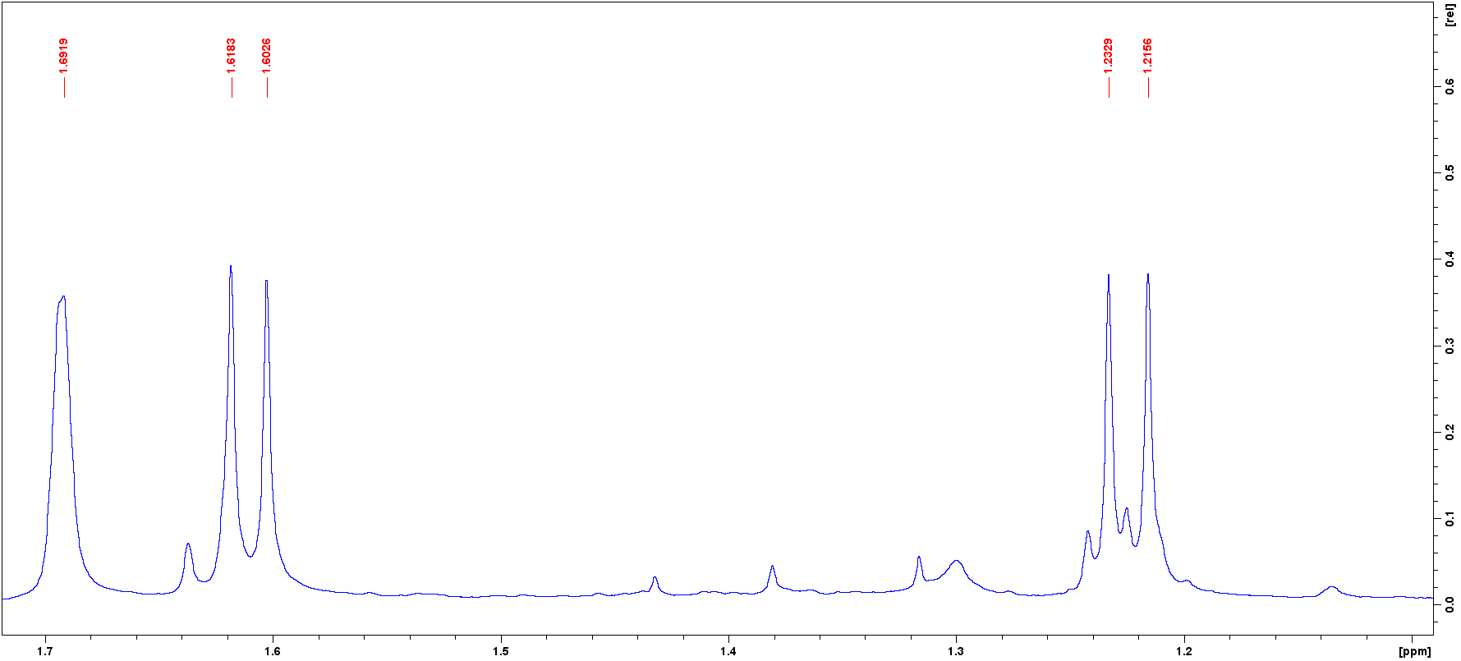
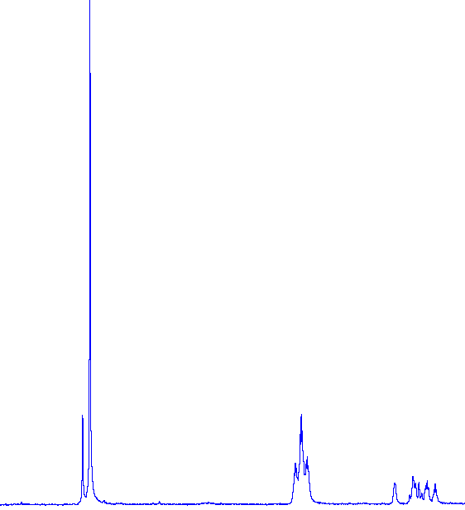
H-5ʹ
H-3ʹ
H-2ʺʹ
H-5ʺʹ
Figure S1 ¹H NMR Spectrum of woodiixanthone A (1)

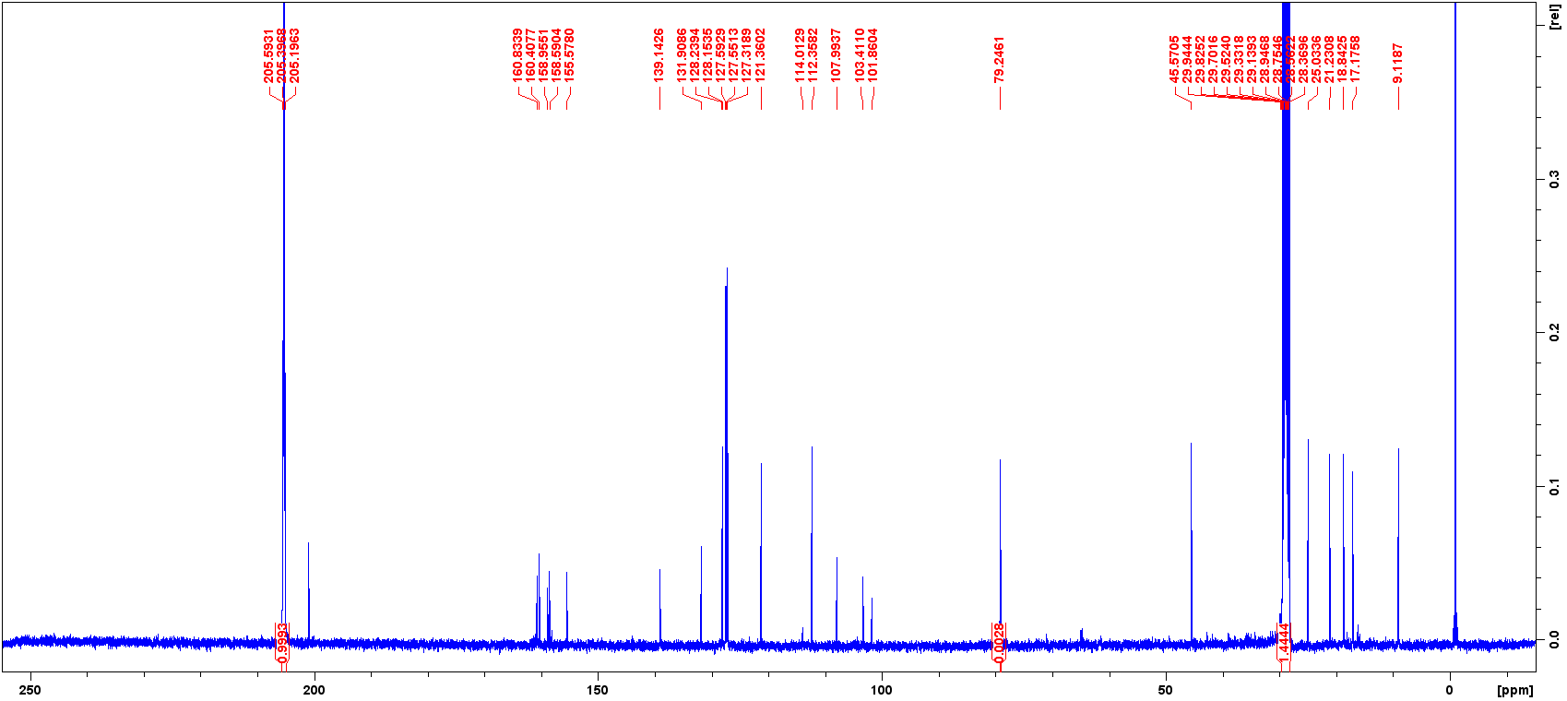
Figure S1 ¹³C NMR of woodiixanthone A (1)

C-5ʹʹʹ
C-2ʹʹʹ
C-3ʹʹʹ
C-1ʹʹʹ
C-5
C-4
C-1ʹ
C-2ʹ
C-3ʹ
C-4ʹ
C-5ʹ
C-6ʹ
C-8
C-4a
C-3
C-7
C-2
C-2ʹʹ
C-6
C-5ʹ’
C-1’ʹ
C-4ʹʹ
C-4ʹʹʹ
C-8a
C-3ʹʹ

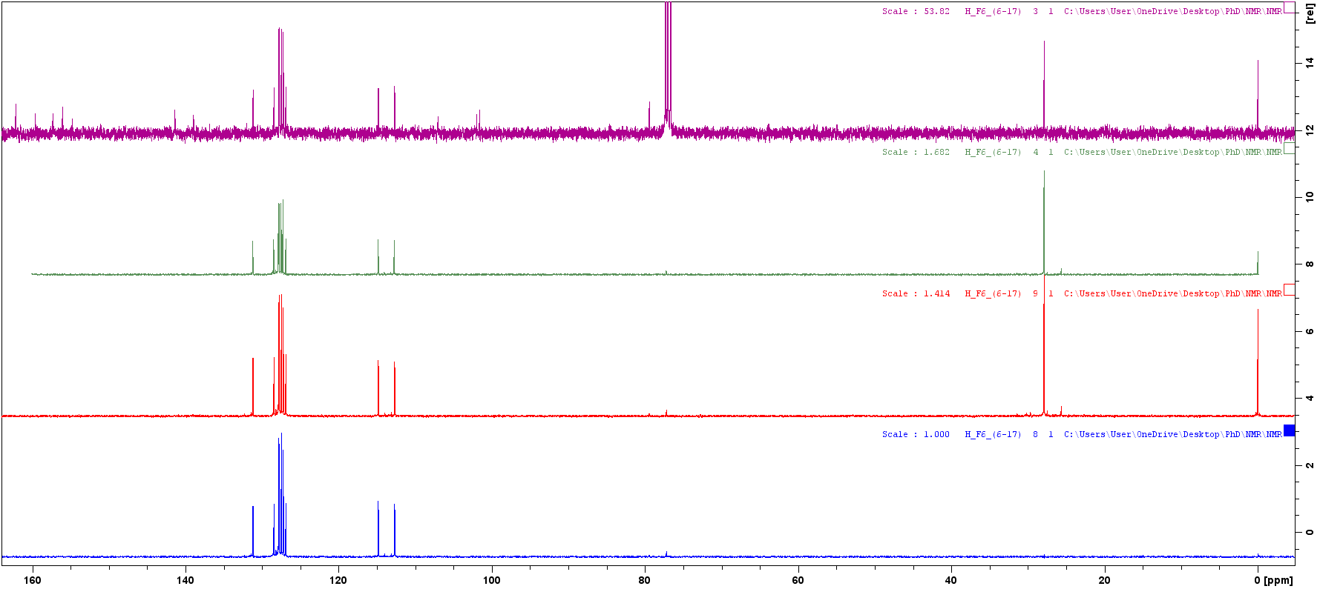
Figure S1 ¹³C DEPT Spectrum of woodiixanthone A (1)
C-13
DEPT-45
DEPT-90
DEPT-135

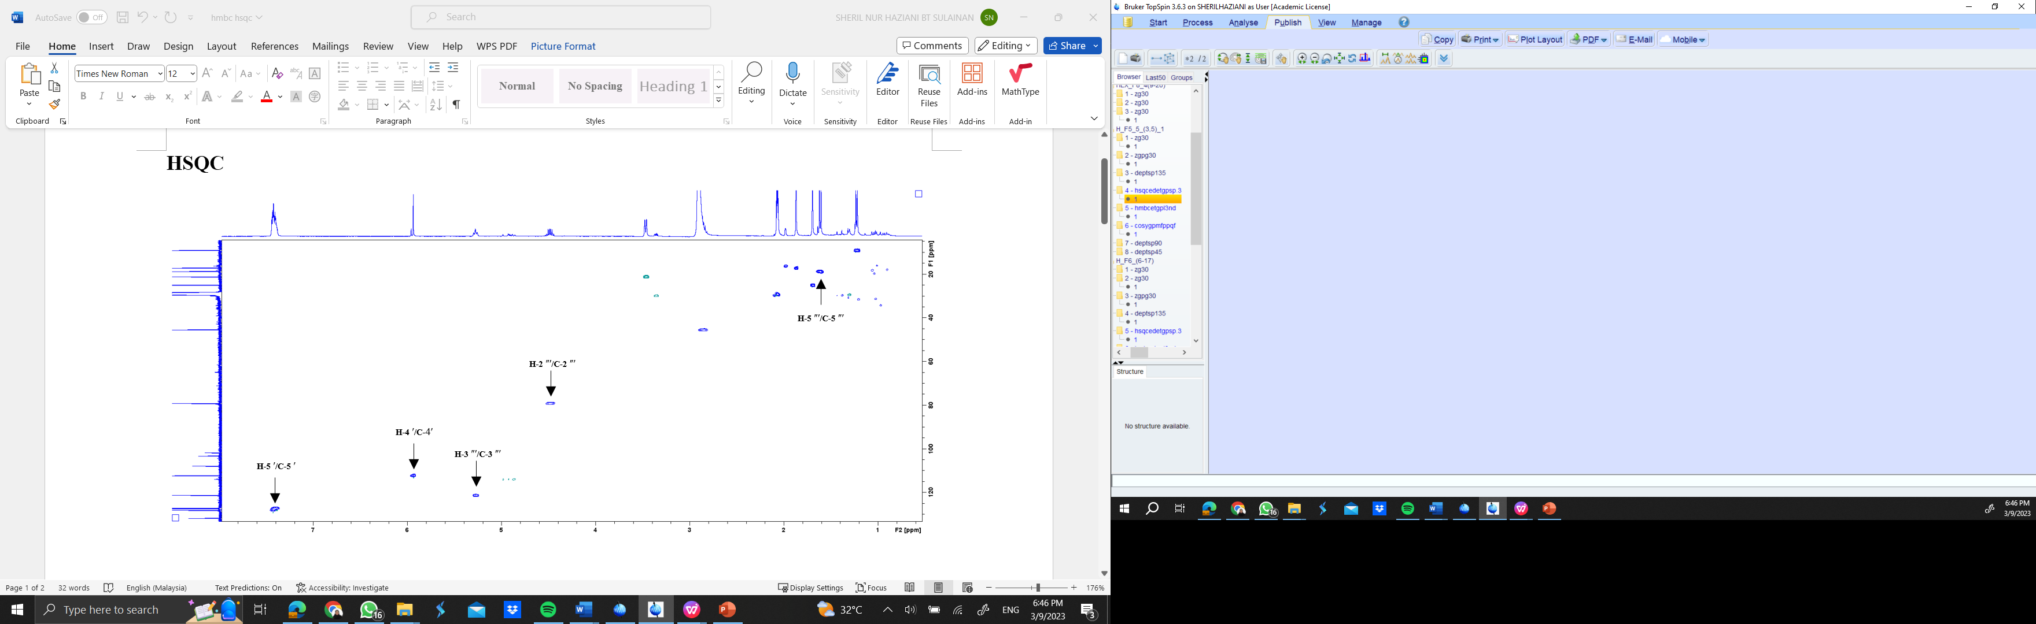
Figure S1 HSQC Spectrum of woodiixanthone A (1)
H-5ʹʹ /C-5ʹʹ
H-4 ʹʹʹ /C-4ʹʹʹ
H-1ʹʹ /C-1ʹʹ
H-2ʹʹʹ /C-2ʹʹʹ
H-4 ʹʹ/C-4ʹʹ

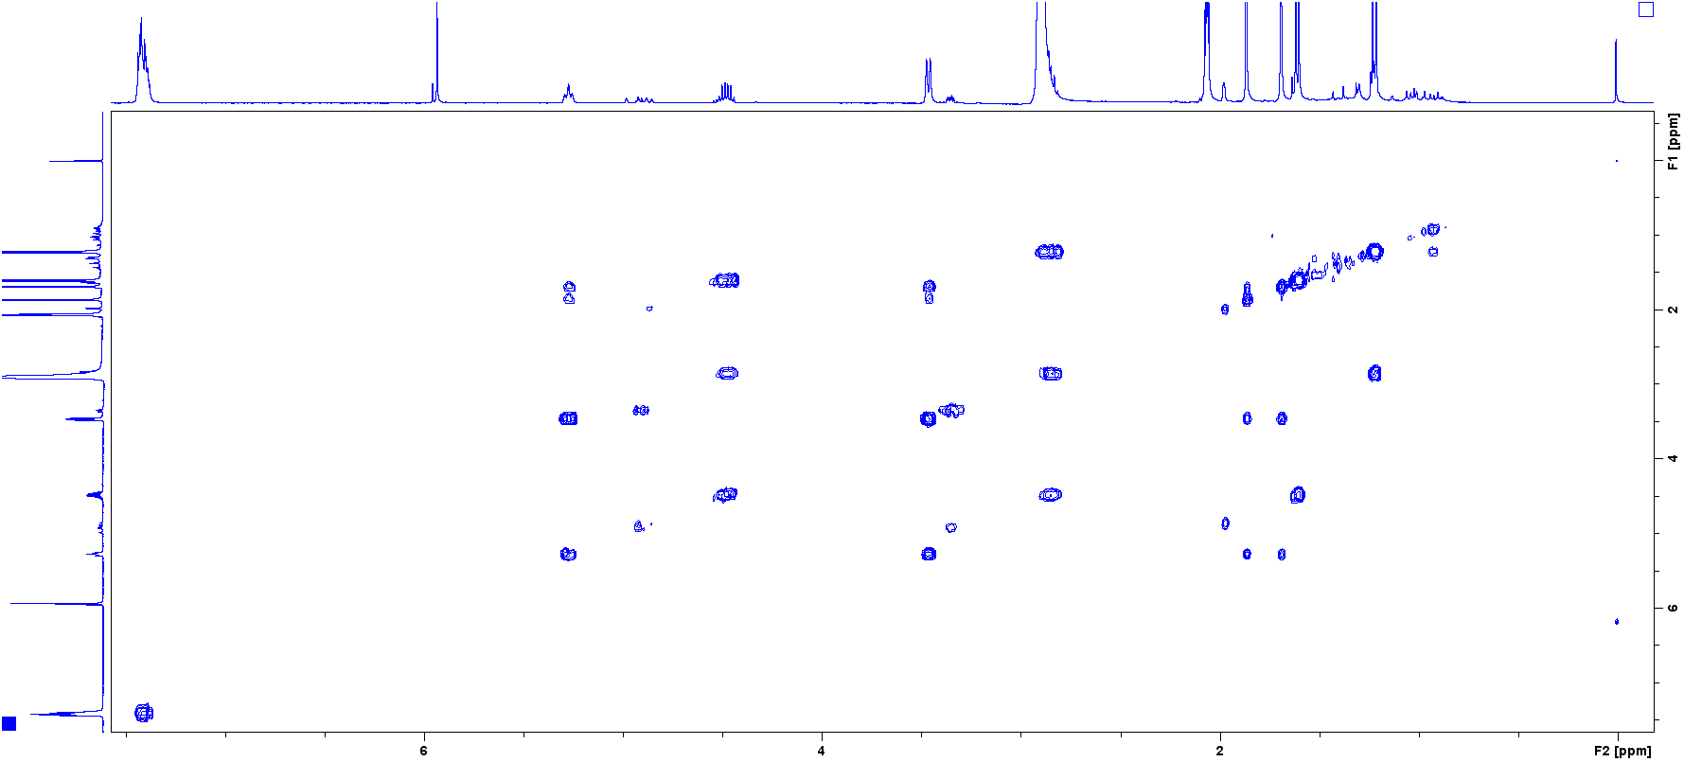
Figure S1 COSY Spectrum of woodiixanthone A (1)
H-4ʹʹʹ
H-5ʹʹʹ
H-3
H-4ʹ
H-2ʹʹʹ
H-3ʹ’’
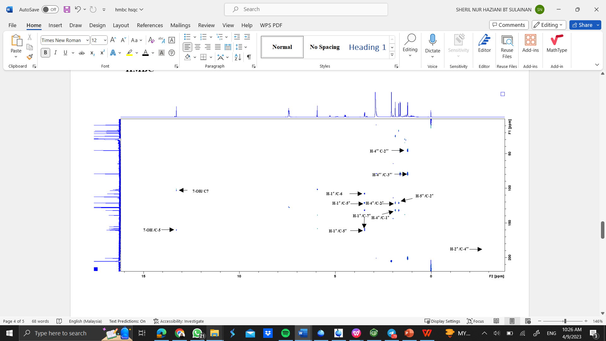
Figure S1 HMBC Spectrum of woodiixanthone A (1)

