Supplementary Figure
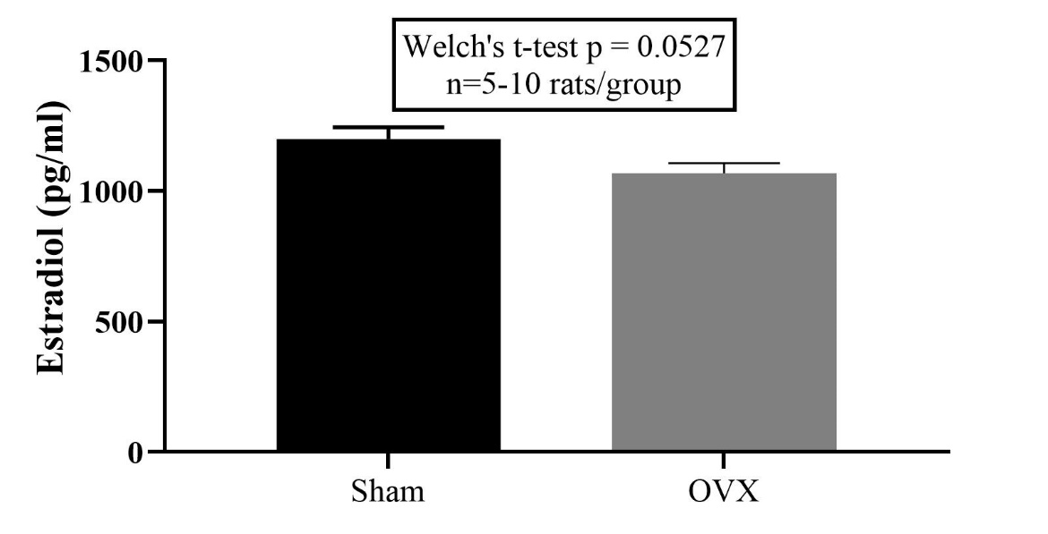
Supplementary Fig. 1 Measurement of estradiol level after 3 weeks post-ovariectomy surgery between sham-operated and ovariectomy group.
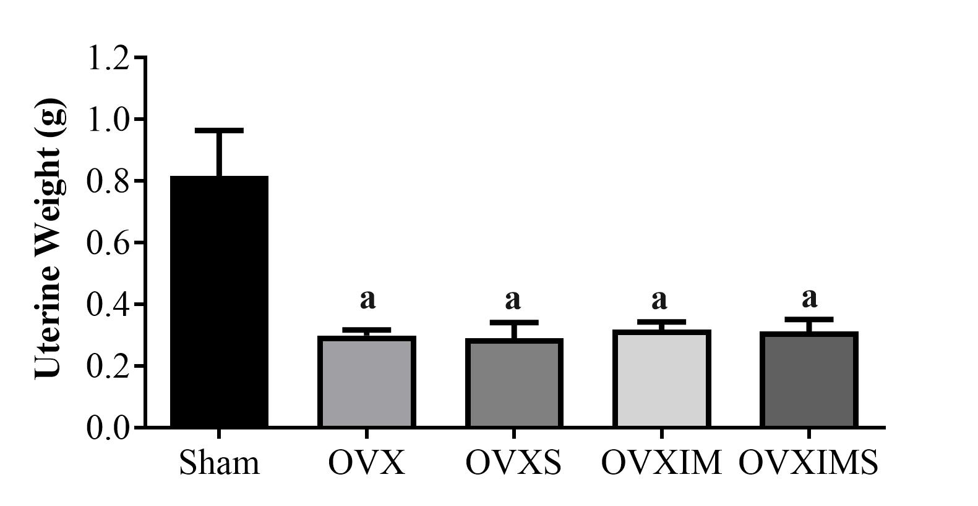
Supplementary Fig. 2 Measurement of uterine weight at the end period of the experiment between sham-operated and ovariectomy group.

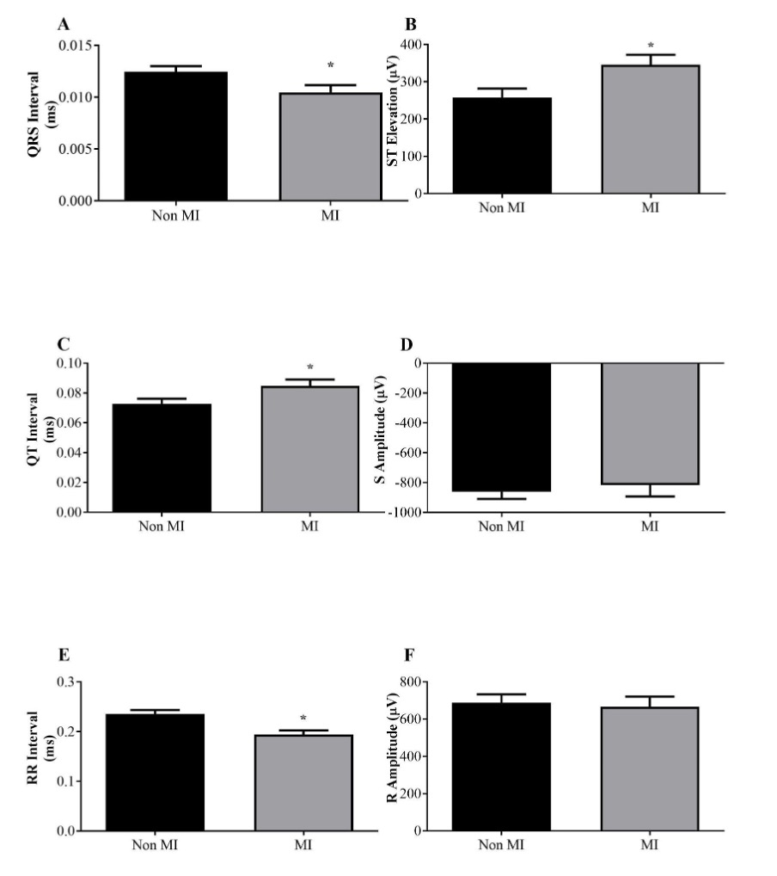
Supplementary Fig. 3 Electrocardiogram parameters difference between non-MI induced group and MI-induced group.

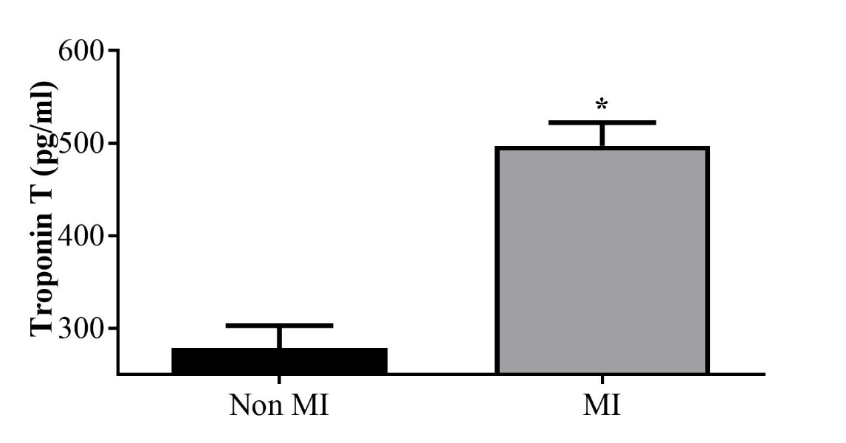
Supplementary Fig. 4 Measurement of cardiac marker Troponin T between non-MI induced group and MI-induced group.

