Supplemental figures

Fig. S1. Kinetics of host T cell activation marker expression after in vitro co-culture with allogeneic graft T cells. (A) Frequency of host T cells expressing activation markers overtime following co-culture with allogeneic TRAC^{KO} graft donor T cells. Data are the combined results from 7 unique graft-host donor pairs. (B) Representative flow cytometry plots showing activation marker expression on host T cells over time. (C) The absolute numbers of remaining graft T cells measured overtime. Data are the combined results from 7 unique graft-host donor pairs.

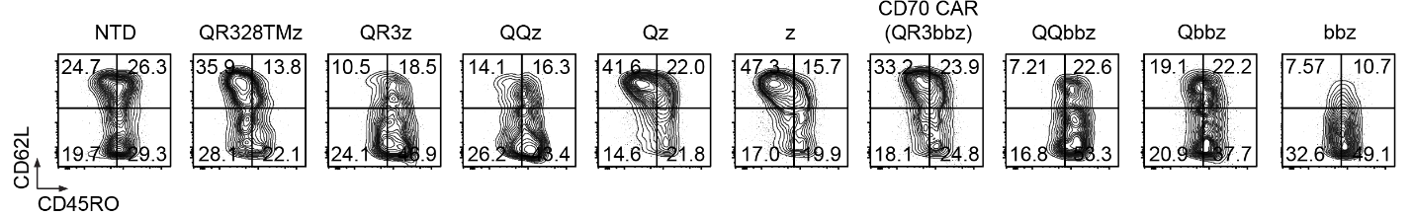
Fig. S2. Phenotyping of allogeneic T cells expressing anti-rejection CD70 CAR variants. Flow cytometry plots showing CD62L and CD45RO expression on human T cells transduced with LLVs encoding a range of CD70 CAR variants. Representative flow cytometry plots are shown within the transgene⁺ cell population for groups expressing a CD70 CAR.

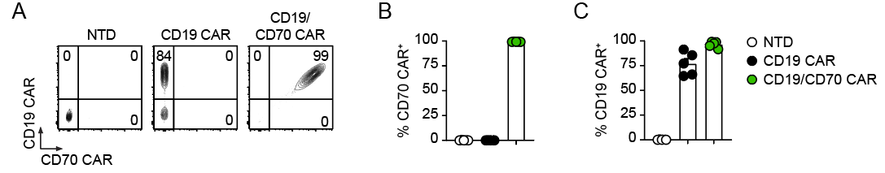

Fig. S3. Phenotyping of CD19 CAR T cells co-expressing an anti-rejection CD70 CAR. (A) Representative flow cytometry plots showing CD19 CAR and CD70 CAR expression on day 14 post activation. (B) Frequencies of CD70 CAR expressing cells on day 14 post activation are shown. (C) Frequencies of CD19 CAR expressing cells on day 14 post activation are shown. Symbols represent unique donors (n = 5).

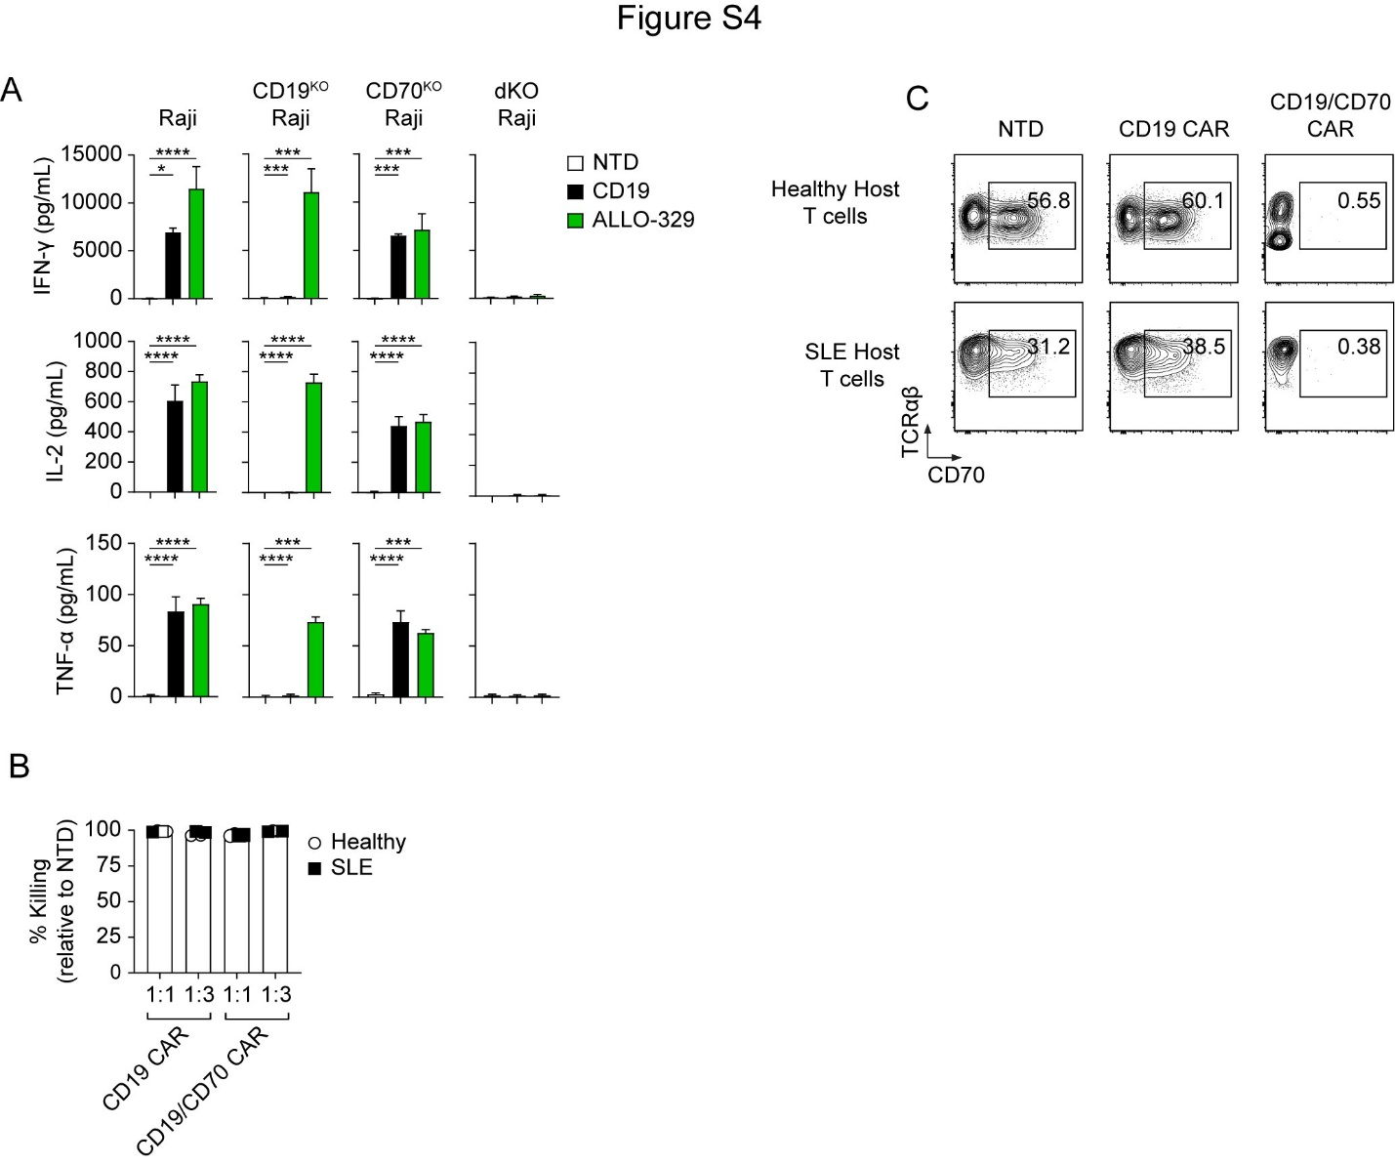

Fig. S4. Target exposure induces cytokine production and cytotoxicity by CD19/CD70 CAR T cells. (A) Cytokine levels in supernatant following target exposure for 24 hours. Data are shown as mean ± SEM of technical replicates from 2 donors tested. (B) Killing of CD19⁺ B cells from PBMCs in a 24-hour killing assay. Symbols represent unique graft-host donor pairs. (C) Killing of Raji target cells over multiple rounds of target exposure. Representative of 2 donors tested. (D) Representative flow cytometry plots showing CD70 expression on host T cells on day 6 in alloreactive T cell MLRs, shown in Figure 3.

Fig. S5. Dual targeting enhances in vivo CAR T cell efficacy. (A) Quantification of bioluminescence from individual mice bearing CD70^{KO} Raji tumors and representative bioluminescence images of tumor burden in control and treated mice shown in Figure 3 (n = 10). (B) Quantification of bioluminescence from individual mice bearing the parental Raji tumors and representative bioluminescence images of tumor burden in control and treated mice shown in Figure 3 (n = 10).

Fig. S6. Co-expression of an anti-rejection CD70z CAR limits CD19 antigen escape in Toledo and Raji lymphoma cells. (A) Representative flow cytometry plots on day 4 of CD19 and CD70 expression in mixed Toledo cell in vitro antigen escape assays. The percentage of CD19⁻CD70⁺ and CD19⁺CD70⁻ Toledo cells are plotted for one representative donor on day 4. Data are representative of four donors tested and two independent experiments. (B) Quantification of bioluminescence from individual mice shown in Figure 4 (n = 10).

Fig. S7. B cell differentiation and CD70 expression on host T cells in NSG mice. (A) Frequency of CD70⁺ host T cells in the spleen of Hu-CD34 mice shown in Figure 5 (n = 3). (B) Frequency of CD19⁺ subsets in the spleen of mice over time after transfer of PBMCs into NSG mice (n = 3). (C) Representative flow cytometry plots of host B cells on day 10 after PBMC transfer into NSG mice (n = 3).

Fig. S8. Virus-specific T cell activity is not abrogated by CD19/CD70 CAR T cells. (A) Schematic of virus-specific T cell (VST) tri-culture assay. (B) Antigen presenting cell (APC) and VST counts from the 8:1:1 ratio at 48h. (C) APC and VST counts from the 4:1:1 ratio at 48h. Data are representative of three unique graft donors tested and are shown as mean ± SEM of three technical replicates.

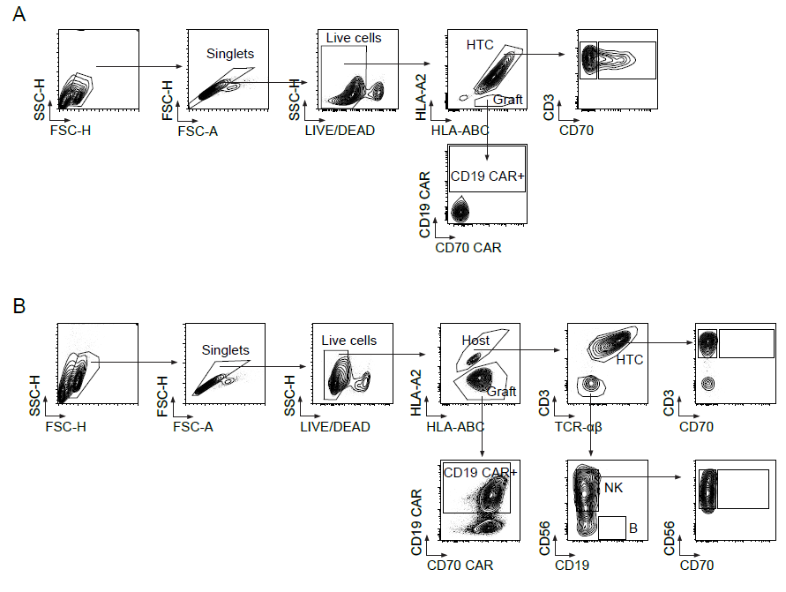
Fig. S9. Flow cytometry gating strategy. Flow cytometry gating strategies are shown for (A) alloreactive T cell MLR and (B) PBMC MLR assays.

