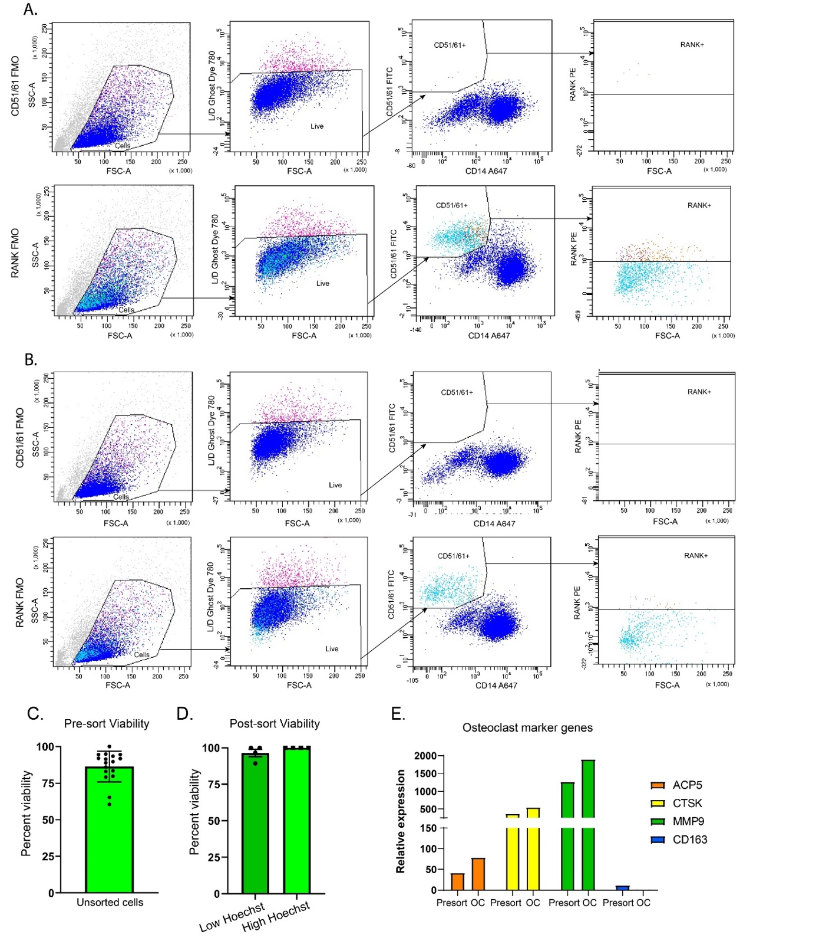
Supplementary Figure 1. Live Cell Sorting for Monocyte Derived Osteoclast Cells. Fluorescent Minus One (FMO) gating controls for CD51/61 (a) and RANK (b) binding for two Representative donor specimen Patient 1 and Patient 2. (c) Average cell viability before cell sorting was 86.36% ± 10.53 % of total nucleated cells measured by AO/PI uptake on a Nexcelom cellometer (d) Average cell viability after cell sorting was 96.48% ± 5.045 % of total nucleated events for ‘Low Hoechst’ cells and 100% ± 0.00 & for ‘High Hoechst’ cells after live cell sorting (e) Quantitative PCR of osteoclast marker genes Acid Phosphatase 5, Tartrate Resistant (ACP5), cathepsin K (CTSK), matrix metalloproteinase 9 (MMP9) and macrophage marker CD163 (CD163), comparing bulk ‘presort cells’ (Presort) to matched ‘High Hoechst’ osteoclasts (OC) shown as relative expression projected to housekeeping genes RPLP0 and POLR2A.

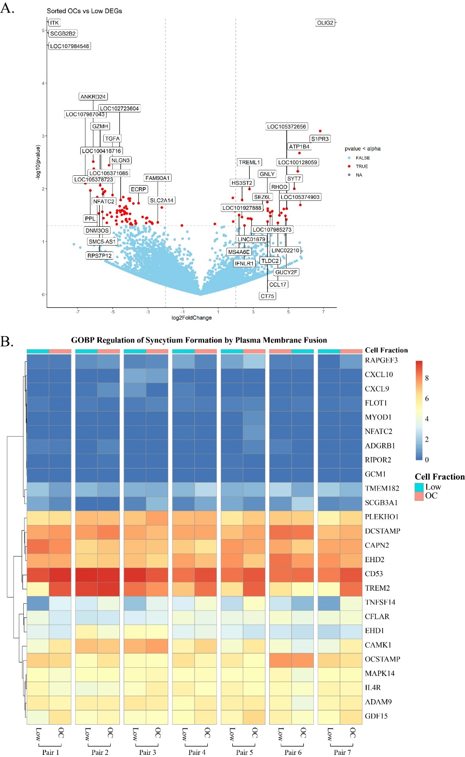
Supplementary Figure 2. Bulk RNAseq of unsorted and sorted osteoclast cells (a) Volcano plot of gene expression change comparing sorted High Hoechst to Low Hoechst osteoclasts (b) Normalized gene expression for the GOBP Regulation of Syncytium Formation by Plasma Membrane Fusion gene set, comparing Low Hoechst and High Hoechst OC matched pairs for all donor pairs.
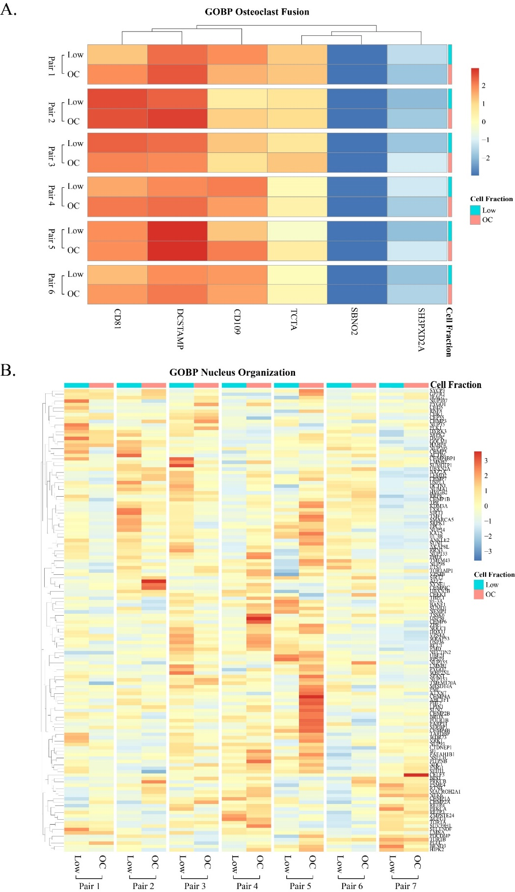
Supplementary Figure 3. Heatmaps of immune cell subsets and gene sets associated with biological processes. (a) Normalized gene expression for the GOBP Osteoclast Fusion gene set, comparing Low to OC matched pairs for all donor pairs (b) Normalized gene expression for the GOBP Regulation of Syncytium Formation by Plasma Membrane Fusion gene set, comparing Low and OC matched pairs for all donor pairs

