Supplementary figure 1:

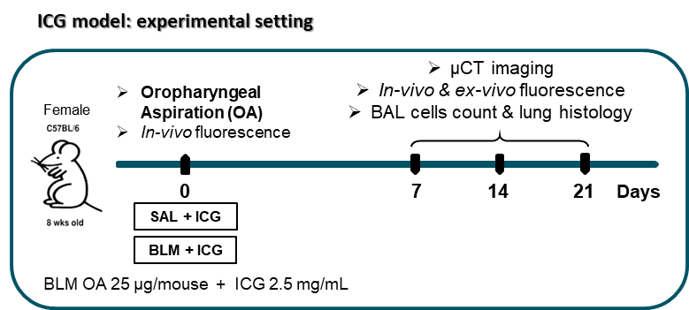

Supplementary Figure 1: Schematic representation of the experimental setting. 8 weeks old female C57BL/6 mice were treated with 2.5 mg/mL ICG in saline (Sal+ICG) or BLM+ICG (25 µg bleomycin in 2.5 mg/mL ICG) through OA at day 0. At 3 endpoints (day 7, 14 and 21 after OA) animals underwent non-invasive in-vivo imaging (Micro-CT and In-vivo fluorescence imaging); a subset of mice was culled to perform ex-vivo fluorescence imaging of lungs, BAL cells count and pulmonary histology. At each time point, 5 Sal+ICG and 12 BLM+ICG animals were used. 3 independent experiments were carried out.

Supplementary figure 2:

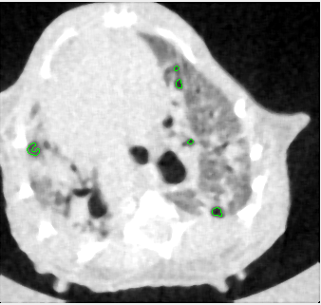
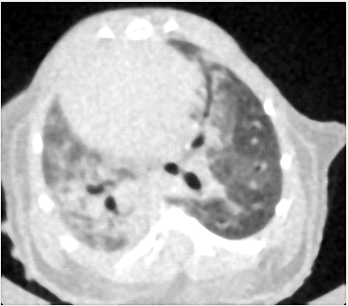
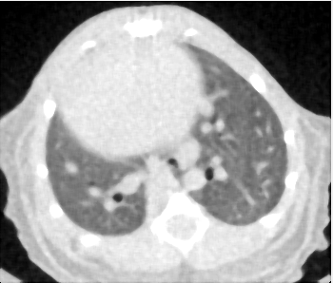
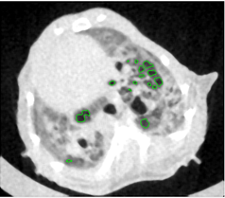
FAE⁺
FAE
Healthy
TBF
C
B
A
D

Supplementary figure2: representative cross-sections of the different patterns. Representative CT images of Healthy lung parenchyma (A), TBF (B), FAE (C) and FAE⁺ (D) Low-attenuation areas are highlighted in green and could be detected in the FAE and FAE⁺ classes.

Supplementary figure 3:

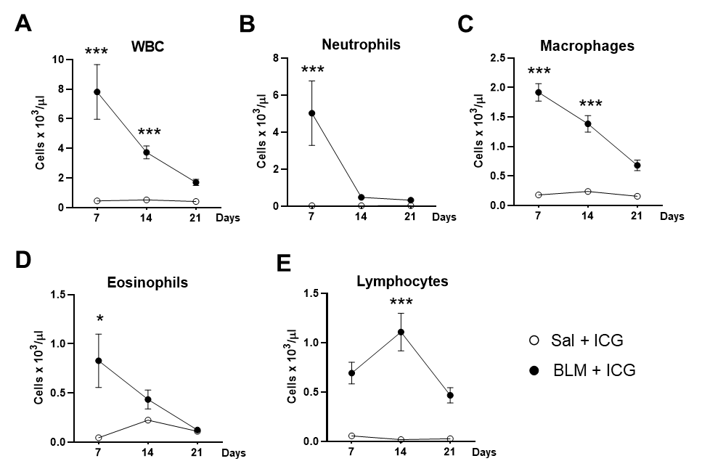

Supplementary figure 3: inflammatory cells count in BAL fluid. Cellular infiltration in the BALF of Sal+ICG and BLM+ICG groups. Time-course of total white blood cells (wbc) (A), neutrophils (B), macrophages (C), eosinophils (D) and lymphocytes (E). Data plotted as mean ± SEM. Two-way ANOVA with Sidak’s correction for multiple comparison was applied to compare BLM+ICG and Sal+ICG group at each time point. *p < 0.05; **p < 0.01 *** p-value < 0.001 vs Sal+ICG group at respective time-point. Number of animals was as follows: Sal+ICG 5 animals at each time point, BLM+ICG 12 animals at each time point. Data collected from 3 independent experiments.

