Table 1: Effect of plant growth promoting fungi (PGPF) on growth parameters of C. sativus
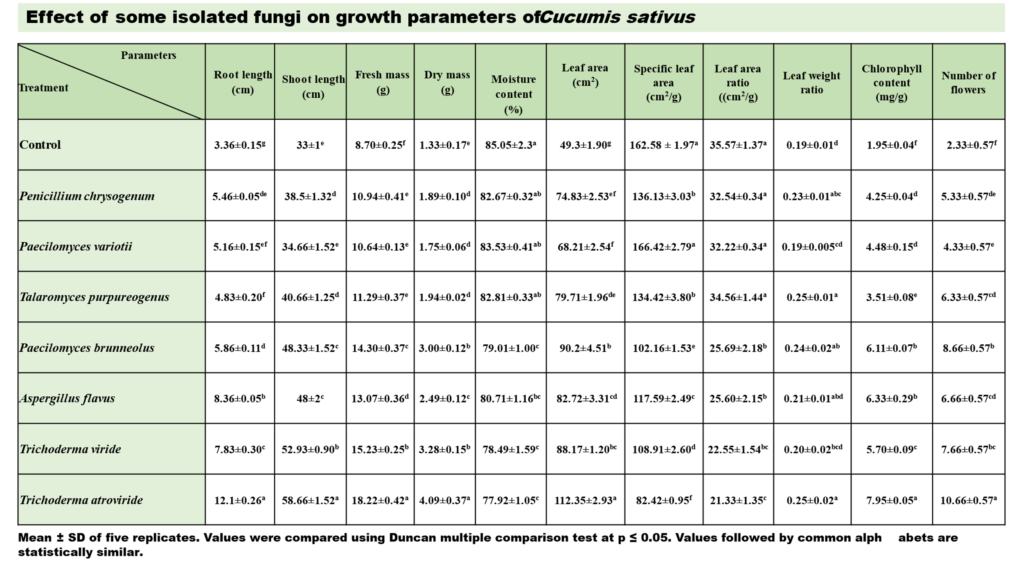 Mean ± SD of five replicates. Values were compared using Duncan multiple comparison test at p ≤ 0.05. Values followed by common alphabets are statistically similar.

